Nottingham Trent University

School of Science and Technology

Project Management Website Application

by

Dominic Hart

in

2018

Project report in part fulfilment

of the requirements for the degree of

Bachelor of Science with Honours

in

Computing

I hereby declare that I am the sole author of this report. I authorize the Nottingham Trent University to lend this report to other institutions or individuals for the purpose of scholarly research.

I also authorize the Nottingham Trent University to reproduce this report by photocopying or by other means, in total or in part, at the request of other institutions or individuals for the purpose of scholarly research.

Signature

## **Abstract**

**Do at end**

## **Acknowledgements**

**Do at end**

**Contents**

**Project Management Website Application** 1

**Abstract** 1

**Acknowledgements** 2

**List of Figures** 4

**List of Chapters** 5

**Chapter 1** 6

**1.1 Introduction** 6

**Chapter 2** 7

**2.1 Literature Review** 8

**2.2 Parallel Product Review** 9

**Chapter 3** 10

**3.1 New Ideas** 10

**3.2 Requirements** 10

**Chapter 4** 11

**4.1 Languages** 11

**4.2 Style Guide** 11

**4.3 Database Design** 11

**4.4 Use Cases** 11

**4.5 Testing** 11

**Chapter 5** 12

**5.1 Test Results** 12

**Chapter 6** 13

**References** 14

**Bibliography** 15

**Appendix A – Project Planning Document** 16

## **List of Figures**

**Do at end**

## **List of Chapters**

**Do at end**

## **Chapter 1**

### **1.1 Introduction**

## **Chapter 2**

### **2.1 Literature Review**

#### 2.1.1 Project management in business

Project Management forms a large part of business operations and while it is vital for the business to be successful; project management is plagued with problems that cause projects to be delayed or even abandoned.

Some of these issues as described in one article are *“limited budget, smaller staffs, shorter deadlines, more demanding stakeholders“*. The article continues to describe the ever increasing pressures on Project Managers to *“get projects done successfully”* (Mossalam, 2017).

Resolving these issues often requires decisions to be made *“outside the scope of day to day project tasks”.* If an issue is not dealt with it can delay the project or even bring progress to a halt. One issue usually leads to further issues as a result; such as a delay to the timescale causing additional resource costs including staff hours.

Project scope creep and cost overruns are common issues in Project Management. After conducting a survey into construction and infrastructure projects one researcher (Smith, 2014) found that the likelihood of cost escalations were *“45% for rail projects, 34% for tunnels and bridges and 20% for roads”*.

Conflict within a project team is another issue that could occur for many reasons. Team members might feel like they are being kept out of the loop, being delegated unimportant tasks or might simply just not like each other. Teamwork is vital to a project’s success but can be difficult to achieve.

One article states that Team members with less *”emotional stability”* are more likely to exhibit *“negative emotions”* which *“reduces team cohesion”,* impacting the performance of the team (Yan et al., 2009). It’s not just people with less emotional stability; some team members may have closed off personalities which makes it difficult for other team members to communicate and share ideas with them.

Due to the nature of project management a lot of issues that occur are often not at the fault of the project manager or any member of the project team. Scope creep is more often caused by the client requesting more features be added to their project during the project. By asserting control and properly defining what is inside and outside of the project scope early on the project manager can mitigate the impact on the project.

If you consider the success rate of projects overall in the United Kingdom only *“37%”* of the companies included in one survey that evaluated project performance *“always or mostly complete projects on time*” (Wellingtone, 2017). Delays to the project timeline are a very common issue and are often caused by unforeseen circumstances.

The survey continues to state that around *“35%”* of these companies *“always or mostly”* achieved all the project deliverables (Wellingtone, 2017). In 65% of the projects, the client does not receive the solution that was initially promised to them. Stripping unnecessary or less important deliverables from a project is a common way to reduce both project cost overruns and delays to the timeline.

Only *“42%”* of the projects were completed to budget (Wellingtone, 2017). The causes of these issues such as poor training and lack of support can be prevented with the correct tools and procedures in place. Other causes however include “poor resource management” and “attempting to run too many projects” (Wellingtone, 2017).

While Project Managers are under immense pressure to perform; issues that occur during the project are preventing the project from being completed on time, to budget and to the standard that was promised to the client.

Not all issues can be avoided; it is difficult to prevent a project from having any delays to timescale or cost escalations. However with the correct tools and procedures in place these issues could be caught early on before they have a serious impact on the project and then mitigated correctly.

#### 2.1.2 How project management applications are used

One tool to help prevent issues in projects is a project management software application. Any organisation that runs projects will already use an application or series of applications to register, track and complete projects.

The best way to review how existing solutions solve project management issues is to conduct a parallel product review. For this review five existing applications that allow projects to be registered, tracked and completed will be selected.

The objectives of this review are to

* Explore existing solutions
* Learn how existing solutions address the issues with projects
* Compare the solutions to each other
* Find out what existing solutions are lacking

##### 2.1.2.1 Parallel Product Review

The first application being reviewed is Microsoft Project. Project is a tool with a focus on scheduling, resource allocation and budget management. It is a popular project tool as *“it is extremely intuitive and offers great balance of usability and complexity”* (Financesonline.com, 2018).

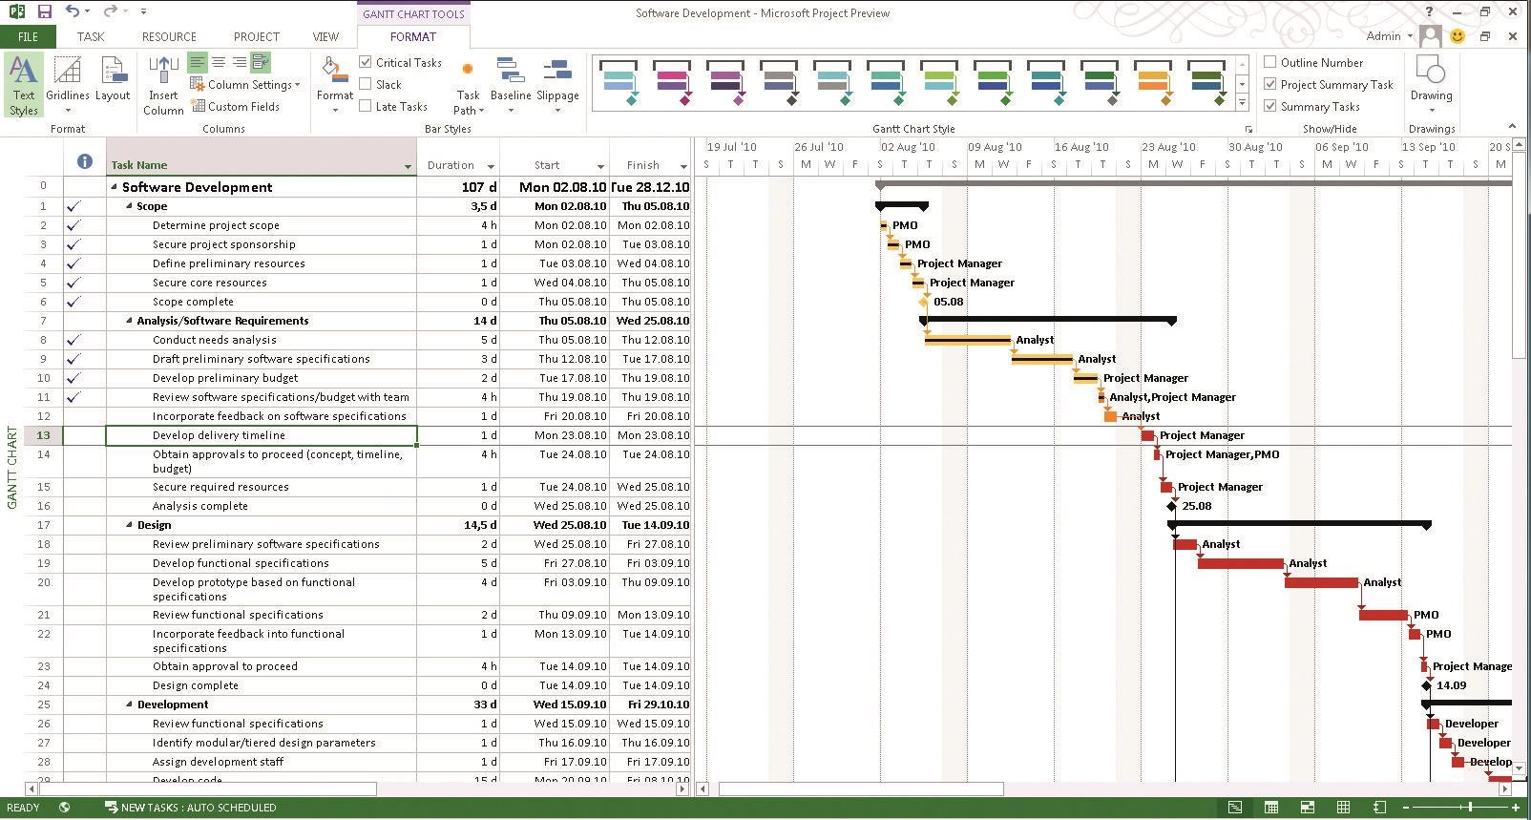Figure 1 (Microsoft Project timeline example, 2018) shows an example of a project timeline as viewed in Microsoft Project.

**Figure 1 - Microsoft Project timeline example.**

At the face of it, this project appears to be a timeline. The timeline is formed of tasks that consist of a start time, end time, duration and dependency. Microsoft Project allows resources to be allocated to each task; these resources can be people or equipment.

As well as resources, Project allows critical path to be defined. Project managers find this application appealing because updating projects in real time by adding new information is easy to do.

While the basics of Microsoft Project are easy to grasp such as adding tasks, setting dependencies and creating a Gantt chart, the more advanced features such as resource and budget allocation are more difficult to learn. To get the most out of this application training is required which will cost a company both time and money.

The second application to be reviewed is Wrike. Wrike was developed by VOCO Creative in order to address communication issues between team members. The existing software being used both for communication and to manage the projects was emailed based which was causing important information to be lost on a frequent basis (Hillsberg, 2018).

Wrike offers a lot of features but an important feature to note is file management. Unlike Microsoft Project: Wrike allows team members to upload and manage files to the system. The files are stored in an organised manner and are even versioned by the application to highlight updated versions of each document (Hillsberg, 2018).

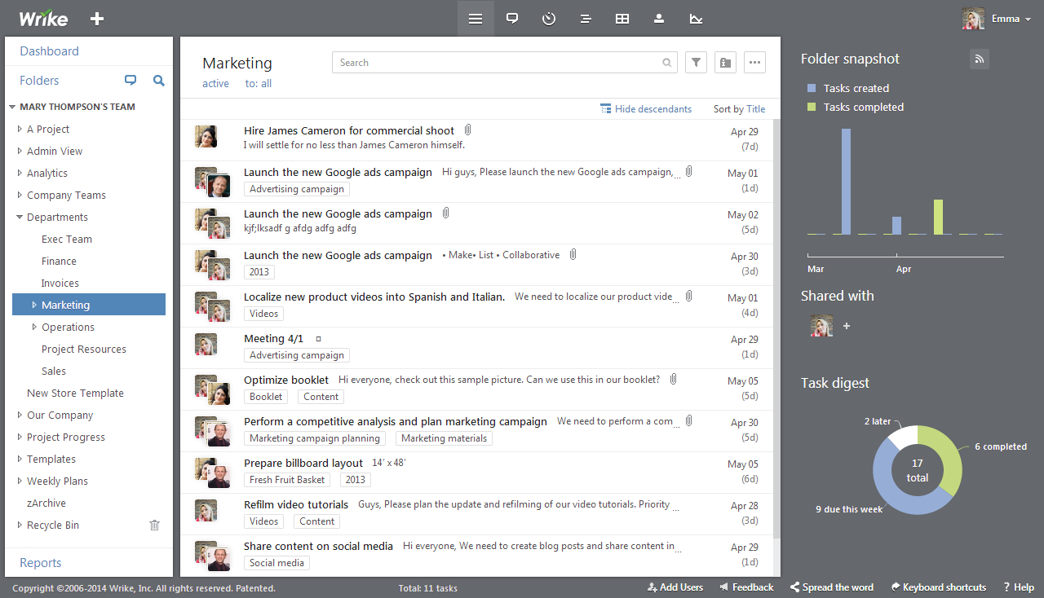Figure 2 (GetApp, 2018) shows a screenshot of Wrike as viewed by a typical user.

**Figure 2 - A screenshot of Wrike.**

From this screenshot Wrike looks like any other email client. Aside from project timeline tracking, resource and budget controls Wrike also offers visual tools. These tools can be used to view information in a Gantt chart style image like Microsoft Project.

In contrast to Microsoft Project: updating projects in Wrike can be time consuming. It is also not as intuitive to use which due to the high number of features can make the software overwhelming for novice users.

The next application to be reviewed is Smartsheet. Smartsheet is a spreadsheet based software used by large companies such as Netflix to manage their projects. The purpose of Smartsheet is to encourage team members to put forward their ideas and collaborate. Similarly to Wrike, Smartsheet also offers file management and resource management (Softwareadvice.com, n.d.-c).

Figure 3 shows the Smartsheet interface (GetApp, n.d.) as viewed by a typical user.

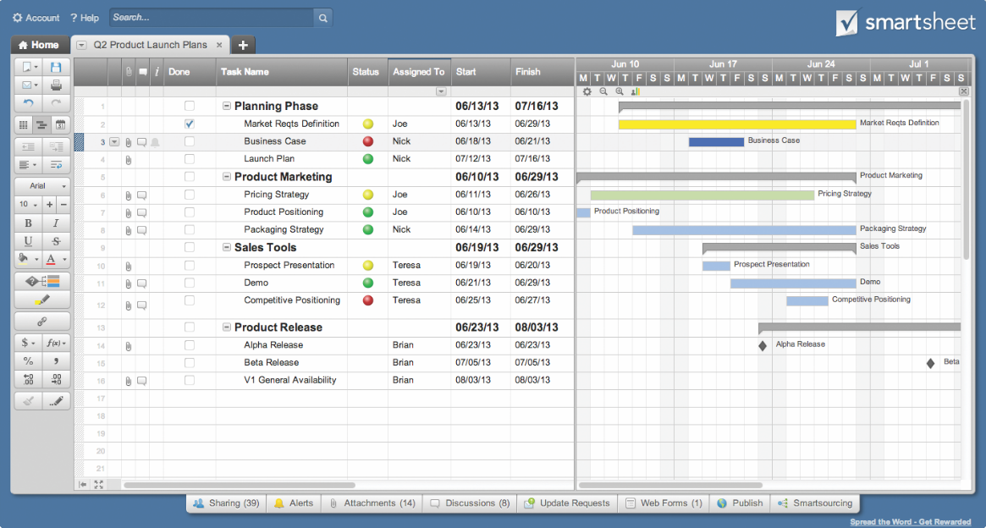

**Figure 3 - Smartsheet interface.**

Smartsheet offers flexible functionality; whether it be creating Gantt charts or managing resources. Overall Smartsheet offers a lot of functionality, accessible from a simple spreadsheet interface. Smartsheet can be customised by the user; enabling them to control how they use the application.

Similar to Wrike, Smartsheet requires a steep learning curve. Users that are familiar with spreadsheet based software will find it easier to learn, however overall it is a difficult application for users to learn. Aside from this Smartsheet is a good option for any business that uses a spreadsheet based system but requires the functionality of a project management application (Eddy, 2015).

Workzone is a project management application with a focus on tracking projects and cross user collaboration. Workzone allows users to view not only their own tasks but also tasks that other users are working on; the idea of this is to give *“organization-wide visibility to projects and resources”* (Softwareadvice.com, n.d.-d).

Figure 4 shows the main interface of Workzone that a user views when they log in.

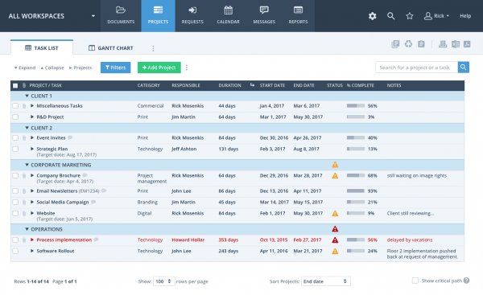

**Figure 4 - Workzone interface.**

Just like Wrike: Workzone allows file sharing and versions the files allowing users to access different versions to track changes to documents. An important aspect of Workzone is that it is designed to accommodate multiple levels of access. File access can be restricted with permissions and user groups (Softwareadvice.com, n.d.-d).

This is important as it allows a business to create roles that reflect the hierarchy of the project team. Users can comment on projects, with new comments being highlighted to the user. Commenting on tasks in the project promotes collaboration and aids communication between team members (McCue, 2013).

The last application being reviewed is Basecamp. Basecamp is an online project management application that is designed to offer the complex functionality of other applications such as Wrike but also have an intuitive interface to encourage quick learning and efficient project management.

The focus of Basecamp is to be user friendly. The more complex functionality an application offers the more to learn; resulting in a steeper learning curve for new users. Basecamp aims to reduce this learning curve, and is described by users as being quick to learn.

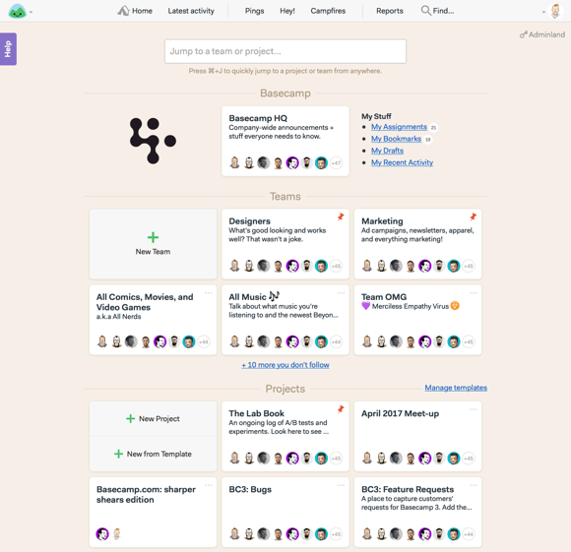Figure 5 shows part of the Basecamp interface.

**Figure 5 - Basecamp interface.**

From figure 5 the design appears to follow the user friendly theme of the application. The menu bar is uncluttered with content being split into sections. This layout makes content more readable while looking clean and professional.

Basecamp encourages organisation of tasks by assigning them to employees and date ranges. Tasks can also be prioritised and reordered as per user needs. One review explains that Basecamp promotes and facilities real time communication between team through a chat system to *“reach fast consensus for every important decision”* (Financesonline.com, n.d.-a).

Like other applications reviewed: Basecamp allows file sharing. Basecamp is designed to be a one solution-fits-all application and can be used by different types of businesses as well as individual users. It is also important to note that Basecamp is not priced per user: the business plan is for unlimited users and projects.

Unlike Smartsheet, Basecamp is not customisable for businesses. This does not necessarily affect productivity but applying branding to an application can be an important deciding factor for a business. When compared to Smartsheet it was also found that Basecamp offered less functionality for time scheduling among other things (Kriz, 2017).

##### 2.1.2.2 Pricing table

| Application pricing table | | |
| --- | --- | --- |
| Name | Vendor | License Cost |
| Project | Microsoft | £559.99 standard license  £949.99 professional license  Included in Office 365 for business  Prices also vary is purchased as part of a partner agreement |
| Wrike | VOCO Creative | Free version with basic features  £7.25 per user monthly professional license  £18.36 per user monthly business license  £25.61 per user monthly marketers license  Enterprise licensing available for larger businesses |
| Smartsheet | Smartsheet | £10.33 per user monthly personal license  £11.07 per user monthly team license  £18.45 per user monthly business licence  Enterprise licensing available for larger businesses |
| Workzone | Workzone | £17.73 per user monthly team license  £25. per user monthly professional license  £32.50 per user monthly enterprise license |
| Basecamp | Basecamp | Free version for teachers and students  £73.06 per business monthly  £737.25 per business annually  £66.42 per non profit/charity monthly |

Table 1 compares the pricing of the reviewed applications. These applications offer a variety of licensing agreements which are priced in US Dollar. Prices were converted to British Pound (as of 04/01/17) for improved readability.

**Table 1 - Application price comparison table.**

From these results a direct comparison of pricing is difficult to the varied nature of the licenses. It is important however to note that only two of these applications offer free versions: Wrike and Basecamp.

The free version of Wrike does not offer the full functionality that paid versions offer but still allows user to learn the software which is important as the interface is not particularly user friendly. This is in direct contrast to Basecamp which offers a free version boasting full functionality for students and teachers: with a user-friendly interface.

##### 2.1.2.3 Conclusion

While offering similar functionality these applications showcase different approaches to solving project management issues. A business will select an application based on the needs of both the business itself and employees.

The Basecamp application offers the most scalable solution since license pricing is not per user. Since Basecamp also offers free licenses to teachers and students it is accessible to a wider audience than the other applications.

Microsoft Project remains popular because it has the interface style of the other Microsoft Office applications such as Word and Excel. Business may lean toward Project due to its familiar nature and the fact that it is included in the Office 365 business license.

An important feature that Microsoft Project lacks is file sharing. Of the five applications reviewed; only Project does not offer file sharing functionality. File sharing is important as information is constantly being input and extracted from projects. With this in mind: Basecamp is the best solution from this review.

#### 2.1.3 How effective are these applications

It is clear from the parallel product review that many companies have already attempted to tackle the problems that arise in project management. There are existing project tools that go a long way towards prevent these issues/mitigating the effects of them as evidenced by the review.

While there has been a variety of approaches to designing a project management solution there seems to be ongoing themes that makes it difficult to label them as ideal. From the review the main recurring issue is regarding usability.

All five of the applications reviewed offer complex functionality; they overlap with the features that are included. However, most of the solutions were not user friendly and presented a steep learning curve for anyone wishing to use them.

Another interesting note is that while each solution offered a variety of functionality; no one solution offered everything. The best solution from the review: Basecamp lacked proper scheduling tools. For an application to be a solution it needs to offer all the tools to tackle the problem; none of the reviewed solutions did this.

Negative points aside; tools already exist to help prevent issues in project management such as time delays, updating information, preventing conflict by encouraging collaboration and more. What was not found however were tools to aid with project scope creep and deliverables.

When a project is falling behind the project scope is often stripped of less necessary deliverables to allow for catch up. Ideally this would be avoided, and the client would receive their product with all the initial deliverables included. However, this practise can’t always be avoided so instead it would be helpful to include tools to manage the project scope; mark deliverables of important and suggest ways to the project manager that the scope can be modified to mitigate either delays to the timescale or cost escalations.

Another important issue that these solutions did not address is communication between the client and project team. While clients must be kept up to date with the progress of their project is not common practise to give them access to the project as it progresses. There are many sensible reasons for this:

* Businesses do not want to reveal their working practises.
* The project manager does not need to update the client on minor issues.
* Important issues in the project can be shared with the client via meetings or conference calls.

However, tools to provide better communication between the client and project team would allow information to be shared more efficiently.

##### 2.1.3.1 Conclusion

The two issues that the existing solutions did not address were: communication between the client and project team and offering all the required functionality.

A lot of functionality is already present in existing solutions; if a new application were to be developed it could include existing ideas and functionality. However, it would also need to address the other issues.

Due to advancements in technology; especially web technology and mobile technology people expect to have the necessary information available to them the instant it is formed. It may be that the future of project management relies on the client having free access to information about their project in real time.

If this were the case, then a new solution would need to be developed that provided the tools to make this happen.

### **2.2 Survey**

The literature review provided a good insight into how existing solutions address the problems within project management however before new ideas could be formed it was important to find out what project managers thought of the applications they used.

A survey was created to discover what applications project managers were using and how successful they are. The survey consisted of five questions that were designed to find out:

* The application/s being used by the project managers.
* How helpful these applications were on the job?
* What features these applications included that were successful?
* What features these applications included that were unsuccessful?
* New features that project managers thought were necessary.

The survey was sent out to five project managers that work for Atkins Global. Four responses were received, and the results collected to be analysed. The results were more qualitative than quantitative as it was important to find out the details of what applications were being used and how they addressed the problem.

#### 2.2.1 Results

The exact survey results are included in Appendix B – Project Survey.

The first question to be asked was: What IT applications do you use to assist with your project management?

This was an open question with the purpose of identifying the application/s being used by the project managers. It is important to note that while all the project managers had access to the same software, the results were varied. Unsurprisingly all of the answers included the Microsoft Enterprise Advantage package as that was the base application they were required to use.

Only two of the project managers used Microsoft Project, Microsoft Word and Microsoft Excel. They all used the Oracle JD Edwards Finance System to manage their project finances as other software did not offer this (JDE did stream data to the other applications however).

The second question was: How helpful are these applications in managing your projects? All four project managers said the applications were indeed helpful. This was also unsurprising as they were using the application/combination of applications that they had a lot of experience with and thought were the most effective.

Next, they were asked: What are the best features, in your opinion, of these applications? The answers were:

* MS Excel
  + Sorting data.
  + Date functions.
  + Calculations.
* MS Project
  + Planning complex projects in an efficient way.
  + Link and roll up activities.
* Enterprise Advantage
  + Translating basic figures from ORACLE JDE for forecasting and budgeting.
  + Good project housekeeping: making sure that, as PM, you consider all project elements (ETC, Cash in, Risks, Changes, Key Milestones, etc), and provides a good set of overview reports.
* MS Word and Outlook
  + Record and communicating decisions.

Three out of the four answers included the base application package (Enterprise Advantage) for the overall functionality and ease of use. MS project and Excel were mentioned for more specific functionality such as date and task related activities.

It was equally important to find out what the project managers thought the applications lacked, and so the fourth question was: Are there any negative features, in your opinion, of these applications?

One project manager answered none; they thought the applications were already sufficient. Another answer mentioned that resource allocation in MS Project is *“very unfriendly”*. This is interesting as it happened to be the same person who mentioned the positive aspects of MS project in the previous question.

All the finances are managed by the ORACLE JDE application and then fed into the Enterprise Advantage package used. One Project Manager said this means “*that figures are not always up to date”* because “*there is a bit of a lag between data being uploaded and it actually becoming live / viewable on the system.”*

The other answer mentioned that the complexity of Enterprise Advantage while well suited to managing large projects, hindered the process of managing smaller projects.

Finally, the Project Managers were asked: Are there any specific features that you would like to see in future applications?

Again, one Project Manager said none. Another wanted “*better Resource allocation and tracking”* from MS Project. Breakdown of finances was an important answer because a lot of applications provide an overview of transactions, but not the finer details and additional information.

The other Project Manager wanted *“A more interactive way of creating your own reports via these systems would be useful, rather than standard template reports.”* Generating documentation from the application was not a common feature mentioned in the literature review and seems to be often overlooked.

#### 2.2.2 Conclusion

The results from the survey suggest that the current applications were helpful to the Project Managers and provided a good range of functionality indeed, one Project Manager couldn’t fault the applications they used nor suggest improvements.

The important issues that were outlined were:

* Difficulty with resource allocation.
* Lack of finance record breakdown.
* Delays in updating information due to separate systems.
* Creating documentation.

An issue that wasn’t mentioned by any of the Project Managers is that they all used multiple applications. None of them had access to one solution that provided all the functionality they required and in one instance this was frustrating (delay between ORACLE JDE and Enterprise Advantage in information processing).

These results will be important in forming new ideas to be defined and addressed by the new solution.

### **2.3 Interviews**

The magazine PROJECT published an article in 2017 that interviewed Project Managers and related staff about the project software they use. Each interviewee was asked the following question: What project management software do you find useful and what would be your dream product?

Rhonda Bennett from Pinsent Masons said that she used Microsoft Project and has had brief experience with MindView. Overall, she thought that the software *“has the ability to produce really good plans"* but continued to point out that it was *“static”.* Ultimately, she believes that having a one solution fits all software that stores all of the project information and generates documentation automatically would be an ideal solution.

Vilas Patel also of Pinsent Masons said that MS Project is efficient for *“monitoring and controlling a project for resources and budgeting”.* She also mentioned that Excel is more configurable. Like Bennett, Patel’s solution would include creating documentation from the information already in the software.

Hitesh Patel of Warburtons LTD uses SAP for his business operations. He is happy with the functionality that SAP already offers but would like software that allows information to be saved to a database, which can then be presented in real time.

Rebekka Stubbs is an Assistant Project Manager at Lhasa LTD which uses JIRA to manage projects. She would benefit from better *“resource management”* which would allow her to *“see what people are working on from across the business and allocate tasks in that way.”*

Tim Knight from Qinetiq finds using multiple applications frustrating and would prefer a more centralised solution, providing all the core functionality that he is used to in one software package. Robert Dale of LV Insurance Company shares this opinion, arguing that there isn’t currently any one solution that offers everything a Project Manager requires to do their job.

## **Chapter 3**

### **3.1 New Ideas**

* One solution – centralised features - Done
* Project registering - Done
* Resource allocation – money and human - Done
* Messaging system - Done
* Tracking milestones, notifications when overdue - Done

#### **3.1.1 Literature Review**

* User friendly interface - Done
* Milestone/task scheduling tools - Done

#### **3.1.2 Survey**

* Tracking finances - Done
* Date functions - Done
* Creating documentation
* Designing interface/functionality to provide advanced tracking for complex projects but also simple tracking for smaller projects - Done

#### **3.1.3 PROJECT article**

* Backend database - Done
* One solution that fits all, generates documentation
* Resource management - Done
* Centralised solution - Done

### **3.2 Requirements**

#### 3.2.1 Agile Methodology

## **Chapter 4**

### **4.1 Languages**

#### 4.1.1 HTML

#### 4.1.2 CSS

#### 4.1.3 PHP

#### 4.1.4 JavaScript

### **4.2 Style Guide**

#### 4.2.1 Colours

#### 4.2.2 Fonts

### **4.3 Database Design**

#### 4.3.1 Entity Relationship Diagram

#### 4.3.2 Data Dictionaries

### **4.4 Use Cases**

### **4.5 Testing**

#### 4.5.1 Test Cases

## **Chapter 5**

### **5.1 Test Results**

## **Chapter 6**

## **References**

Eddy, M. (2015). *Smartsheet*. [online] PCMag UK. Available at: http://uk.pcmag.com/smartsheet/55050/review/smartsheet#content [Accessed 4 Jan. 2018].

Financesonline.com. (2018). *Microsoft Project Reviews: Overview, Pricing and Features*. [online] Available at: https://reviews.financesonline.com/p/microsoft-project/ [Accessed 3 Jan. 2018].

Financesonline.com. (n.d.-a). *Basecamp Reviews: Overview, Pricing and Features*. [online] Available at: https://reviews.financesonline.com/p/basecamp/ [Accessed 4 Jan. 2018].

GetApp (2018). *A screenshot of Wrike*. [image] Available at: https://s3.amazonaws.com/getapp/apps/9964/50bc3def283ba37257767771a517879b [Accessed 3 Jan. 2018].

GetApp (n.d.). *A screenshot of the Smartsheet interface*. [image] Available at: https://ga1.imgix.net/screenshot/o/10391-3474685351.png?ixlib=rb-1.0.0&ch=Width%2CDPR&auto=format [Accessed 4 Jan. 2018].

Hillsberg, A. (2018). *Top Features of Wrike Creative Project Management Software - Financesonline.com*. [online] Financesonline.com. Available at: https://financesonline.com/top-features-wrike-creative-project-management-software/ [Accessed 3 Jan. 2018].

Kriz, W. (2017). *Basecamp Review 2018 | Reviews, Ratings, Complaints, Comparisons*. [online] Merchant Maverick. Available at: https://www.merchantmaverick.com/reviews/basecamp-3-review/ [Accessed 4 Jan. 2018].

McCue, T. (2013). *How Does WorkZone Stack Up? A Review*. [online] Small Business Trends. Available at: https://smallbiztrends.com/2013/09/workzone-project-management-tool-review.html [Accessed 4 Jan. 2018].

Microsoft Project timeline example. (2018). [image] Available at: https://d2.alternativeto.net/dist/s/961396ac-e819-4273-91fb-6b3edb011b4e_1_full.jpg?format=jpg&width=1600&height=1600&mode=min&upscale=false [Accessed 3 Jan. 2018].

Mossalam, A. (2017). Projects’ issue management. *HBRC Journal*, [online] pp.1-8. Available at: https://www.sciencedirect.com/science/article/pii/S1687404817300019 [Accessed 3 Jan. 2018].

Smith, P. (2014). Project Cost Management – Global Issues and Challenges. *Procedia - Social and Behavioral Sciences*, [online] 119, pp.485-494. Available at: https://www.sciencedirect.com/science/article/pii/S1877042814021454 [Accessed 3 Jan. 2018].

Softwareadvice.com. (n.d.-c). *Smartsheet Project Management Reviews, Demo & Pricing - 2018*. [online] Available at: https://www.softwareadvice.com/uk/project-management/smartsheet-profile/ [Accessed 4 Jan. 2018].

Softwareadvice.com. (n.d.-d). *Workzone Project Management Reviews, Pricing & Demo*. [online] Available at: https://www.softwareadvice.com/imglib/products/screenshots/workzone-5283-1-large.png?v=8e6af2e0b289dcaf4c1b0b65c623dcfe [Accessed 4 Jan. 2018].

Wellingtone. (2017). *The State of Project Management Survey 2017*. [online] Available at: http://www.wellingtone.co.uk/the-state-project-management-survey-2017/ [Accessed 3 Jan. 2018].

Yan, M., Houde, W., Lening, W. and Yicheng, L. (2009). *The influencing mechanism of personality traits on team performance: An empirical study based on creative product development project - IEEE Conference Publication*. [online] Ieeexplore.ieee.org. Available at: http://ieeexplore.ieee.org/document/5344308/ [Accessed 4 Jan. 2018].

## **Bibliography**

Basecamp.com. (n.d.). *Replace all over the place with ONE place.*. [online] Available at: https://basecamp.com/ [Accessed 4 Jan. 2018].

BBC News. (2018). *Health IT 'fiasco' costs rising*. [online] Available at: http://www.bbc.co.uk/news/uk-politics-24130684 [Accessed 2 Jan. 2018].

Burger, R. (2018). *The Top 10 Free and Open Source Project Management Software for Your Small Business - Capterra Blog*. [online] Blog.capterra.com. Available at: https://blog.capterra.com/free-open-source-project-management-software/ [Accessed 2 Jan. 2018].

Eddy, M. (2015). *Smartsheet*. [online] PCMag UK. Available at: http://uk.pcmag.com/smartsheet/55050/review/smartsheet#content [Accessed 4 Jan. 2018].

Financesonline.com. (2018). *Microsoft Project Reviews: Overview, Pricing and Features*. [online] Available at: https://reviews.financesonline.com/p/microsoft-project/ [Accessed 3 Jan. 2018].

Financesonline.com. (n.d.-a). *Basecamp Reviews: Overview, Pricing and Features*. [online] Available at: https://reviews.financesonline.com/p/basecamp/ [Accessed 4 Jan. 2018].

Financesonline.com. (n.d.-b). *Smartsheet Reviews: Overview, Pricing and Features*. [online] Available at: https://reviews.financesonline.com/p/smartsheet/ [Accessed 4 Jan. 2018].

GetApp (2018). *A screenshot of Wrike*. [image] Available at: https://s3.amazonaws.com/getapp/apps/9964/50bc3def283ba37257767771a517879b [Accessed 3 Jan. 2018].

GetApp. (n.d.-a). *Wrike Reviews - Ratings, Pros & Cons, Analysis and more | GetApp*. [online] Available at: https://www.getapp.com/project-management-planning-software/a/wrike/reviews/ [Accessed 3 Jan. 2018].

GetApp (n.d.-b). *A screenshot of the Smartsheet interface*. [image] Available at: https://ga1.imgix.net/screenshot/o/10391-3474685351.png?ixlib=rb-1.0.0&ch=Width%2CDPR&auto=format [Accessed 4 Jan. 2018].

Hillsberg, A. (2018-a). *How Much Does Wrike Cost And Why You Should Get A Free Trial - Financesonline.com*. [online] Financesonline.com. Available at: https://financesonline.com/how-much-does-wrike-cost-and-why-you-should-get-a-free-trial/ [Accessed 3 Jan. 2018].

Hillsberg, A. (2018-b). *Top Features of Wrike Creative Project Management Software - Financesonline.com*. [online] Financesonline.com. Available at: https://financesonline.com/top-features-wrike-creative-project-management-software/ [Accessed 3 Jan. 2018].

Kriz, W. (2017). *Basecamp Review 2018 | Reviews, Ratings, Complaints, Comparisons*. [online] Merchant Maverick. Available at: https://www.merchantmaverick.com/reviews/basecamp-3-review/ [Accessed 4 Jan. 2018].

Markgraf, B. (2018). *What Are Reasons for Cost Overruns in Project Management?*. [online] Smallbusiness.chron.com. Available at: http://smallbusiness.chron.com/reasons-cost-overruns-project-management-63225.html [Accessed 2 Jan. 2018].

McCue, T. (2013). *How Does WorkZone Stack Up? A Review*. [online] Small Business Trends. Available at: https://smallbiztrends.com/2013/09/workzone-project-management-tool-review.html [Accessed 4 Jan. 2018].

Microsoft Project timeline example. (2018). [image] Available at: https://d2.alternativeto.net/dist/s/961396ac-e819-4273-91fb-6b3edb011b4e_1_full.jpg?format=jpg&width=1600&height=1600&mode=min&upscale=false [Accessed 3 Jan. 2018].

Mossalam, A. (2017). Projects’ issue management. *HBRC Journal*, [online] pp.1-8. Available at: https://www.sciencedirect.com/science/article/pii/S1687404817300019 [Accessed 3 Jan. 2018].

Products.office.com. (2018). *Microsoft Project | Compare Project Management Software versions*. [online] Available at: https://products.office.com/en-gb/project/compare-microsoft-project-management-software?tab=2 [Accessed 3 Jan. 2018].

Projectmanagementlearning.com. (2018). *What Are the Advantages and Disadvantages of Microsoft Project? – Project Management Learning*. [online] Available at: https://www.projectmanagementlearning.com/what-are-the-advantages-and-disadvantages-of-microsoft-project.html [Accessed 3 Jan. 2018].

project-management.com. (n.d.). *Top 15 Project Management Software in 2017 - Web Apps*. [online] Available at: https://project-management.com/software/top15/ [Accessed 3 Jan. 2018].

Schiff, J. (2018). *8 common project management mistakes — and how to avoid them*. [online] CIO. Available at: https://www.cio.com/article/2391872/project-management/8-common-project-management-mistakes-and-how-to-avoid-them.html [Accessed 2 Jan. 2018].

Smartsheet. (2018). *Smartsheet: Less Talk, More Action*. [online] Available at: https://www.smartsheet.com/ [Accessed 4 Jan. 2018].

Smith, P. (2014). Project Cost Management – Global Issues and Challenges. *Procedia - Social and Behavioral Sciences*, [online] 119, pp.485-494. Available at: https://www.sciencedirect.com/science/article/pii/S1877042814021454 [Accessed 3 Jan. 2018].

Softwareadvice.com. (n.d.-a). *Basecamp Project Management Reviews, Pricing & Demo - 2018*. [online] Available at: https://www.softwareadvice.com/uk/project-management/basecamp-profile/ [Accessed 4 Jan. 2018].

Softwareadvice.com. (n.d.-b). *Best Project Management Software - 2017 Reviews & Pricing*. [online] Available at: https://www.softwareadvice.com/uk/project-management/ [Accessed 4 Jan. 2018].

Softwareadvice.com. (n.d.-c). *Smartsheet Project Management Reviews, Demo & Pricing - 2018*. [online] Available at: https://www.softwareadvice.com/uk/project-management/smartsheet-profile/ [Accessed 4 Jan. 2018].

Softwareadvice.com. (n.d.-d). *Workzone Project Management Reviews, Pricing & Demo*. [online] Available at: https://www.softwareadvice.com/imglib/products/screenshots/workzone-5283-1-large.png?v=8e6af2e0b289dcaf4c1b0b65c623dcfe [Accessed 4 Jan. 2018].

Wellingtone. (2017). *The State of Project Management Survey 2017*. [online] Available at: http://www.wellingtone.co.uk/the-state-project-management-survey-2017/ [Accessed 3 Jan. 2018].

WhatIs.com. (2018). *What is Microsoft Project (Microsoft Office Project)? - Definition from WhatIs.com*. [online] Available at: http://whatis.techtarget.com/definition/Microsoft-Project-Microsoft-Office-Project [Accessed 3 Jan. 2018].

Workzone. (n.d.). *Online Project Management Software | Workzone*. [online] Available at: https://www.workzone.com [Accessed 4 Jan. 2018].

Yan, M., Houde, W., Lening, W. and Yicheng, L. (2009). *The influencing mechanism of personality traits on team performance: An empirical study based on creative product development project - IEEE Conference Publication*. [online] Ieeexplore.ieee.org. Available at: http://ieeexplore.ieee.org/document/5344308/ [Accessed 4 Jan. 2018].

## **Appendix A – Project Planning Document**

## **Appendix B – Project Survey**

Title: FYP Survey

Live link to the survey - https://www.surveymonkey.co.uk/r/GG8Y722

**Question 1: What IT applications do you use to assist with your project management? (Open question)**

Answer 1: Atkins tools I-gate, JDE and Enterprise Advantage. Excel, Word and outlook.

Answer 2: MS Project, Atkins Enterprise Advantage, Oracle JD Edwards Enterpriseone (JDE).

Answer 3: Generally word and excel. I have access to MS project and internally we have a system called Enterprise Advantage.

Answer 4: Primary application is Enterprise Advantage (EA), supported by JD Edwards finance system (Oracle based) for live projects.

**Question 2: How helpful are these applications in managing your projects? (Closed question)**

Answer 1: Very helpful.

Answer 2: Helpful.

Answer 3: Helpful.

Answer 4: Helpful.

**Question 3: What are the best features, in your opinion, of these applications? (Open question)**

Answer 1: Being able to sort data in Excel. I use word and outlook to record and communicate decisions.

Answer 2: MS Project allows you to plan complex projects in an efficient way and enterprise advantage is a good way of translating basic figures from JDE for forecasting and budgeting.

Answer 3: Excel date functions and calculations MS project ability to link activities and roll up activities.

Answer 4: EA ensures good project housekeeping, making sure that, as PM, you consider all project elements (ETC, Cash in, Risks, Changes, Key Milestones, etc), and provides a good set of overview reports.

**Question 4: Are there any negative features, in your opinion, of these applications? (Open question)**

Answer 1: None to date.

Answer 2: The biggest negative with JDE is that the figures are not always up to date as there is a bit of a lag between data being uploaded and it actually becoming live / viewable on the system.

Answer 3: MS project resource allocation is very unfriendly.

Answer 4: EA is focussed more in major projects, and can therefore be a bit heavy when managing lower value projects. It is possible, however, to limit some of the functions by agreement with the PD.

**Question 5: Are there any specific features that you would like to see in future applications? (Open question)**

Answer 1: None to date.

Answer 2: A more interactive way of creating your own reports via these systems would be useful, rather than standard template reports.

Answer 3: MS project would benefit from better Resource allocation and tracking.

Answer 4: I would like to see better breakdown on the cash in screen, currently only a row, but we often invoice different amounts against different sub tasks and this breakdown isn't currently visible.