COMP30151: PROJECT

Project planning document

Dominic Hart N0702543

# Project Planning Document

## Introduction

The idea of this project is to provide Project Managers with a tool that they can utilise to help them plan and manage projects. Projects generate a lot of paperwork. All aspects of the project require documentation e.g. the timeline, deliverables, issues etc.

This system has worked fine in the past, and is still acceptable in present time. Projects are tracked electronically, but they consist of documentation. This system presents a problem because; projects in the future will be different from projects today.

The way they are registered, managed and documented will change as the nature of project management changes. Project information needs to exist in a centralised manner, it needs to be accessed by the project manager, project team and the client.

This application offers a system in which a project can be registered, managed and signed off electronically, all from within a website.

This application will allow for more transparency; the project manager can push updates to their client instantly allowing efficient flow of information. It also allows the client to track their own project, giving them a better idea of how it is progressing.

These instant updates will replace frequent phone calls and emails. Information can be released in small updates rather than larger chunks, this allows information to be shared more instantaneously.

Project management forms a large part of industry, not just Information Technology. Project Managers have a difficult job and would benefit from tools that can aid them to work more efficiently. Project managers already have access to an internal system of some form to track and evaluate their projects but the customer is excluded. It is important for the customer to be updated on their project as it progresses.

The purpose of this project is not to reinvent the wheel. Current applications that allow projects to be registered and managed to exist, and they offer lots of functionality. What does not exist, is an application that offers all the typical project management functionality as well as tools for client/project manager communication.

These applications only allow the project team to access the project, from within the system. Clients can’t track their projects or receive instant updates. Most of these solutions also lack the capability to create Gantt charts.

The solution, proposed further along in this document would have all this functionality. Not only would it allow Gantt charts to be created and updated, but it would also allow the client to see the Gantt charts and receive updates to the project schedule as it progresses. The application will have the functionality of both project management software, and a platform for the project manager to communicate with the client.

## Aims and Objectives

The aim of this project is to develop a robust Project Management tool in the form of a website application. This application will allow Project Managers to track and present their projects via an online gateway which they and their clients can access.

The objectives are to:

* Review existing solutions.
* Survey project managers.
* Plan implementation.
* Prototype the application.
* Address issues with the prototype to create a functional application.
* Test the application.
* Complete the project report.

## Project Scope

The scope of the project is to build a project management website application that allows projects to be registered, tracked and signed off electronically.

Features in the project scope are:

* Registering projects and assigning staff/clients to them.
* Tracking project timelines and milestones.
* Comparing the estimated completion dates against the final dates.
* Calculating milestone slippage.
* Tracking initial project budget.
* Tracking extra monetary resources that are assigned to the project before completion.
* Tracking project expenses.
* Messaging system allowing direct communication between the client and the project manager.
* Project updates to be pushed to the client.

Features that are outside of the project scope are:

* Exporting data as a formatted report.
* An integrated mobile application accompanying the website application.
* Application interface customisation.

The deliverables for this project are:

* A front end website application.
* A backend database.
* A comprehensive report, detailing the project in its entirety.

Table 1 lists the tasks for this project. Each task has an ID, name and a duration between two dates.

| Project Tasks | | | | |
| --- | --- | --- | --- | --- |
| ID | Name | Start | End | Duration |
| 1 | Project Discovery | 06/10/17 | 13/10/17 | 6 days |
| 2 | Define timescale/milestones | 20/10/17 | 27/10/17 | 6 days |
| 3 | Complete Project Planning Document |
| 4 | Requirements definition | 28/10/17 | 04/11/17 | 7 days |
| 5 | Requirements testing |
| 6 | Identify existing features in solutions | 06/11/17 | 13/11/17 | 6 days |
| 7 | Survey existing project managers | 14/11/17 | 28/11/17 | 11 days |
| 8 | Define list of features to be implemented | 29/11/17 | 06/12/17 | 6 days |
| 9 | Decide what needs to be implemented | 07/12/17 | 21/12/17 | 11 days |
| 10 | Plan how to implement these features | 02/01/18 | 15/01/18 | 10 days |
| 11 | Begin building the interface for the application | 02/01/18 | 16/01/18 | 11 days |
| 12 | Begin adding the functionality for the application | 17/01/18 | 14/02/18 | 21 days |
| 13 | Present application prototype to Project Manager | 14/02/18 | 16/02/18 | 3 days |
| 14 | Identify issues with prototype | 19/02/18 | 19/02/18 | 1 day |
| 15 | Fix issues with prototype | 20/02/18 | 06/03/18 | 11 days |
| 16 | Create application test plan | 07/03/18 | 14/03/18 | 6 days |
| 17 | Complete application testing | 15/03/18 | 29/03/18 | 11 days |
| 18 | Complete project report | 30/03/18 | 13/04/18 | 11 days |
| 19 | Present final application | 16/04/18 | 16/04/18 | 1 day |

Table 1 - Project tasks.

Table 2 shows the milestones for this project. Each milestone has an ID, name, description and completion date.

| Project Milestones | | | |
| --- | --- | --- | --- |
| ID | Name | Description | Completion |
| 1 | Complete project planning | Discovery, timescale/milestone definition and requirements. | 04/11/17 |
| 2 | Complete review of existing solutions | Identify existing features. | 13/11/17 |
| 3 | Complete survey of project managers | Survey project managers from industry. | 06/12/17 |
| 4 | Complete implementation | Plan implementation, develop application, present prototype, fix issues. | 06/03/18 |
| 5 | Complete application testing | Plan testing and complete. | 29/03/18 |
| 6 | Sign off project | Complete project report and demo application. | 16/04/18 |

Table 2 - Project milestones.

## Sources of Information

The project will be completed using two computer systems. The documentation will be completed on a standard laptop computer. The code will be developed using a high end desktop computer. Both computer systems will run Microsoft Windows 10. This system will allow code to be written and debugged in a quick manner. A large monitor is also required for application testing.

All documentation will be created and updated using Microsoft Word 2016 apart from the Gantt Chart, which will require Microsoft Project 2013. The application itself will be developed using the Jetbrains PhpStorm Integrated Development Environment. The code will be written, edited and partially tested within this environment. Additional testing tools will be used to ensure that rigorous testing is completed.

These testing tools include the web browsers: Google Chrome, Internet Explorer, Microsoft Edge, Mozilla Firefox and Safari.

Most of the research will be comprised of reviewing existing solutions; finding out what successful features they have and what features they lack. For this, the only resource required is a laptop computer, web browser and an internet connection.

The rest of the research will be in the form of a survey, which will be completed by active Project Managers from the industry.

## Project Risks

Table 3 pertains to the risks to the project. Each risk is named and described. The risk is then rated by how likely it is to occur (probability) and the level of impact it would have on the project (impact). A strategy has been implemented for each risk to reduce the chance of an issue occurring, and to minimise the impact it would have.

| Risk assessment table | | | | |
| --- | --- | --- | --- | --- |
| Risk | Description | Probability | Impact | Mitigation Strategy |
| Scope creep | As the project progresses, the client may decide that they want more features, causing the project scope to shift. | High | Scope creep would cause delays in the project. | Features will be decided on before development begins. Any further features (with some exclusions) will be considered after the application is built as part of a maintenance agreement. |
| Software Budget | To develop the application, a specialist IDE (Integrated Development Environment) will need to be purchased and installed which could be expensive. | High | The software could prove too expensive and the budget may need to be increased. | The software licenses will be purchased in the early phases of the project. If a license cannot be purchased due to monetary constraints; an alternative IDE will be sourced. |
| Lack of programming ability | This application will require good knowledge of the HTML, CSS, PHP, jQuery and MYSQL languages. | Medium | Development would be slowed significantly, with other developers possibly being brought in. | Before development begins, developers will receive training to ensure they are proficient at the languages. |
| Software difficulty | Using the software necessary to develop the application could prove difficult. | High | Development would progress slowly, with other software possibly needing to be used. | Developers will receive training with the software prior to development. |
| Milestone slippage | During the development phase of the project, milestone slippage is likely to occur. | High | Delays to future milestones, project deadline being moved. | Some functionality of the application may be reduced or removed (agreed upon with the client) if it becomes apparent that milestones cannot be met. |

## Professional, Social, Ethical and Legal Issues

All of the client and staff data stored within the backend database will be governed by the DPA (Data Protection Act 1998). This law dictates how data is gathered, processed and stored. All three of these apply to the project (Ico.org.uk, 2017).

The staff/client data that cannot be shared with third parties. It must also be destroyed once it is no longer required. The application should only store information that is required for the project to operate.

The computer misuse act is important because there are three types of people that will use this application, the most important being the Project Manager. The Project Manager can create user accounts for both the project team and the client.

Project Managers therefore, can create new staff/client data. This in itself is not the issue. Modifying the data after it was created is. Project Managers should not be able to access the account or related information. Accessing this information, or modifying it would be a direct violation of the computer misuse act 1990 (Sqa.org.uk, 2017).

It’s important that any practising members of the BCS (British Computer Society) could impact the whole organisation if they were unprofessional or unethical. As a member of BCS they are representing the ideas and interests of the BCS. If they were to break laws or conduct themselves in an unprofessional manner the organisation would suffer.

Misusing the application, therefore having a negative impact on staff and/or clients would be illegal. The most serious way to misuse the application would be for a Project Manager to breach the Data Protection Act by accessing information not related to their projects.

The emphasis of this project is to make projects more transparent for the client. This has to be managed carefully. There will be smaller issues with projects that will be resolved and will have little to none impact on the client. It is down to the Project Manager to decide if these issues need to be shared with the client.

The general public can quickly panic and overreact if they perceive an issue as bigger than it is. Sharing information with the client too openly could have negative repercussions. Causing the client unnecessary stress due to oversharing information about their project, could harm both them and the company.

## Gantt Chart

Figure 1 is a Gantt Chart that breaks down the project into phases. Each phase is described, with dates to show when it begins and ends. This Gantt Chart reflects the project timeline pre-development. The timeline may shift throughout the project.

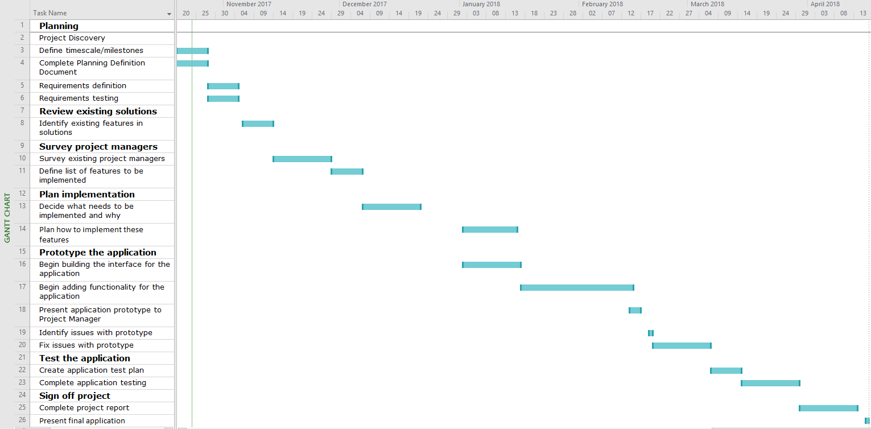

Figure - Project Gantt chart.

# References

Bcs.org. (2017). *About us | BCS - The Chartered Institute for IT*. [online] Available at: http://www.bcs.org/category/5651 [Accessed 25 Oct. 2017].

Ico.org.uk. (2017). *Key definitions of the Data Protection Act*. [online] Available at: https://ico.org.uk/for-organisations/guide-to-data-protection/key-definitions/ [Accessed 24 Oct. 2017].

Sqa.org.uk. (2017). *What is Computer Misuse?*. [online] Available at: https://www.sqa.org.uk/e-learning/ITLaw01CD/page_03.htm [Accessed 24 Oct. 2017].