Student ID: 102983679

Name: Dominic Hudson

# Setup Screenshot

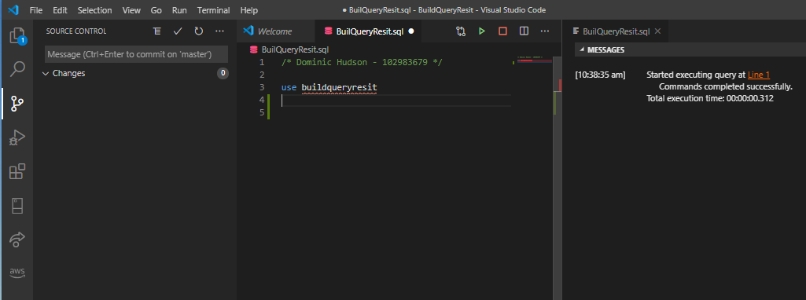

# Task 2 Screenshot

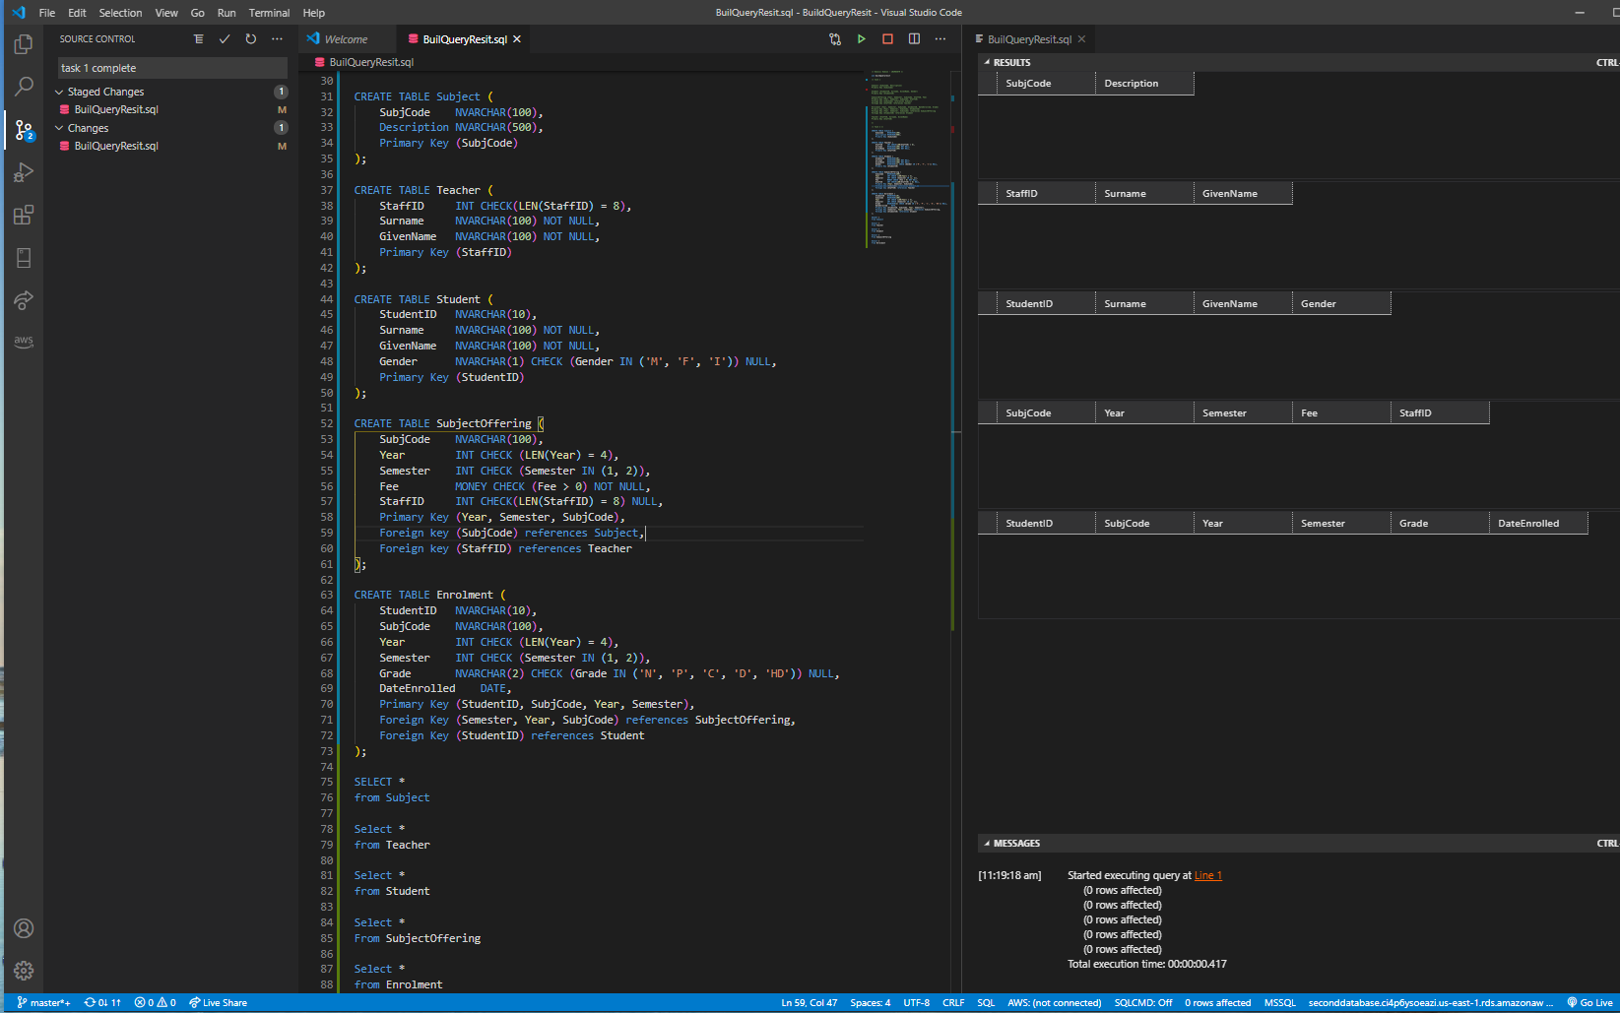

# Task 3 Screenshot

