New VoIP

Pre instructions



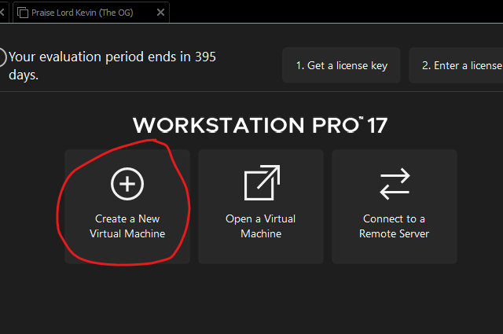



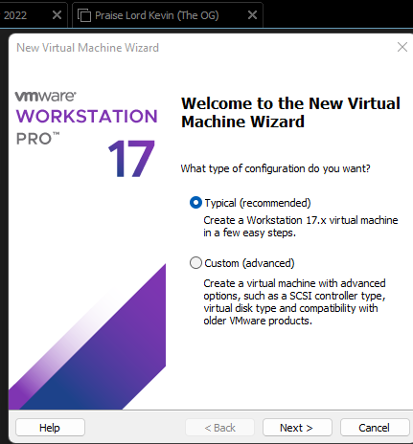



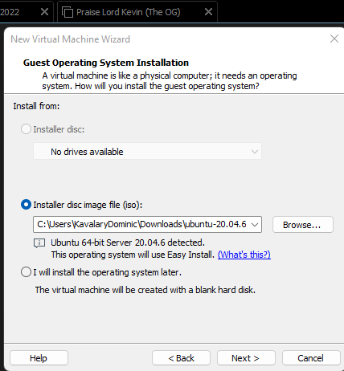



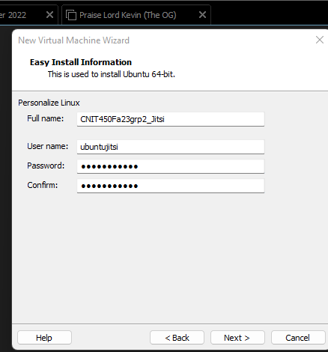



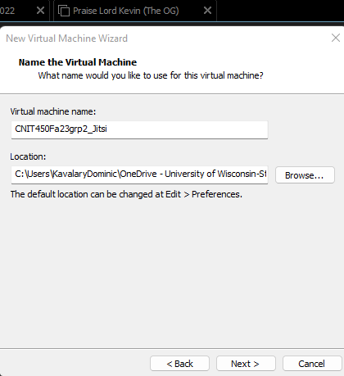



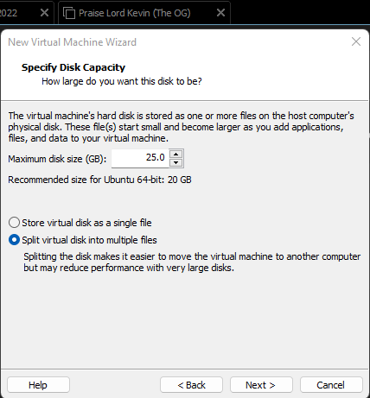



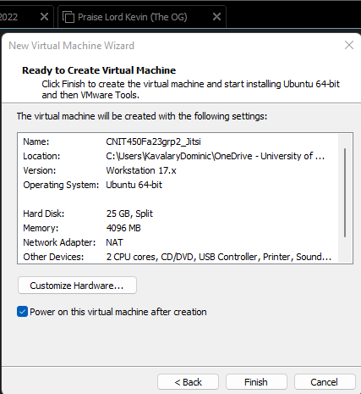



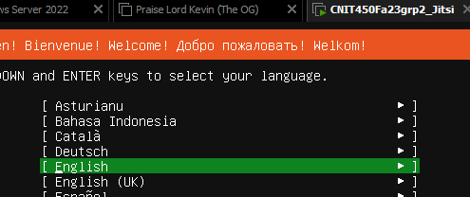



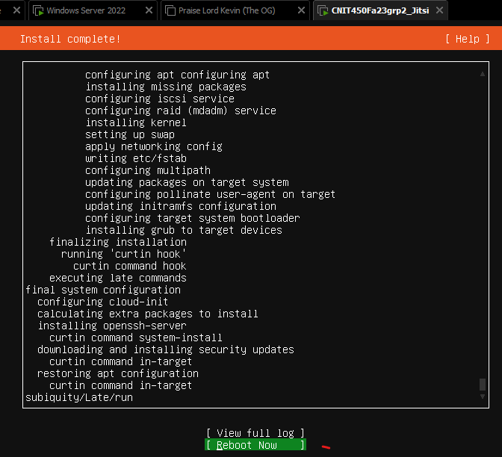



























1. 1. echo deb http://packages.prosody.im/debian $(lsb_release -sc) main | sudo tee -a /etc/apt/sources.list



* 1. wget https://prosody.im/files/prosody-debian-packages.key -O- | sudo apt-key add –

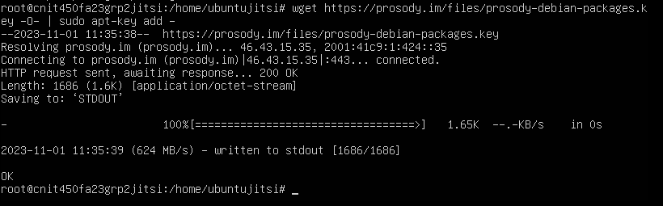

* 1. sudo apt install lua5.2 A screenshot of a computer program

     Description automatically generated

1. 1. curl https://download.jitsi.org/jitsi-key.gpg.key | sudo sh -c 'gpg --dearmor > /usr/share/keyrings/jitsi-keyring.gpg'

* 1. echo 'deb [signed-by=/usr/share/keyrings/jitsi-keyring.gpg] https://download.jitsi.org stable/' | sudo tee /etc/apt/sources.list.d/jitsi-stable.list > /dev/null













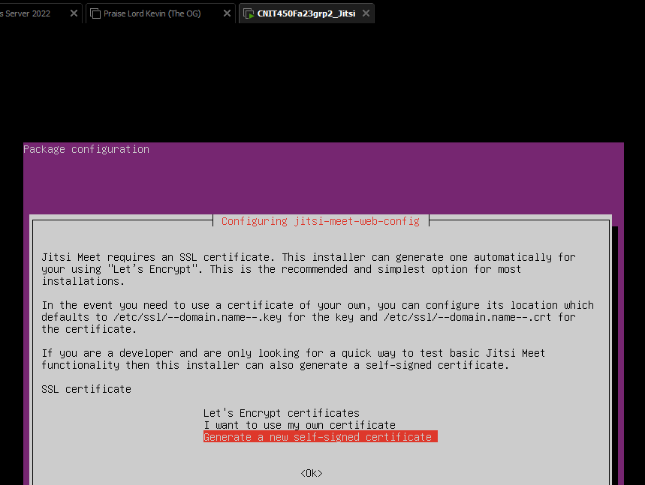

4. If needed





