1. Introduction

For many first-year students, getting used to campus life and finding public facilities can be a difficult task. The challenge is often made worse by not knowing the environment well and not getting enough support from the university. In some universities, student welfare is not given sufficient priority, and essential services, such as orientation programs or personalized guidance, are either limited or absent. As Coffman and Bryan observed, “We have devoted too much attention recently to thinking about finances. The welfare of the student has almost been lost sight of” (237). Although some institutions have acknowledged this issue by offering campus maps or hosting brief orientation sessions, the information provided is often fragmented and fails to fully engage students. For instance, while knowing the location of the canteen is certainly useful, more specific recommendations, such as what dishes are popular or budget-friendly, would be more helpful for newcomers adjusting to daily campus life.

To address these challenges more effectively and engagingly, we looked into the potential of technological solutions. Noticing the widespread use of AI and chatbots, like XiaoIce from Microsoft, we are inspired to consider their potential in improving campus life. According to Shum, He, and Li, “XiaoIce has been the most widely deployed social chatbot since it was released by Microsoft in May 2014” (10). It understands users' emotional needs and engages in interpersonal communications like a friend, cheering users up, encouraging them, and holding their attention throughout the conversation. Recognizing these capabilities, we began to explore how similar chatbots can be applied to address the problems mentioned above. Therefore, our project came into being, developing a campus life chatbot designed to address the needs of our university environment.

2. Rationale of the Application

The existing campus information platform, such as the official website or WeChat account, is not always convenient for students to use. For example, as the articles or instructions need to be prepared and updated in advance, students may have to spend considerable time locating the specific information they need. These limitations make the information delivery efficiency low. As Davis cites Gemmell and Pagano, “active user participation is crucial to the success of an information system” (qtd. in Davis). The non-active user participation in existing campus platforms create an inefficient information system,

To address these shortcomings, our project introduces a chatbot system based on a combination of template-based and retrieval-based approaches, which could help prevent low system usage. The chatbot has the advantage of being easy to use, highly efficient, and controllable. The student may just open our chatbot and ask the question, which helps the student get the answers within a short time. Unlike general-purpose chatbots like ChatGPT, our system is designed specifically for the campus context. However, it shares the same strengths in accuracy and interaction quality. For instance, the average accuracy of a university admission chatbot significantly improved from 41.4% using GPT-3.5 to 89.5% with retrieval-augmented generation (RAG)—as reported by Chen et al. (468). This illustrates that the chatbot is beneficial to the campus information system, justifying the rationality of our project.

3. Objectives

Our project aims to create a campus life chatbot that can respond to students’ needs. For instance, a freshman unfamiliar with the campus may find it difficult to locate a suitable place for lunch. This is where our chatbot demonstrates its capability, as it is equipped with a dataset that includes various restaurants around the campus and canteen menus, which can suit different tastes. This function is not only helpful for freshmen, but also assists seniors, as everyone may struggle with daily meal choices.

Also, the dataset of our chatbot includes the campus facilities and other small details that may be useful when users come across problems in their daily lives. Assume that a student accidentally loses his ID card; he might need to know the location of the university’s Lost and Found office. However, he may not recall the exact location or may have no idea where to start. In such cases, the chatbot can provide the location, opening hours, and other relevant information to assist them efficiently.

For a better user experience, we also introduce NLP and machine learning to improve our chatbot's creativity. Through these techniques, our chatbot can recognize the emotional tone of a user's question and respond with more suitable answers. For example, when the input sentences express an anxious emotion, our chatbot will respond with sentences like “Take it easy” before addressing the core of the query. Similar approaches have proven effective in recent systems, such as ALOHA, which outperforms commercial chatbots by delivering more accurate, timely, and user-friendly responses across multiple languages (Tao et al.).

4. Project Scope

4.1 Function Scope

The function scope of our project mainly focuses on the campus life, such as recommending places to study, relax, eat, and drink on campus or in the surrounding area, as well as other details or information that may be encountered.

4.2 Data Scope

The data scope mainly comes from the student book of our school and the WeChat account made by our seniors. Since the recommendations are from students of our school, the data is more reliable and accurate. And all our data in our dataset will go through the cleaning process and be stored in JSON format for easy retrieval. Such a plentiful dataset can make our chatbot cover all the questions asked by our users.

4.3 User Scope

The target users of our project are mainly students and lecturers of our university, especially the freshmen or newcomers. As they are more likely to encounter challenges in campus life. Additionally, campus visitors can also benefit from the chatbot, as the location-based recommendations can serve as a helpful guide.

4.4 Technical Scope

To ensure completeness and practicality of the chatbot, we will apply machine learning approach and create a retrieval-based chatbot. We will process the information data we collected to feature-label data items in order to train the chatbot.

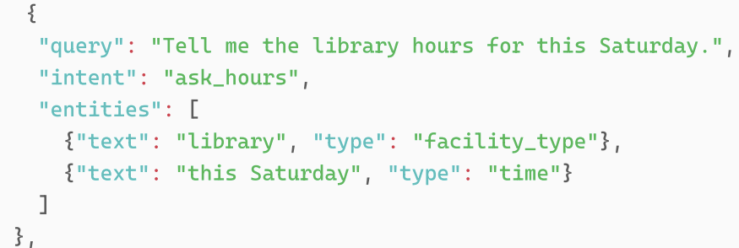

Also, we will use VADER to detect sentiment of user input and use classification algorithms such as SVM to adjust the sentiment of output accordingly. Finally, a clear user interface will be designed to ensure the practicality of the chatbot.

Reference

Chen, Zheng, et al. “Facilitating University Admission Using a Chatbot Based on Large Language Models with Retrieval-Augmented Generation.” *Educational Technology & Society*, vol. 27, no. 4, 2024, pp. 454–470. Airiti Library, <https://doi.org/10.30191/ETS.202410_27(4).TP02>. Accessed 17 May 2025.

Coffman, L. D., and W. L. Bryan. “Major Problems of the Freshman Year.” *Bulletin of the American Association of University Professors (1915–1955)*, vol. 11, no. 5, 1925, pp. 237–39. JSTOR, [https://doi.org/10.2307/40217557. Accessed 17 May 2025](https://doi.org/10.2307/40217557.%20Accessed%2017%20May%202025).

Davis, Fred D. *User Acceptance of Information Technology: System Characteristics, User Perceptions and Behavioral Impacts*. arXiv, 2011. <https://doi.org/10.48550/arXiv.1106.3369>.

Shum, Heung-Yeung, Xiao-Dong He, and Di Li. “From Eliza to XiaoIce: Challenges and Opportunities with Social Chatbots.” *Frontiers of Information Technology & Electronic Engineering*, vol. 19, no. 1, 2018, pp. 10–26. <https://doi.org/10.1631/FITEE.1700826>.

Tao, Mingxu, et al. *ALOHA: Empowering Multilingual Agent for University Orientation with Hierarchical Retrieval*. arXiv, 2025. <https://doi.org/10.48550/arXiv.2505.08130>.