
Course Code | : | DSC201
Course Name | : | Statistical Programming Using R
Lecturer | : | Soo Yin Yi
Academic Session | : | 2026/09
Assessment Title | : | Assignment
Submission Due Date | : | 07/12/2026
Prepared by
Prepared by | : | Student ID | Student Name
Prepared by |  | DSC2409006 | Cui Zeyu
Prepared by |  | DSC24009007 | Deng Kailong
Prepared by |  | DSC2409026 | Min Yiduo
Prepared by |  | DSC2409042 | Yu Fangrui
Prepared by |  | DSC2409043 | Yu Mingquan
Prepared by |  | DSC2409071 | Mounir Ben Hassine
Date Received | : | 07/12/2026
Feedback from Lecturer:

Mark:

Own Work Declaration

I/We acknowledge that my/our work will be examined for plagiarism or any other form of academic misconduct, and that the digital copy of the work may be retained for future comparisons.

I/We confirm that all sources cited in this work have been correctly acknowledged and that I/we fully understand the serious consequences of any intentional or unintentional academic misconduct.

In addition, I/we affirm that this submission does not contain any materials generated by AI tools, including direct copying and pasting of text or paraphrasing. This work is my/our original creation, and it has not been based on any work of other students (past or present), nor has it been previously submitted to any other course or institution.

Signature:

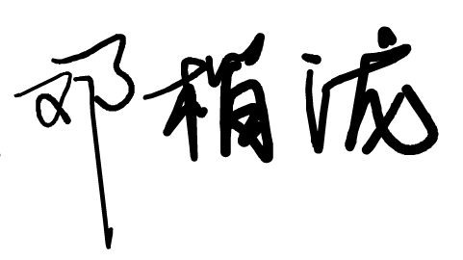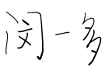
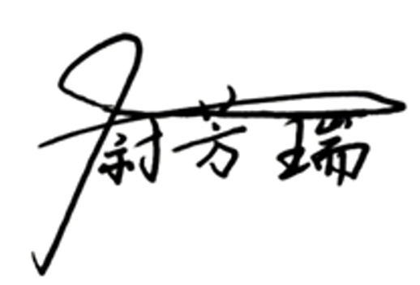

Date: 10/11/2026

