$$2^{29}=\frac{{\left(2^{10}\right)}^{3}}{2}=\frac{{1024}^{3}}{2}\sim \frac{{1000}^{3}}{2}=5*{10}^{8}$$
$$2^{42}={\left(2^{10}\right)}^{4}*4\sim {1000}^{4}*4=4*{10}^{16}$$
$$2^{20}=2^{10}*2^{10}\sim {10}^{6}$$
$$2^{17}=\frac{2^{20}}{8}\sim \frac{{10}^{6}}{8}=\frac{125*8*{10}^{3}}{8}=125000$$
$$2^{16}=\frac{2^{17}}{2}\sim \frac{125000}{2}=62500$$

7544
-> 0001 1101 0111 1000

2974 -> 0000 1011 1001 1110

- ${675}_{10}$=$0000 0010 1010 {0011}_{2}$
- $-{675}_{10}$ =$1111 1101 0101 {1101}_{2}$

a = 0011 1001 1110 1111 (J)
b = 0011 1101 0010 0010
$$a=39EF_{16}={34757}_{8}$$
$$b=3D{22}_{16}={36442}_{8}$$
$$a+b=0111 0111 0001 0001$$
$$-b=1100 0010 1101 1110$$
$$a= 0011 1001 1110 1111$$
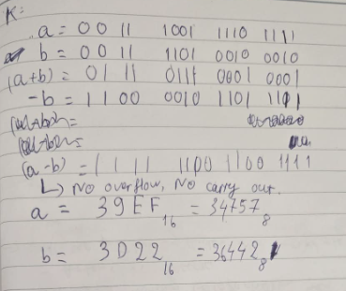
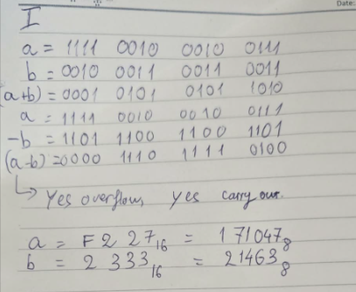
$$a-b no carry out ,no overflow$$

