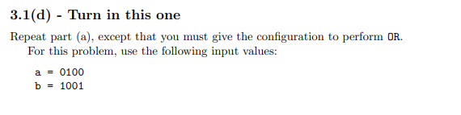
For OR, aluOp = 010
bNegate = 0
AND = 0000
OR = 1101 ** This is the out put of the ALU
Add = 1101
Out = 1101

