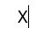


























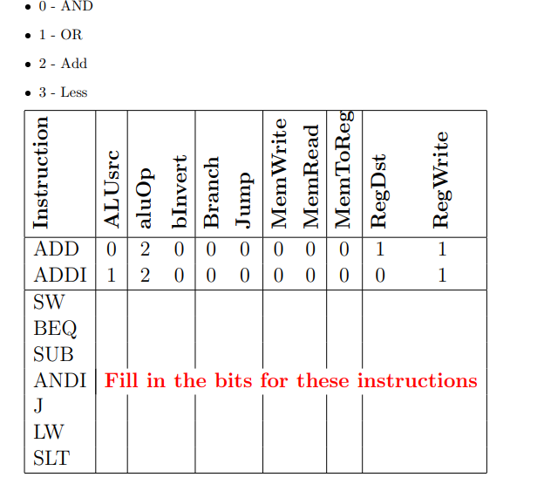

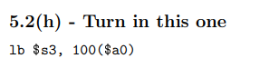
100000 00100 10011 0000000001100100
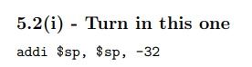

001000 11101 11101 1111111111100000

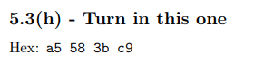
1010 01/ 01 010/ 1 1000/ 0011 1011 1100 1001
- I type
sh $12, 0x3bc9($24)

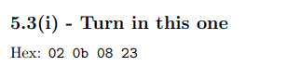
0000 00/10 000/ 0 1011/ 0000 1/ 000 00/ 10 0011
- R type
subu $1, $16, $11

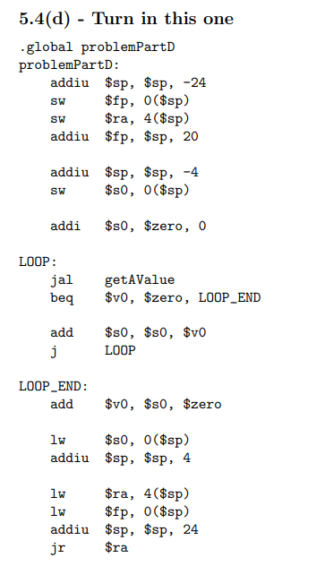
int problemPartD(){
int i =0;
int value = getAvalue();
while ( value!=0) {
i += value;
value = getAvalue();
}
return i;
}

