**Title: Macau's Financial Landscape**

**Subtitle: An Analysis of the Territory's Banking System, Credit Trends, and Economic Growth from 2000 to 2022**

**Content:**

**Introduction**

This study investigates Macau's financial system, emphasizing the structure of commercial banks, the ratio of domestic credit to the private sector to GDP, and the distribution of credit by industry from 2000 to 2022. It also examines the balance between domestic deposits and the issue of currency. Using Ordinary Least Squares analysis, it assesses the link between Macau's GDP per capita and domestic loans and deposits. Through thorough data analysis, our objective is to give a fast knowledge of the financial events affecting Macau's economic environment, providing essential insights for implementing future policies in this continuously changing and expanding region.

**Analyzing the Number of Commercial Banks in Macau**

As of August 2022, Macau's financial hub has a unique system of regulated banks, with 32 institutions contributing to the city's economic activity. Among these, is a considerable group of 12 local banks, each playing a crucial purpose in building Macau's financial identity. The local financial ecosystem contains a multitude of organizations with regional and international relevance. Among them, well-known firms such as Banco Tai Fung, Banco Comercial de Macau, and Banco OCBC (Macau) are veterans of the local financial sector. These institutions are not only the guardians of financial activity but also significantly contribute to Macau's economic development and stability.

The list contains Banco Chines de Macau, Banco Delta Asia, Banco Well Link, Banco Industrial e Comercial da China (Macau), and Nacional Ultramarino. Each of these institutions lends its stamp to Macau's financial story, helping to create diversity and resilience within the banking sector. In addition, Banco Luso Internacional, Banco de Formiga (Macau), Ant Bank (Macau), Banco de Desenvolvimento de Macau, and Banco da China (Macau) further boost the local financial industry. Their existence attests to the international interconnection and spirit of collaboration that defines Macau's financial sector.

This complicated network of 12 local banks illustrates Macau's adherence to financial transparency and stability. The interaction between local and international organizations presents Macau as a vibrant and unique financial hub. As of August 2022, the development of 32 licensed banks stresses the transparency and competitiveness of Macau's financial sector.

**Analysis of the Ratios of Macau’s total amount of domestic loans to the private sector over Macau’s nominal GDP**

Macau's financial trajectory, as measured by the ratio of domestic loans to the private sector to GDP from 2000 to 2022, presents a clear picture of economic advancement. Two separate graphs, a line graph indicating the growth of credit following Macau's GDP and a diagram depicting the growing percentage ratio, illustrate the dance linking lending practices and overall economic output.

The graph below illustrates a massive growth in both credit and GDP across the years. In 2000, credit reached 38,198.9 million MOP, whilst GDP was 54,369 million MOP. As we approach 2022, these values have climbed dramatically, reaching 570,125.3 million MOP for credit and 193,906 million MOP for GDP. This pattern suggests a significant expansion of financial activity and economic output, reflecting the increasing image of Macau's economy.

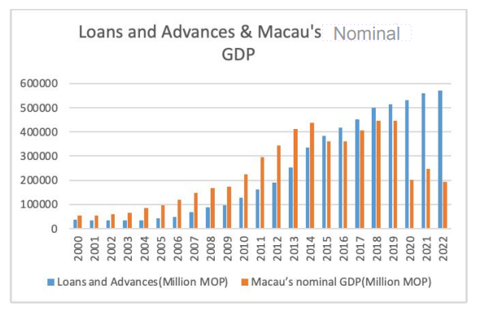

However, the major news comes in the line graph, where the ratio of domestic credit to GDP displays a consistently expanding trend, as shown below. 2000, the ratio was 0.7%, suggesting a balanced link between borrowing and economic output. By 2022, this proportion has risen to 2.9%, indicating a considerable expansion in the dependency on domestic finance relative to the overall size of the economy.

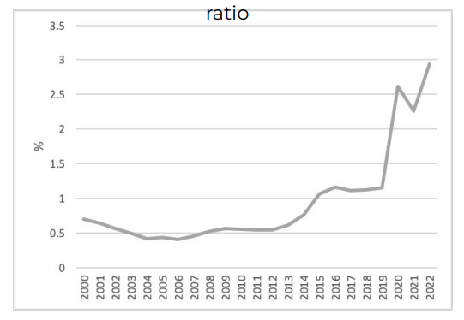

The years 2000 to 2019 reflect a landscape typified by infrastructure investment, a booming housing market, and a diversified industrial structure. However, from 2020 to 2022, there is a change. Economic slump, increased borrowing, and a growing dependency on imported goods take centre stage, providing a significant context for the rising credit-to-GDP ratio.

This trend illustrates a complicated tale - an economic shift from growth and diversification to problems reflected by financial crises and excessive borrowing. The rising demand for imports also indicates the ongoing alteration in Macau's economic environment. The dual depiction of the ratio of domestic credit and GDP via graphs explains Macau's financial journey.

**Analysis of the Shares (i.e. %) of the total amount of domestic loans to the private sector by industries**

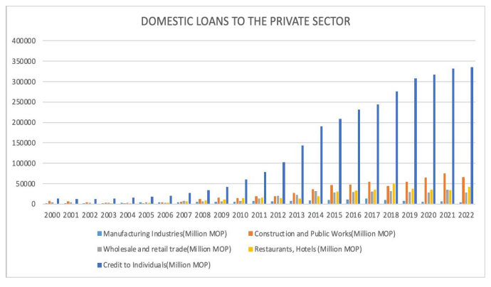

The graph above, displaying the distribution of local credit across different businesses from 2000 to 2022, gives an intriguing picture of Macau's economic history. The key areas show a dynamic voyage across many sectors, illustrating the unique connection between financial activity and the industrial environment. Industry, the cornerstone of economic activity, has witnessed tremendous improvement. From 2537.1 million MOP in 2000, loans to this firm have grown to 4880.5 million MOP in 2022. This increase reflects a dedication to boosting the talents and inventiveness of business within Macau and contributing to its economic stability.

Construction and public Works has been a primary driver in transforming the urban environment and has experienced a massive spike in domestic credit. With 7650.6 million MOP in 2000, this industry has an excellent value of 66,187.4 million MOP in 2022. This increase reflects a devotion to infrastructure development, and attests to the city's openness in embracing modernizing and urban expansion developments.

Wholesale and Retail Trade, the business hub, has demonstrated a similar growing trend. From 4772.4 million MOP in 2000, loans to this firm have climbed to 28,727.8 million MOP in 2022. This development agrees with Macau's economic environment's liveliness and flexibility to adapt to changing client demand.

The sector covering Restaurants and Hotels, a crucial portion of Macau's tourism-supported economy, has witnessed quick development. With 1417 million MOP in 2000, credit to this corporation has climbed to 42,322.6 million MOP in 2022. This growth shows the city's goal to boost its status as a world-class tourism destination. Personal Loans, a measure of consumer financial activity, reveal a spectacular change. From 13,521.2 million MOP in 2000, personal loans have climbed to 335,400.6 million MOP in 2022. This shows the significance of consumer spending and personal loans in fuelling the engine of Macau's economy.

This analysis reveals the diversity of Macau's industrial structure. The planned allocation of domestic credit shows the multiple pathways of economic progress, blending current strengths with growing regions.

**Analysis of the Ratios of Macau’s total amount of domestic deposits over Macau’s nominal GDP**

The bar graph below depicting Macau's domestic deposits and Nominal GDP from 2000 to 2022, alongside the line graph exhibiting the relevant percentage ratios, presents a sophisticated picture of the city's financial environment. As we analyze the central places, the narrative unfolds against the backdrop of significant events and legislative changes, revealing the economic resilience of Macau in the face of numerous problems.

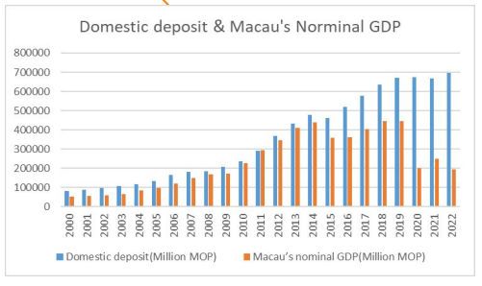

Domestic deposits in Macau have grown considerably yearly, increasing from 83.2 billion MOP in 2000 to 687.2 billion MOP in 2022. This increase is consistent with the city's solid financial infrastructure and growing confidence in its banking system. Looking at the equivalent GDP figures, Macau's economic output has also risen extraordinarily, going from 54.4 billion MOP in 2000 to 193.9 billion MOP in 2022. This economic success is a tribute to Macau's ability to leverage its unique international tourism and financial hub position.

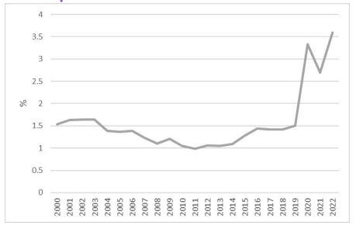

The graph above showing the ratio of domestic deposits to GDP displays an unusual trend. The percentage ratios demonstrate a consistent expanding trend, suggesting a stronger dependency on domestic deposits relative to the overall size of the economy. This figure shows Macau's financial system's expanding dominance of local deposits. Placing the economic chronology and important events in perspective gives essential context for this tendency. The decade between 2003 and 2007 was an age of free-wheeling gaming regulations, stimulating economic growth and affecting deposit behaviour. The 2008-2009 financial crisis and anti-corruption operations in Mainland China throughout 2014-2015 posed challenges, but Macau's financial industry displayed durability.

Recent obstacles, such as the COVID-19 pandemic from 2019 to 2022, further highlight Macau's resilience to survive storms. Despite global economic turbulence, the proportion of domestic deposits stayed on a rising track, indicating the strength and durability of the banking sector. In summary, Macau's financial environment, as evidenced by the proportion of local deposits, shows economic success and the city's capacity to weather consecutive crises.

**Analysis of the Shares of domestic deposits by currency denomination**

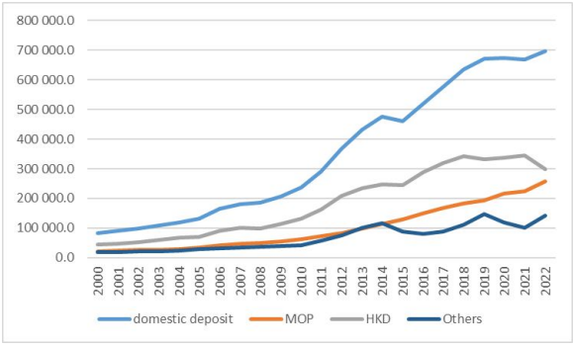

The graph above illustrating the shares of domestic deposits by currency from 2000 to 2022 presents a complete perspective of Macau's financial environment, highlighting the interplay between several currencies and the city's ability to adapt to regional and global economic trends.

The most evident takeaway from the graph is the dominance of domestic deposits, indicating a high percentage in the entire composition. From 2000 to 2022, local deposits constantly held a top position, showing immense faith in Macau's currency, the Macau Pataca (MOP). This trend is shocking given the status of the Macau Pataca as a pegged currency, which reflects the knowledge of the importance of indigenous money within the financial system.

Adding Hong Kong Dollars (HKD) as a significant component of the deposit composition further distorts the look. Despite the anti-corruption effort in Mainland China in 2015 and its projected impact on cross-border financial activities, HKD continues to hold a significant proportion. This resilience indicates the continued relevance of Hong Kong as a prominent financial partner and the stability of HKD within Macau's economic activities.

RMB (Renminbi), the official currency of Mainland China, is undergoing a tremendous shift. From 68,707.895 million MOP in 2014, it lowered to 31,880.4 million MOP in 2015, a considerable reduction driven by the anti-corruption campaign. These alterations highlight how global crises and policy changes may affect currency dynamics.

The graph also depicts the effect of global events, with the trade war between China and the United States in 2018 affecting the share of US Dollars (USD). From 52,951.1 million MOP in 2017, the percentage of USD jumped to 70,293.1 million MOP in 2018, illustrating how Macau is responding to the pull of global trade tensions.

In summary, the currency mix within Macau's domestic deposits reflects economic concerns and the city's flexibility to adjust to global and regional trends. The graph visually represents the delicate interplay between local, regional, and international currencies, delivering essential insights into the stability and diversity of Macau's financial system.

**Analysis of OLS to show for years between 2000 and 2022**

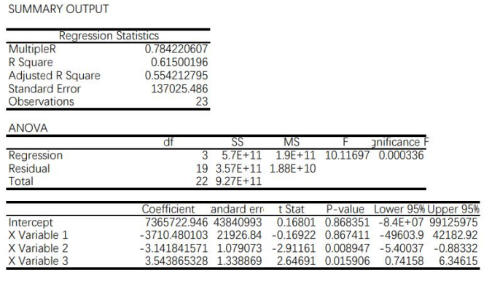

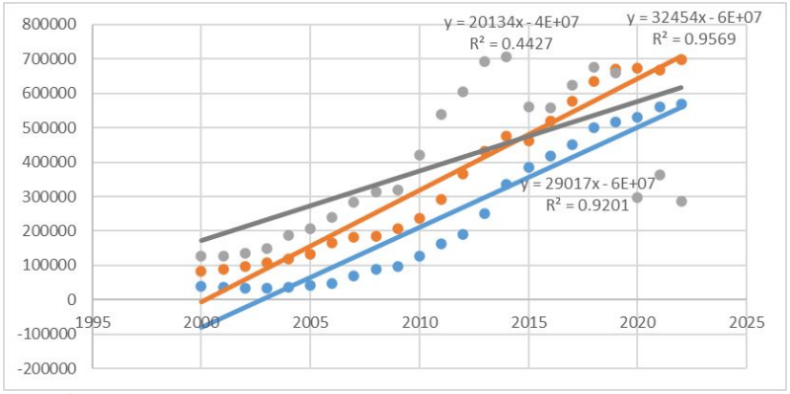

An Ordinary Least Squares (OLS) regression examination between 2000 and 2022 reveals essential insights into the intricate relationship between Macau's GDP per capita and the number of local loans and deposits. The data summary and the derived coefficients offer a quantitative understanding of the economic processes that compose Macau's financial environment.

The regression results yielded an R-squared of 0.784, showing a strong connection between the reported variables. The R-Square score of 0.615 further demonstrates that about 61.5% of the volatility in Macau's GDP per capita may be explained by local loan and deposit variations. Considering the number of predictors, the adjusted R-squared score is 0.554, showing the models fit the data well.

An ANOVA investigation verifies the significance of the regression model with a p-value of 0.000336. This indicates that at least one of the components contributes significantly to understanding the volatility in Macau's GDP per capita. The coefficients of the predictors - domestic loans and deposits - offer more clarity on the nature of their influence.

The baseline, reflecting the average GDP per capita when domestic loans and savings are negligible, is 7,365,722.946 million MOP. When the coefficient of domestic loans (Variable X 2) is negative (-3,710.480103), it is statistically insignificant with a p-value of 0.867. On the other hand, the coefficient of domestic deposits (Variable X 3) is positive (3.543865328) and is statistically significant with a p-value of 0.015906.

This suggests that domestic deposits significantly influence Macau's GDP per capita, contributing in a beneficial way to economic activity. Meanwhile, the impacts of domestic loans appear to be minor within the investigated area. The OLS analysis, coupled with the obtained coefficients and statistical indicators, not only explores the link between economic indicators but also supplies a platform for examining the elements contributing to Macau's economic growth.

**Conclusion**

The study of Macau's financial trends from 2000 to 2022 demonstrates a healthy and stable economic climate. The banking sector, with 32 licensed banks and 12 local institutions, is a backbone of stability and competitiveness. The domestic credit-to-GDP ratio indicates economic movements from growth and diversification to issues such as increased indebtedness. The extensive development of firms within the sector demonstrates Macau's drive to innovation and sustainability. The rise in local deposits, in the face of global anxieties, indicates the endurance of the banking industry. Currency shifts, as shown in the composition of local deposits, demonstrate Macau's ability to adapt to global and regional economic events. Ordinary Least Squares regression demonstrates the substantial influence of domestic deposits on GDP per capita, delivering significant insights for policymakers in managing Macau's dynamic economic environment.