to advance my blender shortcut ability 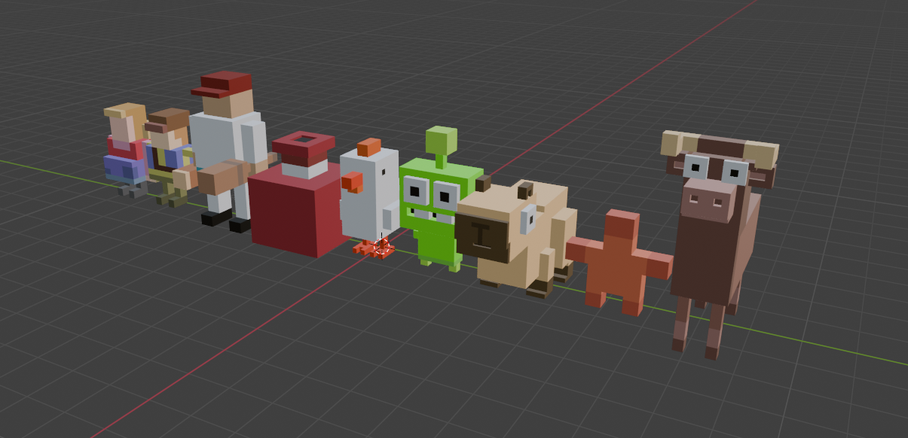

Displays my ability to import levels from Tiled to Unity 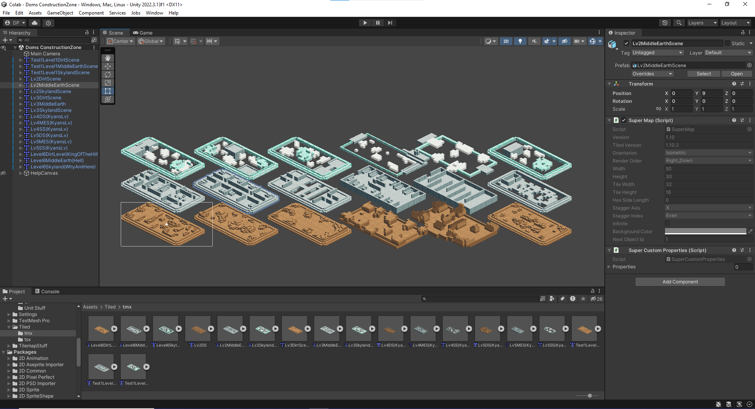 Learn how to make Isometric levels in Tiled 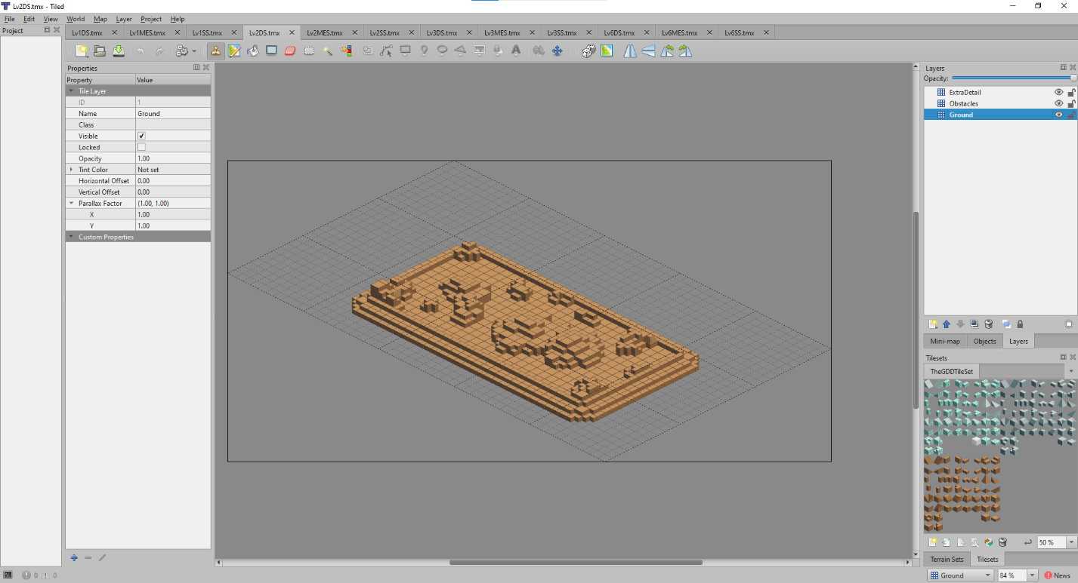

Levels I made for another game 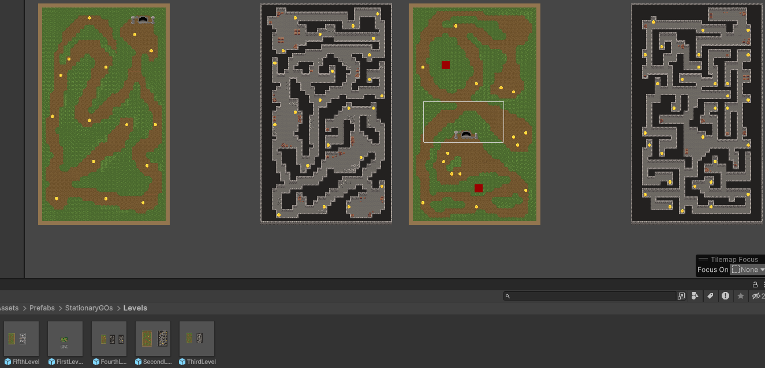

For each example of student work, you should include:

* A copy of the work, if possible
  + If the assignment was hard copy you may include a picture of the assignment
* A brief description of why you chose this assignment

Example:

* I included my first top-down game because I really enjoyed the process of creating a game for the first time. I also felt like I did a very good job of getting the player emotionally attached to the story, and I really liked the art style I chose. My team and I did a good job of working together and discussing how the game should look, and I feel like I did a good job of capturing the steampunk/noir feel we were trying to accomplish.

Bad example:

* I included my entry task because I finally completed every day of one and didn’t lose it by the end of the week