

GAME DESIGN DOCUMENT (GDD) TEMPLATE

Game Name:

MiniMayhem

Genre:

Arcade style with many mini games

Game Elements:

Game elements are the basic activities the player will be doing for fun

Playing a bunch of mini games: Capture the flag, Laser Tag/Paint Ball, Hide n Seek tag, etc.

Player:

The number of players that can play the game at once

Up to 20 players can play in a lobby at once.

# TECHNICAL SPECS

Technical Form:

Basically, there are 2D graphics (flat) and 3D graphics (form)

2D gameplay with a 3D environment = 2.5D

View:

Camera view from which the player will experience the game

Third Person View

Platform:

iOS, Android, Mac, PC

PC Platform

Language:

C#, C++, Ruby, Java

Using C# script

Device:

PC, Mobile, Console

PC

# GAME PLAY

Use the game play section to create a descriptive paragraph about how the game is played. You want the use tor imagine they are actually playing the game. Try not to use generic (i.e., broad, non-descriptive) terms when writing about the game play. For example, few readers want to hear statements such as, “enemy_1 will have more hit points than

enemy_2.” Instead, it’s better to make statements like, “The Lazarus Fighter has more armour than the Apollo Fighter.”

The Game will play as such, upon pressing play the user will be given an option to either create a lobby or join a preexisting lobby, once a lobby is joined/created the first user in the player order will be able to change the queue of the minigames ether picking them by hand or randomly. There are a total of 5 minigames: Capture the flag, Laser Tag/Paint Ball, Hide n Seek, Maze, and Race. Capture the flag will divide players as evenly as possible into two teams, both teams will be on a mirrored colors swapped playing field. Both teams’ goal is to obtain the others flag/totem, to prevent this both teams are given a projectile/water balloon used to “tag” or send the player back to their team spawn. Whatever team has the most flag captures by the time limit wins if both teams have an even number of points the game goes into overtime and ends when a flag is captured. Laser Tag/Paint ball is like capture the flag except the only goal is to decimate the other team using Laser guns/Paintball Guns. Hide n’ Seek tag, one player is chosen to be “IT” them must tag every player to win once a player is tagged, they also become it and must find hiders, any remaining players left unfound win if all players are found then the seeker wins. Each games have a set time limit and whomst ever attains the majority of points will be crowned the winner the game will end, and you’ll be sent to a lobby of sorts. The player can choose to start/join a new queue or quit to main menu.

Game Play Outline

This outline will vary depending on the type of game.

* Opening the game application
* Game options
* Opening Game
* Splash screen of the dream team’s logo (idk)
* Game options
* GameCode enter press play
* lobby maybe wait for game to finish/start
* Mini game1
* Mini game2
* Mini game3
* Mini game4
* Winner Crowned
* quit to MM or join lobby
* new queue
* end
* The player spends time with friends, but the game will have Varity

Key Features

Key features are a list of game elements that are attractive to the player.

Multiplayer: being able to play with friends  
Mini Games: Keeps the gamer entertained with Varity

2.5D camera 2D art style

The top players receive points/coins/something to ether unlock at random or buy cosmetics

# DESIGN DOCUMENT

This document describes how GameObjects behave, how they’re controlled and their properties. This is often referred to as the “mechanics” of the game. This documentation is primarily concerned with the game itself. This part of the document is meant to be modular, meaning you could have several different Game Design Documents attached to the Concept Document.

Capture the flag: The player is given a projectile water balloon for example this will send any enemy on your side player back to their teams spawn you can only strike those who are on your side and you cannot strike if you are on an enemy teams turf. When a flag is captured, you can no longer strike players at all and must sprint to your teams flag to score a point.

Lazertag/paintball

Players are given a Laser gun or a paintball gun to shoot the other team eliminations are tallied during the game pressing tab with give current leaderboard this applies to other minigames as well. Shooting is allowed on both sides whichever team has the most eliminations wins the game

Hide n’ seek:, one player is chosen to be “IT” them must tag every player to win once a player is tagged, they also become it and must find hiders, any remaining players left unfound win if all players are found then the seeker wins.

Design Guidelines

This is an important statement about any creative restrictions that need to be considered and includes brief statements about the general (i.e., overall) goal of the design.

Our Art team will pursue a Fairly simple, Lightly Detailed, whimsical Pixel art design. Due to our game not having much of a story and us wanting the player not to focus on the details we want art that is clean and nice but not too distracting as to pull away from the game itself, the art will emphasize the minigame Kidish theme.

Game Design Definitions

This section established the definition of the game play. Definitions should include how a player wins, loses, transitions between levels, and the main focus of the gameplay.

The winner and losers will be decided based on a point system(1st 12p, 2nd 10p, 3rd 8p, 4th 7p, 5th 6p, 6th 5p, 7th 4p, 8th 3p, 9th 2p, 10th 1p 11 to 20 get 0p)

The transitions will be a loading screen with the map you'll be sent to and the game mode that'll be starting.

Have Fun.

Game Flowchart

The game flowchart provides a visual of how the different game elements and their properties interact. Game flowcharts should represent Objects, Properties, and Actions present in the game. Each of these items should have a number reference to where they exist within the game mechanics document.

* Menu
* Synopsis
* Game Play
* Player Control
* Game Over (Winning and Losing

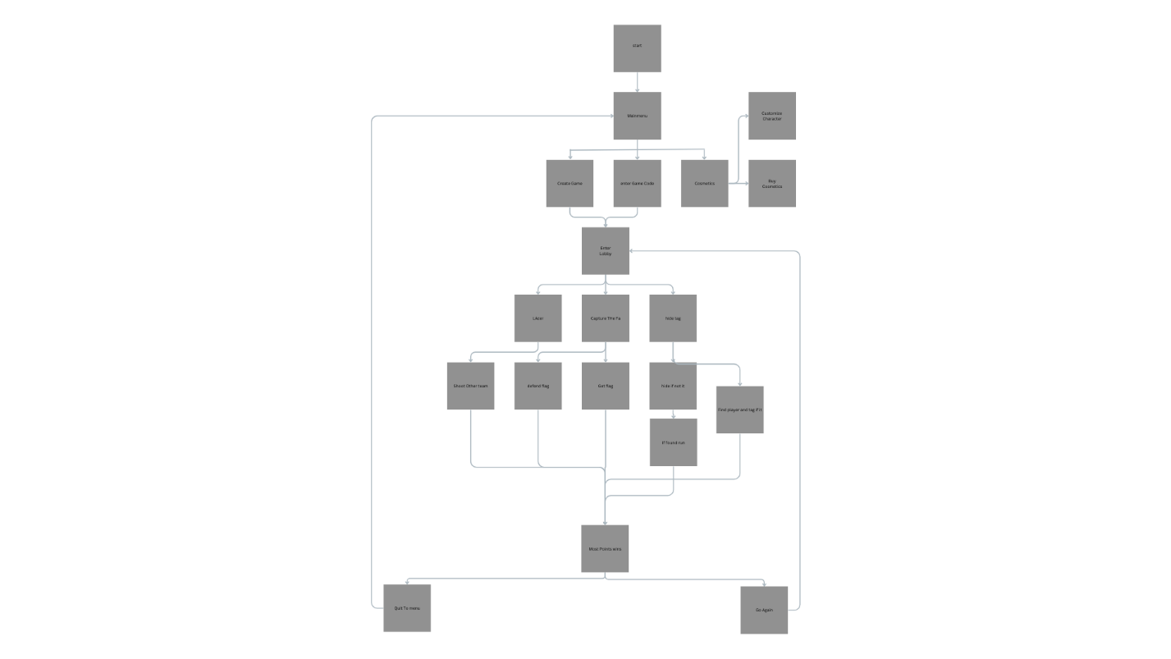

Player Definition

* Use this section for quick descriptions that define the player
* Use the Player Properties section (below) to define the properties for each player. Player Properties can be affected by the player’s action or interaction with other game elements. Define the properties and how they affect the player’s current game.
* Use the Player Rewards section to make a list of all objects that affect the player in a positive way. Define these objects by describing what affect they cause and how the player can use the object.

Player Definitions

A suggested list may include:

* Health
* Weapons
* Actions

* Same as everyone else unless equipped cosmetics
* Depending on minigame has Water Balloon, flag if capturing, and Laser Gun.
* Shoot/throw
* Capture Flag
* The player is given 5 health points

Player Properties

Each property should mention a feedback as a result of the property changing.

* IF the player is hit with a water Balloon or a Laser Bolt/Paintball They respawn at their spawn
* If a player is tagged depending on the theme the player with either freeze/become it or just die
* If the player holds a flag they cannot use any weapons

Player Rewards (power-ups and pick-ups)

Make a list of all objects that affect the player in a positive way (e.g., health replenished)

Speed Boost, Tank Mode Invulnerable for short period, Invisibility, Ammunition, Hand Bombs/Smoke bombs

User Interface (UI)

This is where you’ll include a description of the user’s control of the game. Think about which buttons on a device would be best suited for the game. Consider what the worst layout is, then ask yourself if your UI is it still playable. A visual representation can be added where you relate the physical controls to the actions in the game. When designing the UI, it may be valuable to research quality control and user interface (UI) design information.

The game will be on desktop so the only ui elements might be a health bar on the left top side of the players screen and a counter/team point score thing top middle. The main menu will consist of a play button in the middle or to the side   
(like Skyrim)