Assignment 6 Dominic Sherman CS 143 Oct. 9th

- Gouraud shading calculates the intensity by computing the normal at each vertex. It then calculates the lighting equation for each vertex, and interpolates the colors along the edges for each pixel. The Phong shading is different because rather than calculating the lighting equation at each vertex, it does it at each pixel. It is more computationally intensive because it calculates the normals at each of a polygon as well, but then it interpolates these normal vectors inside the polygon and apllies the lighting equation to each pixel. Below, you can see the difference this creates in the appearance. The image on the left is Gouraud and the one on the right is the Phong. You can see the more realistic reflection shown from the light in the Phong shading model, since it calculates the lighting equation at the pixel level.

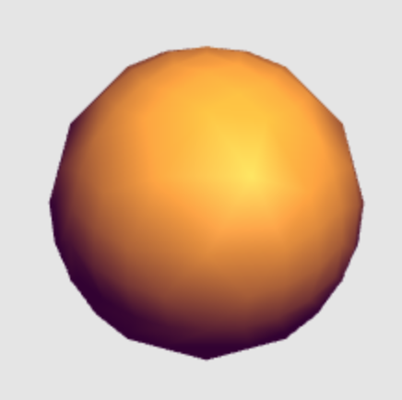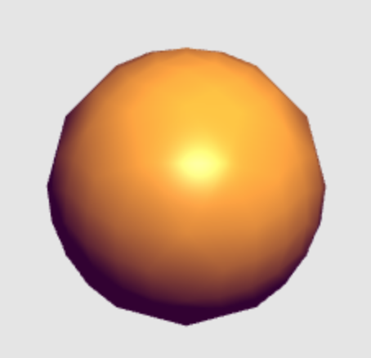

- The first of these non-realistic components is the ambient light. It is very computationally expensive to actually compute all possible light reflections in an environment, so instead we “fake” ambient light by giving the entire object a low level ambient color. The second is the diffuse component. Since in reality a diffuse reflector scatters light in all directions, we use Lambert’s cosine law to simplify the computation and to approximate the diffuse component.

