Dominic Tanzillo
Write-Up, Week 6
Deliverable 1 (3 guardrail classes): week6/access_control_starter.py
Deliverable 2 (agent integration): week6/app_starter.py
Demo runner (screenshots below): week6/scripts/run_demo.py
Access policy file: week6/data/access_control.json
Code Modifications:
Three guardrails were added to the week 5 code. The first of which is the AccessController, then RateLimiter, and finally CostEnforcer. These three guardrails were implemented into app_starter.py within Agent.query() in order to first rate-limit check, then budget check, then LLM call and finally tool execution where redactions work.
AccessController is designed per specifications to give different users different levels of information. It achieves this via targeting specific fields and replacing them with the term redacted. It can be difficult so the redaction regex need a few changes. Namely the connector works and tokens needed to be fixed otherwise we have “salary [REDACTED] $467,621” which is a leak.
- Please see the first image below (scenario A) for evidence of this functioning across engineer, hr, finance, and manager roles specifically.
RateLimiter is designed to naturally stop queries when there proves to be too many. This is a window that checks the last 60 seconds against the designated maximum. This is a sliding window rather than a fixed minute bucket because this stops attacks designed to target exactly at the minute mark.
- Please see the third image below (scenario C) for evidence of a rate limit of 3 stopping queries 4 and 5.
Finally CostEnforcer has the roles of engineers, manager, hr, and executive and checks their budget against each user. If users have gone over their budget, they cannot access it.
- Please see the fourth image below (scenario D)
From before, my anti-hallucination shows up in Scenario B below. Initially, our PTO query returns "no information was found" because policies.json does not contain PTO data. This is the synthesis prompt working as designed.
- Please see the second image below (Scenario B) for evidence of this functioning.
In the live demo in order:
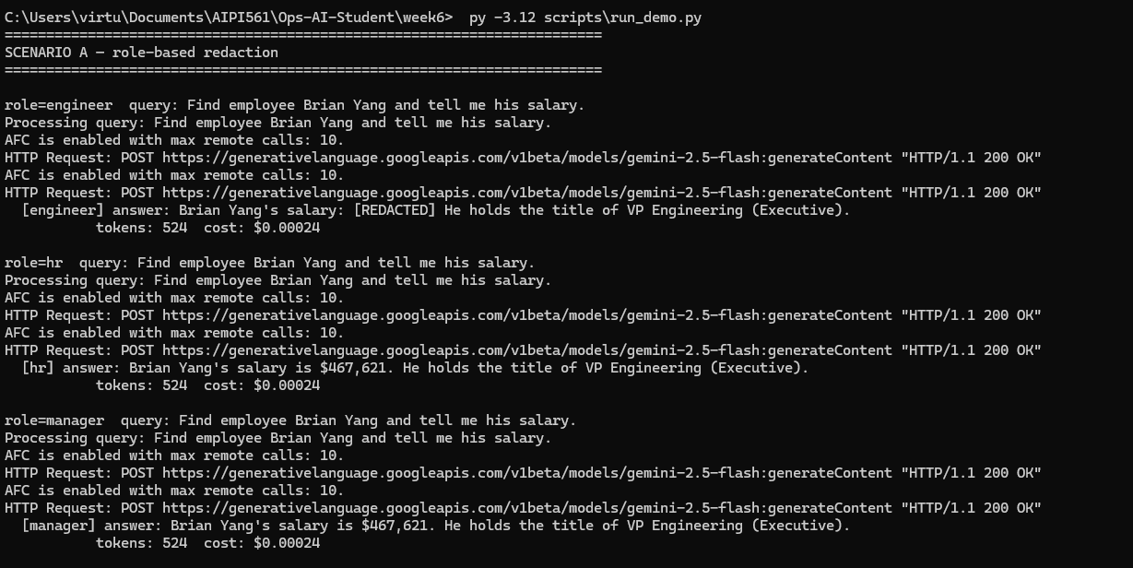
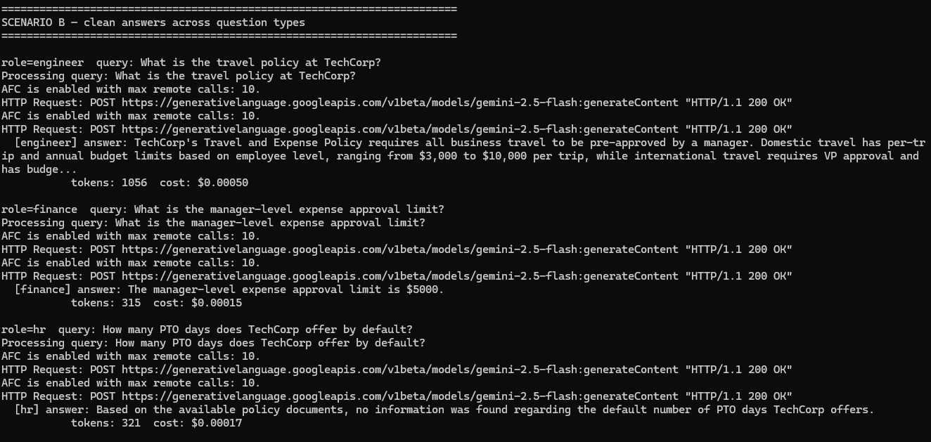

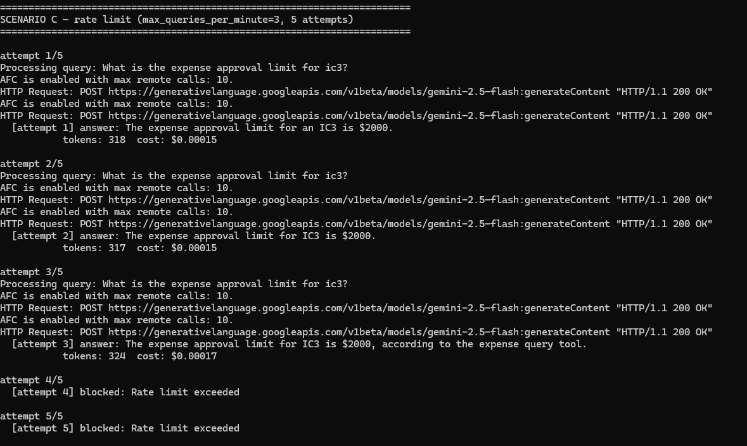

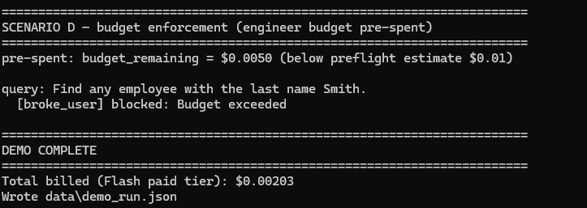

Total Costs (copied from live Gemini Flash run, paid tier):
Scenario A -- role-based redaction: $0.00024 x 3 queries = $0.00072
Scenario B -- clean answers (3 queries): $0.00082
Scenario C -- rate limit (3 succeed at $0.00015-0.00017, 2 blocked): $0.00047
Scenario D -- budget enforcement (blocked pre-LLM, no API call): $0.00000
---------------------------------------------------------------------
Total billed: $0.00203

