Dominic Tanzillo
Write-Up, Week 7
Deliverable 1 (3 classes + inline tests): week7/cost_optimization_starter.py
Evaluation runner (12-query live demo): week7/scripts/evaluate_agent.py
Test queries (12 diverse questions): week7/scripts/test_queries.json
Code Modifications:
Three classes were added on top of the Week 6 agent: CostAnalyzer, OptimizationStrategy, and FeedbackLoop.
CostAnalyzer performs both cost analysis AND spike detection. As it is called it begins to record a per-query cost breakdown across four components. Namely: retrieval, LLM, tool, and error. It then rolls them up via a series of calls: get_cost_breakdown. identify_cost_spikes flags any query whose total_cost exceeds mean plus two standard deviations. To this end, I made a changed where spike detection requires at least three recorded queries before it returns anything; below that, standard deviation is undefined or unstable (even though it could be technically defined).
OptimizationStrategy works as a cache that checks exact match first and then uses semantic similarity (with a cosine-similarity threshold of 0.92). Then a keyword-based model router that uses optimize_retrieval_count with a top-k set to 3 and enable_response_compression caps over 1000 chars. I deliberately did NOT use an LLM to summarize long responses because a second LLM call usually costs more tokens than the truncation saves.
Feedback Loop has the hierarchy from before (engineer=1, hr/finance=2, manager=3, executive=4) and then submit_correction accepts only if the submitter is level three or higher. Corrected answers are longer than the original. validate_correction(index) re-applies those same checks against a stored entry. The two-gate design (authority + length) means a manager cannot rubber-stamp a one-word correction, and an engineer cannot push a detailed correction without escalation.
From the screenshots below:
Total billed: $0.00029
Cache hit rate: 1/23 lookups (one exact hit on the repeated travel-policy query, query 2)
Spike detection: 1 query flagged ($0.000062 Analyze the approval-level structure step by step' is 2 sigma above the mean)
Feedback loop: 2 corrections submitted, 1 validated (manager), 1 rejected (engineer)

The total live spend is orders of magnitude lower than Week 5 ($0.0035) and Week 6 ($0.00203) because the model router sent 75% of queries to flash-lite, which is roughly 1/3 the per-token cost of flash. This is a direct demonstration that the optimization layer works as intended.
Screenshots on the next page!

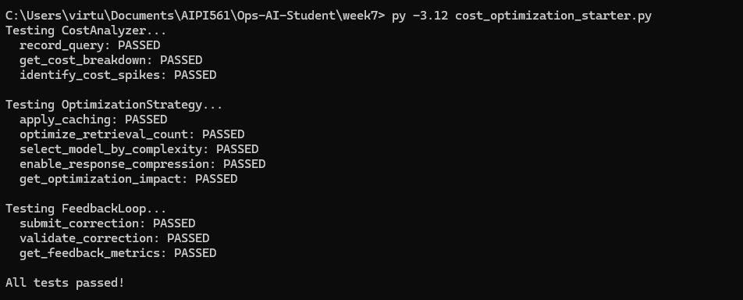
- cost_optimization_starter.py screenshot:
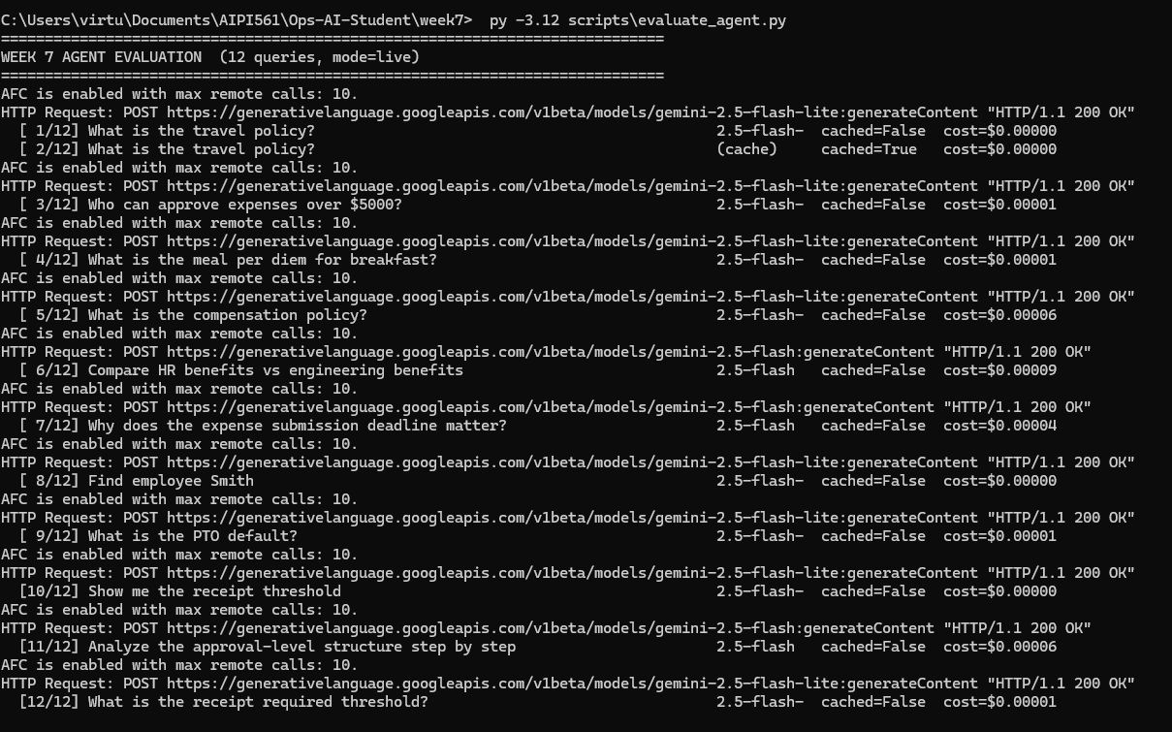
- evaluate_agent.py screenshots:
