Install portainer with docker DOC

- Please make sure already install docker

$ docker -v

- Check docker default daemon file path

$ sudo systemctl status docker.service | grep Loaded

>> Loaded: loaded (/usr/lib/systemd/system/docker.service; enabled; vendor preset: disabled)

- Add config to default daemon file

Find the config
ExecStart=/usr/bin/dockerd -H fd:// --containerd=/run/containerd/containerd.sock under the [Service]
add config
-H tcp://10.10.10.129:12375 -H unix:///var/run/docker.sock

>>

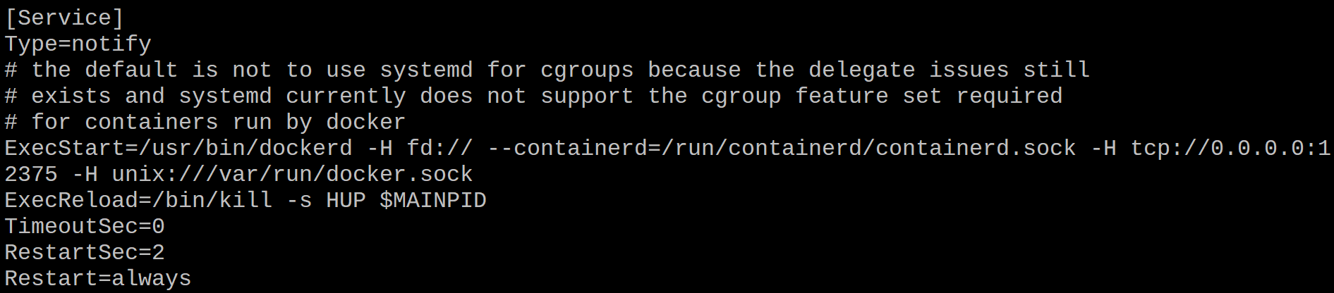
- Reload daemon

$ systemctl daemon-reload

- Reload docker

$ systemctl restart docker.service

- Check dockerd

$ ps -aef | grep 'dockerd'

- Run portainer container ( only on monitor node )

$ docker run -dit -p 19000:9000 --name=portainer --restart=always -v /var/run/docker.sock:/var/run/docker.sock -v portainer_data:/data portainer/portainer

- Use browser check portainer
