How migrate pipeline and template Doc

We will use Dev tools to do migrate pipeline and template . Login kibana and go to list to find Dev tools under Management . Then we can use Elastic command in here .


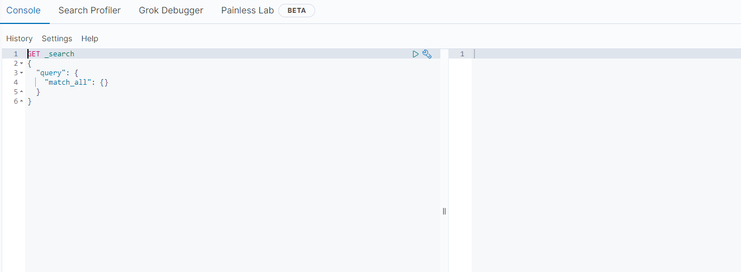


Now we can search our pipeline and template in elk
GET _ingest/pipeline/{{pipeline_name}}

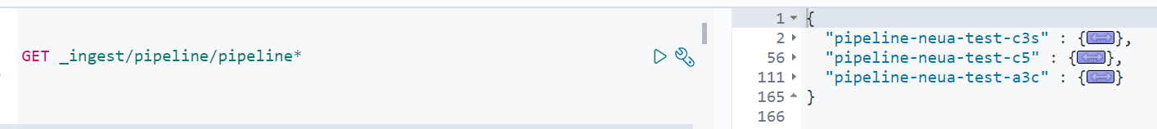
GET _template/{{template_name}}

Copy your pipeline or template and go to new ELK kibana dev tools to put your pipeline or template

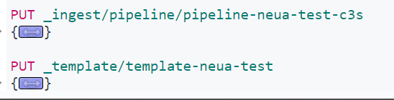
PUT _ingest/pipeline/{{pipeline_name}}
{your_pipeline_json}

PUT _template/{{template_name}}
{your_template_json}

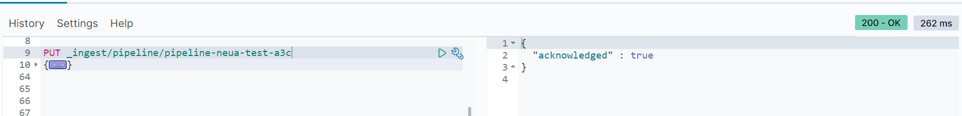
You can see acknowledged at result . Please use GET command to check your pipeline and template is already put in to setting .

