How to export object from kibana

1. Open the form on the top left . And find Stack Management

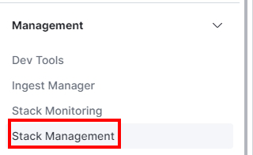

2.

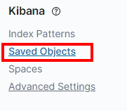

3. select your object and send export
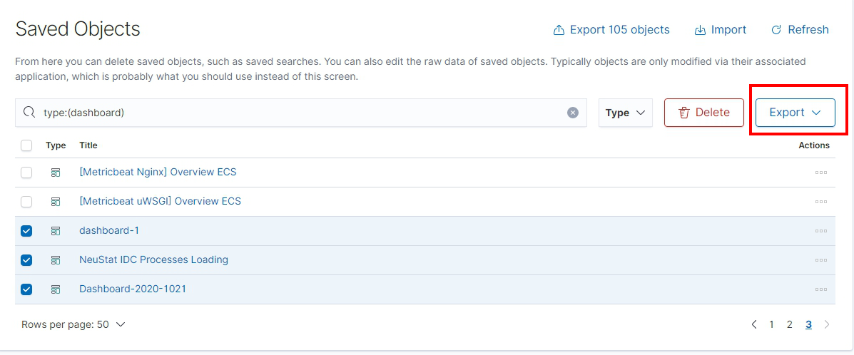
4. you will get ndjson file . Then you can use this file to import object to other kibana
