Postgres on raspberry pi, pgp 9/5/2022

https://pimylifeup.com/raspberry-pi-postgresql/

may want to use pgadmin: https://www.pgadmin.org/ , using command: sudo apt install pgadmin3
setup pgadmin4 on my laptop, using password: pgadmin

to configure postgres for remote connections see: https://opensource.com/article/17/10/set-postgres-database-your-raspberry-pi
user: pi
password: postgres

used pgadmin4 to create a user/user who is superuser.

had to do this in terminal window:
sudo apt install libpq-dev
then this:
sudo pip install psycopg2-binary
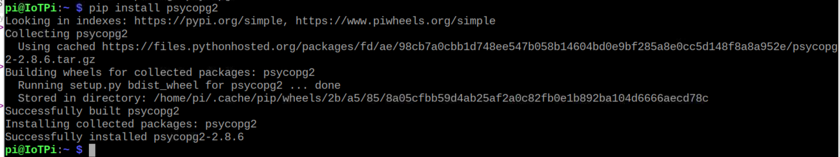

said it worked. So the connector should now be available.

Not yet, now tried:
sudo apt install python3-psycopg2

actually could retrieve data:
