Dominick Girard – Assignment 3   
  
here are my 4 programming languages I used and they were all taken in vs code or visual studio

Python - 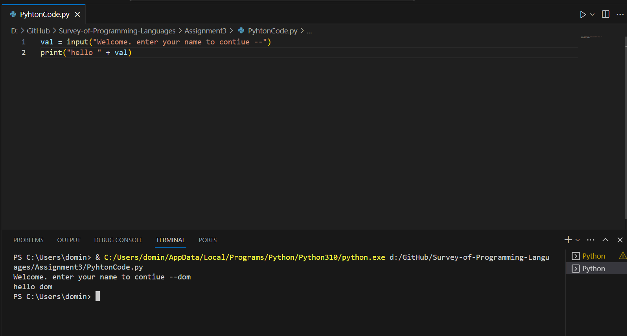  
  
C# - 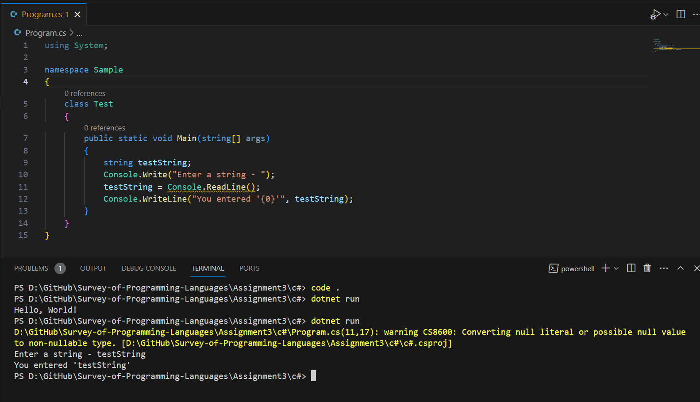

C - 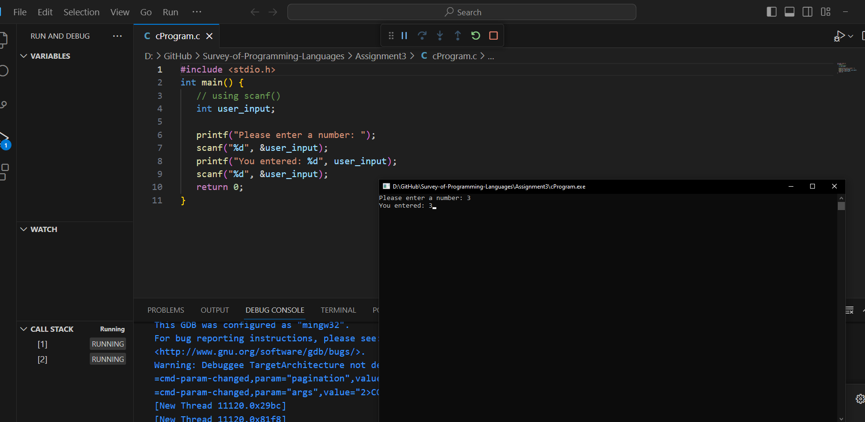

C++ - 