Ex. No.:2 | AI-Powered Blog Content Generator | REG NO: URK23CS1033
DATE: 09/09/2026 | AI-Powered Blog Content Generator | REG NO: URK23CS1033

Aim:
To build an AI-powered Blog Content Generator using Ollama that generates blogs, titles, summaries, SEO keywords, and meta descriptions based on user prompts.
Problem Statement:
Design and develop a modular AI-powered Blog Content Generator using Ollama. The application should generate high-quality blogs from user-provided topics, writing styles, and word counts. It should also generate blog titles, summaries, SEO keywords, and meta descriptions while intelligently routing user requests using an LLM-based intent detector.
Software Requirements:
Software | Version
Python | 3.11.15
Ollama | 0.23.1
Llama 3.2 (local LLM) | llama3.2:latest
ollama (Python client) | 0.6.2
Cursor (VS Code based editor) | 3.15.19
Input Parameters
Parameters | Description
Blog Topic | The subject the blog is written about. Entered by the user; cannot be empty.
Writing Style | How the blog should be written, for example Professional. Default: Professional.
Tone | The voice of the blog, for example Formal. Default: Formal.
Word count | Approximate length of the blog. Accepts 50 to 2000; default 500.
System Architecture
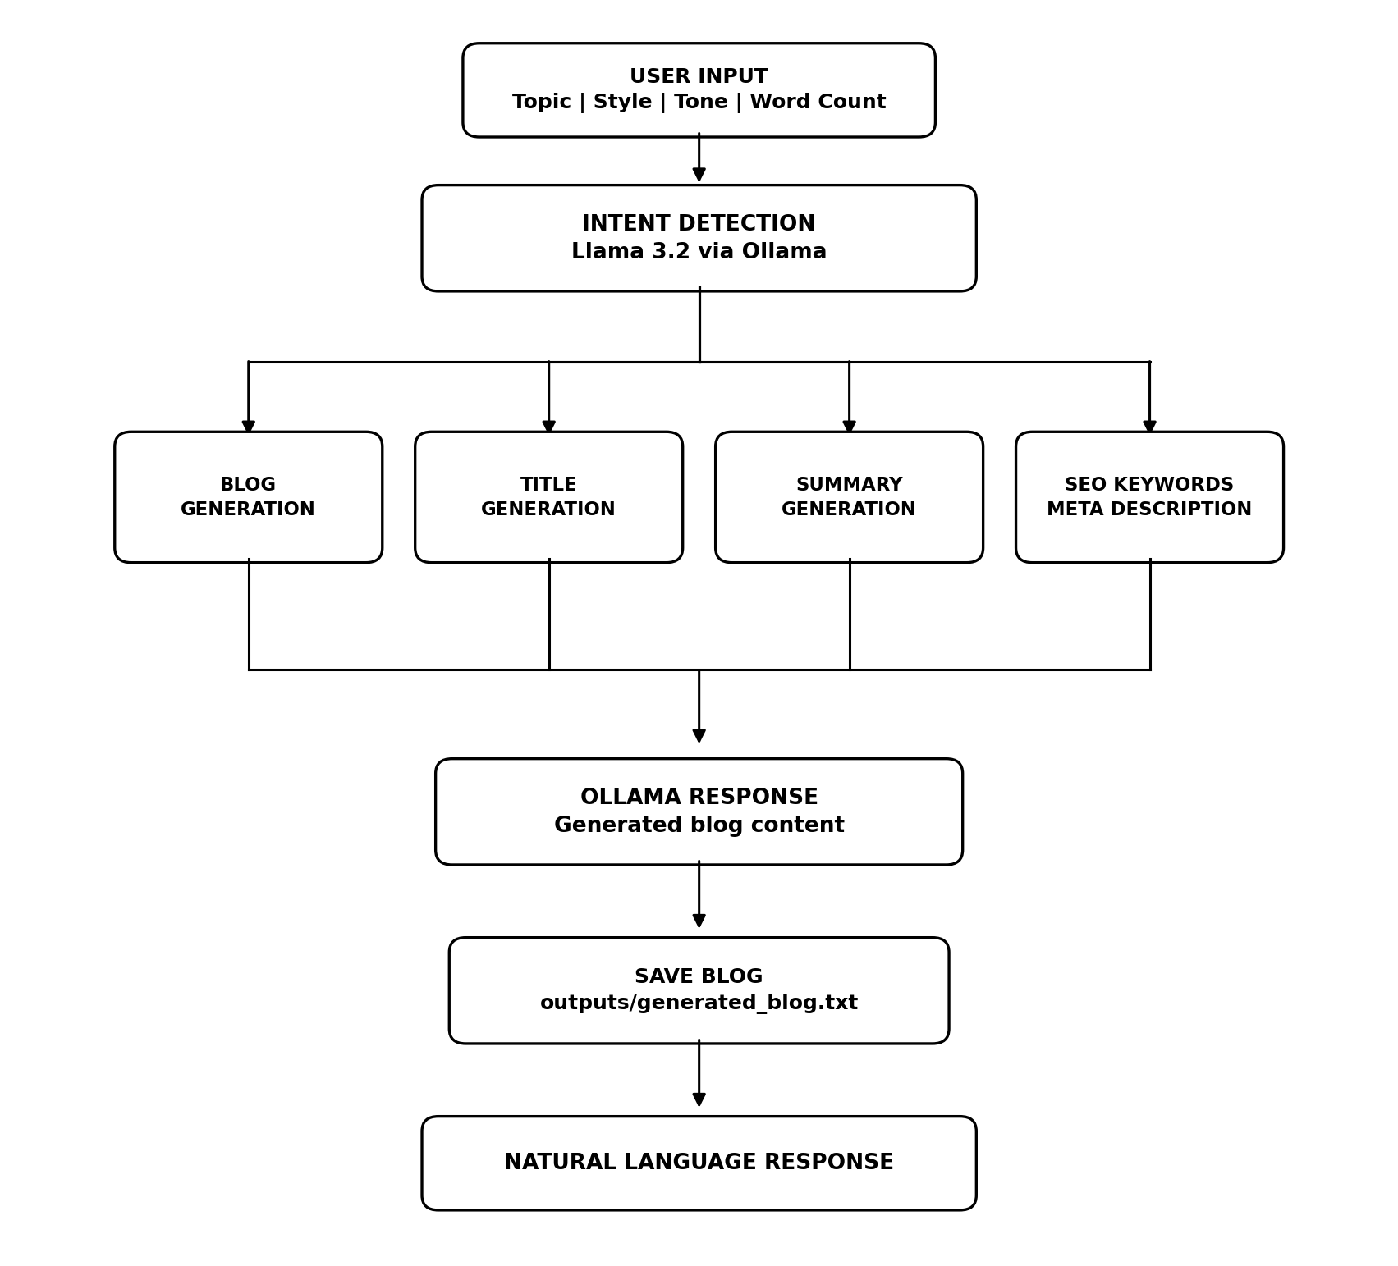
System Architecture of the AI-Powered Blog Content Generator
Module Design
Module | Responsibility
Input Module | Collects the blog topic, writing style, tone and word count, validates them and displays the collected details.
Blog Module | Builds the prompt from the user inputs and generates the complete blog using Llama 3.2 through Ollama.
Title Module | Generates exactly five attractive blog titles for the generated blog.
Summary Module | Generates a summary of approximately 100 words describing the generated blog.
SEO Module | Generates SEO keywords and an SEO meta description within 160 characters.
Intent Module | Uses Ollama to classify a request as BLOG_GENERATION, SUMMARY, KEYWORD_GENERATION or META_DESCRIPTION.
File Module | Saves the generated blog to outputs/generated_blog.txt and reloads it for the other modules.

Implementation
Prompt construction and blog generation (blog_module.py)
def build_prompt(details):
"""Q3 - construct the Ollama prompt from the collected user inputs."""
return ("Write a blog of about {words} words on the topic \"{topic}\".\n"
"Writing style : {style}\n"
"Tone : {tone}\n"
"Include a title, an Introduction, Main Content and a Conclusion."
).format(**details)

def generate_blog(details, verbose=True):
"""Q4 - generate the complete blog using Llama 3.2 through Ollama."""
prompt = build_prompt(details)

if verbose:
print("Prompt sent to Ollama")
print(utils.DASH)
print(prompt)
print(utils.DASH)
print("\nGenerating Blog using {} ...\n".format(utils.OLLAMA_MODEL))

blog = utils.ask(SYSTEM, prompt)
utils.save_blog(blog)

if verbose:
print(utils.DASH)
print(blog)
print(utils.DASH)
print("Word count : {} words".format(len(blog.split())))
return blog
Exactly five blog titles (title_module.py)
def generate_titles(blog, verbose=True):
"""Q5 - generate exactly five attractive blog titles using Ollama."""
reply = utils.ask(SYSTEM, "Suggest five attractive titles for this blog:\n\n"
+ blog[:1500], temperature=0.8)
titles = utils.numbered(reply, WANTED)

# Ask again for any missing title so exactly five are always shown.
attempts = 0
while len(titles) < WANTED and attempts < 2:
attempts += 1
extra = utils.ask(SYSTEM, "Suggest {} more titles for this blog:\n\n{}".format(
WANTED - len(titles), blog[:1500]), temperature=0.9)
for t in utils.numbered(extra):
if t not in titles:
titles.append(t)
if len(titles) == WANTED:
break

titles = titles[:WANTED]

if verbose:
print("Suggested Titles")
print()
for i, title in enumerate(titles, 1):
print("{}. {}".format(i, title))
print()
print("Titles generated : {}".format(len(titles)))
return titles
Meta description within 160 characters (meta_module.py)
def generate_meta(blog, verbose=True):
"""Q8 - generate an SEO meta description and enforce the 160 character limit."""
meta = _clean(utils.ask(SYSTEM, "Write an SEO meta description for this blog:\n\n"
+ blog[:1500], temperature=0.5))

# If the model exceeds the limit, ask it for a shorter version before trimming.
attempts = 0
while len(meta) > LIMIT and attempts < 2:
attempts += 1
if verbose:
print("Response was {} characters - requesting a shorter version ...".format(
len(meta)))
meta = _clean(utils.ask(
SYSTEM,
"Shorten this meta description to at most {} characters:\n\n{}".format(
LIMIT, meta), temperature=0.3))

# Final guarantee: trim on a word boundary if the model still overshoots.
if len(meta) > LIMIT:
meta = meta[:LIMIT - 3].rsplit(" ", 1)[0] + "..."

if verbose:
print("Meta Description")
print()
print(meta)
print()
print("Character count : {} / {}".format(len(meta), LIMIT))
print("Within limit : {}".format("Yes" if len(meta) <= LIMIT else "No"))
return meta
Intent detection using Ollama (intent_module.py)
def detect_intent(query):
"""Q10 - classify the request into exactly one of the four allowed labels.

Handles replies such as "SUMMARY", "Intent: SUMMARY" or "The intent is summary".
"""
raw = utils.ask(SYSTEM, "User: {}\nLabel:".format(query), temperature=0.0)
text = raw.upper().replace("-", "_").replace(" ", "_")

for intent in INTENTS:
if intent in text:
return intent
if "KEYWORD" in text or "SEO" in text:
return "KEYWORD_GENERATION"
if "META" in text:
return "META_DESCRIPTION"
if "SUMMAR" in text:
return "SUMMARY"
if "BLOG" in text or "ARTICLE" in text:
return "BLOG_GENERATION"
return "BLOG_GENERATION"

GitHub Link: https://github.com/ViknanS/Exp-2-AI-Powered-Blog-Content-Generator.git
LinkedIn Post Link: __________

Output Screenshots:
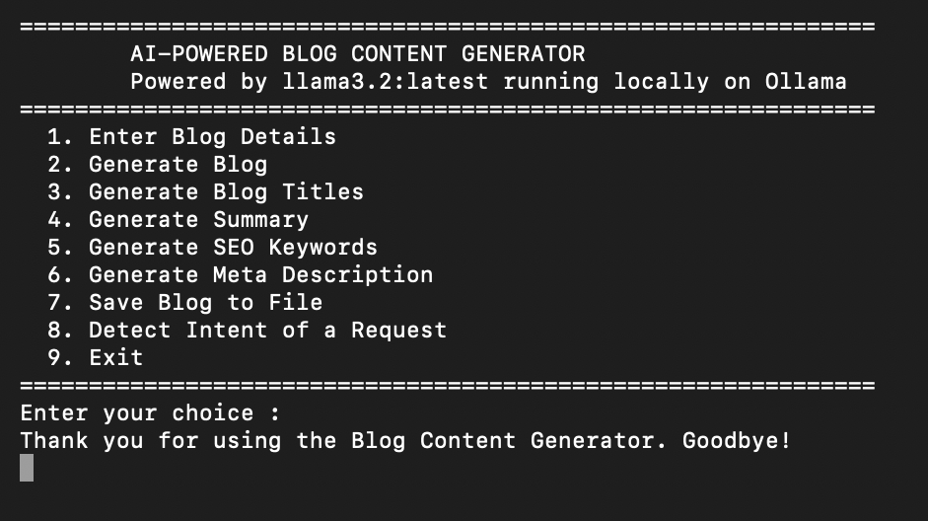
Home Screen
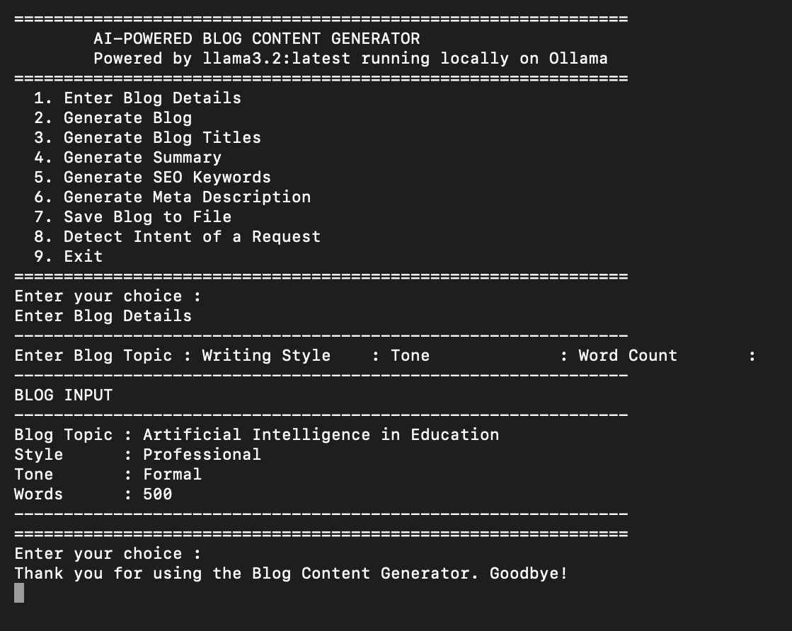
User Input
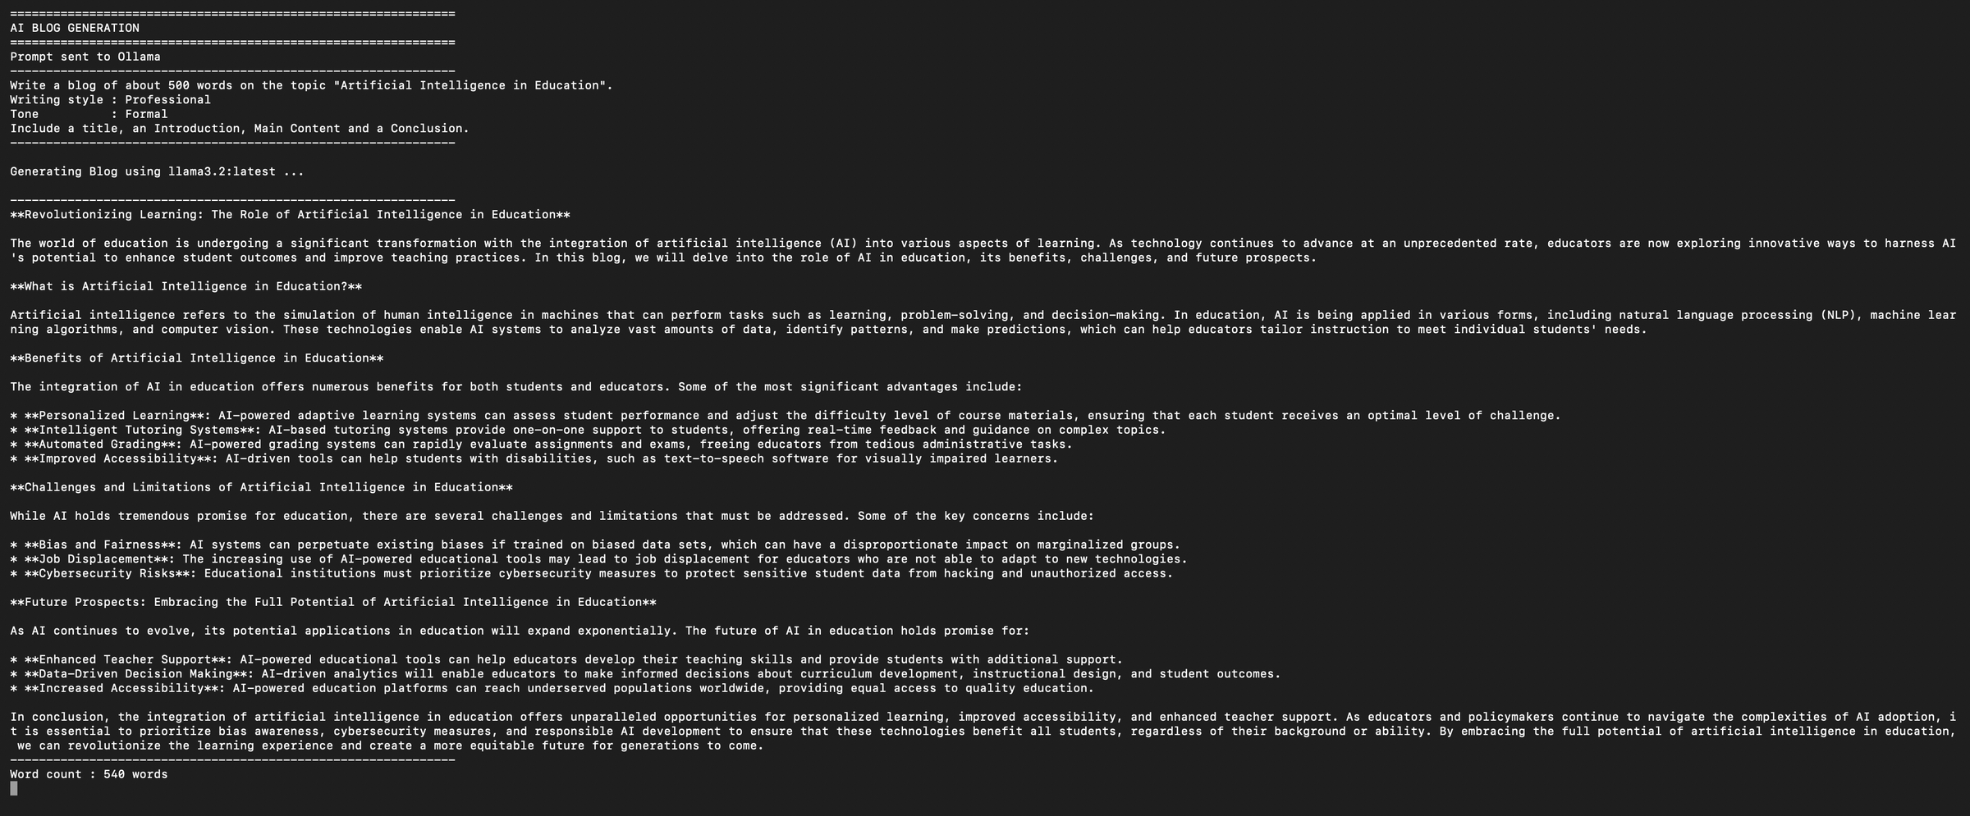
Blog Generation
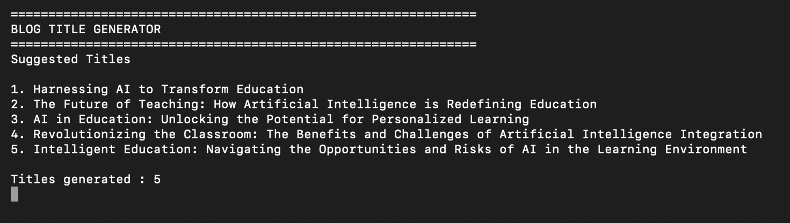
Blog Title Generation
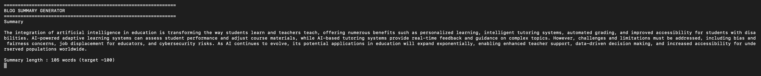
Summary Generation
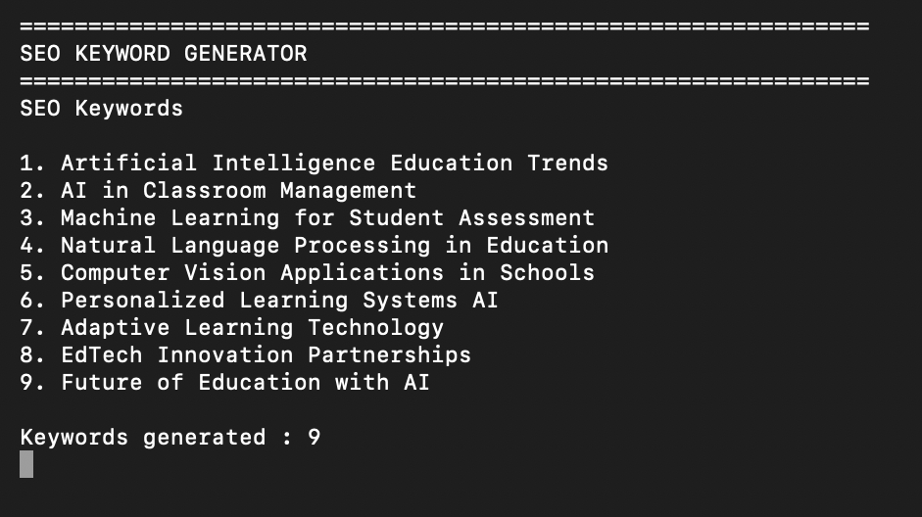
SEO Keywords
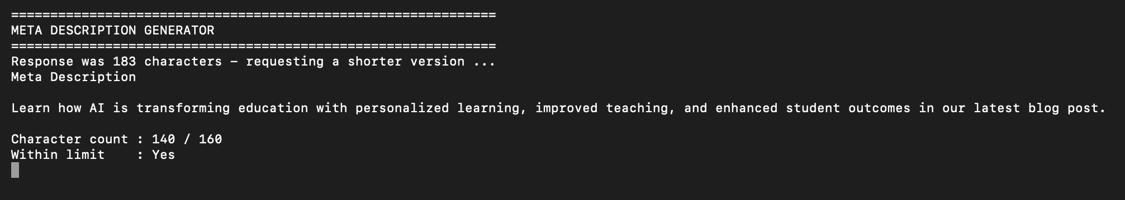
Meta Description
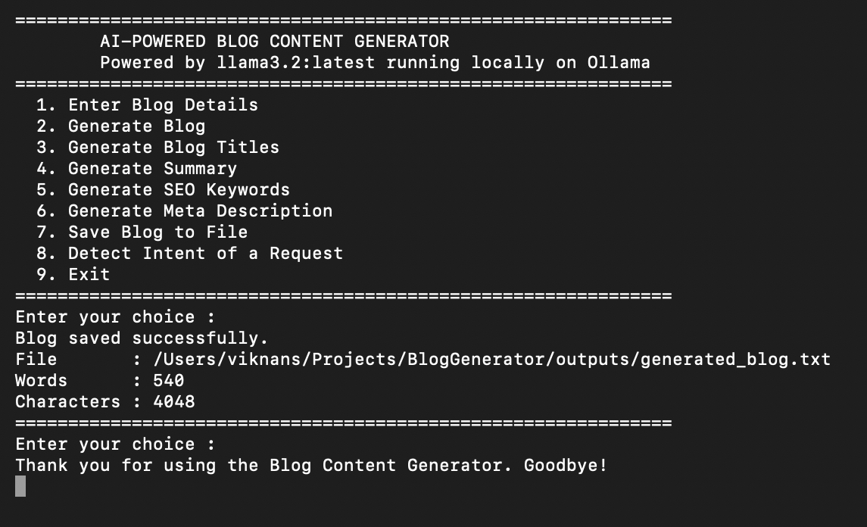
Blog Saved Successfully
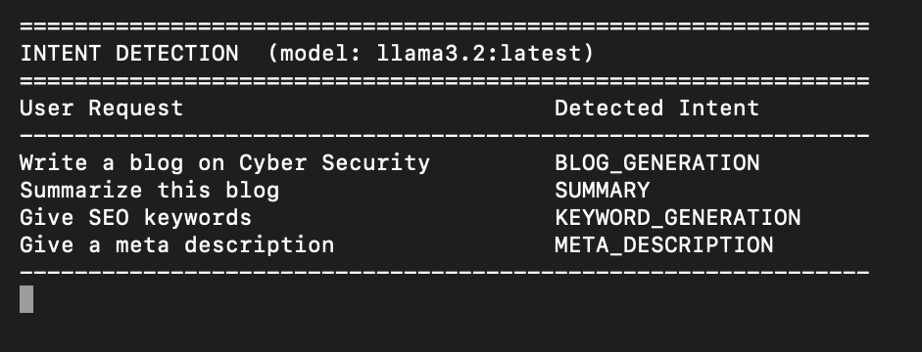
Intent Detection
Result:
Thus, an AI-powered Blog Content Generator was successfully developed using Ollama. The application generates blogs based on user prompts, creates titles, summaries, SEO keywords, and meta descriptions, saves the generated content to a text file, and demonstrates the use of local Large Language Models (LLMs) for content generation without requiring cloud-based APIs.

