Data Visualization: Assignment 1

Student 1: Dominik Ludwiczak

Student 2: Michał Kałmucki

# ObrazekOriginal image

URL: https://vod.tvp.pl/informacje-i-publicystyka,205/wiadomosci-odcinki,273726/odcinek-5918,S01E5918,392609

Context:

Faults:

* Scale on the left axis begins at 7%
* Bars are 3D, which can be misleading especially that when they are shown they have some weird spinning animation
* Also we believe there is a pop out in form of displaying data one by one starting with the highest values which could suggest to focus on how first 2 stations fill almost 90% of shown scale

Implications:

* Scale starting at 7% suggests much bigger difference between TV stations then the factual one
* Moreover 3D bars can further amplify this effect, although these aren’t that tragic since they are quite thin
* Animation and showing bars one by one can misdirect our attention from numbers on scale and make us focus purely on the difference between volumes and heights of bars

Possible improvements:

* Make scale on left axis from 0%
* Show whole graph at once, instead of using distracting animations
* Use 2D bars to display information as clearly as possible

# Sketch

# ObrazekImplementation

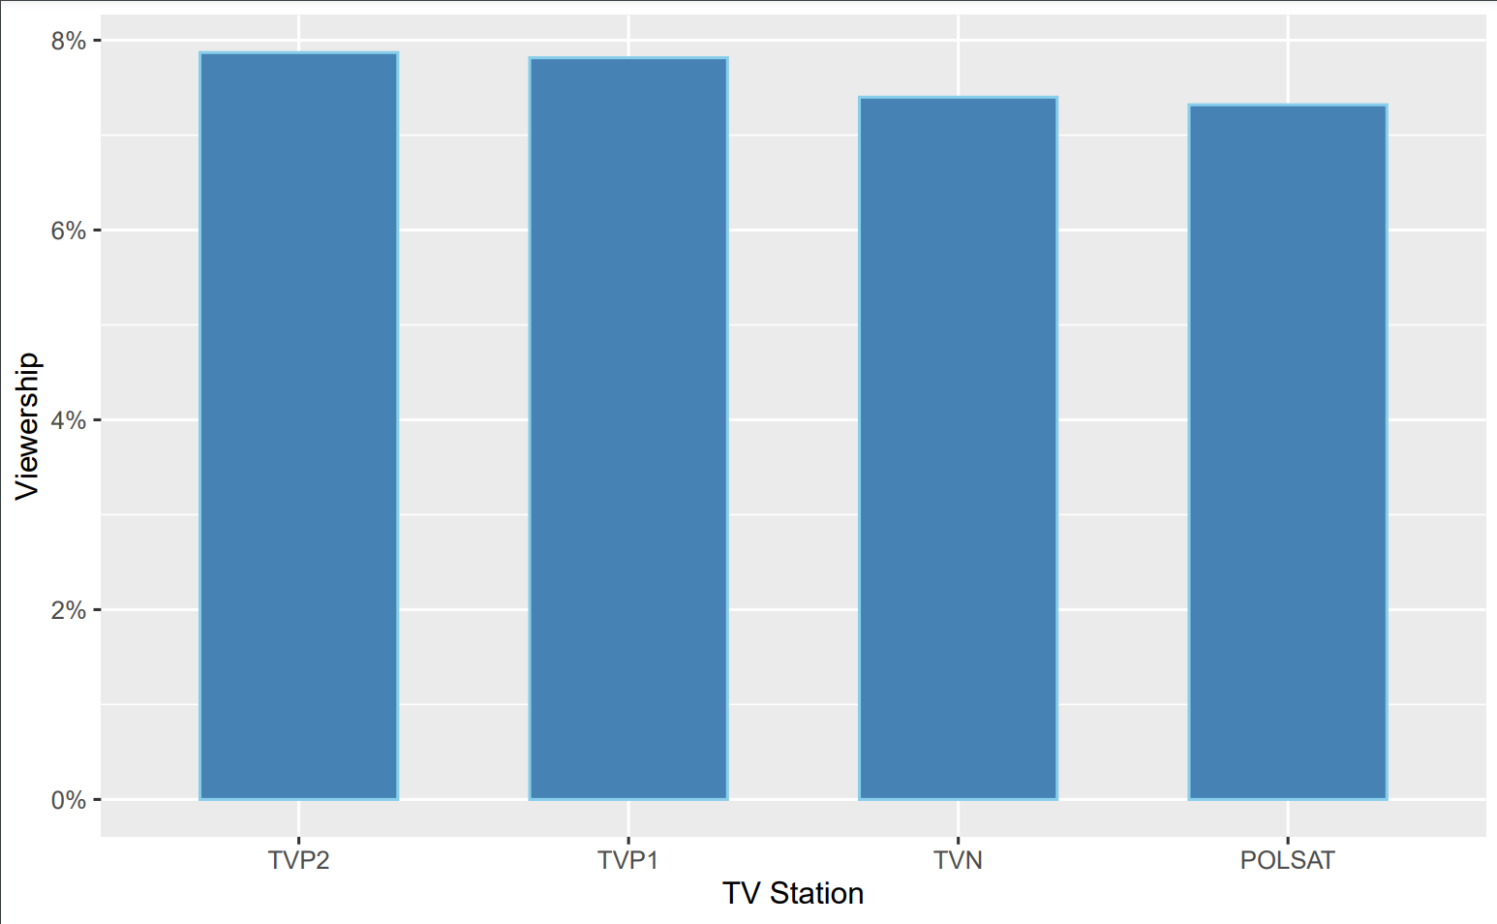

# Implementation code

ggplot(data=df, aes(x=reorder(Station, -Viewership), y=Viewership)) +

geom_bar(stat = 'identity', color = 'skyblue', fill = 'steelblue', width = 0.6) +

scale_y_continuous(labels = scales::percent) + xlab("TV Station")