**Evaluation Report**

**How did you test your website’s usability?**

When testing for usability of the website we were looking for how difficult is it to use the website, will the website be actually used like the user would use it. How functional is it, what could be done to improve usability if it’s not well. During usability testing we were evaluating the functionality and design of our website, we observed our actions and behaviour as we were completing specific tasks.

**How could the website’s usability be improved?**

On the form page, when you resize the screen the form and the text above it don’t resize accordingly as one. They just go their ways with text ending up being cropped. I could not resolve this issue. If I had more time I guess I would find a way to fix it, that’s the only thing I would improve.

**What usability considerations will you take forward to future projects?**

In the future projects I will consider sensible, recognizable and representative nomenclature and make the overall project completely user-centric.

**Which browsers are you testing on and why?**

We tested our website on Opera GX, because all of my friends use it, so we thought why not? But apart from that we tested my website on browsers like Microsoft Edge and Google Chrome, since everybody uses them.

**●What advantages and disadvantages do these browsers offer users?**

Some advantages of using Google Chrome are:

* Chrome is an extremely fast web browser; it loads and displays pages very quickly.
* Chrome has a very basic, simple design, making it easy to use.
* If a site crashes on one of your tabs, other open tabs will not be affected.

Some advantages of using Microsoft Edge are:

* Improved speed/reduced latency.
* Improved security and privacy protection
* Reliability and resiliency

**Which devices are you testing on and why?**

We tested the website on PC and mobile, we did not have a tablet, so we didn’t test the website on tablet. But the main reason why is although your website might look alright when you shrink the screen width on PC to match the mobile look, you still have to see what it looks on mobile because it might look different.

**What challenges did you as a developer face when developing the website for different devices?**

The only challenge I faced when developing the website for different devices was getting the flexbox gallery to work properly. I had to develop a complex cottage layout. I remember struggling a lot with this one, but I eventually got there. Apart from that there were no challenges, in fact the whole project was a big challenge for me.

**Why validate HTML code?**

The main reason to validate your HTML code is to improve usability and functionality because your users are less likely to urn into errors when displayed on browser compared to non-validated websites. Validation is fully compatible with a wide range of dynamic pages, scripting, active content, and multimedia presentations.

**Pass your HTML files through the W3C HTML5 validator (https://validator.w3.org/#validate_by_upload), fixing any errors that occur until they pass. Take screenshots as evidence.**

*Babies Webpage*

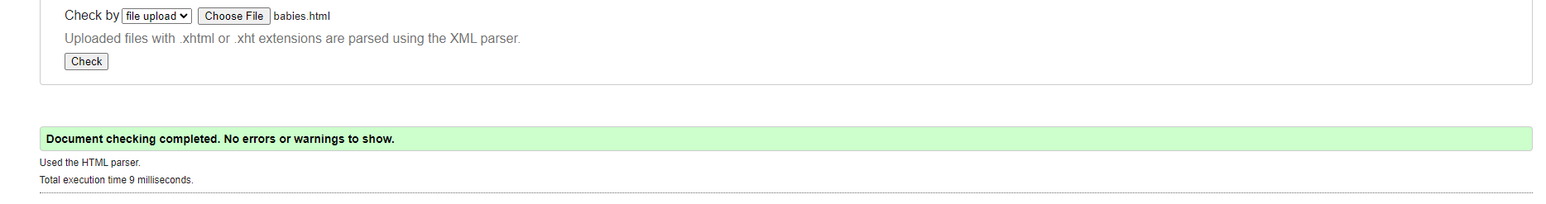

*Book-a-session Webpage*

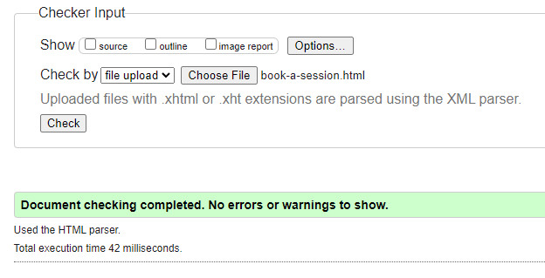

*Booking-checkout Webpage*

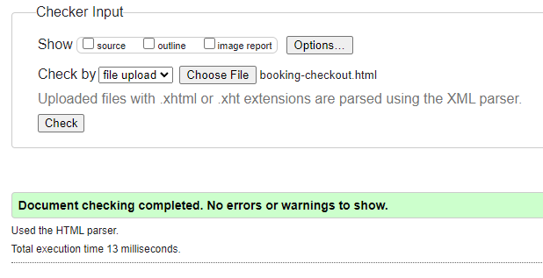

*Family Webpage*

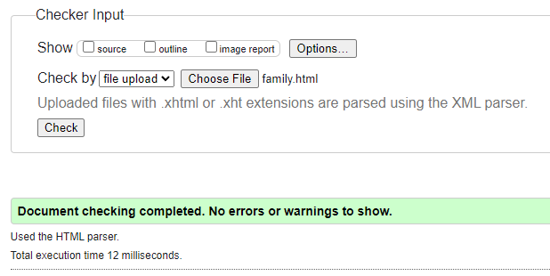

*Form Webpage*

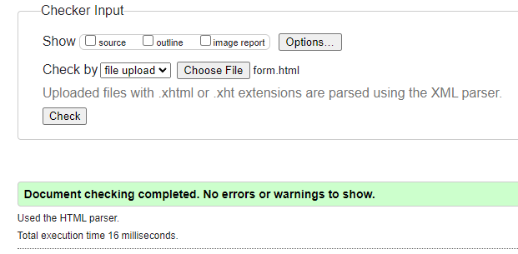

*Gallery Webpage*

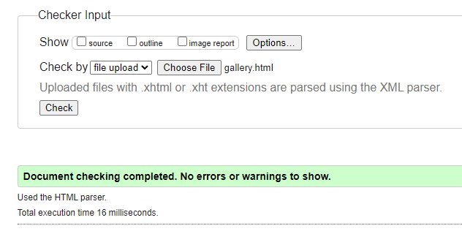

*Index Webpage*

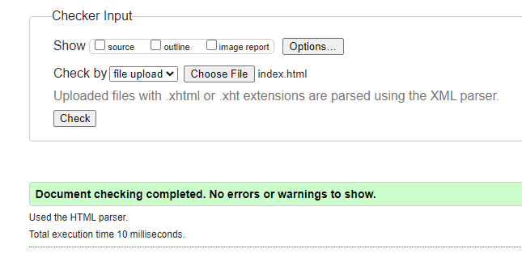

*Not Found Webpage*

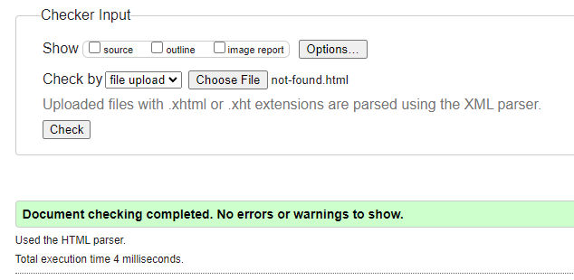

*Service Page Webpage*

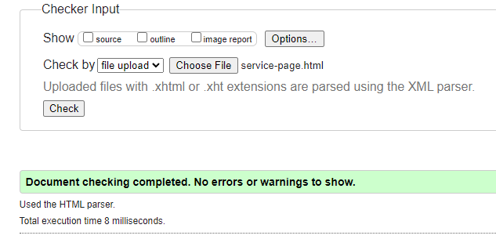

*Success Webpage*

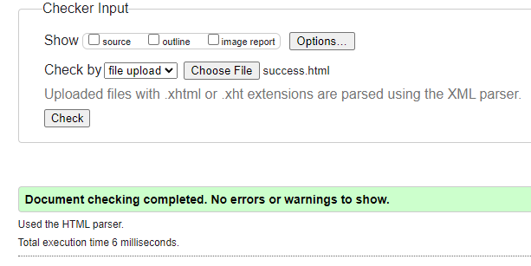

*Weddings Webpage*

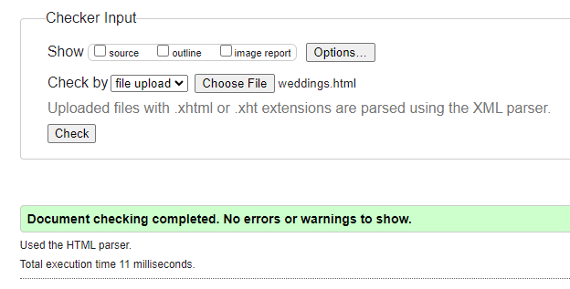

**Why is SEO important?**

SEO is important because it helps build your brand online. SEO optimizes your visibility online. This means that the more people see your website, the more your traffic increases, and the better your chances to provide your product or service to a greater number of people.

**What steps have you taken/will you take to improve your website’s SEO?**

To improve my SEO I would consider creating a list of keywords, building links to my pages, which I already have implemented and focus on content design.

Link to my website hosted online for free: [Riverside Studios: Home (000webhostapp.com)](https://riverside-studio.000webhostapp.com/index.html)