**Security Assessment Report: Mobile Application**

**Assessed By:** Salau Dominion  
**Application Name:** MIGOS

## ****1. Introduction****

This report documents the findings of a security assessment conducted on a mobile application. The assessment focused on identifying vulnerabilities related to insecure data storage, insecure communication, and insecure authentication mechanisms. The analysis was performed using static analysis techniques.

## ****2. Security Findings****

### ****2.1 Permissions and Certificate Handling****

The application requests several permissions that may introduce security risks.

Potential issues identified with certificate handling and SSL/TLS implementation.

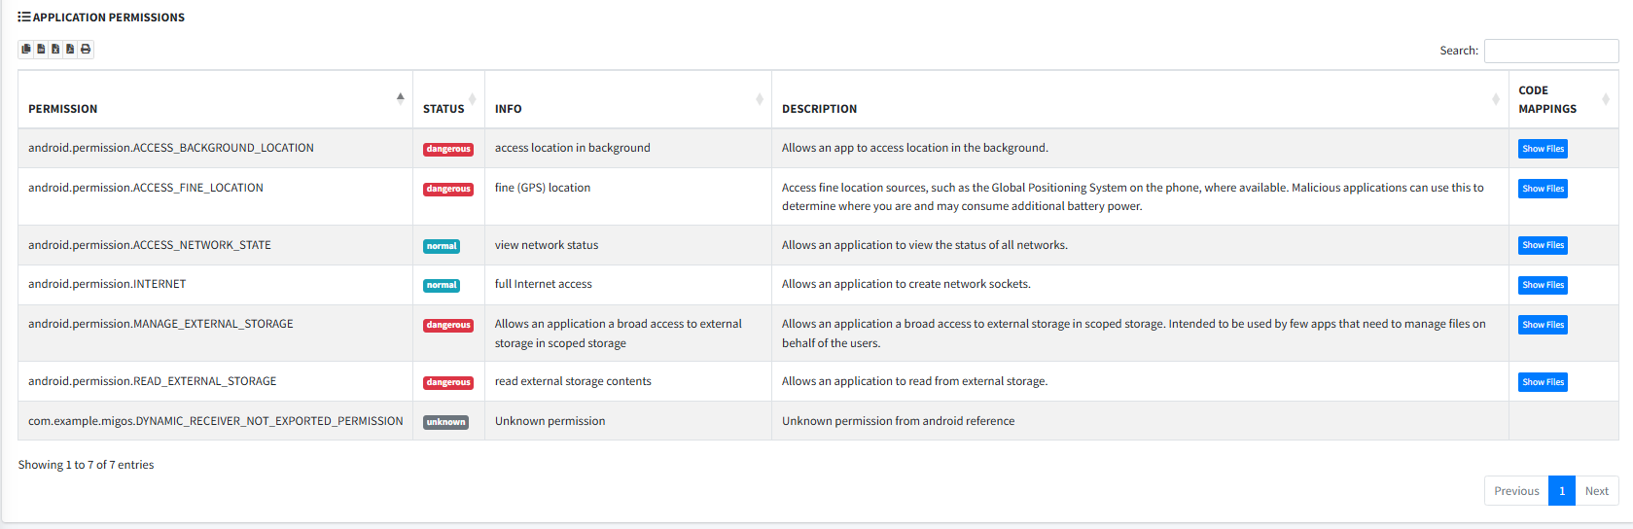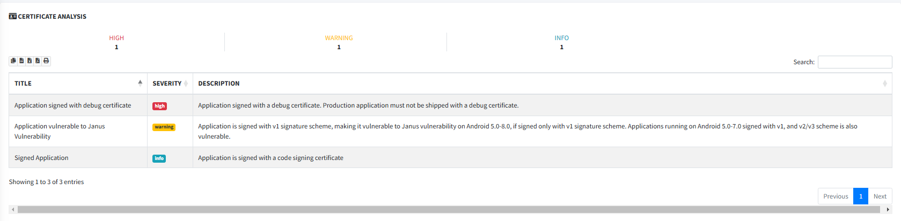

### ****2.2 Web Browsable Activities****

The application contains exported activities with deep linking capabilities.

Identified intent filters allow external applications to interact with sensitive authentication endpoints.

Example: com.google.firebase.auth.internal.GenericIdpActivity uses the scheme genericidp://.

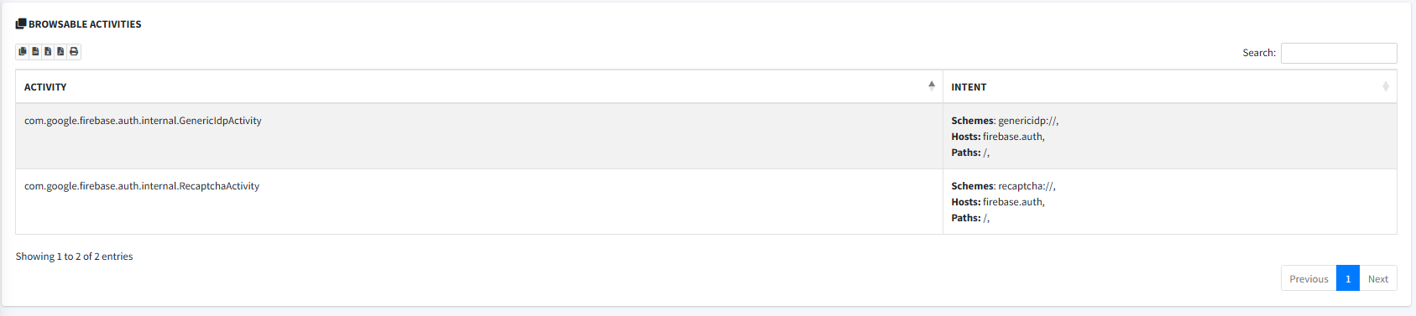

### ****2.3 Security Analysis: Cryptography****

Weak cryptographic implementations detected.

Possible use of hardcoded cryptographic keys.



### ****2.4 Malware Analysis****

The application was scanned for potential malware signatures.

No immediate threats detected.

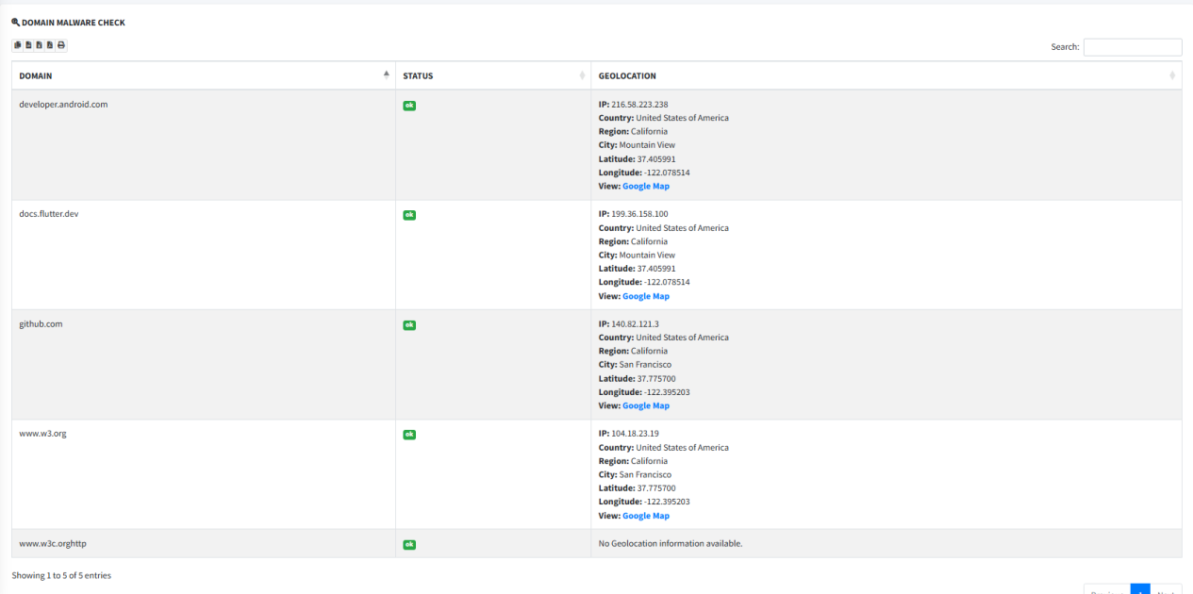

### ****2.5 Inter-Process Communication (IPC) Risks****

Some exported services may be vulnerable to unauthorized access.

Insecure broadcast receivers detected, allowing potential data leakage.

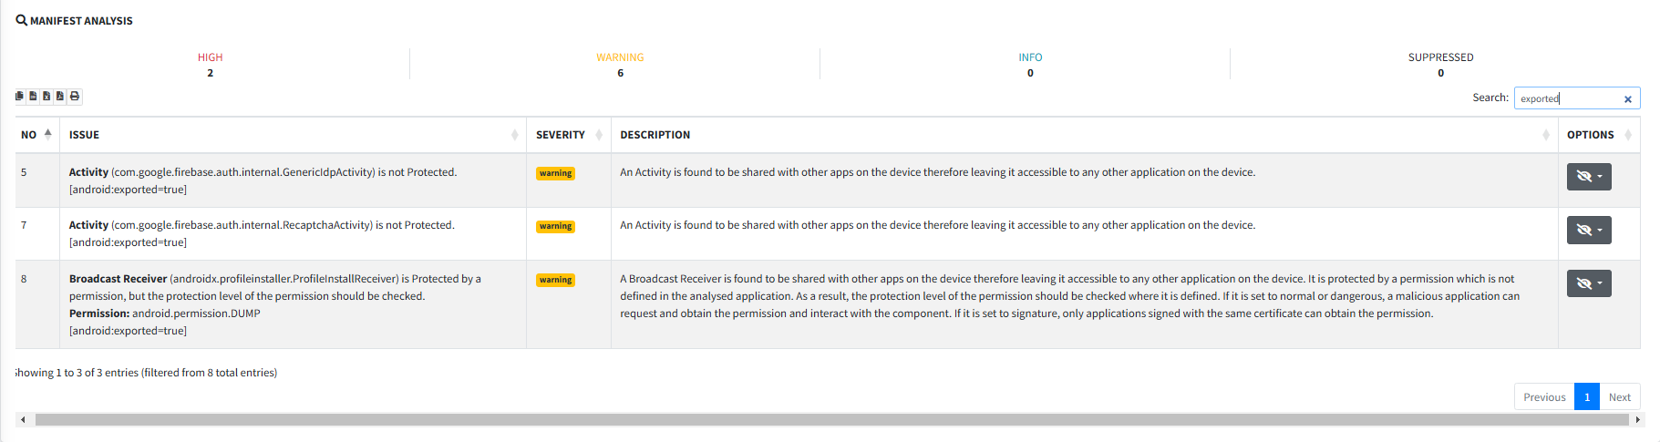

## ****3. Recommendations****

**Review and Restrict Permissions**: Remove unnecessary permissions and ensure only essential permissions are requested.

**Improve Certificate Handling**: Enforce proper SSL/TLS pinning and certificate validation.

**Secure Web Activities**: Ensure deep links are protected with proper authentication and authorization controls.

**Enhance Cryptography Practices**: Avoid hardcoded keys and use industry-standard encryption libraries.

**Mitigate IPC Risks**: Restrict exported services and use secure communication mechanisms between app components.

**Prevent Dynamic Code Execution**: Minimize the use of Java reflection and ensure all dynamically loaded code is trusted.

## ****4. Conclusion****

This assessment has identified several security risks in the mobile application. The issues related to insecure authentication mechanisms, IPC risks, and dynamic code execution should be addressed to improve the overall security posture of the application. Further dynamic analysis is recommended to validate runtime behaviors and potential exploits.

**Next Steps:**

Address the security recommendations.

Conduct a dynamic security assessment.

Perform penetration testing to validate fixes.