Operational Transconductance Amplifier

EDC2 project

Catana Dominic Costin

1231EB

Content

1. Problem………………………… 2

2. DC Circuit……………………… 3

3. LTSpice simulation…………….. 4

4. Finding the best Vg…………….. 6

1. Problem

A two-stage Operational Transconductance Amplifer (OTA) with a differential input and a single-ended output, implemented using bipolar transistors, is shown below.

1. Calculate the theoretical expressions of the DC collector currents of bipolar transistors Q1 - Q8, considering VBE ~= 0.6V. Calculate the theoretical expression of the small-signal voltage gain AV = VO/Vg.

2. Implement the schematic in a circuit simulation software (LTSpice). Design the circuit (i.e. select transistor types for Q1 - Q8, choose a value for R2 and Cinf in order to have a (theoretical) gain value AV = 1250.

3. Simulate the circuit (transient, AC sweep), choosing an appropriate amplitude for Vg in order to minimize output signal distortion.

4. Compare the theoretical AVv value from point b) with the value obtained from the simulation. Name a possible cause for differences between the two values.

5. Specify a method for decreasing the voltage gain (without changing R1, R2, VCC or VCM). Implement the change and re-simulate the circuit in order to demonstrate the effect.



2. DC Circuit

We have the represented scheme in the problem with the intensities I1 and I2 taking in consideration that I2 passes through R2 and I1 through Q1­­. Q6, Q7 and Q8 being current mirrors with Q3 and Q4, the current is passing and is exiting with the same intensity(I2).

Q6 – input terminal for the transistors on the buttom. (Q6, Q7 and Q8)

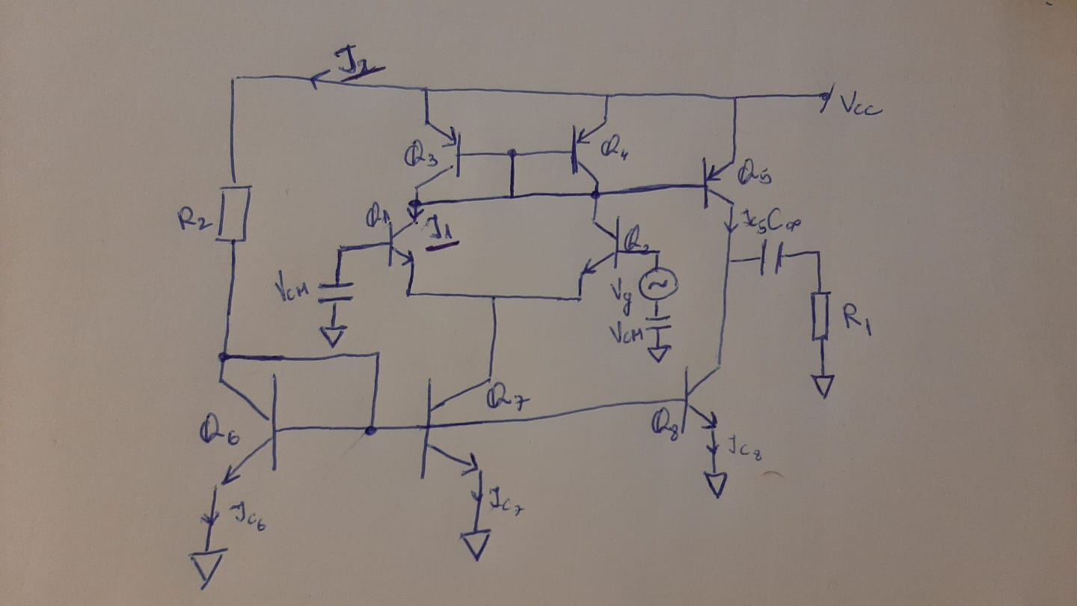

This means that the currents I1 and I2 are equal with the same values with the intensities that correspond with the transistors:

I1 = IC1 + IC2 + IC3 + IC4

I2 = IC5 + IC6 + IC7 + IC8

VBE = VCE = 0.6V

Writing for the branch from VCC from Q6 we have then:

VCC = R2I2 + VCE => I2 = (VCC – VCE)/R2

Writing for the branch from VCC from Q7 we have then:

I1 = (VCC – VCE)/2\*R2

3. LTSpice simulation

We used at the implementation of the circuit:

NPN transistors: BC847B at Q1, Q2, Q6, Q7, Q8

PNP transistors: BC857B at Q3, Q4, Q5

Cinf = 1F

VCM = 1.5V

VCC = 10V

R1 = 313k

R2 = 10k

The scheme of the circuit in LTSpice:

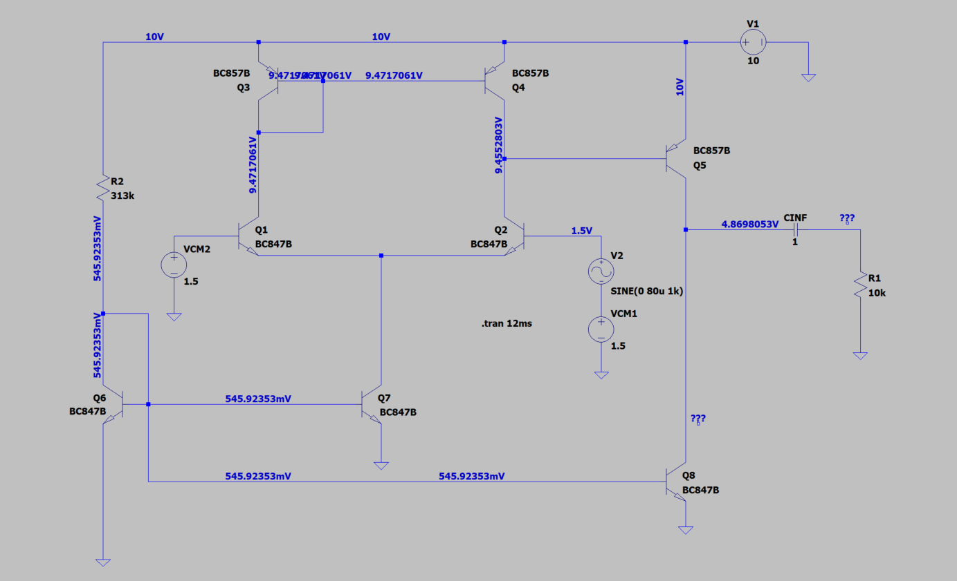

Intensities at Q1:

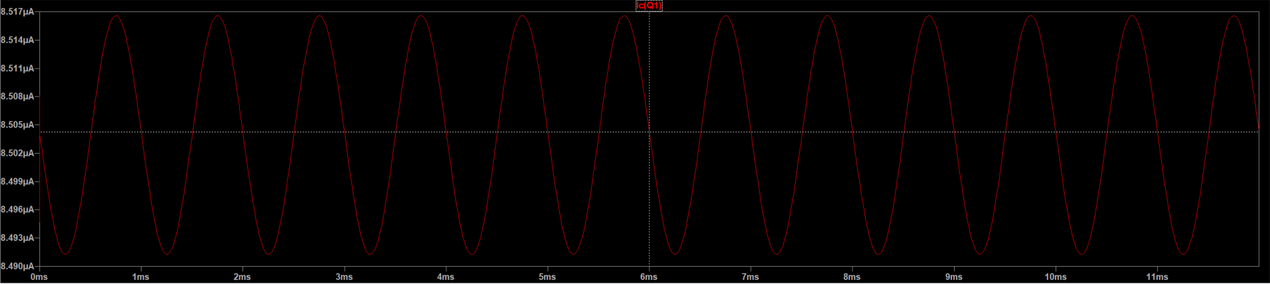

At Q1 and Q6:

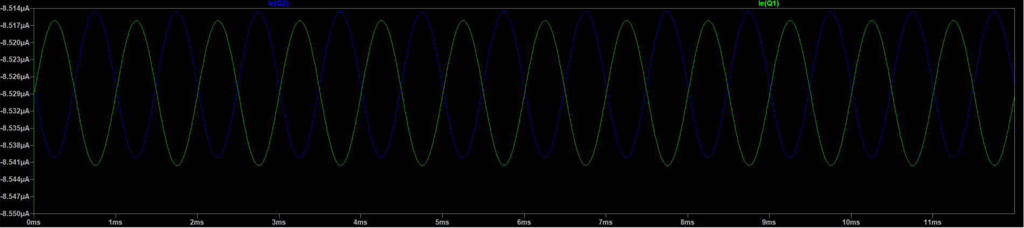

At R1:

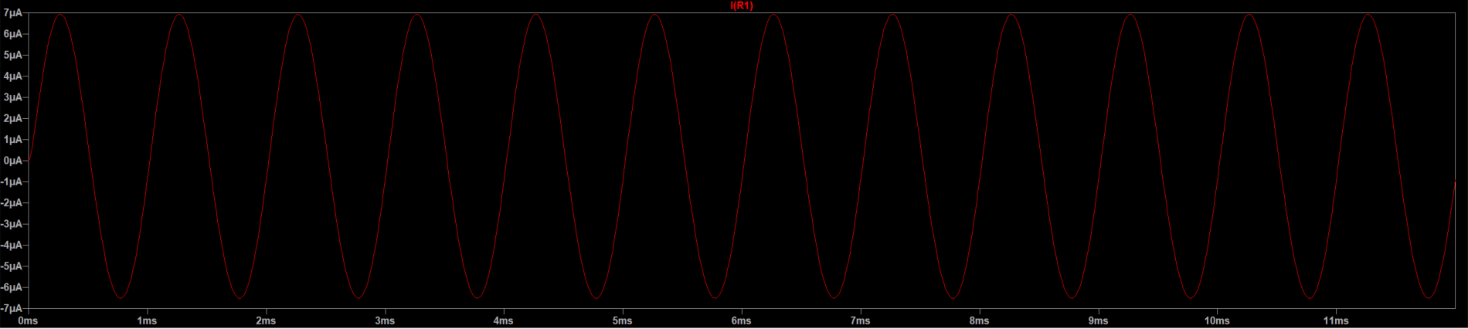

At R2:

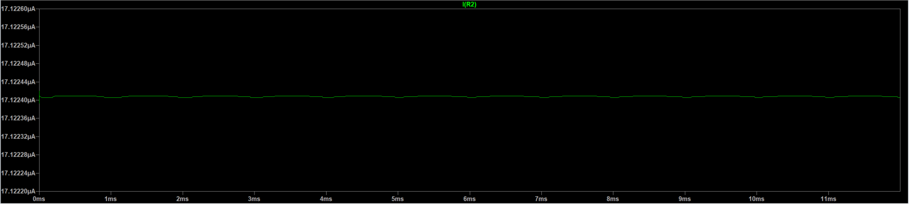

At Q7:

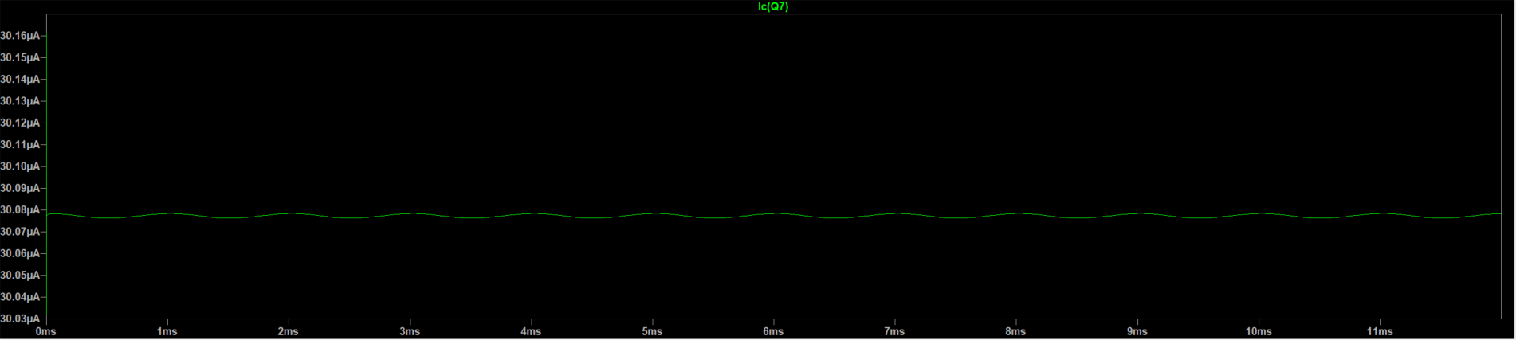

4. Finding the best Vg

On transient simulation:

