Overview

Studied device
Here is the studied device : a thick earthen wall, crossed by hoses where water circulates in a closed loop, in order to increase heat transfers related to temperature differences.
What is hoped for: increase the heat flow with the room in response to a temperature change.

Horizontal section of the wall :

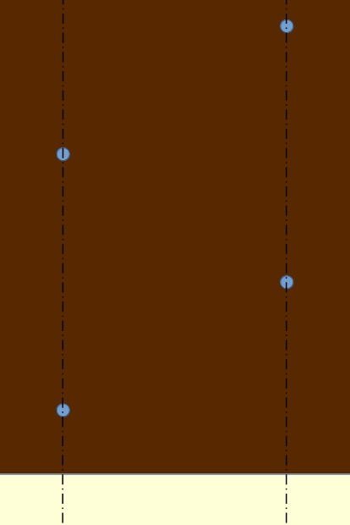

In brown : earth, in blue : water, in pale yellow : room.
There is two axial symmetry lines : what is simulated is between these 2 lines.

What the program does
The area between the two axial symmetry lines is divided into small-sized cells forming a 2D map.

A sinusoidal signal of 1 degree is applied to the cells of the room.
At each simulation time step (= internal unit of time), the temperature of each cell is calculated by an iterative algorithm.

In order to reduce the side effects of starting - switching from zero to alternating signal -, there are several running-in cycles. The information to be considered comes from the steady state (after running-in) cycle.
If there is no hose, the problem comes down to a 1D simulation, using a 1D map, which is much faster.

The flow and the temperature of a few points are recorded, in amplitude and phase shift, and edited in the result file.

Parameters
These parameters are passed as options.
See examples files.

Case without simulation
-h help

Case with or without hose
-v verbose
--lengthU=real_num length internal unit = cell size
--timeU=real_num time internal unit = simulation time step,
one second or a multiple
--width=real_num width of the area, multiple of lengthU, > 0,
significant if hoseNb >0
--deep=real_num deep of the area, multiple of lengthU, > 0
--period=real_num period of heat wave, multiple of timeU, > 0
--earthLambda=real_num earth lambda, > 0
--earthVHeatCap=real_num earth volumetric heat capacity, > 0
--waterVHeatCap=real_num water volumetric heat capacity, > 0,
significant if hoseNb >0
--hoseNb=integer number of hoses

Hose_options, significant if hoseNb >0
--hoseRadius=real_num radius of hose, multiple of lengthU, > 0
--hose1Deep=real_num deep of the first hose, multiple of lengthU,
> hoseRadius
--hoseInterval=real_num deep interval between hoses, multiple of lengthU,
> 2*hoseRadius, significant if hoseNb >1

hose1Deep + hoseInterval*(hoseNb-1) + hoseRadius
< deep

Internal unit discussion

Increase of length internal unit
A doubling (2 mm instead of 1 mm) allows to gain a factor of 8 of exec time: This divides by 4 the cells number, and decreases the diffusivity (in internal unit), and then the iterations number.
But there is a deterioration of precision in the order of half a per thousand.
The shape of the hoses becomes caricatural!

Increase of time internal unit
This increases proportionally the diffusivity (in internal unit), then non-linearly the number of iterations.
Except for little diffusivity, this increases weakly exec speed, because the increase in the number of convergence iterations compensates for the decrease in the number of steps in a cycle (this number = period / time internal unit).
For little diffusivity, the increase in the number of iterations is moderate, which allows more speed gain.
There is a deterioration of precision, in the order of 2 for 10⁵ (timeU=2) to 2 for 10⁴ (timeU=10).

To go faster, summary
Simulations over long periods of time will require a fast solution.
I propose lengthU=0.002, timeU=10, which allows a gain of about 20 on the solution lengthU=0.001, timeU=1.
But one must be aware of the slightest precision.

