

Marymobile
11.11.2023
─
Abdullah AlSubaie
Dominique J Mben
Babalola
IT-210-A
Term project report

Overview 2
Introduction 2
Problem Statement 2
System Requirements 2
- Functional Requirements 2
- Non-Functional Requirements 3
Use Case Diagram and Description 3
Class Diagram and Description 4
Sequence Diagram and Description 4
Flow of events 4
Description: 6
Activity Diagram and Description 7
Description: 9
Conclusion 9

Overview
Marymobile is a mobile application to help students register to classes using their mobile phones without having to access Marynet. Marymobile will be connected to Marynet through the same server as they both will be doing the same thing, the only difference is that Marymobile is going to be the mobile version of Marynet to help ease the process of registering students.

Introduction
The purpose of this document is to present a detailed summary description of the Improved Marynet Class Registration System. It will explain the purpose and features of the system, the interfaces of the system, what the system will do, the constraints under which it must operate and how the system will react to external stimuli.

Problem Statement
The current issue with Marynet is that it requires access through a laptop or a desktop computer. This limitation can be inconvenient for students who rely on mobile devices for internet access. Additionally, the system can sometimes be slow and difficult to access, particularly during peak usage times such as the start of class registration periods. This can lead to frustration and delays for students trying to register for their classes.

System Requirements

Functional Requirements
1. The system should be accessible and fully functional on both desktop and mobile devices.
2. The system should provide real-time updates on seat availability.
3. The system should allow students to register for classes.
4. The system should allow students to drop classes.

Non-Functional Requirements
1. The system should be user-friendly with an intuitive UI/UX design.
2. The system should be able to handle high traffic during peak registration times.
3. The system should maintain fast response times even during peak usage periods.

Use Case Diagram and Description
In this use case diagram, the student is the primary actor, the server is the secondary actor. The use cases are: viewing classes, registering for a class, and dropping a class.
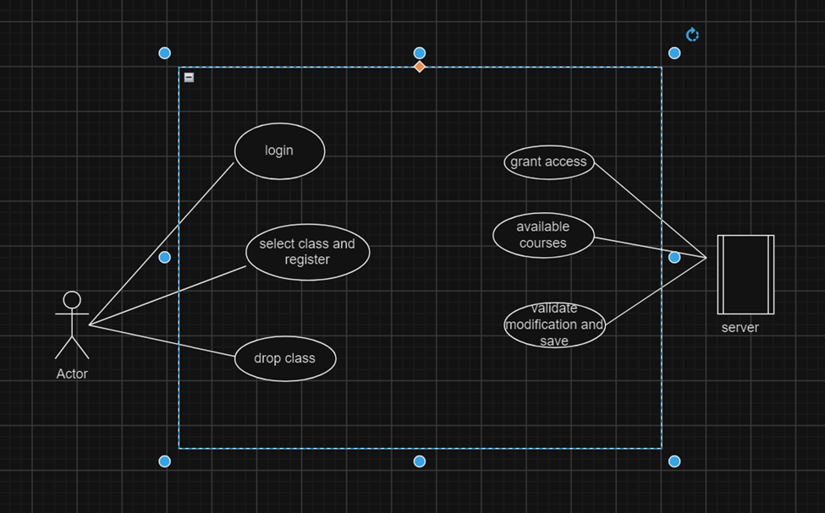

Class Diagram and Description
In this diagram we showcase the blueprint process for the structure of our system, and it consists of: Class name, Attribute Name, Data Type.

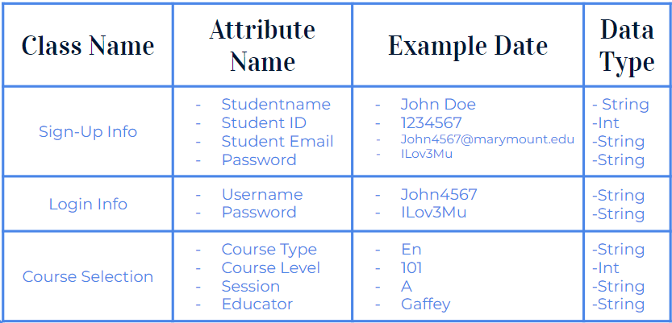

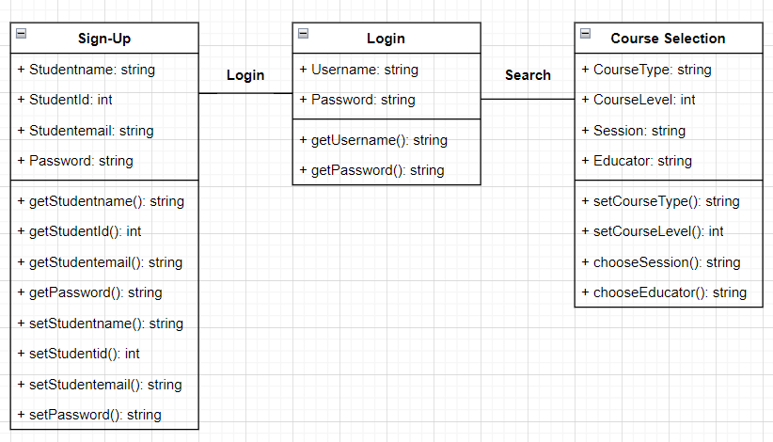

Sequence Diagram and Description

Flow of events
Student:
- Login to their account
- The application authentication begins
- The server confirms
- The student searches for classes
- The student picks the class
- The application checks if the class is available
- The server confirms and the student can continue
- The student finishes the registration process
- The server shows a message registration done!
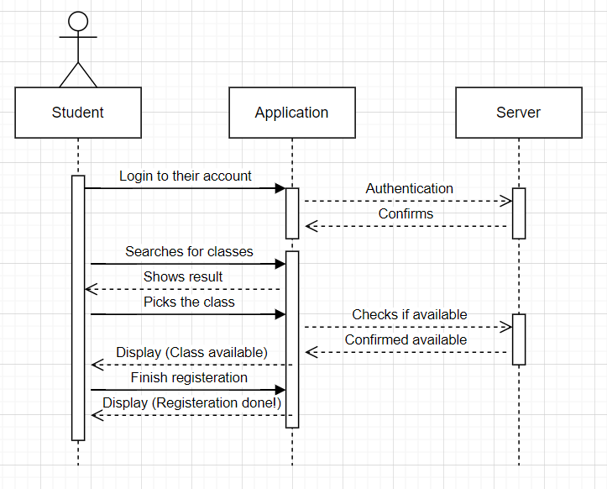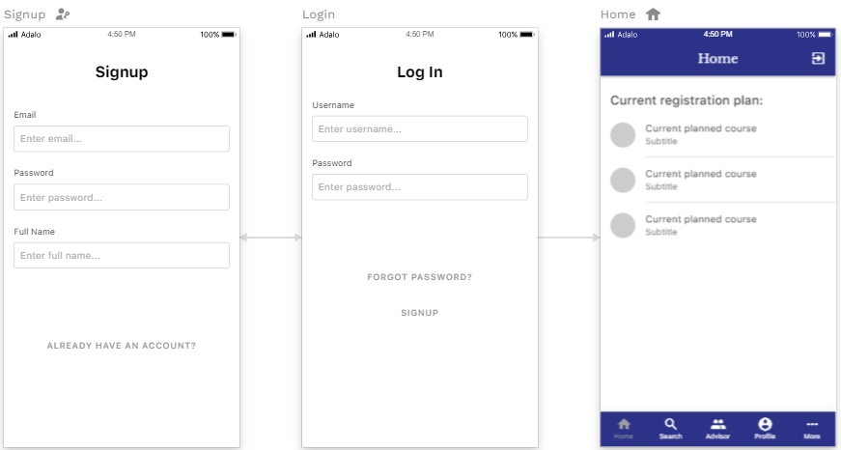

Description:
When the student launches the application, they are presented with the login screen. This is where the student logs in using their university username, and if the student doesn’t have a username they can use the signup tap and after providing the information they will be sent an username via university email. The next page after login is the home page where the student can view the planned courses provided by the advisor. The design is simple, clean, and we also use the university colors which are blue and white.

Activity Diagram and Description
This activity diagram represents the flow of the class registration process.

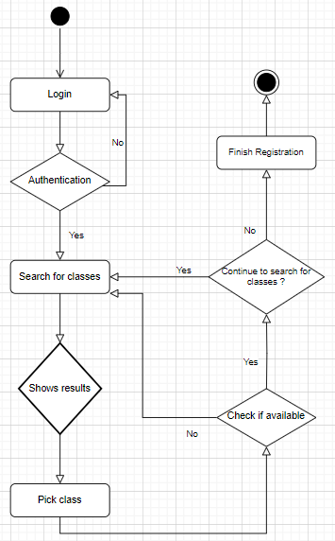
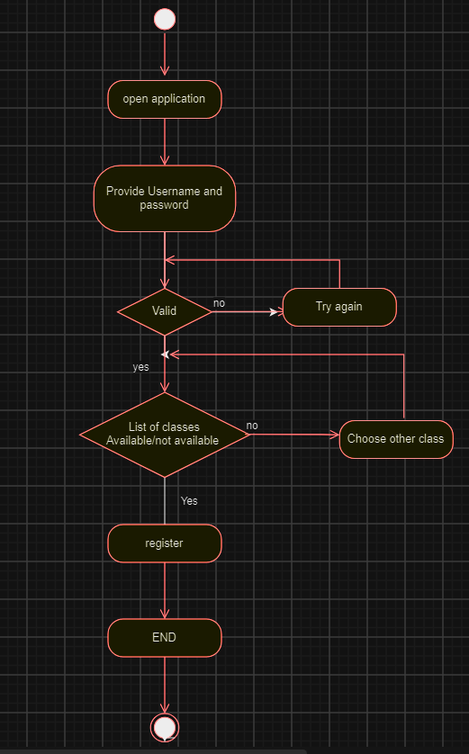

Description:
The student initiates the process by logging in. The system then begins the authentication process. If the student’s credentials are valid, they can proceed to the registration process. If not, they are prompted to re-enter a valid username and password until successful authentication is achieved.
Upon entering the registration process, the student searches for classes. The system responds by displaying the search results. The student then selects their desired class. The system verifies the availability of the selected class. If the class is unavailable, the student is prompted to search for other classes.
If the class is available, it is registered for the student. The system then inquires if the student wishes to add more classes. If the student opts to add more, they are redirected to the class search menu. If they choose not to add more classes, they are prompted to finalize their registration.

Conclusion
This project report system aims to summarize the improvement made to the class registration experience for students at MU by providing real-time updates on seat availability, handling high traffic during peak registration times, and offering full functionality on both desktop, and mainly mobile devices.

