**Tophic interaction models predict interactions across space, not food webs.**

Dominique Caron1,2, Ulrich Brose3,4, Miguel Lurgi5,6, Guillaume Blanchet2,7, Dominique Gravel2,7, Laura J. Pollock1,2

**Affiliations**

1 Department of Biology, McGill University, Montreal, QC, Canada

2 Quebec Centre for Biodiversity Sciences, Montreal, QC, Canada

3 German Centre for Integrative Biodiversity Research (iDiv) Halle-Jena-Leipzig, Leipzig, Germany

4 Institute of Biodiversity, Friedrich Schiller University Jena, Jena, Germany

5 Department of Biosciences, Swansea University, Singleton Park, UK

6 Centre for Biodiversity Theory and Modelling, Theoretical and Experimental Ecology Station, CNRS-Paul Sabatier University, Moulis, 09200 France

7 Département de Biologie, Université de Sherbrooke, Sherbrooke, QC, Canada

**Corresponding author:** Dominique Caron, [dominique.caron@mail.mcgill.ca](mailto:dominique.caron@mail.mcgill.ca)

**Key Words:** ecological predictions; food web; model transferability; terrestrial vertebrates; trait matching; trophic interactions

**Abstract**

Trophic interactions between species are central to our understanding of biodiversity functions such as stability, nutrient cycling, and productivity. Yet, we lack data on predator-prey relationships for most taxa and systems. A promising avenue for tackling this knowledge gap is through predictions of trophic interactions. These predictions can fill gaps in existing food webs (i.e. within food web predictions) or transfer knowledge between areas (i.e. across food web predictions). Here, we used four trait-based models of trophic interactions, each calibrated on a different food web of terrestrial vertebrates from contrasting environments to ask what limit across food web predictions and how well they predict higher-level properties of food webs (species position and entire food web properties). We found that given enough phylogenetic and environmental similarities between food webs, trait-based models predict most interactions and non-interactions correctly in new environments. However, when we collated predicted trophic interactions to recover food webs, species trophic position and food web properties were not well predicted. Predicted food webs tended to be more connected, less modular, and with higher mean trophic levels. Our results show that trait-based models can predict pools of potential interactions in environments we know nothing. We also highlight the need for methodological advances to simultaneously study trophic interactions and the structure of food webs across time and space.

**Introduction**

Many ecosystem functions (e.g., energy flows, material cycling, and stability) depend on the trophic relationships that link species of a community (Harvey et al. 2017; Thompson et al. 2012). These trophic relationships form the food web. Despite recognizing the central role of food webs in ecosystems for over 80 years (Lindeman 1942), we still lack food web data for most places and taxa (Cameron et al. 2019; Hortal et al. 2015; Poisot et al. 2021). The reason for this knowledge gap is two-fold. First, the number of possible interactions grows quadratically with the number of species. Second, observing (and even more quantifying) interactions between two individuals is inherently hard as we need to detect simultaneously two species and the interactions (Jordano 2016). Having more widespread food web data and at larger scales would open research opportunities by integrating the Grinnellian and Eltonian niche into biogeography (Braga et al. 2019; Gravel et al. 2019), incorporating trophic interactions into meta-community ecology (Guzman et al. 2019), and describing the functional role of species in biodiversity-ecosystem functioning (Dehling and Stouffer 2018; Gonzalez et al. 2020).

A promising first step towards filling this knowledge gap about food webs is by predicting potential trophic interactions. This should be possible since predator and prey tend to respond to a predictable set of geographic, phylogenetic and functional relationships (Morales-Castilla et al. 2015). The neutral model predicts that the probability and strength of interactions respond only to the co-occurrences and abundances of species (Canard et al. 2012). Although co-occurrence patterns and species interactions influence each other, they are not evidence of one another (Blanchet, Cazelles, and Gravel 2020). Niche theory predicts that the match between the functional traits of predators and their prey should improve these predictions by identifying which interactions are feasible (Williams and Martinez 2000). These trait-based models have been used to predict food webs in freshwater streams (Pomeranz et al. 2019), of marine fishes (Albouy et al. 2014), terrestrial invertebrates (Laigle et al. 2018), and vertebrates (Caron et al. 2022; Fricke et al. 2022), among others. Phylogenetic relationships are also informative since interactions and species positions tend to be evolutionarily conserved (Gómez, Verdú, and Perfectti 2010; Stouffer et al. 2012). For example, Strydom et al. (2021)recently used the mammal phylogeny to map latent traits extracted from the European mammal food web to predict the Canadian mammal food web.

However, some questions remain about the potential of trophic interaction models to predict food webs. The first question is how well can predictive models transfer knowledge across different regions. Strydom et al. (2021) successfully recovered over 90% of known interactions among Canadian mammals without any information about the food web, but they had very little information on non-interactions. It is hard to evaluate how well their predictions can recover the entire food web (interactions and non-interactions) since they could only evaluate performance on known interactions. Also, despite the little overlap in species, they transferred knowledge between two systems with large shared evolutionary history (one order unique to each in Canada and Europe). Given that their method uses phylogeny as a medium to transfer knowledge, it is unclear how well their methods would perform for more contrasting systems. The second question is how well can models of trophic interactions predict the structure of food webs? By structure, we mean the properties of food webs (e.g., connectance, number of trophic levels) and the position of species (e.g., number of prey, centrality) in food webs. Most studies aimed to predict either the properties of food webs (e.g., Allesina et al., 2008; Allesina & Pascual, 2009; Cattin et al., 2004; Williams & Martinez, 2000) or interactions (e.g., Gravel et al., 2013; Laigle et al., 2018; Pomeranz et al., 2019), but rarely assessed if predicting interactions also recover the structure of food webs. Caron et al. (2022) found that connectance of terrestrial food webs tended to be systematically overpredicted across Europe by 2-4 times, but did not explore other food web properties or species positions. This is an important knowledge gap as many ecosystem functions and the functional role of species are controlled by the global shape of food webs and species positions within the food web (Cirtwill et al. 2018; Dunne, Williams, and Martinez 2002; Smith-Ramesh, Moore, and Schmitz 2016; Thompson et al. 2012).

Here, we trained a set of trait-based predictive models on four contrasting food webs of terrestrial vertebrates: the trophic food web of European tetrapods, the Nunavik food web, the Pyrenees vertebrate food web, and the Serengeti food web. The models are Bayesian generalized hierarchical models that we calibrated on each food web and validated on the other food webs. We used these models to determine how well trait-based models of trophic interactions can transfer across systems. More specifically, we ask: (1) What are the factors (i.e., geographic, environmental, functional, or phylogenetic distances) influencing the transferability of models? (2) How well the trophic role of species are predicted? and (3) How well food web properties are predicted?

**Methods**

*Food web data*

We extracted trophic interactions between terrestrial vertebrates (terrestrial mammals, birds, amphibians and reptiles) from four well-resolved food webs (Table 1):

1. *Europe food web*: The trophic food web of European tetrapods was assembled by Maiorano et al. (2020). The Europe food web contains the potential trophic interactions and non-interactions between all terrestrial vertebrates in Europe based on data from guide books, published papers, and expert opinions. The authors originally reported interactions between predators and prey at different life-stage (eggs, larvae/young, or adult). Here, we only extracted interactions between predators and adult prey.
2. *Pyrenees food web*: The Pyrenees vertebrate food web was assembled indenpendently from the Europe food web by Lurgi et al. (2012). The authors compiled all known interactions between vertebrate species in the southeastern Pyrenees mountain range. To keep the same taxonomic coverage between food webs, we excluded fish species.
3. *Nunavik food web*: The trophic tundra food web of Labrador and northern Quebec (Canada) was compiled by Berteaux et al. (2018). The Nunavik food web is a binary matrix documenting the trophic relationships between all birds, mammals, and some groups of plants and arthropods whose distribution overlaps Labrador and Quebec north of the 50°N. The documented area is dominated by the Canadian tundra ecosystem. Trophic interactions were collated from a literature review, combined with data from existing databases, and expert opinions. We excluded all non-vertebrate species.
4. *Serengeti food web*: The Serengeti food web compiles all interactions between the different trophic groups in the Serengeti National Park (Tanzania) and was assembled from a literature review (Baskerville et al. 2011; de Visser, Freymann, and Olff 2011). We assumed that species within a trophic group share the same predator and prey. We excluded all non-terrestrial vertebrate species.

Table 1: Summary *of the food webs after excluding species for which no match were found in the GBIF Backbone Taxonomy or not documented in the trait database. Trait coverage is the percentage of traits documented in Etard et al. (2020) before imputing missing traits.*

**

*Trait data*

We used the database of ecological traits for terrestrial vertebrates compiled by Etard et al. (2020). Etard et al. (2020) combined the information on species-level body size, longevity, clutch size, trophic level, activity time and habitat use from large freely available secondary trait databases. The database includes traits for 6 990 amphibians, 11 634 birds, 5 380 mammals, and 10 612 reptiles.

To match species in the trait databases to the species in the food webs, we standardized their names following the taxonomic backbone of GBIF. To do so, we used the function *name_backbone* from the package *rgbif (Chamberlain et al. 2022; Chamberlain and Boettiger 2017)* in R. In each food web, we excluded all species for which no match was found in the taxonomic backbone of GBIF or the trait database. We imputed missing traits using the missForest algorithm (Stekhoven and Buehlmann 2012) for amphibians, birds, mammals and reptiles separately.

*Predictive models*

We calibrated a Bayesian hierarchical linear model (GLMM) on each of the four food webs. The response data are trophic interactions that we modelled as Bernouilli distributed. For each model, we used 70% of all interactions, and an equal number of non-interactions for calibration. We used the remaining of the data for validation. Because we previously found that trait-interaction relationships vary between predator groups (Caron et al. 2022), we used the order of the predator as random effect on the intercept and slopes in each model.

The models used 13 trait-based predictors: the trophic level, body mass, habitat breadth, longevity, and clutch size of the predator and the prey, and the match between their activity time, habitat use and body mass. Activity time match is a binary variable where one means the predator and the prey are active at the same time of the day. Habitat match is the Jaccard similarity index between the habitat used by the prey and the predator across the 13 habitat categories in the trait database. Body mass match is the squared difference between the log-transformed body mass of the prey and the predator. We log-transformed body mass, longevity and clutch size. We also scaled each continuous predictor by subtracting it by the mean and dividing by two times the standard deviation, so that the coefficients of the scaled continuous predictors are directly comparable to coefficients of unscaled binary predictors (Gelman 2008).

We used weakly informative priors for the intercept and the slopes of each model. The random effects (intercepts and slopes) were drawn from normal distributions. We used a normal distribution with a mean of 0 and a standard deviation of 1 as prior for the mean and a half Cauchy distribution with a scale parameter of 5 as prior for the standard deviation of the random effects. We describe the models in more detail in appendix XX.

We ran four chains, each with 1000 warm-up iterations, followed by 1000 iterations for inference. We diagnosed convergence and adequacy with trace plots, posterior predictive checks, and calculated the potential scale reduction factor for all runs (Gelman & Rubin, 1992; Appendix XX). We conducted the Bayesian analyses using Stan through the package *brms* in R (Bürkner 2017; Carpenter et al. 2017).

*Predicting species interactions*

To measure how well models transfer, we used each model to predict the other three food webs (Figure 1). For each possible predator-prey pair, we extracted the mean of 100 posterior draws to get the probability of interaction. We compared these probabilities of interactions to the empirical food web interactions to measure how well species interactions are predicted. We measured performance with the area under the receiver operating characteristic curve (AUC). AUC varies from 0.5 to 1 where 0.5 indicates that the model failed to rank interactions higher than non-interactions (i.e., random prediction), and 1 indicates that the model systematically ranked interactions higher than non-interactions (i.e., perfect prediction). We also measured the area under the precision-recall curve, and directly used the posterior draws to get distributions for the true positive rate, true negative rate, positive predictive value and negative predictive value (Appendix XX).

To explore factors influencing model transferability, we modelled the performance of models to predict each food webs with three distance measures: geographic distance, environmental dissimilarity, and phylogenetic relatedness. We measured geographic distance with the euclidean distance between the centroid of the polygon delimiting each food web. We measured environmental dissimilarity using all bioclimatic variables (Hijmans 2021). We randomly drew 500 points within each polygons and extracted bioclimatic data for these points. We then ran a principal component analysis on the extracted bioclimatic variables and calculated the euclidean distance between the centroid of the principal components (Appendix XX). We measured phylogenetic relatedness with the mean phylogenetic distance to the nearest taxon of every species in the predicted food web. In other words, we averaged over all species in the predicted food web the phylogenetic distance to the closest related species in the food web used for calibration. This measures the amount of evolutionary history in the predicted food web undocumented by the food web the model was calibrated on. We used the published phylogeny for birds (W. Jetz et al. 2012), amphibians (Walter Jetz and Pyron 2018), squamates (Tonini et al. 2016), turtles (Thomson, Spinks, and Shaffer 2021), and mammals (Upham, Esselstyn, and Jetz 2019). Following the recommendations by Letten & Cornwell (2015), we square root transformed phylogenetic distances to better represent functional dissimilarity.

We further explored the factors influencing model transfer by analyzing species-specific performance. For each combination of predicted food web-model (i.e., curves in Figure 1), we measured how well the prey and predators of each species were predicted using the AUC. We modelled the species-specific performance to how distinct the focal species is to the species pool used to calibrate the predictive model. We used the functional mean pairwise distance (Mouchet et al. 2010) and distance to nearest taxon (Tucker et al., 2017). Functional mean pairwise distance is the average Gower distance (Gower 1971) between the focal species and all species in the food web used for calibration. To calculate Gower distances, we used all traits available in Etard (2020) through the function *funct.dist* from the package mFD in R (Magneville et al. 2022). Distance to nearest taxon distance is the square root of the phylogenetic distance between the focal species and the closest relative in the species in the food web used for model calibration.

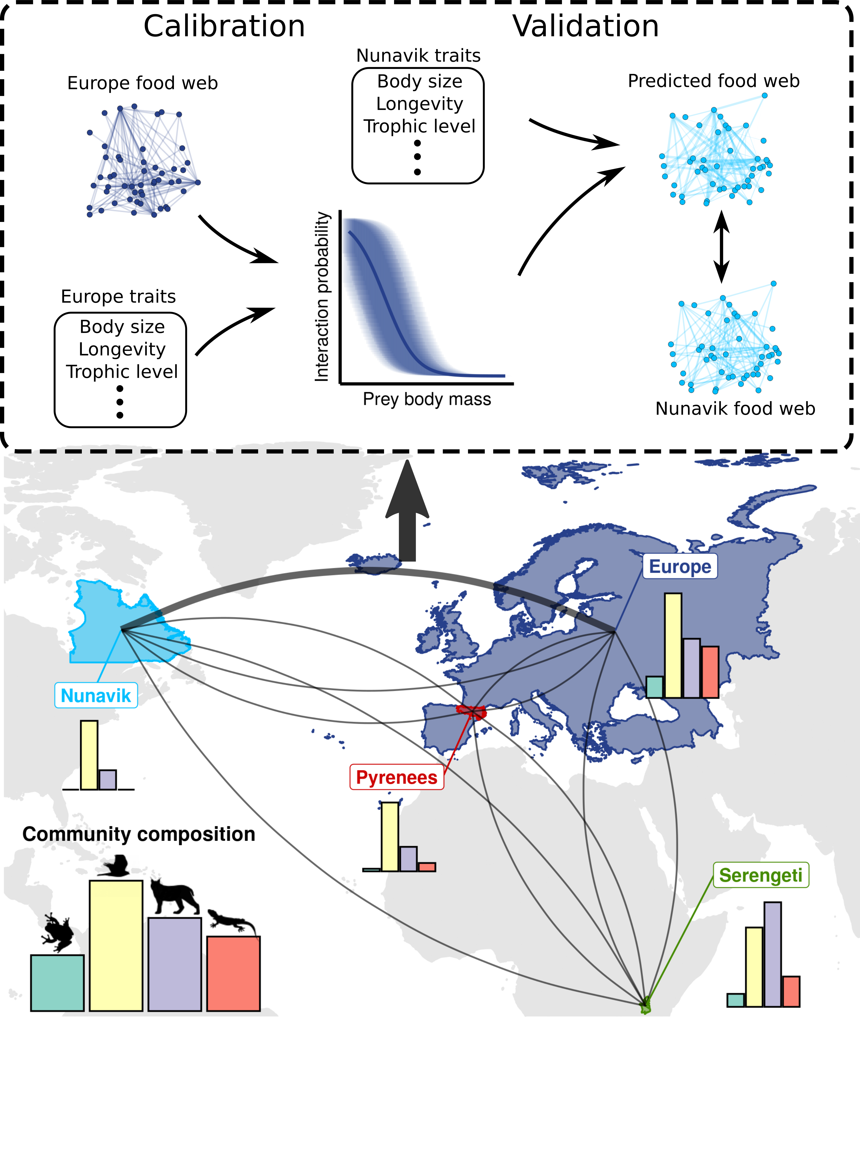  
Figure 1: **Trophic interactions model transferability analysis workflow.** We calibrated a trophic interaction model on a calibration subset of each food webs. We validated the four models on a validation subset for within food web predictions, and the entire food webs for across food web predictions (grey curves). The bar plots show the proportion of amphibians (green), birds (yellow), mammals (purple), and reptiles (red) in each food web. The upper panel shows an example workflow for the across food web predictions (model calibrated i n Europe predicting the Nunavik food web).

*Predicting species’ functional role*s

Next, we were interested in how well species trophic role was predicted. The trophic role of a species is determined by its position in the food web (Cirtwill et al. 2018). Here, we used 5 metrics related to how central the species is (number of prey, number of predators, betweenness, closeness, eigenvector centrality), 2 metrics related to trophic level (trophic levels and omnivory), 2 module-based metrics (within-module degree and participation coefficient; Guimerà & Amaral, 2005), and the motif profile of species (Stouffer et al. 2012)*.* We detail each metric, their relation to functional role, and how they were calculated in Appendix XX.

We measured how well each trophic position metric we compared the species roles in empirical food webs to the species roles in predicted food webs. For predicted food webs, we measured each role metric on 100 posterior predictions of the entire food web and took the mean to get the best point estimate for the metric. For each combination of model, food web predicted, and species role metric, we fitted a linear regression between the predicted position and the empirical position. We used the coefficient of determination (R²) to measure how well species roles were predicted, and the models’ coefficients to determine biases in the predictions.

*Predicting food web properties*

Finally, we investigated how well the global properties of food webs were predicted. Again, several metrics describe the structure of food webs. We chose food web properties that influence food web functioning and stability: connectance, mean trophic level, maximum trophic level, motif distribution, food web diameter, number of clusters, and modularity. As for species position, we evaluated these properties on the empirical food webs and compared them to the properties predicted using 100 posterior predictions. We detail each metric, their relation to food web function, and how they were calculated in Appendix X.

**Results**

*Predicting trophic interactions*

For all food webs, trophic interactions were better predicted by the model calibrated on the same food web (“within food web” predictions) than by model calibrated on other food webs (“across food web” predictions; Table 2). Similarly, all models performed better in predicting the food web they were calibrated on, than other food webs. For within food web predictions, AUC varied between 0.92 and 0.96. The model performance were also good (AUC > 0.82) for across food web predictions between the Europe, Pyrenees, and Nunavik food webs. Compared to other food webs, models did not transferred as well from and to the Serengeti food web. The area under the precision-recall curve, true positive rate, true negative rate, positive predictive value, and negative predictive value were all positively correlated with AUC and showed the same overall pattern (Appendix X).

Table 2: Area under the receiver operating curve (AUC) of each models predicting every food webs.



To explore the factors influencing the transferability of interaction models, we modelled their performance to the geographic, environmental, and phylogenetic distances between the food web the model was calibrated on and the food web predicted (Figure 2). Overall, performance tend to decrease with environmental (direct effect estimate: -0.54, 95%CrI = [-0.95, -0.13]) and phylogenetic distance (direct effect estimate: -0.44, 95%CrI = [-1.01, 0.06]). Performance also decreased with geographic distance (total effect estimate: -0.56, 95%CrI = [-0.80, -0.30]), but not after controlling for phylogenetic and environmental distances (direct effect estimate: -0.03, 95%CrI = [-0.47, 0.39]).

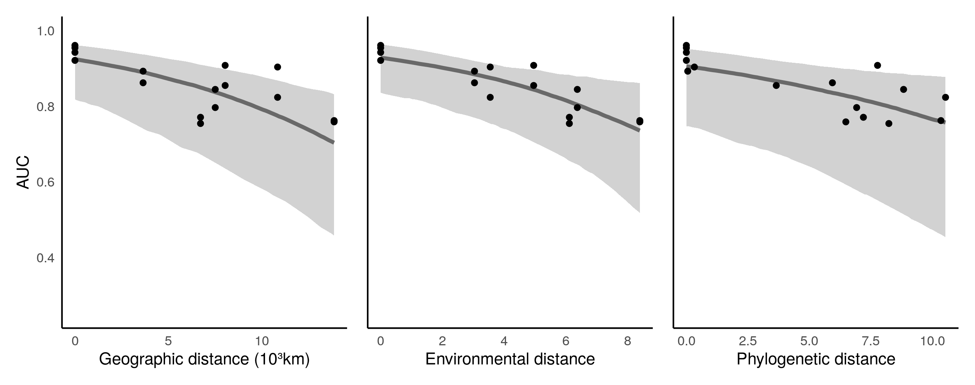Figure 2 : **Transferability of predictive models.** Points are the predictive performance (area under the receiver operating curve) of the sixteen combination of model-food web prediction (Table 2). The trend lines are the median effects with their 95% credible interval of geographic, environmental, and phylogenetic distances on predictive performance. We showed the total effect of geographic distance (not controlling for environmental and phylogenetic distances), and the direct (controlling for geographic distance) effects of environmental and phylogenetic distances.

We also tested the interactions of which species were less well predicted by across food web predictions. We modelled the species-specific performance to the phylogenetic and functional distance between the focal species and the species pool used to train the models (Figure 3). As expected, species with phylogenetically closed relatives in the species pool used for calibration were, on average, better predicted. Species-specific performance slightly decrease at low phylogenetic distances, and then drops significantly at large phylogenetic distances. We found that these large phylogenetic distances represent species for which its class (e.g., amphibians), was not present in the species pool on which the model was calibrated (Appendix X). This situation only occurs with the Nunavik model predicting the other three food webs as there are no amphibians or reptiles in Nunavik. Surprisingly, predictive performance remained qualitatively unchanged by functional distance. We also found that interactions of specialist (i.e., species with few prey and predators) and generalist species (i.e., species with many prey and predators) were, on average, better predicted than interactions of species of intermediate specialization.

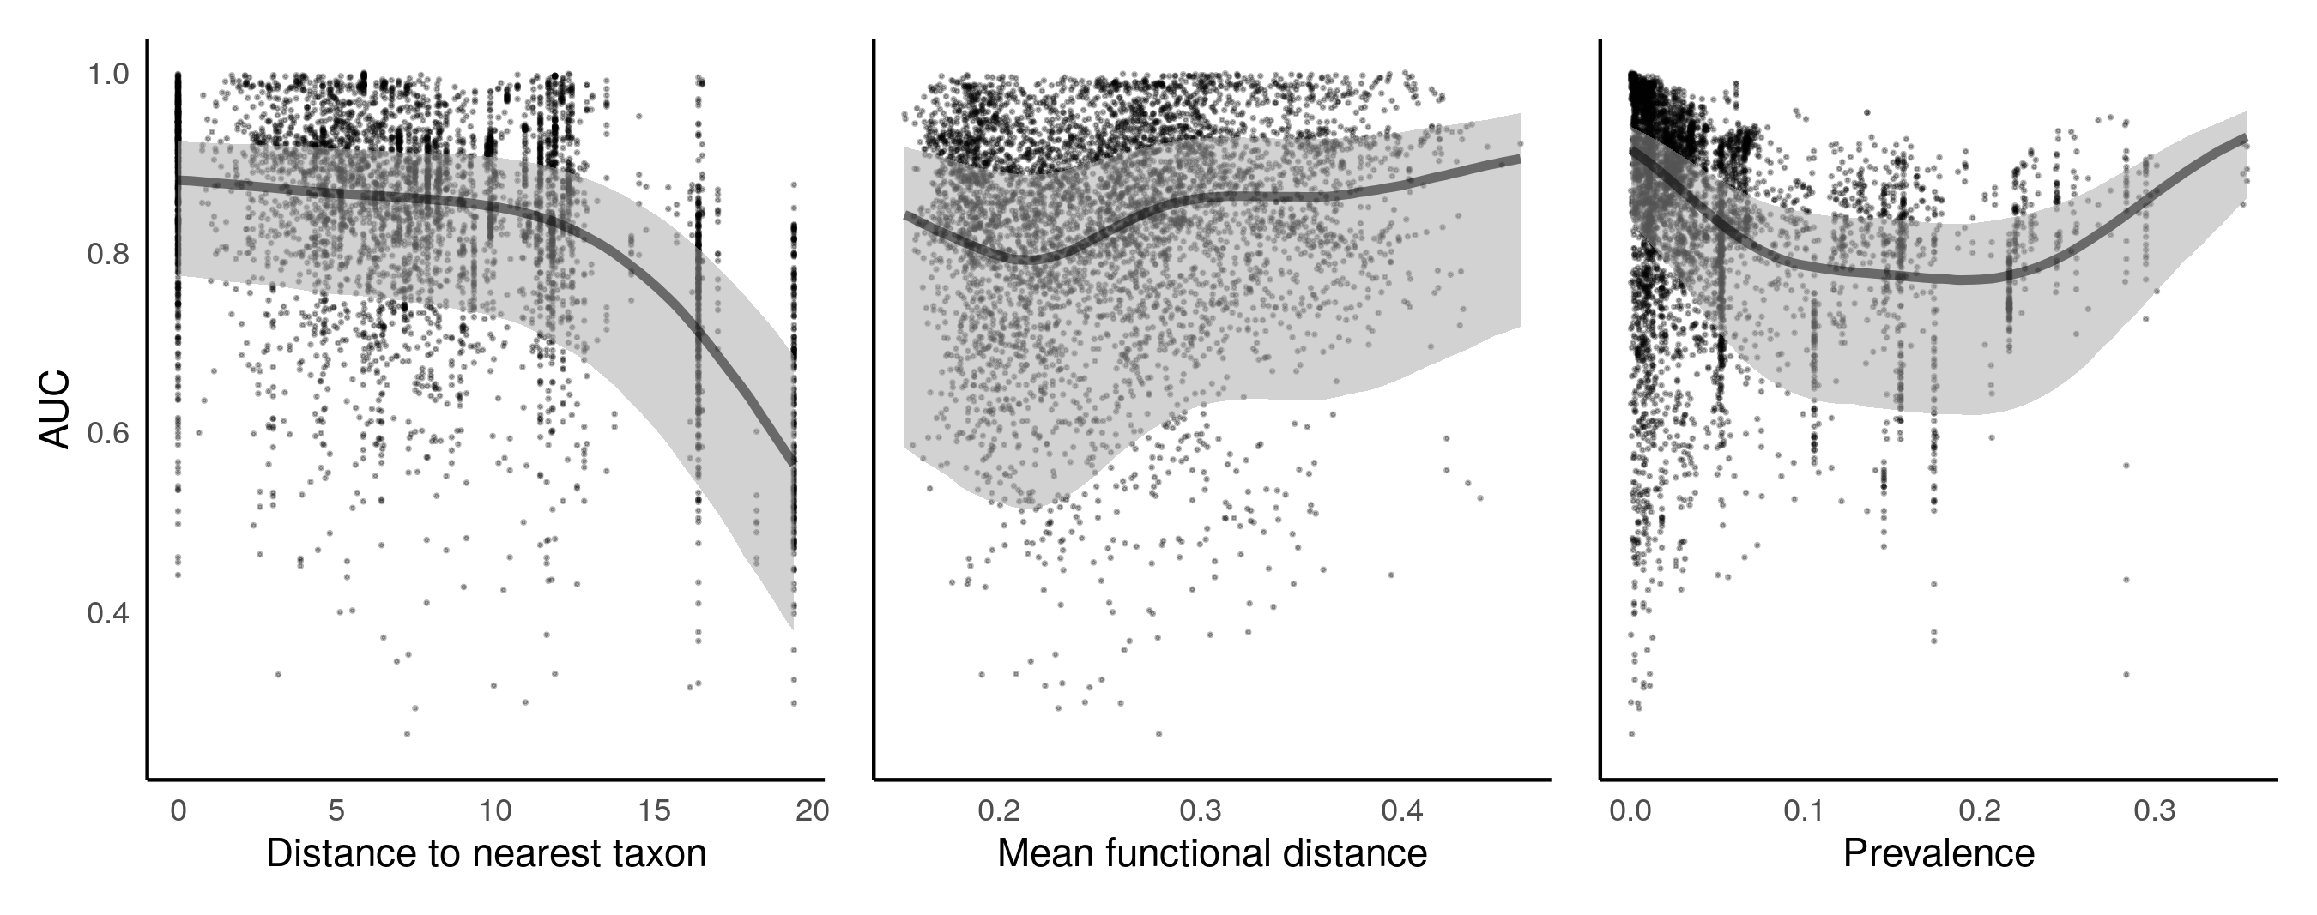Figure *3*: ***Predicting species interactions****. Performance of the model calibrated on each food web to predict the interactions of species in the other food webs. Each point is the performance to predict the prey and predators of a single species. The trend lines are the median effects with their 95% credible interval of distance to the nearest taxon, mean functional pairwise distance, and prevalence on predictive performance.*

*Predicting species functional role*

We found a lot of variation in how well species trophic positions were predicted (Figure 4). Species roles were slightly better predicted by within food web predictions than by across food web predictions. Interestingly, some measures of centrality (betweenness and closeness) were not well predicted, whereas others (number of prey and predators, eigenvector centrality) were relatively well predicted.

We also found important biases in the predictions of species roles when we modelled the predicted roles to the empirical roles. For example, the number of prey, number of predators, trophic level, omnivory, and most motif roles tended to be systematically overpredicted (Appendix X). These biases tended to be constant for all species (slopes close to 1). For other roles, like eigenvector centrality, betweenness, closeness, and module-based roles, species had more similar values in predicted food webs than empirical food webs (Appendix X, slopes lower than 1).

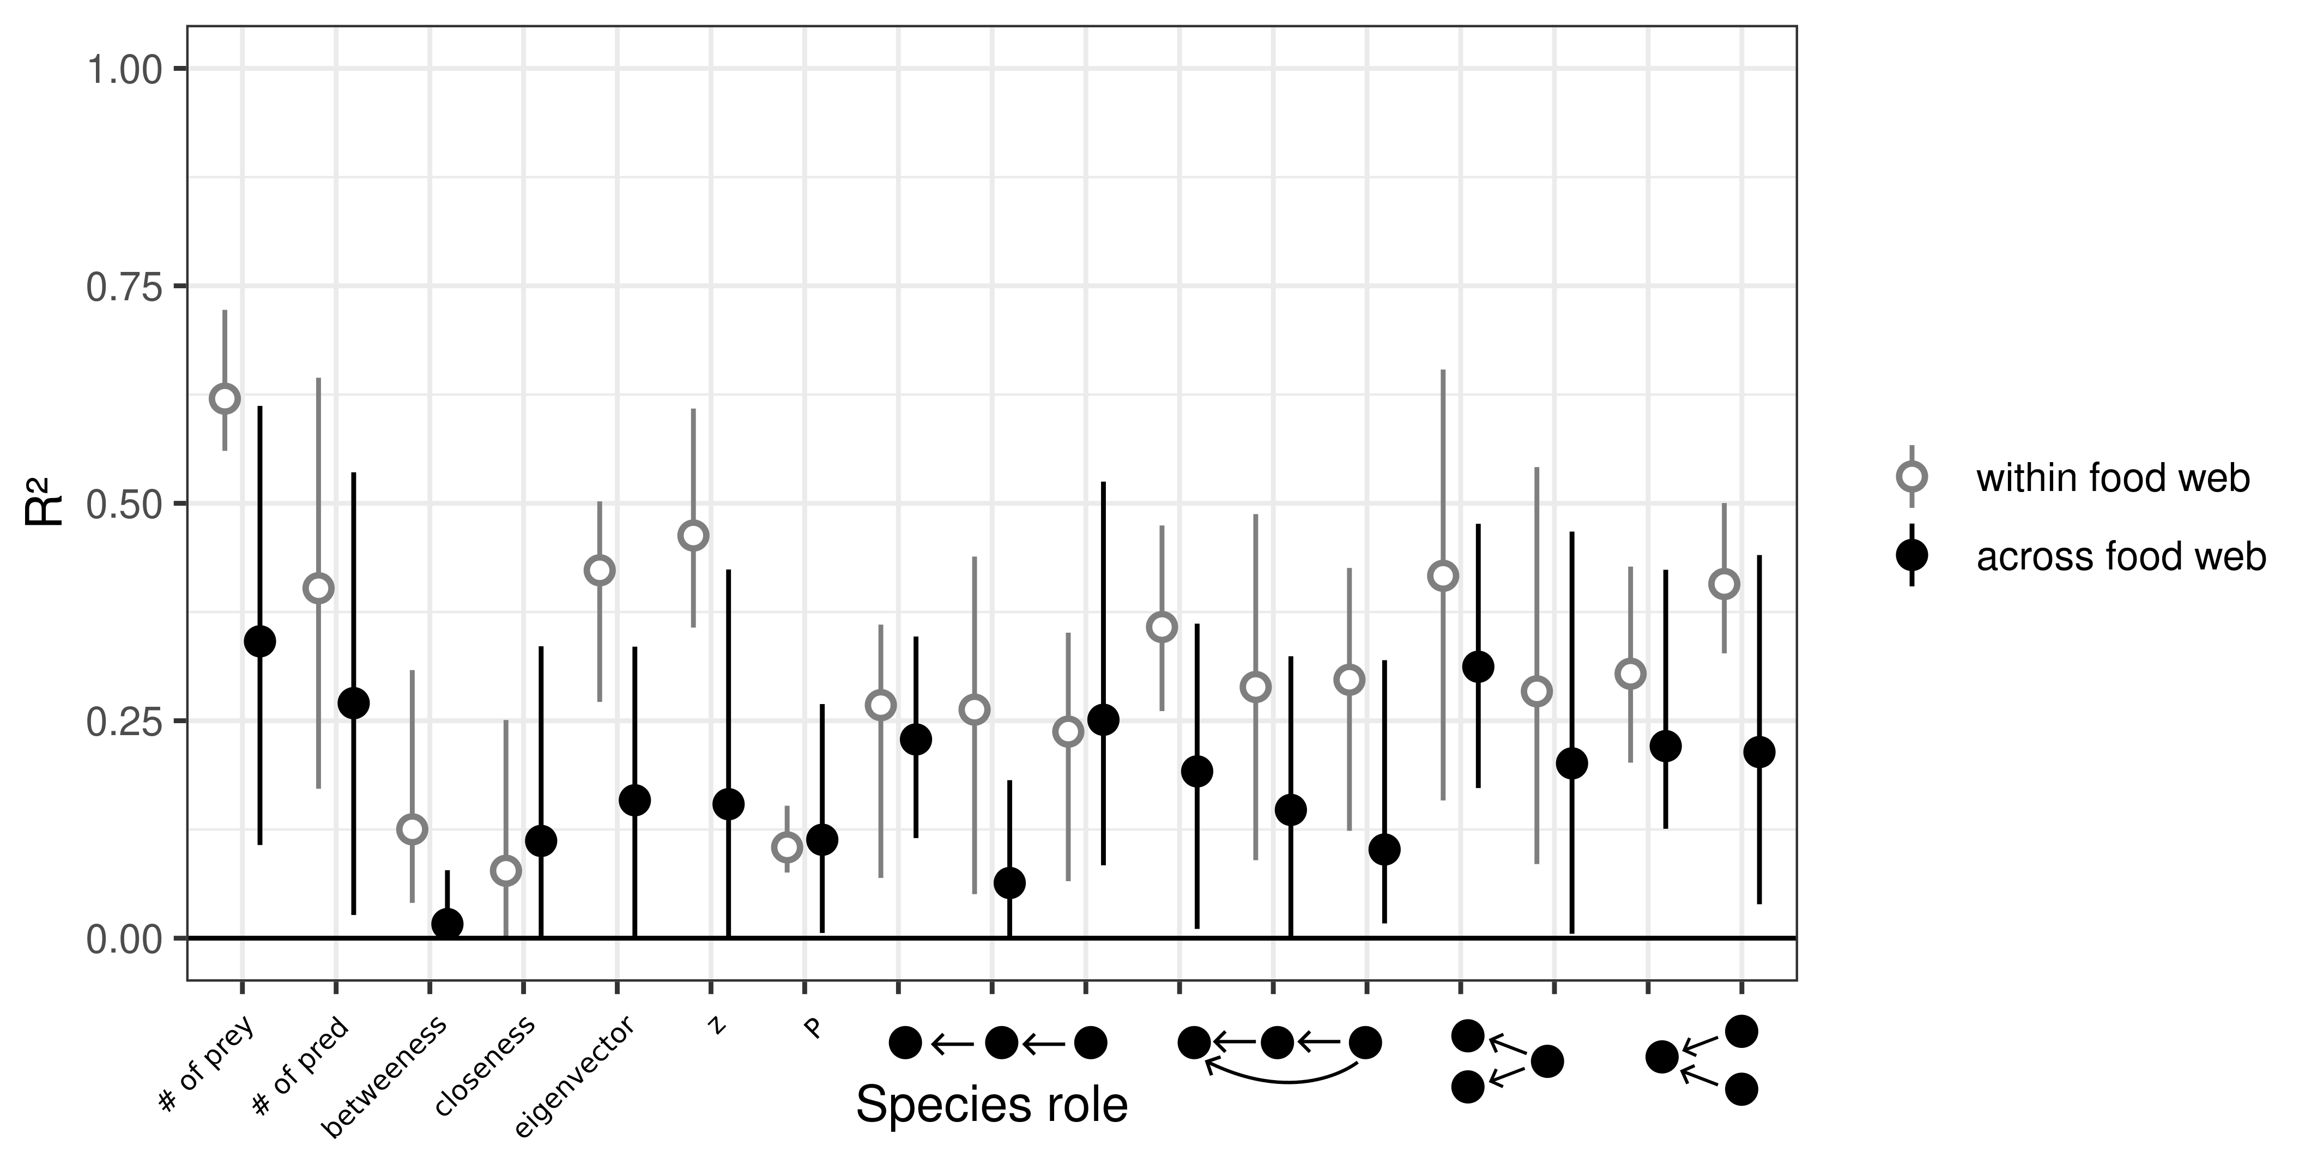  
Figure 4: **Predicting species functional role**. The variance explained of the predicted trophic position by the empirical trophic position. From left to right, the figure shows the number of prey, number of predators, betweenness, closeness, eigenvector centrality, within-module centrality, among-module connector, times the species is at a specific position in the linear chain, intraguild predatrion, direct competition, and apparent competition motifs. White dots are the mean R² with the minimum and maximum values for within food web predictions. Black dots are the mean R² with the minimum and maximum values for within food web predictions.

*Predicting food web properties*

Many food web properties were not well predicted by our interaction models (Figure 5). Connectance, mean and max trophic levels, and the frequency of most motifs were overpredicted, whereas the number of clusters and modularity were slightly underpredicted by our models. The mean and variance of relative errors were greater for between food web predictions compared to within food web predictions. In all, predicted food webs were more connected, increasing the frequency of most motifs, and resulting in a less modular food web and with less basal species which increased the trophic level of most species.

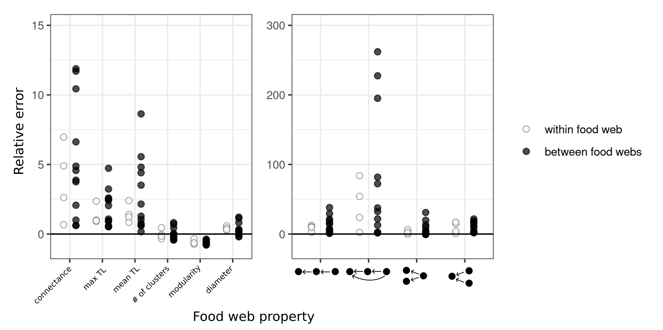  
Figure 5: **Predicting global food web properties**. The relative error of the predicted food web properties. Relative error is the difference between the predicted and empirical estimates divided by the empirical estimate. From left to right, the figure shows, connectance, maximum trophic level, mean trophic level, number of clusters, modularity, diameter, number of linear chain, intraguild predation, direct competition, and apparent competition motifs. White dots are the relative errors for within food web predictions, and black dots are the relative errors for across food web predictions.

**Discussion**

Predictive models of trophic interactions will be central in filling knowledge gaps about how predator and prey interact across space and time. Here, we showed that trait-based trophic interaction models can predict interactions across systems. We found that, given enough phylogenetic and environmental similarities between the system on which the model is calibrated and the system for which the predictions are made, models predicted most interactions reasonably well. Our results suggest that, for terrestrial vertebrate food webs, the trait relationships driving interactions appear to be relatively general even in highly contrasting environments. Although most interactions were well predicted, higher-level properties of the food webs were not as well predicted. We found systematic biases in the species position and food web properties predictions. Biases varied across metrics, but overall, the predicted food webs were better connected, less modular, had more trophic levels, and species were more equally connected. These higher-level properties of food webs were especially poorly predicted when making across food web predictions (i.e., knowledge transfer).

The trait-matching framework of trophic niche theory assumes that spatial variation in food webs arises either through variation in the trait-matching rules driving interactions, the distribution of traits in different systems, or both (Gravel, Albouy, and Thuiller 2016). Our ability to predict food web interactions across contrasting environment suggests that spatial food web variation is mainly driven by changes in the distribution of functional traits, and less so by the variation of trait-matching relationships. These are in line with previous results finding generalities in trait-interactions relationships across European bioregions (Caron et al. 2022), the predator-prey body-size ratios within habitat, predator, and prey types (Brose et al. 2006), trait-interactions relationships in soil invertebrates across three forest areas in Germany (Laigle et al. 2018). The finding that trait-matching rules driving species interactions seem general in reasonably similar environments opens the opportunity to use data from well-studied areas to predict interactions in areas we know very little about or forecast (and hindcast) food webs given new trait distributions. Strydom et al. (2021) also found that latent trait models could accurately transfer knowledge through phylogenetic relationships. In the future, different predictors (e.g., trait-based models, phylogeny-based models), and models (e.g., linear models, machine learning) could be combined into ensemble models. Ensemble models have the potential to make better predictions by cancelling the noise created by the specific data and models (Araújo and New 2007; Dormann et al. 2018), but do not always outperform individual models. (Hao et al. 2020).

We also highlighted a major limitation of trophic interaction models: trophic interaction models predict interactions, not food webs. Food webs are more than the sum of their parts (Cohen et al. 2009). The structural properties of food webs (i.e., connectance, number of trophic levels, modularity) influence the stability, invasibility, and productivity of ecosystems (Baiser, Russell, and Lockwood 2010; Duffy et al. 2007; Wang and Brose 2018), whereas the position of species within food webs determine their functional role, and can help identify keystone species and prevent cascading effects of extinction (Cirtwill et al. 2018; Estes et al. 2011; McDonald-Madden et al. 2016). Here, predicting individual links failed to predict higher-level properties, suggesting that there are constraints acting on the structures of food webs that trophic interaction models cannot capture. Spatial and temporal variation of ecological network structure has gained a lot of interest recently (Baiser et al. 2019; Gravel et al. 2019). Because sampling interactions at large scales is difficult, predictions by interaction models could help to investigate the variation of interactions and network structures simultaneously (e.g., Albouy et al., 2014). This would be possible only if the biases in predicted network structure are constant across the gradient of interest (e.g., spatial, temporal, environmental gradients). In the future, testing this assumption should be necessary to robustly test the variation in ecological network structure. Alternatively, we propose to use food web structural models (e.g., trophic niche models; Williams & Martinez, 2000) which can predict higher-level properties relatively well.

We can also view the failure to predict higher-level properties as an opportunity to improve species interaction predictions. Methods that would combine predictions of interactions and networks have the potential to provide better food web predictions. Different models can predict the number of links that we expect from the number of species (MacDonald, Banville, and Poisot 2020). With the number of links and species, structural food web models can predict the probability distribution of many food web properties (Allesina, Alonso, and Pascual 2008; Allesina and Pascual 2009; Cattin et al. 2004; Williams and Martinez 2000). Information on probable food web structure could be used to correct posterior predictive distributions of species interactions. In species distribution models, methods are already developed to use higher-level properties (e.g., species richness) to correct distribution prediction (e.g., Leung et al., 2019). These models correct systematic biases in prediction, such as those we found in our study.

We need to mention a few limitations for our study. First, we used four food webs of terrestrial vertebrates. Although there is no clear *a priori* reason not to be applicable in other systems, our results are unlikely to be general across all taxa and types of interactions. We don’t know any other test of interaction model transferability, but it would be interesting to investigate if our results hold for systems where trait-matching relationships are stronger or weaker. Second, the food webs we used are potential and binary food webs. Trait-matching models predict the probabilities that a species could eat another species given they are encounting. Additional data, such as co-occurrence and abundance data, are needed to make predictions of realized and quantitative interactions. Finally, due to the scarcity of food web data, we only had four food webs to work with. This means we only had four within food web predictions, and 12 across food web predictions. This explains the large uncertainty for some of our results (e.g., Figure 2). Despite the low sample size, we still detected significant signal in model transferability.

In all, we found that trait-based interaction models can transfer knowledge relatively well given enough phylogenetic and environmental similarities between systems. These models can predict pools of potential interactions even in contrasting environments, suggesting that changes in food webs are more explain by changes in trait distribution than by changes in the trait-interaction relationships. However, the resulting food webs should be viewed as a preliminary set of interactions, asking for refinement since the structure and trophic positions of species are not correctly predicted. These refinements could take the form of bias correction methods using predictions of higher-level food web properties, or by combining predictions to other types of data (i.e., expert knowledge, co-occurrences, abundances, etc). Such methodological advancements would allow better prediction of both interactions and food webs across space and time, which in turn, play a large role in filling the large knowledge gaps on how species interact and allow to investigate how global changes may impact ecosystems (Albouy et al. 2014; Cameron et al. 2019; Fricke et al. 2022).

**Acknowledgements**

**Author contributions**

**References**

Albouy, Camille, Laure Velez, Marta Coll, Francesco Colloca, François Le Loc’h, David Mouillot, and Dominique Gravel. 2014. “From Projected Species Distribution to Food-Web Structure under Climate Change.” *Global Change Biology* 20 (3): 730–41. https://doi.org/10.1111/gcb.12467.

Allesina, Stefano, David Alonso, and Mercedes Pascual. 2008. “A General Model for Food Web Structure.” *Science* 320 (5876): 658–61. https://doi.org/10.1126/science.1156269.

Allesina, Stefano, and Mercedes Pascual. 2009. “Food Web Models: A Plea for Groups.” *Ecology Letters* 12 (7): 652–62. https://doi.org/10.1111/j.1461-0248.2009.01321.x.

Araújo, Miguel B., and Mark New. 2007. “Ensemble Forecasting of Species Distributions.” *Trends in Ecology & Evolution* 22 (1): 42–47. https://doi.org/10.1016/j.tree.2006.09.010.

Baiser, Benjamin, Dominique Gravel, Alyssa R. Cirtwill, Jennifer A. Dunne, Ashkaan K. Fahimipour, Luis J. Gilarranz, Joshua A. Grochow, et al. 2019. “Ecogeographical Rules and the Macroecology of Food Webs.” *Global Ecology and Biogeography* 28 (9): 1204–18. https://doi.org/10.1111/geb.12925.

Baiser, Benjamin, Gareth J. Russell, and Julie L. Lockwood. 2010. “Connectance Determines Invasion Success via Trophic Interactions in Model Food Webs.” *Oikos* 119 (12): 1970–76. https://doi.org/10.1111/j.1600-0706.2010.18557.x.

Baskerville, Edward B., Andy P. Dobson, Trevor Bedford, Stefano Allesina, T. Michael Anderson, and Mercedes Pascual. 2011. “Spatial Guilds in the Serengeti Food Web Revealed by a Bayesian Group Model.” *PLoS Computational Biology* 7 (12). https://doi.org/10.1371/journal.pcbi.1002321.

Berteaux, Dominique, Pascal Ropars, and Nicolas Casajus. 2018. “Toundra Nunavik : Matrice Des Relations Trophiques Entre Espèces Du Labrador et Du Québec Nordique, v. 1.0 (1980-2010).” *Nordicana D36*. https://doi.org/10.5885/45555CE-DA1FF11FA4254703.

Blanchet, F. Guillaume, Kevin Cazelles, and Dominique Gravel. 2020. “Co-Occurrence Is Not Evidence of Ecological Interactions.” *Ecology Letters* 23 (7): 1050–63. https://doi.org/10.1111/ele.13525.

Braga, João, Laura J. Pollock, Ceres Barros, Núria Galiana, José M. Montoya, Dominique Gravel, Luigi Maiorano, et al. 2019. “Spatial Analyses of Multi-Trophic Terrestrial Vertebrate Assemblages in Europe.” *Global Ecology and Biogeography* 28 (11): 1636–48. https://doi.org/10.1111/geb.12981.

Brose, Ulrich, Tomas Jonsson, Eric L. Berlow, Philip Warren, Carolin Banasek-Richter, Louis-Félix Bersier, Julia L. Blanchard, et al. 2006. “Consumer–Resource Body-Size Relationships in Natural Food Webs.” *Ecology* 87 (10): 2411–17. https://doi.org/10.1890/0012-9658(2006)87[2411:CBRINF]2.0.CO;2.

Bürkner, Paul-Christian. 2017. “**Brms** : An *R* Package for Bayesian Multilevel Models Using *Stan*.” *Journal of Statistical Software* 80 (1). https://doi.org/10.18637/jss.v080.i01.

Cameron, Erin K., Maja K. Sundqvist, Sally A. Keith, Paul J. CaraDonna, Erik A. Mousing, Karin A. Nilsson, Daniel B. Metcalfe, and Aimée T. Classen. 2019. “Uneven Global Distribution of Food Web Studies under Climate Change.” *Ecosphere* 10 (3): e02645. https://doi.org/10.1002/ecs2.2645.

Canard, Elsa, Nicolas Mouquet, Lucile Marescot, Kevin J. Gaston, Dominique Gravel, and David Mouillot. 2012. “Emergence of Structural Patterns in Neutral Trophic Networks.” *PLOS ONE* 7 (8): e38295. https://doi.org/10.1371/journal.pone.0038295.

Caron, Dominique, Luigi Maiorano, Wilfried Thuiller, and Laura J. Pollock. 2022. “Addressing the Eltonian Shortfall with Trait‐based Interaction Models.” Edited by Jonathan Chase. *Ecology Letters*, January, ele.13966. https://doi.org/10.1111/ele.13966.

Carpenter, Bob, Andrew Gelman, Matthew D. Hoffman, Daniel Lee, Ben Goodrich, Michael Betancourt, Marcus Brubaker, Jiqiang Guo, Peter Li, and Allen Riddell. 2017. “*Stan* : A Probabilistic Programming Language.” *Journal of Statistical Software* 76 (1). https://doi.org/10.18637/jss.v076.i01.

Cattin, Marie-France, Louis-Félix Bersier, Carolin Banašek-Richter, Richard Baltensperger, and Jean-Pierre Gabriel. 2004. “Phylogenetic Constraints and Adaptation Explain Food-Web Structure.” *Nature* 427 (6977): 835–39. https://doi.org/10.1038/nature02327.

Chamberlain, Scott, Vijay Barve, Dan Mcglinn, Damiano Oldoni, Peter Desmet, Laurens Geffert, and Karthik Ram. 2022. “Rgbif: Interface to the Global Biodiversity Information Facility API.” Manual. https://CRAN.R-project.org/package=rgbif.

Chamberlain, Scott, and Carl Boettiger. 2017. “R Python, and Ruby Clients for GBIF Species Occurrence Data.” *PeerJ PrePrints*. https://doi.org/10.7287/peerj.preprints.3304v1.

Cirtwill, Alyssa R., Giulio Valentino Dalla Riva, Marilia P. Gaiarsa, Malyon D. Bimler, E. Fernando Cagua, Camille Coux, and D. Matthias Dehling. 2018. “A Review of Species Role Concepts in Food Webs.” *Food Webs* 16 (September): e00093. https://doi.org/10.1016/j.fooweb.2018.e00093.

Cohen, Joel E., Daniella N. Schittler, David G. Raffaelli, and Daniel C. Reuman. 2009. “Food Webs Are More than the Sum of Their Tritrophic Parts.” *Proceedings of the National Academy of Sciences* 106 (52): 22335–40. https://doi.org/10.1073/pnas.0910582106.

Dehling, D. Matthias, and Daniel B. Stouffer. 2018. “Bringing the Eltonian Niche into Functional Diversity.” *Oikos* 127 (12): 1711–23. https://doi.org/10.1111/oik.05415.

Dormann, Carsten F., Justin M. Calabrese, Gurutzeta Guillera-Arroita, Eleni Matechou, Volker Bahn, Kamil Bartoń, Colin M. Beale, et al. 2018. “Model Averaging in Ecology: A Review of Bayesian, Information-Theoretic, and Tactical Approaches for Predictive Inference.” *Ecological Monographs* 88 (4): 485–504. https://doi.org/10.1002/ecm.1309.

Duffy, J. Emmett, Bradley J. Cardinale, Kristin E. France, Peter B. McIntyre, Elisa Thébault, and Michel Loreau. 2007. “The Functional Role of Biodiversity in Ecosystems: Incorporating Trophic Complexity.” *Ecology Letters* 10 (6): 522–38. https://doi.org/10.1111/j.1461-0248.2007.01037.x.

Dunne, Jennifer A., Richard J. Williams, and Neo D. Martinez. 2002. “Food-Web Structure and Network Theory: The Role of Connectance and Size.” *Proceedings of the National Academy of Sciences* 99 (20): 12917–22. https://doi.org/10.1073/pnas.192407699.

Estes, James A., John Terborgh, Justin S. Brashares, Mary E. Power, Joel Berger, William J. Bond, Stephen R. Carpenter, et al. 2011. “Trophic Downgrading of Planet Earth.” *Science* 333 (6040): 301–6. https://doi.org/10.1126/science.1205106.

Etard, Adrienne, Sophie Morrill, and Tim Newbold. 2020. “Global Gaps in Trait Data for Terrestrial Vertebrates.” *Global Ecology and Biogeography* 29 (12): 2143–58. https://doi.org/10.1111/geb.13184.

Fricke, Evan C., Chia Hsieh, Owen Middleton, Daniel Gorczynski, Caroline D. Cappello, Oscar Sanisidro, John Rowan, Jens-Christian Svenning, and Lydia Beaudrot. 2022. “Collapse of Terrestrial Mammal Food Webs since the Late Pleistocene.” *Science* 377 (6609): 1008–11. https://doi.org/10.1126/science.abn4012.

Gelman, Andrew. 2008. “Scaling Regression Inputs by Dividing by Two Standard Deviations.” *Statistics in Medicine* 27 (15): 2865–73. https://doi.org/10.1002/sim.3107.

Gelman, Andrew, and Donald B. Rubin. 1992. “Inference from Iterative Simulation Using Multiple Sequences.” *Statistical Science* 7 (4): 457–72. https://doi.org/10.1214/ss/1177011136.

Gómez, José M., Miguel Verdú, and Francisco Perfectti. 2010. “Ecological Interactions Are Evolutionarily Conserved across the Entire Tree of Life.” *Nature* 465 (7300): 918–21. https://doi.org/10.1038/nature09113.

Gonzalez, Andrew, Rachel M. Germain, Diane S. Srivastava, Elise Filotas, Laura E. Dee, Dominique Gravel, Patrick L. Thompson, et al. 2020. “Scaling-up Biodiversity-Ecosystem Functioning Research.” *Ecology Letters* 23 (4): 757–76. https://doi.org/10.1111/ele.13456.

Gower, J. C. 1971. “A General Coefficient of Similarity and Some of Its Properties.” *Biometrics* 27 (4): 857–71. https://doi.org/10.2307/2528823.

Gravel, Dominique, Camille Albouy, and Wilfried Thuiller. 2016. “The Meaning of Functional Trait Composition of Food Webs for Ecosystem Functioning.” *Philosophical Transactions of the Royal Society B: Biological Sciences* 371 (1694): 20150268. https://doi.org/10.1098/rstb.2015.0268.

Gravel, Dominique, Benjamin Baiser, Jennifer A. Dunne, Jens-Peter Kopelke, Neo D. Martinez, Tommi Nyman, Timothée Poisot, et al. 2019. “Bringing Elton and Grinnell Together: A Quantitative Framework to Represent the Biogeography of Ecological Interaction Networks.” *Ecography* 42 (3): 401–15. https://doi.org/10.1111/ecog.04006.

Gravel, Dominique, Timothée Poisot, Camille Albouy, Laure Velez, and David Mouillot. 2013. “Inferring Food Web Structure from Predator-Prey Body Size Relationships.” Edited by Robert Freckleton. *Methods in Ecology and Evolution* 4 (11): 1083–90. https://doi.org/10.1111/2041-210X.12103.

Guimerà, Roger, and Luís A. Nunes Amaral. 2005. “Cartography of Complex Networks: Modules and Universal Roles.” *Journal of Statistical Mechanics: Theory and Experiment* 2005 (02): P02001. https://doi.org/10.1088/1742-5468/2005/02/P02001.

Guzman, Laura Melissa, Rachel M. Germain, Coreen Forbes, Samantha Straus, Mary I. O’Connor, Dominique Gravel, Diane S. Srivastava, and Patrick L. Thompson. 2019. “Towards a Multi-Trophic Extension of Metacommunity Ecology.” *Ecology Letters* 22 (1): 19–33. https://doi.org/10.1111/ele.13162.

Hao, Tianxiao, Jane Elith, José J. Lahoz-Monfort, and Gurutzeta Guillera-Arroita. 2020. “Testing Whether Ensemble Modelling Is Advantageous for Maximising Predictive Performance of Species Distribution Models.” *Ecography* 43 (4): 549–58. https://doi.org/10.1111/ecog.04890.

Harvey, Eric, Isabelle Gounand, Colette L. Ward, and Florian Altermatt. 2017. “Bridging Ecology and Conservation: From Ecological Networks to Ecosystem Function.” *Journal of Applied Ecology* 54 (2): 371–79. https://doi.org/10.1111/1365-2664.12769.

Hijmans, Robert J. 2021. “Raster: Geographic Data Analysis and Modeling.” Manual. https://CRAN.R-project.org/package=raster.

Hortal, Joaquín, Francesco de Bello, José Alexandre F. Diniz-Filho, Thomas M. Lewinsohn, Jorge M. Lobo, and Richard J. Ladle. 2015. “Seven Shortfalls That Beset Large-Scale Knowledge of Biodiversity.” *Annual Review of Ecology, Evolution, and Systematics* 46 (1): 523–49. https://doi.org/10.1146/annurev-ecolsys-112414-054400.

Jetz, W., G. H. Thomas, J. B. Joy, K. Hartmann, and A. O. Mooers. 2012. “The Global Diversity of Birds in Space and Time.” *Nature* 491 (7424): 444–48. https://doi.org/10.1038/nature11631.

Jetz, Walter, and R. Alexander Pyron. 2018. “The Interplay of Past Diversification and Evolutionary Isolation with Present Imperilment across the Amphibian Tree of Life.” *Nature Ecology & Evolution* 2 (5): 850–58. https://doi.org/10.1038/s41559-018-0515-5.

Jordano, Pedro. 2016. “Sampling Networks of Ecological Interactions.” *Functional Ecology* 30 (12): 1883–93. https://doi.org/10.1111/1365-2435.12763.

Laigle, Idaline, Isabelle Aubin, Christoph Digel, Ulrich Brose, Isabelle Boulangeat, and Dominique Gravel. 2018. “Species Traits as Drivers of Food Web Structure.” *Oikos* 127 (2): 316–26. https://doi.org/10.1111/oik.04712.

Letten, Andrew D., and William K. Cornwell. 2015. “Trees, Branches and (Square) Roots: Why Evolutionary Relatedness Is Not Linearly Related to Functional Distance.” *Methods in Ecology and Evolution* 6 (4): 439–44. https://doi.org/10.1111/2041-210X.12237.

Leung, Brian, Emma J. Hudgins, Anna Potapova, and Maria C. Ruiz-Jaen. 2019. “A New Baseline for Countrywide α-Diversity and Species Distributions: Illustration Using >6,000 Plant Species in Panama.” *Ecological Applications* 29 (3): e01866. https://doi.org/10.1002/eap.1866.

Lindeman, Raymond L. 1942. “The Trophic-Dynamic Aspect of Ecology.” *Ecology* 23 (4): 399–417. https://doi.org/10.2307/1930126.

Lurgi, Miguel, Bernat C. López, and José M. Montoya. 2012. “Climate Change Impacts on Body Size and Food Web Structure on Mountain Ecosystems.” *Philosophical Transactions of the Royal Society B: Biological Sciences* 367 (1605): 3050–57. https://doi.org/10.1098/rstb.2012.0239.

MacDonald, Arthur Andrew Meahan, Francis Banville, and Timothée Poisot. 2020. “Revisiting the Links-Species Scaling Relationship in Food Webs.” *Patterns* 1 (7). https://doi.org/10.1016/j.patter.2020.100079.

Magneville, Camille, Nicolas Loiseau, Camille Albouy, Nicolas Casajus, Thomas Claverie, Arthur Escalas, Fabien Leprieur, Eva Maire, David Mouillot, and Sébastien Villéger. 2022. “MFD: An R Package to Compute and Illustrate the Multiple Facets of Functional Diversity.” *Ecography* 2022 (1). https://doi.org/10.1111/ecog.05904.

Maiorano, Luigi, Alessandro Montemaggiori, Gentile Francesco Ficetola, Louise O’Connor, and Wilfried Thuiller. 2020. “TETRA‐EU 1.0: A Species‐level Trophic Metaweb of European Tetrapods.” Edited by Allen Hurlbert. *Global Ecology and Biogeography*, June, geb.13138. https://doi.org/10.1111/geb.13138.

McDonald-Madden, E., R. Sabbadin, E. T. Game, P. W. J. Baxter, I. Chadès, and H. P. Possingham. 2016. “Using Food-Web Theory to Conserve Ecosystems.” *Nature Communications* 7 (1): 1–8. https://doi.org/10.1038/ncomms10245.

Morales-Castilla, Ignacio, Miguel G. Matias, Dominique Gravel, and Miguel B. Araújo. 2015. “Inferring Biotic Interactions from Proxies.” *Trends in Ecology & Evolution* 30 (6): 347–56. https://doi.org/10.1016/j.tree.2015.03.014.

Mouchet, Maud A., Sébastien Villéger, Norman W. H. Mason, and David Mouillot. 2010. “Functional Diversity Measures: An Overview of Their Redundancy and Their Ability to Discriminate Community Assembly Rules.” *Functional Ecology* 24 (4): 867–76. https://doi.org/10.1111/j.1365-2435.2010.01695.x.

Poisot, Timothée, Gabriel Bergeron, Kevin Cazelles, Tad Dallas, Dominique Gravel, Andrew MacDonald, Benjamin Mercier, Clément Violet, Steve Vissault, and Daniel Chapman. 2021. “Global Knowledge Gaps in Species Interaction Networks Data.” *Journal of Biogeography*, April, jbi.14127. https://doi.org/10.1111/jbi.14127.

Pomeranz, Justin P. F., Ross M. Thompson, Timothée Poisot, and Jon S. Harding. 2019. “Inferring Predator–Prey Interactions in Food Webs.” *Methods in Ecology and Evolution* 10 (3): 356–67. https://doi.org/10.1111/2041-210X.13125.

Smith-Ramesh, Lauren M., Alexandria C. Moore, and Oswald J. Schmitz. 2016. “Global Synthesis Suggests That Food Web Connectance Correlates to Invasion Resistance.” *Global Change Biology*, August, n/a-n/a. https://doi.org/10.1111/gcb.13460.

Stekhoven, Daniel J., and Peter Buehlmann. 2012. “MissForest - Non-Parametric Missing Value Imputation for Mixed-Type Data.” *Bioinformatics (Oxford, England)* 28 (1): 112–18.

Stouffer, Daniel B., Marta Sales-Pardo, M. Irmak Sirer, and Jordi Bascompte. 2012. “Evolutionary Conservation of Species’ Roles in Food Webs.” *Science* 335 (6075): 1489–92. https://doi.org/10.1126/science.1216556.

Strydom, Tanya, Salomé Bouskila, Francis Banville, Cerres Barros, Dominique Caron, Maxwell J. Farrell, Marie-Josée Fortin, et al. 2021. “Food Web Reconstruction through Phylogenetic Transfer of Low-Rank Network Representation.” EcoEvoRxiv. https://doi.org/10.32942/osf.io/y7sdz.

Thompson, Ross M., Ulrich Brose, Jennifer A. Dunne, Robert O. Hall, Sally Hladyz, Roger L. Kitching, Neo D. Martinez, et al. 2012. “Food Webs: Reconciling the Structure and Function of Biodiversity.” *Trends in Ecology & Evolution* 27 (12): 689–97. https://doi.org/10.1016/j.tree.2012.08.005.

Thomson, Robert C., Phillip Q. Spinks, and H. Bradley Shaffer. 2021. “A Global Phylogeny of Turtles Reveals a Burst of Climate-Associated Diversification on Continental Margins.” *Proceedings of the National Academy of Sciences* 118 (7): e2012215118. https://doi.org/10.1073/pnas.2012215118.

Tonini, João Filipe Riva, Karen H. Beard, Rodrigo Barbosa Ferreira, Walter Jetz, and R. Alexander Pyron. 2016. “Fully-Sampled Phylogenies of Squamates Reveal Evolutionary Patterns in Threat Status.” *Biological Conservation*, Advancing reptile conservation: Addressing knowledge gaps and mitigating key drivers of extinction risk, 204 (December): 23–31. https://doi.org/10.1016/j.biocon.2016.03.039.

Tucker, Caroline M., Marc W. Cadotte, Silvia B. Carvalho, T. Jonathan Davies, Simon Ferrier, Susanne A. Fritz, Rich Grenyer, et al. 2017. “A Guide to Phylogenetic Metrics for Conservation, Community Ecology and Macroecology.” *Biological Reviews* 92 (2): 698–715. https://doi.org/10.1111/brv.12252.

Upham, Nathan S., Jacob A. Esselstyn, and Walter Jetz. 2019. “Inferring the Mammal Tree: Species-Level Sets of Phylogenies for Questions in Ecology, Evolution, and Conservation.” *PLOS Biology* 17 (12): e3000494. https://doi.org/10.1371/journal.pbio.3000494.

Visser, Sara N. de, Bernd P. Freymann, and Han Olff. 2011. “The Serengeti Food Web: Empirical Quantification and Analysis of Topological Changes under Increasing Human Impact.” *Journal of Animal Ecology* 80 (2): 484–94. https://doi.org/10.1111/j.1365-2656.2010.01787.x.

Wang, Shaopeng, and Ulrich Brose. 2018. “Biodiversity and Ecosystem Functioning in Food Webs: The Vertical Diversity Hypothesis.” *Ecology Letters* 21 (1): 9–20. https://doi.org/10.1111/ele.12865.

Williams, Richard J., and Neo D. Martinez. 2000. “Simple Rules Yield Complex Food Webs.” *Nature* 404 (6774): 180–83. https://doi.org/10.1038/35004572.