Chapter 3: Consequences of seasonal geographic and niche movements for North American bird biogeography

Dominique Caron^{1,2}, Maximiliane Jousse^{1,2}, Morgan W. Tingley³, Dirk Nikolaus Karger⁴, Dominique Gravel^{2,5}, Laura J. Pollock^{1,2}

Affiliations:
¹ Department of Biology, McGill University, Montreal, QC, Canada
² Quebec Centre for Biodiversity Sciences, Montreal, QC, Canada
³ Department of Ecology and Evolutionary Biology, University of California, Los
Angeles, United States
⁴ Swiss Federal Research Institute WSL, Birmensdorf, Switzerland
⁵ Département de biologie, Université de Sherbrooke, Sherbrooke, QC, Canada

The following is in preparation for submission to Global Ecology and Biogeography

Abstract
Seasonality plays an important, yet often overlooked role in explaining and predicting ecological processes and distributions. Birds respond to seasonal variation through a well-known energetic trade-off of enduring winter or escaping it via seasonal migration. Less is known about how traits explain this trade-off and the degree to which these strategies impact classic ecogeographical relationships. We address these questions by asking: (1) which traits (body mass, hand-wing index, and diet) are most closely associated with the strategy of enduring winter (‘niche-switching’; movement within climatic space) versus escaping it (‘niche-tracking’; movement in geographic space) and (2) how species with different strategies influence the latitudinal diversity gradient and the assemblage-level temperature-size rule. We quantify the degree of ‘niche-tracking’ versus ‘niche-switching’ for 546 North American bird species using weekly distribution estimates and daily climate data at a fine spatial scale (2.8 x 2.8 km grid) and model the degree of ‘niche-tracking’ as a function of species traits. We find a non-linear relationship between species’ movements in geographic space and climatic space, with species migrating longer distances minimizing movement within their niche until a certain distance (approximately 4 5000 km). Very long-distance migrants seem to track other factors (e.g., resource availability) as they tend to track less climatic conditions. We also found that species traits are strongly tied to movements both in geographic and climatic spaces. Birds only follow the classic richness gradient during winter, but not in summer driven by the seasonal movement of ‘niche-trackers’. Finally, we find contrasting effects of season on the body mass-temperature relationship among ‘niche-trackers’ and ‘niche-switchers’, explaining some of the discrepancies in the literature. In the current context of changing climate and shifting seasonal dynamics, our results illustrate how predictions of biodiversity responses without considering seasonality would be, at best, part of the story and, at worst, misleading.

Introduction
Every year, almost 20% of the world’s bird species migrate, sometimes over thousands of kilometres, in response to seasonal variations in the environment (Kirby et al., 2008). This extraordinary adaptation to seasonality presumably evolved to maintain fidelity to breeding grounds, while escaping harsh conditions (Winger et al., 2019). Migration has the advantage over other adaptations to seasonal environments (e.g., hibernation, freeze tolerance) in that migrating species can maintain similar thermal conditions throughout the year, but migration also brings movement costs (Gómez et al., 2016; Nakazawa et al., 2004). Indeed, Somveille et al. (2015, 2019) demonstrated that breeding and wintering destinations of migratory birds are optimized to avoid unfavourable climatic conditions, competition, and minimize geographic distance travelled. Therefore, evidence suggests there is a fundamental trade-off between the costs of movement within geographic space and within climatic niche space (Gómez et al., 2016; Nakazawa et al., 2004), but it is poorly understood how the differences between species change the balance of this trade-off.

The degree to which species minimize movement within their climatic niche space (hereinafter referred to as ‘niche-tracking’ sensu Nakazawa et al., 2004), as opposed to sustaining large variation in climatic conditions (hereinafter referred to as ‘niche-switching’ sensu Nakazawa et al., 2004), ultimately involves geographic, morphological, life history, predatory, and feeding habit considerations (J. Cohen & Jetz, 2022; McKinnon et al., 2010; Zurell et al., 2018). For example, Zurell et al. (2018) studied the overlap in breeding and wintering climatic conditions experienced by 717 Holarctic species and found that region, range position, and range size were important determinants of tracking. They also found that larger species tended to experience more similar breeding and wintering climatic conditions, contrary to what we might expect and to the recent findings of J. Cohen & Jetz (2022). Larger species typically need more energy to migrate (Watanabe, 2016) and can tolerate colder temperatures (Blackburn et al., 1999). Therefore, it should be relatively more beneficial for bigger species to sustain variation in climatic conditions, resulting in an overall broader niche, than to closely track their niche optimum throughout the year. In contrast, species with larger hand-wing index, a measure of flight efficiency (Sheard et al., 2020), should favour ‘niche-tracking’ since efficient fliers can migrate longer distances at lower energetic cost. ‘Niche-switching’ should also be associated with species with flexible diets. For example, many birds, like the Northern cardinal (Cardinalis cardinalis), seasonally switch their diet, foraging in the canopy to eat insects and berries during summer months and on the ground for grains the rest of the year (Gill, 2007). While these examples show how certain traits explain why some birds favour movement within climatic space over movement in geographic space, we still lack evidence for other traits and how they combine to explain the trade-off.

If traits can explain the ‘niche-tracking/switching’ trade-off, this would lead to a more mechanistic understanding of the large seasonal shifts in diversity increasingly highlighted in recent literature. For example, Ng et al. (2022) recently found seasonal shifts in biomass, abundance, and richness of nocturnally migrating landbirds in the United States. They found that birds are more abundant and more diverse in the Southeast and the Pacific coast during winter, whereas the Northeastern and Midwestern United States are home to more individuals and species during summer. Similarly, La Sorte et al. (2022) found that, during migration, bird richness was highest on islands within the northern mid-latitudes, whereas, during winter, bird richness was highest on islands within tropical latitudes. The trait composition of bird assemblages also varies across seasons. For example, Jarzyna & Stagge (2023) recently found that in the Northeastern United States, functional richness is highest in winter despite a loss in species richness. Together these results suggest a strong functional basis for seasonal diversity patterns, but the extent to which different traits drive major diversity gradients is less understood.

One such gradient of longstanding interest is the relationship between body mass and latitude. Originally proposed by Bergmann (1848), the rule is traditionally defined as ‘races of warm blooded vertebrates from cooler climates tend to be larger than races of the same species from warmer climates’ (Mayr, 1956). It has now been extended to the relationship between size and latitude, for ectotherms, and across closely related species (as was originally proposed by Bergmann; Blackburn et al., 1999). Indeed, this relationship has strong support in many taxa, including birds (Blackburn & Gaston, 1996; He et al., 2023; Meiri & Dayan, 2003; Youngflesh et al., 2022). However, this prediction is potentially diluted by migration, because the selective pressure for increased body size with latitude should be weaker for birds that escape the harsh conditions of winter (‘niche-trackers’). There are mixed results for the few studies that have tested this expectation. In support, Ramirez et al. (2008) found a stronger body size gradient across latitudes during winter for New World birds. Studies have also found stronger support for Bergmann’s rule for sedentary birds than for migratory birds within (Meiri & Dayan, 2003) and across species (Mainwaring & Street, 2021), but another study found the opposite trend (He et al., 2023). Bergman’s rule is further complicated by recent findings that smaller birds tend to migrate further and track climate more than larger birds (J. Cohen & Jetz, 2022; Soriano-Redondo et al., 2020). Consequently, it is still unclear how the relationship between body mass and migratory behaviour impacts Bergmann’s rule across seasons.

To better understand how seasonality influences Bergman’s rule and the latitudinal biodiversity gradient more generally, we need to first link ‘niche-tracking’ and ‘switching’ to traits and then evaluate biodiversity patterns in this context. So far, the study of bird ‘niche-tracking’ and biogeography has remained largely disconnected, likely, in part, due to the necessity for large spatial scale and high temporal resolution distribution data for entire bird communities and climate variables. Recent data products make this challenge more possible with weekly bird distributions, daily climate data, and species-specific traits. Now, we can better explore how the relationship between species migration and the degree of ‘niche-tracking’ shapes the distribution of bird diversity and traits across seasons at macroecological scales.

Our objectives are to determine (1) how body mass, hand-wing index, and trophic guild influence the trade-off between movement within climate niche space and movement in geographic space, and (2) the consequences of those relationships on two ecogeographical rules: the latitudinal diversity gradient and Bergmann’s rule. To do this, we combine weekly estimates of species abundances and occurrences for most of the bird diversity in the United States and Canada, along with daily climatic variables, and species-level traits and address the following hypotheses. First, we expect a trade-off between ‘niche-tracking’ and ‘switching’, and for that trade-off to be explained by traits. We expect to see this trade-off with a negative relationship between the distance travelled by species in geographic space and climatic space (H1). For traits (H2), we expect larger species to favour movement in climate space and species with a larger hand-wing index (more flight efficiency) to favour movement in geographic space. We also expect guilds feeding on seasonal resources (e.g., invertivores, frugivores, nectarivores) to minimize movement in climatic space compared to guilds feeding on less seasonal resources (e.g., omnivores and granivores). Second, we expect ‘niche-trackers’ to dilute or negate classic biodiversity gradients. Specifically, we expect (H3) that the latitudinal richness gradient is lessened in the summer, when ‘niche-trackers’ migrate northward, and (H4) an increase in average body mass toward the poles (Bergmann’s rule) only for ‘niche-switchers’ and not ‘niche-trackers’ who escape the body mass constraints imposed by harsh winters.

Material and methods
Bird distributions and traits
We extracted weekly estimates of bird occurrence and relative abundance from the 2022 version of eBird Status and Trends (Fink et al., 2020, 2023) for bird species in the Avibase (Lepage et al., 2014) checklists for Canada and the United States. eBird Status and Trends relates eBird observations between 2008 and 2022 to elevation, topography, and land cover in a hierarchical machine learning model that accounts for observation effort and temporal scales to model species distribution for each week of the year. We extracted the data using the R package ebirdst (Strimas-Mackey et al., 2022) at the highest resolution available (2.8 × 2.8 km) within continental North and South America. Predictions for all 52 weeks within the study area were available for 546 species out of the 824 birds in Avibase checklists.

We extracted the body mass, hand-wing index, and trophic guild for the 546 species from AVONET (Tobias et al., 2022). AVONET compiles species-level trait means for all the world's bird species. Hand-wing index is a quantitative morphological trait correlated to flight efficiency (Sheard et al., 2020). Trophic guild is a categorical trait describing species major resource types: frugivore (6 species), granivore (40 species), nectarivore (14 species), terrestrial herbivore (11 species), aquatic herbivore (16 species), invertivore (203 species), omnivore (112 species), vertivore (32 species), aquatic predator (110 species), and scavenger (2 species).

Climate data and tracking
To match climate data to bird distributions, we extracted daily minimum near-surface air temperature and daily precipitation rates between 2008 and 2022 from CHELSA v.2.1 (Karger et al., 2017, 2021) resampled to the 2.8 km grid of eBird Status and Trends within continental North and South America by using the mean of all 1 km grid cells that overlapped with a 2.8 km grid cell. We use daily minimum near-surface air temperature and precipitation rates because they have been shown to greatly control species richness and distributions (Qian, 2010) and are usually not highly collinear. We calculated weekly climatological means by averaging daily minimum near-surface air temperatures and daily precipitation rates for the years 2008 to 2022 for each week of the year, starting January 1st and ending December 31st.

We calculated the climatic and geographic centroids of each species each week by estimating the weekly mean latitude, mean longitude, mean daily minimum near-surface air temperature, and mean daily precipitation rates, weighted by species’ abundances within each 2.8 km pixel. Before calculating climatic centroids, we centred and scaled weekly mean daily minimum near-surface air temperature and weekly mean daily precipitation rates to account for different units. Since we are interested in annual movements, we reduced the ‘noise’ in the geographic and climatic centroids time series caused by week-to-week variations in distributions by taking the moving window average. We used a window size of 5 weeks (e.g., the geographic centroid of a species for week 3 is the average of the centroids of weeks 1-5), which smoothed the time series without losing too much of the temporal resolution (Appendix S2). We estimated the distance travelled in climatic space (i.e., degree of ‘niche-switching’) as the sum of Euclidean distances between the climate centroids of consecutive weeks. Similarly, we estimated distance travel in geographic space as the sum of distances between the geographic centroids occupied by species during consecutive weeks.

Climate condition tracking models
We first evaluated the relationships between distance travelled in geographic space, distance within climatic space and species traits. First, we modelled distance travelled in climatic space (degree of ‘niche-switching’) as a function of geographic distance for all species. We use a piecewise linear model (segmented regression) as we expect different relationships for long-distance migrators. Somveille et al. (2019) showed that species that migrate intermediate distances tend to track better temperatures, whereas species travelling longer distances track available resources. Additionally, the model coefficients (e.g., slopes, breakpoint) of the segmented regression allow direct inference of the biology and behavior of species. Second, we modelled distance travelled in climatic space as a function of body mass, hand-wing index, and trophic guild as a single multiple linear regression. We also fit three separate simple regressions to test the total effect of each trait (i.e., without controlling for the effects of the other traits). Third, we modelled geographic distance travelled as a function of body mass, hand-wing index, and trophic guild, again, as a single multiple linear regression, and as three separate simple regressions. For every model, we log-transformed geographic distance, climatic distance, and body mass to achieve linearity. We also centred and scaled body mass and hand-wing index to account for different units. As these traits are phylogenetically not independent, with closer related species usually showing similar traits, we additionally refitted each model after controlling for phylogenetic relatedness (Appendix S3) by adding a varying intercept over species constrained with a covariance matrix built from the avian phylogeny from Jetz et al. (2012).

Model parameters were estimated with Hamiltonian Monte Carlo (Neal, 2011). We ran four chains, each with 1000 warm-up iterations, followed by 1000 iterations for inference. We diagnosed convergence and adequacy with trace rank plots and posterior predictive checks, and we calculated the rank-normalized potential scale reduction factor on split chains for all runs (Vehtari et al., 2021; Appendix S4). We conducted the analyses using Stan (Carpenter et al., 2017) through the package brms in R (Bürkner, 2018).

Seasonality of ecogeographical rules
We estimated the species richness for each pixel and week by summing probabilities of occurrence across all eBird Status and Trends layers. We calculated total bird richness, richness for each trophic guild, richness of ‘niche-trackers’, and richness of ‘niche-switchers’. Although the degree of ‘niche-switching’ and ‘tracking’ is a gradient, we treated it here as a binary variable as a convenient simplification to explore the role of species that travel less distance in climatic space (‘niche-trackers’) than average on the seasonal variation of the ecogeographical rules. We defined ‘niche-switchers’ as species that travel more within their climatic niche than the average species. Similarly, we defined ‘niche-trackers’ as species that travel less within their climatic niche than the average species. We compared the diversity distributions across latitudes for all 52 weeks, and additionally also only between the summer (from June 18 to September 17) and winter seasons (from December 18 to March 18). We fit a generalized additive model using a random sample of 10 000 pixels (0.5% of all pixels) to reduce spatial autocorrelation effects with species richness as response variable and latitude as predictor using the R package mgcv (Wood, 2011).

We used an assemblage-based approach to explore the seasonal variation in Bergmann’s rule at the community level (Gaston et al., 2008; Olalla-Tárraga et al., 2010). For each pixel and week, we calculated community weighted mean body mass:
,
where is the community weighted mean body mass for pixel on week , is the probability of occurrence of species in pixel on week , and is the body mass of species . We used the probability of occurrences and not relative abundances because eBird Status and Trends’ relative abundance estimates are comparable for a given species but not across species. Similar to richness, we calculated the average body mass across all species, for each trophic guild, and for ‘niche-trackers’ and ‘niche-switchers’. We fit a linear model for summer and winter with log-transformed body mass as a response and the latitude as a predictor with varying slopes for trophic guilds and for strategy (‘niche-trackers’ vs. ‘niche-switchers’). We compared parameter estimates (slopes) associated to evaluate whether adherence to Bergmann’s rule across species differed between seasons, guilds, and strategies. Linear models were fit using a random sample of 10 000 pixels (0.5% of all pixels) and were estimated with Hamiltonian Monte Carlo (Neal, 2011) through Stan and the R package brms.

Results
Climate condition tracking
Long-distance migrants travelled less distance within their climatic niche than residents and short-distance migrants (Figure 3.1). Climatic distance travelled by a bird species decreased with distance travelled in geographic space (posterior mean slope = -0.09; 95% CrI = [-0.12, -0.05]) until a breakpoint at a geographic distance of 4457 km [95% CrI = [3448 km, 5726 km], after which climatic distance increased with increasing geographic distance (posterior mean slope = 0.26; 95% CrI = [0.19, 0.34]). Distance travelled in geographic space explained 15.1% (R²; 95% CrI = [10.3%, 20.3%]) of the variation in climatic distance travelled by species.

Body mass, hand-wing index, and trophic guild explained 38.8% (R²; 95% CrI = [33.7%, 43.8%]) of the variation in migration distance travelled across species (Table 3.1a; Figure 3.2). In all guilds, birds with large hand-wing indices migrated further than birds with small hand-wing indices. Across guilds, larger species travelled longer distances. However, after controlling for hand-wing index, smaller species tended to travel longer distances compared to bigger birds within most guilds. Aquatic predators tended to travel more than most other guilds, whereas frugivores tended to travel less distances. These guild effects were generally weaker after controlling for morphological differences.

Body mass, hand-wing index, and trophic guild of species explained 16.1% (R²; 95% CrI = [10.8%, 21.5%]) of the variation in climatic distance travelled across species (Table 3.1b; Figure 3.2). Across guilds, larger birds and birds with smaller hand-wing indices tracked more climatic conditions across seasons. The effect of body mass remained relatively stable after controlling for differences in hand-wing index and guilds, whereas the effect of hand-wing index was stronger after controlling for other traits within many guilds. We found no significant difference among guilds in how much they track climate before or after controlling for morphological differences.

Overall, contrary to our expectations, these results suggest that species with larger body mass tend to have a larger hand-wing index and diet that allow them to migrate further to minimize movement in climatic space. Interestingly, species with larger hand-wing indices travel longer distances both in geographic and climatic spaces. Finally, we found little evidence that guilds feeding on more seasonal resources (invertivores, aquatic predators, nectarivores) migrate longer distances to minimize movement within their climatic niche.

Seasonality of ecogeographical rules
During winter weeks, bird richness followed the expected latitudinal diversity gradient with a decrease in diversity toward northern latitudes (Figure 3.3). However, the relationship changed during summer weeks, with an increase in richness from south to mid-latitude (~40º), followed by a decrease towards higher latitudes. This observation is explained by the movement of ‘niche-trackers’ from south to north during spring migration. ‘Niche switchers’ did not follow a decrease in richness in both summer and winter. In northern latitudes, the richness of ‘niche-trackers’ became greater than ‘niche-switchers’ during winter weeks, whereas in summer and southern latitudes, ‘niche-trackers’ represented the majority of bird richness. Based on Birdlife range maps of all species (Birdlife International, 2022), it does not seem like incomplete sampling of the North American bird assemblage (eBird status and trends modelled 546 species out of the 824 birds in Avibase checklists) would impact our findings (Appendix S1).

Across all bird species, we did not find evidence for Bergmann’s rule: increased average body mass across species at lower temperatures and higher latitudes (Figure 3.4). However, within each niche strategy (‘niche-tracking’ and ‘niche-switchers’), we found evidence for Bergmann’s rule in both seasons. Interestingly, we found a stronger relationship for ‘niche-trackers’ in winter, but the opposite for ‘niche-switchers’, with average body mass more strongly correlated with latitude and temperature in summer. Overall, we found little evidence for Bergmann’s rule within most trophic guilds neither in summer nor in winter. The only guilds that adhered to the rule were omnivores and aquatic herbivores both during summer and winter. We found the opposite relationship for granivores and invertivores in both seasons. For terrestrial herbivores and aquatic predators, we found evidence for Bergmann’s rule in winter, but not in summer. Finally, vertivores tended to be bigger at lower latitudes and higher temperatures in summer, but this relationship faded in winter.

Discussion
We asked whether the trade-off in distance travelled in climate versus geographic space can be explained by traits and whether ecogeographical patterns are strongly influenced. We found evidence to support both. First, we observed evidence of a trade-off, as movement within climate niche decreased with distance travelled in geographic space, up to approximately 4500 km, beyond which climate niche movement increases with geographic distance. This trade-off was attributed to larger birds with better migration capacities migrating further and better tracking climate conditions across seasons. Second, we found that seasonal migration strongly influenced both the latitudinal richness gradient and Bergmann’s rule. We detected the latitudinal richness gradient in winter with a decline towards the pole, but not in summer when ‘niche-trackers’ moved north and diversity peaks at mid-latitudes. Similarly, while Bergmann’s rule was not observed year-round across all birds or within most trophic guilds, ‘niche-switchers’ and ‘niche-trackers’ adhered to Bergmann’s rule, but with different seasonal influences.

As expected, species that travel longer distances in geographic space tend to travel less within their climatic niche supporting the hypothesis that migrating birds seek areas with similar climatic conditions throughout the year (Somveille et al., 2019; Winger et al., 2019). Although the trade-off between energy spent for movement in geographic space and climatic space stands on solid theoretical grounds, the empirical evidence in the literature supporting it has received mixed support. Many previous studies found some evidence of ‘niche-tracking’ for migratory species (but see Dufour et al., 2020 and Ponti et al., 2020) when compared to null expectations (Eyres et al., 2020; Zurell et al., 2018) or resident species (Gómez et al., 2016), but many found no (Gómez et al., 2016; Laube et al., 2015) or a negative (Ponti et al., 2020; Zurell et al., 2018) relationship between migration distance and ‘niche-tracking’. In contrast, similar to our results, Cohen & Jetz (2022) found a positive relationship between migration distance and ‘niche-tracking’. Differences in methodology, data, and study systems could explain the mix of results across studies. For example, many studies used coarse breeding and wintering range maps (Ponti et al., 2020; Eyres et al., 2020; Zurrell et al., 2018; Dufour et al., 2020; Laube et al., 2015) and use yearly or monthly climatic averages (e.g., Laube et al., 2015; Gómez et al., 2016; Dufour et al., 2020; Eyres et al., 2020; Ponti et al., 2020; Zurrell et al., 2018), missing potentially important variations in the climate-occurrence relationships at both finer spatial and temporal resolution. Here, we used fine-grained distributions for each week together with daily climatic data. Finally, we found that the relationship between migration distances and climatic distances is segmented, with a positive relationship for very long-distance migrants. This finding parallels the results by Somveille et al (2019) who suggested that long-distance migrants prioritize areas with enhanced resource accessibility rather than closely tracking thermal conditions. Here, we only considered movement within the Grinnellian (environment) dimensions of the niche. Many species switch or track their resources (Eltonian niche), which could represent another type of energetic trade-off. It would be interesting to explore and compare how species shift different dimensions of their niche across seasons.

We also found support for the hypothesis that traits influence the trade-off between the cost of movement and the cost of adapting to broader climatic conditions (Somveille et al., 2015, 2019), but that these trait-movements relationships are more complex than expected. Birds with larger hand-wing index, indicative of flight efficiency, tended to travel longer distances in both geographic and within climate niche spaces. This result partly diverges from our initial expectation that more efficient migrators would travel longer distances to minimize movement within their niche. This discrepancy might be attributed to the observation that very long-distance migrants, likely possessing a large hand-wing index, track resource availability rather than closely tracking climate conditions (Somveille et al., 2019). Additionally, species with greater migration capabilities may inhabit more seasonal areas, experiencing substantial climate variations within seasons despite evading winters. This hypothesis finds support in our discovery of a negative relationship between hand-wing index and climatic distance when exclusively considering inter-seasonal movements (distance between breeding and non-breeding centroids; Appendix S2). Surprisingly, but in line with the results of Zurell et al. (2018), we also found that, across all birds, bigger species tend to travel longer distances and minimize movements within their climatic niches. These body mass effects however mainly faded when accounting for variations in movements and hand-wing index across guilds. For instance, aquatic predators, typically characterized by larger body size and hand-wing index, exhibited longer travel distances in geographic space while minimizing movement within their climatic niche. Other traits and considerations likely influence migration behaviour. For example, Soriano-Redondo et al. (2020) found that life history traits influence migration distance, with migrant birds living faster paces of life (larger clutch size, earlier maturity, and shorter lifespan) than resident species. Also, we assumed that migration energetic cost is linear with distance, but migration routes are much more complex and depend on barriers (Cano et al., 2020; Lok et al., 2015), winds (Kranstauber et al., 2015; Norevik et al., 2020), stop-overs (E. B. Cohen et al., 2021), among other factors. Thus, geographic factors likely influence how species balance the migration-’niche-switching’ trade-off (Zurell et al., 2018).

As was shown in previous research (Jarzyna & Stagge, 2023; La Sorte et al., 2022; Ng et al., 2022), we found a profound seasonal shift in the latitudinal diversity gradient of birds across the United States and Canada. We found the expected latitudinal diversity gradient, species richness peaking towards the equator and decreasing towards the pole during winter. In contrast, we found an unimodal distribution of richness across latitudes for the summer, with diversity peaking at mid-latitude, around 40°. This shift in diversity was driven by the movement of species that minimize movement within their climatic niche more than the average (‘niche-trackers’) across seasons. Species that move more within their niche than the average (‘niche-switchers’) still adhere to the expected latitudinal diversity gradient. Dufour et al. (2024) recently suggested that the inverse latitudinal diversity gradient observed in some bird clades is the result of migratory behaviour allowing the colonization of highly seasonal areas where diversification was increased compared to the ancestral tropical biomes. Our results support this hypothesis, with the classic decrease in bird richness at higher latitudes observed in winter, when birds occupy their ancestral range, but the inverse pattern in summer, when ‘niche-trackers’ occupy ranges that migration allowed them to colonize. Future work could seek to link the evolution of ‘niche-tracking’ behaviour with diversity gradients.

We also found mixed evidence for interspecific Bergmann’s rule. While we did not detect the classic negative relationship between average body size and latitude across all birds or within most guilds, we did find evidence for Bergmann’s rule within ‘niche-switchers’ and ‘niche-trackers’ throughout the year. Interestingly, the relationship between body size and temperature was stronger in summer for ‘niche-switchers’, but weaker for ‘niche-trackers’. This may indicate that different mechanisms shape Bergmann’s rule within these two groups (Blackburn et al., 1999; Henry et al., 2023). For example, if heat dissipation (larger surface-to-volume ratio helps smaller individuals stay cool in warm and dry environments) is the primary mechanism, we would expect the relationship to be stronger in summer, as observed among ‘niche-switchers’. In contrast, if heat conservation (smaller surface-to-volume ratio minimizes heat loss in cold temperatures) mainly shapes body size-temperature relationships, we would expect a stronger relationship in winter, as observed for ‘niche-trackers’. Further research is needed to distinguish between the role of these and other mechanisms among different migratory strategies. Also, we used an assemblage-based approach to test the temperature-size relationship, but Bergmann’s rule is traditionally a species-level relationship. Processes acting at the community level might predict relationships between body size and temperature opposite to Bergmann’s rule (Classen et al., 2017). For example, in energy-restricted habitats, increased extinction risk of larger animals could result in an overall decline in the mean body sizes within species communities (Aava, 2001; Brown & Maurer, 1989). Therefore, it is possible that, within some guilds or during certain seasons, community-level processes outweigh species-level processes to explain the community mean body size-temperature relationship, but this would need to be tested.

Describing how and why trait distributions change has important implications for the stability and functioning of ecosystems. For example, species body mass and dietary guilds explain many ecological processes such as predation (Brose, 2010; Jacob et al., 2011) and competition (Leyequién et al., 2007; Monterroso et al., 2020). Given the shifts in diversity, body mass, and guild distribution across space and seasons, we predict that species interactions and the networks they encompass will sustain substantial rewiring across seasons. Seasonal forcing has the potential to stabilize or destabilize ecological networks (Donohue & Piiroinen, 2016; Duchenne et al., 2022; Saavedra et al., 2016). Of course, here we only indirectly investigate variation in food webs using two trophic traits, guild and body mass, but directly using interaction data would enable us to tackle the question of seasonal variation of food webs at continental scales. Our results add to the growing evidence that it is imperative to integrate seasonality in ecological models to describe, predict, and understand populations, communities, and ecosystems (White & Hastings, 2020). This is especially critical given that we know migratory species are declining (Bairlein, 2016), and that the length, intensity, and timing of seasons are changing globally (Stevenson et al., 2015).

References
Aava, B. (2001). Primary productivity can affect mammalian body size frequency distributions. Oikos, 93(2), 205–212. https://doi.org/10.1034/j.1600-0706.2001.930204.x
Bairlein, F. (2016). Migratory birds under threat. Science, 354(6312), 547–548. https://doi.org/10.1126/science.aah6647
Bergmann, C. (1848). Über die Verhältnisse der Wärmeökonomie der Thiere zu ihrer Grösse. Vandenhoeck und Ruprecht.
Blackburn, T. M., & Gaston, K. J. (1996). Spatial Patterns in the Body Sizes of Bird Species in the New World. Oikos, 77(3), 436–446. https://doi.org/10.2307/3545933
Blackburn, T. M., Gaston, K. J., & Loder, N. (1999). Geographic gradients in body size: A clarification of Bergmann’s rule. Diversity and Distributions, 5(4), 165–174. https://doi.org/10.1046/j.1472-4642.1999.00046.x
Brose, U. (2010). Body-mass constraints on foraging behaviour determine population and food-web dynamics. Functional Ecology, 24(1), 28–34. https://doi.org/10.1111/j.1365-2435.2009.01618.x
Brown, J. H., & Maurer, B. A. (1989). Macroecology: The Division of Food and Space Among Species on Continents. Science, 243(4895), 1145–1150. https://doi.org/10.1126/science.243.4895.1145
Bürkner, P.-C. (2018). Advanced Bayesian Multilevel Modeling with the R Package brms. The R Journal, 10(1), 395. https://doi.org/10.32614/RJ-2018-017
Cano, N., Bayly, N. J., & Wilson, S. (2020). Is there more than one way to cross the Caribbean Sea? Migratory strategies of Nearctic-Neotropical landbirds departing from northern Colombia. Journal of Avian Biology, 51(7). https://doi.org/10.1111/jav.02394
Carpenter, B., Gelman, A., Hoffman, M. D., Lee, D., Goodrich, B., Betancourt, M., Brubaker, M., Guo, J., Li, P., & Riddell, A. (2017). Stan: A Probabilistic Programming Language. Journal of Statistical Software, 76(1). https://doi.org/10.18637/jss.v076.i01
Classen, A., Steffan-Dewenter, I., Kindeketa, W. J., & Peters, M. K. (2017). Integrating intraspecific variation in community ecology unifies theories on body size shifts along climatic gradients. Functional Ecology, 31(3), 768–777. https://doi.org/10.1111/1365-2435.12786
Cohen, E. B., Horton, K. G., Marra, P. P., Clipp, H. L., Farnsworth, A., Smolinsky, J. A., Sheldon, D., & Buler, J. J. (2021). A place to land: Spatiotemporal drivers of stopover habitat use by migrating birds. Ecology Letters, 24(1), 38–49. https://doi.org/10.1111/ele.13618
Cohen, J., & Jetz, W. (2022). Diverse strategies for tracking seasonal environmental niches at hemispheric scale [Preprint]. Ecology. https://doi.org/10.1101/2022.07.15.500241
Donohue, J. G., & Piiroinen, P. T. (2016). The effects of predation on seasonally migrating populations. Theoretical Ecology, 9(4), 487–499. https://doi.org/10.1007/s12080-016-0304-1
Duchenne, F., Wüest, R. O., & Graham, C. H. (2022). Seasonal structure of interactions enhances multidimensional stability of mutualistic networks. Proceedings of the Royal Society B: Biological Sciences, 289(1982), 20220064. https://doi.org/10.1098/rspb.2022.0064
Dufour, P., Crochet, P.-A., Condamine, F. L., & Lavergne, S. (2024). Seasonal migration and the evolution of an inverse latitudinal diversity gradient in shorebirds. Global Ecology and Biogeography, 33(5), e13817. https://doi.org/10.1111/geb.13817
Dufour, P., Descamps, S., Chantepie, S., Renaud, J., Guéguen, M., Schiffers, K., Thuiller, W., & Lavergne, S. (2020). Reconstructing the geographic and climatic origins of long‐distance bird migrations. Journal of Biogeography, 47(1), 155–166. https://doi.org/10.1111/jbi.13700
Eyres, A., Böhning-Gaese, K., Orme, C. D. L., Rahbek, C., & Fritz, S. A. (2020). A tale of two seasons: The link between seasonal migration and climatic niches in passerine birds. Ecology and Evolution, 10(21), 11983–11997. https://doi.org/10.1002/ece3.6729
Fink, D., Auer, T., Johnston, A., Ruiz‐Gutierrez, V., Hochachka, W. M., & Kelling, S. (2020). Modeling avian full annual cycle distribution and population trends with citizen science data. Ecological Applications, 30(3). https://doi.org/10.1002/eap.2056
Fink, D., Auer, T., Johnston, A., Strimas-Mackey, M., Ligocki, S., Robinson, O., Hochachka, W., Jaromczyk, L., Crowley, C., Dunham, K., Stillman, A., Davies, I., Rodewald, A., Ruiz-Gutierrez, V., & Wood, C. (2023). eBird Status and Trends [dataset]. https://doi.org/10.2173/ebirdst.2022
Gaston, K. J., Chown, S. L., & Evans, K. L. (2008). Ecogeographical rules: Elements of a synthesis. Journal of Biogeography, 35(3), 483–500. https://doi.org/10.1111/j.1365-2699.2007.01772.x
Gill, F. B. (2007). Ornithology (3rd ed). W.H. Freeman.
Gómez, C., Tenorio, E. A., Montoya, P., & Cadena, C. D. (2016). Niche-tracking migrants and niche-switching residents: Evolution of climatic niches in New World warblers (Parulidae). Proceedings of the Royal Society B: Biological Sciences, 283(1824), 20152458. https://doi.org/10.1098/rspb.2015.2458
He, J., Tu, J., Yu, J., & Jiang, H. (2023). A global assessment of Bergmann’s rule in mammals and birds. Global Change Biology, 29(18), 5199–5210. https://doi.org/10.1111/gcb.16860
Henry, E., Santini, L., Huijbregts, M. A. J., & Benítez-López, A. (2023). Unveiling the environmental drivers of intraspecific body size variation in terrestrial vertebrates. Global Ecology and Biogeography, 32(2), 267–280. https://doi.org/10.1111/geb.13621
Jacob, U., Thierry, A., Brose, U., Arntz, W. E., Berg, S., Brey, T., Fetzer, I., Jonsson, T., Mintenbeck, K., Möllmann, C., Petchey, O. L., Riede, J. O., & Dunne, J. A. (2011). The Role of Body Size in Complex Food Webs: A Cold Case. In A. Belgrano (Ed.), Advances in Ecological Research (Vol. 45, pp. 181–223). Academic Press. https://doi.org/10.1016/B978-0-12-386475-8.00005-8
Jarzyna, M. A., & Stagge, J. H. (2023). Decoupled spatiotemporal patterns of avian taxonomic and functional diversity. Current Biology, 33(6), 1153-1161.e4. https://doi.org/10.1016/j.cub.2023.01.066
Jetz, W., Thomas, G. H., Joy, J. B., Hartmann, K., & Mooers, A. O. (2012). The global diversity of birds in space and time. Nature, 491(7424), Article 7424. https://doi.org/10.1038/nature11631
Karger, D. N., Conrad, O., Böhner, J., Kawohl, T., Kreft, H., Soria-Auza, R. W., Zimmermann, N. E., Linder, H. P., & Kessler, M. (2017). Climatologies at high resolution for the earth’s land surface areas. Scientific Data, 4(1), Article 1. https://doi.org/10.1038/sdata.2017.122
Karger, D. N., Wilson, A. M., Mahony, C., Zimmermann, N. E., & Jetz, W. (2021). Global daily 1 km land surface precipitation based on cloud cover-informed downscaling. Scientific Data, 8(1), Article 1. https://doi.org/10.1038/s41597-021-01084-6
Kirby, J. S., Stattersfield, A. J., Butchart, S. H. M., Evans, M. I., Grimmett, R. F. A., Jones, V. R., O’Sullivan, J., Tucker, G. M., & Newton, I. (2008). Key conservation issues for migratory land- and waterbird species on the world’s major flyways. Bird Conservation International, 18(S1), S49–S73. https://doi.org/10.1017/S0959270908000439
Kranstauber, B., Weinzierl, R., Wikelski, M., & Safi, K. (2015). Global aerial flyways allow efficient travelling. Ecology Letters, 18(12), 1338–1345. https://doi.org/10.1111/ele.12528
La Sorte, F. A., Somveille, M., Dokter, A. M., & Miller, E. T. (2022). Seasonal species richness of birds on the world’s islands and its geographical correlates. Proceedings of the Royal Society B: Biological Sciences, 289(1980), 20221105. https://doi.org/10.1098/rspb.2022.1105
Laube, I., Graham, C. H., & Böhning-Gaese, K. (2015). Niche availability in space and time: Migration in Sylvia warblers. Journal of Biogeography, 42(10), 1896–1906. https://doi.org/10.1111/jbi.12565
Lepage, D., Vaidya, G., & Guralnick, R. (2014). Avibase – a database system for managing and organizing taxonomic concepts. ZooKeys, 420, 117–135. https://doi.org/10.3897/zookeys.420.7089
Leyequién, E., de Boer, W. F., & Cleef, A. (2007). Influence of body size on coexistence of bird species. Ecological Research, 22(5), 735–741. https://doi.org/10.1007/s11284-006-0311-6
Lok, T., Overdijk, O., & Piersma, T. (2015). The cost of migration: Spoonbills suffer higher mortality during trans-Saharan spring migrations only. Biology Letters, 11(1), 20140944. https://doi.org/10.1098/rsbl.2014.0944
Mainwaring, M. C., & Street, S. E. (2021). Conformity to Bergmann’s rule in birds depends on nest design and migration. Ecology and Evolution, 11(19), 13118–13127. https://doi.org/10.1002/ece3.8034
Mayr, E. (1956). Geographical character gradients and climatic adaptation. Evolution, 10(1), 105–108.
McKinnon, L., Smith, P. A., Nol, E., Martin, J. L., Doyle, F. I., Abraham, K. F., Gilchrist, H. G., Morrison, R. I. G., & Bêty, J. (2010). Lower Predation Risk for Migratory Birds at High Latitudes. Science, 327(5963), 326–327. https://doi.org/10.1126/science.1183010
Meiri, S., & Dayan, T. (2003). On the validity of Bergmann’s rule. Journal of Biogeography, 30(3), 331–351. https://doi.org/10.1046/j.1365-2699.2003.00837.x
Monterroso, P., Díaz-Ruiz, F., Lukacs, P. M., Alves, P. C., & Ferreras, P. (2020). Ecological traits and the spatial structure of competitive coexistence among carnivores. Ecology, 101(8), e03059. https://doi.org/10.1002/ecy.3059
Nakazawa, Y., Peterson, A. T., Martínez-Meyer, E., & Navarro-Sigüenza, A. G. (2004). SEASONAL NICHES OF NEARCTIC-NEOTROPICAL MIGRATORY BIRDS: IMPLICATIONS FOR THE EVOLUTION OF MIGRATION. The Auk, 121(2), 610. https://doi.org/10.1642/0004-8038(2004)121[0610:SNONMB]2.0.CO;2
Neal, R. M. (2011). MCMC Using Hamiltonian Dynamics. In Handbook of Markov Chain Monte Carlo (pp. 113–162). CRC Press. https://doi.org/10.1201/b10905-7
Ng, W. H., Fink, D., La Sorte, F. A., Auer, T., Hochachka, W. M., Johnston, A., & Dokter, A. M. (2022). Continental‐scale biomass redistribution by migratory birds in response to seasonal variation in productivity. Global Ecology and Biogeography, 31(4), 727–739. https://doi.org/10.1111/geb.13460
Norevik, G., Åkesson, S., Artois, T., Beenaerts, N., Conway, G., Cresswell, B., Evens, R., Henderson, I., Jiguet, F., & Hedenström, A. (2020). Wind-associated detours promote seasonal migratory connectivity in a flapping flying long-distance avian migrant. Journal of Animal Ecology, 89(2), 635–646. https://doi.org/10.1111/1365-2656.13112
Olalla-Tárraga, M. Á., Bini, L. M., Diniz-Filho, J. A. F., & Rodríguez, M. Á. (2010). Cross-species and assemblage-based approaches to Bergmann’s rule and the biogeography of body size in Plethodon salamanders of eastern North America. Ecography, 33(2), 362–368. https://doi.org/10.1111/j.1600-0587.2010.06244.x
Ponti, R., Arcones, A., Ferrer, X., & Vieites, D. R. (2020). Seasonal climatic niches diverge in migratory birds. Ibis, 162(2), 318–330. https://doi.org/10.1111/ibi.12784
Qian, H. (2010). Environment–richness relationships for mammals, birds, reptiles, and amphibians at global and regional scales. Ecological Research, 25(3), 629–637. https://doi.org/10.1007/s11284-010-0695-1
Ramirez, L., Diniz-Filho, J. A. F., & Hawkins, B. A. (2008). Partitioning phylogenetic and adaptive components of the geographical body-size pattern of New World birds. Global Ecology and Biogeography, 17(1), 100–110. https://doi.org/10.1111/j.1466-8238.2007.00346.x
Saavedra, S., Rohr, R. P., Fortuna, M. A., Selva, N., & Bascompte, J. (2016). Seasonal species interactions minimize the impact of species turnover on the likelihood of community persistence. Ecology, 97(4), 865–873. https://doi.org/10.1890/15-1013.1
Sheard, C., Neate-Clegg, M. H. C., Alioravainen, N., Jones, S. E. I., Vincent, C., MacGregor, H. E. A., Bregman, T. P., Claramunt, S., & Tobias, J. A. (2020). Ecological drivers of global gradients in avian dispersal inferred from wing morphology. Nature Communications, 11(1), Article 1. https://doi.org/10.1038/s41467-020-16313-6
Somveille, M., Manica, A., & Rodrigues, A. S. L. (2019). Where the wild birds go: Explaining the differences in migratory destinations across terrestrial bird species. Ecography, 42(2), 225–236. https://doi.org/10.1111/ecog.03531
Somveille, M., Rodrigues, A. S. L., & Manica, A. (2015). Why do birds migrate? A macroecological perspective. Global Ecology and Biogeography, 24(6), 664–674. https://doi.org/10.1111/geb.12298
Soriano-Redondo, A., Gutiérrez, J. S., Hodgson, D., & Bearhop, S. (2020). Migrant birds and mammals live faster than residents. Nature Communications, 11(1), Article 1. https://doi.org/10.1038/s41467-020-19256-0
Stevenson, T. J., Visser, M. E., Arnold, W., Barrett, P., Biello, S., Dawson, A., Denlinger, D. L., Dominoni, D., Ebling, F. J., Elton, S., Evans, N., Ferguson, H. M., Foster, R. G., Hau, M., Haydon, D. T., Hazlerigg, D. G., Heideman, P., Hopcraft, J. G. C., Jonsson, N. N., … Helm, B. (2015). Disrupted seasonal biology impacts health, food security and ecosystems. Proceedings of the Royal Society B: Biological Sciences, 282(1817), 20151453. https://doi.org/10.1098/rspb.2015.1453
Strimas-Mackey, M., Ligocki, S., Auer, T., & Fink, D. (2022). ebirdst: Tools for loading, plotting, mapping and analysis of eBird Status and Trends data products. https://ebird.github.io/ebirdst/
Tobias, J. A., Sheard, C., Pigot, A. L., Devenish, A. J. M., Yang, J., Sayol, F., Neate-Clegg, M. H. C., Alioravainen, N., Weeks, T. L., Barber, R. A., Walkden, P. A., MacGregor, H. E. A., Jones, S. E. I., Vincent, C., Phillips, A. G., Marples, N. M., Montaño-Centellas, F. A., Leandro-Silva, V., Claramunt, S., … Schleuning, M. (2022). AVONET: Morphological, ecological and geographical data for all birds. Ecology Letters, 25(3), 581–597. https://doi.org/10.1111/ele.13898
Vehtari, A., Gelman, A., Simpson, D., Carpenter, B., & Bürkner, P.-C. (2021). Rank-Normalization, Folding, and Localization: An Improved Rˆ for Assessing Convergence of MCMC (with Discussion). Bayesian Analysis, 16(2), 667–718. https://doi.org/10.1214/20-BA1221
Watanabe, Y. Y. (2016). Flight mode affects allometry of migration range in birds. Ecology Letters, 19(8), 907–914. https://doi.org/10.1111/ele.12627
White, E. R., & Hastings, A. (2020). Seasonality in ecology: Progress and prospects in theory. Ecological Complexity, 44, 100867. https://doi.org/10.1016/j.ecocom.2020.100867
Winger, B. M., Auteri, G. G., Pegan, T. M., & Weeks, B. C. (2019). A long winter for the Red Queen: Rethinking the evolution of seasonal migration. Biological Reviews, 94(3), 737–752. https://doi.org/10.1111/brv.12476
Wood, S. N. (2011). Fast stable restricted maximum likelihood and marginal likelihood estimation of semiparametric generalized linear models. Journal of the Royal Statistical Society (B), 73(1), 3–36.
Youngflesh, C., Saracco, J. F., Siegel, R. B., & Tingley, M. W. (2022). Abiotic conditions shape spatial and temporal morphological variation in North American birds. Nature Ecology & Evolution, 6(12), Article 12. https://doi.org/10.1038/s41559-022-01893-x
Zurell, D., Gallien, L., Graham, C. H., & Zimmermann, N. E. (2018). Do long-distance migratory birds track their niche through seasons? Journal of Biogeography, 45(7), 1459–1468. https://doi.org/10.1111/jbi.13351

Table and figures
Table 3.1: Effect of each trait on migration distance (A) and climatic distance (B). Univariate regression columns show the total effect of each trait (not controlling for other traits), whereas multivariate regression columns show the direct effect of each trait (controlling for other traits). The values are the mean coefficients and the 95% credible interval from the posterior predictive distribution of the models.

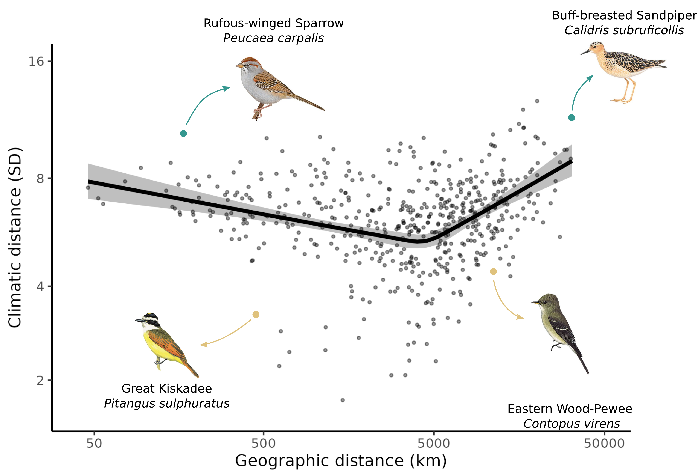Figure 3.1: Trade-off between movements in geographic and climatic space. Relationship between climatic and geographic distance travelled by each species. Each point is the sum of distances between the centroids of consecutive weeks in climatic and geographic space weighted by abundance. The line is the mean effect and the envelope is the 95% credible interval built using the posterior predictive distribution of the piecewise model. We highlighted an example of a resident ‘niche-switcher’ (Rufous-winged Sparrow), a resident ‘niche-tracker’ (Great Kiskadee), a migrant ‘niche-switcher’ (Buff-breasted Sandpiper), and a migrant ‘niche-tracker’ (Eastern Wood-Pewee). Turquoise points are the highlighted ‘niche-switchers’, and golden points are the highlighted ‘niche-trackers’.

Figure 3.2: Relationships between migratory behaviour and species traits. Effects of body mass (left panels), hand-wing index (centre panels), and trophic guilds (right panels) on geographic distance (upper panels) and climatic distance (lower panels) travelled by birds. Each point is a species, and the lines and boxplot are the effects determined by the posterior predictive distribution. For each trait, the figure shows the direct effect of the trait (after controlling for other traits).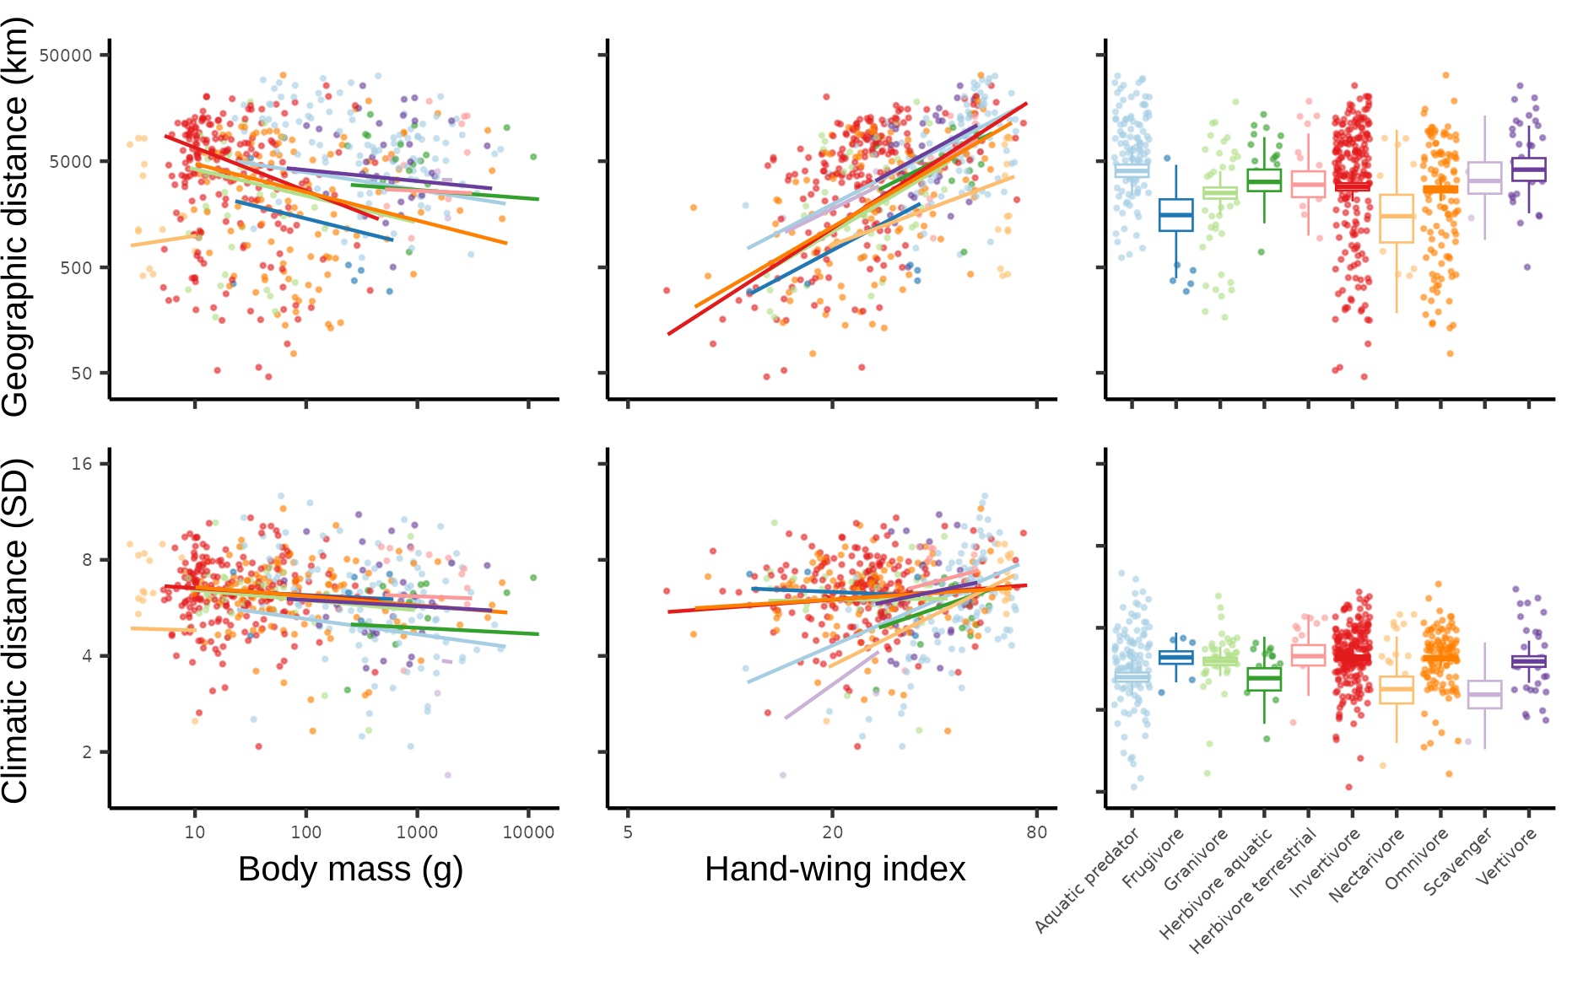

Figure 3.4: Seasonal variation in the latitudinal div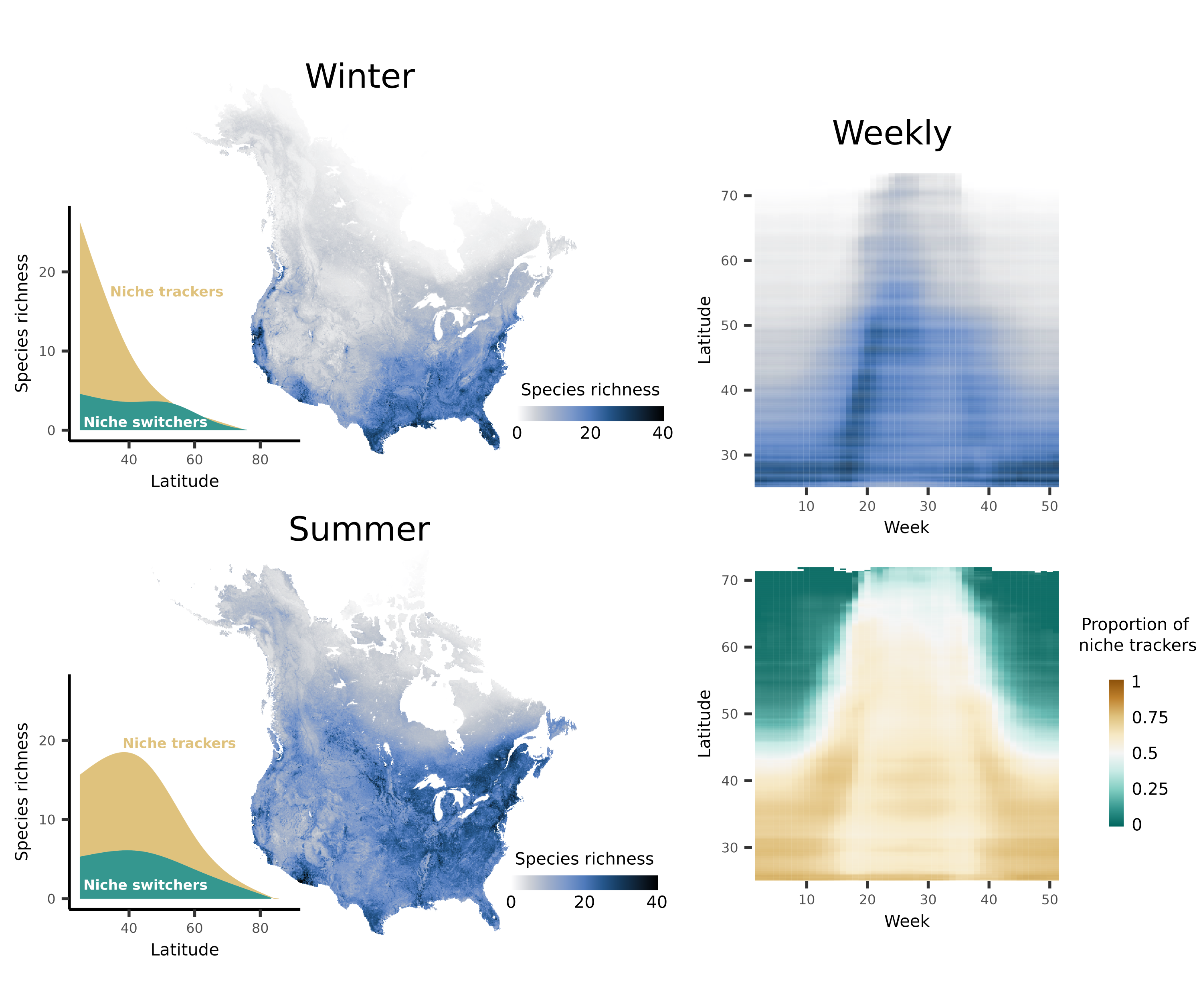ersity gradient. Maps show the species richness calculated as the sum of the probability of occurrences for winter and summer. The area plots show the latitudinal diversity gradient for ‘niche-trackers’ and ‘niche-switchers’. ‘Niche-trackers’ and ‘switchers’ are respectively defined as species that travel less and more than average in climatic space. The upper heatmap shows the average species richness for each week and latitude, whereas the lower heatmap shows the average proportion of ‘niche-trackers’, calculated as the number of ‘niche-tracker’ species divided by total richness, for each latitude and week.

Figure 3.4: Seasonal variation in Bergmann’s rule. Relationship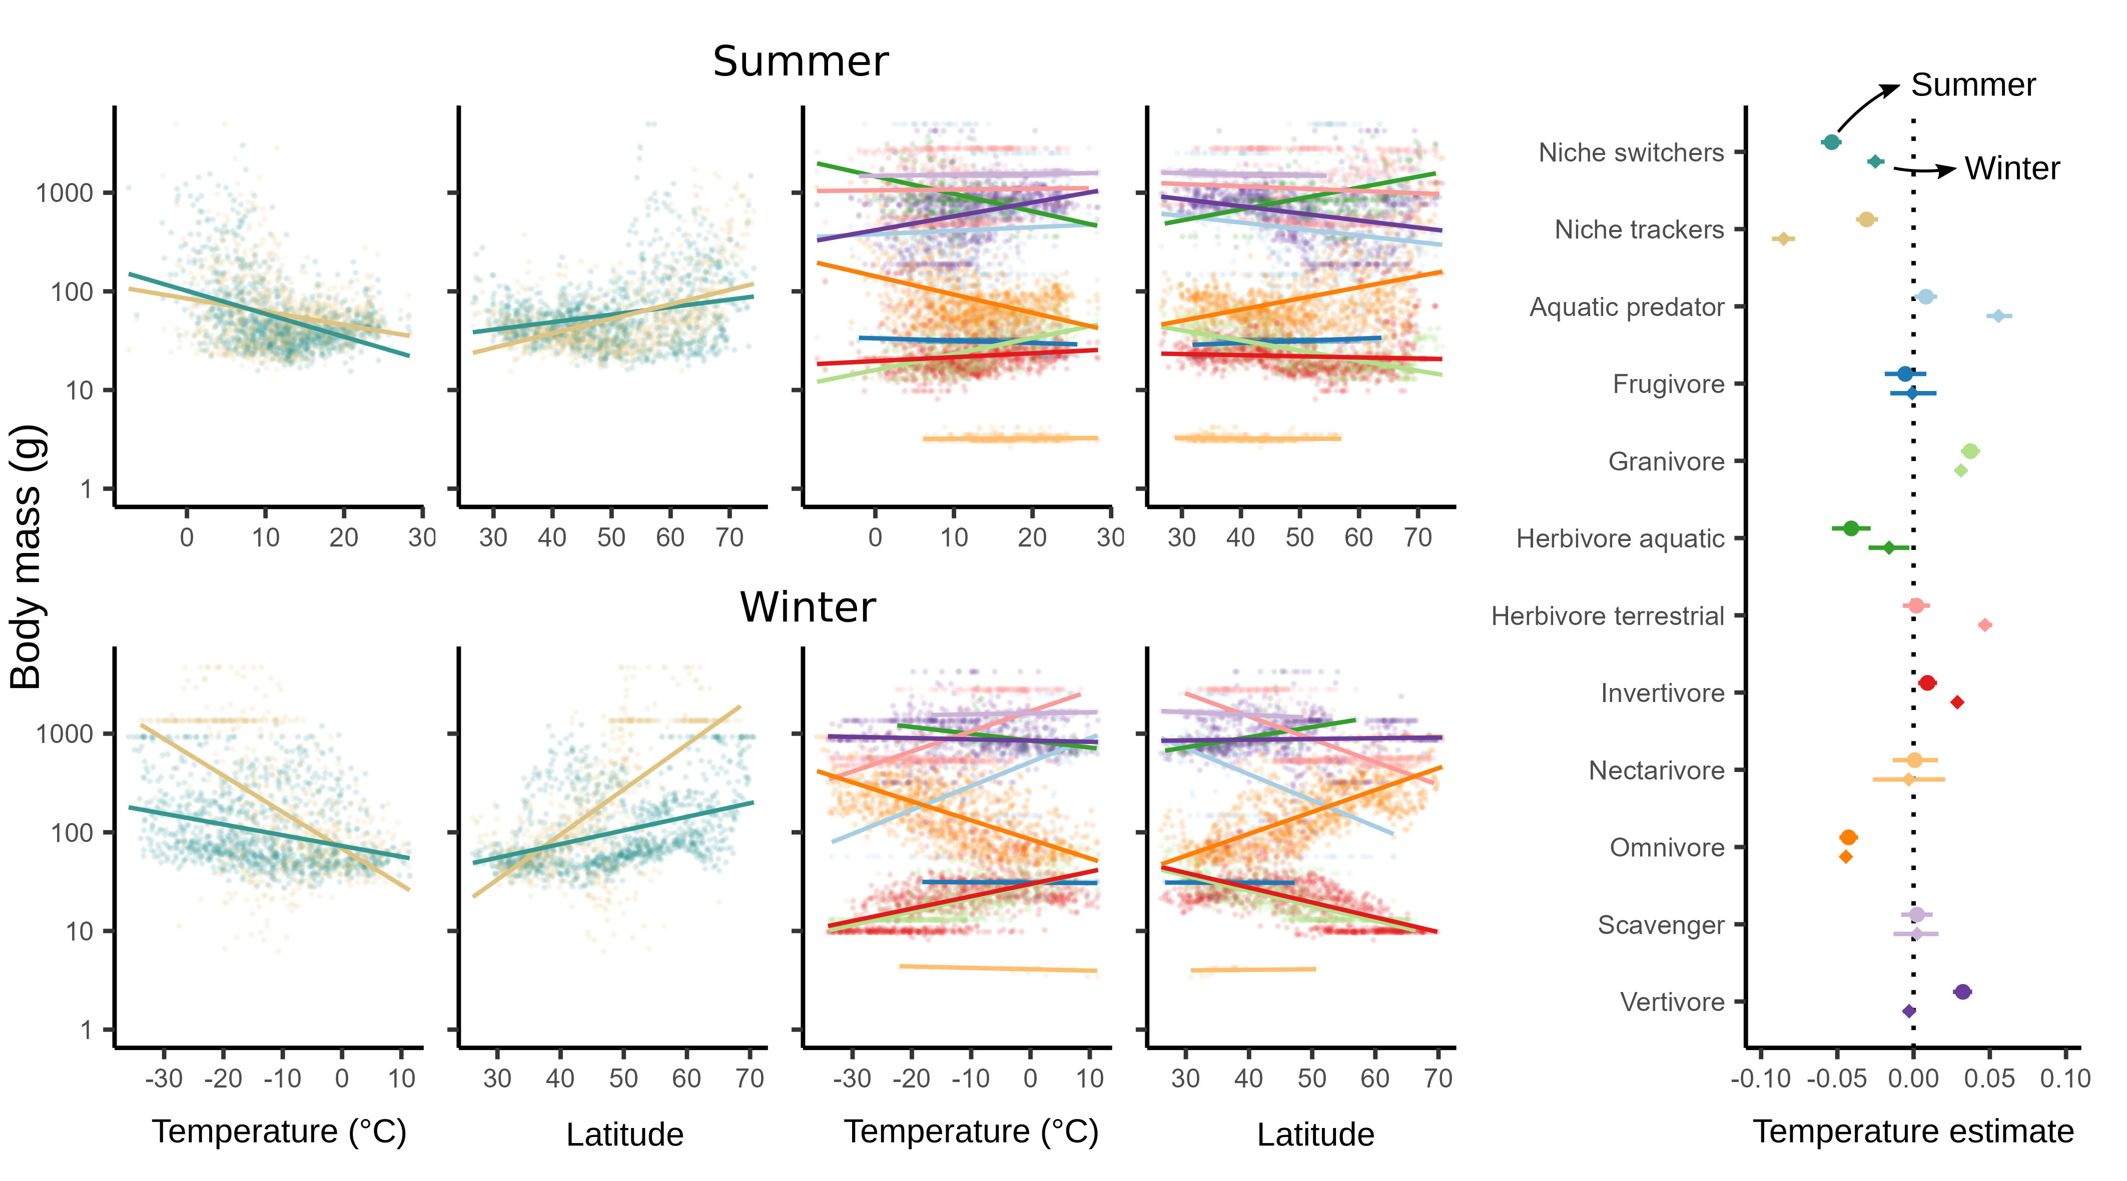s between community-weighted mean body mass and temperature and latitude. Models allowed varying slopes for tracking strategy (‘niche-switchers’ in turquoise and ‘trackers’ in gold) in the two leftmost scatterplot columns or for trophic guilds in the two rightmost scatterplot columns. The upper panels show the mean effects for summer and the lower panels the mean effects for winter. The rightmost plot shows the mean effect of temperature on log-transformed body mass with the 95% credible interval built from the posterior distribution.

