Chapter 4: The level of human impact and lack of protection during migration drive the decline of the North American avifauna
Dominique Caron^{1,2}, Pierre Legagneux³, David Beauchesne⁴, Phillippe Archambault³, Laura J. Pollock^{1,2}

Affiliations
¹ Department of Biology, McGill University, Montreal, QC, Canada
² Quebec Centre for Biodiversity Sciences, Montreal, QC, Canada
³ Département de Biologie and Centre d’études Nordiques, Université Laval, Québec, QC, Canada
⁴ University of Toronto, Toronto, Ontario, Canada

The following is in preparation for submission to Current Biology

Summary
The decline of North American birds poses a significant threat to ecosystems. Although human pressure is largely responsible for this decline, its impact on species abundance trends throughout the entire annual cycle of birds remains poorly understood. This paper investigates how human footprint and coverage in protected areas throughout the year relate to population trends for 487 North American bird species. We found a decline of 19% and 39% in bird abundance within breeding areas over the entire study area between 1970 and 2017. The only positive trends were seen for the tundra during the wintering season, driven by the increase in abundance of the few overwintering residents. As expected, birds facing more human pressure during migration had more pronounced population declines; this supports evidence that migration is a critical season for bird conservation and that protecting migration routes and stopovers could play a critical role in mitigating anthropogenic impacts. Contrary to expectations, we observed positive effects of human footprint during breeding or wintering seasons, possibly driven by the increases in urban-tolerant species or ecosystem recoveries of high-human footprint areas. Additionally, we found that smaller birds and those undertaking longer migration distances tend to decline more, highlighting the importance of considering species-specific vulnerabilities in conservation strategies. Overall, our findings underscore the need for holistic conservation approaches that integrate species traits, spatiotemporal variations in stressors and protection measures.

Introduction
Biodiversity is declining across the globe and is increasingly threatened by environmental pressures driven by human activities (Di Marco et al., 2018; Halpern et al., 2019; Venter et al., 2016; Williams et al., 2020). Bending the curve of biodiversity loss ultimately depends on our ability to reduce the effect of these human impacts on populations (Leclère et al., 2020). But, understanding how multiple stressors affect populations is challenging, especially when they vary in time and space, affecting species at single or multiple life stages (Beauchesne et al., 2021; Côté et al., 2016; D. Vinebrooke et al., 2004); this is especially crucial for declining migratory species exposed to varying levels over their annual cycle (Bairlein, 2016; Wilcove & Wikelski, 2008).

Migratory birds are one of such declining groups exposed to different stressors throughout the year (Inger et al., 2015; Lees et al., 2022; Rosenberg et al., 2019). Rosenberg et al. (2019) reported a net loss of 29% of bird abundance in North America between 1970 and 2017. Of course, not all bird species are declining. While the abundance of shorebirds and landbirds has been declining by 37.4% and 27.1% respectively, the abundance of waterfowl has been increasing by 56% (Rosenberg et al., 2019). A major source of mortality in birds is human and industrial activities (Calvert et al., 2013; Loss et al., 2015). It is estimated that domestic cats kill billions of birds in the United States and Canada, and hundreds of millions of birds die from collisions with buildings, automobiles, or power lines each year (Loss et al., 2015). Habitat loss, pesticides, and harvesting have also been identified as the main drivers for the severe decline of farmland birds observed in North America (Stanton et al., 2018). For seabirds, another group experiencing an important decline, invasive species (e.g., rats and cats), incidental mortality in fisheries, and overfishing are the main threats for many species (Dias et al., 2019). So, bird decline is likely driven, at least partly, by direct human impacts within their breeding, wintering, and migrating ranges.

Recent studies have shown how the level of threats and their effects on population trends can vary across seasons (Buchan et al., 2022; Howard et al., 2020; La Sorte et al., 2022; Vickery et al., 2014; Wilson et al., 2018). For example, La Sorte et al. (2022) showed that most nocturnally migrating North American bird populations were exposed to higher levels of air pollution during migration and winter, but did not relate this temporal pattern to long-term population trends. For migratory birds breeding in Europe, Buchan et al. (2022) found that the level of anthropogenic threats during the wintering season better predicted long-term population trends, even if it tended to be lower than during the breeding season. In contrast, Howard et al. (2020) found that population trends among European migratory birds were more closely associated with changes in climate than changes in land cover on their breeding grounds. They found the opposite on their wintering ground, where changes in land cover were more closely associated with population trends than climate changes. So, although the levels of stress birds are exposed to vary during their annual cycle, it remains unclear how they affect population trends, especially during migration seasons.

During migration, birds interrupt their travel between breeding and wintering grounds and aggregate in high density in stopover sites to rest and refuel (Schmaljohann et al., 2022). This creates a large migratory network that populations rely on to fulfill their full annual cycle (Moisan et al., 2023; Zhang et al., 2023). It has been shown that mortality during wintering season and migration can often exceed mortality during the breeding season (Rushing et al., 2017; Sillett & Holmes, 2002). Stressors affecting a species in one season can also carry over to affect the performance of individuals in other seasons (Norris et al., 2004; Reudink et al., 2009). It has therefore been suggested that habitat quality at stopover sites is especially crucial for survival and reproductive success (Guo et al., 2023; Morrick et al., 2022; Studds et al., 2017). Yet, most research has focused solely on the breeding season (Faaborg et al., 2010; Marra et al., 2015).

One of the main strategy governments have agreed on to slow biodiversity decline is the establishment of protected areas (CBD, 2022). While protected areas have been showed to benefit natural populations (Brighton et al., 2024; Brown et al., 2019; Langhammer et al., 2024; Michel et al., 2021; Sanderson et al., 2023; Wauchope et al., 2022), for migratory species, the success of conservation efforts rely on a network of sufficiently protected areas (Runge et al., 2014; Zhang et al., 2023). Yet, most Important Bird and Biodiversity Areas, which serve as basis for bird site-based protection worldwide, are based on bird’s breeding distributions. It is therefore likely that protection of migrating routes are not adequately protected. In fact, Runge et al. (2015) showed that, globally, just 9% of 1451 migratory birds are sufficiently covered by protected areas across all stages of their annual cycle, in comparison with 45% for nonmigratory birds. Similarly, Lin et al. (2020) found that less than 10% of stopover sites in North America, which contains around 30% of resident bird abundance in spring and fall migratory periods, were protected. Using a different methodology, Guo et al. (2024) found that landbirds in Northeastern United States tend to aggregate in protected areas as stopovers, but that overall, only a third of high density stopovers are protected and more than half of the protected stopovers are subject to extractive uses. Ultimately, birds rely on a large and well-distributed migratory network, but how the protection level over their full annual cycle explain variations in population trends within and across guilds is still unclear.

Species responses to human impacts and protection also depends species traits like habitat specialization, diet, and body size drive species responses to disturbances (Matuoka et al., 2020; Neate-Clegg et al., 2023). For example, Stevens et al. (2024) recently found that smaller body size, habitat and diet specialization, and longer migration distances were all associated with more severe decline among North American birds. So, birds decline likely depends on the combination of their traits, and their exposure to human pressure within their breeding, wintering, and migrating ranges.

In this study, we consider human pressure and protection over the full annual cycle of North American birds to investigate the drivers of trends in bird abundance across and within groups. To do this, we use weekly and seasonal distributions of species abundances for most bird species in the United States and Canada, along with spatial estimates of cumulative human footprint indices, a cumulative measure of human impacts, on land and water, species-level traits, and estimates of species-level trends. We expect wintering ranges of species to be more impacted but also more protected as many North American birds breed in relatively intact and ‘naturally protected’ Northern regions. We test whether increasing human pressure and lower protection during each season leads to stronger declines. Finally, we test whether species body mass, migratory distances, and diet explain variation in these trends. We expect traits to be important given that many large-bodied species recovered from declines after proactive conservation policies during the last decades (Rosenberg et al., 2019), many long-distance migrants are declining among birds and other groups (Bairlein, 2016; Wilcove & Wikelski, 2008), and that more specialized diet and certain guilds, like aerial insectivores, might be more affected by the decline of their resources (Bowler et al., 2019; Spiller & Dettmers, 2019).

Results
Spatiotemporal patterns of abundance and loss
The distribution of North American birds varies strongly between breeding, wintering, and migration seasons (seasons of each species defined by eBird). We estimated this by combining the seasonal distribution of 487 bird species estimated by eBird Status and Trends (Fink et al., 2020, 2023) with their population size and change in abundances between 1970 and 2017 estimated by Rosenberg et al., 2019. We assumed that the number of individuals lost for a given species in a given area is proportional to its local density (see Methods for details).

Specifically, birds are more concentrated during the wintering season than in other seasons (Figure 4.1d-e). During the wintering season, birds are concentrated in southern and coastal United States, with very few individuals in Northern regions (Figure 4.1e). In contrast, bird abundances are more dispersed during the breeding season, with the Midwest United States, Northeast United States, Pacific Northwest, and areas around the St. Lawrence River being home to the highest density of birds (Figure 4.1c). During migration, bird abundances show an intermediate spread between the breeding and wintering seasons, with the US midwest and northeast coast having the highest density (Figure 4.1d).

Overall, bird abundance decreased in nearly all regions and seasons (Figure 4.1f-h). On average, bird abundances decreased by 29% (with 50% of the pixels between 19% and 39% decrease) in the breeding season, by 31% (with 50% of the pixels between 24% and 39% decrease) during the migratory season, and by 23% (with 50% of the pixels between 8% and 37% decrease) during the wintering seasons between 1970 and 2017. During the wintering season, we found an overall increase in bird abundance in the Arctic Tundra. This is driven by the increase of the very few species present in the region during winter. For example, Rosenberg et al. (2019) estimated that the abundances of the Common raven (Corvus corax) and the Hoary Redpoll (Acanthis hornemanni) have increased by around 80% and 66% respectively between 1970 and 2017.

Seasonal patterns of human footprint and protection
Overall, we find that birds are exposed to more human pressures during winter than summer (Figure 4.2a and 4.2c), but that their range is also better protected during winter (Figure 4.2b and 4.2d). This result is likely driven by the lower level of protection and human footprint in Northern regions (Figure 4.1a-b), where the vast majority of species are only present during summer. We estimate this by calculating the mean cumulative human impact on land and water over each species’ weekly range (Figure 4.1a) weighted by the abundance. For each bird, we also estimated the level of protection for each week by calculating the proportion of species ranges that overlap with protected areas (Figure 4.1b) weighted by abundance.

We also found distinct spatiotemporal distribution of protection and human impact between aquatic (waterbirds, waterfowls and wetland birds) versus terrestrial birds (landbirds) and between declining and increasing birds. Specifically, declining aquatic migratory birds are exposed to less human pressures on land, more human pressure on water, and are better protected than birds for which the abundance increased (Figure 4.2a-b). Conversely, there is no qualitative difference of human impact between birds declining or increasing in abundance (Figure 4.2c). However, the ranges of land migratory birds increasing in abundance is better protected than the ones declining, especially during summer (Figure 4.2d).

Effect of human footprint and protection to trends
We found that seasonal human pressures and protection have significant, but sometimes contrasting effects on migratory birds, and no apparent effect on resident birds (Figure 4.3). We estimated these effects from modelling species trends as a function of the levels of human impact and protection during breeding, wintering, and migration seasons. We consider an effect significant when the 95% credible interval (95% CrI) does not contain 0 and insignificant otherwise.

For migratory land birds, abundance declined less with higher human impact, but only during migratory season (Figure 4.3a). Human footprint had a positive effect on trends during wintering (posterior mean: 0.0063; 95%CrI: [0.0014, 0.0112]), a positive effect during breeding (posterior mean: 0.0082; 95%CrI: [0.0004, 0.0160]), but a negative effect during migration (posterior mean: -0.0095; 95%CrI: [-0.0189, -0.0000]). In other words, species exposed to greater human pressures during their migration tend to decline more, while species with greater exposure during the breeding and wintering seasons tend to decline less. We also found that species that are better protected during migration tend to decline less, although not significantly (posterior mean: 0.0049; 95% CrI: [-0.0030, 0.0127]).

For water-based migratory birds, human impact on land had a weaker effect on trends compared to land migratory birds (Figure 4.3c). Not surprisingly, the level of human impact on water was more important than human impact on land for water migratory birds. We found a significant negative effect of human footprint during migration (posterior mean: -0.0163; 95% CrI: [-0.0317, -0.0003]), and a significant positive effect of human footprint during breeding (posterior mean: 0.0176; 95%CrI: [0.0054, 0.0291]). In contrast to migratory land birds, species for which the migration ranges were better protected were declining more (posterior mean: -0.0106; 95%CrI: [-0.0194, -0.0018]).

Traits of declining birds
We found that smaller species, and species migrating longer distances tended to decline more, demonstrated by modelling trends as a function of traits (Figure 4.4). Overall, species body mass had the strongest effect (posterior mean: 0.0086; 95%CrI: [0.0031, 0.0140]). Migration distance had also an effect, but negative and not significant (posterior mean: -0.0043; 95%CrI: [-0.0101, 0.0015]). Grassland birds declined more than other guilds both when other traits are taken into account (posterior mean: -0.0189; 95%CrI: [-0.0329, -0.0050]) and when they are not (posterior mean: -0.0170; 95%CrI: [-0.0319, -0.0031]). Aerial insectivores also declined more than other guilds (posterior mean: -0.0120; 95%CrI: [-0.0207, -0.0032]), but only when differences in body mass and migration distance are not taken into account. Finally, birds of prey (posterior mean: 0.0181; 95%CrI: [0.0036, 0.0325]) and seabirds (posterior mean: 0.0241; 95%CrI: [0.0086, 0.0398]) increased more in abundance than other guilds, but again, only when differences in body mass and migration distance are not taken into account.

Discussion
Migratory bird populations, which are declining globally, are exposed to diverse human-driven stressors and levels of protection throughout their annual cycles. In this paper, we investigated the spatiotemporal dynamics of stressors and protection across the annual cycle of North American birds and their association with population trends. We found that: 1) bird communities declined on average between 19% and 39% across all seasons and most locations between 1970 and 2017 with the notable exception being resident birds that winter in the north, 2) while human impact and protection influenced abundance in, sometimes, unexpected ways, the level of protection and human impact in migratory ranges appeared to be particularly important, and 3) smaller birds and birds that travel longer distances tend to decline more than average. These results highlight the importance of considering full annual cycles and species-specific traits in conservation efforts.

One reason for the nuanced results is that the two stressors (human impact and lack of protection) are somewhat inversely related and could offset each other in some cases. For example, birds tend to experience higher human impact but also are better protected in the winter. In contrast, many birds breed in areas with fewer humans but also less protection. This result is not surprising given that many birds breed in the relatively intact, but less protected, boreal and arctic ecosystems and winters in more human densely occupied lower latitudes. Previous studies reported similar findings. For example, La Sorte et al. (2022) found that light and air pollution is at its lowest during breeding among nocturnally migrating birds. Wilson et al. (2018) also reported that the Canada Warbler (Cardellina canadensis) is exposed to higher human footprint within its wintering range compared to its breeding range. Similar to our finding, Lin et al. (2020) found that breeding ground are usually less well protected than winter range.

Our results add to the body of literature showing the importance of the migratory season. Birds experiencing higher human pressures during migration exhibit more pronounced declines, demonstrating that the quality of migration routes and stopovers is especially essential to mitigate the negative effects of anthropogenic disturbances on migratory bird populations. This corroborates recent results and calls for focusing management efforts on the quality of bird migration routes, especially on stopovers (Bayly et al., 2018; Marra et al., 2015; Newton, 2006). For example, Studds et al. (2017) found that the reliance of migratory shorebirds of the East Asian-Australasian Flyway on the Yellow Sea tidal mudflats - where more than 50% of the area has been lost over the past 50 years (Murray et al., 2015) - as stopover sites is a leading driver of population declines. It has also been shown that mortality is often at its highest during migration (Rushing et al., 2017) and that the quality of stopovers might have a large impact on the survival and reproductive success during breeding (Legagneux et al., 2011; McGowan et al., 2011). During this relatively long period, birds need to refuel and rest in an already stressful situation due to large movement costs. Therefore, changes in habitat quality can have disproportionate effects that could carry over to affect individuals during other seasons.

Surprisingly, we found positive effects of human footprint on species trends during breeding and wintering seasons. A few reasons could explain this finding. First, urban tolerant species might be both declining less and breeding/wintering more often in areas of high human influence, driving this relationship. This, however, is not supported by the recent results of Petrenko et al. (2024) who found no relationship between bird urban tolerance (measured as reliance on urban habitats during breeding) and population trends among North American bird species. Second, the human footprints we used documents only a single year (1993 for terrestrial and 2003 for marine human footprint) that do not fit all the years documented by the trend data (1970-2017). In North America, many areas of high human footprint have been stable or improving in the last decades (Halpern et al., 2019; Venter et al., 2016). So, birds breeding and wintering in high human footprint areas could also benefited from recovering ecosystems. We tested whether the discrepancy might influence by using the human footprint for the most recent years available (2009 for terrestrial and 2013 for marine human footprint), but found qualitatively identical results (Appendix S1). Third, correlations between human footprints in different seasons were sometimes very high (Appendix S2). It is therefore possible that the correlation between variables (collinearity) enhanced some of the relationships between human impact and species trends we found. However, based on our sensitivity analyses and model diagnostics, our models converged well and coefficients were stable (Appendix S2). Finally, Serratosa et al. (2024) recently found that human-induced mortality in the African-Eurasian flyway was highest at intermediate levels of human footprint. Therefore, the relationship between species trends and human footprint might be non-linear.

Furthermore, our analysis of species traits provides additional insights into the drivers of population trends. Consistent with previous studies (Gilroy et al., 2016; Soykan et al., 2016; Stevens et al., 2024), we found that smaller birds tend to decline more than larger ones. This positive relationship between body mass and species trends contrasts with the general “downsizing” (i.e., loss of larger species) observed for the tetrapods (Atwood et al., 2020; Cooke et al., 2019; Ripple et al., 2017). Soykan et al. (2016) and Stevens et al. (2024) attribute this relationship to the recent recovery of many species, such as raptors and waterfowl, following environmental regulations and management efforts. The increase in birds of prey over the last decades could also explain why smaller species, that are more likely to be preyed upon, are declining more. Additionally, birds undertaking longer migration distances also show a trend toward decreased abundance. This is consistent with recent findings that long-distance migrants, which are exposed to additional threats along their migration routes, are declining globally (Horns & Şekercioğlu, 2018; Koleček et al., 2021; Stevens et al., 2024; Wilcove & Wikelski, 2008). Many migratory populations seasonally aggregate in small areas (e.g., staging areas), making them especially vulnerable to perturbations, such as habitat deterioration. They also rely on the connectivity of large migratory networks, which are insufficiently protected (Runge et al., 2015). Finally, climate change may disproportionately affect migrating species by shifting their phenology, migration timing, passage and wintering areas (Visser et al., 2009). The differential trends among trophic guilds, body masses, and migration distance, highlight the loss of functional diversity among birds, having a potentially large impact on ecosystem functions.

Overall, our study underscores the importance of adopting a holistic approach to avian conservation that integrates spatiotemporal variation in stressors, protection measures, and species traits. Conservation efforts should prioritize the identification and protection of critical stopover sites and migration corridors, especially in regions experiencing high human pressures. Implementing dynamic conservation areas during critical periods (e..g, stopovers during migration) to complement the network of permanent protected areas where long-term place-based protection is unfeasible could be especially beneficial for migratory species (D’Aloia et al., 2019; Runge et al., 2014). Additionally, targeted conservation interventions tailored to the specific needs and large vulnerabilities of different bird species and habitats are essential for effectively mitigating biodiversity loss and promoting the long-term survival of migratory bird populations.

Figures
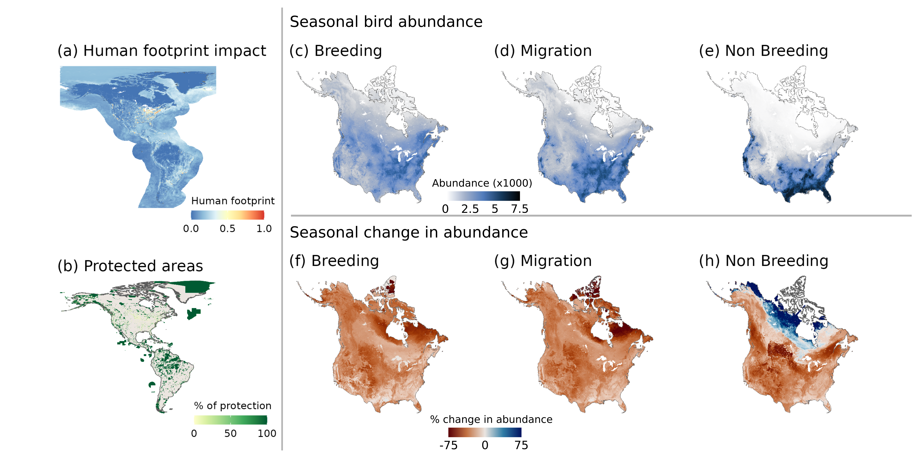Figure 4.1: Seasonal bird abundances and changes in abundances between 1970 and 2017. a and b, we show the distribution of human footprint and protected areas over North and South America. % of protection represent the % of the pixel that is protected. c-d, we show the number of birds found in each pixel during breeding, migration, and non breeding seasons. f-h show the estimated change in number of individuals in each pixel during breeding, migrating and non breeding seasons when assuming that the local loss of individual of a given species is proportional to its local abundance. For c-f, we used species-specific seasons defined by eBird Status and Trends, and non-migratory birds are included in all three seasons.

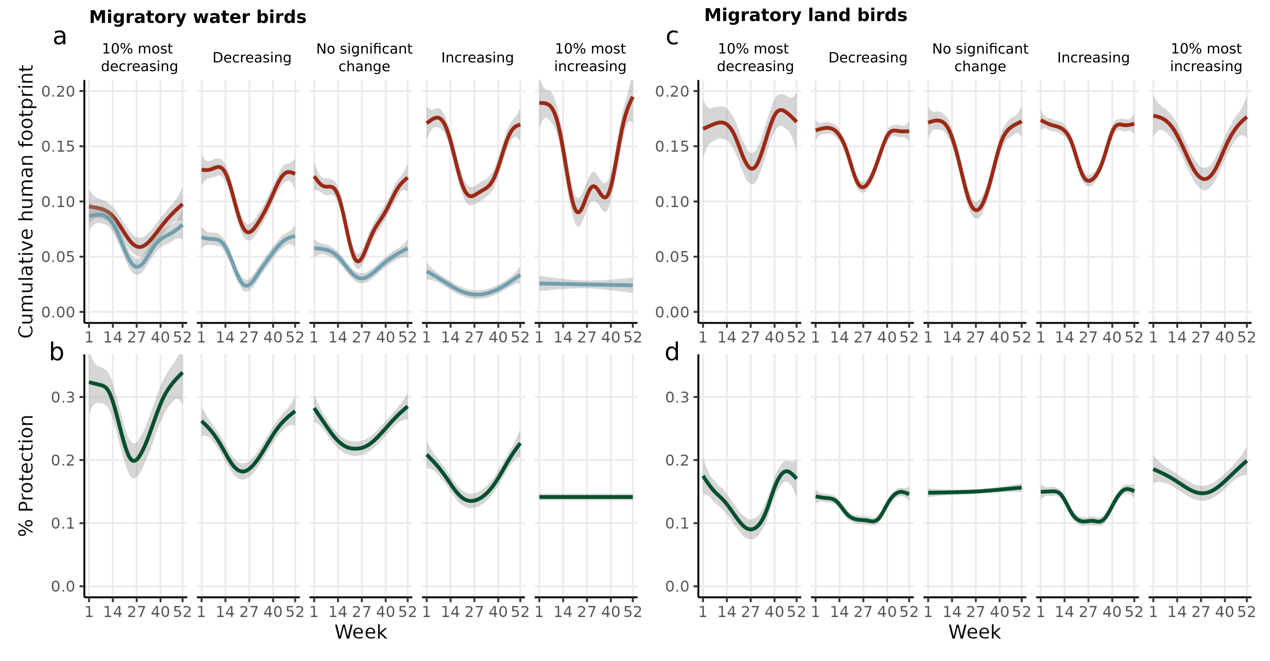Figure 4.2: Weekly level of human footprint and protection across migratory water birds and migratory land birds. In each panel, the line shows the posterior mean and 95% credible interval estimated from generalized additive models; a shows the level of human impact of each week on land (red) and on water (blue) for migratory water birds; b shows the level of protection for each week (green); c shows the level of human impact of each week on land (red) for migratory water birds; and d shows the level of protection for each week (green) for migratory land birds. Species are divided into 5 categories based on their trends between 1970 and 2017.

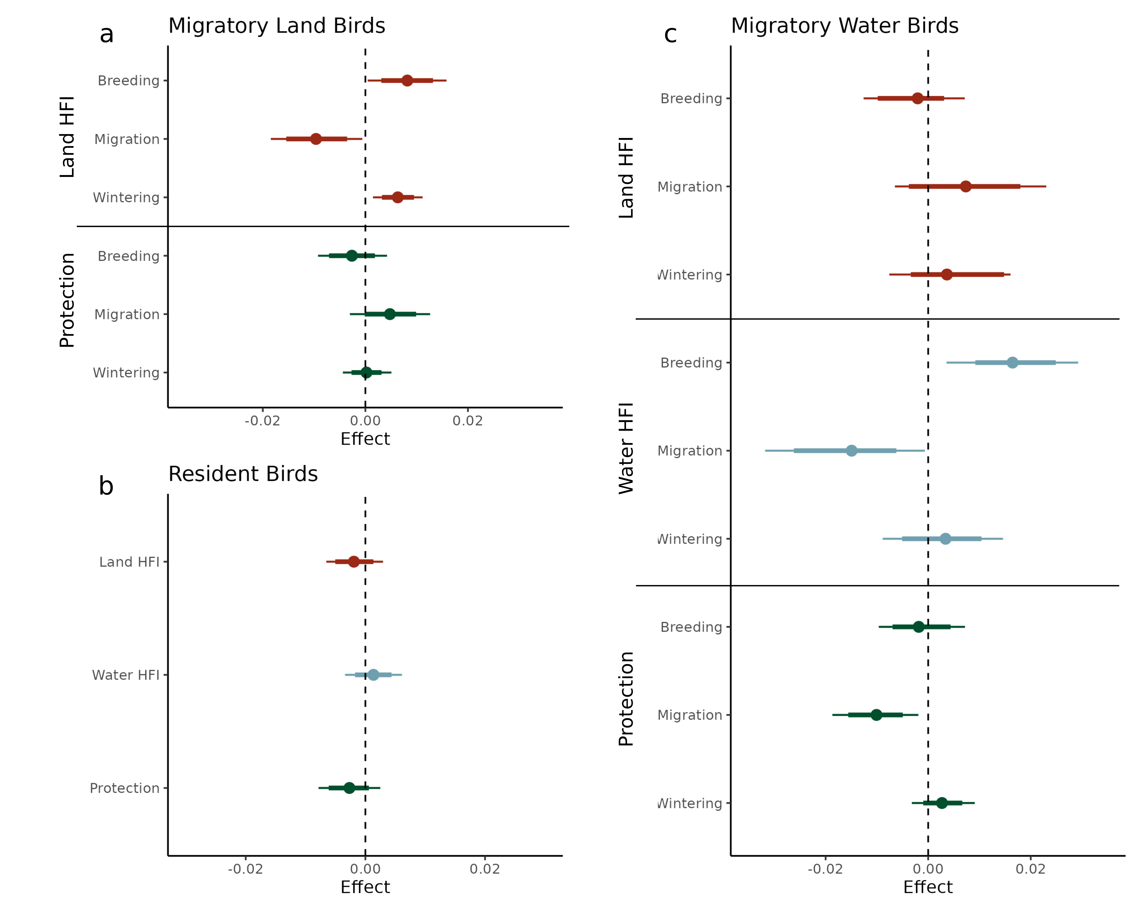Figure 4.3: Effects of seasonal level of human footprint and protection on species trends. Point is the posterior mean with their 80% and 95% credible intervals of the effect of each predictor variable on the average yearly proportional change in abundance for species. Predictor variables are log-transformed and scaled.

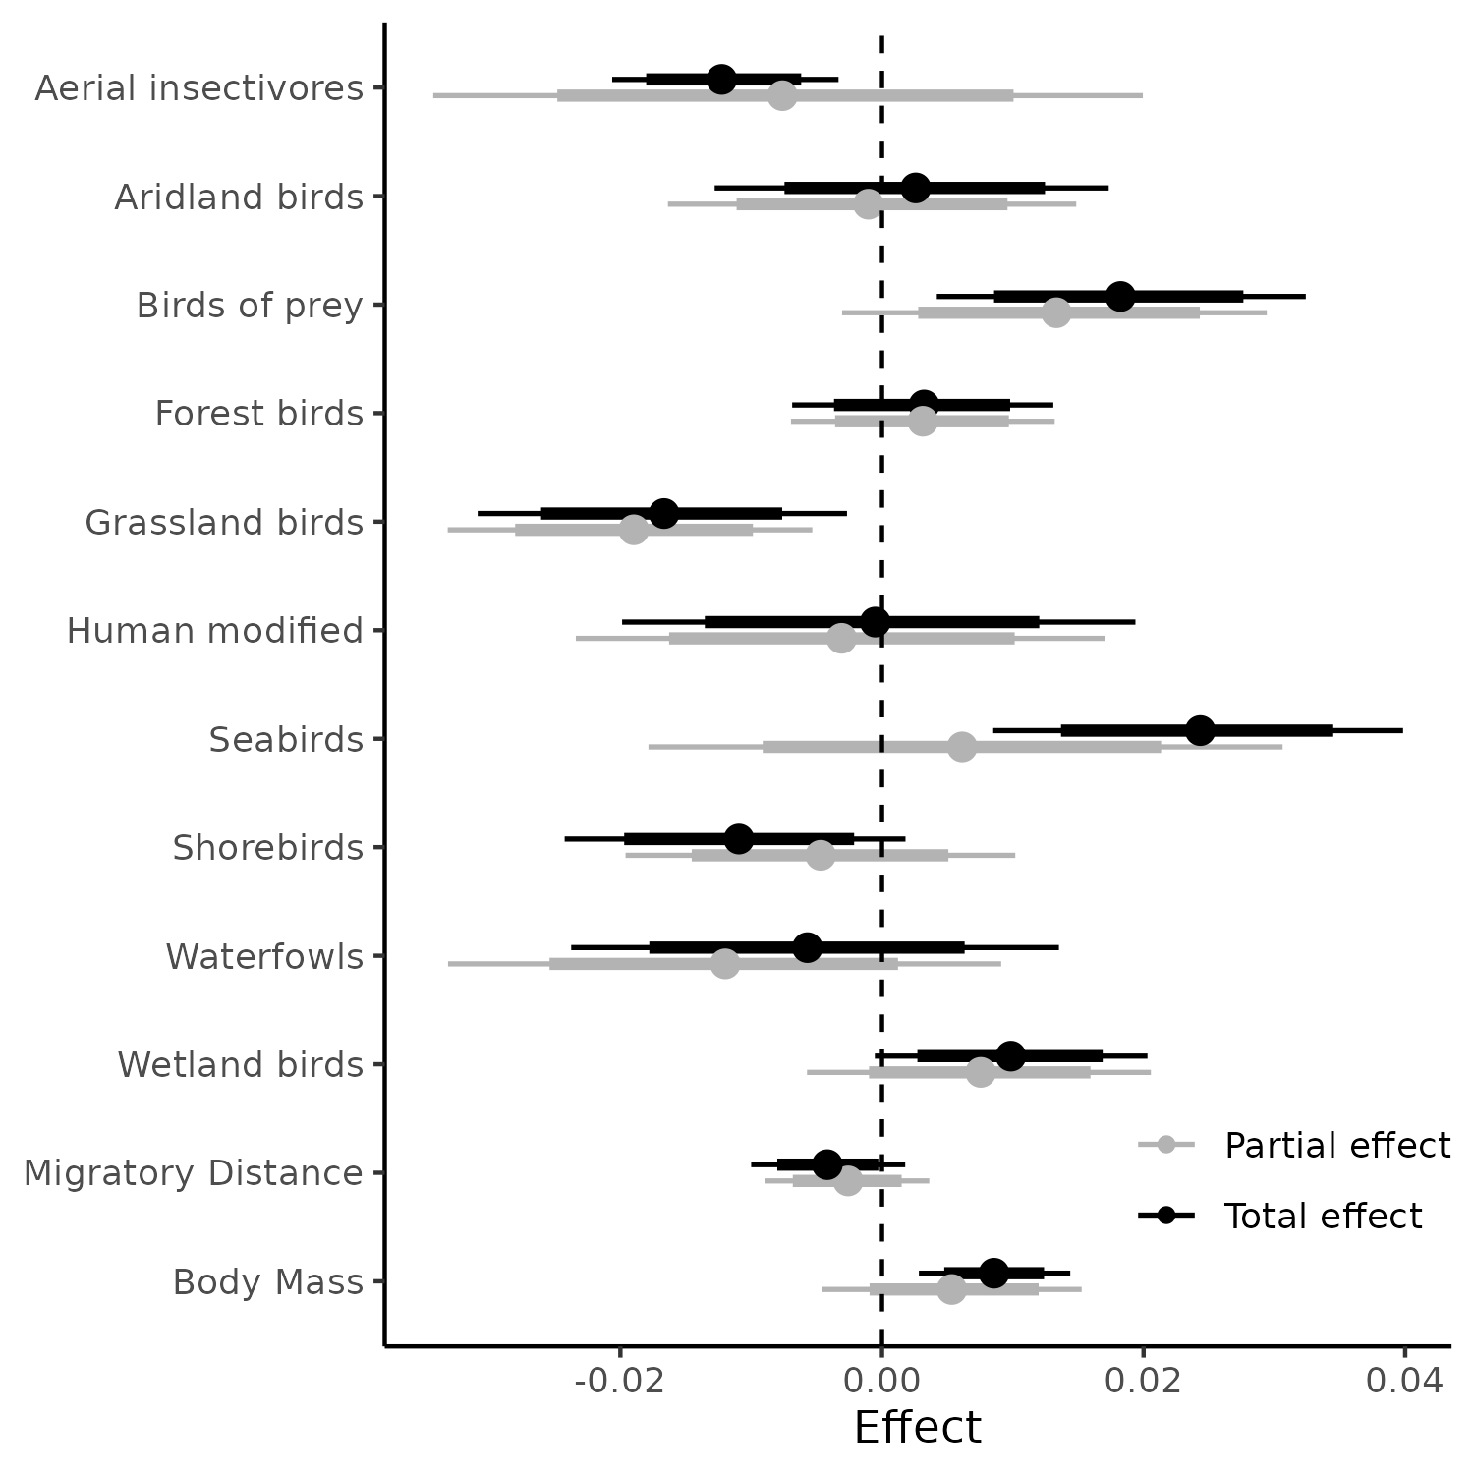Figure 4.4: Effects of species traits on species trends. Point is the posterior mean with their 80% and 95% credible intervals of the effect of each predictor variable on the average yearly proportional change in abundance for species. Body mass and migratory distance are log-transformed and scaled.
STAR Methods

Resource availability
Lead contact
Further information and requests for resources and reagents should be directed to and will be
fulfilled by the lead contact, Dominique Caron (dominique.caron@mail.mcgill.ca).

Materials availability
This study did not generate new unique reagents

Data and code availability
This paper analyzes existing, publicly available data. These accession numbers for the datasets are listed in the key resources table. All original code has been deposited on the Open Science Framework repository (https://osf.io/emjb3/?view_only=d796170b6c304f68b6b545a19b7879df) and is publicly available as of the date of publication. DOIs are listed in the key resources table.

Method details
Study area
Most of migratory birds breeding in Canada and the United States of America winters in Southern United States, Mexico, Central America, Caribbean or South America. Consequently, we chose, as a study area, a buffered region around North and South America. We downloaded the World Continents basemap layer from ESRI Data and Maps. We kept the polygons for North America and South America and applied a buffer of 1000 km.

For exploring the spatial variation of bird abundance and loss across seasons, we further constrained our study area to continental United States and Canada. We downloaded Natural Earth v5.0.0’s country polygons at a 10m resolution (https://www.naturalearthdata.com/downloads/10m-cultural-vectors/10m-admin-0-countries/), and kept the Canada’s and United States of America’s polygons. We removed Hawaii and other insular areas in the Caribbean and the Pacific.

Bird trends, distributions, and traits
We focused our analysis on birds breeding in the United States and Canada. We extracted the bird population estimates and trends of 529 species from Rosenberg et al. (2019). Population estimates represent the estimated number of individuals of each species in North America usually between 2006 and 2015. We also extracted the median population trends, which represent the estimated change in the number of individuals for each species usually between 1970 and 2017. Population trends and estimates are based on multiple standardized bird-monitoring datasets (e.g., North American Breeding Bird Survey). Trends are estimated using hierarchical Bayesian model that estimates the population sizes for each species. Finally, we extracted from Rosenberg et al. (2019) species management group: landbirds, shorebirds, waterbirds, and waterfowl. This gives us one estimate of population size and trends for each species.

Then, to understand how these species-level trends relate to how birds could be experiencing stress across seasons and space as they move through their full annual cycle, we extracted weekly and seasonal population abundance estimate from eBird Status and Trends data (version 2022) for each of the North American birds using the R package ebirst v3.2022. eBird Status and Trends relates eBird observations to elevation, topography, and land cover in a hierarchical machine learning model that accounts for observation effort and temporal scales to model species distribution for each week. We extracted the relative abundance of each species at the highest resolution available (2.8 × 2.8 km) within the study area (North and South America). We normalized each layer so that the sum of pixels equals 1. Values therefore represent the proportion of the population found in a given pixel at a given time. Models were available for 486 species out of the 529 birds for which we have trend estimates.

For traits, we extracted body mass and diet category for the 486 species from AVONET. AVONET compiles species-level trait means for all the world's bird species. We categorized species into ten guilds based on the State of the Birds report groups (Birds Canada and Environment and Climate Change Canada, 2024): aerial insectivores, aridland birds, birds of prey, forest birds, grassland birds, human modified specialists, seabirds, shorebirds, waterfowls, and wetland birds. We also estimated migratory distance of each species by taking the Great Circle Distance of geographical centroids of the breeding and wintering ranges. Geographical centroids of the breeding and wintering ranges was calculated using the mean latitude and longitude weighted by the relative abundance at each season separately.

Human footprint index and protection
We extracted terrestrial human footprint for 1993 from Venter et al. (2016) and the marine human impact for 2003 from Halpern et al. (2019). We used these years as they are the closest to the median year of the time range documented by the species trend data (1970-2017). In both cases, we extracted values of the cumulative impacts for the study area (buffered North and South America) at a 1km-grid resolution. Cumulative impact combines different stressors into a single estimate of human-driven pressure. Cumulative terrestrial human footprint is a composite of 8 human pressures: built environment, population density, electric infrastructures, crop lands, pasture lands, roads, railways, and navigable waterways. Marine cumulative footprint is a composite of 14 human pressures from fishing (6 layers), climate change (3 layers), shipping (1 layer), pollution (2 layers), light (1 layer), and human presence (1 layer). We standardized both layers of human footprint by dividing values by the respective maximum value within the study areas so that cumulative human impact varies from 0 to 1.

We extracted polygons for protected areas within the Americas from the World Database on Protected Areas (WDPA). WDPA is the most comprehensive global database of marine and terrestrial protected areas. We excluded protected areas for which the status is “Proposed” and protected areas for which the year of the status was 1970 or later to match the species trend data. After filtering, the database included 29 451 protected areas, including conservation easement areas, private conservation lands, preserves, parks, and marine protected areas. We rasterized and projected the vector layer to the eBird projection, and took the proportion of each pixel within a protected area as value. We also re-did all analyses including protected areas established between 1970 and 2017.

Quantification and statistical analysis
Spatiotemporal abundances and trends
To understand how bird abundances change across space and seasons, we estimated the seasonal abundance of birds for each pixel in North America by taking the product of each species’ population size estimate and the relative abundance of all birds for each season:
,
where Abundance_{jk} is the total number of individuals estimated for pixel j during season k, RelativeAbundance_{ijk} is the proportion of species i found in pixel j during season k, and popest_{i} is the latest mean population estimate for species i. For each migratory species, we have abundance estimates for “breeding”, “wintering”, “post-breeding” and “pre-breeding” seasons, whereas, for resident species, we have a single “resident” season.

For migratory species, we summed their abundance over all species for each pixel in each season separately. For resident species, we sum their abundance for each pixel. We then added the abundance of resident species to each seasonal abundance layer. For migration season, we took the mean between abundance estimate “post-breeding season” and “pre-breeding season”.

To estimate local changes in abundance, we assumed that, for each species, the change in abundance in a given pixel is proportional to its local relative abundance. To do so, we multiplied the seasonal relative abundance estimate with each species’ trend estimate. We then summed over all species trend layers. Similarly to local abundance layers, we did this for each season separately.
,
where RelativeAbundance_{ijk} is the proportion of species i found in pixel j during season k, and IndividualsLost is the number of individuals lost for species i. The result, AbundanceChange_{jk}, is an estimate of the absolute number of individuals lost in each pixel and season. We additionally divided the AbundanceChange layers by the correspondent Abundance layers to get an estimate of the percentage change in bird abundance for each pixel and season. While ideally, we would have population-level estimates of whether birds are declining in each season and each grid cell, our approach provides a useful approximation by combining species-level trends with levels of human impact and protection across space and time.

Seasonality of protection and human impacts
For each species, we estimated the exposition to weekly cumulative impact on terrestrial and marine areas for each week and season. To do so, we assume that the level of human footprint within a pixel is constant within a year. We multiplied the relative abundance estimate of each bird and time with the human footprint layer. We then summed over the values of each layer. This results in the average human footprint experienced by an individual of a given species at a given time.

We also estimated the level of protection for each species and week and season. To do so, we multiplied the relative abundance estimate of each bird and time with the protected area layer, and then summed up the values of each layer. This results in an estimate of the percentage of individuals found in a protected area for a given species at a given time.

To explore the level of human footprint and protection experienced by birds in each season, we fitted a generalized additive model with week as predictor. We did this analysis for water migratory birds (shorebirds, waterbirds, and waterfowl groups in Rosenberg, 2019) and land migratory birds (landbirds group in Rosenberg, 2019) separately. For water migratory birds, we separated human footprints on terrestrial and marine areas since they were extracted from two different sources and assembled using different methodologies. For land migratory birds, we excluded human footprint on marine areas since none of their range was found on water for most species. We excluded resident birds from the temporal analysis since the level of human footprint and protection do not vary over time. We further separated species into 5 subcategories according to their trends to estimate if the temporal dynamics of human footprint and protection qualitatively differ between increasing and declining birds. We first identified the 10% most declining and 10% most increasing birds in terms of percentage change in abundance between 1970 and 2017 and used the 95% credible interval reported by Rosenberg et al. (2019) to identify species that are significantly increasing and declining.

Trends-impact and protection relationships
For each species, we standardized trends by dividing the change in abundance by the number of years the change documents and by the population estimate for the species:
,

where IndividualsLost is the number of individuals lost between FirstYear and LastYear, and popest is the latest mean population estimate for species i. Therefore, Trend_{i} represents the average yearly proportional change in abundance for species i in North America.

We modelled trends as a function of the levels of protection and human footprint for land migratory birds, water migratory birds, and resident birds separately. For land migratory birds, we modelled trends as a function of the levels of protection and human footprint on land during the breeding, wintering, and migration seasons (six fixed effects). For water migratory birds, we added fixed effects for the level of human footprint during breeding, wintering, and migration season (nine fixed effects in total), and a random intercept for bird management group (three levels: waterfowl, waterbird, shorebird). Finally, for resident birds, the model only had three fixed effects: level of protection, land human footprint, and water human footprint. For each model, all fixed effects (level of protection and human footprints) were log-transformed and scaled.

Trends-trait relationship
We also modelled trend as a function species traits. We considered three traits: guild, body mass, and migratory distance. Guild was a categorical variable with 5 levels: Aerial insectivores (39 species), aridland birds (21 species), birds of prey (25 species), forest birds (127 species), grassland birds (25 species), human modified habitat birds (10 species), seabirds (19 species), shorebirds (34 species), waterfowls (12 species), and wetland birds (97 species). Migratory distance and body mass were log-transformed and standardized by dividing by twice their standard deviation to make coefficients of quantitative and categorical predictors comparable (Gelman, 2008).

Parameters of all models were estimated with Hamiltonian Monte Carlo (Neal, 2011). We ran four chains, each with 1000 warm-up iterations, followed by 1000 iterations for inference. We diagnosed convergence and adequacy with trace rank plots, posterior predictive checks, and we calculated the rank-normalized potential scale reduction factor on split chains for all runs (Vehtari et al., 2021). We conducted the analyses using Stan (Carpenter et al., 2017) through the package brms in R (Bürkner, 2018).

Key Resource Table
REAGENT or RESOURCE | SOURCE | IDENTIFIER
Deposited data
Bird distributions | Fink et al., 2023 | https://doi.org/10.2173/ebirdst.2022
Bird trends | Rosenberg et al., 2019 | https://doi.org/10.1126/science.aaw1313
Bird traits | Tobias et al., 2022 | https://doi.org/10.111/ele.13898
Land human footprint | Venter et al., 2017 | https://doi.org/10.5061/dryad.052q5
Marine human footprint | Frazier, 2019 | https://doi.org/10.5063/F12B8WBS
Protected areas | UNEP-WCMC & IUCN (2023) | N/A
Country boundaries version 5.0.0 | Natural Earth | N/A
Continent boundaries | Esri Data and Maps | N/A
Analyzed data | This paper | https://osf.io/emjb3/?view_only=d796170b6c304f68b6b545a19b7879df
Software and algorithms
R Statistical Computing language version 4.3.3 | R Core Team, 2024 | https://cran.r-project.org/src/base/R-4/R-4.3.3.tar.gz
ebirdst R package version 3.2022 | Strimas-Mackey et al., 2023 | https://ebird.github.io/ebirdst/
terra R package version 1.7-55 | Hijmans, 2023 | https://CRAN.R-project.org/package=terra
brms R package 2.20.6 | Bürkner, 2017, 2018 | https://doi.org/10.18637/jss.v080.i01
Code to replicate analyses of this study | This paper | https://osf.io/emjb3/?view_only=d796170b6c304f68b6b545a19b7879df

References
Atwood, T. B., Valentine, S. A., Hammill, E., McCauley, D. J., Madin, E. M. P., Beard, K. H., & Pearse, W. D. (2020). Herbivores at the highest risk of extinction among mammals, birds, and reptiles. Science Advances, 6(32), eabb8458. https://doi.org/10.1126/sciadv.abb8458
Bairlein, F. (2016). Migratory birds under threat. Science, 354(6312), 547–548. https://doi.org/10.1126/science.aah6647
Bayly, N. J., Rosenberg, K. V., Easton, W. E., Gómez, C., Carlisle, J., Ewert, D. N., Drake, A., & Goodrich, L. (2018). Major stopover regions and migratory bottlenecks for Nearctic-Neotropical landbirds within the Neotropics: A review. Bird Conservation International, 28(1), 1–26. https://doi.org/10.1017/S0959270917000296
Beauchesne, D., Cazelles, K., Archambault, P., Dee, L. E., & Gravel, D. (2021). On the sensitivity of food webs to multiple stressors. Ecology Letters, 24(10), 2219–2237. https://doi.org/10.1111/ele.13841
Birds Canada and Environment and Climate Change Canada. 2024. The State of Canada’s Birds Report. Accessed from NatureCounts. DOI: https://doi.org/10.71842/8bab-ks08
Bowler, D. E., Heldbjerg, H., Fox, A. D., de Jong, M., & Böhning-Gaese, K. (2019). Long-term declines of European insectivorous bird populations and potential causes. Conservation Biology, 33(5), 1120–1130. https://doi.org/10.1111/cobi.13307
Brighton, C. H., Massimino, D., Boersch-Supan, P., Barnes, A. E., Martay, B., Bowler, D. E., Hoskins, H. M. J., & Pearce-Higgins, J. W. (2024). The benefits of protected areas for bird population trends may depend on their condition. Biological Conservation, 292, 110553. https://doi.org/10.1016/j.biocon.2024.110553
Brown, J. A., Lockwood, J. L., Avery, J. D., Curtis Burkhalter, J., Aagaard, K., & Fenn, K. H. (2019). Evaluating the long-term effectiveness of terrestrial protected areas: A 40-year look at forest bird diversity. Biodiversity and Conservation, 28(4), 811–826. https://doi.org/10.1007/s10531-018-01693-5
Buchan, C., Franco, A. M. A., Catry, I., Gamero, A., Klvaňová, A., & Gilroy, J. J. (2022). Spatially explicit risk mapping reveals direct anthropogenic impacts on migratory birds. Global Ecology and Biogeography, 31(9), 1707–1725. https://doi.org/10.1111/geb.13551
Bürkner, P.-C. (2017). brms: An R Package for Bayesian Multilevel Models Using Stan. Journal of Statistical Software, 80(1). https://doi.org/10.18637/jss.v080.i01
Bürkner, P.-C. (2018). Advanced Bayesian Multilevel Modeling with the R Package brms. The R Journal, 10(1), 395. https://doi.org/10.32614/RJ-2018-017
Calvert, A. M., Bishop, C. A., Elliot, R. D., Krebs, E. A., Kydd, T. M., Machtans, C. S., & Robertson, G. J. (2013). A Synthesis of Human-related Avian Mortality in Canada. Avian Conservation and Ecology, 8(2), art11. https://doi.org/10.5751/ACE-00581-080211
Carpenter, B., Gelman, A., Hoffman, M. D., Lee, D., Goodrich, B., Betancourt, M., Brubaker, M., Guo, J., Li, P., & Riddell, A. (2017). Stan: A Probabilistic Programming Language. Journal of Statistical Software, 76(1). https://doi.org/10.18637/jss.v076.i01
CBD. (2022). The Kunming-Montreal Global Biodiversity Framework. Conference of the Parties to the Convention on Biological Diversity, Montreal, Canada. https://www.cbd.int/doc/c/e6d3/cd1d/daf663719a03902a9b116c34/cop-15-l-25-en.pdf
Cooke, R. S. C., Eigenbrod, F., & Bates, A. E. (2019). Projected losses of global mammal and bird ecological strategies. Nature Communications, 10(1), 2279. https://doi.org/10.1038/s41467-019-10284-z
Côté, I. M., Darling, E. S., & Brown, C. J. (2016). Interactions among ecosystem stressors and their importance in conservation. Proceedings of the Royal Society B: Biological Sciences, 283(1824), 20152592. https://doi.org/10.1098/rspb.2015.2592
D. Vinebrooke, R., L. Cottingham, K., Norberg, J., Marten Scheffer, I. Dodson, S., C. Maberly, S., & Sommer, U. (2004). Impacts of multiple stressors on biodiversity and ecosystem functioning: The role of species co-tolerance. Oikos, 104(3), 451–457. https://doi.org/10.1111/j.0030-1299.2004.13255.x
D’Aloia, C. C., Naujokaitis-Lewis, I., Blackford, C., Chu, C., Curtis, J. M. R., Darling, E., Guichard, F., Leroux, S. J., Martensen, A. C., Rayfield, B., Sunday, J. M., Xuereb, A., & Fortin, M.-J. (2019). Coupled Networks of Permanent Protected Areas and Dynamic Conservation Areas for Biodiversity Conservation Under Climate Change. Frontiers in Ecology and Evolution, 7. https://doi.org/10.3389/fevo.2019.00027
Di Marco, M., Venter, O., Possingham, H. P., & Watson, J. E. M. (2018). Changes in human footprint drive changes in species extinction risk. Nature Communications, 9(1), 4621. https://doi.org/10.1038/s41467-018-07049-5
Dias, M. P., Martin, R., Pearmain, E. J., Burfield, I. J., Small, C., Phillips, R. A., Yates, O., Lascelles, B., Borboroglu, P. G., & Croxall, J. P. (2019). Threats to seabirds: A global assessment. Biological Conservation, 237, 525–537. https://doi.org/10.1016/j.biocon.2019.06.033
Faaborg, J., Holmes, R. T., Anders, A. D., Bildstein, K. L., Dugger, K. M., Gauthreaux Jr., S. A., Heglund, P., Hobson, K. A., Jahn, A. E., Johnson, D. H., Latta, S. C., Levey, D. J., Marra, P. P., Merkord, C. L., Nol, E., Rothstein, S. I., Sherry, T. W., Sillett, T. S., Thompson III, F. R., & Warnock, N. (2010). Conserving migratory land birds in the New World: Do we know enough? Ecological Applications, 20(2), 398–418. https://doi.org/10.1890/09-0397.1
Fink, D., Auer, T., Johnston, A., Ruiz‐Gutierrez, V., Hochachka, W. M., & Kelling, S. (2020). Modeling avian full annual cycle distribution and population trends with citizen science data. Ecological Applications, 30(3). https://doi.org/10.1002/eap.2056
Fink, D., Auer, T., Johnston, A., Strimas-Mackey, M., Ligocki, S., Robinson, O., Hochachka, W., Jaromczyk, L., Crowley, C., Dunham, K., Stillman, A., Davies, I., Rodewald, A., Ruiz-Gutierrez, V., & Wood, C. (2023). eBird Status and Trends [Dataset]. https://doi.org/10.2173/ebirdst.2022
Frazier, M. (2019). Recent pace of change in human impact on the world’s ocean: Cumulative impacts [Text/xml]. [object Object]. https://doi.org/10.5063/F12B8WBS
Gelman, A. (2008). Scaling regression inputs by dividing by two standard deviations. Statistics in Medicine, 27(15), 2865–2873. https://doi.org/10.1002/sim.3107
Gilroy, J. J., Gill, J. A., Butchart, S. H. M., Jones, V. R., & Franco, A. M. A. (2016). Migratory diversity predicts population declines in birds. Ecology Letters, 19(3), 308–317. https://doi.org/10.1111/ele.12569
Guo, F., Buler, J. J., Smolinsky, J. A., & Wilcove, D. S. (2023). Autumn stopover hotspots and multiscale habitat associations of migratory landbirds in the eastern United States. Proceedings of the National Academy of Sciences, 120(3), e2203511120. https://doi.org/10.1073/pnas.2203511120
Guo, F., Buler, J. J., Smolinsky, J. A., & Wilcove, D. S. (2024). Seasonal patterns and protection status of stopover hotspots for migratory landbirds in the eastern United States. Current Biology, 34(2), 235-244.e3. https://doi.org/10.1016/j.cub.2023.11.033
Halpern, B. S., Frazier, M., Afflerbach, J., Lowndes, J. S., Micheli, F., O’Hara, C., Scarborough, C., & Selkoe, K. A. (2019). Recent pace of change in human impact on the world’s ocean. Scientific Reports, 9(1), 11609. https://doi.org/10.1038/s41598-019-47201-9
Hijmans, R. J. (2023). terra: Spatial Data Analysis. https://CRAN.R-project.org/package=terra
Horns, J. J., & Şekercioğlu, Ç. H. (2018). Conservation of migratory species. Current Biology, 28(17), R980–R983. https://doi.org/10.1016/j.cub.2018.06.032
Howard, C., Stephens, P. A., Pearce-Higgins, J. W., Gregory, R. D., Butchart, S. H. M., & Willis, S. G. (2020). Disentangling the relative roles of climate and land cover change in driving the long-term population trends of European migratory birds. Diversity and Distributions, 26(11), 1442–1455. https://doi.org/10.1111/ddi.13144
Inger, R., Gregory, R., Duffy, J. P., Stott, I., Voříšek, P., & Gaston, K. J. (2015). Common European birds are declining rapidly while less abundant species’ numbers are rising. Ecology Letters, 18(1), 28–36. https://doi.org/10.1111/ele.12387
Koleček, J., Reif, J., Šálek, M., Hanzelka, J., Sottas, C., & Kubelka, V. (2021). Global population trends in shorebirds: Migratory behaviour makes species at risk. The Science of Nature, 108(2), 9. https://doi.org/10.1007/s00114-021-01717-1
La Sorte, F. A., Horton, K. G., Johnston, A., Fink, D., & Auer, T. (2022). Seasonal associations with light pollution trends for nocturnally migrating bird populations. Ecosphere, 13(3). https://doi.org/10.1002/ecs2.3994
Langhammer, P. F., Bull, J. W., Bicknell, J. E., Oakley, J. L., Brown, M. H., Bruford, M. W., Butchart, S. H. M., Carr, J. A., Church, D., Cooney, R., Cutajar, S., Foden, W., Foster, M. N., Gascon, C., Geldmann, J., Genovesi, P., Hoffmann, M., Howard-McCombe, J., Lewis, T., … Brooks, T. M. (2024). The positive impact of conservation action. Science, 384(6694), 453–458. https://doi.org/10.1126/science.adj6598
Leclère, D., Obersteiner, M., Barrett, M., Butchart, S. H. M., Chaudhary, A., De Palma, A., DeClerck, F. A. J., Di Marco, M., Doelman, J. C., Dürauer, M., Freeman, R., Harfoot, M., Hasegawa, T., Hellweg, S., Hilbers, J. P., Hill, S. L. L., Humpenöder, F., Jennings, N., Krisztin, T., … Young, L. (2020). Bending the curve of terrestrial biodiversity needs an integrated strategy. Nature, 585(7826), 551–556. https://doi.org/10.1038/s41586-020-2705-y
Lees, A. C., Haskell, L., Allinson, T., Bezeng, S. B., Burfield, I. J., Renjifo, L. M., Rosenberg, K. V., Viswanathan, A., & Butchart, S. H. M. (2022). State of the World’s Birds. Annual Review of Environment and Resources, 47(Volume 47, 2022), 231–260. https://doi.org/10.1146/annurev-environ-112420-014642
Legagneux, P., Fast, P. L. F., Gauthier, G., & Bêty, J. (2011). Manipulating individual state during migration provides evidence for carry-over effects modulated by environmental conditions. Proceedings of the Royal Society B: Biological Sciences, 279(1730), 876–883. https://doi.org/10.1098/rspb.2011.1351
Lin, H.-Y., Schuster, R., Wilson, S., Cooke, S. J., Rodewald, A. D., & Bennett, J. R. (2020). Integrating season-specific needs of migratory and resident birds in conservation planning. Biological Conservation, 252, 108826. https://doi.org/10.1016/j.biocon.2020.108826
Loss, S. R., Will, T., & Marra, P. P. (2015). Direct Mortality of Birds from Anthropogenic Causes. Annual Review of Ecology, Evolution and Systematics, 46(Volume 46, 2015), 99–120. https://doi.org/10.1146/annurev-ecolsys-112414-054133
Marra, P. P., Cohen, E. B., Loss, S. R., Rutter, J. E., & Tonra, C. M. (2015). A call for full annual cycle research in animal ecology. Biology Letters, 11(8), 20150552. https://doi.org/10.1098/rsbl.2015.0552
Matuoka, M. A., Benchimol, M., Almeida-Rocha, J. M. de, & Morante-Filho, J. C. (2020). Effects of anthropogenic disturbances on bird functional diversity: A global meta-analysis. Ecological Indicators, 116, 106471. https://doi.org/10.1016/j.ecolind.2020.106471
McGowan, C. P., Hines, J. E., Nichols, J. D., Lyons, J. E., Smith, D. R., Kalasz, K. S., Niles, L. J., Dey, A. D., Clark, N. A., Atkinson, P. W., Minton, C. D. T., & Kendall, W. (2011). Demographic consequences of migratory stopover: Linking red knot survival to horseshoe crab spawning abundance. Ecosphere, 2(6), art69. https://doi.org/10.1890/ES11-00106.1
Michel, N. L., Saunders, S. P., Meehan, T. D., & Wilsey, C. B. (2021). Effects of stewardship on protected area effectiveness for coastal birds. Conservation Biology, 35(5), 1484–1495. https://doi.org/10.1111/cobi.13698
Moisan, L., Gravel, D., Legagneux, P., Gauthier, G., Léandri-Breton, D.-J., Somveille, M., Therrien, J.-F., Lamarre, J.-F., & Bêty, J. (2023). Scaling migrations to communities: An empirical case of migration network in the Arctic. Frontiers in Ecology and Evolution, 10. https://www.frontiersin.org/articles/10.3389/fevo.2022.1077260
Morrick, Z. N., Lilleyman, A., Fuller, R. A., Bush, R., Coleman, J. T., Garnett, S. T., Gerasimov, Y. N., Jessop, R., Ma, Z., Maglio, G., Minton, C. D. T., Syroechkovskiy, E., & Woodworth, B. K. (2022). Differential population trends align with migratory connectivity in an endangered shorebird. Conservation Science and Practice, 4(1), e594. https://doi.org/10.1111/csp2.594
Murray, N. J., Ma, Z., & Fuller, R. A. (2015). Tidal flats of the Y ellow S ea: A review of ecosystem status and anthropogenic threats. Austral Ecology, 40(4), 472–481. https://doi.org/10.1111/aec.12211
Neal, R. M. (2011). MCMC Using Hamiltonian Dynamics. In Handbook of Markov Chain Monte Carlo (pp. 113–162). CRC Press. https://doi.org/10.1201/b10905-7
Neate-Clegg, M. H. C., Tonelli, B. A., Youngflesh, C., Wu, J. X., Montgomery, G. A., Şekercioğlu, Ç. H., & Tingley, M. W. (2023). Traits shaping urban tolerance in birds differ around the world. Current Biology, 33(9), 1677-1688.e6. https://doi.org/10.1016/j.cub.2023.03.024
Newton, I. (2006). Can conditions experienced during migration limit the population levels of birds? Journal of Ornithology, 147(2), 146–166. https://doi.org/10.1007/s10336-006-0058-4
Norris, D. R., Marra, P. P., Kyser, T. K., Sherry, T. W., & Ratcliffe, L. M. (2004). Tropical winter habitat limits reproductive success on the temperate breeding grounds in a migratory bird. Proceedings of the Royal Society of London. Series B: Biological Sciences, 271(1534), 59–64. https://doi.org/10.1098/rspb.2003.2569
Petrenko, J. A., Martin, P. R., Fanelli, R. E., & Bonier, F. (2024). Urban tolerance does not protect against population decline in North American birds. Biology Letters, 20(1), 20230507. https://doi.org/10.1098/rsbl.2023.0507
R Core Team. (2024). R: A Language and Environment for Statistical Computing. R Foundation for Statistical Computing. https://www.R-project.org/
Reudink, M. W., Marra, P. P., Kyser, T. K., Boag, P. T., Langin, K. M., & Ratcliffe, L. M. (2009). Non-breeding season events influence sexual selection in a long-distance migratory bird. Proceedings of the Royal Society B: Biological Sciences, 276(1662), 1619–1626. https://doi.org/10.1098/rspb.2008.1452
Ripple, W. J., Wolf, C., Newsome, T. M., Hoffmann, M., Wirsing, A. J., & McCauley, D. J. (2017). Extinction risk is most acute for the world’s largest and smallest vertebrates. Proceedings of the National Academy of Sciences, 114(40), 10678–10683. https://doi.org/10.1073/pnas.1702078114
Rosenberg, K. V., Dokter, A. M., Blancher, P. J., Sauer, J. R., Smith, A. C., Smith, P. A., Stanton, J. C., Panjabi, A., Helft, L., Parr, M., & Marra, P. P. (2019). Decline of the North American avifauna. Science, 366(6461), 120–124. https://doi.org/10.1126/science.aaw1313
Runge, C. A., Martin, T. G., Possingham, H. P., Willis, S. G., & Fuller, R. A. (2014). Conserving mobile species. Frontiers in Ecology and the Environment, 12(7), 395–402. https://doi.org/10.1890/130237
Runge, C. A., Watson, J. E. M., Butchart, S. H. M., Hanson, J. O., Possingham, H. P., & Fuller, R. A. (2015). Protected areas and global conservation of migratory birds. Science, 350(6265), 1255–1258. https://doi.org/10.1126/science.aac9180
Rushing, C. S., Hostetler, J. A., Sillett, T. S., Marra, P. P., Rotenberg, J. A., & Ryder, T. B. (2017). Spatial and temporal drivers of avian population dynamics across the annual cycle. Ecology, 98(11), 2837–2850. https://doi.org/10.1002/ecy.1967
Sanderson, F. J., Wilson, J. D., Franks, S. E., & Buchanan, G. M. (2023). Benefits of protected area networks for breeding bird populations and communities. Animal Conservation, 26(3), 279–289. https://doi.org/10.1111/acv.12832
Schmaljohann, H., Eikenaar, C., & Sapir, N. (2022). Understanding the ecological and evolutionary function of stopover in migrating birds. Biological Reviews, 97(4), 1231–1252. https://doi.org/10.1111/brv.12839
Serratosa, J., Oppel, S., Rotics, S., Santangeli, A., Butchart, S. H. M., Cano-Alonso, L. S., Tellería, J. L., Kemp, R., Nicholas, A., Kalvāns, A., Galarza, A., Franco, A. M. A., Andreotti, A., Kirschel, A. N. G., Ngari, A., Soutullo, A., Bermejo-Bermejo, A., Botha, A. J., Ferri, A., … Jones, V. R. (2024). Tracking data highlight the importance of human-induced mortality for large migratory birds at a flyway scale. Biological Conservation, 293, 110525. https://doi.org/10.1016/j.biocon.2024.110525
Sillett, T. S., & Holmes, R. T. (2002). Variation in survivorship of a migratory songbird throughout its annual cycle. Journal of Animal Ecology, 71(2), 296–308. https://doi.org/10.1046/j.1365-2656.2002.00599.x
Soykan, C. U., Sauer, J., Schuetz, J. G., LeBaron, G. S., Dale, K., & Langham, G. M. (2016). Population trends for North American winter birds based on hierarchical models. Ecosphere, 7(5), e01351. https://doi.org/10.1002/ecs2.1351
Spiller, K. J., & Dettmers, R. (2019). Evidence for multiple drivers of aerial insectivore declines in North America. The Condor, 121(2), duz010. https://doi.org/10.1093/condor/duz010
Stanton, R. L., Morrissey, C. A., & Clark, R. G. (2018). Analysis of trends and agricultural drivers of farmland bird declines in North America: A review. Agriculture, Ecosystems & Environment, 254, 244–254. https://doi.org/10.1016/j.agee.2017.11.028
Stevens, H. C., Smith, A. C., Buechley, E. R., Şekercioğlu, Ç. H., Shirey, V., Rosenberg, K. V., La Sorte, F. A., Tallamy, D., & Marra, P. P. (2024). Species-specific ecological traits, phylogeny, and geography underpin vulnerability to population declines for North American birds. Ornithological Applications, 126(1), duad046. https://doi.org/10.1093/ornithapp/duad046
Strimas-Mackey, M., Ligocki, S., Auer, T., & Fink, D. (2023). ebirdst: Access and Analyze eBird Status and Trends Data Products. https://ebird.github.io/ebirdst/
Studds, C. E., Kendall, B. E., Murray, N. J., Wilson, H. B., Rogers, D. I., Clemens, R. S., Gosbell, K., Hassell, C. J., Jessop, R., Melville, D. S., Milton, D. A., Minton, C. D. T., Possingham, H. P., Riegen, A. C., Straw, P., Woehler, E. J., & Fuller, R. A. (2017). Rapid population decline in migratory shorebirds relying on Yellow Sea tidal mudflats as stopover sites. Nature Communications, 8(1), 14895. https://doi.org/10.1038/ncomms14895
Tobias, J. A., Sheard, C., Pigot, A. L., Devenish, A. J. M., Yang, J., Sayol, F., Neate-Clegg, M. H. C., Alioravainen, N., Weeks, T. L., Barber, R. A., Walkden, P. A., MacGregor, H. E. A., Jones, S. E. I., Vincent, C., Phillips, A. G., Marples, N. M., Montaño-Centellas, F. A., Leandro-Silva, V., Claramunt, S., … Schleuning, M. (2022). AVONET: Morphological, ecological and geographical data for all birds. Ecology Letters, 25(3), 581–597. https://doi.org/10.1111/ele.13898
Vehtari, A., Gelman, A., Simpson, D., Carpenter, B., & Bürkner, P.-C. (2021). Rank-Normalization, Folding, and Localization: An Improved Rˆ for Assessing Convergence of MCMC (with Discussion). Bayesian Analysis, 16(2), 667–718. https://doi.org/10.1214/20-BA1221
Venter, O., Sanderson, E. W., Magrach, A., Allan, J. R., Beher, J., Jones, K. R., Possingham, H. P., Laurance, W. F., Wood, P., Fekete, B. M., Levy, M. A., & Watson, J. E. M. (2016). Sixteen years of change in the global terrestrial human footprint and implications for biodiversity conservation. Nature Communications, 7(1), 12558. https://doi.org/10.1038/ncomms12558
Venter, O., Sanderson, E. W., Magrach, A., Allan, J. R., Beher, J., Jones, K. R., Possingham, H. P., Laurance, W. F., Wood, P., Fekete, B. M., Levy, M. A., & Watson, J. E. M. (2017). Data from: Global terrestrial Human Footprint maps for 1993 and 2009 (Version 2, p. 1720945220 bytes) [Dataset]. [object Object]. https://doi.org/10.5061/DRYAD.052Q5
Vickery, J. A., Ewing, S. R., Smith, K. W., Pain, D. J., Bairlein, F., Škorpilová, J., & Gregory, R. D. (2014). The decline of Afro-Palaearctic migrants and an assessment of potential causes. Ibis, 156(1), 1–22. https://doi.org/10.1111/ibi.12118
Visser, M. E., Perdeck, A. C., Van BALEN, J. H., & Both, C. (2009). Climate change leads to decreasing bird migration distances. Global Change Biology, 15(8), 1859–1865. https://doi.org/10.1111/j.1365-2486.2009.01865.x
Wauchope, H. S., Jones, J. P. G., Geldmann, J., Simmons, B. I., Amano, T., Blanco, D. E., Fuller, R. A., Johnston, A., Langendoen, T., Mundkur, T., Nagy, S., & Sutherland, W. J. (2022). Protected areas have a mixed impact on waterbirds, but management helps. Nature, 605(7908), 103–107. https://doi.org/10.1038/s41586-022-04617-0
Wilcove, D. S., & Wikelski, M. (2008). Going, Going, Gone: Is Animal Migration Disappearing. PLOS Biology, 6(7), e188. https://doi.org/10.1371/journal.pbio.0060188
Williams, B. A., Venter, O., Allan, J. R., Atkinson, S. C., Rehbein, J. A., Ward, M., Di Marco, M., Grantham, H. S., Ervin, J., Goetz, S. J., Hansen, A. J., Jantz, P., Pillay, R., Rodríguez-Buriticá, S., Supples, C., Virnig, A. L. S., & Watson, J. E. M. (2020). Change in Terrestrial Human Footprint Drives Continued Loss of Intact Ecosystems. One Earth, 3(3), 371–382. https://doi.org/10.1016/j.oneear.2020.08.009
Wilson, S., Saracco, J. F., Krikun, R., Flockhart, D. T. T., Godwin, C. M., & Foster, K. R. (2018). Drivers of demographic decline across the annual cycle of a threatened migratory bird. Scientific Reports, 8(1), 7316. https://doi.org/10.1038/s41598-018-25633-z
Zhang, W., Wei, J., & Xu, Y. (2023). Prioritizing global conservation of migratory birds over their migration network. One Earth, 6(10), 1340–1349. https://doi.org/10.1016/j.oneear.2023.08.017

