Chapter 2: Trait-matching models predict pairwise interactions across regions, not food web properties

Dominique Caron^{1,2}, Ulrich Brose^{3,4}, Miguel Lurgi^{5,6}, F., Guillaume Blanchet^{2,7,8,9}, Dominique Gravel^{2,7}, Laura J. Pollock^{1,2}

Affiliations:
¹ Department of Biology, McGill University, Montreal, QC, Canada
² Quebec Centre for Biodiversity Sciences, Montreal, QC, Canada
³ German Centre for Integrative Biodiversity Research (iDiv) Halle-Jena-Leipzig, Leipzig, Germany
⁴ Institute of Biodiversity, Friedrich Schiller University Jena, Jena, Germany
⁵ Department of Biosciences, Swansea University, Singleton Park, UK
⁶ Centre for Biodiversity Theory and Modelling, Theoretical and Experimental Ecology Station, CNRS, Moulis, France
⁷ Département de biologie, Université de Sherbrooke, Sherbrooke, Quebec, Canada
⁸ Département de mathématiques, Université de Sherbrooke, Sherbrooke, Quebec, Canada
⁹ Département des sciences de la santé communautaire, Université de Sherbrooke, Sherbrooke, Quebec, Canada

The following has been published in Global Ecology and Biogeography under the reference: Caron, D., Brose, U., Lurgi, M., Blanchet, F. G., Gravel, D., & Pollock, L. J. (2024). Trait‐matching models predict pairwise interactions across regions, not food web properties. Global Ecology and Biogeography, e13807. https://doi.org/10.1111/geb.13807

Abstract
Aim: Food webs are essential for understanding how ecosystems function. However, empirical data on the interactions that make up these ecological networks are lacking for most taxa in most ecosystems. Fortunately, they can be estimated using trait-based models to some degree. We test how well these models can extrapolate to new ecological communities (necessary for the success of these models to fill data gaps) both in terms of pairwise predator-prey interactions and higher-level food web attributes (i.e., species position, food web-level properties).
Location: Canada, Europe, Tanzania.
Time period: Current.
Major taxa studied: Terrestrial vertebrates.
Methods: We train trait-based models of pairwise trophic interactions on four independent vertebrate food webs (Canadian tundra, Serengeti, alpine south-eastern Pyrenees, and entire Europe) and evaluate how well these models predict pairwise interactions and network properties for each set of food webs.
Results: We find that, overall, trait-based models predict most interactions and their absence correctly, even across highly contrasting environments. Performance declined with environmental and phylogenetic distance from within food webs (AUC > 0.90) to between webs, such as the strong contrast observed for the tundra-Serengeti ecosystems (AUC > 0.75). Network metrics were less well-predicted than single interactions by our models with predicted food webs being more connected, less modular, and with higher mean trophic levels than observed.
Main conclusions: Theory predicts that the variability observed in food webs can be explained by differences in trait distributions and trait-matching relationships. Our finding that trait-based models can predict many trophic interactions, even in contrasting environments, suggests that there are general constraints on interactions and that trait-based methods can serve as a first approximation of food webs in unknown areas. However, food webs are more than the sum of their parts, and predicting network attributes will likely require models that simultaneously predict individual interactions and community constraints.

Key Words: ecological predictions; food web; model transferability; terrestrial vertebrates; trait matching; trophic interactions

Introduction
Ecosystem functions (e.g., energy flows and material cycling) and community stability depend on the trophic relationships that link species within a community (Harvey et al., 2017). Despite the importance of food webs for understanding ecosystem structure and dynamics, recognized over the last 80 years (Lindeman, 1942), we still face major challenges when developing accurate descriptions of natural food webs. One major obstacle is the lack of trophic interaction data across most locations and taxa (Poisot et al., 2021) lies at the core of the fundamental technical and practical challenges in food web ecology. The difficulty is that, to detect an interaction, one must observe individuals of both species while interacting (Jordano, 2016). This means that trophic interactions are substantially more difficult to observe than species, which is in itself a biodiversity data shortfall. Adding to the detection issues, the number of possible interactions within food webs increases quadratically with the number of species resulting in extremely large sets of potential interactions in realistic communities. Observing all possible interactions among species within a food web is very difficult even in species-poor ecosystems, so a systematic approach for predicting interactions with available data is essential.

In response to this need, models have been developed that predict interactions based on food web theory (Strydom et al., 2021). These models identify feasible interactions based on some combination of the traits of predators, the traits of prey, and the ‘match’ of traits between predator and prey (e.g., smaller predators eat smaller prey; Bartomeus et al., 2016). Such trait-based models have been used to predict food webs for freshwater streams (Pomeranz et al., 2019), marine fishes (Albouy et al., 2014), terrestrial systems comprising vertebrate (Caron et al., 2022; Fricke et al., 2022) and invertebrate species (Laigle et al., 2018), among others. Phylogenetic relationships are also informative since they can serve as proxy for trait relationships, and because interactions and species’ roles (i.e., species’ positions in the food web) tend to be evolutionary conserved (Gómez et al., 2010; Stouffer et al., 2012).

While trait-based models have been shown to predict trophic interactions when fitted to data on species within a given ecosystem, a more challenging, yet largely untested, proposition is whether trait-based models fit on one ecosystem could predict the food web of another. If trait-matching rules determining interactions are general, then i) we should observe the same trait-interaction relationships across regions and ii) a model trained in one location should be transferable to other ecosystems. Also, given the strong data deficiency, many ecosystems may require extrapolation from other ecosystems. Initial results suggest that this is possible in the case of terrestrial mammals. Strydom et al. (2022) used a mammal phylogeny to map latent traits extracted from a European mammalian food web to predict its Canadian counterpart and were able to recover 90% of known trophic interactions among Canadian mammals without any prior information on the food web. This demonstrates the potential for transferability between vast regions, where trait-interaction relationships are expected to be general, with relatively similar bioclimatic conditions and somewhat related species (more than half of Canadian mammals have congeneric species in Europe). Given transferability should depend on the similarity of the environment and species composition of the respective food webs (Gravel et al., 2016), this raises the question of how well trait-based models could extrapolate to more contrasting environments.

A second, related question is whether these trait-based trophic interaction models can estimate aggregate food web properties such as network connectance, number of trophic levels and species position within the food web. These higher-level properties emerge from the joint effect of trait-matching between interacting partners, the trait distribution of species composing the food web (Gravel et al., 2016), and are influenced by the spatial scale of the network (Galiana et al., 2018). Most studies are aimed at predicting either the properties of food webs (e.g., Williams & Martinez, 2008) or their pairwise interactions (e.g., Laigle et al., 2018; Pomeranz et al., 2019), but initial results that combine the two show that food web connectance was systematically over-estimated across Europe by 2-4 times (Caron et al., 2022). While this result is not particularly surprising given the model was calibrated for predicting pairwise interactions, not network properties, it is still interesting to understand whether this is the case more generally. By doing this, we can begin to hypothesize whether there are fundamental differences in the scale of ecological processes that constrain food web properties (e.g., the number of feasible interactions) from those that drive pairwise interactions, which is commonly the focus of trophic interaction models (Strydom et al., 2021). This requires more knowledge of how well trait-matching models can be used to estimate a range of food web properties.

Here, we first ask whether predictive trait-based models from one region of the world can reliably predict predator-prey interactions in other regions. We estimate transferability (how well a model fit in one region predicts the other) between regions (Europe, the Pyrenees, Northern Québec and Labrador, and the Serengeti) using trait-based Bayesian hierarchical models. We expect better transferability between food webs that share more ecologically similar species and environment. To test this, we determine how transferability changes with geographic, environmental, trait, and phylogenetic distances. Second, we evaluate how well these models can be used to estimate a species’ role in the network and food web structure. Given previous findings and the fact that the models only indirectly estimate these metrics, we expect that the models are better at predicting pairwise interactions than estimating the role of a species in a network and food web properties. We similarly expect a decline in performance when models are trained and tested on different ecosystems.

Methods
Food web data
We extracted predator-prey interactions among terrestrial vertebrates (mammals, birds, amphibians and reptiles) from four well-resolved food webs (Table 2.1, Figure 2.1): the European food web of tetrapods (Maiorano et al., 2020), the Pyrenees vertebrate food web (Lurgi et al., 2012), the Northern Québec and Labrador food web (Berteaux et al., 2018), and the Serengeti food web (de Visser et al., 2011). The four food webs document the predator-prey interactions between all known terrestrial vertebrates in their respective geographical region. Trophic interaction is defined as a binary variable where 0 represents the absence and 1 the presence of a potential predator-prey interaction between two species (i.e., the predator could feed on the prey species). All four food webs were compiled from literature reviews and completed with expert knowledge. Since experts filled some of the missing interactions ubiquitous to observation-based food webs (Jordano, 2016), we expect presences and absences of interaction to be similarly uncertain. Nodes in the original Serengeti food web represent trophic groups including one or more vertebrate species. In this study, we assumed that species within a trophic group share the same predator and prey species. Thus, we can expect more false positives (i.e., non-interactions documented as interactions) in the Serengeti than in the other three food webs. Food webs are fully described in Appendix S1.

The species composition of the four food webs is different (Table 2.1). There are no amphibians or reptiles in Northern Québec and Labrador; the Pyrenees food web is dominated by birds (67%) and mammals (23%), with very few reptiles (8%); the European food web has a comparable number of reptiles (21%) and mammals (25%), and almost half (46%) of the Serengeti food web are mammals. The Europe, Pyrenees, and Northern Québec and Labrador food webs all have comparable mean trophic levels (between 1.24 and 1.3) and connectance (between 0.02 and 0.05) but the Serengeti differed (mean trophic level: 1.61; connectance: 0.12). Here, the first trophic level (i.e., basal species) is defined as species not feeding on any other terrestrial vertebrates. In Europe, the Pyrenees, and Northern Québec and Labrador most species are basal species (e.g., insectivores, herbivores, piscivores), whereas many more species feed on terrestrial vertebrates (non-basal species) in the Serengeti.

Trait data
We extracted traits from the database compiled by Etard et al. (2020). This dataset combines species-level information from large freely available secondary trait databases (e.g., EltonTraits: Wilman et al. (2014), AmphiBIO: Oliveira et al. (2017)). Overall, the database includes traits for 6 990 amphibian, 11 634 bird, 5 380 mammal, and 10 612 reptile species. We extracted the available body mass (mean: 11 kg; range: 0.001–4 220 kg), longevity (mean: 5 885 days; range: 91–46 386 days), litter or clutch size (mean: 131 offspring; range: 1–20 000 offspring), habitat breadth (number of habitats a species uses, using level 2 of the IUCN Habitat Classification Scheme; mean: 10 habitats, range: 1-90 habitats), trophic level (3 levels: herbivore, omnivore, carnivore), activity time (2 categories: nocturnal, non-nocturnal) and habitat use (12 categories: forest, savanna, shrubland, grassland, wetland, rocky areas/cave/subterranean, desert, marine, marine/intertidal or coastal/supratidal, artificial, introduced vegetation) for every species considered in our study.

We standardized species names following the taxonomic backbone of the Global Biodiversity Information Facility (GBIF) using the function name_backbone from the package rgbif (Chamberlain et al., 2022) in the R statistical language (R Core Team, 2022). We excluded species for which no taxonomic information or none of the traits were available. More than 80% of traits were available across species of all food webs (Table 2.1; Appendix S2). For remaining species, we imputed missing traits using the MissForest algorithm implemented in the missForest R package (Stekhoven & Buehlmann, 2012) for amphibians, birds, mammals and reptiles separately. MissForest uses random forests to iteratively predict missing data from the known data. Each random forest uses a different trait as response variable and the remaining traits as predictors.

Phylogeny data
We used published global phylogenies for birds (Jetz et al., 2012), amphibians (Jetz & Pyron, 2018), squamates (Tonini et al., 2016), turtles (Thomson et al., 2021), and mammals (Upham et al., 2019). All five phylogenies were built from molecular data and delivered as a posterior distribution of trees. We sampled 100 trees from the posterior of each phylogeny and calculated the mean cophenetic distance from these samples between all species of the four food webs. Following Letten & Cornwell (2015), we square root transformed cophenetic distances to better relate to ecological processes such as trophic interactions.

Predictive models
We trained a Bayesian hierarchical generalized linear model on each of the four food webs (Figure 2.1a) with trophic interactions following a Bernoulli distribution. Because Caron et al. (2022) found that trait-interaction relationships vary between predator groups, we added varying slope and intercept terms for the taxonomic order of predators. For each model, we randomly drew 30% of the data for validation to keep the prevalence of trophic interaction in the validation subset equal to the prevalence of the entire food web. We used all predator-prey interactions of the remaining 70% of the data and an equal number of absences of interaction for calibration to have a more optimal balance of presences and absences for calibration (i.e., random undersampling).
,
,
where is the occurrence of interaction between predator j and prey i, is the associated probability of interaction, is the fixed intercept and the slope corresponding to the trait-based predictor in the linear model. Similarly, is the random intercept and the random slope corresponding to the trait-based predictor for the order of predator j.

We used 13 trait-based predictors in the models: five predator traits (trophic level, body mass, habitat breadth, longevity, and clutch size), five prey traits (trophic level, body mass, habitat breadth, longevity, and clutch size), and three trait-match predictors (match in activity time, habitat use and body mass). Since the activity time trait is binary (nocturnal and non-nocturnal), activity time match is also a binary variable where a 1 means the predator and the prey share the same activity time trait. Habitat match is the Jaccard similarity index between the habitat used by the prey and the predator across the 12 habitat categories, which considers overlap in habitat and specialization to shared habitats. Body mass match is the squared difference between the log-transformed body mass of the prey and the predator because we expect predators to eat prey within a given body mass interval (small enough to be handled, but large enough to be profitable). We log-transformed body mass, longevity, and clutch size, scaled each continuous predictor (after transformation) by subtracting out the mean and dividing by two times the standard deviation over the entire set of species so coefficients of continuous predictors are comparable to unscaled binary predictors (Gelman, 2008).

Fixed effects were drawn from a normal distribution with a mean of 0 and a standard deviation of 1. Random effects were drawn from normal distributions. We used a normal distribution with a mean of 0 and a standard deviation of 1 as prior for the mean and a Half-Cauchy distribution with a scale parameter of 5 as prior for the standard deviation of the random effects:
,
,
,

Model parameters were estimated with Hamiltonian Monte Carlo (Neal, 2011). We ran four chains, each with 2000 warm-up iterations, followed by 2000 iterations for inference. We diagnosed convergence and adequacy with trace rank plots, posterior predictive checks, and we calculated the rank-normalized potential scale reduction factor on split chains for all runs (Vehtari et al., 2021; Appendix S6). We conducted the analyses using Stan (Carpenter et al., 2017) through the package brms in R (Bürkner, 2017).

Predicting species interactions
We used each model to predict the food web on which it was trained and that of the other regions considered (Figure 2.1a). For each possible predator-prey pair, we extracted the mean of the posterior as the probability of interaction, and the standard deviation of the posterior as the uncertainty around the predicted probability of interaction. We compared the predicted interaction probabilities to the validation subset of the same food web (within-food web predictions) and compared the predicted interaction probabilities to entire empirical food webs (between-food web predictions). We measured performance with the area under the receiver operating characteristic curve (AUC; Hanley & McNeil, 1982) and the area under the precision-recall-gain curve (AUPRG; Flach & Kull, 2015). AUC varies from 0 to 1 where 0.5 indicates that the model failed to rank interactions higher than absences of interactions (i.e., random predictions), and 1 indicates that the model systematically ranked interactions higher than non-interactions (i.e., perfect predictions). AUPRG is independent of the true negative rate, making it useful for highly imbalanced datasets, like food webs where there are many more absences than presences of interaction to predict (Saito & Rehmsmeier, 2015). AUPRG takes a value of 0 for random predictions and a value of 1 for perfect predictions.

We assessed the performance of models to predict each food web using three distance measures: geographic distance, environmental dissimilarity, and phylogenetic relatedness. To do so, we fitted hierarchical linear models with logit-transformed AUC as a function of distance measures, with random intercepts for the food web predicted and the one used for calibration (Appendix S7). We measured geographic distance as the great-circle distance between the polygon centroid delimiting the spatial domain of each food web. We quantified environmental dissimilarity using all 19 bioclimatic variables in WorldClim (Hijmans, 2021). We extracted the bioclimatic data for all pixels (10’ resolution) falling within the spatial domain of the food webs and used the mean of each bioclimatic variable to calculate the bioclimatic centroid of each food web. We calculated environmental distance as the Euclidean distance between the food web bioclimatic centroids. We used the mean cophenetic distance to the nearest taxon of every species in the predicted food web to measure phylogenetic relatedness. We averaged over all species in the predicted food web the cophenetic distance to the phylogenetically closest species in the food web used for calibration. This approach measures the amount of evolutionary history in the predicted food web undocumented by the food web on which the model was trained.

We also analyzed predictive performance at the species level. For each combination of predicted food web models (curves in Figure 2.1b), we measured how accurately the set of prey and predators of each species was predicted also using the AUC and AUPRG. We fitted a hierarchical linear model with species-specific performance as a function of how connected the focal species is and how distinct the focal species is to the species pool used to train the predictive model (Appendix S7). To do this, we used species normalized degree (number of interactions divided by the maximum possible number of interactions), the functional mean pairwise distance (Mouchet et al., 2010) and distance to nearest taxon (Tucker et al., 2017). We quantified functional mean pairwise distance using the average Gower distance (Gower, 1971) between the focal species and all species in the food web used for calibration. To calculate Gower distances, we used all traits available in Etard (2020) through the function funct.dist from the R package mFD (Magneville et al., 2022). We quantified distance to nearest taxon as the cophenetic distance between the focal species and the closest relative in the species in the food web used for model calibration.

Predicting species’ roles
Next, we were interested in how well species’ roles within the food web were predicted. The role of a species is determined by its position in the food web (Cirtwill et al., 2018), which we quantified using five metrics related to the species’ centrality within the food web (number of prey, number of predators, betweenness, closeness, eigenvector centrality), two metrics related to their trophic position (trophic levels and omnivory), two module-based metrics (within-module degree and participation coefficient; Guimerà & Amaral, 2005), and the motif role of each species (Stouffer et al., 2012). We detail each metric, their relation to species’ role, and how they were calculated in Appendix S4.

We compared each species’ role metric in empirical food webs to the species’ role in predicted food webs. We quantified each metric of species’ role on 100 draws of the posterior predictive distribution of predicted food webs. We used the mean value across posterior draws as the best point estimate for each metric, and the standard deviation as the measure of uncertainty. For each combination of model, predicted food web, and species’ role metric, we fitted a linear regression between the predicted role and the empirical role and calculated the coefficient of determination (R²). We also explored prediction biases (e.g., systematic overestimation/underestimation) using the simple linear models’ coefficients. We expect an intercept of zero for unbiased predictions of species’ role. An intercept greater than zero would suggest an overall overestimation of the role metric, whereas an intercept less than zero would suggest a systematic underestimation of the role metric. We expect a slope of one for perfect predictions. A slope less than one would suggest that the role values at the lower range are overpredicted, whereas the role values at the upper range are underpredicted (i.e., more homogeneous values across species than in the empirical food web). A slope greater than one would suggest the opposite (i.e., more heterogeneous values across species than in the empirical food web).

Predicting food web properties
Finally, we investigated how well the global properties of food webs were predicted. We selected a range of metrics commonly used to quantify food web structure and which have been shown to influence food web functioning and stability: connectance, mean trophic level, maximum trophic level, motif profile, food web diameter, number of clusters, and modularity (Borrelli, 2015; Vermaat et al., 2009). As for species’ role, we evaluated these properties on the empirical food webs and compared them to the properties predicted using the mean of 100 draws of the posterior food web prediction. We detail each metric, their relation to food web function, and how they were calculated in Appendix S4.

Boosted regression trees
To make sure our esults are general and not dependent on the model framework chosen (Bayesian hierarchical generalized linear models), we fitted boosted regression trees (BRTs) on each food web and ran the same analyses (Appendix S5). BRTs are a machine learning algorithm that allows non-linear relationships between predictors and the response variable (Friedman, 2001). To make results comparable, we used the exact same training/validation splits and the same predictor variables to train and measure performance of BRTs and Bayesian hierarchical generalized linear models.

Results
Predicting pairwise interactions
For all food webs, pairwise interactions were better predicted by the model trained on the same food web (within-food web predictions) than by models trained on other food webs (between-food web predictions; Table 2.2). For within-food web predictions, AUC ranged from 0.92 and 0.96 and AUPRG ranged from 0.93 and 0.96. Model performance was also good (AUC > 0.82; AUPRG > 0.84) for transfer between the Europe, Pyrenees, and Northern Québec and Labrador food webs, except for the model trained on the Pyrenees web when predicting the Europe web. For this case, AUC was high (0.89) whereas AUPRG (0.63) was comparatively small, suggesting that the model was much better at discriminating the absences than presences of interactions. Models did not transfer as well from and to the Serengeti food web, but performance was still good (AUC > 0.75; AUPRG > 0.73). The transferability of the Serengeti food web was expected to be more challenging because nodes do not represent species (as is the case for the other food webs), but trophic groups, as mentioned in the Food web data subsection. Overall, removing the Serengeti food web, or keeping trophic groups as the nodes of the food web did not qualitatively changed our findings (Appendix S10). The area under the precision-recall-gain curve, true positive rate, true negative rate, positive predictive value, and negative predictive value were all positively correlated with AUC and showed the same overall pattern (Appendix S7).

Model performance tended to decline for ecologically different food webs (Figure 2.2). Specifically, performance tended to decrease with environmental (direct effect estimate: -0.30, 95%CrI = [-0.90, 0.32]) and phylogenetic distance (direct effect estimate: -0.31, 95%CrI = [-0.69, 0.06]). Performance also tended to decrease with geographic distance (total effect estimate: -0.57, 95%CrI = [-0.78, -0.36]), but this effect largely disappeared after controlling for phylogenetic and environmental distances (direct effect estimate: -0.26, 95%CrI = [-0.87, 0.35]). Therefore, transferability likely decreases with geographic distance mainly because the environment and phylogeny diverged between the predicted food webs and those used to train the model.

We also found that species-specific model performance tended to decline when a focal species was ecologically different than the species pool used to train models (Figure 2.3). As expected, species with phylogenetically close relatives in the species pool used for calibration were, on average, better predicted than distant relatives (Figure 2.3a). Species-specific performance slightly decreased at low to intermediate phylogenetic distances and then dropped significantly at large distances. Models trained and predicted across classes (e.g., mammals to amphibians) had the lowest performance, as expected. This situation only occurs when the Northern Québec and Labrador model predicts the other three food webs as there are no amphibians or reptiles in Northern Québec and Labrador. Surprisingly, predictive performance remained qualitatively unchanged by trait distance (Figure 2.3b). We also found that interactions of specialist (i.e., species with few interactions) and generalist species (i.e., species with many interactions) were, on average, better predicted than interactions of species of intermediate specialization (Figure 2.3c).

Predicting species’ role
Species’ roles were slightly better predicted by within-food web predictions than by between-food web predictions (Figure 2.4). Interestingly, some measures of centrality (betweenness and closeness) were not well predicted, whereas others (number of prey and predators, eigenvector centrality) were relatively well predicted.

We also found important biases in the predictions of species’ roles when we fitted linear regressions between species’ roles in predicted food webs to their roles in the empirical food webs. The number of prey, predators, trophic level, omnivory, and the frequency of motif positions tended to be overestimated across species (intercept greater than 0). For other measures such as eigenvector centrality, betweenness, closeness, and module-based roles, species had more similar values in the predicted than in the empirical food webs (Appendix S8, slopes less than 1).

Predicting food web properties
Most food web properties were not well predicted by our interaction models (Figure 2.5). Connectance, mean and max trophic levels, and the frequency of most motifs were overpredicted, whereas modularity was slightly underpredicted. The frequency of the omnivory motif was particularly overpredicted, with the motif being often 50 times more prevalent in the predicted food webs than in the observed food webs. The mean and variance of relative errors were greater for between- compared to within-food web predictions. In general, predicted food webs were more connected, less modular, with fewer basal species, and increased, but less distinct (more omnivory), trophic levels.

Boosted regression trees
We found the same general results with BRTs (Appendix S5). Overall, BRTs performed similarly to Bayesian linear model to predict interactions within and across food webs (AUC between 0.69 and 0.98; AUPRG between 0.73 and 0.96). Species’ role and food web properties were also not well predicted by BRTs, and we found similar biases in predictions (Appendix S5).

Discussion
Predictive models of trophic interactions have recently become central in filling the substantial knowledge gaps of how food webs vary across space and time. In the most comprehensive test so far, we evaluate how well these models can transfer to other ecosystems (i.e., can make predictions for an ecosystem using only data from another). Overall, we found that: (1) our models were able to predict pairwise interactions across ecosystems reasonably well (AUC > 0.82), (2) pairwise interactions were well predicted (AUC > 0.80) for most novel species unless no species of the same class was present in the food web used for training, and (3) as expected, models were not as good at predicting food web properties, over-estimating some metrics (e.g. connectance, trophic level, omnivory) and under-estimating others (e.g. modularity), especially when extrapolating to new regions. Results suggest both optimism for the use of these models when data for some regions are lacking or future communities with no current analog, and the need for novel approaches that combine pairwise interactions with higher-order food web metrics.

Theory describes how the variation in food webs arises from two key processes: trait-interaction rules (e.g., body mass relationships between predators and their prey) and the distribution of traits in different systems (Gravel et al., 2016). Our ability to predict food web interactions across contrasting environments suggests that spatial food web variation is mainly driven by changes in the distribution of functional traits, and less so by the variation of trait-interaction relationships. These results are in line with previous research finding generalities made on trait-matching relationships across European bioregions (Caron et al., 2022), predator-prey body-size ratios within habitat, predator, and prey types (Brose et al., 2006), and the trait-interaction relationships in soil invertebrates across three forest areas in Germany (Laigle et al., 2018). The generalities we found in trait-matching relationships within major taxonomic groups (order and class) also add to previous research indicating evolutionary conservation of species interactions (Gómez et al., 2010) and role (Stouffer et al., 2012). These generalities in the trait-interaction relationships across space and within taxonomic groups demonstrate the potential for using data from well-studied areas to predict interactions in areas we know very little about or forecast (and hindcast) food webs given new trait distributions.

As expected, pairwise trophic interaction models predict interactions, not necessarily food web properties, and here this is shown for a much wider set of metrics than previous comparisons (e.g., Caron et al., 2022). The explanation could be biological, methodological, or both. Food webs are more than a collection of independent pairwise interactions (Strydom et al., 2021) and could be constrained by ecological processes such as dispersal limitation or even area (Galiana et al., 2018), which are not included in our models. How these constraints lead to the spatial and temporal variation of ecological networks is gaining interest recently (Baiser et al., 2019; Gravel et al., 2019). While a process-based understanding of ecological constraints is beyond the scope of this study, our findings can offer some hints as to what might be causing the differences between predicted and observed network properties.

In particular, our study adds to the previous findings that connectance is over-estimated with these models, often with the number of interactions two-fold greater than observed. Caron et al. (2022) previously found similar results for the European web and showed how the over-estimation increased with species richness. Our study additionally shows that the over-estimation is even more exaggerated with extrapolation (predicting to novel conditions), in which the models are even less likely to contain the relevant ecological constraints. For example, if there is a different structure of specialists and generalists in the training and testing ecosystem, then we would expect differences in network properties. The Serengeti contained more generalist and less basal species than others, so models trained there are more likely to overestimate connectance in other regions. Our results also show that predator-prey interactions are predicted less accurately in species with intermediate levels of specialization. This suggests that trophic niches of species that are neither specialists nor generalists are harder to define by traits and would ask for more attention when sampling interactions. Finally, our results show that predicted food web have more, but less distinct (more omnivory), trophic levels. Again, adding better species trophic level information, or giving special attention to omnivorous interactions during sampling, would help refine predicted food webs.

The overall overestimation of the number of prey and predators (Appendix S8), probably propagated through the food webs, explaining why the centrality of species was more evenly distributed, and why the predicted food webs were more connected, less modular, and with higher trophic levels. Statistically speaking, even if most interactions and absences of interactions are well predicted (high true positive and negative rates), there are often an order of magnitude more absences of interactions to predict than presences in real food webs (low connectance). Another explanation recently proposed is constraints on food webs due to the area of the food web (Galiana et al., 2018). This could influence our findings as we compared food webs with very different areas (ranging from 36 thousand km² for Serengeti to 11 million km² for Europe). However, in this case, area does not seem to be a major constraint given within-food web predictions were also biased. Additional research is needed to understand how realized food webs differ from feasible trophic interactions.

There are also many methodological possibilities for correcting biases in higher-level properties that arise from aggregating sets of independent models. This problem has been addressed extensively in the field of species distribution modelling, where individual models predict species well, but not necessarily species richness in communities (Zurell et al., 2020). Methods have been developed to harness biases in higher-level properties to correct distribution predictions. For example, (Leung et al., (2019) combined predicted species distributions and expected species richness to quantify species and spatial biases. They correlated biases to species traits and environmental co-variates to improve predicted species distribution. Similar methods integrating predictions of interactions and networks have the potential to provide better food web predictions (Isaac et al., 2020).

Until then, these food webs remain very useful first-order approximations of food webs when there is little to no data in these ecosystems. Most food webs, even expert-based, are missing some interactions (e.g., cryptic and opportunistic interactions). And one could argue that over-estimating connections is better than under-estimating given these are candidate interactions, which can then be refined through geographic subsets, expert opinion or additional data.

Future studies could address other limitations of our study, such as the reliance on terrestrial vertebrates. The exclusion of non-vertebrates (e.g., plants, invertebrates, parasites) meant the first trophic levels were vertebrates, not primary producers, but the extension of trait-matching models to also include invertebrates can be achieved with a coarser resolution (Li et al., 2023) or with additional traits (Laigle et al., 2018). Second, the food webs we used were binary food webs. Trait-matching models predict the probabilities that a species could eat another species given they are encountering each other. Additional data, such as co-occurrence and abundance data, are needed to make predictions of realized and quantitative interactions. Third, due to the scarcity of food web data, we only had four food webs to work with. This means we only had four sets of within-food web predictions and 12 sets of between-food web predictions. This explains the large uncertainty for some of our results (e.g., Figure 2.2). Finally, our trait-based predictions rely on species-level traits, ignoring intraspecific variation within and across regions. Different environmental conditions and co-evolutionary dynamics can lead to shifts in trait-interaction relationships if the shifts in the traits of prey and predators are asymmetric (Gomulkiewicz et al., 2000). It is reasonable to believe that intraspecific variation is less important in regional and potential food webs than local and realized food webs, but future studies would need to evaluate the extent and scale to which co-evolutionary dynamics influence trait-based predictions of trophic interactions and food webs.

Overall, we found that our trait-based interaction models can transfer knowledge relatively well given enough phylogenetic and environmental similarities between systems. They are useful for producing initial expectations even in contrasting ecosystems and for future communities. This, and other recent research (Brose et al., 2006; Caron et al., 2022; Laigle et al., 2018), suggests there are fundamental trait-based constraints on trophic interactions that are generalizable to some extent. Food web variation thus results from species traits rather than the ‘match’ between a predator and its prey, which has interesting ties to the broader question of how traits vary between regions and along gradients (Gravel et al., 2016). Future research could better link subfields within trait-based ecology for a comprehensive understanding of how species traits and network structure relate to their environment and enable trait-matching approach to inform restoration and re-wilding initiatives on the choice of appropriate species to re-establish former links and potentially ecosystem functions related to these interactions.

References
Albouy, C., Velez, L., Coll, M., Colloca, F., Loc’h, F. L., Mouillot, D., & Gravel, D. (2014). From projected species distribution to food-web structure under climate change. Global Change Biology, 20(3), 730–741. https://doi.org/10.1111/gcb.12467
Baiser, B., Gravel, D., Cirtwill, A. R., Dunne, J. A., Fahimipour, A. K., Gilarranz, L. J., Grochow, J. A., Li, D., Martinez, N. D., McGrew, A., Poisot, T., Romanuk, T. N., Stouffer, D. B., Trotta, L. B., Valdovinos, F. S., Williams, R. J., Wood, S. A., & Yeakel, J. D. (2019). Ecogeographical rules and the macroecology of food webs. Global Ecology and Biogeography, 28(9), 1204–1218. https://doi.org/10.1111/geb.12925
Bartomeus, I., Gravel, D., Tylianakis, J. M., Aizen, M. A., Dickie, I. A., & Bernard‐Verdier, M. (2016). A common framework for identifying linkage rules across different types of interactions. Functional Ecology, 30(12), 1894–1903. https://doi.org/10.1111/1365-2435.12666
Berteaux, D., Ropars, P., & Casajus, N. (2018). Toundra Nunavik: Matrice des relations trophiques entre espèces du Labrador et du Québec nordique, v. 1.0 (1980-2010). Nordicana D36. https://doi.org/10.5885/45555CE-DA1FF11FA4254703
Blanchet, F. G., Cazelles, K., & Gravel, D. (2020). Co-occurrence is not evidence of ecological interactions. Ecology Letters, 23(7), 1050–1063. https://doi.org/10.1111/ele.13525
Borrelli, J. J. (2015). Selection against instability: Stable subgraphs are most frequent in empirical food webs. Oikos, 124(12), 1583–1588. https://doi.org/10.1111/oik.02176
Brose, U., Jonsson, T., Berlow, E. L., Warren, P., Banasek-Richter, C., Bersier, L.-F., Blanchard, J. L., Brey, T., Carpenter, S. R., Blandenier, M.-F. C., Cushing, L., Dawah, H. A., Dell, T., Edwards, F., Harper-Smith, S., Jacob, U., Ledger, M. E., Martinez, N. D., Memmott, J., … Cohen, J. E. (2006). Consumer–Resource Body-Size Relationships in Natural Food Webs. Ecology, 87(10), 2411–2417. https://doi.org/10.1890/0012-9658(2006)87[2411:CBRINF]2.0.CO;2
Bürkner, P.-C. (2017). brms: An R Package for Bayesian Multilevel Models Using Stan. Journal of Statistical Software, 80(1). https://doi.org/10.18637/jss.v080.i01
Canard, E., Mouquet, N., Marescot, L., Gaston, K. J., Gravel, D., & Mouillot, D. (2012). Emergence of Structural Patterns in Neutral Trophic Networks. PLOS ONE, 7(8), e38295. https://doi.org/10.1371/journal.pone.0038295
Caron, D., Maiorano, L., Thuiller, W., & Pollock, L. J. (2022). Addressing the Eltonian shortfall with trait‐based interaction models. Ecology Letters, ele.13966. https://doi.org/10.1111/ele.13966
Carpenter, B., Gelman, A., Hoffman, M. D., Lee, D., Goodrich, B., Betancourt, M., Brubaker, M., Guo, J., Li, P., & Riddell, A. (2017). Stan: A Probabilistic Programming Language. Journal of Statistical Software, 76(1). https://doi.org/10.18637/jss.v076.i01
Chamberlain, S., Barve, V., Mcglinn, D., Oldoni, D., Desmet, P., Geffert, L., & Ram, K. (2022). rgbif: Interface to the global biodiversity information facility API [Manual]. https://CRAN.R-project.org/package=rgbif
Cirtwill, A. R., Dalla Riva, G. V., Gaiarsa, M. P., Bimler, M. D., Cagua, E. F., Coux, C., & Dehling, D. M. (2018). A review of species role concepts in food webs. Food Webs, 16, e00093. https://doi.org/10.1016/j.fooweb.2018.e00093
Davis, J., & Goadrich, M. (2006). The relationship between Precision-Recall and ROC curves. Proceedings of the 23rd International Conference on Machine Learning - ICML ’06, 233–240. https://doi.org/10.1145/1143844.1143874
de Visser, S. N., Freymann, B. P., & Olff, H. (2011). The Serengeti food web: Empirical quantification and analysis of topological changes under increasing human impact. Journal of Animal Ecology, 80(2), 484–494. https://doi.org/10.1111/j.1365-2656.2010.01787.x
Duffy, J. E., Cardinale, B. J., France, K. E., McIntyre, P. B., Thébault, E., & Loreau, M. (2007). The functional role of biodiversity in ecosystems: Incorporating trophic complexity. Ecology Letters, 10(6), 522–538. https://doi.org/10.1111/j.1461-0248.2007.01037.x
Estes, J. A., Terborgh, J., Brashares, J. S., Power, M. E., Berger, J., Bond, W. J., Carpenter, S. R., Essington, T. E., Holt, R. D., Jackson, J. B. C., Marquis, R. J., Oksanen, L., Oksanen, T., Paine, R. T., Pikitch, E. K., Ripple, W. J., Sandin, S. A., Scheffer, M., Schoener, T. W., … Wardle, D. A. (2011). Trophic Downgrading of Planet Earth. Science, 333(6040), 301–306. https://doi.org/10.1126/science.1205106
Etard, A., Morrill, S., & Newbold, T. (2020). Global gaps in trait data for terrestrial vertebrates. Global Ecology and Biogeography, 29(12), 2143–2158. https://doi.org/10.1111/geb.13184
Flach, P., & Kull, M. (2015). Precision-Recall-Gain Curves: PR Analysis Done Right. In C. Cortes, N. Lawrence, D. Lee, M. Sugiyama, & R. Garnett (Eds.), Advances in Neural Information Processing Systems (Vol. 28). Curran Associates, Inc. https://proceedings.neurips.cc/paper_files/paper/2015/file/33e8075e9970de0cfea955afd4644bb2-Paper.pdf
Fricke, E. C., Hsieh, C., Middleton, O., Gorczynski, D., Cappello, C. D., Sanisidro, O., Rowan, J., Svenning, J.-C., & Beaudrot, L. (2022). Collapse of terrestrial mammal food webs since the Late Pleistocene. Science, 377(6609), 1008–1011. https://doi.org/10.1126/science.abn4012
Friedman, J. H. (2001). Greedy Function Approximation: A Gradient Boosting Machine. The Annals of Statistics, 29(5), 1189–1232. JSTOR.
Galiana, N., Lurgi, M., Claramunt-López, B., Fortin, M.-J., Leroux, S., Cazelles, K., Gravel, D., & Montoya, J. M. (2018). The spatial scaling of species interaction networks. Nature Ecology & Evolution, 2(5), Article 5. https://doi.org/10.1038/s41559-018-0517-3
Gelman, A. (2008). Scaling regression inputs by dividing by two standard deviations. Statistics in Medicine, 27(15), 2865–2873. https://doi.org/10.1002/sim.3107
Gómez, J. M., Verdú, M., & Perfectti, F. (2010). Ecological interactions are evolutionarily conserved across the entire tree of life. Nature, 465(7300), Article 7300. https://doi.org/10.1038/nature09113
Gower, J. C. (1971). A General Coefficient of Similarity and Some of Its Properties. Biometrics, 27(4), 857–871. https://doi.org/10.2307/2528823
Gravel, D., Albouy, C., & Thuiller, W. (2016). The meaning of functional trait composition of food webs for ecosystem functioning. Philosophical Transactions of the Royal Society B: Biological Sciences, 371(1694), 20150268. https://doi.org/10.1098/rstb.2015.0268
Gravel, D., Baiser, B., Dunne, J. A., Kopelke, J.-P., Martinez, N. D., Nyman, T., Poisot, T., Stouffer, D. B., Tylianakis, J. M., Wood, S. A., & Roslin, T. (2019). Bringing Elton and Grinnell together: A quantitative framework to represent the biogeography of ecological interaction networks. Ecography, 42(3), 401–415. https://doi.org/10.1111/ecog.04006
Guimerà, R., & Amaral, L. A. N. (2005). Cartography of complex networks: Modules and universal roles. Journal of Statistical Mechanics: Theory and Experiment, 2005(02), P02001. https://doi.org/10.1088/1742-5468/2005/02/P02001
Hanley, J. A., & McNeil, B. J. (1982). The meaning and use of the area under a receiver operating characteristic (ROC) curve. Radiology, 143(1), 29–36. https://doi.org/10.1148/radiology.143.1.7063747
Harvey, E., Gounand, I., Ward, C. L., & Altermatt, F. (2017). Bridging ecology and conservation: From ecological networks to ecosystem function. Journal of Applied Ecology, 54(2), 371–379. https://doi.org/10.1111/1365-2664.12769
Hijmans, R. J. (2021). raster: Geographic data analysis and modeling [Manual]. https://CRAN.R-project.org/package=raster
Jetz, W., & Pyron, R. A. (2018). The interplay of past diversification and evolutionary isolation with present imperilment across the amphibian tree of life. Nature Ecology & Evolution, 2(5), Article 5. https://doi.org/10.1038/s41559-018-0515-5
Jetz, W., Thomas, G. H., Joy, J. B., Hartmann, K., & Mooers, A. O. (2012). The global diversity of birds in space and time. Nature, 491(7424), Article 7424. https://doi.org/10.1038/nature11631
Jordano, P. (2016). Sampling networks of ecological interactions. Functional Ecology, 30(12), 1883–1893. https://doi.org/10.1111/1365-2435.12763
Laigle, I., Aubin, I., Digel, C., Brose, U., Boulangeat, I., & Gravel, D. (2018). Species traits as drivers of food web structure. Oikos, 127(2), 316–326. https://doi.org/10.1111/oik.04712
Letten, A. D., & Cornwell, W. K. (2015). Trees, branches and (square) roots: Why evolutionary relatedness is not linearly related to functional distance. Methods in Ecology and Evolution, 6(4), 439–444. https://doi.org/10.1111/2041-210X.12237
Leung, B., Hudgins, E. J., Potapova, A., & Ruiz-Jaen, M. C. (2019). A new baseline for countrywide α-diversity and species distributions: Illustration using >6,000 plant species in Panama. Ecological Applications, 29(3), e01866. https://doi.org/10.1002/eap.1866
Li, J., Luo, M., Wang, S., Gauzens, B., Hirt, M. R., Rosenbaum, B., & Brose, U. (2023). A size-constrained feeding-niche model distinguishes predation patterns between aquatic and terrestrial food webs. Ecology Letters, 26(1), 76–86. https://doi.org/10.1111/ele.14134
Lindeman, R. L. (1942). The Trophic-Dynamic Aspect of Ecology. Ecology, 23(4), 399–417. https://doi.org/10.2307/1930126
Lurgi, M., Galiana, N., López, B. C., Joppa, L. N., & Montoya, J. M. (2014). Network complexity and species traits mediate the effects of biological invasions on dynamic food webs. Frontiers in Ecology and Evolution, 2. https://www.frontiersin.org/articles/10.3389/fevo.2014.00036
Lurgi, M., López, B. C., & Montoya, J. M. (2012). Climate change impacts on body size and food web structure on mountain ecosystems. Philosophical Transactions of the Royal Society B: Biological Sciences, 367(1605), 3050–3057. https://doi.org/10.1098/rstb.2012.0239
Magneville, C., Loiseau, N., Albouy, C., Casajus, N., Claverie, T., Escalas, A., Leprieur, F., Maire, E., Mouillot, D., & Villéger, S. (2022). mFD: An R package to compute and illustrate the multiple facets of functional diversity. Ecography, 2022(1). https://doi.org/10.1111/ecog.05904
Maiorano, L., Montemaggiori, A., Ficetola, G. F., O’Connor, L., & Thuiller, W. (2020). TETRA‐EU 1.0: A species‐level trophic metaweb of European tetrapods. Global Ecology and Biogeography, geb.13138. https://doi.org/10.1111/geb.13138
Mouchet, M. A., Villéger, S., Mason, N. W. H., & Mouillot, D. (2010). Functional diversity measures: An overview of their redundancy and their ability to discriminate community assembly rules. Functional Ecology, 24(4), 867–876. https://doi.org/10.1111/j.1365-2435.2010.01695.x
Neal, R. M. (2011). MCMC Using Hamiltonian Dynamics. In Handbook of Markov Chain Monte Carlo (pp. 113–162). CRC Press. https://doi.org/10.1201/b10905-7
Oliveira, B. F., São-Pedro, V. A., Santos-Barrera, G., Penone, C., & Costa, G. C. (2017). AmphiBIO, a global database for amphibian ecological traits. Scientific Data, 4(1), Article 1. https://doi.org/10.1038/sdata.2017.123
Poisot, T., Bergeron, G., Cazelles, K., Dallas, T., Gravel, D., MacDonald, A., Mercier, B., Violet, C., Vissault, S., & Chapman, D. (2021). Global knowledge gaps in species interaction networks data. Journal of Biogeography, jbi.14127. https://doi.org/10.1111/jbi.14127
Pomeranz, J. P. F., Thompson, R. M., Poisot, T., & Harding, J. S. (2019). Inferring predator–prey interactions in food webs. Methods in Ecology and Evolution, 10(3), 356–367. https://doi.org/10.1111/2041-210X.13125
R Core Team. (2022). R: A Language and Environment for Statistical Computing. R Foundation for Statistical Computing. https://www.R-project.org/
Saito, T., & Rehmsmeier, M. (2015). The Precision-Recall Plot Is More Informative than the ROC Plot When Evaluating Binary Classifiers on Imbalanced Datasets. PLOS ONE, 10(3), e0118432. https://doi.org/10.1371/journal.pone.0118432
Stekhoven, D. J., & Buehlmann, P. (2012). MissForest—Non-parametric missing value imputation for mixed-type data. Bioinformatics (Oxford, England), 28(1), 112–118.
Stouffer, D. B., Sales-Pardo, M., Sirer, M. I., & Bascompte, J. (2012). Evolutionary Conservation of Species’ Roles in Food Webs. Science, 335(6075), 1489–1492. https://doi.org/10.1126/science.1216556
Strydom, T., Bouskila, S., Banville, F., Barros, C., Caron, D., Farrell, M. J., Fortin, M.-J., Hemming, V., Mercier, B., Pollock, L. J., Runghen, R., Dalla Riva, G. V., & Poisot, T. (2022). Food web reconstruction through phylogenetic transfer of low-rank network representation. Methods in Ecology and Evolution, 13(12), 2838–2849. https://doi.org/10.1111/2041-210X.13835
Strydom, T., Catchen, M. D., Banville, F., Caron, D., Dansereau, G., Desjardins-Proulx, P., Forero-Muñoz, N. R., Higino, G., Mercier, B., Gonzalez, A., Gravel, D., Pollock, L., & Poisot, T. (2021). A roadmap towards predicting species interaction networks (across space and time). Philosophical Transactions of the Royal Society of London. Series B, Biological Sciences, 376(1837), 20210063. https://doi.org/10.1098/rstb.2021.0063
Thomson, R. C., Spinks, P. Q., & Shaffer, H. B. (2021). A global phylogeny of turtles reveals a burst of climate-associated diversification on continental margins. Proceedings of the National Academy of Sciences, 118(7), e2012215118. https://doi.org/10.1073/pnas.2012215118
Tonini, J. F. R., Beard, K. H., Ferreira, R. B., Jetz, W., & Pyron, R. A. (2016). Fully-sampled phylogenies of squamates reveal evolutionary patterns in threat status. Biological Conservation, 204, 23–31. https://doi.org/10.1016/j.biocon.2016.03.039
Tucker, C. M., Cadotte, M. W., Carvalho, S. B., Davies, T. J., Ferrier, S., Fritz, S. A., Grenyer, R., Helmus, M. R., Jin, L. S., Mooers, A. O., Pavoine, S., Purschke, O., Redding, D. W., Rosauer, D. F., Winter, M., & Mazel, F. (2017). A guide to phylogenetic metrics for conservation, community ecology and macroecology. Biological Reviews, 92(2), 698–715. https://doi.org/10.1111/brv.12252
Upham, N. S., Esselstyn, J. A., & Jetz, W. (2019). Inferring the mammal tree: Species-level sets of phylogenies for questions in ecology, evolution, and conservation. PLOS Biology, 17(12), e3000494. https://doi.org/10.1371/journal.pbio.3000494
Vehtari, A., Gelman, A., Simpson, D., Carpenter, B., & Bürkner, P.-C. (2021). Rank-Normalization, Folding, and Localization: An Improved Rˆ for Assessing Convergence of MCMC (with Discussion). Bayesian Analysis, 16(2), 667–718. https://doi.org/10.1214/20-BA1221
Vermaat, J. E., Dunne, J. A., & Gilbert, A. J. (2009). Major dimensions in food-web structure properties. Ecology, 90(1), 278–282. https://doi.org/10.1890/07-0978.1
Wang, S., & Brose, U. (2018). Biodiversity and ecosystem functioning in food webs: The vertical diversity hypothesis. Ecology Letters, 21(1), 9–20. https://doi.org/10.1111/ele.12865
Williams, R. J., & Martinez, N. D. (2008). Success and Its Limits among Structural Models of Complex Food Webs. Journal of Animal Ecology, 77(3), 512–519.
Wilman, H., Belmaker, J., Simpson, J., Rosa, C. de la, Rivadeneira, M. M., & Jetz, W. (2014). EltonTraits 1.0: Species-level foraging attributes of the world’s birds and mammals. Ecology, 95(7), 2027–2027. https://doi.org/10.1890/13-1917.1
Zurell, D., Zimmermann, N. E., Gross, H., Baltensweiler, A., Sattler, T., & Wüest, R. O. (2020). Testing species assemblage predictions from stacked and joint species distribution models. Journal of Biogeography, 47(1), 101–113. https://doi.org/10.1111/jbi.13608

Data Accessibility Statement
All data sources have been previously published. All data used in the analyses and relevant code are archived on the Open Science Framework repository OSF | Interaction model Transferability.

Acknowledgements
This research was supported by an NSERC Discovery Grant (NSERC RGPIN-2019-05771). We thank Brian Leung and Luigi Maiorano for comments on the study design and results and Timothée Poisot for discussions on model calibration and validation.

Tables and figures
Table 2.1: Summary statistics of the food webs used in this study after excluding species for which no match was found in the GBIF Backbone Taxonomy or was not documented in the trait database. Trait coverage is the percentage of traits documented in Etard et al. (2020) before imputing missing traits.
 | Europe | Pyrenees | North Québec and Labrador | Serengeti
No. of species | 1135 | 196 | 200 | 298
Prop of amphibians | 0.09 | 0.02 | 0 | 0.06
Prop of birds | 0.45 | 0.67 | 0.78 | 0.35
Prop of mammals | 0.25 | 0.23 | 0.22 | 0.46
Prop of reptiles | 0.21 | 0.08 | 0 | 0.13
No. of interactions | 57 746 | 831 | 1 098 | 11 038
Connectance | 0.05 | 0.02 | 0.03 | 0.12
Mean trophic level | 1.24 | 1.25 | 1.3 | 1.61
Trait coverage (%) | 83.9 | 92.1 | 96.3 | 81.9

Table 2.2: Area under the receiver operating curve (AUC) and area under the precision-recall-gain curve (AUPRG) where each food web model is used to predict food web data.
 | Food web
Model | Europe | Pyrenees | North Québec and Labrador | Serengeti
AUC
Europe | 0.96 | 0.89 | 0.9 | 0.8
Pyrenees | 0.87 | 0.95 | 0.86 | 0.76
North Québec  And Labrador | 0.81 | 0.91 | 0.95 | 0.76
Serengeti | 0.84 | 0.87 | 0.78 | 0.95
AUPRG
Europe | 0.97 | 0.66 | 0.86 | 0.84
Pyrenees | 0.9 | 0.98 | 0.95 | 0.84
North Québec  And Labrador | 0.88 | 0.91 | 0.96 | 0.8
Serengeti | 0.84 | 0.86 | 0.83 | 0.97

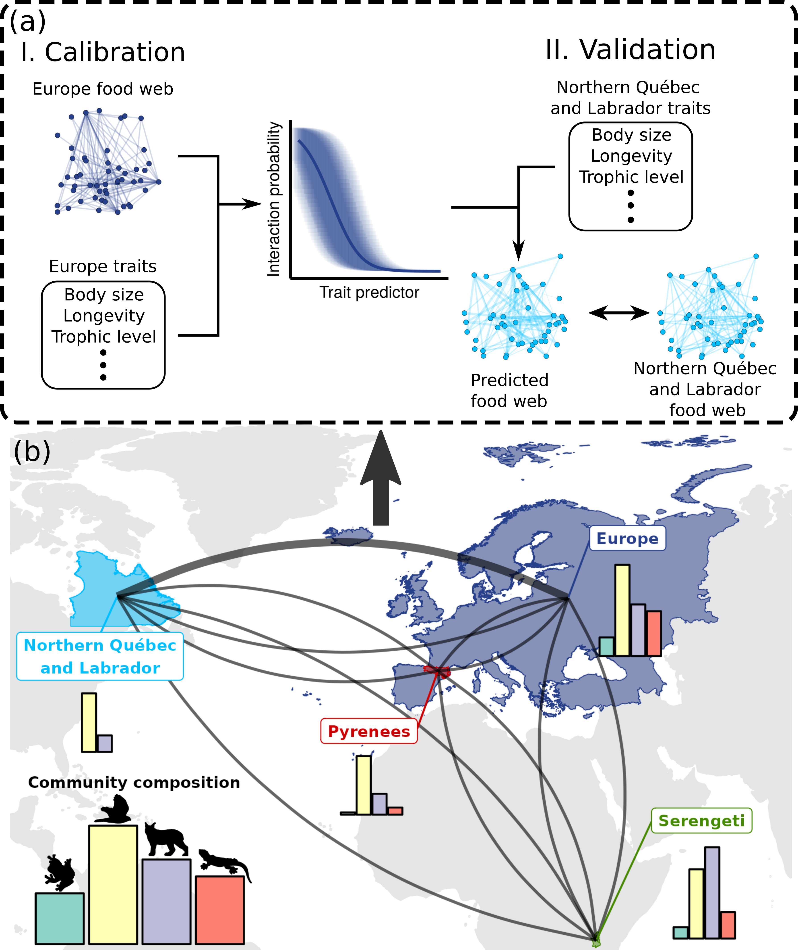Figure 2.1: Trophic interactions model transferability analysis workflow. Panel (a) shows an example workflow for between-food web predictions. We trained a trophic interaction model using each food web considered in this study (panel a.I). We measured the performance of the four models on a validation subset for within-food web predictions, and the entire food webs for between-food web predictions (panel a.II). Panel (b) maps the spatial domain of each food web. The curves present the pairs of food web model used to make between-food web predictions. Within-food web predictions are not shown in the figure. Bar plots illustrate the proportion of amphibians (green), birds (yellow), mammals (purple), and reptiles (red) in each food web.
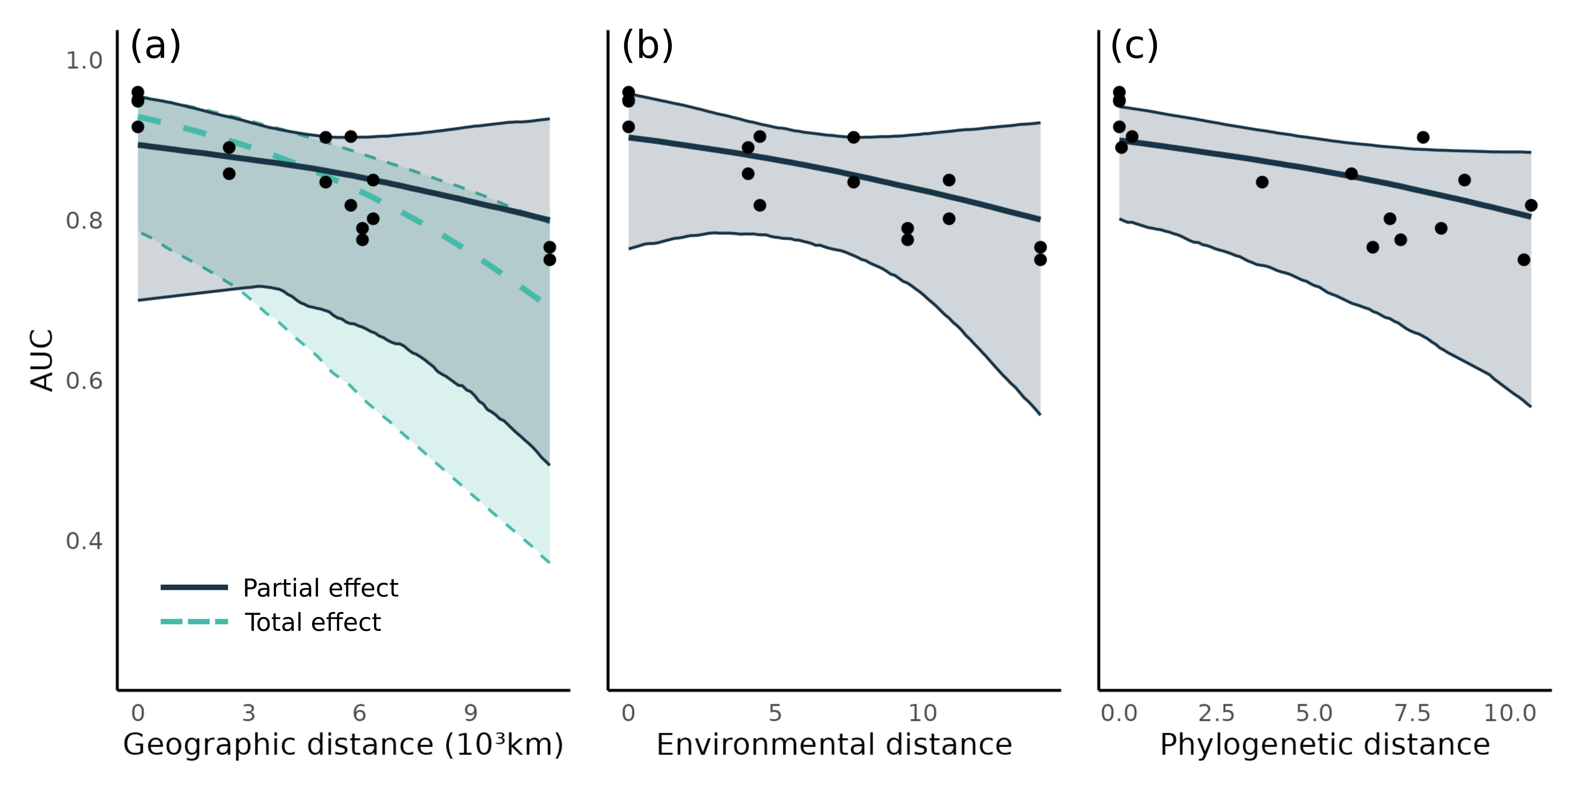Figure 2.2: Transferability of predictive models across geographic, environmental and phylogenetic distance. In each panel, the points present the predictive performance (as area under the receiver operating curve, AUC) of a model food web prediction combination (16 combination; Table 2.2). For each panel, the thick line is the median effects while the envelope is the 95% credible interval on predictive performance built using the posterior predictive distribution of geographic, environmental and phylogenetic distances. Panel (a) illustrates the total (includes the indirect effects of environmental and phylogenetic distances; turquoise) and partial (controlling for environmental and phylogenetic distances; dark blue) effects of geographic distance. Panel (b) shows the effect of environmental distance after controlling for geographic distance Panel (c) presents the effect of phylogenetic distance after controlling for geographic distance.

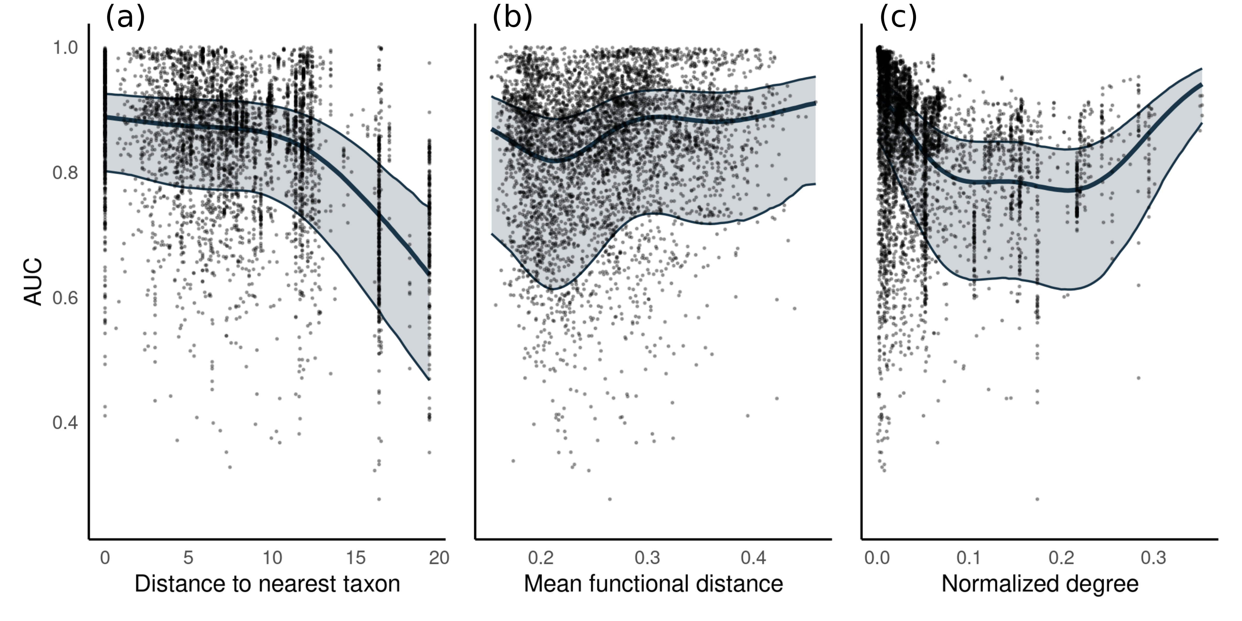Figure 2.3: Predicting species interactions. Model predictive performance for the species interactions in alternative food webs. Each point shows the model performance in predicting the prey and predators of a single species using area under the receiver operating curve (AUC) as a metric. For each panel, the thick line is the median effect while the envelope is the 95% credible interval on predictive performance built using the posterior predictive distribution of (a) distance to the nearest taxon, (b) mean functional pairwise distance and (c) normalized degree on predictive performance.

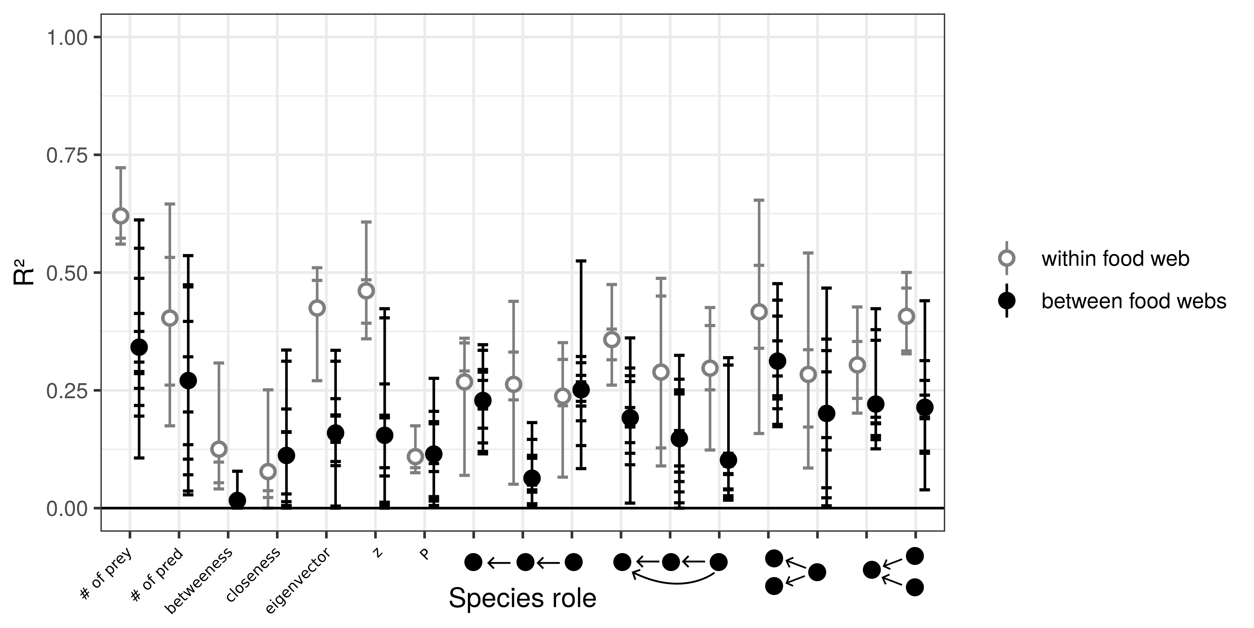Figure 2.4: Predicting species functional role. Performance of models to predict species functional role measured as the proportion of the variance in trophic positions explained by the models (R²). From left to right, the figure shows the number of prey, number of predators, betweenness, closeness, eigenvector centrality, within-module degree (z), participation coefficient (P), times the species is at a specific position in the linear chain (predator – consumer - resource), intraguild predation (omnivore – consumer - resource), direct competition (2 consumers – 1 resource), and apparent competition motifs (1 consumer – 2 resources). The short horizontal lines highlight the R² for each role, model, and food web predicted combination. Grey open dots are the mean R² for within-food web predictions. Full black dots are the mean R² for between-food web predictions.
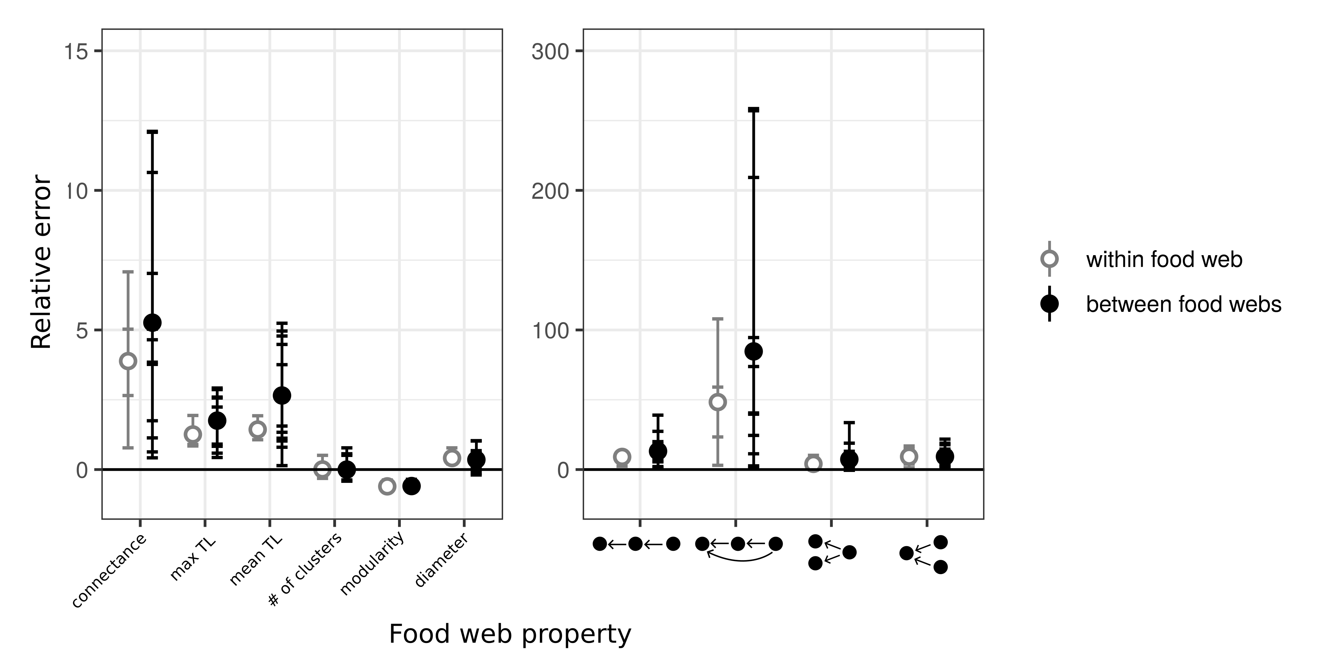Figure 2.5: Prediction error of global food web properties. Relative error is the difference between the predicted and the empirical estimates divided by the empirical estimate. From left to right, the figure shows the relative error for connectance, maximum trophic level, mean trophic level, number of clusters, modularity, diameter, number of linear chain (predator – consumer - resource), intraguild predation (omnivore – consumer - resource), direct competition (2 consumers – 1 resource), and apparent competition (1 consumer – 2 resources) motifs. Short horizontal lines are the relative errors for each property, model, and food web predicted combination. Grey open dots are the mean relative errors for within - food web predictions and full black dots are the mean relative errors for between -food web predictions. We divided the figure in two panels because the food web properties in panels (a) and (b) had widely different relative errors.

