# Using Quarto to Generate MS Word Documents in APA Style (7th Edition)

Ana Fulana1,2, Blanca Zutana1, Carina Mengana3,4, and Dolorita Perengana5

1Department of Psychology, Ana and Blanca’s University

2Ana’s Secondary Affiliation

3Carina’s Primary Affiliation

4Carina’s Secondary Affiliation

5Buffalo, NY

# Author Note

Ana Fulana https://orcid.org/0000-0000-0000-0000

Carina Mengana https://orcid.org/0000-0000-0000-0001

Dolorita Perengana https://orcid.org/0000-0000-0000-0003

Correspondence concerning this article should be addressed to Ana Fulana, Department of Psychology, Ana and Blanca’s University, 1234 Capital St., Albany, NY 12084-1234, Email: sm@example.org

# Abstract

This document is a template demonstrating the apaquarto format.

*Keywords*: keyword, other keyword

# Using Quarto to Generate MS Word Documents in APA Style (7th Edition)

This is my introductory paragraph. The title will be placed above it automatically. *Do not start with an introductory heading* (e.g., “Introduction”). The title acts as your Level 1 heading for the introduction.

Readers are better able to follow your ideas if you differentiate sections in your introduction with headings. Mostly stick to level 2 headers. Sometimes level 3 heading are needed. Try not to use a level 3 heading Be sparing to the point of stinginess with levels 4 and 5.

## Level 2 Heading: Flush Left, Bold, Title Case

Subsections of the introduction have level 2 headings. A paragraph after a level 2 Heading is on a new line. Regular paragraphs are indented, flush left, and double-spaced.

You do not need to put text after a heading. You can put higher-level heading directly underneath if you want.

## A Level 2 Heading Without Text Below It

### Level 3 Heading: Flush Left, Bold Italic, Title Case

Subsections of a level 2 heading are placed under level 3 headings.

### Another Level 3 Heading

#### Level 4 Heading: Indented, Flush Left, Bold, Title Case, Ending With a Period.

A paragraph after a level 4 or 5 geading is on a new line in this markdown document but will appear as if it were in the same paragraph .docx format. You need at least one paragraph after a level 4 or 5 heading. If you forget the period at the end of the level 4 or 5 heading, it will be added automatically. A period will not be added if the heading ends with a question mark or an exclamation point.

Subsequent paragraphs go on their own lines.

##### Level 5 Heading: Indented, Flush Left, Bold Italic, Title Case, Ending With a Period.

Notice that there was no period after this level 5 heading in the markdown document, but it does appear in the rendered document.

## How to Cite References

I am going to cite a reference here in square brackets (Cameron & Trivedi, 2013). This reference was in my bibliography file. Here are some variations on parenthetical citations:

* Page references (or any other suffixes are placed after the reference. If you want a comma, you’ll need to insert it yourself: (Cameron & Trivedi, 2013, pp. 35–41)
* Prefixes (with or without a comma) are placed before the reference: (e.g., Cameron & Trivedi, 2013)
* 2 or more citations separated by a semicolon (Cameron & Trivedi, 2013; Cohen et al., 2003)
* Any prefixes or suffixes needing a literal semicolon will confuse Quarto (actually Pandoc). To make it clear that you need to print a semicolon, put a backslash before the semicolon: (FOIL; Cameron & Trivedi, 2013)

Text references are possible, too.

* Cameron and Trivedi (2013) said some interesting things.
* Cohen et al. (2003, pp. 101–103) said specific things on specific pages.
* Place the reference’s year by itself with a minus sign: (2013)

# Method

General remarks on method. This paragraph is optional.

## Participants

Who are they? How were they recruited? Perhaps some basic demographic stats are in order. A table is a great way to avoid repetition in statistical reporting.

## Measures (or Materials or Aparatus)

### Measure A

Describe Measure A.

### Measure B

Describe Measure B.

### Procedure

What did participants do?

### Analysis Plan

How are the data going to be analyzed?

# Results

## Descriptive Statistics

Here we describe the basic characteristics of our primary variables.

Let’s make a figure. A reference label for a figure in APA format must have the prefix apafg-. This is different from the usual quarto prefix tbl-, which will put the caption on one line below the table. For APA format, we can do this:

Figure 1

This is the figure caption.

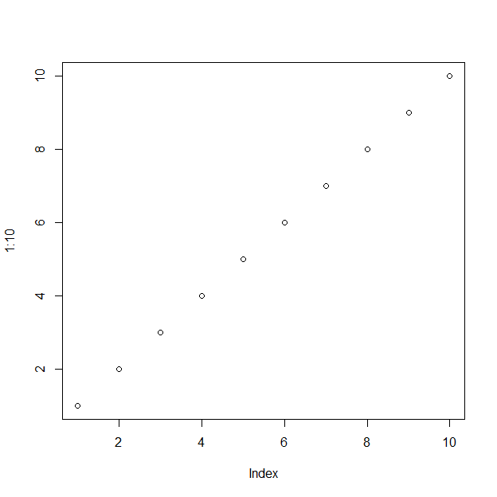

*Note*. This is a note below the figure.

To refer to any figure or table, but the chunk label in curly braces. For example, see Figure 1 In Figure 2 we import an image.

Figure 2

This is an imported graphic.

We can make a table the same way as a figure except that the label prefix is apatb-. Again, this is different from the usual quarto prefix tbl-, which will put the table table caption in the wrong place and with non-APA formatting.

Table 1

Here is the table caption.

| Numbers | Letters |
| --- | --- |
| 1 | A |
| 2 | B |
| 3 | C |
| 4 | D |

*Note*. Here is the note below the table.

To refer to this table in text, put the table’s reference label in curly braces like so: As seen in Table 1 there is not much information.

What if you want the tables and figures to be at the end of the document? No problem. Just put them all at the end, in order. The reference labels will work no matter where they are in the text. In Table 2 I give an example of making a table at the end using markdown only.

# Discussion

Describe results in non-statistical terms.

## Limitations and Future Directions

Every study has limitations. Based on this study, some additional steps might include…

## Conclusion

Let’s sum this up.

# References

Cameron, A. C., & Trivedi, P. K. (2013). *Regression analysis of count data* (2nd ed.). Cambridge University Press.

Cohen, J., Cohen, P., West, S. G., & Aiken, L. S. (2003). *Applied multiple regression/correlation analysis for the behavioral sciences*. Routledge.

# Appendix

If there are multiple appendices, label them with level 1 headings as Appendix A, Appendix A, and so forth.

Table 2

This a a table caption.

| Column 1 | Column 2 |
| --- | --- |
| A | Yes |
| B | No |

*Note*. This is a table note.