# Using Quarto to Generate Documents in APA Style (7th Edition)

Ana Fulana1, Blanca Zutana1, Carina Mengana2,3, and Dolorita Perengana4

1Department of Psychology, Ana and Blanca’s University

2Carina’s Primary Affiliation

3Carina’s Secondary Affiliation

4Buffalo, NY

# Author Note

Ana Fulana  https://orcid.org/0000-0000-0000-0000

Carina Mengana  https://orcid.org/0000-0000-0000-0001

Dolorita Perengana  https://orcid.org/0000-0000-0000-0003

Ana Fulana is now at X University. Carina Mengana is deceased.

This article is based on data published in Pulaski (2017).

Author roles were classified using the Contributor Role Taxonomy (CRediT; https://credit.niso.org/) as follows: *Ana Fulana*: Conceptualization and Writing - original draft; *Blanca Zutana*: Project administration; *Carina Mengana*: Formal Analysis; *Dolorita Perengana*: Writing - review & editing, Methodology, and Formal Analysis

Correspondence concerning this article should be addressed to Ana Fulana, Department of Psychology, Ana and Blanca’s University, 1234 Capital St., Albany, NY 12084-1234, Email: sm@example.org

# Abstract

This document is a template demonstrating the apaquarto format.

*Keywords*: keyword1, keyword2, keyword3

# Using Quarto to Generate Documents in APA Style (7th Edition)

This is my introductory paragraph. The title will be placed above it automatically. *Do not start with an introductory heading* (e.g., “Introduction”). The title acts as your Level 1 heading for the introduction.

Readers are better able to follow your ideas if you differentiate sections in your introduction with headings. Mostly stick to level 2 headers. Sometimes level 3 headings are needed, though. Be sparing to the point of stinginess with levels 4 and 5.

## Level 2 Heading

Subsections of the introduction have level 2 headings. A paragraph after a level 2 Heading is on a new line. Regular paragraphs are indented, flush left, and double-spaced.

You do not need to put text after a heading. You can put a higher-level heading directly underneath if you want.

## A Level 2 Heading Without Text Below It

### Level 3 Heading: Flush Left, Bold Italic, Title Case

Subsections of a level 2 heading are placed under level 3 headings.

### Another Level 3 Heading

#### Level 4 Heading.

A level 4 heading should be indented, flush left, bold, title case, and end with a period. A paragraph after a level 4 or 5 heading is on a new line in this markdown document but will appear as if it were in the same paragraph when rendered. You need at least one paragraph after a level 4 or 5 heading. If you forget the period at the end of the level 4 or 5 heading, it will be added automatically. A period will not be added if the heading ends with a question mark or an exclamation point.

Subsequent paragraphs go on their own lines.

##### Level 5 Heading.

A level 5 heading should be indented, flush left, bold italic, title case, and end with a period. Notice that there was no period after this level 5 heading in the markdown document, but it does appear in the rendered document.

Subsequent paragraphs go on their own lines.

## How to Cite References

I am going to cite a reference here in square brackets (Cameron & Trivedi, 2013). This reference was in my bibliography file. Here are some variations on parenthetical citations:

* Page references (or any other suffixes are placed after the reference. If you want a comma, you’ll need to insert it yourself: (Cameron & Trivedi, 2013, pp. 35–41)
* Prefixes (with or without a comma) are placed before the reference: (e.g., Cameron & Trivedi, 2013).
* 2 or more citations separated by a semicolon (Cameron & Trivedi, 2013; Cohen et al., 2003). If you need a prefix at the beginning of 2 or more citations, you will have rearrange the citations so that the prefix accompanies the citation that is first alphabetically. That is, (e.g., Cameron & Trivedi, 2013; Cohen et al., 2003), not (Cameron & Trivedi, 2013; e.g., Cohen et al., 2003)
* Any prefixes or suffixes needing a literal semicolon will confuse Quarto (actually Pandoc). To make it clear that you need to print a semicolon, put a backslash before the semicolon: (FOIL; Cameron & Trivedi, 2013).

Text references are possible, too.

* Cameron and Trivedi (2013) said some interesting things.
* Cohen et al. (2003, pp. 101–103) said specific things on specific pages.
* Place the reference’s year by itself with a minus sign: (2013)

## Block Quotes and Suppressing Indentation

Sometimes you want to give a longer quote that needs to go in its own paragraph. Block quotes are on their own line starting with the > character. For example, Jane Austen’s (1814/1990) *Mansfield Park* has some memorable insights about the mind:

If any one faculty of our nature may be called more wonderful than the rest, I do think it is memory. There seems something more speakingly incomprehensible in the powers, the failures, the inequalities of memory, than in any other of our intelligences. The memory is sometimes so retentive, so serviceable, so obedient; at others, so bewildered and so weak; and at others again, so tyrannic, so beyond control! We are, to be sure, a miracle every way; but our powers of recollecting and of forgetting do seem peculiarly past finding out. (p. 163)

If the text after a quote is a new paragraph, you can create it in the usual fashion (i.e., plain text with an empty line between the block text and the new paragraph). However, if the text after a quote is part of the same paragraph, you can suppress the indentation by creating a div with the .NoIndent class. This paragraph is an example of how to do so.

## Hypotheses, Aims, and Objectives

The last paragraph of the introduction usually states the specific hypotheses of the study, often in a way that links them to the research design.

# Method

General remarks on method. This paragraph is optional.

Not all papers require each of these sections. Edit them as needed. Consult the [Journal Article Reporting Standards](https://apastyle.apa.org/jars) for what is needed for your type of article.

## Participants

Who are they? How were they recruited? Report criteria for participant inclusion and exclusion. Perhaps some basic demographic stats are in order. A table is a great way to avoid repetition in statistical reporting.

## Measures

This section can also be titled **Materials** or **Apparatus**. Whatever tools, equipment, or measurement devices used in the study should be described.

### Measure A

Describe Measure A.

### Measure B

Describe Measure B.

## Procedure

What did participants do?

How are the data going to be analyzed?

# Results

## Descriptive Statistics

Here we describe the basic characteristics of our primary variables.

Let’s make a figure. A reference label for a figure in APA format must have the prefix apafg-. This is different from the usual Quarto prefix fig-.

Figure 1

This is the figure caption.

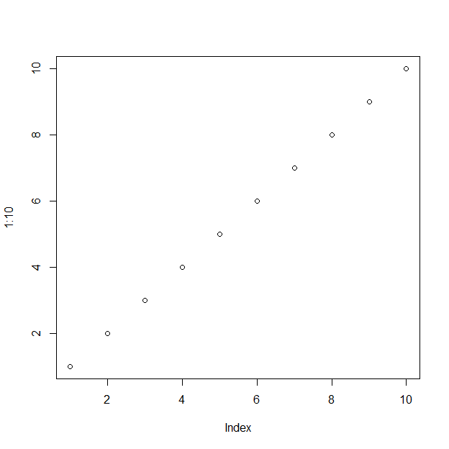

*Note*. This is a note below the figure.

To refer to any figure or table, put the chunk label in curly braces. For example, see Figure 1. In Figure 2, we import an image.

Figure 2

This is an imported graphic.

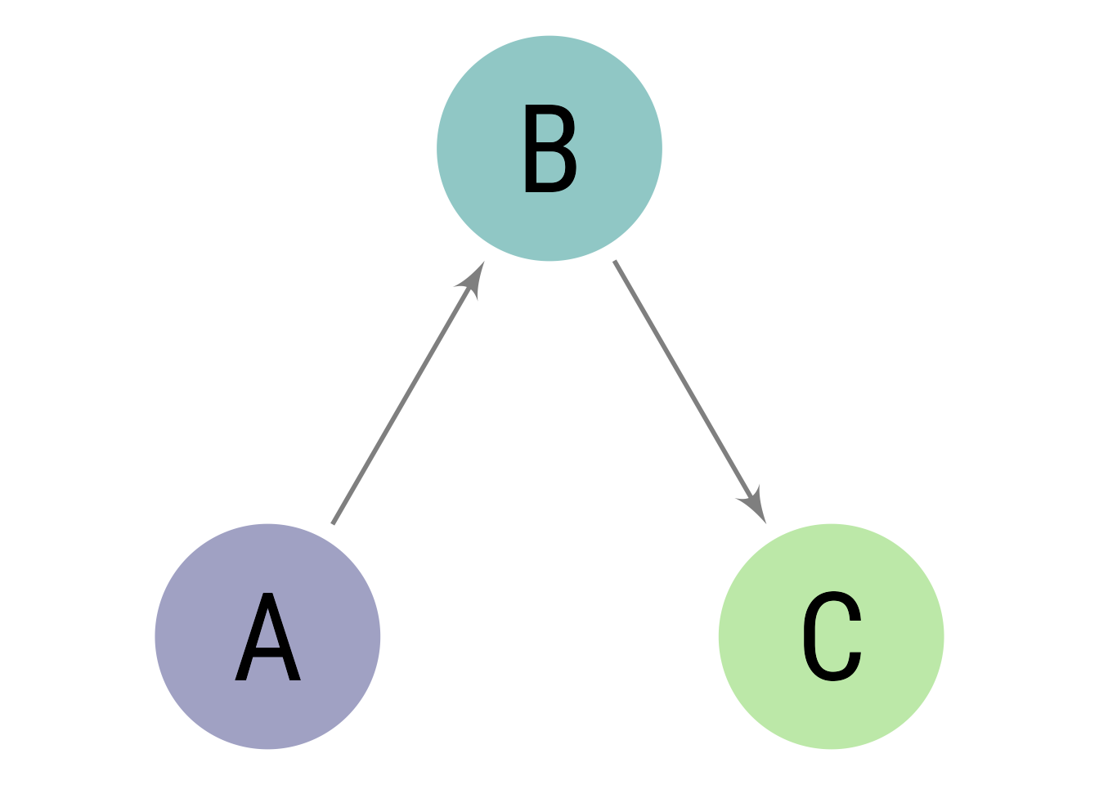

*Note*. My note.

We can make a table the same way as a figure except that the label prefix is apatb-. Again, this is different from the usual quarto prefix tbl-, which will put the table table caption in the wrong place and with non-APA formatting.

Table 1

Here is the table caption.

| Numbers | Letters |
| --- | --- |
| 1 | A |
| 2 | B |
| 3 | C |
| 4 | D |

*Note*. Here is the note below the table.

To refer to this table in text, put the table’s reference label in curly braces like so: As seen in Table 1, there is not much information.

Table 2 is an example of a table without a note beneath.

Table 2

This is a table without a note.

| Numbers | Letters |
| --- | --- |
| 1 | A |
| 2 | B |
| 3 | C |
| 4 | D |

In Table 3, there is an example of using a plain markdown table via the asis engine.

Table 3

Table caption of a markdown table

| Default | Left | Right | Center |
| --- | --- | --- | --- |
| 12 | 12 | 12 | 12 |
| 123 | 123 | 123 | 123 |
| 1 | 1 | 1 | 1 |

*Note*. This is a note below the markdown table.

What if you want the tables and figures to be at the end of the document? In the .pdf format, you can set the floatsintext option to false. For .html and .docx documents, there is not yet an automatic way to put tables and figures at the end. You can, of course, just put them all at the end, in order. The reference labels will work no matter where they are in the text.

# Discussion

Describe results in non-statistical terms.

## Limitations and Future Directions

Every study has limitations. Based on this study, some additional steps might include…

## Conclusion

Let’s sum this up.

# References

Austen, J. (1990). *Mansfield park*. Oxford University Press. (Original work published 1814)

Cameron, A. C., & Trivedi, P. K. (2013). *Regression analysis of count data* (2nd ed.). Cambridge University Press. <https://doi.org/10.1017/CBO9781139013567>

Cohen, J., Cohen, P., West, S. G., & Aiken, L. S. (2003). *Applied multiple regression/correlation analysis for the behavioral sciences* (3rd ed.). Lawrence Erlbaum Associates.

# Appendix

If there are multiple appendices, label them with level 1 headings as Appendix A, Appendix B, and so forth.