## Solutions to SWED-Exercises-1.

1. Install an IDE (Cursor) and List 10 Advantages over a Simple Text Editor

* Installation:  
  Cursor is a modern, AI-powered IDE based on Visual Studio Code. 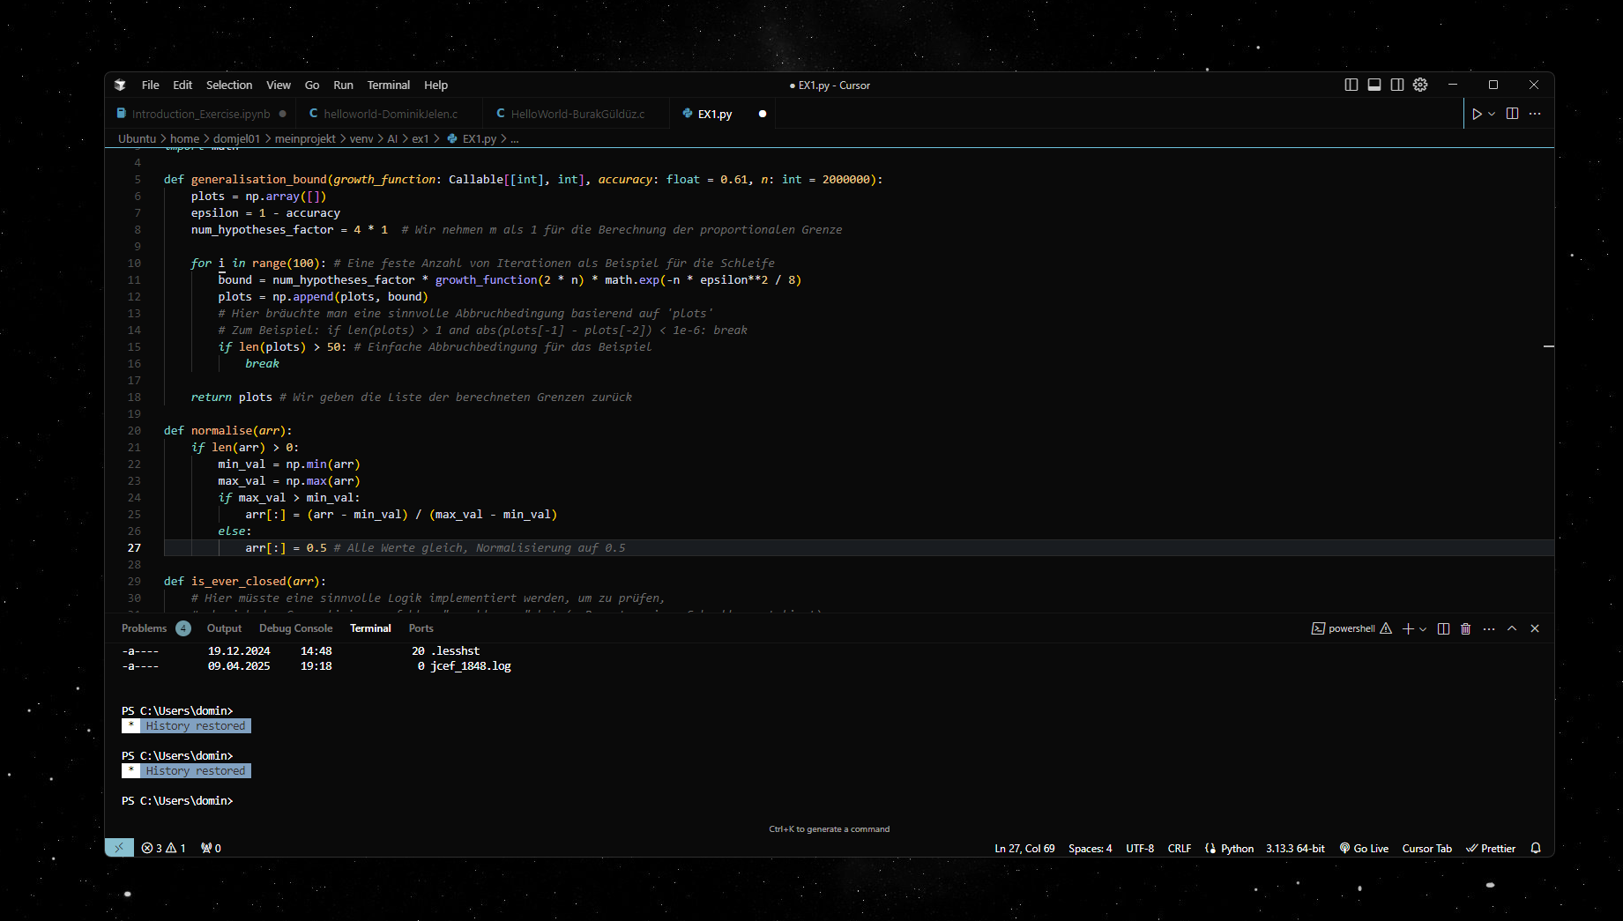
* 10 Advantages of an IDE like Cursor over a Simple Text Editor:
  + Intelligent code completion: Context-aware suggestions powered by AI.
  + Automatic error detection: Real-time syntax and semantic error highlighting.
  + Integrated debugging: Set breakpoints, step through code, inspect variables.
  + Project management: Organize multiple files and folders in a project explorer.
  + Version control integration: Built-in Git support for commits, branching, and history.
  + Refactoring tools: Automated renaming, code extraction, and optimization features.
  + Documentation support: View and generate documentation for classes and functions.
  + Extensibility: Add plugins and extensions for additional languages and tools.
  + Integrated terminal and build tools: Run commands and build scripts without leaving the IDE.
  + AI-powered code analysis and explanation: Cursor can explain code and answer questions about it.

2.

Attempt 1:

n =4 =even -> 4/2 =2

2 = even -> 2/2=1

4-2-1

Attempt 2:

n =5 =odd -> 3x5+1 =16

16 = even -> 16/2 =8

8 -> 4

4 -> 2

2 -> 1

5-16-8-4-2-1

3.

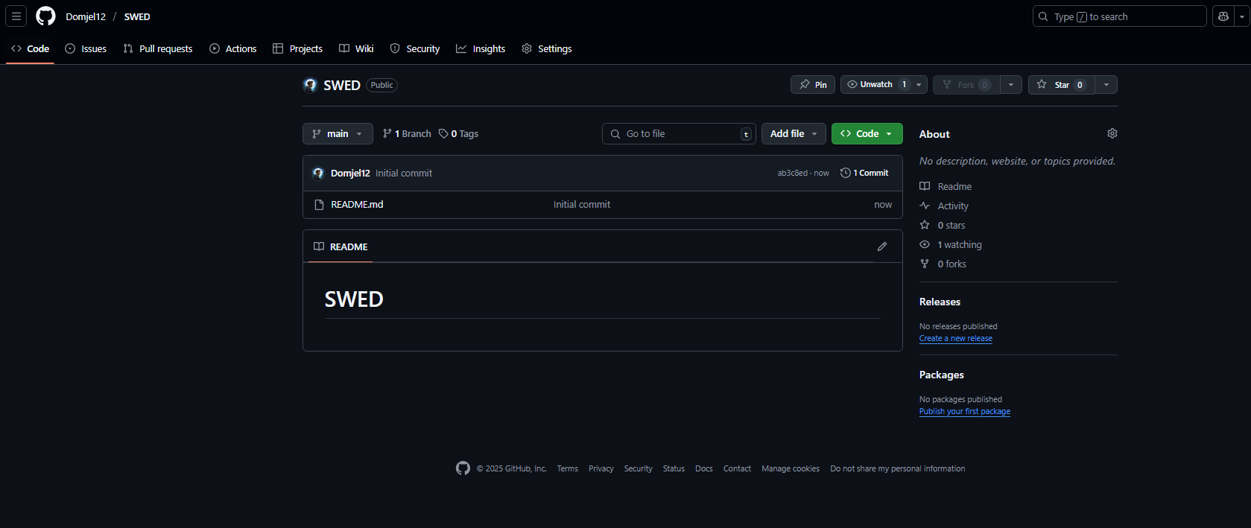

4.

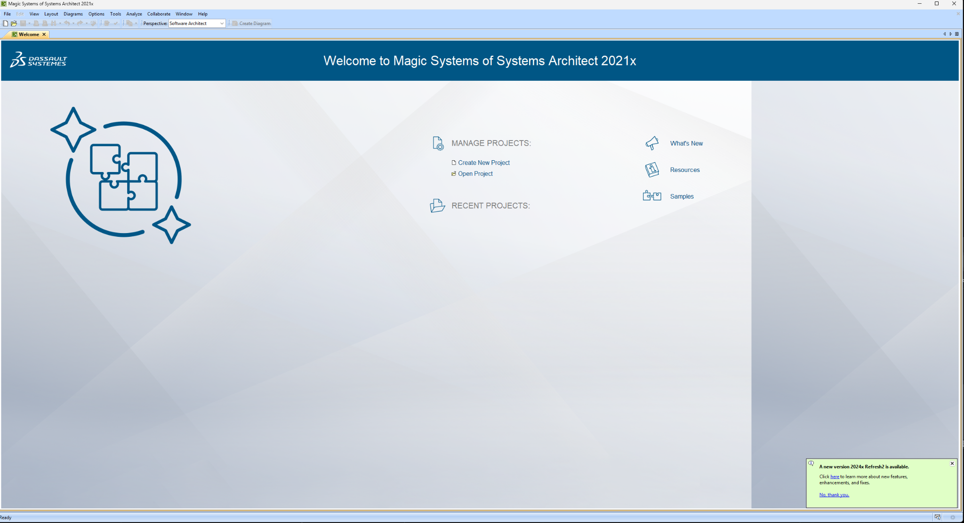

5.

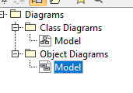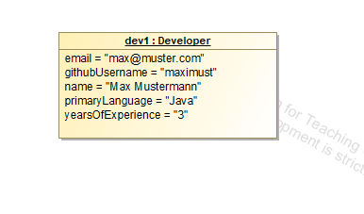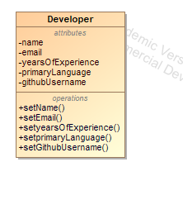

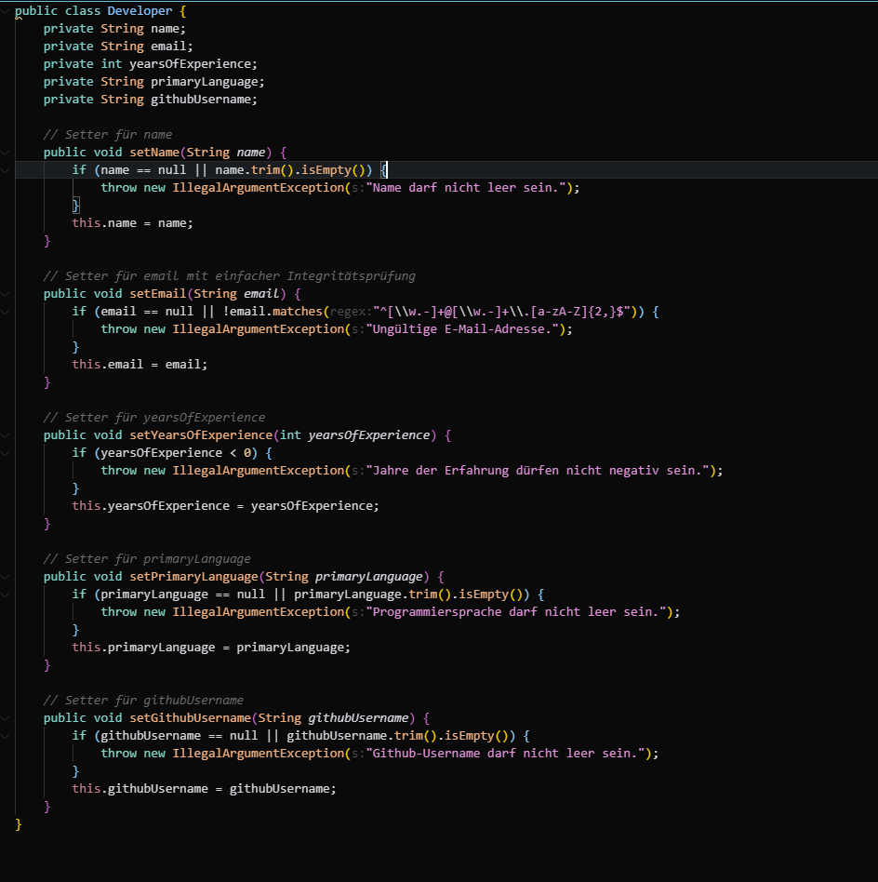

6. Define Software Design and Explain the Difference to Software Analysis

* Software Design:  
  The process of defining the architecture, components, interfaces, and other characteristics of a software system based on requirements.
* Software Analysis:  
  The process of gathering and specifying what the software should do (requirements and constraints).
* Difference:  
  Analysis asks *what* the system should do; design specifies *how* it will be technically implemented.

7. Why is Software Design Necessary?

* Software design ensures structure, maintainability, and scalability.
* Without design:
  + Code becomes unstructured and hard to maintain.
  + Increased risk of errors and technical debt.
  + Difficulties in team collaboration and future extensions.
* Projects without design are only feasible for very small, one-off scripts.

8. Are Design Activities Independent or Interdependent?

* The activities are interdependent:
  + Example: Choosing a microservices architecture affects database design (distributed databases), UI design (multiple frontends), and component structure.
* Conclusion: Changes in one area (e.g., UI) can impact others (e.g., architecture, database).