Exercise 8
1. Difference between a Virtual Machine and a Docker Container
- Virtual Machine (VM): A VM emulates a whole computer, including the hardware. It runs a full guest OS on top of your main OS. This makes them big and slow to start.
- Docker Container: A container only virtualizes the OS. It shares the kernel of the host machine. It just packages the app and its specific libraries. That's why containers are super lightweight and start in seconds.

2. What is the main purpose of Continuous Integration?
The answer is c) frequently integrate code into a shared repository and run automated tests.
Basically, CI is all about merging your code changes with the main branch often, and then automatically running tests to catch bugs early.
3. 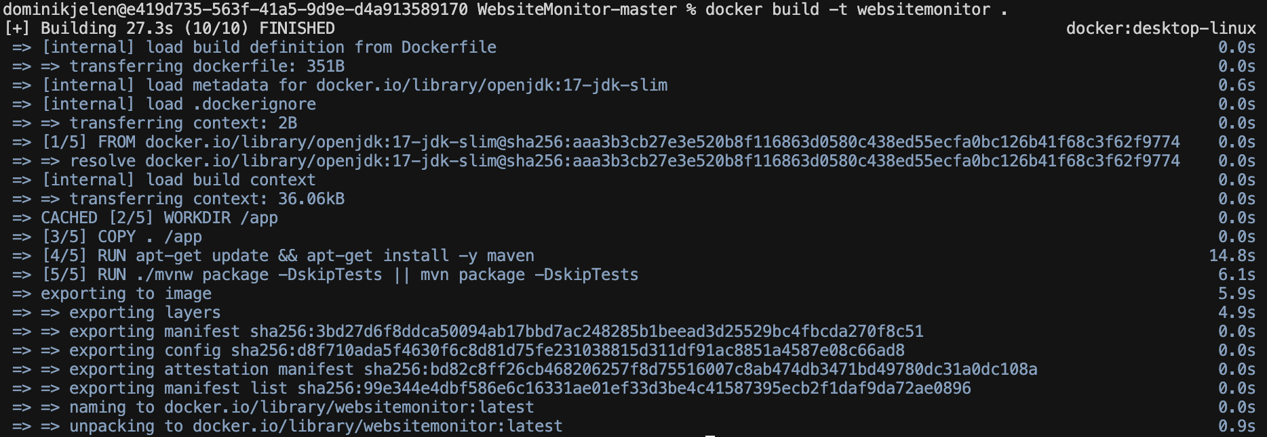

4. Which tool is commonly used to orchestrate CICD pipelines?
The answer is b) Jenkins.
Jenkins is the classic automation server used to build and manage the entire CI/CD pipeline (build, test, deploy). The other tools are used within a pipeline, but don't orchestrate it:
- Kubernetes: Runs containers.
- Ansible: Configures servers.
- Terraform: Builds infrastructure (like servers in the cloud).

5. The testing stage in your CI pipeline is too slow. Name strategies to speed it up.
If tests are causing timeouts, you can:
- Run tests in parallel: Don't run them one by one. Split them up to run at the same time on different agents.
- Use caching: Cache all the dependencies and packages so the pipeline doesn't have to download them from scratch every single time.
- Split test stages: Run the quick unit tests first. If they pass, then trigger the longer, more complex integration or end-to-end tests.
- Optimize the tests: Find the slowest tests and see if you can make them more efficient or remove redundant ones.
6. Think about a hard question for the final written exam.
Here's an idea for a tough question:
Question: "Design a system architecture for a web shop that needs to survive a massive traffic spike like on Black Friday. You must:
- Choose and justify an architecture pattern (e.g., microservices).
- Explain your strategies to ensure high availability and prevent crashes (e.g., load balancing, circuit breakers).
- Outline a CI/CD pipeline that would allow you to deploy new features with zero downtime (e.g., using a blue-green deployment).
Explain why you made your choices."

