1)
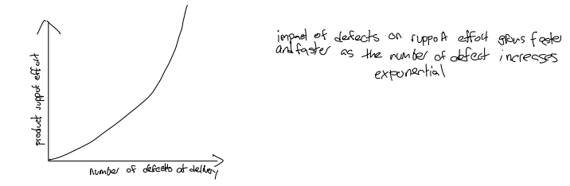
2)
For developers testing their own programs:
- They know their code best.
- It’s faster to find bugs.
- Saves money.
- They can fix problems right away.
- They learn from their mistakes.
Against developers testing their own programs:
- They might miss their own mistakes.
- They are not objective.
- They don’t think like real users.
- They might skip some tests.
- They can be too confident their code works.
4)
Regression testing means testing a program after changes (like bug fixes or new features) to make sure that old parts still work. It checks that nothing is broken by the new changes.In simple words: After you change something, you test again to see if everything still works as before.
5)
