September 2026 Release Notes

New Features and Enhancements

App Studio Enhancements

Card Location Visibility
The card details info icon, which shows where a card is located, now also displays the App Studio pages the card exists on. The info icon is also available on the right panel next to the card name.
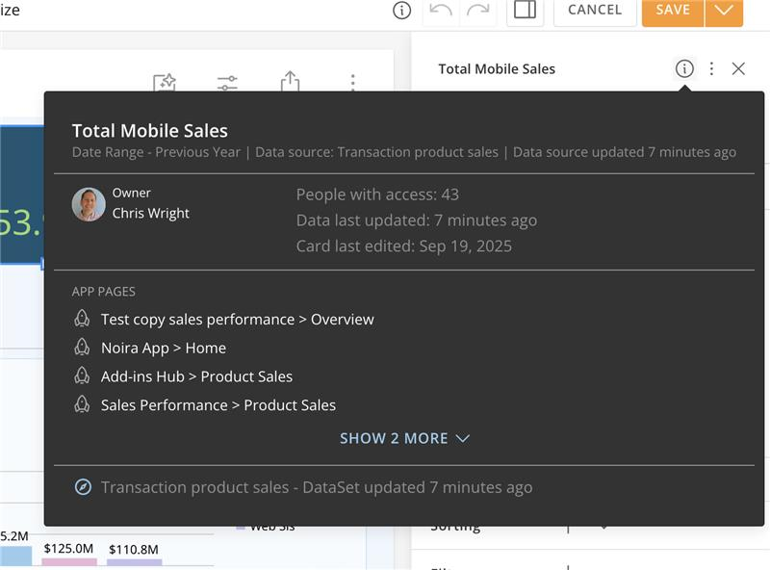

Move and Copy Cards
The Move/Copy functionality from Dashboards is now available in App Studio. Access it from the three-dot menu in the right panel to move or copy cards between pages.
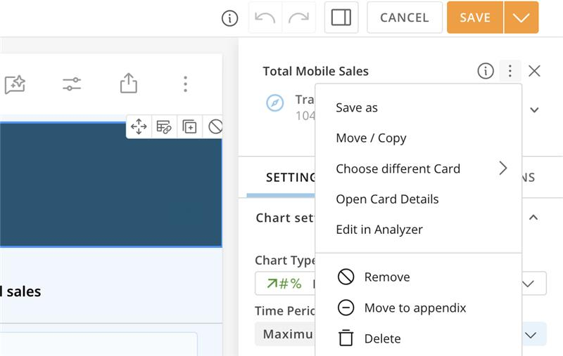

Archived DataSets Visual Indicator
Domo optimizes data access by archiving DataSets that have not been queried by cards or Analyzer for a period of time. Archived DataSets are not deleted, but they can't be accessed until they are unarchived. The archived-state notice has been made more prominent so it's no longer easy to miss:
- The notification now appears at the top of the DataSet Overview tab
- It uses red to draw attention and signal that you may need to take action to access the DataSet
This update reduces confusion and makes it clearer when a DataSet is archived and how to unarchive it.
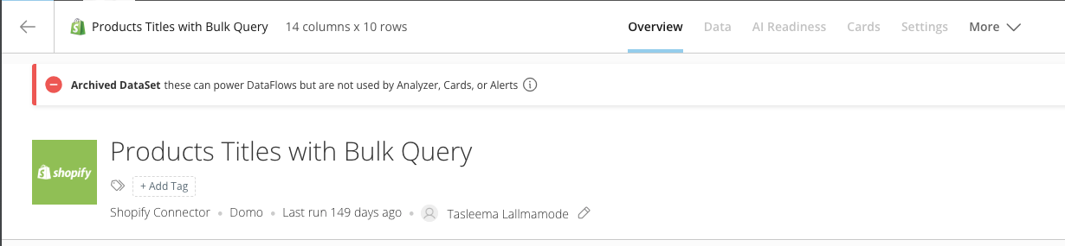

Azure SQL Active Directory Service Principal Authentication
Azure SQL Cloud Integrations now support Active Directory Service Principal as a native authentication method. Previously limited to username and password authentication, Azure SQL connections can now use service-based identity access, providing consistency across your Azure data sources and eliminating the need for shared user credentials.
When creating or editing an Azure SQL Cloud Integration, select Active Directory Service Principal as the authentication method on the integration configuration screen.

Card Embed Enhancements
Card Embed Enhancements introduce updates to the embed framework, delivering an improved embedded user interface and expanded customization capabilities. You can now enable or disable features such as segments, quick filters, and variables, along with configuring parameters like background color, scale line color, and text color. Cards render with cleaner sizing and scaling, and drill-down works as expected with a back button, visible filter breadcrumbs, and the final data table. This also adds support for Notebook cards beyond charts and custom apps.
The following screenshots show the difference between the old and new embedded card experience.
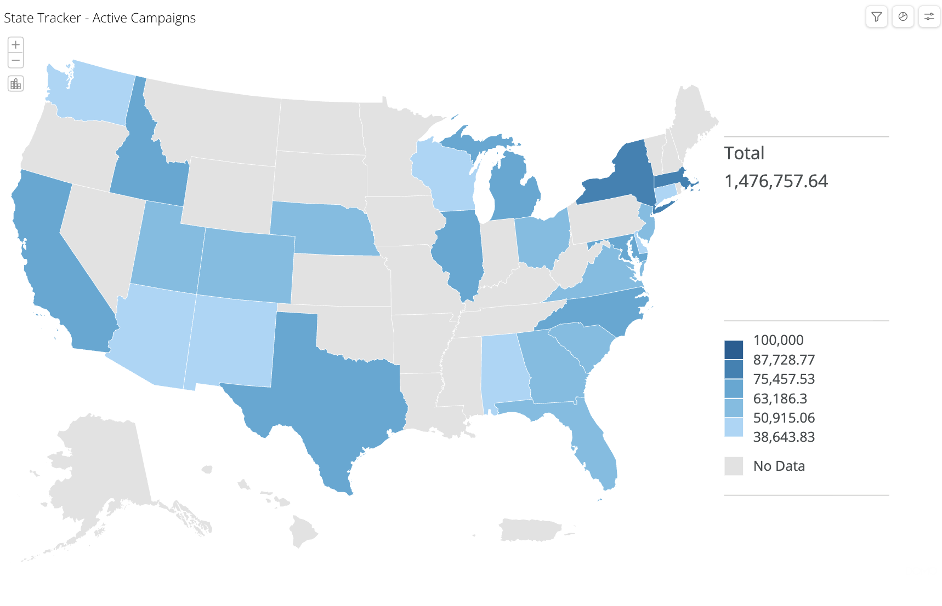
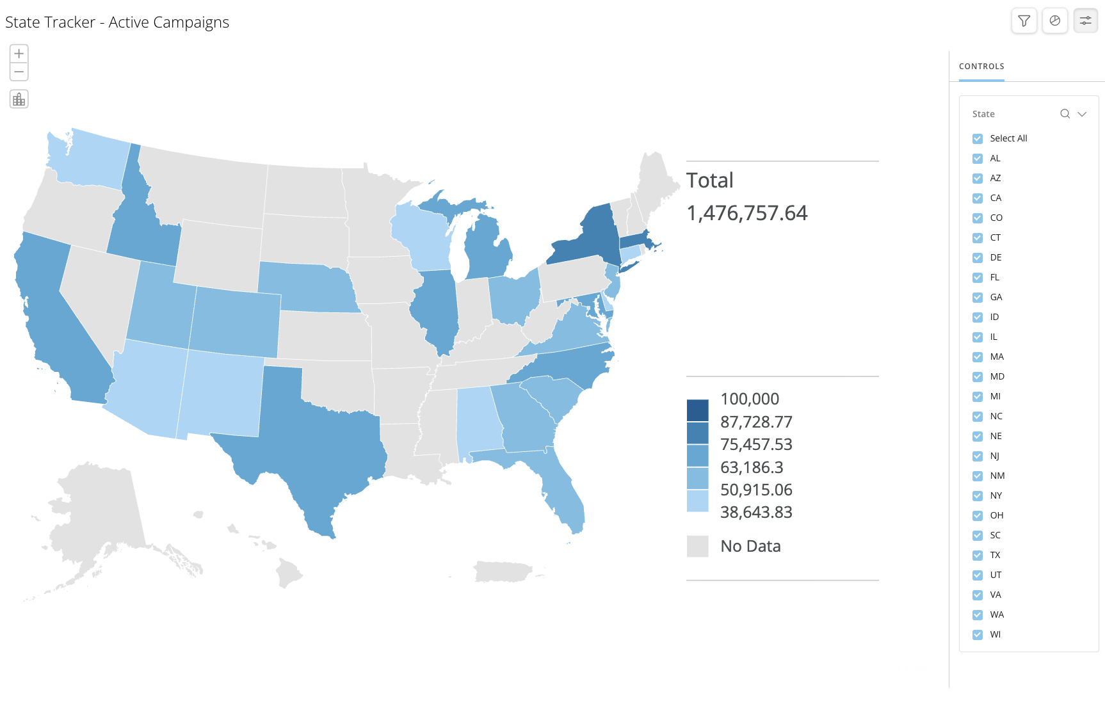
The embed dialog also reflects these changes. The new version surfaces with additional display options (segments, quick filters, variables) and shows both the new embed URL and the soon to be deprecated URL, so you can identify which version is in use and migrate to the new embedded experience.
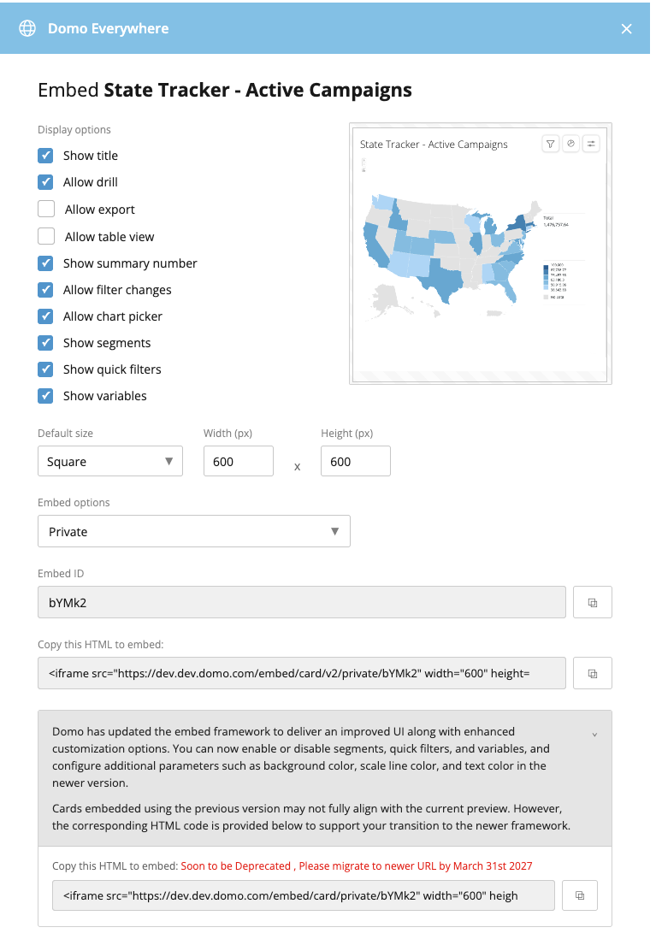
Learn more about Card Embed Enhancements.
Important: The previous card embed framework is being deprecated on March 31, 2027. Please update all embedded cards to the new URL before that date.
For step-by-step migration instructions for public, private, and programmatic embed, see Migrate Embedded Cards to the New Card Embed URL.

Code Engine Package Usage Visibility and Deletion
You can now see where your deployed Code Engine packages are used and delete packages that are no longer referenced anywhere in Domo.
Usage visibility gives you a clear, real-time view of every custom app and workflow referencing a package, including a count of private references you can't access, so you always know a package's full reach before making a change. Safe deletion then lets you permanently remove deployed packages that are no longer in use, providing a remediation path for packages that were published with sensitive information such as API keys or credentials.
Key benefits include:
- Full usage visibility across custom apps and workflows before you make changes
- Safe deletion of deployed packages that are no longer referenced
- Guardrailed deletion that is blocked whenever any usage exists, including references you can't see
- Protection for Domo-provided packages, which cannot be deleted

Data Modeling Builder and Visualization Integration
Domo's data modeling experience is now integrated throughout the BI layer, so you can build a semantic model once and use it across Analyzer, App Studio, card filters, page filters, and Dashboards. Chart rendering, filtering, sorting, summary numbers, and Beast Mode all work against the model.
Models support Magic ETL DataSets, DataSet Views, and Snowflake DataSets, letting you surface warehouse data in the modeling experience instead of materializing large, redundant flat tables.

Databricks Writeback to Azure-Hosted Domo Instances
Databricks writeback is now supported on Azure-hosted Domo instances. Previously available only on AWS-hosted Domo instances, Databricks writeback now works regardless of where your Domo instance is hosted, so customers on Azure-hosted Domo can write data back to their Databricks environment — for both Azure and AWS Databricks — without changing their existing workflow.

Legacy Authentication Update
Domo is updating the way it handles user authentication and retiring an older login token called DA-SID. This is a behind-the-scenes security improvement, and most users will not notice any change. Any customers who need to take action will be contacted by Domo directly.

Magic ETL Enhancements

Classification Tile
The AI Classification tile categorizes your data, including text, images, and files, into predefined classes, letting you focus on your classification entities instead of configuration details.
Learn more about the Classification tile in Magic ETL.

Convert to SQL
The Convert to SQL option lets you see the underlying SQL generated by the drag-and-drop actions in your DataFlows. You can customize and edit the SQL in each tile, or extract an action as SQL for documentation or to use the logic in another system. Seeing the SQL behind your DataFlows helps you and your support teams diagnose problems, optimize queries, and improve performance.

Customizable Window Layout
You can now customize the position of the windows in your Magic ETL authoring canvas, including the action pane, configuration pane, and preview window, and choose whether each is pinned open or closed. Save and persist your layouts across DataFlows so Magic ETL fits the way you work on different screens.

Dark Mode
Dark mode is now available in the Magic ETL canvas. Choose a default appearance for your canvas, including light, dark, or inherit from your system setting, giving you control over how you view and use Magic ETL.

Execution Details Heatmap
When analyzing DataFlow executions, it can be hard to tell which actions account for most of the processing time, or where rows are dropping out or multiplying. A heatmap and accompanying telemetry metrics have been added to the DataFlow Execution Details page so you can troubleshoot and better understand executions. Select from telemetry options including resource usage impact, Rows Processed, and Rows Out, and view the metric for each action right on the execution graph.
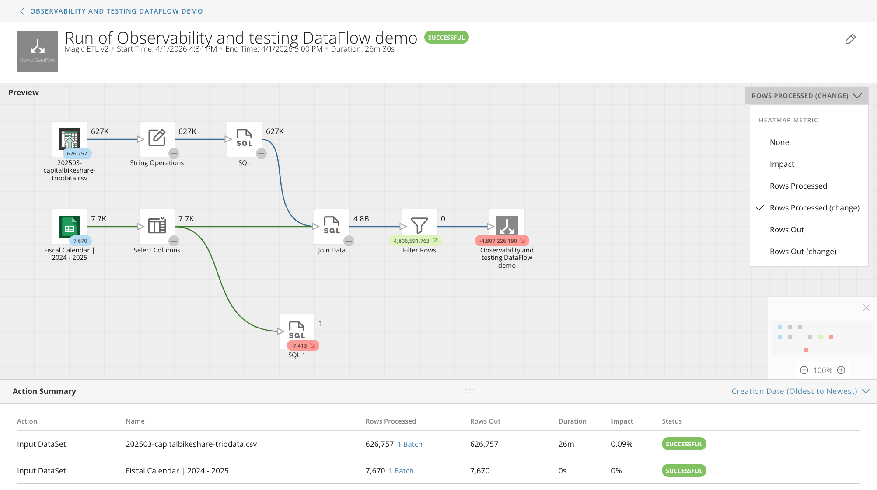

Load Prior DataFlow Versions
You can now view prior versions of a DataFlow without first making an older version the current version. Open an earlier version to see all of its logic and configuration, then save it as a new version or as an entirely new DataFlow.

Multi-Statement SQL Tile
The Multi-Statement SQL tile lets you write multiple SQL statements in a single tile rather than stringing together multiple SQL tiles, and create multiple outputs. This provides a higher-code feel and lets you build interstitial tables as part of a single SQL script.

New Canvas Navigation Controls
You can now choose how you navigate the Magic ETL canvas. In addition to the original scroll-to-navigate behavior, a new click-drag navigation option lets you click and drag to move around the canvas, similar to other canvas-based tools. Set your preference in the Magic ETL User Preferences menu.
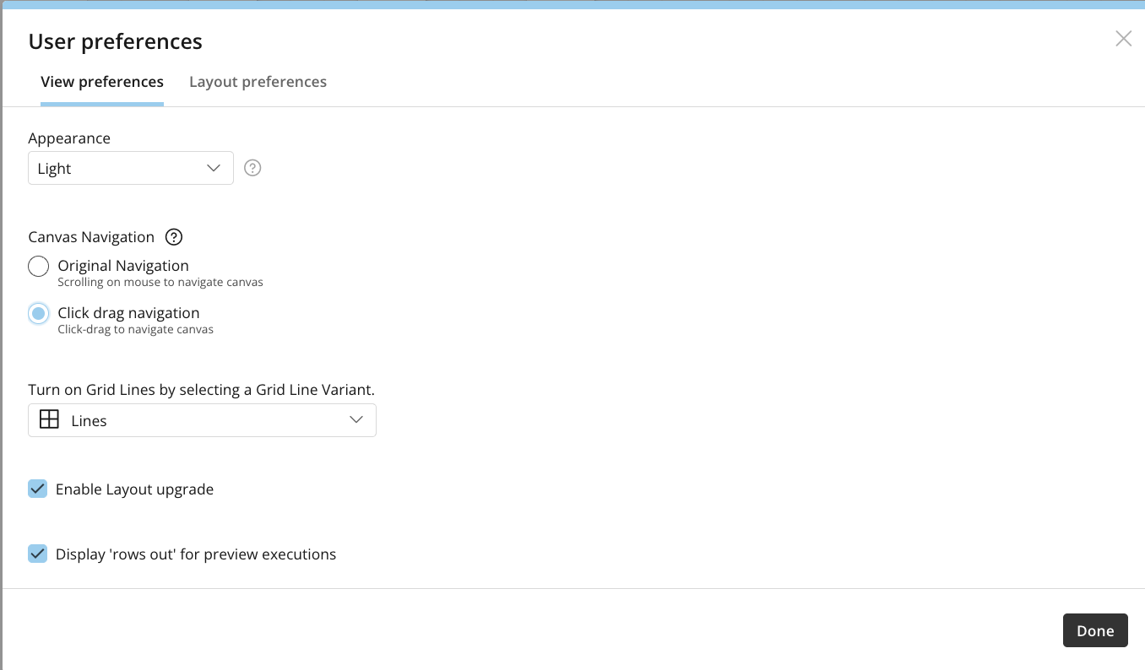

Persistent User-Level Settings
You can now persist user-level preferences across all your DataFlows in an instance, including grid line variant, appearance (light or dark mode), layout upgrade, and whether to display "rows out" for preview executions.

Row Counts in Previews
When you run a preview while authoring a DataFlow, you can now see the number of rows output by each action, displayed on or near the output nodes. This makes it easier to track how each action affects your data and to spot quality issues before creating the output DataSet.

Select Columns Tile Enhancements
The Select Columns tile has been redesigned to make reordering and managing columns easier, with better options for reordering columns and groups of columns.

Sentiment Analysis Tile
The Sentiment Analysis tile automatically classifies text such as reviews, social media posts, and surveys as positive, negative, or neutral, so you can monitor brand reputation and act on the results.
Learn more about the Sentiment Analysis tile in Magic ETL.

Mason App Editor Deprecation
Starting October 14, 2026, the ability to create and edit Mason apps will no longer be available in Domo. Mason app authoring, including creating new Mason apps and editing existing ones, will be discontinued. This affects anyone who currently builds or maintains apps using the Mason framework.
Existing Mason apps will continue to run and remain accessible to end users; only the authoring and editing experience is being removed. No changes are being made to other app development tools or the broader App Studio ecosystem at this time.
If you currently develop or maintain Mason apps, we recommend transitioning your development workflow to Domo Apps (custom apps).
Learn more about building Domo apps with the Pro-code Editor.

New Chart Improvements in App Studio and Analyzer
Three new chart types and rounded bars give your apps more ways to show data and a more modern look:
- Multi Progress Bar gives every category its own row, showing actual, maximum, and target in a single line
- Symbol Matrix plots two dimensions in a grid, sizing and coloring each symbol by value
- Ribbon Chart connects stacked segments across categories, so shifts in share and rank read as movement
Bars now also support rounded corners for a softer, more modern look across your app.
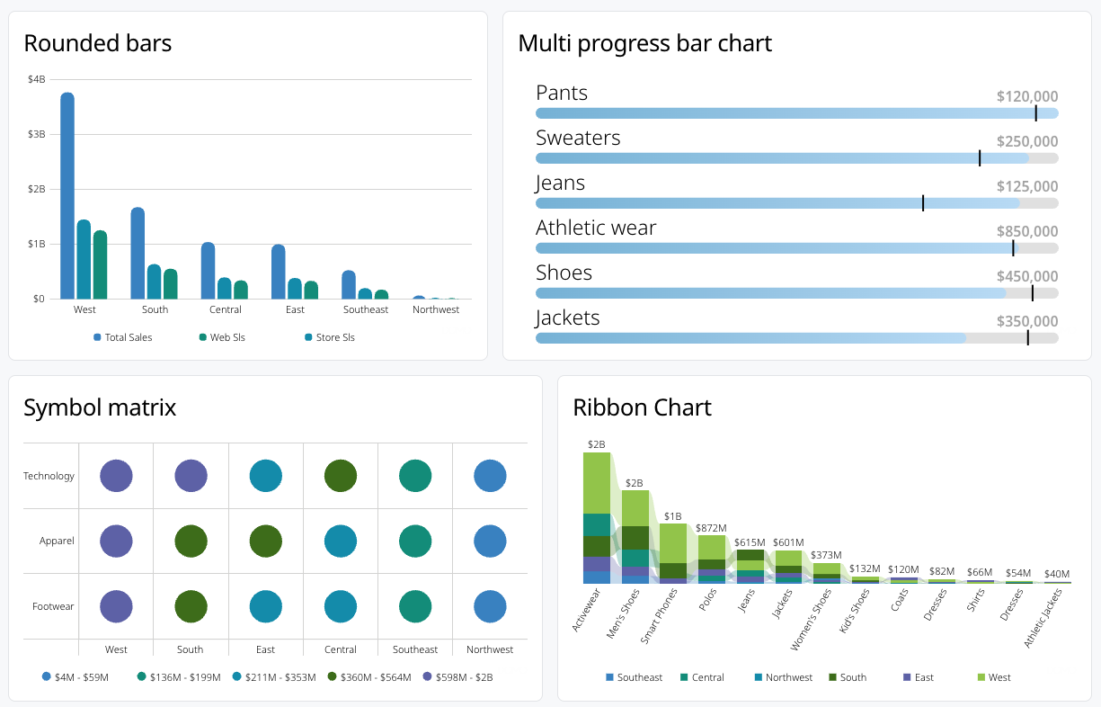

New Left Navigation Onboarding
Domo now makes it easier to discover and move to the new left navigation. Administrators see an in-product banner announcing that the new navigation is available, with a Learn More option that opens Navigation Settings, where you can enable it for all users, for administrators only, or for a specific group. Navigation Settings also links to documentation and other resources to help you plan the change.
When an administrator turns on the new navigation, each user is welcomed the first time they sign in with a short message and video that introduces the new experience.
Learn more about migrating users to the new left navigation.

OAuth-Only Read-Only Integrations
You can now natively create an OAuth-only integration that is read-only for every engine that supports OAuth, including Databricks, Snowflake, and BigQuery. Enterprises that standardize on OAuth can connect using user-to-machine OAuth authentication without configuring other credential types.

Pvariable Support for Dashboards, App Studio, and Embed
Domo now supports pvariables across Dashboards, App Studio, and Embed. Pass a page URL parameter to apply variables when the page loads, so a link can open with the right variable values already in place.
Learn more about Variables in Domo.

Regional Date and Number Formatting
Domo now formats dates and numbers according to the CLDR international standard, ensuring consistent formatting across all browsers and operating systems.

Semantic View Integration
You can now register a Snowflake semantic view through Cloud Integration just like any other Snowflake table, so the tables, relationships, synonyms, descriptions, and metrics you already defined in Snowflake come into Domo without rebuilding that business logic by hand.
Domo imports the semantic view as a read-only data model, displays its metadata in the Domo schema, maps its relationships in the data model editor, and exposes its dimensions, measures, and derived metrics in Analyzer and App Studio. Snowflake remains the source of truth, so metric definitions stay consistent while analysts build cards immediately without recreating the model.

Workflows Enhancements

DataSet Query Task No-Row Support
The DataSet Query Task now supports queries that return no results. You can save configurations and generate output parameters even when a query returns no rows, making it easier to design and test scenarios where empty result sets are expected. DataSet Query Tasks also now execute successfully at runtime when no data is returned.

MCP Trigger
The new MCP trigger gives AI a supported, governed, and purpose-built way to start a workflow directly, instead of repurposing triggers designed for other use cases. The MCP trigger is enabled automatically when a workflow is deployed, so no configuration is required, and the Workflow Execution Details page identifies when a workflow was started by AI for clear visibility into AI-initiated executions.
Learn more about connecting AI tools to Domo using MCP and managing Workflows.

Versioning Code Engine Functions
Updating Code Engine function versions in Workflows is now easier with the new Change Version option. Compare inputs and outputs between your current function version and the version you want to switch to before making the change, so you have clear visibility into parameter differences. When the same inputs and outputs exist in both versions, existing mappings are preserved automatically, eliminating unnecessary remapping.

Fast Follows - October 1st

AI Chat Updates
AI Chat can now handle complex, multi-part questions and answer questions that span multiple DataSets. Though cross-DataSet joins and unions still aren't supported — instead, it queries each DataSet independently and synthesizes the results. It also supports more in-depth analysis and now works with Documents (unstructured data). Additionally, it now supports visualizations, letting you view and create them. You can upload files, paste images & @mention to include additional knowledge. AI Chat now how access to the Knowledge Base (KB), expanding what you can accomplish conversationally in Domo.
Learn more about AI Chat.

AI Chat Consumption Model
AI Chat now draws on Domo's AI Pro consumption model for credit usage, aligning AI Chat with the same consumption framework used across Domo's AI Pro features.
Learn more about AI Chat.

Beta Features
The following features are available through Domo's beta program.

Activity Log Webhook
You can now stream a subset of Activity Log events to an external destination through a webhook, so a system you own can receive activity events as they happen.
Learn more about the Activity Log.

undefinedMCP Toolkits - Alerts and Workspaces
The MCP Toolkits - Alerts and Workspaces offering lets Domo AI agents manage Alerts and Workspaces on your behalf, so you can manage them conversationally through Domo AI. Capabilities include full create, read, update, and delete for Alerts and Workspaces; management of related concepts such as items, folders, subscribers, and sharing; and permission-aware behavior, since every tool respects the calling user's access to the underlying resources.
Learn more about connecting AI tools to Domo using MCP.

App Broadcasting
App Broadcasting allows custom apps on the same Domo page to communicate with each other in real time, without relying on page filters or Variables. Capabilities include:
- Apps can publish named messages to a topic and subscribe to messages from other apps on the page
- Map apps can drive KPI cards
- Filter panels can update up to three charts at once
- Apps can declare their channels in the manifest.json file, and App Studio provides a visual wiring interface so authors can connect apps without touching code
Additional details and implementation guidance are available in the developer documentation at developer.domo.com.

undefinedMCP Toolkits - Automation
The new MCP Toolkits - Automation offering lets Domo AI securely create, update, manage, and execute automations across your automation services through natural language. The toolkits are available in the AI Library, with all existing grants and permissions for those services continuing to apply:
- MCP Toolkits - Workflows covers the full workflow lifecycle
- MCP Toolkits - Code Engine manages Code Engine packages
- MCP Toolkits - Queues (Task Center) manages Task Center work queues
- MCP Toolkits - Forms manages forms
Learn more about connecting AI tools to Domo using MCP.

Case Statement Builder
The Case Statement Builder provides a guided builder for common conditional logic use cases, so you no longer need to know DQL to build conditional logic. When creating a calculated field, choose the Rule Builder or plain Beast Mode; stack rules top to bottom in the Condition Builder; and reopen saved rules in the builder rather than as raw SQL. Anything the builder can't handle can be converted to a Beast Mode.

Documents Support in Magic ETL
You can now bring unstructured document data into a Magic ETL DataFlow, process it alongside your other data, and write the resulting files back to a Document Collection. Three new tiles under Documents make this possible:
- Collection Input selects a Document Collection as an input to your ETL
- Document Read reads file bytes from a collection
- Document Write writes files to a target collection
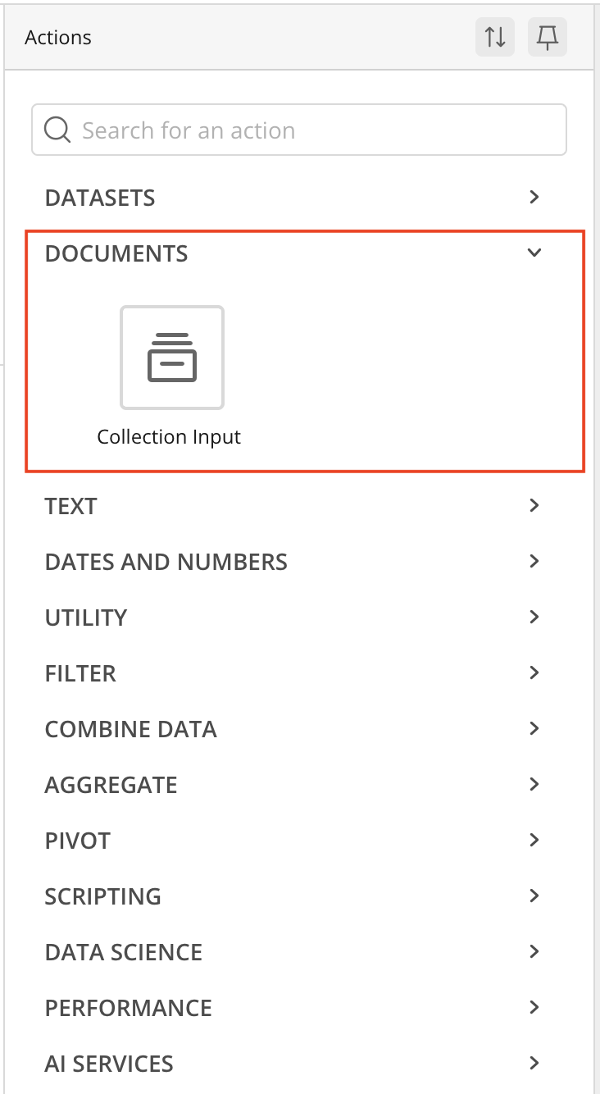
Learn more about the Documents tiles in Magic ETL.

undefinedMCP Toolkits - Domo Sandbox
The MCP Toolkits - Domo Sandbox offering provides tools for managing Domo Sandbox repositories, including creating, committing, promoting, deleting, and managing sharing of repositories, along with orchestration to tie those actions together. These toolkits are available in the AI Library.
Learn more about connecting AI tools to Domo using MCP.

Global and Fiscal Calendar Support
Cloud Integrations now let you register your own calendar table to support both custom fiscal calendars and standard calendars, so organizations with non-standard fiscal years get accurate date-based reporting without leaving their data warehouse. Set one up two ways:
- Generate a new calendar using a guided wizard that walks through calendar type, fiscal year start, validation dates, and year range
- Connect an existing calendar by pointing Domo to a calendar table that already exists in your warehouse
Once registered, cards and Analyzer reports use the calendar to drive accurate date grouping and period-over-period comparisons, including support for 4-4-5, 4-5-4, and 5-4-4 fiscal structures.
Learn more about Fiscal and Standard Calendar Configuration for Cloud Integrations.

Resolved Issues

Data Model Schema Mapping on BigQuery and Databricks
Querying a data model on BigQuery or Databricks could load schema mapping incorrectly. Data models now resolve schema correctly across all supported engines.

Data Lineage Calculation Performance
Recalculating how many cards and other downstream artifacts a DataSet feeds could be slow and, in some cases, report an inaccurate count. Lineage recalculation is now faster and more accurate.

Support
Domo provides education, community answers, and technical support.
- Search for a topic in the Help Center.
- Learn from Domo University.
- Search for training apps in the Appstore .
- Get answers in the Community Forums.
- Contact Technical Support by entering a help ticket in the Domo Support Portal.
- Reach out to your Domo account team.

