Inventory - Bug Report

BUG-01: Purchase order search not working with capital letters
Steps:
1. Go to Purchase Orders.
2. Type PO-000002 in the search box.
Description: PO-000002 should come in the list, but it shows "No purchase orders found". It works only if we type in small letters.
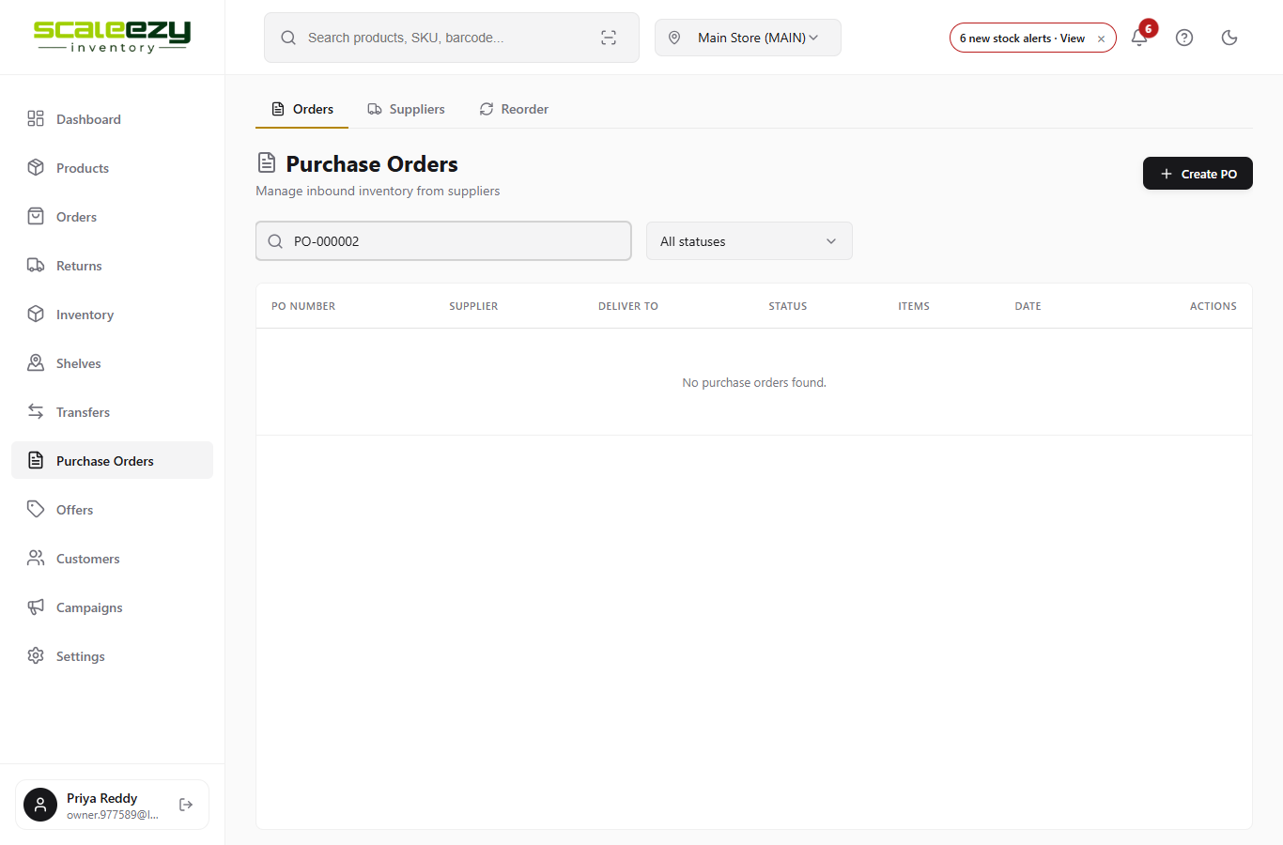
Where it breaks: src/pages/PurchaseOrders.jsx, line 115

BUG-02: Supplier search not finding supplier by name
Steps:
1. Go to Purchase Orders > Suppliers.
2. Type Kanchi in the search box.
Description: Kanchi Weavers should come, but it shows "No suppliers found".
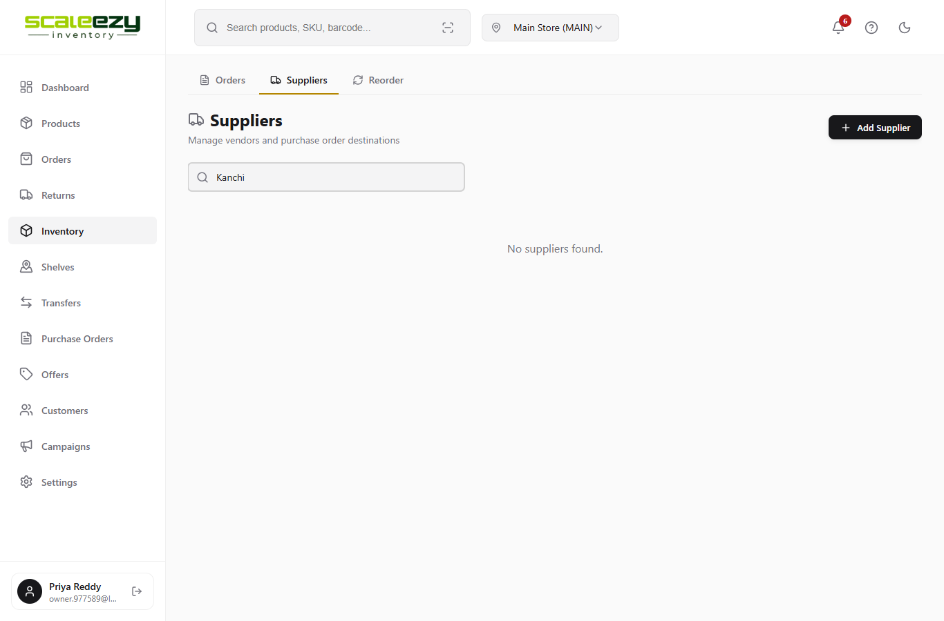
Where it breaks: src/pages/Suppliers.jsx, line 25

BUG-03: Out of Stock count showing -1
Steps:
1. Go to Inventory > Stock alerts.
Description: Out of Stock tab should show (0), but it shows (-1).
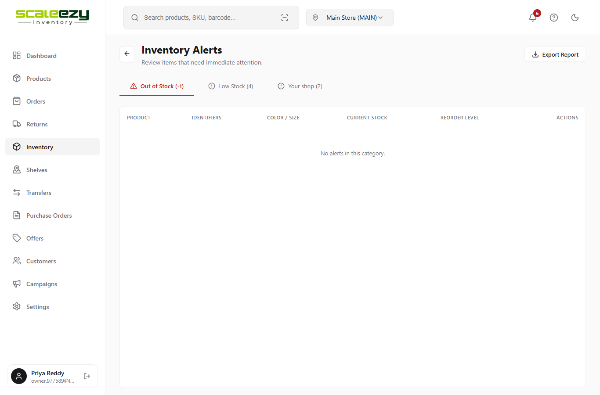
Where it breaks: src/pages/AlertCenter.jsx, line 96

BUG-04: Zero stock not showing in red
Steps:
1. Go to Inventory.
2. See Stock Qty of Anarkali Suit Set.
Description: Stock 0 should show in red, but it shows in black like other items.
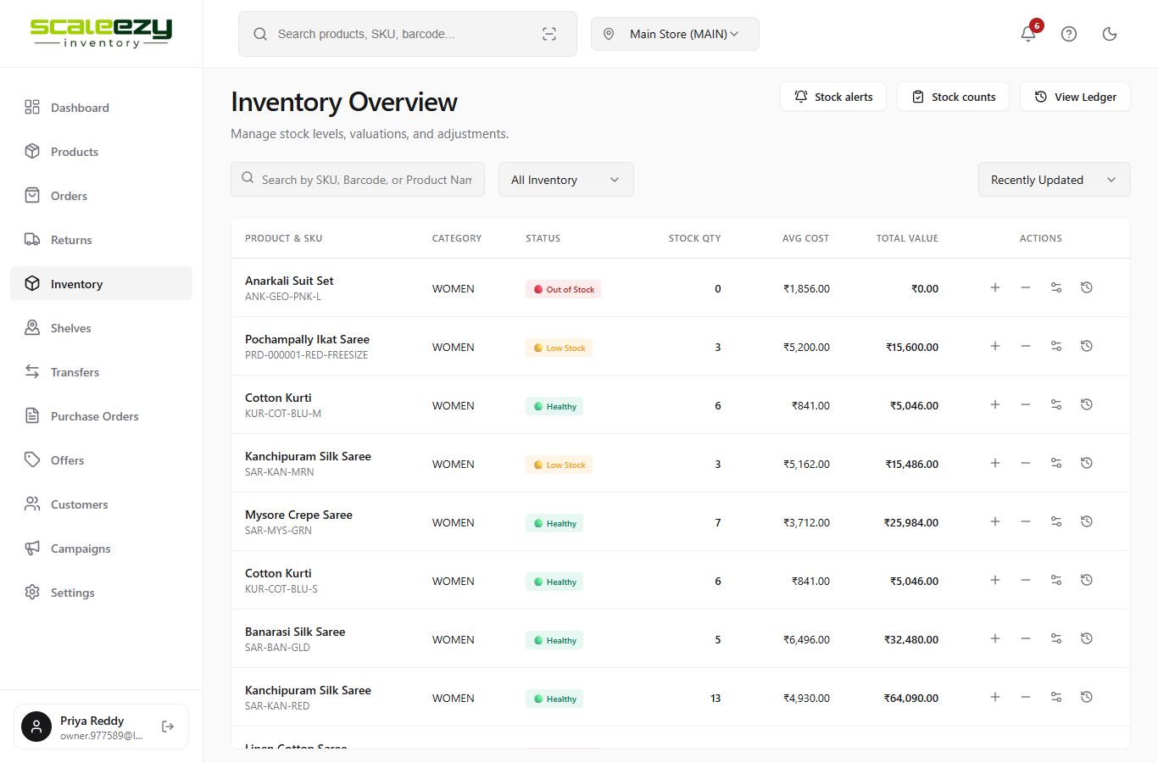
Where it breaks: src/pages/InventoryOverview.jsx, line 202

BUG-05: Stock Units showing wrong number in Products
Steps:
1. Go to Products.
2. See Stock Units of Chanderi Cotton Saree.
Description: Stock Units should show 7, but it shows 2 (same as Variants). All rows have this problem.
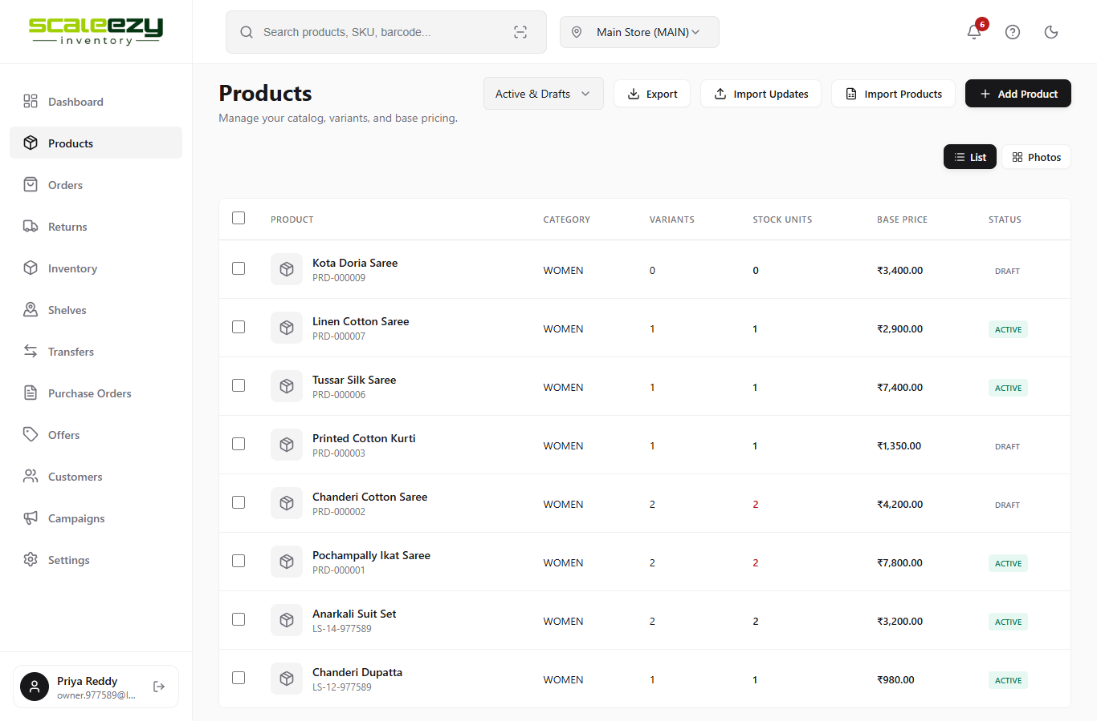
Where it breaks: src/pages/Products.jsx, line 372

BUG-06: Customer created date showing wrong month
Steps:
1. Go to Customers.
2. See the Created date under any customer.
Description: Customer was created on 6/10/2026, but it shows 6/9/2026.
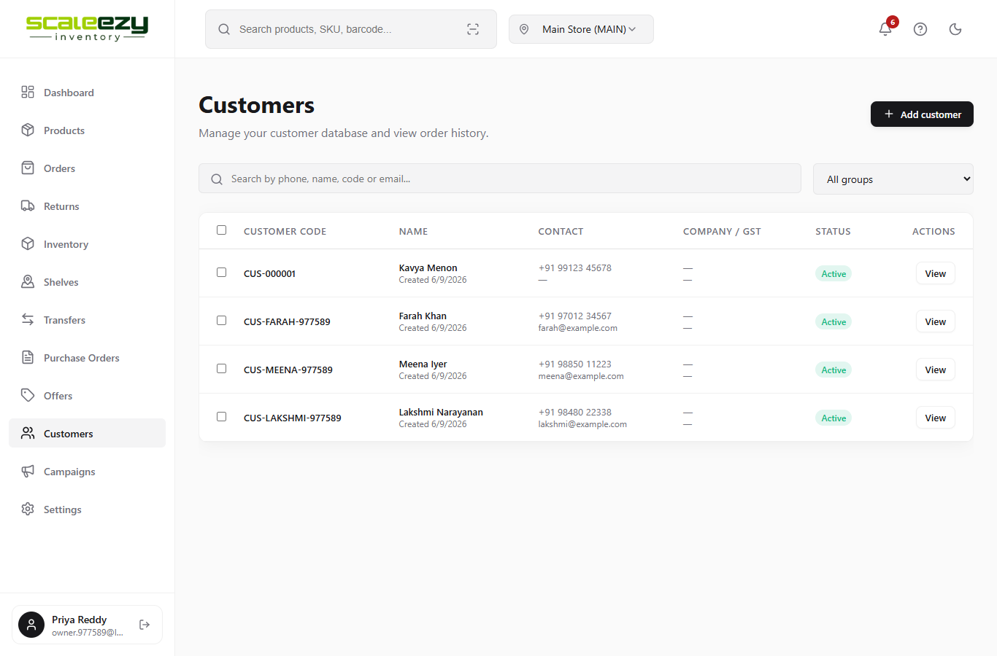
Where it breaks: src/pages/sales/Customers.jsx, line 186

BUG-07: Top Suppliers rank starting from #0
Steps:
1. Go to Dashboard > Analytics.
2. See the Top Suppliers card.
Description: First supplier should be #1, but it shows #0.
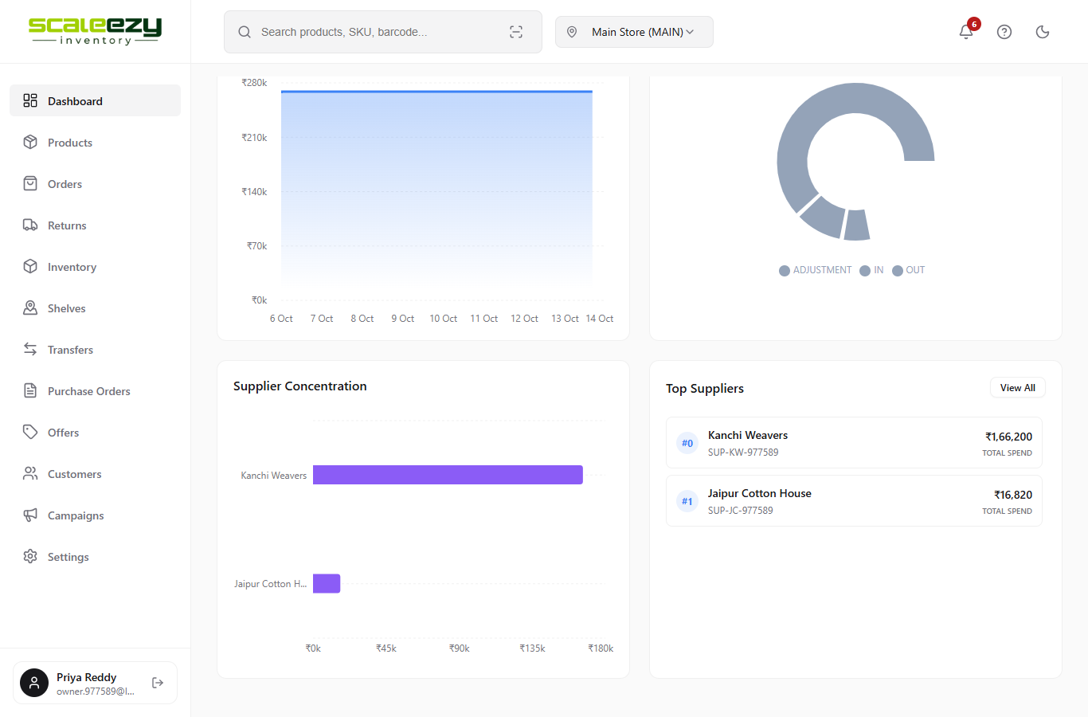
Where it breaks: src/components/dashboard/SupplierSpendWidget.jsx, line 56

