My elementary school experience begins at Tagoloan Central School.

I've been doing fantastically well in terms of attendance, ceremonies, and so on.

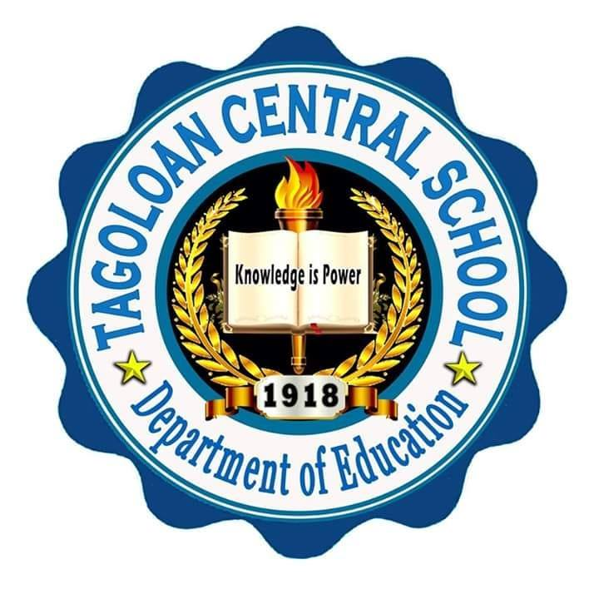Drum and lyre corps, as well as With Honors. That's where I've met a lot of my friends.

Graduate in the same class.

My High School Experience at Tagoloan National High School is starting to feel

Like a rough take. I chose Technology voc because I want to try new things.

Regular is the preferred option. We had three options in Tech Voc: cooking, engineering, and technology. I chose Cookery because I enjoy cooking over time.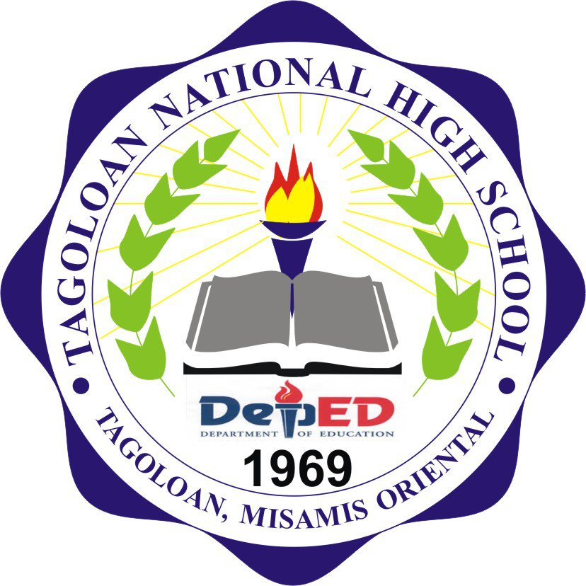

My Senior High School Experience at Capitol University

I'm having difficulties not only with my classmates, but also with myself.

I have issues with myself. The important thing is that I finish all of my assignments.

My task and homework were completed without a hitch, and no problems remained.