User Manual

Version 1.10

*DivSeek*

**Table of Contents**

**Introduction** **3**

**Scope and Purpose** **3**

**Process Overview** **3**

**[Process/WorkFlow ]** **4**

[**[Create Empty Folder]   
Create empty folder by right clicking on an empty space on your computer like shown below:**](#_z27ptkxn9rq2) **4**

**[Place Vagrantfile Into Previously Created Folder]** **5**

**[Go into Command Prompt/Git Bash]** **6**

# Introduction

This is a user manual which will guide you along the way on how to setup Vagrant and Docker on your local machines.

# 

## Scope and Purpose

A deployable genomics web portal that utilizes a Vagrant environment setup with the use of a pre-configured script to automate installation on any machine. The key benefits of this portal is the ability to link various analytical tools for plants/crops data for scientists to easily manage their own data. There can be as many instances of this application running simultaneously without affecting each other’s information.

This will cover how to run the script and configure a Linux virtual machine environment to setup the web portal.

**Prerequisites**

* Oracle VM Virtualbox (<https://www.virtualbox.org>)
* Vagrant (<https://www.vagrantup.com>)
* Computer (Any OS)
* For Windows Machine Git Bash is required (<https://git-scm.com/downloads>)

## Process Overview

1. Create empty folder (Folder can be named anything you want)
2. Place given Vagrantfile (script) into the folder
3. Press Window Key and type ‘cmd’ -> enter
4. Navigate to the Vagrantfile folder with the command ‘**cd**’ e.g. if your folder is on your C: Drive then command would be something like this ( cd c:\[Folder Name] )
5. Once inside the Directory, enter the command **vagrant up** and the Vagrantfile will automatically install all the necessary files
6. Open your web browser and put in your local address specified in the Vagrantfile and the port 3000/tripal to go to the web portal e.g. 192.111.33.11:3000/tripal
7. On the left hand side of the navigation tab, there will be Trait and JBrowse which upon clicking will bring you to the Trait module page or JBrowse page

# [Process/WorkFlow ]

This section covers the process you would need to set up our environment to get the web portal running

## [Create Empty Folder] Create empty folder by right clicking on an empty space on your computer like shown below:

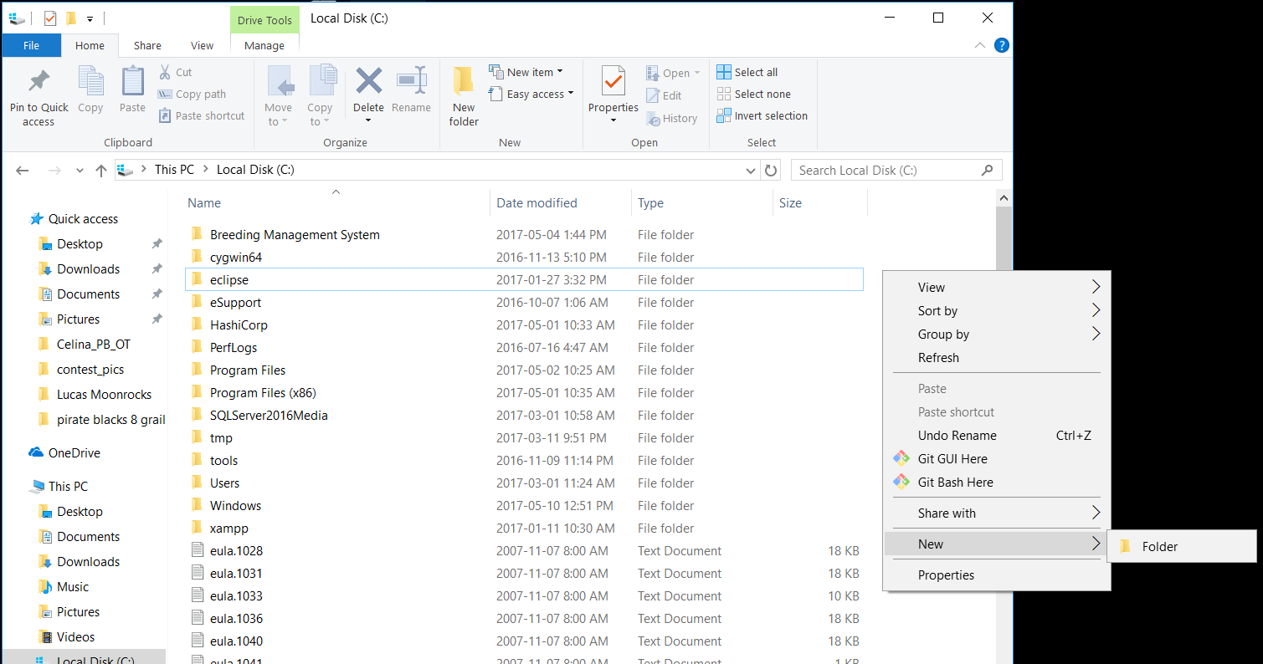

## [Place Vagrantfile Into Previously Created Folder]

Place the given Vagrant file into the folder you just created

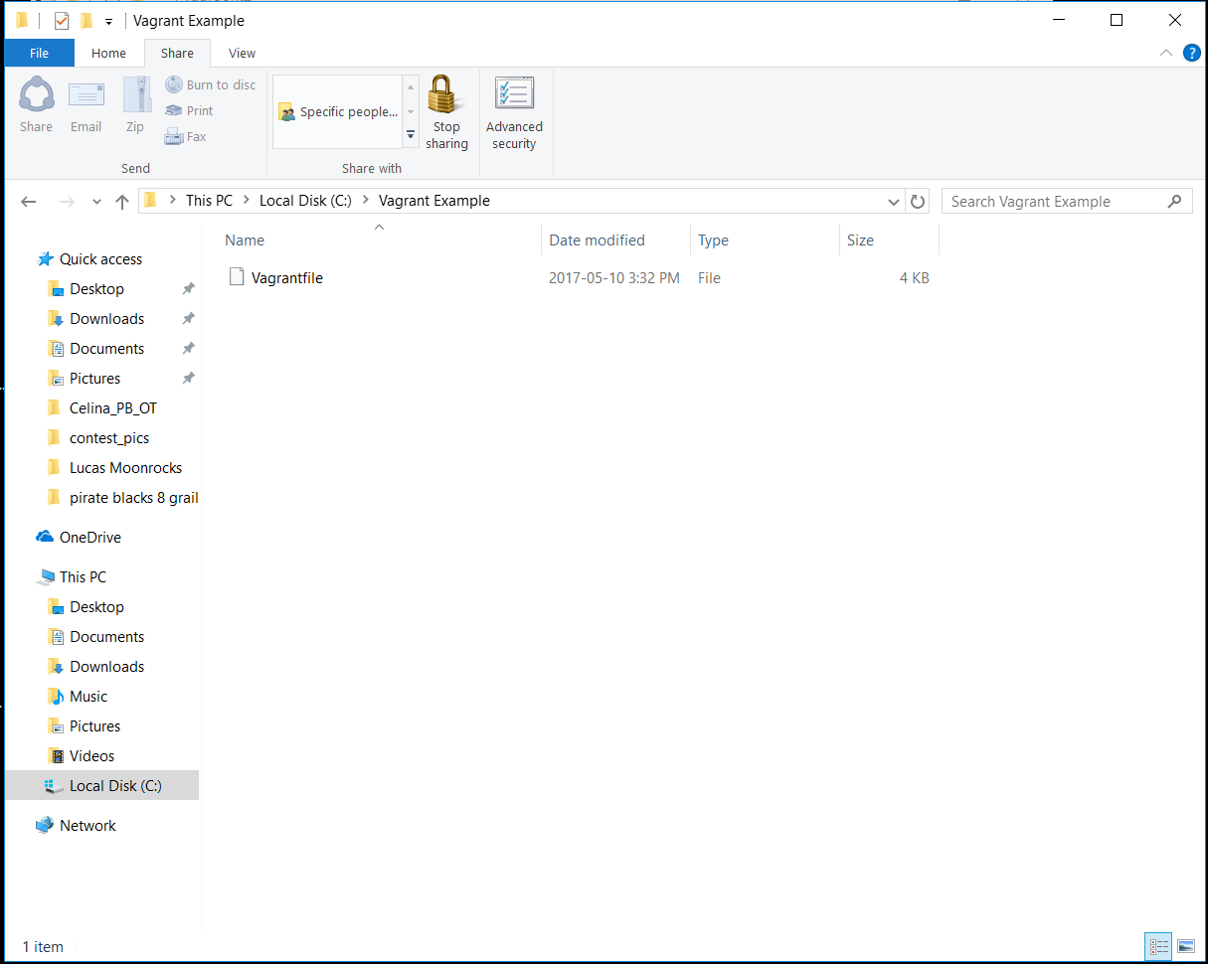

## [Go into Command Prompt/Git Bash]

Go into command prompt by hitting the window key on your keyboard, type cmd/git bash and hit enter, and you should arrive to this screen

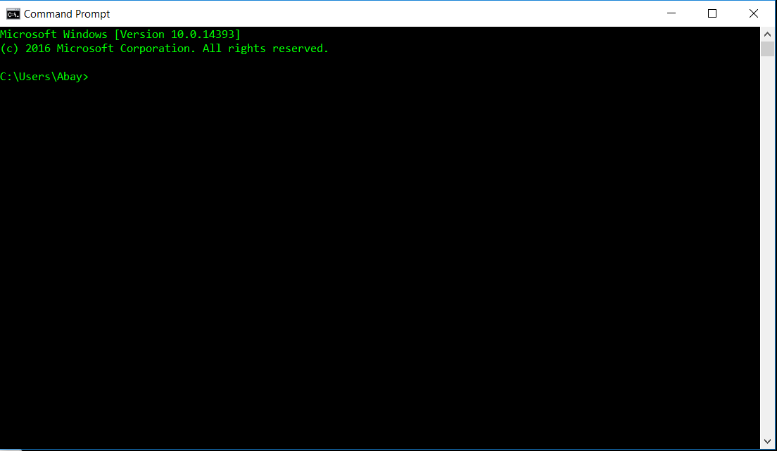

**2.3.1 [Change Directory to Your Vagrantfile Folder]**

To change directory, the command is cd [file path here] so in this guide we will cd into our C: Drive and then our Vagrant Example folder

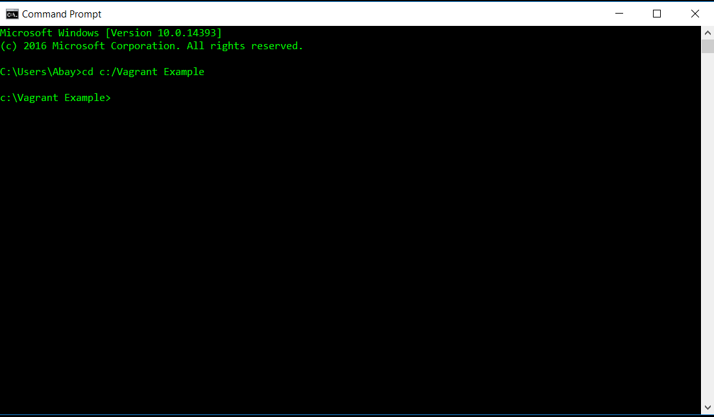

**2.4 [Executing the Vagrantfile for Automatic Installation]**

Type **vagrant up** in the command line once you’re in the folder. In some occasions one of your ports might be used and get an error like this

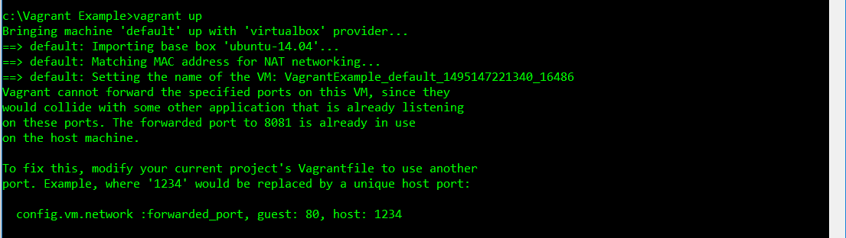

To fix this we need to change the port number in our Vagrantfile with notepad or notepad++ to anything we want, in this case it says port 8081 is being used so we can just change it to a port that isn’t being used

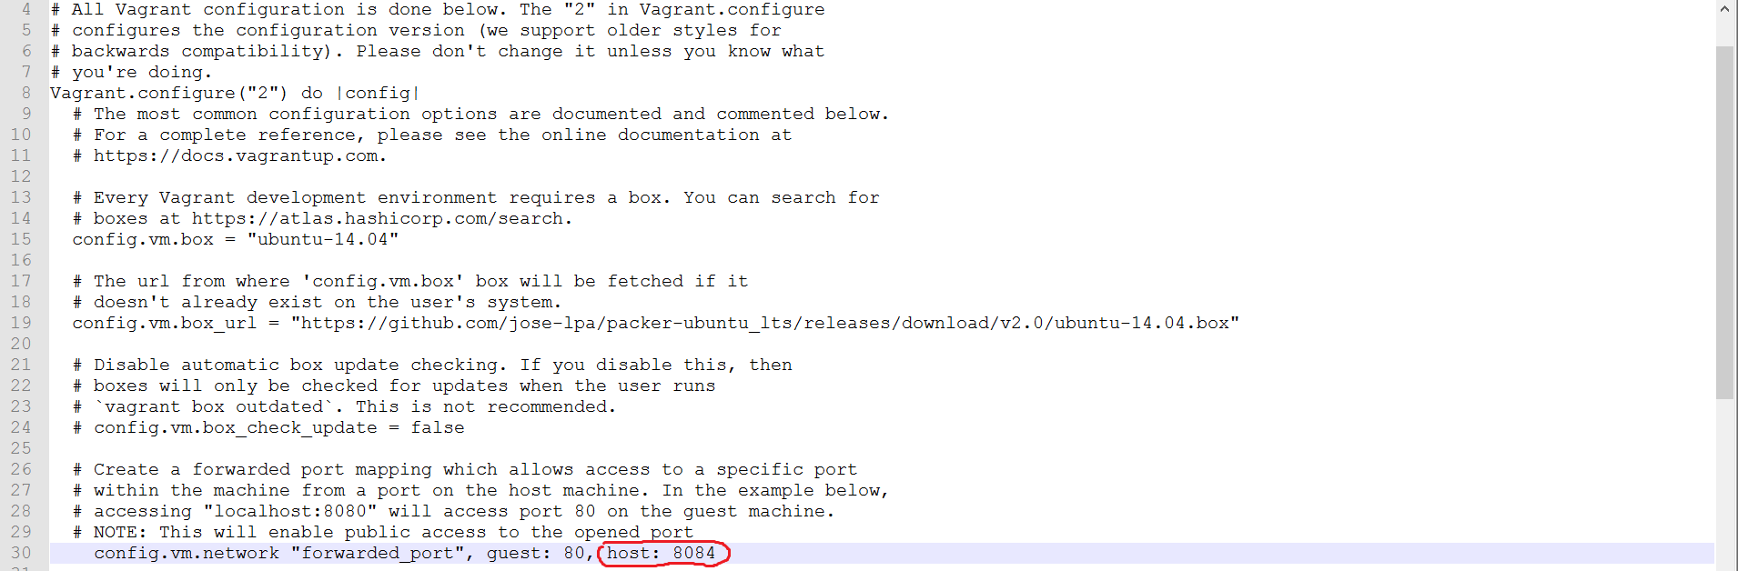

After that, save the file and do **vagrant up** again and if it’s working you should get a similar screen like this

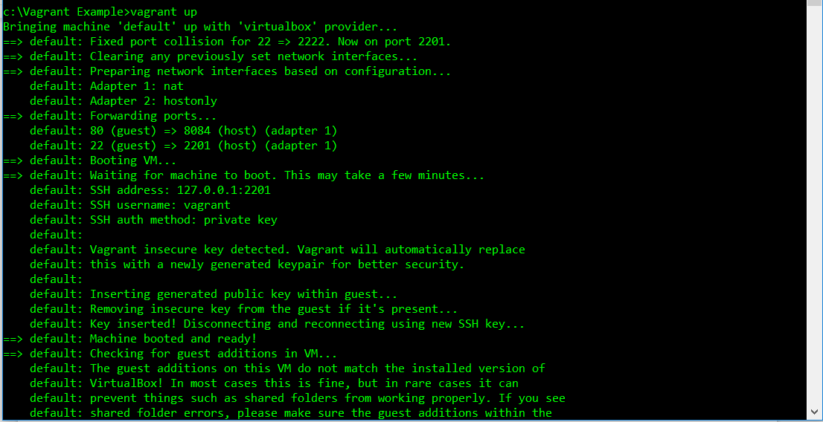

The Vagantfile script will then install everything and once it’s done you should have a screen like this

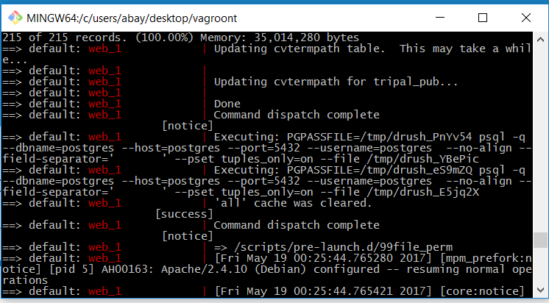

**2.5 [Going to Web Portal On Web Browser]**

Our base URL is 192.168.33.11:3000/tripal to enter our web portal

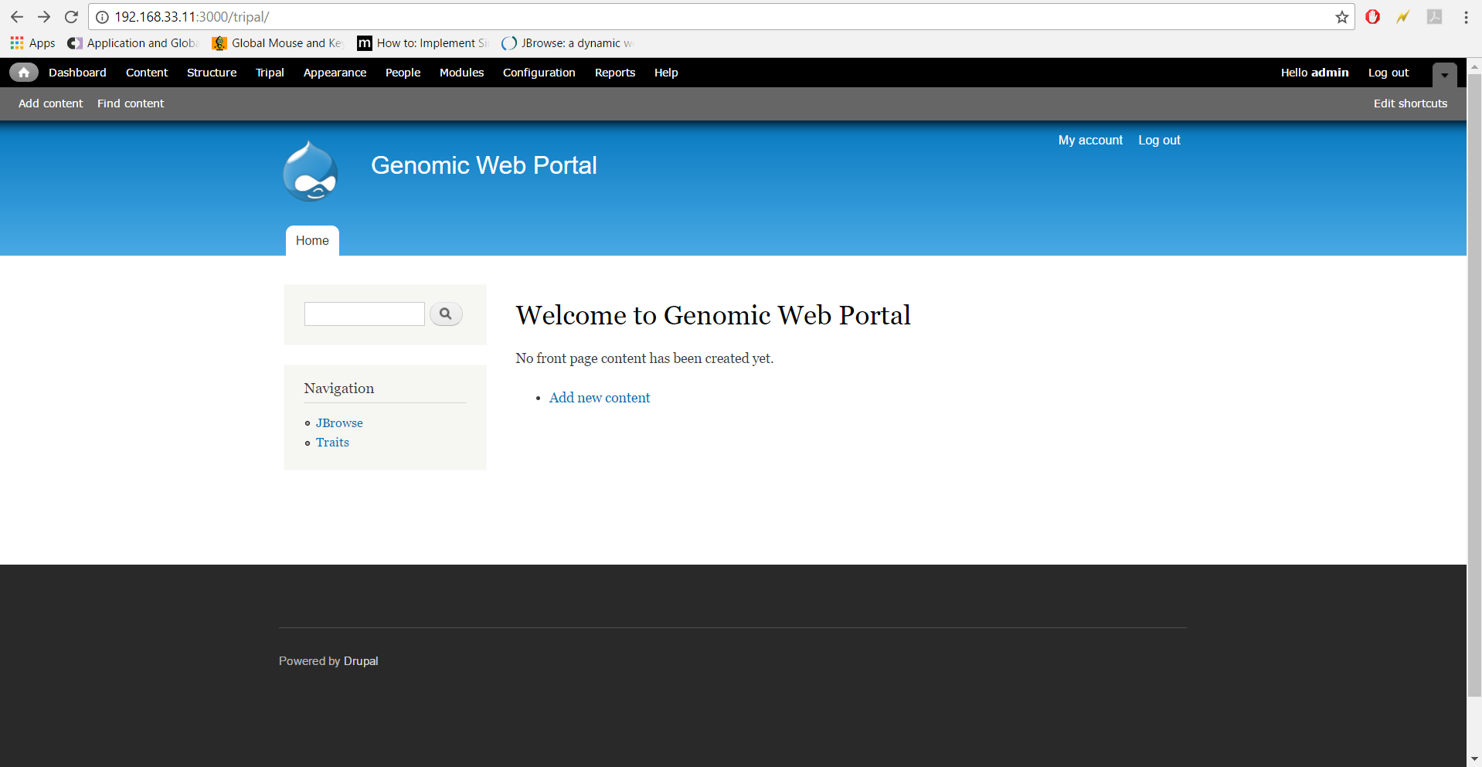

On the left hand side would be the tools we have for crop analysis, clicking them would redirect you to those page modules.