Adaptive RAG Clinical Assistant
A Retrieval-Augmented Generation system for clinical trial documentation that adapts response complexity based on user expertise. Built as an M.Tech thesis project at IIT Jodhpur.
Version 2.0.0 · Author: Khalid Siddiqui · Date: 2026-02-18 · Python 3.11+ · Apache 2.0 License

01 Project Overview
Imagine you work at a hospital or pharmaceutical company running a clinical trial -- a carefully controlled medical study to test whether a new drug or treatment is safe and effective. These trials generate enormous documents called IRC Charters (Independent Review Committee Charters) and protocols that can be hundreds of pages long. When someone on the team has a question -- "What are the inclusion criteria for this trial?" or "How do I measure tumor response?" -- they have to search through these massive documents manually. This project solves that problem.
The Adaptive RAG Clinical Assistant lets users upload a clinical trial PDF, then ask questions about it in natural language. The system finds the most relevant passages using a sophisticated hybrid search that combines two different search strategies, then feeds those passages to a large language model (LLM) to generate a clear answer. But here is what makes it special: the system detects whether you are a novice just learning the ropes, a seasoned expert, a regulatory professional, or an executive -- and adapts its response accordingly. A novice gets simple explanations with definitions; an expert gets dense technical detail with regulatory citations.
The system was built as part of an M.Tech thesis at the Indian Institute of Technology Jodhpur, and demonstrates that persona-aware RAG systems can meaningfully improve the usability of clinical trial documentation for diverse stakeholders.

02 Tech Stack
Every tool in this project was chosen for a specific reason. Here is the complete stack, what each piece does, and why it was selected.
Technology | Role | Why This One?
Python 3.11+ | Core language | The standard for ML/AI projects. Rich ecosystem for NLP, embeddings, and LLM integration.
Streamlit | Web interface (frontend) | Lets you build interactive web apps in pure Python -- no JavaScript needed. Ideal for data-heavy research demos.
LangChain | LLM orchestration framework | Provides pre-built components for document loading, text splitting, vector stores, and retrieval. Acts as the glue connecting all AI pieces.
ChromaDB | Vector database (storing embeddings) | Lightweight, runs locally without a server, persists to disk. Perfect for a research project that needs to work on a single machine.
HuggingFace Transformers + Sentence-Transformers | Embedding models | Provides access to medical-specialized models like S-PubMedBert-MS-MARCO that understand clinical terminology better than general models.
OpenAI API | Cloud LLM provider (GPT-4o) | Top-tier response quality for generating answers. Used when cloud access is acceptable.
Ollama | Local LLM provider | Runs LLMs like Llama 3.1 and BioMistral entirely on your machine -- no data leaves the premises. Critical for HIPAA compliance in healthcare settings.
rank-bm25 | BM25 lexical search | Provides keyword-based search to complement semantic search. Together they form the "hybrid" in hybrid retrieval.
PyPDF | PDF document loading | Extracts text from uploaded PDF clinical documents.
Pydantic v2 | Data validation | Ensures configuration objects (like response settings) are always valid.
pytest | Testing framework | Industry standard for Python. The project has 50+ tests covering all core logic.
ruff | Linting and formatting | Replaces Black, Flake8, and isort in a single tool. Extremely fast.
Conda (Miniconda) | Environment management | Manages Python versions and complex scientific dependencies (like PyTorch) more reliably than pip alone.
NumPy + Pandas | Numerical computation and data analysis | Used in the evaluation suite for calculating metrics like diversity scores, latency statistics, and model comparisons.

03 Project Structure
Below is every file and folder in the project with a one-line explanation. Think of it as a map of the codebase -- when you need to find something, start here.
MTech-Adaptive_RAG_Clinical_Assistant/
app.py # Main application entry point (Streamlit web UI)
run_eval.py # CLI entry point for the evaluation suite
CLAUDE.md # Project conventions and build instructions for AI assistants
README.md # Project documentation with setup, usage, and results
pyproject.toml # Python project config: ruff, pytest, mypy settings
requirements.txt # Pinned Python dependencies (pip freeze output)
environment.yml # Conda environment definition for reproducible setup
.env.example # Template for environment variables (API keys)
.gitignore # Files and folders excluded from version control
LICENSE # Apache 2.0 license
test_llm_providers.py # Standalone script to test LLM provider connectivity
src/ # Core source code package
__init__.py # Package init -- exports all public APIs, version info
config.py # All constants: models, defaults, limits, colors
personas.py # User type detection and response configuration
query_classifier.py # Classifies queries into 9 types via regex patterns
retrieval.py # RRF algorithm + HybridRetriever combining semantic+BM25
embeddings.py # Loads embedding models with fallback chains
prompts.py # Builds adaptive LLM prompts from persona + query type
utils.py # Utility functions: hashing, diversity, dedup, formatting
llm/ # LLM provider abstraction layer
__init__.py # Package exports for LLM module
base.py # Abstract base class (LLMProvider, LLMResponse)
factory.py # LLMFactory: creates providers from config dicts
openai_provider.py # OpenAI GPT-4o/GPT-4o-mini implementation
ollama_provider.py # Ollama local model implementation (Llama, BioMistral, etc.)
eval/ # Evaluation and benchmarking suite
__init__.py # Package exports for eval module
model_comparison.py # Compares 6 embedding models on retrieval quality
hybrid_comparison.py # Benchmarks hybrid (RRF) vs semantic-only retrieval
persona_evaluation.py # Tests response quality across all 5 personas
latency_measurement.py # Measures end-to-end pipeline latency
metrics.py # Aggregates results into final metrics summary
tests/ # pytest test suite
conftest.py # Shared fixtures (sample documents, user profiles)
test_rrf.py # Tests for RRF score formula and fusion behavior
test_personas.py # Tests for persona detection and config generation
test_query_classifier.py # Tests for 9-type query classification
test_llm_factory.py # Tests for LLM factory, aliases, and provider creation
test_config.py # Tests for configuration completeness and consistency
docs/ # Documentation
architecture.md # High-level system architecture and design decisions
API.md # API reference for all public modules
CONTRIBUTING.md # Contribution guidelines
data/ # Clinical trial PDF documents (git-ignored)
results/ # Evaluation outputs: CSVs, summaries, figures (git-ignored)
reports/ # Generated reports (git-ignored)
tasks/ # Task tracking files (git-ignored)

Tip: Where to start reading
If you are new to this codebase, read the files in this order: config.py(to understand the constants), then personas.pyand query_classifier.py(the intelligence layer), then retrieval.py(the search engine), then prompts.py(how prompts are built), and finally app.py(where everything comes together).

04 Architecture Diagram
The diagram below shows every major component in the system and how they connect. The colors indicate component types: blue for the user-facing frontend, purple for backend processing logic, pink for data storage, and teal for external AI services. Arrows show the direction of data flow.
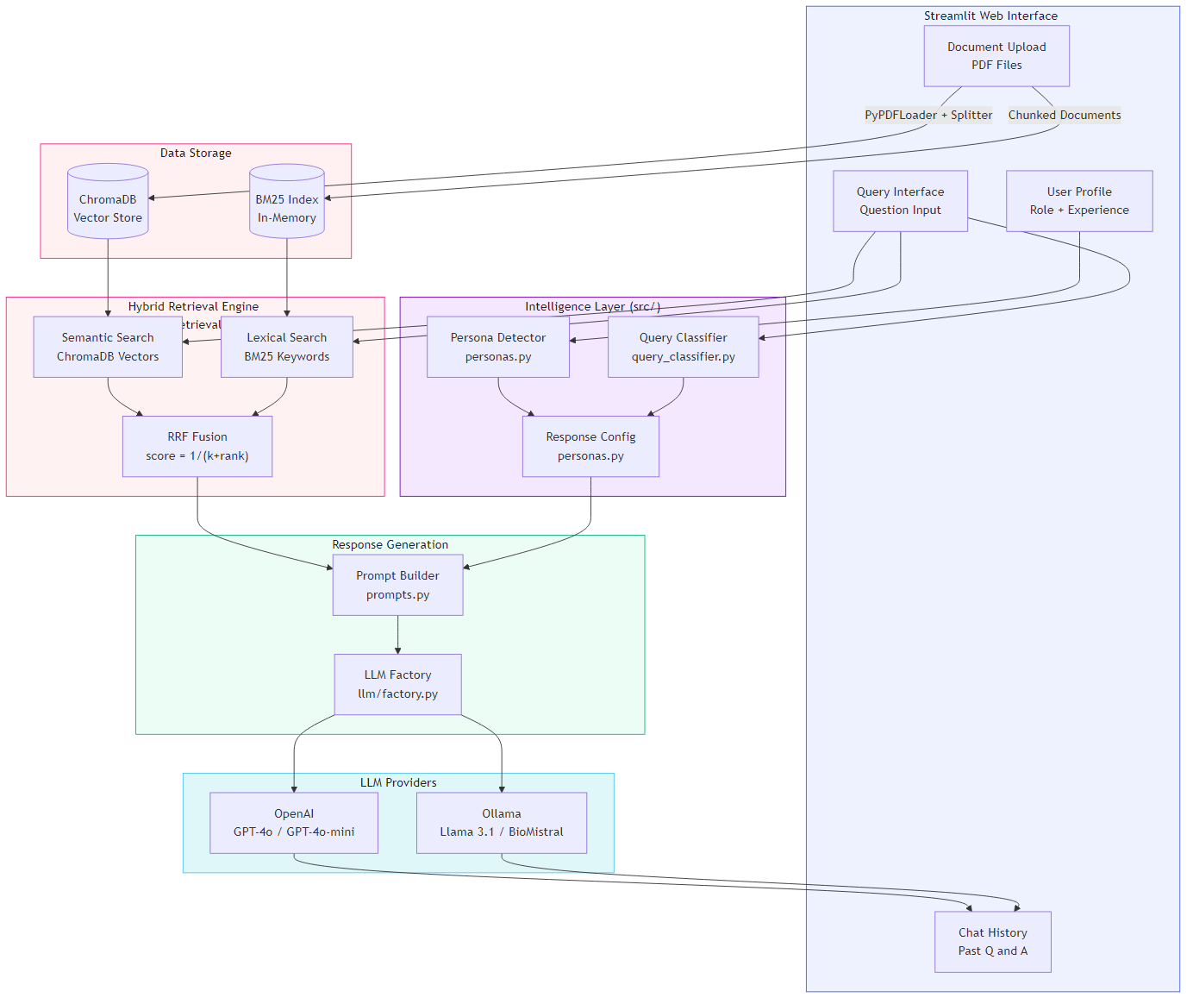
The key takeaway is that the system follows a clear pipeline: user input flows through an intelligence layer (persona detection + query classification), then through a hybrid retrieval engine, and finally through an adaptive prompt builder before reaching the LLM. This separation of concerns means each component can be tested, improved, or replaced independently -- for example, you could swap ChromaDB for Pinecone without touching the persona logic.

05 Data Flow Diagram
This diagram traces the complete lifecycle of data through the system, from the moment a PDF is uploaded to when a formatted answer appears on screen. There are two distinct phases: the indexing phase (which happens once when a document is uploaded) and the query phase (which happens every time the user asks a question).
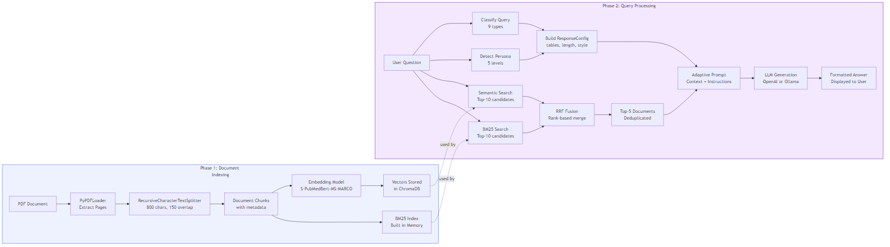
Notice how the two phases are connected by the data stores (ChromaDB and BM25 index) built during indexing. During the query phase, both retrieval paths run in parallel, then merge through RRF fusion. The "intelligence" (persona detection and query classification) happens in parallel with retrieval, and all three streams converge at the prompt builder. This parallel design keeps latency low -- the system does not wait for persona detection to finish before starting the search.

06 Query / Request Flow
Let us walk through exactly what happens when a user types a question and clicks "Get Answer." This sequence diagram shows the step-by-step interaction between all the system components, in the exact order they execute.
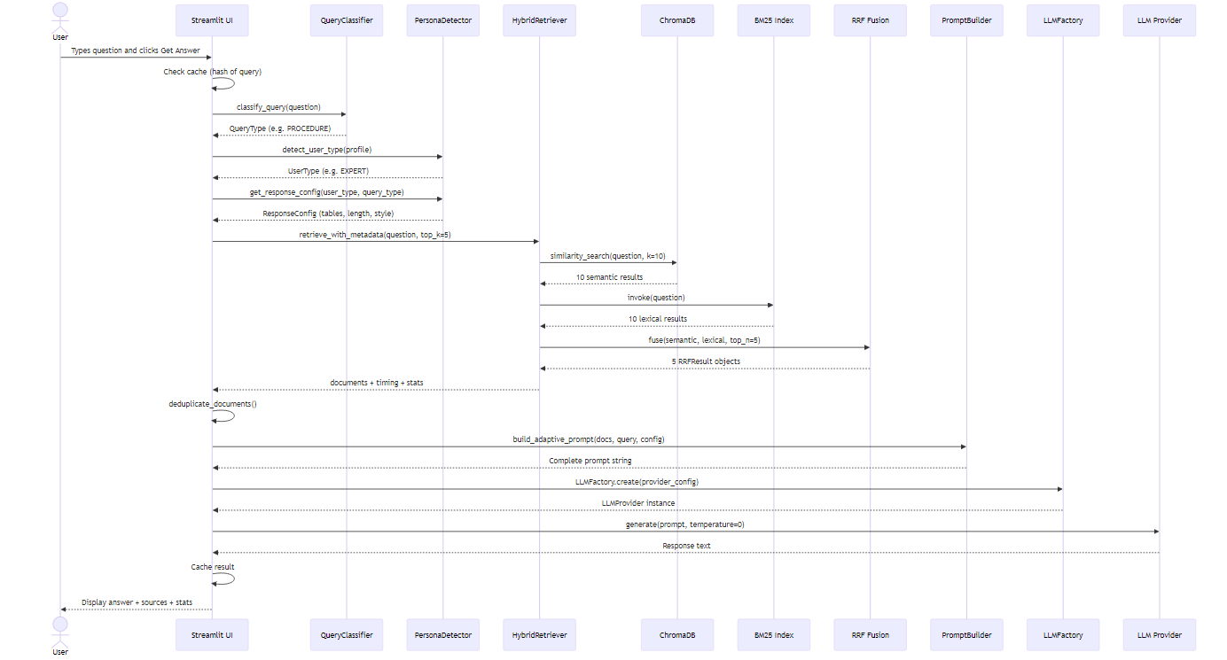
Here is what each step means in plain English:
1. Cache check: The system hashes the query to see if it has already been answered. If so, it returns the cached result instantly.
2. Query classification: The question is analyzed using regex patterns to determine its type (definition, procedure, compliance, etc.).
3. Persona detection: The user's role and experience years are checked against keyword rules to determine their expertise level.
4. Response config: The persona and query type are combined to create a configuration object that controls response formatting (use tables? include definitions? how many words?).
5. Hybrid retrieval: The question is sent to both ChromaDB (semantic/meaning search) and BM25 (keyword search). Each returns 10 candidate passages.
6. RRF fusion: The 20 candidates are merged using Reciprocal Rank Fusion, which boosts documents that appear in both result sets. The top 5 are kept.
7. Prompt building: The retrieved passages, the user's question, and the response configuration are assembled into a carefully structured prompt with specific instructions for the LLM.
8. LLM generation: The prompt is sent to either OpenAI's API or a local Ollama model. The LLM generates a response following the persona-specific instructions.
9. Display: The answer is shown to the user along with source references, retrieval statistics, and configuration details.

07 Key Modules Explained

config.py -- The Central Brain
Think of this file as the project's settings panel. It defines every constant the system uses: which embedding models are available (and their dimensions, types, and recommended use cases), which LLM models are supported (both cloud and local), default chunking sizes (800 characters with 150 overlap), retrieval parameters (RRF k=60, top-k=5), response length limits per persona, and even color codes for highlighting critical information. If you removed this file, every other module would break because they all import their configuration from here.

personas.py -- The Expertise Detector
This module is like a smart receptionist who figures out how to talk to you based on who you are. It contains the UserType enum (five levels from NOVICE to EXECUTIVE), the detect_user_type() function that uses keyword matching on job titles plus experience-year thresholds, and the get_response_config() function that generates a complete ResponseConfig object. The config controls everything: whether to include definitions, use tables, add executive summaries, set response length, and more. Without this module, every user would get the same generic response regardless of their background.

query_classifier.py -- The Question Understander
When you ask "What is RECIST 1.1?" versus "How do I measure target lesions?", these are fundamentally different types of questions that deserve different response formats. The QueryClassifier uses compiled regex patterns to sort queries into one of nine categories: Definition, Procedure, Compliance, Comparison, Numerical, Timeline, Safety, Eligibility, or Complex. The classification is done in priority order -- more specific types (like Safety or Compliance) are checked before the broad Definition fallback. Multi-part questions with multiple question marks are automatically classified as Complex. Removing this module would mean all questions get the same generic formatting.

retrieval.py -- The Search Engine
This is the mathematical heart of the system. It implements Reciprocal Rank Fusion (RRF), an algorithm published in 2009 that is now used by Elasticsearch, Azure Cognitive Search, and Pinecone. The key insight: when you have two search engines that rank documents differently, you can combine their rankings using the formula score(d) = sum of 1/(k + rank). Documents that both engines rank highly get a higher combined score. The HybridRetriever class wraps this into a clean interface that takes a query and returns the best documents with timing statistics. Without this module, the system would rely on a single search method and miss relevant passages.

embeddings.py -- The Model Manager
This module is like a car dealership for embedding models. It knows about six different models (from tiny BERT to medical-specialized PubMedBERT), can load any of them on demand, and has a three-tier fallback chain: if the requested model fails to load, it tries the configured fallback model, and if that fails, it falls back to the lightweight MiniLM model. This resilience means the system never crashes due to a model loading issue -- it gracefully degrades instead.

prompts.py -- The Prompt Engineer
This module assembles the final prompt that gets sent to the LLM. It is like writing a detailed brief for a human expert: "Your audience is a novice, the question is about procedures, use numbered steps, include a key takeaway, keep it under 300 words, and here is the context from the document." The ResponseStyler class contains pre-written instruction templates for each persona and query type, and the build_adaptive_prompt() function stitches everything together with source attribution. Without this module, the LLM would have no guidance on how to format or pitch its response.

llm/ (Provider Package) -- The AI Gateway
This package implements the Strategy pattern for LLM access. The abstract base class LLMProvider defines the interface (generate, generate_with_metadata, is_available), and two concrete implementations -- OpenAIProvider and OllamaProvider -- handle the actual API calls. The LLMFactory creates the right provider from a simple config dictionary. The Ollama provider includes model aliases (so you can type "biomistral" instead of "adrienbrault/biomistral-7b:Q4_K_M") and supports vision models. This abstraction means you can switch between cloud and local inference by changing one line of configuration.

app.py -- The Conductor
This is the 700-line Streamlit application that orchestrates everything. It builds the web interface (sidebar with user profile, document upload area, query input), manages session state (uploaded documents, cached queries, chat history), and wires all the modules together in the correct order. It handles the complete lifecycle: document loading, chunking, embedding, index building, query classification, retrieval, prompt generation, LLM invocation, and result display. It is the glue that makes the system usable by non-programmers.

eval/ (Evaluation Suite) -- The Quality Inspector
These five modules form a comprehensive benchmarking system: model_comparison.py tests all six embedding models on 10 queries, hybrid_comparison.py measures whether hybrid search beats semantic-only, persona_evaluation.py generates responses for all five personas and compares word counts and generation times, latency_measurement.py profiles every pipeline stage, and metrics.py aggregates everything into a final report. The entry point run_eval.py lets you run any combination of evaluations from the command line.

08 Core Functions Walkthrough
Let us examine the most important functions in the codebase, line by line. These are the functions that do the real work.
Function 1: RRF fuse

1. ReciprocalRankFusion.fuse() -- The Ranking Algorithm
This is the mathematical core of the hybrid retrieval system. It combines search results from two different engines using only their rank positions, not their scores.
def fuse(
self,
semantic_results: list[Document],
lexical_results: list[Document],
top_n: int = DEFAULT_TOP_K,
) -> list[RRFResult]:
doc_scores: dict[str, dict[str, Any]] = {}

# Process semantic results (rank starts at 1)
for rank, doc in enumerate(semantic_results, start=1):
doc_id = self._get_document_id(doc)
rrf_score = 1.0 / (self.k + rank)
doc_scores[doc_id] = {
"document": doc,
"rrf_score": rrf_score,
"semantic_rank": rank,
"lexical_rank": None,
}

# Process lexical results (rank starts at 1)
for rank, doc in enumerate(lexical_results, start=1):
doc_id = self._get_document_id(doc)
rrf_score = 1.0 / (self.k + rank)
if doc_id in doc_scores:
doc_scores[doc_id]["rrf_score"] += rrf_score
doc_scores[doc_id]["lexical_rank"] = rank
else:
doc_scores[doc_id] = {
"document": doc,
"rrf_score": rrf_score,
"semantic_rank": None,
"lexical_rank": rank,
}

sorted_items = sorted(doc_scores.values(),
key=lambda x: x["rrf_score"], reverse=True)
return [RRFResult(...) for item in sorted_items[:top_n]]

How it works, step by step:
• Lines 1-5: The function takes two ranked lists (semantic and lexical) and a desired output size. Think of it like a judge receiving rankings from two different panels.
• Lines 8-14: For each document from semantic search, compute its RRF score using 1/(k + rank). With k=60, the top-ranked document gets 1/61 = 0.0164, the second gets 1/62 = 0.0161, etc. The scores decrease very gradually, which is intentional -- it prevents one low-ranked document from dominating.
• Lines 17-27: For each document from BM25 search, compute its score the same way. Here is the crucial part: if the document already appeared in the semantic results, its scores are added together. A document ranked #1 by both engines gets 1/61 + 1/61 = 0.0328 -- nearly double the score of a document found by only one engine.
• Lines 29-30: Sort all documents by their combined RRF score and return the top N. Documents found by both engines naturally float to the top.

Why This Matters
RRF solves a fundamental problem: BM25 scores can range from 0 to infinity while cosine similarity ranges from 0 to 1. You cannot simply add them together. RRF sidesteps this entirely by using only rank positions, making it mathematically robust regardless of the underlying score distributions.
Function 2: detect_user_type

2. detect_user_type() -- The Persona Detector
This function looks at a user's job title and experience to figure out what expertise level they are at. Think of it like a hospital triage system that routes patients to the right department.
def detect_user_type(user_profile: dict) -> UserType:
role = user_profile.get("role", "").lower()
experience_years = user_profile.get("experience_years", 0)

def has_keyword(text: str, keyword: str) -> bool:
return bool(re.search(rf"\b{re.escape(keyword)}\b", text))

# Priority 1: Check for regulatory/compliance roles
for keyword in ROLE_KEYWORDS[UserType.REGULATORY]:
if has_keyword(role, keyword):
return UserType.REGULATORY

# Priority 2: Check for executive/leadership roles
for keyword in ROLE_KEYWORDS[UserType.EXECUTIVE]:
if has_keyword(role, keyword):
return UserType.EXECUTIVE

# Priority 3: Check for expert/senior roles
for keyword in ROLE_KEYWORDS[UserType.EXPERT]:
if has_keyword(role, keyword):
return UserType.EXPERT

# Priority 4: Check for novice/entry-level roles
for keyword in ROLE_KEYWORDS[UserType.NOVICE]:
if has_keyword(role, keyword):
return UserType.NOVICE

# Priority 5: Experience-based fallback
if experience_years == 0:
return UserType.NOVICE
elif experience_years < 3:
return UserType.INTERMEDIATE
elif experience_years >= 5:
return UserType.EXPERT

return UserType.INTERMEDIATE

How it works:
• Priority-based matching: The function checks for role keywords in a specific order. Regulatory roles are checked first because a "Regulatory Affairs Director" should be treated as regulatory, not executive, even though "Director" is an executive keyword.
• Word-boundary matching: The has_keyword helper uses regex word boundaries (\b) so that "coo" matches "COO" but not "coordinator." This was a real bug that was fixed in the project history.
• Experience fallback: If no role keywords match, the system falls back to experience years: 0 years = novice, 1-2 years = intermediate, 5+ years = expert. This handles cases like "Consultant" or "Analyst" that do not appear in any keyword list.

Function 3: classify_query

3. QueryClassifier.classify() -- The Question Sorter
This function reads a question and decides what kind of question it is, so the system can format the answer appropriately.
@classmethod
def classify(cls, query: str) -> QueryType:
cls._compile_patterns()
query_lower = query.lower()

# Check for complex queries first
sentence_count = len([s for s in query.split(".") if s.strip()])
question_count = query.count("?")

if sentence_count > 2 or question_count > 1:
return QueryType.COMPLEX

# Check each query type's patterns in priority order
for query_type, patterns in cls._compiled_patterns.items():
for pattern in patterns:
if pattern.search(query_lower):
return query_type

return QueryType.DEFINITION

Key design choices:
• Complexity check first: Questions with multiple sentences or multiple question marks are always classified as COMPLEX, regardless of keywords. "What is RECIST? How does it compare to RANO?" gets COMPLEX treatment with a systematic breakdown.
• Priority order matters: The patterns dictionary is ordered so that specific domain types (Procedure, Compliance, Safety) are checked before the broad Definition type. This means "What is the process for adjudication?" matches PROCEDURE (via "process") before it could match DEFINITION (via "What is").
• Lazy compilation: Regex patterns are compiled once and cached, so subsequent calls are fast.

Function 4: build_adaptive_prompt

4. build_adaptive_prompt() -- The Prompt Assembler
This function takes retrieved documents, the user's question, and the response configuration, and assembles them into a single prompt that tells the LLM exactly how to respond.
def build_adaptive_prompt(
documents: list[Document], query: str, config: ResponseConfig
) -> str:
# Format context from documents with source attribution
context_parts = []
for i, doc in enumerate(documents, 1):
page = doc.metadata.get("page", "N/A")
chunk_id = doc.metadata.get("chunk_id", i)
context_parts.append(
f"[Source {i}: Page {page}, Chunk {chunk_id}]\n{doc.page_content}"
)
context = "\n\n---\n\n".join(context_parts)

return ResponseStyler.generate_prompt(context, query, config)

This is deceptively simple on the surface. The real complexity lives inside ResponseStyler.generate_prompt(), which combines three template layers: audience instructions (e.g., "Use simple, non-technical language" for novices), query format instructions (e.g., "Use numbered steps" for procedures), and formatting flags (tables, color coding, length limits). The result is a prompt like: "You are an AI assistant. AUDIENCE: Novice user. FORMAT: Use numbered steps. Target length: 300 words. CONTEXT: [5 document excerpts]. QUESTION: How do I measure target lesions?"
Function 5: create_embedder

5. create_embedder() -- The Model Loader with Fallbacks
This function loads an embedding model and has a resilient three-tier fallback system -- like having a backup generator for your backup generator.
def create_embedder(
model_key: str, device: str = "cpu",
normalize_embeddings: bool = True, batch_size: int = 32
) -> HuggingFaceEmbeddings | None:
model_config = EMBEDDING_MODELS.get(model_key, {})
model_name = model_config.get("name", model_key)

try:
# Attempt to load the primary model
embedder = HuggingFaceEmbeddings(
model_name=model_name, model_kwargs={"device": device},
encode_kwargs={"normalize_embeddings": normalize_embeddings,
"batch_size": batch_size},
)
_ = embedder.embed_query("test") # Verify it works
return embedder
except Exception:
# Try fallback model if configured
fallback = model_config.get("fallback")
if fallback:
try:
embedder = HuggingFaceEmbeddings(model_name=fallback, ...)
return embedder
except Exception:
pass

# Last resort: MiniLM
try:
return HuggingFaceEmbeddings(
model_name="sentence-transformers/all-MiniLM-L6-v2", ...)
except Exception:
return None

The three tiers are: (1) try the requested model, (2) try its configured fallback (e.g., BioBERT falls back to MiniLM), (3) as a last resort, try the lightweight MiniLM model that almost always works. After loading, the function runs a test embedding to verify the model actually works before returning it.
Function 6: LLMFactory.create

6. LLMFactory.create() -- The Provider Factory
This function creates the right LLM provider from a configuration dictionary, like a vending machine that gives you either a cloud-connected GPT or a local Llama model based on which button you press.
@classmethod
def create(cls, config: dict) -> LLMProvider:
provider_name = config.get("provider", "ollama").lower()

if provider_name not in cls.PROVIDERS:
raise ValueError(
f"Unknown provider: '{provider_name}'. "
f"Available: {list(cls.PROVIDERS.keys())}"
)

provider_class = cls.PROVIDERS[provider_name]
defaults = cls.DEFAULTS.get(provider_name, {})

# Merge defaults with provided config
merged_config = {**defaults, **config}
merged_config.pop("provider", None)

return provider_class(**merged_config)

The factory pattern here means the rest of the application never needs to know which specific provider it is using. It just calls llm.generate(prompt) and gets a response, whether that response came from OpenAI's servers in the cloud or a Llama model running on the user's GPU.
Function 7: calculate_diversity_score

7. calculate_diversity_score() -- The Quality Metric
This function measures how diverse a set of retrieved documents is -- because returning five passages from the same page is less useful than five passages from different parts of the document.
def calculate_diversity_score(documents: list[Document]) -> float:
if not documents or len(documents) == 1:
return 0.0 if not documents else 1.0

# Page diversity: how many unique pages?
pages = [doc.metadata.get("page", 0) for doc in documents]
page_diversity = len(set(pages)) / len(documents)

# Content diversity: Jaccard distance between word sets
contents = [set(doc.page_content.lower().split()) for doc in documents]
overlaps = []
for i in range(len(contents)):
for j in range(i + 1, len(contents)):
intersection = len(contents[i] & contents[j])
union = len(contents[i] | contents[j])
overlaps.append(intersection / union if union > 0 else 0)

content_diversity = 1 - np.mean(overlaps)

# Combined: 40% page diversity + 60% content diversity
return round(0.4 * page_diversity + 0.6 * content_diversity, 3)

The score combines two signals: page diversity (are the results from different pages?) and content diversity (do the results contain different words?). The Jaccard similarity between every pair of documents is computed, averaged, and subtracted from 1 to get a diversity score. A score of 1.0 means completely unique results; 0.0 means all results are identical.

09 How to Run the Project
Follow these steps from a fresh machine to get the system running. Every command is included -- nothing is assumed.

Prerequisites
• Python 3.11+ installed (via python.org or Miniconda)
• Miniconda recommended: https://docs.conda.io/en/latest/miniconda.html
• Git for cloning the repository
• For Cloud LLM: An OpenAI API key (get one at platform.openai.com)
• For Local LLM:Ollama installed with at least one model pulled

Step 1: Clone and Enter the Project
git clone https://github.com/Don-K-Quixote/Adaptive-RAG-Clinical-Assistant.git
cd Adaptive-RAG-Clinical-Assistant

Step 2: Create the Conda Environment
If the environment.yml file exists (it does in this project):
conda env create -f environment.yml
conda activate adaptive-rag

If starting fresh without environment.yml:
conda create -n adaptive-rag python=3.11 -y
conda activate adaptive-rag
pip install -r requirements.txt

Step 3: Configure Environment Variables
# Copy the example env file
cp .env.example .env

# Edit .env and add your OpenAI API key (for cloud mode)
# OPENAI_API_KEY=sk-your-key-here

Tip: Using Local LLM Only?
If you plan to use only Ollama (local models), you do not need an OpenAI API key. Install Ollama, then pull a model: ollama pull llama3.1:8b. The app will detect it automatically.

Step 4: (Optional) Set Up Ollama for Local LLM
# Install Ollama from https://ollama.com/
# Then pull models:
ollama pull llama3.1:8b # General purpose (recommended)
ollama pull adrienbrault/biomistral-7b:Q4_K_M # Medical-specialized
ollama pull alibayram/medgemma:4b # Google MedGemma

Step 5: Run the Application
streamlit run app.py

Open your browser to http://localhost:8501. You should see the Adaptive RAG Clinical Assistant interface.

Step 6: Using the Application
1. Select your role and experience level in the sidebar
2. Choose your LLM provider (OpenAI Cloud or Ollama Local)
3. Choose an embedding model (S-PubMedBert-MS-MARCO recommended for clinical docs)
4. Upload a clinical trial PDF document
5. Click "Build Index" and wait for processing
6. Type a question and click "Get Answer"

Step 7: Run Tests
# Run all tests (verbose, stop on first failure)
pytest -xvs

# Run with coverage report
pytest --cov=src --cov-report=term

Step 8: Run Linting
ruff check . --fix
ruff format .

Step 9: Run the Evaluation Suite
# Run all evaluations against a PDF document
python run_eval.py --document data/Sample-IRC.pdf --all

# Run specific evaluations
python run_eval.py --document data/Sample-IRC.pdf --models # Embedding comparison
python run_eval.py --document data/Sample-IRC.pdf --hybrid # Hybrid vs semantic
python run_eval.py --document data/Sample-IRC.pdf --personas # Persona evaluation
python run_eval.py --document data/Sample-IRC.pdf --latency # Latency profiling

# Calculate metrics from existing results
python run_eval.py --metrics

Warning: First Run is Slow
The first time you build an index, the system will download the embedding model from HuggingFace (several hundred MB for medical models). This only happens once -- subsequent runs use the cached model.

10 Glossary
Every technical term used in this document, defined in plain English.
Adaptive Prompt
A prompt (set of instructions sent to an AI model) that changes its wording based on who is asking and what they are asking about. Like a teacher who explains photosynthesis differently to a 5-year-old versus a biology PhD student.
BM25
A keyword-based search algorithm (Best Matching 25). It finds documents by matching exact words in your query, weighting rare words more heavily. Think of it as a very smart version of Ctrl+F. It complements semantic search because it catches exact terminology that meaning-based search might miss.
Chunking
The process of splitting a long document into smaller pieces (chunks). Like cutting a long newspaper article into individual paragraphs so you can find the one paragraph that answers your question. This project uses 800-character chunks with 150-character overlap so no information falls through the cracks at chunk boundaries.
ChromaDB
An open-source vector database that stores embeddings (numerical representations of text) on your local disk. Think of it as a filing cabinet where documents are organized by meaning rather than alphabetically.
Clinical Trial
A carefully controlled medical study to test whether a new drug, treatment, or device is safe and effective for humans. Governed by strict regulations and detailed documentation.
Conda
A package and environment manager that creates isolated Python environments. Like having separate tool sheds for each project so their tools never interfere with each other.
Cosine Similarity
A way to measure how similar two pieces of text are by comparing the angles between their embedding vectors. A score of 1.0 means identical meaning; 0.0 means completely unrelated.
Embedding
A list of numbers (a vector) that represents the meaning of a piece of text. Similar texts get similar numbers. "Heart attack" and "myocardial infarction" would have very similar embeddings because they mean the same thing, even though the words are different.
Embedding Model
A machine learning model that converts text into embeddings. Medical embedding models (like S-PubMedBert) are trained on medical literature so they understand that "AE" means "adverse event" and not "after effects."
Factory Pattern
A programming design pattern where a single function creates different types of objects based on input parameters. Like a vending machine that gives you different drinks based on which button you press.
Fallback Chain
A series of backup options tried in sequence when the primary option fails. If Model A fails to load, try Model B; if that fails, try Model C.
Hybrid Retrieval
A search strategy that combines two or more different search methods (in this case, semantic search and BM25 keyword search) to get better results than either method alone. Like using both Google and a library catalog to find a book.
IRC Charter
Independent Review Committee Charter. A detailed document that describes how an independent panel will review imaging data in a clinical trial. These documents can be 50-200 pages long.
LangChain
A Python framework that provides ready-made building blocks for applications powered by large language models. It handles document loading, text splitting, vector storage, and retrieval so you do not have to build these from scratch.
LLM (Large Language Model)
An AI model trained on massive amounts of text that can understand and generate human-like language. GPT-4, Llama, and Gemma are examples. Think of it as a very knowledgeable assistant that can write, summarize, and answer questions.
Ollama
A tool that lets you run LLMs locally on your own computer, without sending any data to external servers. Important for healthcare where patient data must stay private.
Persona
A representation of a type of user with specific characteristics. This system defines five personas (Novice, Intermediate, Expert, Regulatory, Executive) that determine how the AI responds.
RAG (Retrieval-Augmented Generation)
A technique where an AI first retrieves relevant information from a knowledge base, then uses that information to generate an answer. Without RAG, the AI can only use what it learned during training. With RAG, it can answer questions about documents it has never seen before.
RECIST 1.1
Response Evaluation Criteria in Solid Tumors, version 1.1. A standardized way to measure whether cancer tumors are growing, shrinking, or staying the same during treatment. Commonly referenced in clinical trial documents.
Reciprocal Rank Fusion (RRF)
An algorithm that combines rankings from multiple search engines using the formula score(d) = sum of 1/(k + rank). A document ranked #1 by both engines gets a higher combined score than a document ranked #1 by only one. Used by Elasticsearch, Azure Cognitive Search, and Pinecone.
Regex (Regular Expression)
A pattern-matching language used to search for specific text patterns. The query classifier uses regex to detect words like "how to" (procedure) or "FDA" (compliance) in user questions.
Semantic Search
A search method that finds documents based on meaning rather than exact keywords. If you search for "heart attack symptoms," it can find a document about "signs of myocardial infarction" even though the exact words are different.
Session State
In Streamlit, a way to store data that persists between user interactions. When you upload a document, the resulting index is stored in session state so it is available when you ask questions later.
Streamlit
A Python library that lets you build web applications using only Python code -- no HTML, CSS, or JavaScript required. Perfect for data science demos and research prototypes.
Vector Database
A database optimized for storing and searching embeddings (lists of numbers). Instead of matching exact text like a traditional database, it finds the most mathematically similar vectors. ChromaDB is the vector database used in this project.
Word Boundary
In regex, the \b marker that matches the edge of a word. Used in this project so that the keyword "coo" matches the title "COO" but not the word "coordinator."

Adaptive RAG Clinical Assistant · Version 2.0.0 · M.Tech Thesis, IIT Jodhpur
Author: Khalid Siddiqui · Supervisor: Dr. Divya Saxena · Apache 2.0 License
Generated on 2026-02-18. This document is self-contained and requires no server to view.

