MAKERERE UNIVERSITY

SCHOOL OF COMPUTING AND INFORMATICS TECHNOLOGY

CSC (Year III ) Semester One 2023

Test 1 ADVANCED PROGRAMMING
Date: 11/10/2023 Time: 12:00AM-1:00AM
Instructions:
- Attempt All Questions
- Use relevant Diagrams where applicable
- Poor handwriting may lead to loss of marks
Duration: 1hour
Alice signs up into Google Using Biometric authentication. On logging into her Gmail account, she receives a text message on her phone. This program module that enables one to receive text messages has the potential to decrease or increase the company's revenues and profit margins per annum. The program developers at Google have been asked to review the security implications of this module through performing product threat modeling evaluations plus various vulnerability scans to determine whether this module is not a big threat to the company. However one should not that having this module may have the potential to introduce additional vulnerabilities plus integrity issues and further investigations need to be carried out during the Secure Software Planning, requirements collection, Design and Development phases of the various back-end and front-end modules of the system to make sure that they have been correctly connected, validated and sanitized.
- Describe two reasons why you think the system above is insecure and lacks defensive programming mechanisms? (2 Marks)

Insufficient Input Validation: If the system doesn't properly validate the incoming data, such as the text message received, it can be manipulated to inject malicious code or trigger unexpected behaviors, leading to vulnerabilities.

Incomplete Threat Modeling: Inadequate threat modeling could result in overlooking potential attack vectors or security weaknesses. Without a comprehensive understanding of potential threats, the system's defenses might not cover all critical areas.
- A security plan for the organization in the extract above identifies and organizes the security activities for a computing system. The plan is both a description of the current situation and a map for improvement. It is both an official record of current security practices and a blueprint for orderly change to improve those practices. Briefly describe four components of the Security Plan (4 Marks)

- Policy, indicating the goals of a computer security effort and the willingness of the people involved to work to achieve those goals
- Current state, describing the status of security at the time of the plan
- Requirements, recommending ways to meet the security goals
- Recommended controls, mapping controls to the vulnerabilities identified in the policy and requirements
- Accountability, documenting who is responsible for each security activity
- Timetable, identifying when different security functions are to be done
- Maintenance, specifying a structure for periodically updating the security plan
OR
- Risk Assessment: Identifying potential threats and vulnerabilities.
- Security Policies: Clearly defined rules and guidelines for safeguarding the system.
- Incident Response Plan: Procedures to follow in case of security breaches or incidents.
- Security Training and Awareness: Educating employees/users about security best practices.

- Comment on the appropriateness of biometric authentication in the extract showcased above and describe whether it requires replacement or it’s in conjunction with the system.

Biometric authentication, in conjunction with other factors like receiving a text message for login verification, can enhance security. However, it's important to note that biometric data can be compromised, so it might not be foolproof. It could be used in conjunction with other authentication factors for increased security.
(2 Marks)
- Write short notes on each of the following with an example based on extract above
(2Marks@)
- Secure Programming
- Vulnerability

Secure Programming: Involves writing code with security considerations to prevent vulnerabilities. For example, using input validation to prevent SQL injection attacks in the text message receiving module.

ii) Vulnerability: Refers to weaknesses in the system that can be exploited. An example could be an unencrypted transmission of the text message, making it susceptible to interception.

A category of entities, or a circumstance, that poses a potential danger to an asset (through unauthorized access, destruction, disclosure, modiﬁcation or denial of service).

- List any two (2) benefits of Secure Planning and Security requirements collection during Secure software development life Cycle (2 Marks)

Early Risk Mitigation: Identifying and addressing security concerns early reduces the likelihood of costly fixes later in the development process.

Better Compliance: Ensures that security standards and regulations are met from the outset, preventing potential legal issues.
- State two advantages that biometric authentication has compared to password authentication in the case scenarios showcased below. (2 Marks@)

The student’s ingenuity should be exercised in the questions below

  - Payment for food and drinks in a university’s food outlets (a currently used system is payment by university ID smart cards).
  - Authentication for module registration on a university’s web portal for students (the currently-used authentication system is login/password).
  - Authentication of students sitting university exams (the currently used system is visual inspection of the photograph on the student ID).
a. Payment for food and drinks: Biometric authentication eliminates the risk of lost or stolen ID cards.

b. Module registration: It provides a more secure and unique identification method compared to passwords, reducing the risk of unauthorized access.

c. Exam authentication: Biometrics can ensure the person taking the exam is the rightful student, minimizing impersonation.

- Briefly identify and describe any two security Requirements that have been showcased in the case scenario above (2 marks)

Data Integrity: Ensuring that data (text messages in this case) remains intact and unaltered during transmission and storage.

Authentication: Verifying the identity of the user trying to access the system.
Kindly check the slides

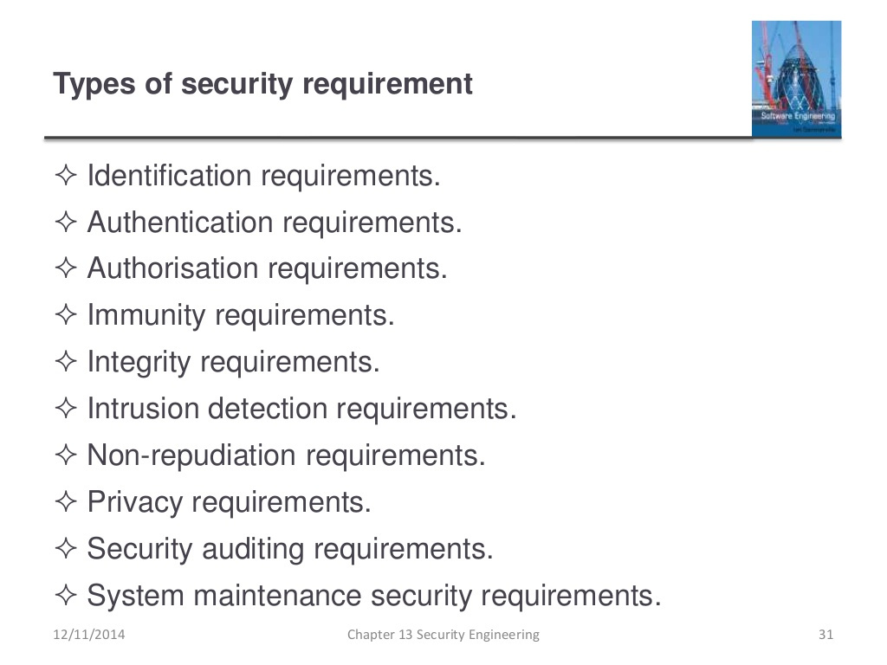
- Briefly Describe two assumptions that can be used during the security planning phase based on the extract above (2 Marks)

Student should feel free to express him/herself
- Adherence to Best Practices: Assuming that the development team will follow established security guidelines and industry best practices.

- Continuous Improvement: Assuming that security measures will evolve and improve over time to counter emerging threats.

- Explain how integrating security into the Software Development Life Cycle (SDLC) can improve the overall security of a software project. Provide an example of a security activity at each SDLC phase. (8 Marks)

Answer: Integrating security into SDLC ensures ongoing security consideration. Example activities:

Requirements Phase: Define security requirements, e.g., "Must prevent unauthorized access."
Design Phase: Conduct threat modeling to identify potential vulnerabilities.
Development Phase: Perform code reviews for security issues.
Testing Phase: Conduct security testing, such as penetration testing.
Deployment Phase: Configure security settings on servers.
Maintenance Phase: Monitor for and patch security vulnerabilities.

OR
- Planning Phase:

Security Activity: Risk Assessment
Explanation: Identifying potential security risks and threats that the software might face. For instance, determining if the text message module might be vulnerable to interception or unauthorized access.
- Requirements Phase:

Security Activity: Security Requirements Specification
Explanation: Defining specific security requirements needed for the software. For example, stipulating the need for end-to-end encryption for text messages to safeguard sensitive information.
- Design Phase:

Security Activity: Threat Modeling
Explanation: Creating models to anticipate potential threats and vulnerabilities. For instance, considering various attack vectors that could exploit weaknesses in the text message handling system.
- Implementation Phase:

Security Activity: Code Reviews and Security Testing
Explanation: Conducting code reviews focused on security aspects and performing security testing. This could involve ensuring that the text message reception module implements proper input validation to prevent injection attacks.
- Testing Phase:

Security Activity: Security Testing and Quality Assurance
Explanation: Evaluating the software's security measures through various tests. For example, examining the resilience of the text message system against simulated attacks or breaches.
- Deployment Phase:

Security Activity: Security Configuration Management
Explanation: Configuring the software securely before deployment. For instance, ensuring that access controls are properly set for the text message module to prevent unauthorized access.
- Maintenance Phase:

Security Activity: Patch Management and Incident Response
Explanation: Applying patches and updates regularly to address any vulnerabilities discovered. Additionally, having an incident response plan in place to handle security breaches, such as if there's a breach in the text message system.

- Describe the steps a company should take when responding to a security incident in their application. Provide an example incident and outline the actions to be taken. (10 Marks)

Answer: Steps for incident response include:

Identification: Detect and confirm the incident.
Containment: Isolate affected systems.
Eradication: Remove the threat and prevent re-entry.
Recovery: Restore affected systems from backups.
Notification: Inform affected parties and authorities.
Investigation: Analyze the incident's cause.
Documentation: Maintain records.
Improvement: Implement security enhancements.
Example incident: Data breach due to a SQL injection attack.

OR
- Responding to a Security Incident:
Detection: Identify the security incident, such as a data breach in the text message reception system.
- Containment: Isolate affected systems to prevent further damage or unauthorized access.
Investigation: Analyze the incident to determine its cause and impact, e.g., unauthorized
access to sensitive messages.
- Mitigation: Take immediate steps to minimize the impact, like blocking unauthorized access
points or disabling compromised features.
- Notification: Inform stakeholders affected by the incident, such as users whose messages
might have been compromised.
- Resolution: Implement measures to fix the issue, like improving encryption or enhancing access controls.
- Follow-up: Review and update security measures to prevent similar incidents in the future.

- Given that the threat tree for the module in the extract above is as shown and that it helps to identify the critical threats that might be encountered in the design phase describe atleast three threats and their likely requirements to counter them at the requirements collection phase. (6 Marks)

Addressing Threats at Requirements Collection Phase:
Threat: Unauthorized Access to Text Messages
Requirement: Implement robust access control mechanisms specifying user permissions to access and modify messages.

Threat: Data Interception during Transmission
Requirement: Mandate encryption protocols for transmitting messages over the network to prevent interception.

Threat: Injection Attacks via Text Messages
Requirement: Implement strict input validation protocols to ensure messages do not contain malicious code or SQL injection attempts.

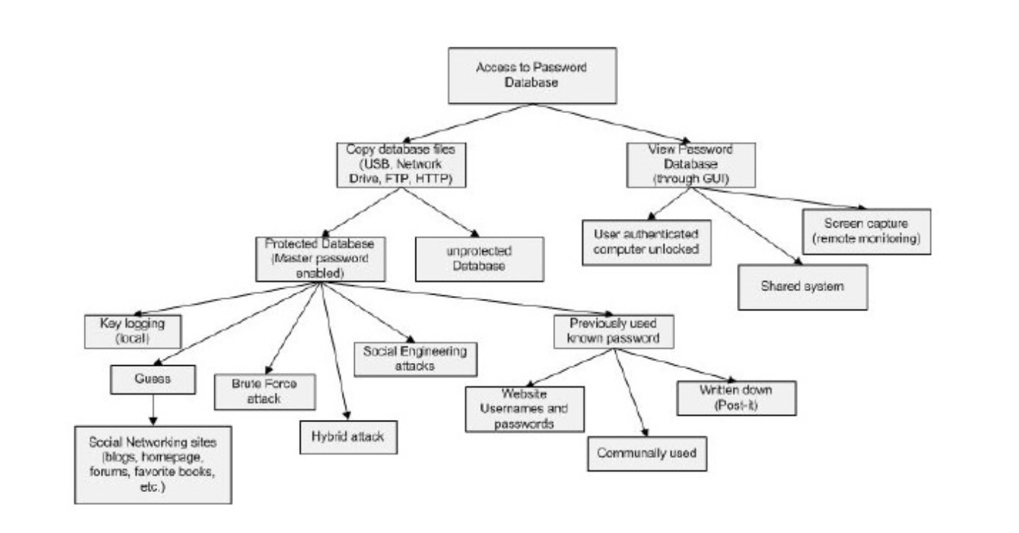

END

