MAKERERE UNIVERSITY

SCHOOL OF COMPUTING AND INFORMATICS TECHNOLOGY

CSC (Year III ) Semester One 2023

Test 2 ADVANCED PROGRAMMING
Date: 11/21/2023 Time: 4:00PM-5:00PM
Instructions:
- Attempt All Questions
- Use relevant Diagrams where applicable
- Poor handwriting may lead to loss of marks
Duration: 1hour

QUESTION ONE

Everyone in a company needs to understand the importance of programming paradigms and the role they play in maintaining security. One way to accomplish this is to create things like abstract programs and to publish reasonable programming artifacts.
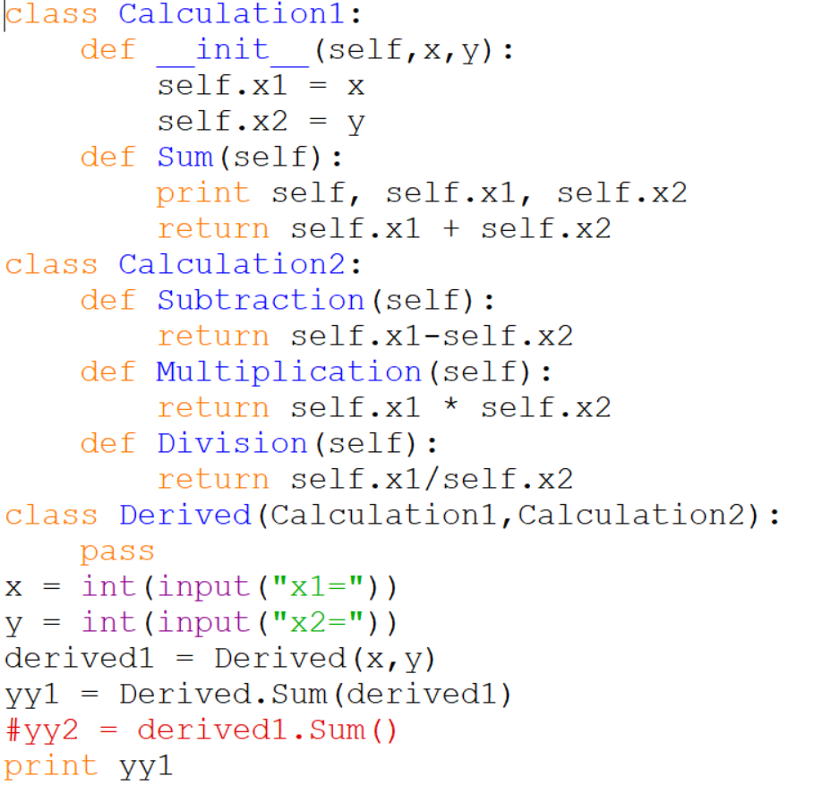
  - Briefly describe what is happening in the code extract above and showcase the output using the last two values of your student Number (5 Marks)
  - The software development team in the company above is working on a data processing module in Python. Describe the importance of regression testing in ensuring the reliability and stability of this module amidst continuous updates and enhancements. (5 Marks)
  - Rewrite the code above and introduce some python visualization library for the input and output data (10 Marks)

QUESTION TWO

Software applications are used for many day to day activities and their development calls for a disciplined approach as they are becoming very complex and critical in business, health, banking and education. This disciplined approach can be termed as Web Engineering”. The CWE/SANS declared the top 5 most dangerous software attacks in 2018 as:
- OS Command Injection
- Cross-site Scripting
- Session Hijacking
- Cross-Site Request Forgery
- SQL Injection
- With the help of simple code snippets from your django coursework briefly describe how the following software attacks above might occur (20 Marks)
- Briefly describe with help of simple code snippets how you would program defensively against each of the attacks above to mitigate against the attacks. (10 Marks)

