**Backstreet Boys**

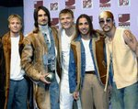

### Charities & foundations supported

* Children's Miracle Network Hospitals
* City of Hope
* Kids Wish Network
* Lupus LA

### Causes supported

* AIDS & HIV
* Cancer
* Children
* Grief Support
* Health

# Bailee Madison



### Charities & foundations supported

* Girl Prep
* Starlight Children's Foundation

### Causes supported

* AIDS & HIV
* At-Risk/Disadvantaged Youths
* Cancer
* Children
* Health
* Miscellaneous
* Women

# Band From TV



### Charities & foundations supported

* Band From TV Global Charity Trust
* Child Abuse Prevention Program
* Children Mending Hearts
* Conservation Fund
* Epilepsy Foundation
* Guitar Center Music Foundation
* Hollywood Note Foundation
* IU-Kenya Partnership
* National Coalition Against Domestic Violence
* Rush Epilepsy Center
* Save the Children
* The Art of Elysium

### Causes supported

* Abuse
* Adoption
* Fostering
* Orphans
* AIDS & HIV
* Cancer
* Children
* Conservation
* Creative Arts
* Disaster Relief
* Education
* Environment
* Health
* Miscellaneous
* Poverty
* Women

# Barack Obama

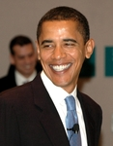

### Charities & foundations supported

* Avoided Deforestation Partners
* CARE
* Clinton Bush Haiti Fund
* Eracism Foundation
* It Gets Better Project
* K.I.D.S.
* Kids Wish Network
* National Park Foundation
* Neurofibromatosis, Inc.
* The Trevor Project
* UMPS CARE
* USAID

### Causes supported

* Abuse
* Adoption
* Fostering
* Orphans
* AIDS & HIV
* At-Risk/Disadvantaged Youths
* Children
* Conservation
* Creative Arts,
* Depression and Suicide
* Disaster Relief
* Economic/Business Support
* Education
* Environment
* Family/Parent Support
* Gay/Lesbian Support
* Grief Support
* Health
* Homelessness
* Human Rights
* Hunger
* Literacy
* Miscellaneous
* Peace
* Poverty
* Rape/Sexual Abuse
* Veteran/Service Member Support
* Voter Education,
* Women

**Barbara Bush**

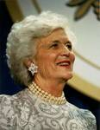

### Charities & foundations supported

* Heifer International
* Susan G. Komen for the Cure

### Causes supported

* AIDS & HIV
* Animals
* Cancer
* Children
* Hunger
* Poverty

**Barbara Hendricks**



### Charities & foundations supported

* UNHCR

### Causes supported

* Human Rights
* Refugees

**Barbara Walters**



### Charities & foundations supported

* Michael J. Fox Foundation

### Causes supported

* Health

# Barbara Windsor

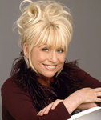

### Charities & foundations supported

* Age Concern
* Age UK
* Amy Winehouse Foundation
* Anchor House
* Fable
* Help The Aged
* National Osteoporosis Society
* Variety - The Children's Charity
* WellChild

### Causes supported

* Addiction
* At-Risk/Disadvantaged Youths
* Children
* Health
* Homelessness
* Mental Challenges
* Miscellaneous
* Physical Challenges
* Poverty
* Senior Citizen Support

**Barbra Streisand**



### Charities & foundations supported

* American Foundation for Equal Rights
* Barbara Davis Center for Childhood Diabetes
* Cedars-Sinai Medical Center
* Clinton Foundation
* David Foster Foundation
* Oceana
* Society of Singers
* St. Francis Food Pantries and Shelters
* Streisand Foundation

### Causes supported

* Animals
* Children
* Conservation
* Economic/Business Support
* Education
* Environment
* Family/Parent Support
* Gay/Lesbian Support
* Health
* Human Rights
* Hunger
* Oceans
* Peace
* Poverty
* Unemployment/Career Support
* Voter Education
* Water
* Weapons Reduction
* Women

**Barenaked Ladies**

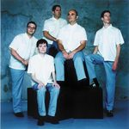

### Charities & foundations supported

* Green Music Group
* Habitat For Humanity
* rock CAN roll

### Causes supported

* Disaster Relief
* Environment
* Homelessness
* Hunger

# Barron Hilton

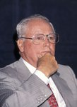

### Charities & foundations supported

* Conrad N. Hilton Foundation

### Causes supported

* Children
* Education
* Homelessness
* Hunger
* Physical Challenges
* Poverty
* Water

# Barry Gibb

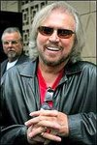

### Charities & foundations supported

* 21st Century Leaders
* Diabetes Research Institute
* Miami Beach Health Foundation
* Prince's Trust
* Whatever It Takes

### Causes supported

* At-Risk/Disadvantaged Youths
* Children
* Education
* Health
* Miscellaneous

Barry Manilow



### Charities & foundations supported

* 21st Century Leaders
* ACT for MS
* Barbara Davis Center for Childhood Diabetes
* City of Hope
* First Book
* Great Ormond Street Hospital
* Love Our Children USA
* Muscular Dystrophy Association
* Red Cross
* Society of Singers
* STOMP Out Bullying
* The Salvation Army
* Whatever It Takes

### Causes supported

* Abuse
* AIDS & HIV
* At-Risk/Disadvantaged Youths
* Cancer
* Children
* Creative Arts
* Disaster Relief
* Education
* Family/Parent Support
* Grief Support
* Health
* Homelessness
* Human Rights
* Miscellaneous
* Senior Citizen Support
* Unemployment/Career Support

**Barry McGuigan**

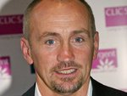

### Charities & foundations supported

* Anchor House

### Causes supported

* Homelessness

# Barry W. Levy



### Charities & foundations supported

* The Trevor Project

### Causes supported

* Children
* Depression and Suicide
* Gay/Lesbian Support

BB King

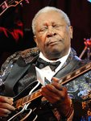

### Charities & foundations supported

* Barbara Davis Center for Childhood Diabetes
* Precious Paws

### Causes supported

* Animals
* Children
* Health

# Bear Grylls

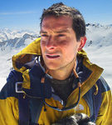

### Charities & foundations supported

* Comic Relief
* Global Angels
* Help for Heroes
* Kids Wish Network
* Prince's Trust
* Royal National Lifeboat Institution

**Causes supported**

* Adoption
* Fostering
* Orphans
* At-Risk/Disadvantaged Youths
* Children
* Disaster Relief
* Education
* Emergency services
* Grief Support
* Health
* Homelessness
* Human Rights
* Hunger
* Poverty
* Refugees
* Veteran/Service Member Support

**Beastie Boys**

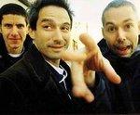

### Charities & foundations supported

* ASPCA
* Food Bank For New York City
* Habitat For Humanity
* Live Earth
* Rational Animal
* The Lunchbox Fund

### Causes supported

* Animals
* At-Risk/Disadvantaged Youths
* Disaster Relief
* Environment
* Homelessness
* Hunger
* Poverty

**Beate Antares**



### Charities & foundations supported

* Global Futbol Initiative
* Hope is a Game-Changer Project
* Mama na Dada
* Sirens of Soccer
* SOS Children's Villages
* Village Volunteers

### Causes supported

* Adoption
* Fostering
* Orphans
* AIDS & HIV
* At-Risk/Disadvantaged Youths
* Children
* Disaster Relief
* Education
* Homelessness
* Human Rights
* Peace
* Poverty
* Sports
* Women

**Beau Bridges**



### Charities & foundations supported

* Kiva
* Oceana
* Sea Shepherd Conservation Society
* St. Francis Food Pantries and Shelters

### Causes supported

* Animals
* Conservation
* Economic/Business Support,
* Environment
* Hunger
* Oceans
* Water
* Weapons Reduction

**Bebe Neuwirth**

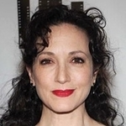

### Charities & foundations supported

* Broadway Cares/Equity Fights AIDS
* Career Transitions For Dancers
* Human Rights Campaign

### Causes supported

* AIDS & HIV
* Creative Arts
* Gay/Lesbian Support
* Unemployment/Career Support

**Bee Gees**

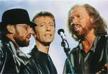

### Charities & foundations supported

* 21st Century Leaders
* Diabetes Research Institute
* Miami Beach Health Foundation
* Prince's Trust
* Whatever It Takes

Causes supported

* At-Risk/Disadvantaged Youths
* Children
* Education
* Health
* Miscellaneous

# Behati Prinsloo



### Charities & foundations supported

* Environmental Justice Foundation

### Causes supported

* Environment
* Human Rights

# Belinda Stronach



### Charities & foundations supported

* ONEXONE
* Spread the Net
* UNICEF

### Causes supported

* Cancer
* Children
* Health
* Human Rights
* Hunger
* Poverty

# Bella Thorne



### Charities & foundations supported

* DoSomething.org
* Friends of El Faro
* STOMP Out Bullying
* TJ Martell Foundation

### Causes supported

* Abuse
* Adoption
* Fostering
* Orphans
* AIDS & HIV
* Cancer
* Children
* Education
* Family/Parent Support
* Health
* Philanthropy

**Ben Affleck**



### Charities & foundations supported

* Ante Up For Africa
* A-T Children's Project
* Children Mending Hearts
* Declare Yourself
* Eastern Congo Initiative
* ENOUGH Project
* Feeding America
* GLAAD
* International Medical Corps
* Jimmy Fund
* Music Rising
* National Center for Missing and Exploited Children
* Not On Our Watch
* ONEXONE
* Operation Gratitude
* Paralyzed Veterans of America
* Parents, Families, and Friends of Lesbians and Gays
* Robin Hood
* Sundance Institute
* The Art of Elysium
* UNHCR
* Unite for Japan
* Vital Voices

### Causes supported

* Abuse
* AIDS & HIV
* At-Risk/Disadvantaged Youths
* Cancer
* Children
* Creative Arts
* Disaster Relief
* Economic/Business Support
* Education
* Family/Parent Support
* Gay/Lesbian Support
* Health
* Human Rights
* Hunger
* Miscellaneous
* Missing Children
* Peace
* Physical Challenges
* Poverty
* Rape/Sexual Abuse
* Refugees
* Unemployment/Career Support
* Veteran/Service Member Support
* Voter Education
* Women

# Ben Barnes



### Charities & foundations supported

* Greenpeace
* Make-A-Wish Foundation

### Causes supported

* Animals
* Cancer
* Children
* Conservation
* Environment
* Health

**Benedict Cumberbatch**

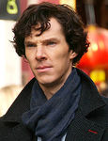

### Charities & foundations supported

* Prince's Trust

### Causes supported

* At-Risk/Disadvantaged Youths
* Children
* Education

**Ben Gibbard**



### Charities & foundations supported

* Bridge School
* PETA
* Planned Parenthood

### Causes supported

* Animals
* Children
* Education
* Hunger
* Miscellaneous
* Physical Challenges
* Voter Education
* Women

# Ben Harper

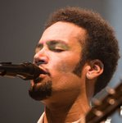

### Charities & foundations supported

* Amnesty International
* Blue Planet Run Foundation
* Clothes Off Our Back
* Collaboration Foundation
* Comic Relief
* David Lynch Foundation
* Feeding America
* Global Fund for Women
* Healthy Child Healthy World
* Hudson River Sloop Clearwater
* Kelly Slater Foundation
* Los Angeles Regional Foodbank
* MusiCares
* The Guacamole Fund

### Causes supported

* Children
* Conservation
* Creative Arts
* Disaster Relief
* Economic/Business Support
* Education
* Environment
* Health
* Homelessness
* Human Rights
* Hunger
* Miscellaneous
* Peace
* Poverty
* Unemployment/Career Support
* Water
* Women

**Benicio del Toro**



### Charities & foundations supported

* 21st Century Leaders
* Afghanistan Relief Organization
* American Foundation for AIDS Research
* Declare Yourself
* Luke Neuhedel Foundation
* ONE Campaign
* Oxfam
* (RED)
* Rock For Darfur
* Save Darfur Coalition
* Tony Hawk Foundation
* Waterkeeper Alliance
* Whatever It Takes

### Causes supported

* AIDS & HIV
* At-Risk/Disadvantaged Youths
* Cancer
* Children
* Disaster Relief
* Education
* Environment
* Family/Parent Support
* Health
* Human Rights
* Miscellaneous
* Oceans
* Poverty
* Refugees
* Sports
* Voter Education
* Water
* Women

**Benjamin Bratt**

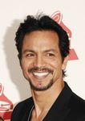

### Charities & foundations supported

* Artists for a New South Africa
* Autism Speaks
* NALIP

### Causes supported

* AIDS & HIV
* Creative Arts
* Health
* Mental Challenges

# Benji Madden

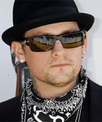

### Charities & foundations supported

* American Foundation for Suicide Prevention
* Ante Up For Africa
* Artists for Peace and Justice
* Children's Hospital Los Angeles
* Chrysalis
* Designers Against AIDS
* ENOUGH Project
* Feeding America
* Global Green
* Keep A Child Alive
* Kristin Brooks Hope Center
* Los Angeles Regional Foodbank
* Mia Hamm Foundation
* Music for Relief
* Not On Our Watch
* Population Services International
* The Art of Elysium
* UNICEF
* Vine Group
* WhyHunger
* YouthAIDS

### Causes supported

* AIDS & HIV
* Cancer
* Children
* Depression and Suicide
* Disaster Relief
* Economic/Business Support
* Education
* Environment
* Family/Parent Support,
* Grief Support
* Health
* Homelessness
* Human Rights
* Hunger
* Miscellaneous
* Peace
* Poverty
* Rape/Sexual Abuse
* Refugees
* Sports
* Water

**Ben Kingsley**

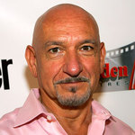

### Charities & foundations supported

* 21st Century Leaders
* Cinema For Peace
* First Star
* Prince's Trust
* Teenage Cancer Trust
* Variety Club
* Whatever It Takes
* WildAid

### Causes supported

* Abuse
* Animals
* At-Risk/Disadvantaged Youths
* Cancer
* Children
* Conservation
* Education
* Environment
* Health
* Miscellaneous
* Peace
* Physical Challenges

# Ben McKenzie

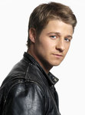

### Charities & foundations supported

* Invisible Children
* Young Storytellers Foundation

### Causes supported

* Children
* Education
* Human Rights
* Literacy
* Peace

# Ben Stiller

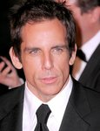

### Charities & foundations supported

* Artists for Peace and Justice
* A Star For The Night
* Centre For Environmental Education
* Clinton Foundation
* Declare Yourself
* DNA Foundation
* Elizabeth Glaser Pediatric AIDS Foundation
* Last Chance for Animals
* Michael J. Fox Foundation
* Oxfam
* Rape Foundation
* Red Cross
* Robert F Kennedy Memorial
* Save the Children
* Starlight Children's Foundation
* STILLERSTRONG
* Unite for Japan

### Causes supported

* Abuse
* AIDS & HIV
* Animals
* Cancer
* Children
* Disaster Relief
* Economic/Business Support
* Education
* Environment
* Family/Parent Support
* Health
* Human Rights
* Mental Challenges,
* Miscellaneous
* Peace
* Poverty
* Rape/Sexual Abuse
* Voter Education

**Ben Vereen**

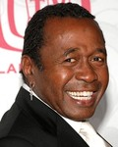

### Charities & foundations supported

* Boys & Girls Clubs of America

### Causes supported

* At-Risk/Disadvantaged Youths
* Children

# Bernadette Peters



### Charities & foundations supported

* Actors Fund of America
* BID 2 BEAT AIDS
* Broadway Barks
* Broadway Cares/Equity Fights AIDS
* Standing Tall
* Worldwide Orphans Foundation

### Causes supported

* Adoption
* Fostering
* Orphans
* AIDS & HIV
* Animals
* Children
* Creative Arts
* Education
* Mental Challenges
* Miscellaneous
* Physical Challenges
* Poverty

**Bernard Hill**

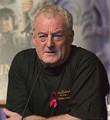

### Charities & foundations supported

* Royal National Lifeboat Institution

### Causes supported

* Emergency services

# Bernie Kopell



### Charities & foundations supported

* Alzheimer's Association
* American Lung Association

### Causes supported

* Cancer
* Health

# Bernie Williams

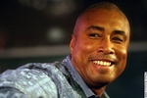

### Charities & foundations supported

* Friends of Scotland
* Little Kids Rock

### Causes supported

* Children
* Creative Arts
* Hunger
* Miscellaneous

# Bethany Hamilton

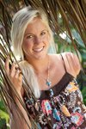

### Charities & foundations supported

* SurfAid
* Women's Sports Foundation
* World Vision

### Causes supported

* Adoption
* Fostering
* Orphans
* AIDS & HIV
* Children
* Health
* Miscellaneous
* Poverty
* Sports
* Women

**Bethenny Frankel**

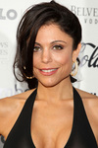

### Charities & foundations supported

* Candie's Foundation
* Children's Health Fund
* Hero in Heels
* PETA
* Wish Upon A Hero Foundation

### Causes supported

* Animals
* At-Risk/Disadvantaged Youths
* Cancer
* Children
* Health
* Philanthropy
* Women

# Beth Orton

# Beth Orton

### Charities & foundations supported

* Peace One Day
* The CarbonNeutral Company
* Treatment Action Campaign
* War Child

### Causes supported

* AIDS & HIV
* Children
* Disaster Relief
* Environment
* Peace

# Beth Ostrosky



### Causes supported

* Animals

# Bette Midler

### Bette Midler

### Charities & foundations supported

* Audubon Society
* Audubon Women In Conservation
* Barbara Davis Center for Childhood Diabetes
* Love Our Children USA
* Mayor's Fund to Advance New York City
* New York Restoration Project
* Smile Train
* St. Francis Food Pantries and Shelters
* STOMP Out Bullying
* Worldwide Orphans Foundation

**Causes supported**

* Abuse
* Adoption
* Fostering
* Orphans
* AIDS & HIV
* Animals
* At-Risk/Disadvantaged Youths
* Children
* Conservation
* Education
* Environment
* Family/Parent Support
* Health
* Hunger
* Miscellaneous
* Poverty
* Water

**Betty White**

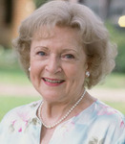

### Charities & foundations supported

* American Humane Association
* Morris Animal Foundation
* PAWS/LA
* spcaLA
* St. Francis Food Pantries and Shelters

### Causes supported

* Abuse
* AIDS & HIV
* Animal
* Children
* Grief Support
* Health
* Human Rights
* Hunger
* Senior Citizen Support

# Beverley Knight



### Charities & foundations supported

* Amnesty International
* Cancer Research UK
* Christian Aid
* Crusaid
* Oxfam
* Terrence Higgins Trust
* Treatment Action Campaign
* Willow Foundation

### Causes supported

* AIDS & HIV
* Cancer
* Disaster Relief
* Health
* Human Rights
* Peace
* Poverty
* Women

**Beverly Johnson**



### Charities & foundations supported

* Andre Agassi Foundation for Education

### Causes supported

* At-Risk/Disadvantaged Youths
* Children
* Education

**Beyoncé Knowles**

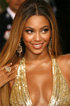

### Charities & foundations supported

* 46664
* Artists for Peace and Justice
* Barbara Davis Center for Childhood Diabetes
* Candie's Foundation
* Clinton Bush Haiti Fund
* Clothes Off Our Back
* Feeding America
* Food Bank For New York City
* Kids Wish Network
* Love Our Children USA
* Miami Children's Hospital Foundation
* MusiCares
* Music Rising
* Oxfam
* Save The Music Foundation
* Stand Up To Cancer
* Survivor Foundation
* The Lunchbox Fund
* The Samburu Project
* Women's Fund for Scotland

### Causes supported

* Abuse
* AIDS & HIV
* Animals
* At-Risk/Disadvantaged Youths
* Cancer
* Children
* Creative Arts
* Disaster Relief
* Education
* Family/Parent Support
* Grief Support
* Health
* Human Rights,
* Hunger
* Miscellaneous
* Poverty
* Unemployment/Career Support
* Water
* Women

**Bianca Embley**



### Charities & foundations supported

* Fibromyalgia Association

### Causes supported

* Health

**Bianca Jagger**

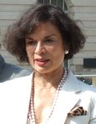

### Charities & foundations supported

* ActionAid
* Amazon Watch
* Avoided Deforestation Partners
* Cinema For Peace
* Greenpeace
* Nuclear Age Peace Foundation
* The Rainforest Foundation

### Causes supported

* Animals
* Conservation,
* Environment
* Human Rights
* Hunger
* Peace
* Poverty
* Water
* Weapons Reduction

**Big Kenny**

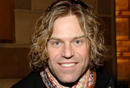

### Charities & foundations supported

* Global Fund
* Little Kids Rock
* Red Cross
* United Nations Foundation

### Causes supported

* AIDS & HIV
* Children
* Creative Arts
* Disaster Relief
* Environment
* Health
* Human Rights
* Peace
* Poverty
* Women

# Bill Bailey



### Charities & foundations supported

* International Animal Rescue (IAR)
* Sumatran Orangutan Society

### Causes supported

* Animals
* Conservation

# Bill Bryson

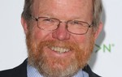

### Charities & foundations supported

* Campaign to Protect Rural England

### Causes supported

* Conservation
* Environment

# Bill Clinton

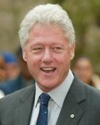

### Charities & foundations supported

* 46664
* Aid Still Required
* ALAS
* American Foundation for AIDS Research
* American India Foundation
* Artists for Peace and Justice
* Avoided Deforestation Partners
* Bottletop
* Bush Clinton Coastal Recovery Fund
* CAMFED
* CHOC South Africa
* Chris Tucker Foundation
* Clinton Bush Haiti Fund
* Clinton Foundation
* Clinton Global Initiative
* Cotlands
* FC Harlem
* Food Bank For New York City
* Global Fund
* Heifer International
* HELP USA
* Ithemba Trust
* Jewish National Fund
* J/P Haitian Relief Organization
* K.I.D.S.
* Kiva
* Make-A-Wish Foundation
* MASSIVEGOOD
* MusiCares
* Music Rising
* Reach For A Dream Foundation
* Red Cross
* ROTA
* Rush Philanthropic Arts Foundation
* Save the Children
* STILLERSTRONG
* St. Mary's Hospital
* The Lunchbox Fund
* TJ Martell Foundation
* US Doctors for Africa
* Usher's New Look Foundation
* Walkabout Foundation
* Walter Sisulu Paediatric Cardiac Centre for Africa
* Yum-o!

### Causes supported

* Abuse
* Adoption
* Fostering
* Orphans
* AIDS & HIV
* Animals
* At-Risk/Disadvantaged Youths
* Cancer
* Children
* Conservation
* Creative Arts
* Disaster Relief
* Economic/Business Support
* Education
* Environment
* Family/Parent Support
* Health
* Homelessness
* Human Rights
* Hunger
* Literacy
* Mental Challenges
* Miscellaneous
* Peace
* Physical Challenges
* Poverty
* Sports
* Unemployment/Career Support
* Veteran/Service Member Support
* Water
* Women

# Bill Cosby

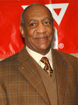

### Charities & foundations supported

* Airlift Research Foundation
* Children's Miracle Network Hospitals
* Hello Friend/Ennis William Cosby Foundation
* Jackie Robinson Foundation
* Jumpstart
* Keep A Child Alive
* Robert F Kennedy Memorial

### Causes supported

* AIDS & HIV
* Children
* Education
* Family/Parent Support
* Health
* Human Rights
* Literacy
* Veteran/Service Member Support

**Bill Duke**



### Charities & foundations supported

* Black AIDS Institute
* Educating Young Minds

### Causes supported

* AIDS & HIV,
* Education
* Women

# Bill Gates



### Charities & foundations supported

* Bill and Melinda Gates Foundation
* Children's Vaccine Program
* Children with AIDS
* Earth Institute
* Estamos
* Food Bank For New York City
* GALVMed
* Make A Child Smile Appeal
* MASSIVEGOOD
* The Lunchbox Fund

### Causes supported

* AIDS & HIV
* Animals
* At-Risk/Disadvantaged Youths
* Children
* Education
* Environment
* Family/Parent Support
* Health
* Homelessness
* Human Rights
* Hunger
* Poverty
* Water

**Billie Jean King**



### Charities & foundations supported

* CityParks Foundation
* Elton John AIDS Foundation
* Food Bank For New York City
* GLAAD
* Starkey Hearing Foundation
* Women's Sports Foundation

### Causes supported

* AIDS & HIV,
* At-Risk/Disadvantaged Youths
* Conservation
* Creative Arts
* Education
* Gay/Lesbian Support
* Health
* Hunger
* Sports
* Women

**Bill Maher**

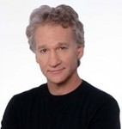

### Charities & foundations supported

* Barbara Davis Center for Childhood Diabetes
* Best Friends Animal Society
* Comic Relief
* Dogs Deserve Better
* Global Green
* Robert F Kennedy Memorial
* Save the Chimps
* Somaly Mam Foundation
* The Humane Society

**Causes supported**

* Animals
* Children
* Disaster Relief
* Environment
* Health
* Homelessness
* Human Rights
* Peace
* Poverty
* Rape/Sexual Abuse
* Water
* Women

# Bill Murray

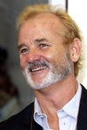

### Charities & foundations supported

* Augie's Quest
* Casey Lee Ball Foundation
* Guardian Catholic Schools
* St. Vincent's HealthCare

### Causes supported

* Cancer
* Children
* Education
* Health

# Bill Nighy

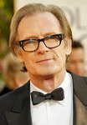

### Charities & foundations supported

* ActionAid
* Comic Relief
* Make Poverty History
* Oxfam
* Starlight Children's Foundation

### Causes supported

* AIDS & HIV
* Cancer
* Children
* Disaster Relief
* Health
* Homelessness
* Human Rights
* Hunger
* Poverty

# Bill Oddie

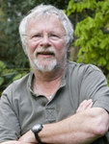

### Charities & foundations supported

* PETA
* Pro Dono
* World Land Trust

### Causes supported

* Animals
* Conservation
* Environment
* Philanthropy

# Bill O'Reilly

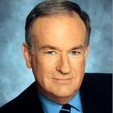

### Charities & foundations supported

* St. Francis Food Pantries and Shelters
* The Doe Fund
* Tuesday's Children
* Wounded Warrior Project
* Yellow Ribbon Fund

### Causes supported

* Children
* Family/Parent Support
* Health
* Homelessness
* Hunger
* Veteran/Service Member Support

# Bill Pullman

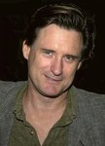

### Charities & foundations supported

* Autism Speaks
* CANY
* SickKids Foundation

### Causes supported

* At-Risk/Disadvantaged Youths
* Children
* Creative Arts
* Health
* Mental Challenges
* Miscellaneous

# Bill Rancic

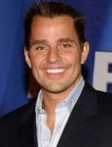

### Charities & foundations supported

* Children's Miracle Network Hospitals
* Give Back Hollywood Foundation
* Habitat For Humanity
* Memorial Sloan-Kettering
* Ronald McDonald House Charities

### Causes supported

* Cancer
* Children
* Disaster Relief
* Family/Parent Support
* Health
* Homelessness
* Philanthropy

**Bill Walton**

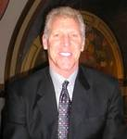

### Charities & foundations supported

* Life Rolls On Foundation
* Table to Table

### Causes supported

* Hunger
* Physical Challenges
* Sports

# Billy Bob Thornto

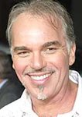

### Charities & foundations supported

* Animal Rescue Foundation
* Damon and Stella Foundation
* GRAMMY Foundation
* MusiCares
* Solid Rock
* St. Jude Children's Research Hospital
* Wildlife WayStation

### Causes supported

* Animals
* Children
* Creative Arts
* Depression and Suicide
* Education
* Family/Parent Support
* Health
* Sports
* Unemployment/Career Support

**Billy Boy**

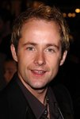

### Charities & foundations supported

* Children in Need
* Nordoff Robbins

### Causes supported

* Abuse
* Children
* Health
* Homelessness
* Mental Challenges
* Miscellaneous
* Physical Challenges
* Substance Abuse

# Billy Bragg



### Charities & foundations supported

* Amnesty International

### Causes supported

* Human Rights

**Billy Bush**



### Charities & foundations supported

* Lollipop Theater Network
* Operation Smile
* Soles4Souls

### Causes supported

* Children
* Disaster Relief
* Health
* Poverty
* Refugees

**Billy Connolly**

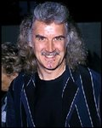

### Charities & foundations supported

* 21st Century Leaders
* Comic Relief
* Whatever It Takes

### Causes supported

* Disaster Relief
* Homelessness
* Human Rights
* Miscellaneous
* Poverty

**Billy Crudup**

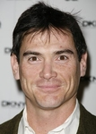

### Charities & foundations supported

* City Harvest
* Randy Foye Foundation
* The Lunchbox Fund

### Causes supported

* At-Risk/Disadvantaged Youths
* Children
* Hunger
* Poverty

**Billy Crystal**

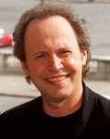

### Charities & foundations supported

* Augie's Quest
* Chris Evert Charities
* Comic Relief
* Dream Foundation
* Muhammad Ali Parkinson Center

### Causes supported

* Addiction
* Children
* Disaster Relief
* Family/Parent Support
* Health
* Homelessness
* Human Rights
* Poverty

**Billy Idol**

# Billy Idol

### Charities & foundations supported

* Bridge School
* Los Angeles Youth Network
* Precious Paws
* Raven Drum Foundation
* The Art of Elysium

### Causes supported

* AIDS & HIV
* Animals
* At-Risk/Disadvantaged Youths
* Cancer
* Children
* Health
* Homelessness
* Physical Challenges
* Unemployment/Career Support
* Veteran/Service Member Support

**Billy Joel**



### Charities & foundations supported

* Charity Begins At Home
* Farm Aid
* Hillsides
* Home For Our Troops
* Love Our Children USA
* MusiCares
* Rainforest Foundation Fund
* Raising Malawi
* Soles4Souls
* St. Francis Food Pantries and Shelters
* STOMP Out Bullying
* UNICEF
* United Service Organization

### Causes supported

* Abuse
* Adoption
* Fostering
* Orphans
* AIDS & HIV,
* At-Risk/Disadvantaged Youths
* Children
* Creative Arts
* Disaster Relief
* Economic/Business Support
* Environment
* Family/Parent Support
* Health
* Homelessness
* Human Rights
* Hunger
* Miscellaneous
* Physical Challenges
* Poverty
* Rape/Sexual Abuse
* Refugees
* Unemployment/Career Support
* Veteran/Service Member Support

**Billy Ray Cyrus**



### Charities & foundations supported

* Feeding America
* Operation Once in a Lifetime

### Causes supported

* Family/Parent Support
* Hunger
* Veteran/Service Member Support

**Billy Zane**

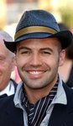

### Charities & foundations supported

* Aviation Angels
* Hillsides
* Orca Network

### Causes supported

* Animals
* At-Risk/Disadvantaged Youths
* Children
* Conservation
* Rape/Sexual Abuse

# Bindi Irwin



### Charities & foundations supported

* Wildlife Warriors Worldwide

### Causes supported

* Animals
* Children
* Environment
* Health

**Biz Stone**

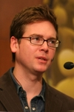

### Charities & foundations supported

* Farm Sanctuary

**Causes supported**

* Animals

**BJ Flores**

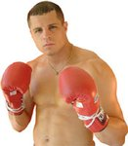

### Charities & foundations supported

* Celebrity Fight Night Foundation
* Cystic Fibrosis Foundation
* Muhammad Ali Parkinson Center

### Causes supported

* Health

**Bjork**

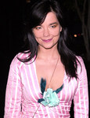

### Charities & foundations supported

* UNICEF

### Causes supported

* Children
* Health
* Human Rights
* Poverty

**Black Eyed Peas**



### Charities & foundations supported

* Adobe Foundation
* Artists for Peace and Justice
* Children Uniting Nations
* City Harvest
* Green For All
* i.am scholarship Fund
* League of Conservation Voters
* RETHINK Fabrics
* Stand Up To Cancer
* The Black Eyed Peas Foundation

### Causes supported

* Adoption
* Fostering
* Orphans
* AIDS & HIV
* At-Risk/Disadvantaged Youths
* Cancer
* Children
* Conservation
* Disaster Relief
* Education
* Environment
* Family/Parent Support
* Hunger
* Miscellaneous
* Peace
* Poverty

**Blair Underwood**

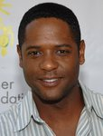

### Charities & foundations supporte

* AmberWatch Foundation
* Artists for a New South Africa
* Clothes Off Our Back
* Fulfillment Fund
* Love Our Children USA
* Muscular Dystrophy Association
* Population Services International
* The Nature Conservancy
* US Doctors for Africa
* YouthAIDS

### Causes supported

* Abuse
* AIDS & HIV,
* At-Risk/Disadvantaged Youths
* Children
* Education
* Environment
* Family/Parent Support
* Health
* Missing Children
* Poverty

**Blake Griffin**

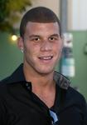

### Charities & foundations supported

* Aid Still Required
* DoSomething.org

### Causes supported

* Disaster Relief
* Philanthropy
* Sports

**Blake Shelton**

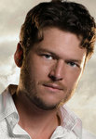

### Charities & foundations supported

* United Service Organization

### Causes supported

* Veteran/Service Member Support

**Blur**

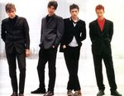

### Charities & foundations supported

* Teenage Cancer Trust
* Willow Foundation

### Causes supported

* Cancer
* Children
* Health

**Blurred Vision**

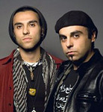

### Charities & foundations supported

* Amnesty International

### Causes supported

* Human Rights

**Bob Barker**

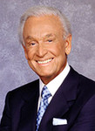

### Charities & foundations supported

* Animal Defenders International
* DJ&T Foundation
* Orca Network
* Rising Stars Outreach
* Save the Chimps
* The Humane Society
* United Activists for Animal Rights

**Causes supported**

* Animals
* Conservation
* Education
* Health
* Physical Challenges

**Bobbie Eakes**

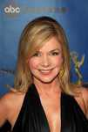

### Charities & foundations supported

* AHOPE for Children

**Bobby Robson**



### Charities & foundations supporte

* Sir Bobby Robson Foundation

### Causes supported

* Cancer

**Bobby Shriver**

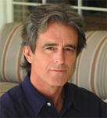

### Charities & foundations supported

* American Foundation for AIDS Research
* Global Fund
* (RED)
* Special Olympics

### Causes supported

* AIDS & HIV
* Children
* Health
* Mental Challenges
* Physical Challenges
* Poverty
* Women

# Bob Costas

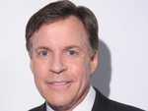

### Charities & foundations supported

* Buoniconti Fund To Cure Paralysis
* Wounded Warrior Project

### Causes supported

* Physical Challenges
* Veteran/Service Member Support

**Bob Dylan**



### Charities & foundations supported

* Amnesty International
* End Hunger Network
* Feeding America
* K9 Connection
* Music Rising

### Causes supported

* Animals
* At-Risk/Disadvantaged Youths
* Creative Arts
* Disaster Relief
* Human Rights
* Hunger
* Unemployment/Career Support

**Bob Geldof**



### Charities & foundations supported

* 21st Century Leaders
* 46664
* Aegis Trust
* Amnesty International
* Bottletop
* Cinema For Peace
* Estamos
* Live 8
* Make Poverty History
* Mo Farah Foundation
* ONE Campaign
* Population Services International
* RADD
* Raisa Gorbachev Foundation
* War Child
* Whatever It Takes
* Willow Foundation

### Causes supported

* Adoption
* Fostering
* Orphans
* AIDS & HIV
* At-Risk/Disadvantaged Youths
* Cancer
* Children
* Disaster Relief
* Education
* Environment
* Health
* Human Rights
* Hunger
* Miscellaneous
* Peace
* Poverty
* Substance Abuse,
* Water

**Bob Goen**

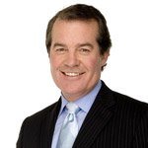

### Charities & foundations supported

* Lili Claire Foundation
* Make-A-Wish Foundation

### Causes supported

* Cancer
* Children
* Family/Parent Support
* Health
* Mental Challenges

**Bob Guiney**

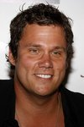

### Charities & foundations supported

* Band From TV Global Charity Trust
* Guitar Center Music Foundation
* Lupus LA
* Reality Cares
* The Art of Elysium

### Causes supported

* Abuse
* AIDS & HIV
* Cancer
* Children
* Conservation
* Creative Arts
* Health
* Miscellaneous

**Bob Harper**

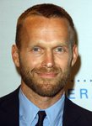

### Causes supported

* Animals

**Bob Hope**

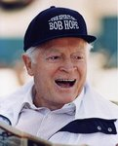

### Charities & foundations supported

* MedicAlert Foundation
* United Service Organization

### Causes supported

* Health
* Veteran/Service Member Support

**Bob Marley**

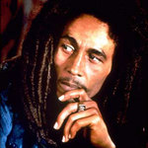

### Charities & foundations supported

* 1Love.org

### Causes supported

* Environment
* Miscellaneous
* Peace
* Philanthropy

**Bob Saget**



### Charities & foundations supported

* Augie's Quest
* BID 2 BEAT AIDS
* Much Love Animal Rescue
* Scleroderma Research Foundation
* Susan G. Komen for the Cure
* The Hollywood Cookbook
* The Saban Free Clinic
* Voice For The Animals Foundation

### Causes supported

* AIDS & HIV
* Animals
* At-Risk/Disadvantaged Youths
* Cancer
* Children
* Disaster Relief
* Health
* Homelessness
* Women

**Bob Weir**

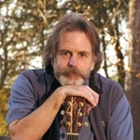

### Charities & foundations supported

* Earth Day Network
* HeadCount
* Reef Relief
* Table to Table
* Earth Day Network
* HeadCount
* Reef Relief
* Table to Table

**Bob Wilson**

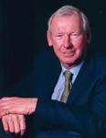

### Charities & foundations supported

* Willow Foundation

### Causes supported

* Cancer, Health

**Bob Woodruff**

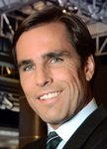

### Charities & foundations supported

* Bob Woodruff Foundation
* Kidsave

### Causes supported

* Children
* Veteran/Service Member Support

**Bode Miller**

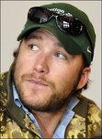

### Charities & foundations supported

* ANNIKA Foundation
* Sheckler Foundation
* Turtle Ridge Foundation

### Causes supported

* Cancer
* Children
* Health
* Miscellaneous
* Sports

**Bo Derek**

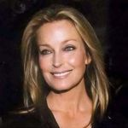

### Charities & foundations supported

* Big Cat Rescue
* Muhammad Ali Parkinson Center
* Peace Over Violence
* St. Jude Children's Research Hospital
* United Service Organization
* WildAid

### Causes supported

* Abuse
* Animals
* Children
* Conservation
* Environment
* Health
* Rape/Sexual Abuse
* Veteran/Service Member Support
* Women

**Bond**



### Charities & foundations supported

* Help for Heroes

### Causes supported

* Veteran/Service Member Support

**Bon Jovi**

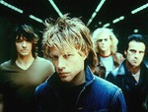

### Charities & foundations supported

* City Hearts: Kids Say Yes to the Arts
* Habitat For Humanity
* Jon Bon Jovi Soul Foundation
* Live Earth
* Musicians on Call
* Precious Paws
* Project HOME
* Stand Up To Cancer
* Tico Torres Children Foundation
* Valerie Fund

### Causes supported

* Abuse
* Animals
* At-Risk/Disadvantaged Youths
* Cancer
* Children
* Creative Arts
* Disaster Relief
* Education
* Environment
* Health
* Homelessness
* Poverty

**Bonnie Raitt**



### Charities & foundations supported

* Aid Still Required
* Dream Foundation
* End Hunger Network
* Green Music Group
* Heifer International
* Little Kids Rock
* Plastic Pollution Coalition
* Rainforest Action Network
* Safety Harbor Kids
* Somaly Mam Foundation
* Stop Global Warming
* Sweet Relief Musicians Fund
* The Guacamole Fund
* The Rhythm & Blues Foundation
* Treatment Action Campaign

**Causes supported**

* Adoption
* Fostering
* Orphans
* AIDS & HIV
* Animals
* At-Risk/Disadvantaged Youths
* Children
* Conservation
* Creative Arts
* Disaster Relief
* Economic/Business Support
* Education
* Environment
* Family/Parent Support
* Health
* Hunger
* Miscellaneous
* Oceans
* Peace
* Poverty
* Rape/Sexual Abuse
* Unemployment/Career Support
* Women

**Bonnie Somerville**

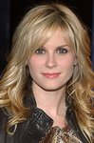

### Charities & foundations supported

* Band From TV Global Charity Trust
* Child Abuse Prevention Program
* National Coalition Against Domestic Violence
* The Art of Elysium

### Causes supported

* Abuse
* AIDS & HIV
* Cancer
* Children
* Conservation
* Health
* Miscellaneous
* Women

**Bonnie Tyler**



### Charities & foundations supported

* Barnardo's

### Causes supported

* Abuse
* At-Risk/Disadvantaged Youths
* Children
* Family/Parent Support
* Homelessness
* Mental Challenges
* Physical Challenges

**Bono**

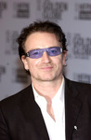

### Charities & foundations supported

* 46664
* ALAFA
* Amnesty International
* Charity Projects Entertainment Fund
* Chernobyl Children's Project International
* DATA
* EDUN
* Food Bank For New York City
* Global Fund
* Greenpeace
* Keep A Child Alive
* Live 8
* Make Poverty History
* Mencap
* Millennium Promise
* Millennium Villages
* Mulago Positive Women’s Network
* MusiCares
* Not On Our Watch
* ONE Campaign
* Oxfam
* (RED)
* Red Cross
* Simon Community
* The Lunchbox Fund
* UNICEF
* UN Millennium Project
* War Child
* Wildlife Conservation Society
* Witness
* Zero Hunger

**Causes supported**

* Adoption
* Fostering
* Orphans
* AIDS & HIV
* Animals
* At-Risk/Disadvantaged Youths
* Children
* Conservation
* Creative Arts
* Disaster Relief
* Economic/Business Support
* Environment
* Fair Trade
* Family/Parent Support
* Health
* Homelessness
* Human Rights
* Hunger
* Literacy
* Mental Challenges
* Peace
* Poverty
* Refugees
* Unemployment/Career Support
* Water,
* Women

**Boo Boo Stewart**

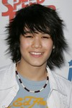

### Charities & foundations supported

* A Place Called Home
* Los Angeles Mission
* Reality Cares
* The Thirst Project

### Causes supported

* At-Risk/Disadvantaged Youths
* Homelessnes
* Miscellaneous
* Water

**Boomer Esiason**

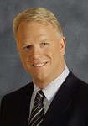

### Charities & foundations supported

* Boomer Esiason Foundation
* Garden of Dreams

### Causes supported

* At-Risk/Disadvantaged Youths,
* Children,
* Health

**Bootsy Collins**

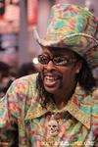

### Charities & foundations supported

* Little Kids Rock

### Causes supported

* At-Risk/Disadvantaged Youths,
* Children,
* Creative Arts

**Boris Becker**

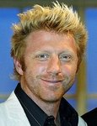

### Charities & foundations supported

* Ante Up For Africa
* ENOUGH Project
* Laureus Sport for Good Foundation
* Make-A-Wish Foundation
* Not On Our Watch

**Causes supported**

* At-Risk/Disadvantaged Youths,
* Cancer,
* Children,
* Disaster Relief,
* Health,
* Human Rights,
* Peace,
* Rape/Sexual Abuse,
* Refugees,
* Sports

**Boti Bliss**



### Charities & foundations supported

* American Diabetes Association

### Causes supported

* Health

**Boy George**

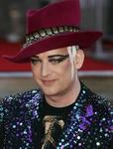

### Charities & foundations supported

* Action on Hearing Loss
* Children with AIDS
* The Hunger Project

**Causes supported**

* AIDS & HIV
* Children
* Family/Parent Support
* Health
* Hunger

**Boys Like Girls**

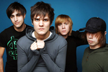

### Charities & foundations supporte

* Food Bank For New York City
* To Write Love on Her Arms

**Causes supported**

* Addiction
* Depression and Suicide
* Hunger
* Substance Abuse

**Boyz II Men**

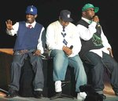

### Charities & foundations supported

* Shriners Hospitals for Children
* The Fatone Family Foundation

### Causes supported

* Cancer
* Children
* Health

**Boyzone**

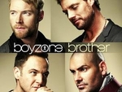

### Charities & foundations supported

* Children in Need
* Sport Relief

### Causes supported

* Abuse
* AIDS & HIV,
* Cancer,
* Children
* , Conservation
* , Education,
* Environment,
* Fair Trade,
* Health,
* Homelessness,
* Human Rights,
* Hunger
* , Literacy
* , Mental Challenges
* , Miscellaneous
* , Physical Challenges,
* Poverty,
* Substance Abuse

**Brad Garrett**

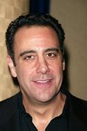

### Charities & foundations supported

* Ante Up For Africa
* Believe in Dreams
* Stand Up To Cancer
* TLC for the Blind
* Vine Group

### Causes supported

* Cancer
* Education
* Family/Parent Support
* Health
* Human Rights
* Physical Challenges
* Refugees

**Bradley Whitford**

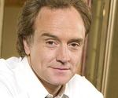

### Charities & foundations supported

* Clothes Off Our Back
* Feeding America
* Heifer International
* Red Cross
* SixDegrees.org
* Smile Train
* The Hollywood Cookbook

### Causes supported

* AIDS & HIV,
* Animals,
* At-Risk/Disadvantaged Youths,
* Children,
* Disaster Relief,
* Health,
* Homelessness,
* Human Rights,
* Hunger,
* Miscellaneous,
* Philanthropy,
* Poverty,
* Women

**Brad Paisley**



### Charities & foundations supported

* Elizabeth Glaser Pediatric AIDS Foundation
* Fisher House Foundation
* Kids Wish Network

### Causes supported

* AIDS & HIV,
* Children,
* Disaster Relief,
* Family/Parent Support,
* Grief Support,
* Health,
* Veteran/Service Member Support

**Brad Pitt**

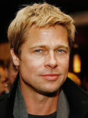

### Charities & foundations supported

* African Children's Choir
* Alliance For The Lost Boys Of Sudan
* Ante Up For Africa
* Boys' and Girls' Clubs of Canada
* Care to Learn
* Child Find Ontario
* Cure Autism Now
* Daniel Pearl Foundation
* DATA
* Direct Change
* Donate Life America
* EB Medical Research Foundation
* ENOUGH Project
* Global Action for Children
* Global Green
* HALO Trust
* Human Rights Watch
* Jolie-Pitt Foundation
* Live 8
* Make It Right
* Make Poverty History
* Millennium Promise
* Millennium Villages
* Mineseeker Foundation
* Not On Our Watch
* ONE Campaign
* ONEXONE
* Project A.L.S.
* Right To Play
* Satellite Sentinel Project
* Solar Neighbors Program
* Sophie's Gift
* UNHCR
* UNICEF
* UN Millennium Project
* World Food Programme
* Yéle Haiti Foundation

### Causes supported

* Adoption
* Fostering,
* Orphans,
* AIDS & HIV,
* At-Risk/Disadvantaged Youths,
* Blood, Marrow & Organ Donation,
* Cancer,
* Children,
* Creative Arts,
* Disaster Relief,
* Economic/Business Support,
* Education,
* Environment,
* Fair Trade,
* Health,
* Homelessness,
* Human Rights,
* Hunger,
* Mental Challenges,
* Miscellaneous,
* Missing Children,
* Peace,
* Poverty,
* Rape/Sexual Abuse,
* Refugees,
* Water,
* Weapons Reduction

**Brandi Carlile**



### Charities & foundations supported

* American Diabetes Association
* JDRF
* Little Kids Rock

### Causes supported

* At-Risk/Disadvantaged Youths,
* Children,
* Creative Arts,
* Environment,
* Health

# Brandon Barash

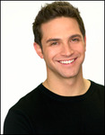

### Charities & foundations supported

* Muscular Dystrophy Association

### Causes supported

* Health

**Brandon Molale**

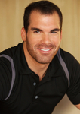

### Charities & foundations supported

* Best Friends Animal Society
* Children Affected by AIDS Foundation
* Elizabeth Glaser Pediatric AIDS Foundation
* Los Angeles Mission
* Make-A-Wish Foundation
* Special Olympics

### Causes supported

* AIDS & HIV,
* Animals,
* Cancer,
* Children,
* Family/Parent Support,
* Health,
* Homelessness,
* Mental Challenges,
* Physical Challenges

**Brandon Routh**

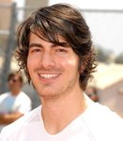

### Charities & foundations supported

* Charlize Theron Africa Outreach Project
* Christopher & Dana Reeve Foundation
* Fulfillment Fund

### Causes supported

* AIDS & HIV,
* Children,
* Education,
* Family/Parent Support,
* Health,
* Physical Challenges

**Brandon Tyler Russell**



### Charities & foundations supported

* American Cancer Society
* Susan G. Komen for the Cure
* The Humane Society

**Causes supported**

* Animals,
* Cancer,
* Health

**Brandy**

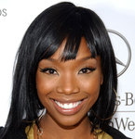

### Charities & foundations supported

* Barbara Davis Center for Childhood Diabetes
* G-Unity Foundation
* Stand Up To Cancer

### Causes supported

* At-Risk/Disadvantaged Youths,
* Cancer,
* Children,
* Health,
* Poverty

# Brenda Blethyn

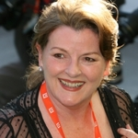

### Charities & foundations supported

* Prince's Trust

### Causes supported

* At-Risk/Disadvantaged Youths,
* Children,
* Education

**Brendan Fraser**



### Charities & foundations supported

* End Hunger Network
* Eracism Foundation
* FilmAid International
* Kids Cancer Connection Inc
* Make Poverty History
* P.S. ARTS
* The Hollywood Cookbook

### Causes supported

* Adoption,
* Fostering,
* Orphans,
* AIDS & HIV,
* At-Risk/Disadvantaged Youths,
* Cancer,
* Children,
* Creative Arts,
* Disaster Relief
* , Education,
* Family/Parent Support,
* Health,
* Homelessness,
* Human Rights,
* Hunger,
* Peace,
* Poverty,
* Women

**Brenda Strong**



### Charities & foundations supported

* Make-A-Wish Foundation

### Causes supported

* Cancer,
* Children,
* Health

**Bret Michaels**

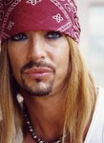

### Charities & foundations supported

* American Diabetes Association
* City of Hope
* Diabetes Research Institute
* JDRF
* Make-A-Wish Foundation
* RADD
* Raven Drum Foundation
* rock CAN roll
* Skylar Neil Memorial Foundation
* Stand Up To Cancer
* St. Jude Children's Research Hospital

### Causes supported

* AIDS & HIV,
* Cancer,
* Children,
* Health,
* Hunger,
* Miscellaneous,
* Substance Abuse,
* Veteran/Service Member Support

**Brett Favre**

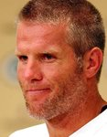

### Charities & foundations supported

* Brett Favre Fourward Foundation
* Deanna Favre Hope Foundation

### Causes supported

* At-Risk/Disadvantaged Youths,
* Cancer,
* Children,
* Mental Challenges,
* Physical Challenges,
* Women

**Brian Austin Green**

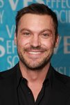

### Charities & foundations supported

* Racing for Kids

**Causes supported**

* Children

**Brian Baumgartner**

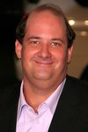

### Charities & foundations supported

* Lili Claire Foundation
* Make-A-Wish Foundation
* Nevada Cancer Institute

**Causes supported**

* [Cancer](http://www.looktothestars.org/cause/cancer),
* [Children](http://www.looktothestars.org/cause/children),
* [Family/Parent Support](http://www.looktothestars.org/cause/family-parent-support),
* [Health](http://www.looktothestars.org/cause/health),
* [Mental Challenges](http://www.looktothestars.org/cause/mental-challenges)

**Brian Blessed**

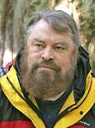

### Charities & foundations supported

* Action Medical Research
* Born Free Foundation
* Hauser Bears
* Royal Marsden Cancer Charity
* TigerTime
* Walking With The Wounded

### Causes supported

* Animals,
* Cancer,
* Children,
* Conservation,
* Health,
* Veteran/Service Member Support

# Brian Cox

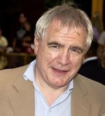

### Charities & foundations supported

* Age Concern
* Age UK

### Causes supported

* Health,
* Miscellaneous,
* Senior Citizen Support

**Brian Griese**

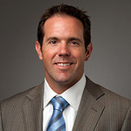

### Charities & foundations supported

* Judi's House

### Causes supported

* Grief Support

**Brian May**

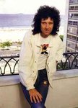

### Charities & foundations supported

* 21st Century Leaders
* 46664
* ABC Trust
* ChildLine
* Humane Society International
* International Fund For Animal Welfare
* Nordoff Robbins
* Prince's Trust
* Teenage Cancer Trust
* The Gorilla Organization
* Whatever It Takes

### Causes supported

* Abuse,
* AIDS & HIV,
* Animals,
* At-Risk/Disadvantaged Youths,
* Cancer,
* Children,
* Conservation,
* Depression and Suicide,
* Education,
* Environment,
* Health,
* Miscellaneous

**Brian Williams**

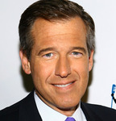

### Charities & foundations supported

* Robin Hood
* Save the Children
* Soles4Souls
* Stand Up To Cancer
* Yellow Ribbon Fund

### Causes supported

* Abuse,
* AIDS & HIV,
* Cancer,
* Children,
* Disaster Relief,
* Economic/Business Support,
* Education,
* Poverty,
* Refugees,
* Veteran/Service Member Support

**Brian Wilson**



### Charities & foundations supported

* Prince's Trust
* Rainforest Foundation Fund
* Stand Up For A Cure

### Causes supported

* At-Risk/Disadvantaged Youths,
* Cancer,
* Children,
* Education,
* Environment,
* Human Rights

# Bridget Moynahan



### Charities & foundations supported

* EB Medical Research Foundation
* Elizabeth Glaser Pediatric AIDS Foundation
* Jumpstart

### Causes supported

* AIDS & HIV,
* Children,
* Education,
* Family/Parent Support,
* Health,
* Literacy

**Brielle Barbusca**



### Charities & foundations supported

* Children's Miracle Network Hospitals

### Causes supported

* Children,
* Health

**Brigitte Bardot**

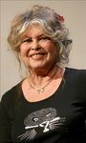

### Charities & foundations supported

* Brigitte Bardot Foundation
* Children's Medical Research Institute
* Jeans for Genes

### Causes supported

* Animals,
* Children,
* Family/Parent Support,
* Health

**Brimstone**



### Charities & foundations supported

* American Cancer Society
* March Of Dimes
* RADD
* Ronald McDonald House Charities
* Toys for Tots

### Causes supported

* At-Risk/Disadvantaged Youths,
* Cancer,
* Children,
* Family/Parent Support,
* Health,
* Miscellaneous,
* Substance Abuse

**Britney Spears**

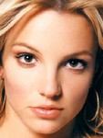

### Charities & foundations supported

* Barbara Davis Center for Childhood Diabetes
* Britney Spears Foundation
* Elevate Hope Foundation
* Keep A Child Alive
* Kids Wish Network
* Luke Neuhedel Foundation
* Music Rising
* Promises Foundation
* Red Cross
* St. Bernard Project
* United Way

**Causes supported**

* Abuse,
* AIDS & HIV
* , At-Risk/Disadvantaged Youths,
* Cancer,
* Children,
* Creative Arts,
* Disaster Relief,
* Education,
* Family/Parent Support,
* Grief Support,
* Health,
* Human Rights,
* Miscellaneous,
* Poverty,
* Senior Citizen Support,
* Unemployment/Career Support

**Brittany Snow**



### Charities & foundations supported

* Clothes Off Our Back
* Declare Yourself
* DoSomething.org
* Feeding America
* Love Our Children USA
* Point Foundation
* Red Cross
* Soles4Souls
* STOMP Out Bullying
* The Heart Truth
* The Trevor Project

**Causes supported**

* Abuse,
* AIDS & HIV,
* At-Risk/Disadvantaged Youths,
* Children,
* Depression and Suicide,
* Disaster Relief,
* Family/Parent Support,
* Gay/Lesbian Support,
* Health,
* Human Rights,
* Hunger,
* Philanthropy,
* Poverty,
* Refugees,
* Voter Education,
* omen

**Brix Smith-Start**



### Charities & foundations supported

* Mind
* Save the Children

### Causes supported

* Abuse,
* AIDS & HIV,
* Children,
* Disaster Relief,
* Education,
* Mental Challenges,
* Poverty

**Brooke Burke**



### Charities & foundations supported

* Hero in Heels
* Libby Ross Foundation
* Nancy Davis Foundation for Multiple Sclerosis
* Rock the Vote
* Soles4Souls
* Wish Upon A Hero Foundation

### Causes supported

* Cancer,
* Disaster Relief,
* Health,
* Philanthropy,
* Poverty,
* Refugees,
* Voter Education,
* Women

**Brooke Fraser**

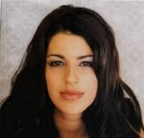

### Charities & foundations supported

* World Vision

### Causes supported

* Adoption,
* Fostering,
* Orphans,
* AIDS & HIV,
* Children,
* Poverty

**Brooke Shields**



### Charities & foundations supported

* American Cancer Society
* Healthy Child Healthy World
* Keep America Beautiful
* Listen Campaign
* Project A.L.S.
* St. Francis Food Pantries and Shelters
* The Art of Elysium
* Toys for Tots
* V-Day
* World Smile Foundation

**Causes supported**

* Abuse,
* AIDS & HIV,
* At-Risk/Disadvantaged Youths,
* Cancer,
* Children,
* Conservation,
* Disaster Relief,
* Economic/Business Support,
* Education
* , Environment,
* Health,
* Homelessness,
* Human Rights,
* Hunger,
* Literacy,
* Miscellaneous,
* Peace,
* Poverty,
* Rape/Sexual Abuse
* , Refugees,
* Water,
* Women

**Bruce Boxleitner**



### Charities & foundations supported

* Children's Hospice & Palliative Care Coalition
* National Space Society

### Causes supported

* Children,
* Education,
* Family/Parent Support,
* Grief Support,
* Health,
* Miscellaneous

**Bruce Forsyth**

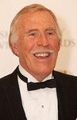

### Charities & foundations supported

* Cats Protection
* Caudwell Children
* Help for Heroes
* Hoping Foundation
* National Osteoporosis Society
* Prince's Trust

### Causes supported

* Animals,
* At-Risk/Disadvantaged Youths,
* Children
* , Education,
* Health,
* Refugees,
* Veteran/Service Member Support

**Bruce Laird**

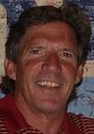

### Charities & foundations supported

* Fourth and Goal

### Causes supported

* Sports

**Bruce Springsteen**

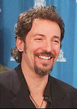

### Charities & foundations supported

* Amnesty International
* Bob Woodruff Foundation
* Hudson River Sloop Clearwater
* Kristen Ann Carr Fund
* MusiCares
* Musicians on Call
* Project Green Leaf
* Rainforest Foundation Fund
* WhyHunger

### Causes supported

* Cancer,
* Conservation,
* Creative Arts,
* Economic/Business Support,
* Environment,
* Health,
* Human Rights,
* Hunger,
* Poverty,
* Unemployment/Career Support,
* Veteran/Service Member Support,
* Voter Education

**Bruce Willis**

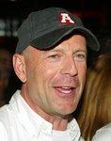

### Charities & foundations supported

* Bruce Willis Foundation
* Children's Hospice & Palliative Care Coalition
* Fisher House Foundation
* Screen Actors Guild Foundation
* Special Olympics

### Causes supported

* Adoption,
* Fostering,
* Orphans,
* Animals,
* At-Risk/Disadvantaged Youths,
* Children,
* Creative Arts,
* Family/Parent Support,
* Grief Support,
* Health,
* Mental Challenges,
* Physical Challenges,
* Veteran/Service Member Support

**Bruno Mars**

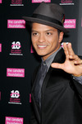

### Charities & foundations supported

* Candie's Foundation
* DoSomething.org
* Musicians on Call
* Red Cross

### Causes supported

* AIDS & HIV,
* At-Risk/Disadvantaged Youths,
* Disaster Relief,
* Health,
* Human Rights,
* Philanthropy,
* Women

# Bryan Adams

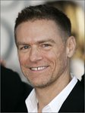

### Charities & foundations supported

* 46664
* Amnesty International
* Bryan Adams Foundation
* Greenpeace
* Love Our Children USA
* Nordoff Robbins
* Peace One Day
* PETA
* Prince's Trust
* STOMP Out Bullying
* Sunnybrook Foundation
* The Gorilla Organization
* War Child

**Causes supported**

* Abuse,
* AIDS & HIV,
* Animals,
* At-Risk/Disadvantaged Youths,
* Children,
* Conservation,
* Disaster Relief,
* Education,
* Environment,
* Family/Parent Support
* , Health,
* Human Rights,
* Mental Challenges,
* Miscellaneous,
* Peace,
* Physical Challenges,
* Senior Citizen Support

**Bryan Dattilo**

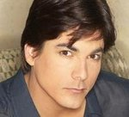

### Charities & foundations supported

* Autism Speaks
* National Kidney Foundation

### Causes supported

* Blood, Marrow & Organ Donation,
* Health,
* Mental Challenges

**Bryan Ferry**

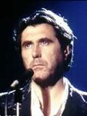

### Charities & foundations supported

* Amnesty International

### Causes supported

* Human Rights

**Bryon Friedman**

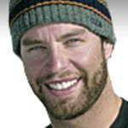

### Charities & foundations supported

* Heal the Snow

### Causes supported

* Environment

**Buddy Collette**

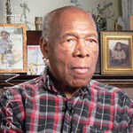

### Charities & foundations supported

* California Jazz Foundation

### Causes supported

* Creative Arts,
* Human Rights,
* Unemployment/Career Support

# Burney Lamar

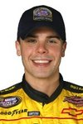

### Charities & foundations supporte

* Red Cross

### Causes supported

* AIDS & HIV,
* Disaster Relief,
* Human Rights

**Busy Philipps**

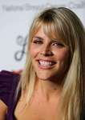

### Charities & foundations supported

* DoSomething.org
* H.E.L.P. Malawi

### Causes supported

* Children,
* Education,
* Philanthropy,
* Poverty

**Buzz Aldrin**

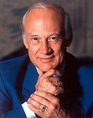

### Charities & foundations supported

* Bony Pony Ranch
* Cinema For Peace
* Nancy Davis Foundation for Multiple Sclerosis
* Starkey Hearing Foundation
* Variety - The Children's Charity

### Causes supported

* At-Risk/Disadvantaged Youths,
* Children,
* Creative Arts,
* Education,
* Health,
* Peace