**CaCee Cobb**

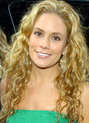

### Charities & foundations supported

* Los Angeles Mission
* Soles4Souls

### Causes supported

* Disaster Relief,
* Homelessness,
* Poverty,
* Refugees

# Cady McClain

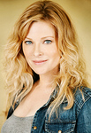

### Causes supported

* AIDS & HIV
* Women

# Calista Flockhar



### Charities & foundations supported

* Bony Pony Ranch
* Conservation International
* Peace Over Violence
* St. Jude Children's Research Hospital
* V-Day

### Causes supported

* Abuse,
* Animals,
* At-Risk/Disadvantaged Youths
* , Children,
* Conservation,
* Creative Arts
* Education,
* Environment,
* Health,
* Human Rights,
* Rape/Sexual Abuse,
* Women

# Calpernia Addams



### Charities & foundations supported

* V-Day

### Causes supported

* Abuse,
* Human Rights,
* Rape/Sexual Abuse,
* Women

# Cal Ripken, Jr



### Charities & foundations supported

* Athletes For Hope
* Bicycle For A Day
* Cal Ripken Sr. Foundation
* Jeff Gordon Children's Foundation
* Living Classrooms Foundation

### Causes supported

* At-Risk/Disadvantaged Youths,
* Cancer,
* Children,
* Education,
* Environment,
* Health,
* Miscellaneous,
* Sports

# Calvin Klein

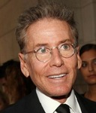

### Charities & foundations supported

* Elephant Family

### Causes supported

* Animals

# Cameron Diaz

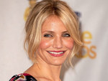

### Charities & foundations supported

* 4REAL Foundation
* Act Green
* AIDS Project Los Angeles
* Centre For Environmental Education
* Children's Defense Fund
* Declare Yourself
* Environmental Media Association
* Food Bank For New York City
* Green Treks
* Hillsides
* Make Poverty History
* Motion Picture and Television Fund Foundation
* ONE Campaign
* Pangea Day
* Racing for Kids
* Red Cross
* The Lunchbox Fund
* Unite for Japan

**Causes supported**

* Addiction,
* AIDS & HIV,
* Animals,
* At-Risk/Disadvantaged Youths,
* Children,
* Creative Arts,
* Disaster Relief,
* Education,
* Environment,
* Family/Parent Support,
* Health,
* Homelessness,
* Human Rights,
* Hunger,
* Mental Challenges,
* Miscellaneous,
* Peace,
* Physical Challenges,
* Poverty,
* Rape/Sexual Abuse,
* Substance Abuse,
* Voter Education

# Cameron Mathison

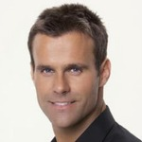

* Feeding America
* Love Our Children USA
* STOMP Out Bullying

**Causes supported**

* Abuse,
* At-Risk/Disadvantaged Youths,
* Children,
* Family/Parent Support,
* Hunger

# Camilla Belle



### Charities & foundations supported

* Artists for Peace and Justice
* Free The Slaves
* H.E.L.P. Malawi
* Kids With A Cause

### Causes supported

* Children,
* Disaster Relief,
* Education,
* Human Rights,
* Miscellaneous,
* Poverty

# Cam Neely

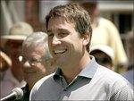

### Charities & foundations supported

* Cam Neely Foundation

### Causes supported

* Cancer,
* Children,
* Family/Parent Support

# Camryn Manheim



### Charities & foundations supported

* ACT Today!
* American Cancer Society
* Center for Autism and Related Disorders
* Dream Foundation
* Rape, Abuse & Incest National Network
* Vine Group

### Causes supported

* Cancer,
* Children,
* Education,
* Family/Parent Support,
* Health,
* Mental Challenges,
* Physical Challenges,
* Rape/Sexual Abuse

# Candice Accola



### Charities & foundations supported (3)

* A Day Made Better
* Children's Miracle Network Hospitals
* Give Back Hollywood Foundation

### Causes supported

* Children,
* Education,
* Health,
* Philanthropy

# Candice Bergen

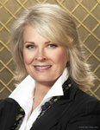

### Charities & foundations supported (4)

* American Cancer Society
* Dogs Deserve Better
* Smile Train
* Vital Voices

### Causes supported

* Abuse,
* Animals,
* Cancer,
* Children,
* Economic/Business Support
* , Health,
* Human Rights,
* Miscellaneous,
* Rape/Sexual Abuse,
* Women

# Candice Hillebrand



### Charities & foundations supported (1)

* Mineseeker Foundation

### Causes supported

* Hunger,
* Miscellaneous,
* Weapons Reduction

# Candy Coburn



### Charities & foundations supported (1)

* Susan G. Komen for the Cure

### Causes supported

* Cancer

# Carey Mulligan

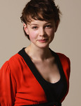

### Charities & foundations supported (2)

Carey Mulligan has supported the following charities:

* Alzheimer's Society
* Oxfam

### Causes supported

* Disaster Relief,
* Health,
* Human Rights,
* Poverty

# Carla Bruni

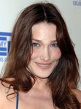

### Charities & foundations supported

* 46664
* Global Fund

### Causes supported

* AIDS & HIV,
* Health,
* Poverty

# Carl Fogarty



### Charities & foundations supported (1)

* National Society for the Prevention of Cruelty to Children

### Causes supported

* Abuse,
* Children

# Carlos Mencia

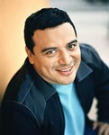

### Charities & foundations supported (5)

* Children's Hospital Los Angeles
* Mia Hamm Foundation
* Padres Contra el Cancer
* Racing for Kids
* Wyland Foundation

### Causes supported

* Cancer,
* Children,
* Conservation,
* Environment,
* Family/Parent Support,
* Health,
* Sports,
* Water

# Carlos Santana

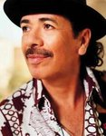

### Charities & foundations supported

* Andre Agassi Foundation for Education
* Artists for a New South Africa
* Clothes Off Our Back
* Elevate Hope Foundation
* Feeding America
* Guitar Center Music Foundation
* HeadCount
* Little Kids Rock
* Make-A-Wish Foundation
* Milagro Foundation
* Musicians on Call
* National Stroke Association
* ONEXONE
* P.A.D.
* Safety Harbor Kids
* Spirit of Women Health Network
* We Are The World Foundation

### Causes supported

* Abuse,
* Adoption,
* Fostering,
* Orphans,
* AIDS & HIV,
* At-Risk/Disadvantaged Youths,
* Cancer,
* Children,
* Creative Arts,
* Disaster Relief,
* Education,
* Health,
* Human Rights,
* Hunger,
* Literacy,
* Voter Education,
* Women

# Carly Simon

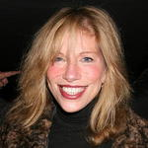

### Charities & foundations supported (2)

* Amnesty International
* MusiCares

### Causes supported

* Creative Arts,
* Human Rights,
* Unemployment/Career Support

# Carly Zucker



### Charities & foundations supported (1)

* ChildLine

### Causes supported

* Abuse,
* Children,
* Depression and Suicide

# Carmella Garcia

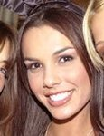

### Charities & foundations supported (1)

* Garcia Pass It On Foundation

### Causes supported

* Miscellaneous

# Carmelo Anthony

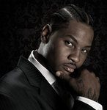

### Charities & foundations supported (2)

* Soles4Souls
* WildAid

### Causes supported

* Animals,
* Conservation,
* Disaster Relief,
* Environment,
* Poverty,
* Refugees

# Carmen Electra



### Charities & foundations supported

* Elevate Hope Foundation
* Habitat For Humanity
* Head To Hollywood
* Hillsides
* Nancy Davis Foundation for Multiple Sclerosis
* Parkinson Society Maritime Region
* Ronald McDonald House Charities
* The HollyRod Foundation
* The Rescue Train
* The Trevor Project
* Until There's a Cure

### Causes supported

* Abuse,
* AIDS & HIV,
* Animals,
* Cancer,
* Children,
* Creative Arts,
* Depression and Suicide,
* Disaster Relief,
* Family/Parent Support,
* Gay/Lesbian Support,
* Health,
* Homelessness,
* Physical Challenges,
* Rape/Sexual Abuse

# Carmen Marc Valvo

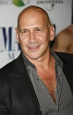

### Charities & foundations supported (3)

* Colon Cancer Alliance
* Entertainment Industry Foundation
* The Heart Truth

### Causes supported

* Cancer,
* Children,
* Creative Arts,
* Education,
* Health,
* Hunger,
* Poverty,
* Women

# Carmine Appice

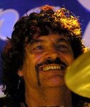

### Charities & foundations supported

* Little Kids Rock

### Causes supported

* At-Risk/Disadvantaged Youths,
* Cancer,
* Children,
* Creative Arts

# Carol Ann Duffy

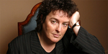

### Charities & foundations supported

* The Children's Trust, Tadworth

**Causes supported**

* Children,
* Conservation,
* Environment,
* Health

# Carole King



### Charities & foundations supported

### Aid Still Required

* MusiCares
* National Parks Conservation Association

### Causes supported

* Conservation,
* Creative Arts,
* Disaster Relief,
* Environment,
* Unemployment/Career Support

# Caroline Rhea



### Charities & foundations supported

### Dream Foundation

* Rosie's Broadway Kids

### Causes supported

* Children,
* Education,
* Family/Parent Support,
* Health

# Caroline Sunshine

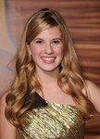

### Charities & foundations supported

* TJ Martell Foundation

**Causes supported**

* AIDS & HIV,
* Cancer,
* Children,
* Health

# Caroline Trentini



### Charities & foundations supported

* Environmental Justice Foundation

### Causes supported

* Environment,
* Human Rights

# Carrie Ann Inaba



### Charities & foundations supported

* Andrea Rizzo Foundation
* Barbara Davis Center for Childhood Diabetes
* Clothes Off Our Back
* Dizzy Feet Foundation
* Entertainment Industry Foundation
* Reality Cares
* Revlon Run/Walk For Women
* spcaLA
* Spirit of Women Health Network
* The Humane Society

### Causes supported

* Animals,
* Cancer,
* Children,
* Creative Arts,
* Education,
* Health,
* Hunger,
* Miscellaneous,
* Poverty,
* Women

# Carrie Catherine

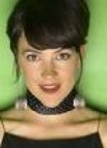

### Charities & foundations supported

* [World Vision Canada](http://www.looktothestars.org/charity/world-vision-canada)

### Causes supported

* AIDS & HIV,
* Children,
* Disaster Relief,
* Education,
* Environment
* Health,
* Human Rights
* , Miscellaneous,
* Poverty

# Carrie Fisher

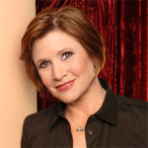

### Charities & foundations supported

* Alzheimer's Association
* Make-A-Wish Foundation

### Causes supported

* Cancer,
* Children,
* Health

# Carrie Underwood

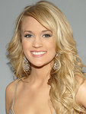

### Charities & foundations supported

* Barbara Davis Center for Childhood Diabetes
* C.A.T.S.
* City of Hope
* Clothes Off Our Back
* Habitat For Humanity
* Monroe Carell Jr. Children's Hospital at Vanderbilt
* Music for Relief
* Music Rising
* PETA
* Project Clean Water
* Red Cross
* Stand Up To Cancer
* St. Jude Children's Research Hospital
* The Humane Society
* United Service Organization

### Causes supported

* AIDS & HIV,
* Animals,
* Cancer,
* Children,
* Creative Arts,
* Disaster Relief,
* Environment,
* Health,
* Homelessness,
* Human Rights,
* Miscellaneous,
* Unemployment/Career Support,
* Veteran/Service Member Support,
* Water

# Carson Kressle

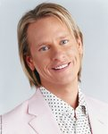

### Charities & foundations supported

* American Humane Association
* The Trevor Project

### Causes supported

* Abuse,
* Animals,
* Children,
* Depression and Suicide,
* Gay/Lesbian Support,
* Human Rights

# Casey Affleck

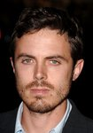

### Charities & foundations supported

* 4REAL Foundation
* ENOUGH Project
* Farm Sanctuary
* Food Bank For New York City
* Millennium Promise
* Not On Our Watch
* PETA
* Stand Up To Cancer
* The Art of Elysium
* The Lunchbox Fund

### Causes supported

* Addiction,
* AIDS & HIV,
* Animals,
* At-Risk/Disadvantaged Youths,
* Cancer,
* Children,
* Disaster Relief,
* Environment,
* Health,
* Human Rights,
* Hunger,
* Peace,
* Poverty,
* Rape/Sexual Abuse,
* Refugees,
* Substance Abuse

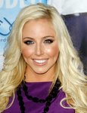

### Charities & foundations supported

* CASEY Foundation

### Causes supported

* At-Risk/Disadvantaged Youths, Education

# Casper Van Dien



### Charities & foundations supported

* Amma
* Best Buddies International
* Childhelp USA
* Save the Children
* V-Day

### Causes supported

* Abuse,
* AIDS & HIV,
* Children
* , Disaster Relief,
* Education,
* Environment,
* Family/Parent Support,
* Human Rights,
* Mental Challenges,
* Miscellaneous,
* Poverty,
* Rape/Sexual Abuse,
* Women

# Cat Deeley



### Charities & foundations supported

* UNICEF

### Causes supported

* Children,
* Health,
* Human Rights,
* Poverty

# Cate Blanchett



### Charities & foundations supported

### Australian Conservation Foundation

* Kids Help Line
* Robert F Kennedy Memorial
* SolarAid

### Causes supported

* Abuse,
* Addiction,
* At-Risk/Disadvantaged Youths,
* Children,
* Depression and Suicide,
* Environment,
* Family/Parent Support,
* Human Rights,
* Rape/Sexual Abuse,
* Substance Abuse

# Catherine Bell



### Charities & foundations supported

* Bony Pony Ranch
* Communities in Schools
* Communities In Schools of New Orleans, Inc.
* EB Medical Research Foundation
* H.E.L.P.
* Warriors in Pink

### Causes supported

* At-Risk/Disadvantaged Youths,
* Cancer,
* Children,
* Creative Arts,
* Education,
* Health,
* Literacy

# 

# Catherine McNeil



### Charities & foundations supported

### Environmental Justice Foundation

### Causes supported

* Environment,
* Human Rights

# Catherine Oxenberg

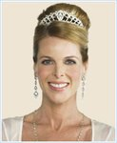

### Charities & foundations supported

* Amma
* Best Buddies International
* Childhelp USA
* Save the Children
* V-Day

### Causes supported

* Abuse,
* AIDS & HIV,
* Children,
* Disaster Relief,
* Education
* , Environment,
* Family/Parent Support,
* Human Rights,
* Mental Challenges,
* Miscellaneous,
* Poverty,
* Rape/Sexual Abuse,
* Women

# Catherine Tate



### Charities & foundations supported

* Epilepsy Action
* Great Ormond Street Hospital
* Neurofibromatosis Association
* Willow Foundation

### Causes supported

* Cancer,
* Children,
* Health

# Catherine Zeta Jones



### Charities & foundations supported

* Broadway Cares/Equity Fights AIDS
* Cinema For Peace
* Global Missing Children's Network
* Longfields Day Centre
* Motion Picture and Television Fund Foundation
* National Society for the Prevention of Cruelty to Children
* Noah's Ark Appeal
* Worldwide Orphans Foundation

### Causes supported

* Abuse,
* Adoption,
* Fostering,
* Orphans,
* AIDS & HIV,
* Cancer,
* Children,
* Creative Arts,
* Family/Parent Support,
* Health,
* Mental Challenges,
* Missing Children,
* Peace,
* Poverty

# Cathy Lee Crosby

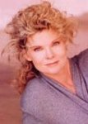

### Charities & foundations supported

* Vijay Amritraj Foundation

### Causes supported

* Adoption
* , Fostering,
* Orphans,
* AIDS & HIV,
* Children,
* Mental Challenges,
* Miscellaneous,
* Physical Challenges,
* Women

# Cathy Rigby



### Charities & foundations supported

### Discovery Arts

### Causes supported

* Cancer,
* Children,
* Creative Arts,
* Health

# CCH Pounder



### Charities & foundations supported

* Artists for a New South Africa
* Autism Speaks
* Until There's a Cure

**Causes supported**

* AIDS & HIV,
* Health,
* Mental Challenges

# Cedric the Entertainer

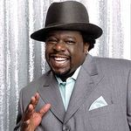

### Charities & foundations supported

* Ante Up For Africa
* Cedric "The Entertainer" Charitable Foundation
* Diamond Empowerment Fund
* National Kidney Foundation
* Youth Lifeline America

### Causes supported

* At-Risk/Disadvantaged Youths,
* Blood, Marrow & Organ Donation,
* Children,
* Education,
* Health,
* Human Rights,
* Refugees,
* Sports

# Cee Lo Green

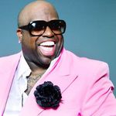

### Charities & foundations supported

* GreenHouse Foundation
* Soles4Souls

**Causes supported**

* Disaster Relief,
* Environment,
* Poverty,
* Refugees

# Celia Imrie



### Charities & foundations supported

### Royal National Lifeboat Institution

### Causes supported

* Emergency services

# Céline Dion



### Charities & foundations supported

* American Heart Association
* Angels' Place
* Artists Against Racism
* Autism Speaks
* Barbara Davis Center for Childhood Diabetes
* Canadian Cystic Fibrosis Foundation
* Charity Projects Entertainment Fund
* David Foster Foundation
* EB Medical Research Foundation
* GRAMMY Foundation
* Kids Wish Network
* MusiCares
* Reality Cares
* Society of Singers
* Starkey Hearing Foundation
* STOMP Out Bullying
* Treatment Action Campaign
* War Child

### Causes supported

* Abuse
* , AIDS & HIV,
* Children,
* Creative Arts,
* Disaster Relief,
* Family/Parent Support,
* Grief Support,
* Health,
* Mental Challenges
* , Miscellaneous,
* Peace,
* Poverty,
* Unemployment/Career Support

# Cerrie Burnell



### Causes supported

* Children,
* Physical Challenges

# Cesar Millan

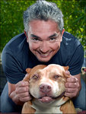

### Charities & foundations supported

### Millan Foundation

### Causes supported

* Animals

# Chace Crawford



### Charities & foundations supported :

* Alzheimer's Association
* Soles4Souls

### Causes supported

* Disaster Relief,
* Health,
* Poverty,
* Refugees

# Chad Faust



### Charities & foundations supported

### American Diabetes Association

### Causes supported

* Health

# Chad Hedrick

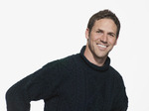

### Charities & foundations supported

* Special Olympics

### Causes supported

* Mental Challenges,
* Physical Challenges

# Chad Lowe

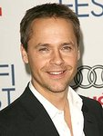

### Charities & foundations supported

* Heal the Bay
* Surfrider Foundation

### Causes supported

* At-Risk/Disadvantaged Youths
* , Education,
* Environment,
* Oceans

# Chaka Khan



### Charities & foundations *supported*

### Chaka Khan Foundation

### Causes supported

* At-Risk/Disadvantaged Youths,
* Children,
* Women

# Chandler Lutz

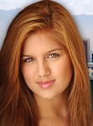

### Charities & foundations supported

* Believe in Dreams

### Causes supported

* Family/Parent Support,
* Health

# Channing Tatum

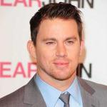

### Charities & foundations supported

* Dizzy Feet Foundation
* Keep A Child Alive
* The Rainforest Foundation

### Causes supported

* AIDS & HIV,
* Children,
* Creative Arts,
* Environment,
* Family/Parent Support,
* Health,
* Human Rights

# Chantal Kreviazuk



### Charities & foundations supported

* War Child

### Causes supported

* Children,
* Disaster Relief,
* Peace

# Charice Pempengco



### Charities & foundations supported

* A Place Called Home
* Leeza's Place
* Olivia Newton-John Cancer & Wellness Centre
* Operation Smile
* World Vision

### Causes supported

* Adoption,
* Fostering,
* Orphans,
* AIDS & HIV,
* At-Risk/Disadvantaged Youths,
* Cancer,
* Children,
* Health,
* Poverty

# 

# Charisma Carpenter



### Charities & foundations supported

* The Thirst Project

### Causes supported

* Water

# Charles Barkley

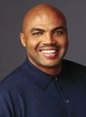

### Charities & foundations supported

* Ante Up For Africa
* ENOUGH Project
* LIVESTRONG
* Not On Our Watch
* Stand Up To Cancer
* United Service Organization

### Causes supported

* Cancer,
* Disaster Relief,
* Human Rights,
* Peace,
* Rape/Sexual Abuse,
* Refugees,
* Veteran/Service Member Support

# Charles Durning



### Charities & foundations supported

* California Disabled Veteran Business Alliance
* Vijay Amritraj Foundation

### Causes supported

* Adoption,
* Fostering,
* Orphans,
* AIDS & HIV,
* Children,
* Mental Challenges,
* Miscellaneous,
* Physical Challenges,
* Veteran/Service Member Support,
* Women

# Charles Grodin



### Charities & foundations supported

* Children's Cancer & Blood Foundation
* HELP USA
* Robert F Kennedy Memorial

### Causes supported

* AIDS & HIV,
* Cancer,
* Children,
* Health,
* Homelessness,
* Human Rights

# Charley Boorman



### Charities & foundations supported

* CHAS
* Riders For Health
* UNICEF

### Causes supported

* AIDS & HIV,
* Cancer,
* Children,
* Family/Parent Support,
* Grief Support,
* Health,
* Human Rights,
* Poverty

# Charley Pride

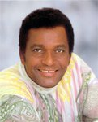

### Charities & foundations supported

### TJ Martell Foundation

### Causes supported

* AIDS & HIV
* , Cancer,
* Children,
* Health

# Charlie Bewley

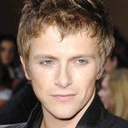

### Causes supported

* Cancer

# Charlie Brooker



### Charities & foundations supported

* Disasters Emergency Committee
* End Water Poverty

### Causes supported

* Disaster Relief,
* Human Rights,
* Water

# Charlie Brooks

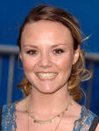

### Charities & foundations supported

* National Centre for Domestic Violence

**Causes supported**

* Abuse,
* Rape/Sexual Abuse

# Charlie Daniels

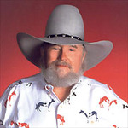

### Charities & foundations supported

### Boot Campaign

* St. Jude Children's Research Hospital

### Causes supported

* Children,
* Health,
* Veteran/Service Member Support

# Charlie Sheen

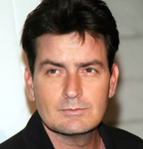

### Charities & foundations supported

* Aid For AIDS
* Chrysalis
* Dine Out Los Angeles
* Lili Claire Foundation
* Nancy Davis Foundation for Multiple Sclerosis
* Organization for Bipolar Affective Disorder

### Causes supported

* AIDS & HIV,
* Children,
* Depression and Suicide,
* Family/Parent Support,
* Health,
* Homelessness,
* Hunger,
* Mental Challenges

# Charlize Theron

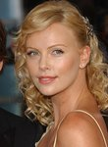

### Charities & foundations supported

* 21st Century Leaders
* American Foundation for AIDS Research
* Artists for Peace and Justice
* Best Friends Animal Society
* Charlize Theron Africa Outreach Project
* Clothes Off Our Back
* Dogs Deserve Better
* Entertainment Industry Foundation
* Food Bank For New York City
* Global Green
* Luke Neuhedel Foundation
* Madison Foundation
* Mpilonhle
* Much Love Animal Rescue
* National Center for Missing and Exploited Children
* PETA
* Population Services International
* Project Angel Food
* Red Cross
* Stand Up To Cancer
* Whatever It Takes
* YouthAIDS

### Causes supported

* AIDS & HIV,
* Animals,
* Cancer,
* Children,
* Creative Arts,
* Disaster Relief,
* Education,
* Environment,
* Family/Parent Support,
* Grief Support,
* Health,
* Human Rights,
* Hunger,
* Miscellaneous,
* Missing Children,
* Peace,
* Poverty,
* Rape/Sexual Abuse,
* Water,
* Women

# Charlotte Church



### Charities & foundations supported

* Breast Cancer Care
* Noah's Ark Appeal
* Topsy Foundation

### Causes supported

* Adoption,
* Fostering,
* Orphans,
* AIDS & HIV,
* Blood, Marrow & Organ Donation,
* Cancer,
* Children,
* Health,
* Poverty,
* Women

# Charlotte Riley



### Charities & foundations supported

### Bowel Cancer UK

### Causes supported

* Cancer

# Charlotte Ross

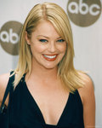

### Charities & foundations supported

* Make-A-Wish Foundation
* Operation Blankets of Love
* PETA
* spcaLA

### Causes supported

* Animals,
* Cancer,
* Children,
* Health

# Charlton Heston



### Causes supported

* Environment

# Charo

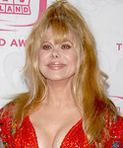

### Charities & foundations supported

### Muscular Dystrophy Association

### PETA

### Causes supported

* Animals,
* Health

# Chase Johnson

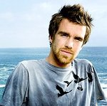

### Charities & foundations supported

### Invisible Children

* Make-A-Wish Foundation
* Operation Smile

### Causes supported

* Cancer,
* Children,
* Health,
* Human Rights,
* Peace

# Chaske Spencer

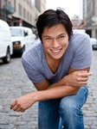

### Charities & foundations supported

* Red Cross
* United Global Shift

### Causes supported

* AIDS & HIV,
* Disaster Relief,
* Human Rights,
* Philanthropy

# Chayanne



### Charities & foundations supported

* Red Cross
* We Are The World Foundation

### Causes supported

* AIDS & HIV,
* Children,
* Disaster Relief,
* Human Rights,
* Hunger,
* Poverty

# Cheech Marin

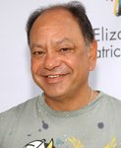

### Charities & foundations supported

* Arthritis Society of Canada
* Casey Lee Ball Foundation
* Celebs for Kids
* Hispanic Scholarship Fund
* Lupus Canada

### Causes supported

* Cancer,
* Children,
* Education,
* Health

# Chelsea Clinton



### Charities & foundations supported

* Clinton Foundation
* Clinton Global Initiative
* Walkabout Foundation

### Causes supported

* Economic/Business Support,
* Education,
* Environment,
* Health,
* Peace,
* Physical Challenges,
* Poverty

# Chelsea Staub



### Charities & foundations supported

### Mattel Children's Hospital

* Reality Cares
* Red Cross

### Causes supported

* AIDS & HIV,
* Children,
* Disaster Relief,
* Health,
* Human Rights
* , Miscellaneous

# Chely Wright



### Charities & foundations supported

* GLAAD

### Causes supported

* Gay/Lesbian Support

# Cher



### Charities & foundations supported

* Afghanistan Relief Organization
* American Foundation for AIDS Research
* MedicAlert Foundation
* Music Rising
* Operation Helmet
* St. Francis Food Pantries and Shelters
* United Service Organization

### Causes supported

* AIDS & HIV,
* Creative Arts,
* Disaster Relief,
* Education,
* Health,
* Hunger,
* Miscellaneous,
* Unemployment/Career Support,
* Veteran/Service Member Support

# Cherry Jones

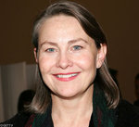

### Charities & foundations supported

* Point

### Causes supported

* Gay/Lesbian Support

# Cheryl Baker

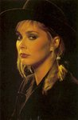

### Charities & foundations supported

### Brain Tumour UK

### Causes supported

* Health

# Cheryl Cole



### Charities & foundations supported

### Comic Relief

### Causes supported

* Disaster Relief,
* Homelessness,
* Human Rights,
* Poverty

# Cheryl Hines

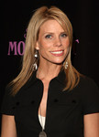

### Charities & foundations supported

* A Day Made Better
* Ante Up For Africa
* Cedars-Sinai Medical Center
* Clothes Off Our Back
* Elizabeth Glaser Pediatric AIDS Foundation
* Libby Ross Foundation
* United Cerebral Palsy

### Causes supported

* AIDS & HIV,
* Cancer,
* Children,
* Education,
* Family/Parent Support,
* Health,
* Human Rights,
* Refugees,
* Women

# Chevy Chase

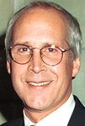

### Charities & foundations supported

* Amnesty International
* Andre Agassi Foundation for Education
* Captain Planet Foundation
* Centre For Environmental Education
* Earth Day Network
* Samuel Waxman Cancer Research Foundation

### Causes supported

* At-Risk/Disadvantaged Youths,
* Cancer,
* Children,
* Education,
* Environment,
* Health,
* Human Rights

# Chicago

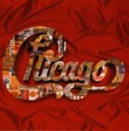

### Charities & foundations supported

* American Cancer Society
* Ara Parseghian Medical Research Foundation
* Hannah and Friends
* WhyHunger

### Causes supported

* Cancer,
* Children,
* Economic/Business Support,
* Health,
* Hunger,
* Mental Challenges,
* Physical Challenges,
* Poverty

# Chloë Sevigny



### Charities & foundations supported

* Sentebale
* The Doe Fund

### Causes supported

* Abuse,
* AIDS & HIV,
* At-Risk/Disadvantaged Youths,
* Homelessness,
* Physical Challenges

# Chow Yun Fat



### Charities & foundations supported

* One Foundation

### Causes supported

* Disaster Relief

# Chris Brown

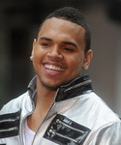

### Charities & foundations supported

* Aid Still Required
* Best Buddies International
* Kids Wish Network
* Stand Up To Cancer

### Causes supported

* Cancer,
* Children,
* Disaster Relief,
* Grief Support,
* Health,
* Mental Challenges

# Chris Cornell



### Charities & foundations supported

* Global Angels
* Live Earth
* MusiCares
* Nordoff Robbins
* Save The Music Foundation

### Causes supported

* Adoption,
* Fostering,
* Orphans,
* At-Risk/Disadvantaged Youths,
* Children,
* Creative Arts,
* Education,
* Environment,
* Health,
* Homelessness,
* Human Rights,
* Hunger,
* Miscellaneous,
* Poverty,
* Refugees,
* Unemployment/Career Support

# Chris Daughtry

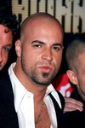

### Charities & foundations supported

* ACT Today!
* Autism Speaks
* Love Our Children USA
* MusiCares
* Musicians on Call
* ONE Campaign
* Parkinson Society Maritime Region
* Save the Children
* Save The Music Foundation
* UNICEF

### Causes supported

* Abuse,
* AIDS & HIV,
* At-Risk/Disadvantaged Youths,
* Children,
* Creative Arts,
* Disaster Relief,
* Education,
* Family/Parent Support,
* Health,
* Homelessness,
* Human Rights,
* Mental Challenges,
* Physical Challenges,
* Poverty,
* Unemployment/Career Support

# Chris De Burgh

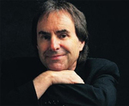

### Causes supported

* Health

# Chris DeRose

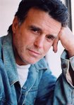

### Charities & foundations supported

* Last Chance for Animals

### Causes supported

* Animals

# Chris Evert

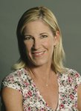

### Charities & foundations supported

* Chris Evert Charities
* Make-A-Wish Foundation
* March Of Dimes
* Red Cross
* Special Olympics

### Causes supported

* Addiction,
* AIDS & HIV,
* Cancer,
* Children,
* Disaster Relief,
* Health,
* Human Rights,
* Mental Challenges,
* Physical Challenges

# Chris Holmes, MBE

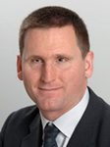

### Charities & foundations supported

* Fight for Sight

### Causes supported

* Health,
* Miscellaneous,
* Physical Challenges

# Chris Hope

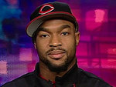

### Charities & foundations supported

* Soles4Souls

### Causes supported

* Disaster Relief,
* Poverty,
* Refugees

# Chris Isaak

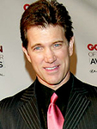

### Charities & foundations supported

* GRAMMY Foundation

### Causes supported

* Creative Arts

# Chris Jacobs

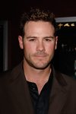

### Charities & foundations supported

* American Cancer Society

### Causes supported

* Cancer, Health

# Chris Knight

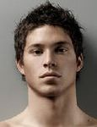

### Charities & foundations supported

* Global Green Plan
* Greenpeace
* Naked For a Cause
* PETA
* The McGrath Foundation
* Wildlife Warriors Worldwide
* World Society for the Protection of Animals

### Causes supported

* AIDS & HIV,
* Animals,
* Cancer,
* Conservation,
* Environment,
* Human Rights

# Chris Martin

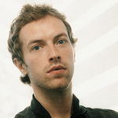

### Charities & foundations supported

* 21st Century Leaders
* Amnesty International
* Bridge School
* Hoping Foundation
* Keep A Child Alive
* Make Trade Fair
* Mencap
* Mercy Corps
* Mines Advisory Group
* Oxfam
* Peace One Day
* Red Cross
* The CarbonNeutral Company
* War Child
* Whatever It Takes

### Causes supported

* AIDS & HIV,
* Children,
* Disaster Relief,
* Environment,
* Fair Trade,
* Family/Parent Support,
* Health,
* Human Rights,
* Literacy,
* Mental Challenges,
* Miscellaneous,
* Peace,
* Physical Challenges,
* Poverty,
* Refugees,
* Unemployment/Career Support,
* Weapons Reduction

# Chris Massey

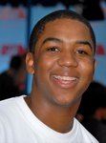

### Charities & foundations supported

* First Star
* Nancy Davis Foundation for Multiple Sclerosis
* Starlight Children's Foundation

### Causes supported

* Abuse,
* AIDS & HIV,
* At-Risk/Disadvantaged Youths,
* Cancer,
* Children,
* Health

# Chris Masterson

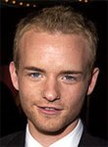

### Charities & foundations supported

* Citizens Commission on Human Rights

**Causes supported**

* Human Rights,
* Mental Challenges

# Chris Noth

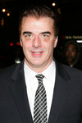

### Charities & foundations supported

### Rainforest Action Network

### Causes supported

* Environment

# Chris Packham



### Charities & foundations supported

### Humane Society International

* Population Matters

### Causes supported

* Animals,
* Environment

# Chris Pine

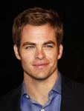

### Charities & foundations supported

### Milk+Bookies

### Causes supported

* Literacy,
* Philanthropy

**Chris Rock**



### Charities & foundations supported

* Andre Agassi Foundation for Education
* Angel Rock Project
* Artists for a New South Africa
* Champions for Children
* Elevate Hope Foundation
* HOPE Worldwide
* Music for Relief
* Raising Malawi
* (RED)
* The HollyRod Foundation
* The Salvation Army
* UNICEF

### Causes supported

* Abuse,
* Adoption,
* Fostering,
* Orphans,
* AIDS & HIV,
* At-Risk/Disadvantaged Youths,
* Cancer,
* Children,
* Creative Arts,
* Disaster Relief,
* Economic/Business Support,
* Education,
* Environment,
* Family/Parent Support,
* Grief Support,
* Health,
* Homelessness,
* Human Rights
* , Philanthropy,
* Physical Challenges
* , Poverty,
* Senior Citizen Support,
* Women

# Chrissie Hynde



### Charities & foundations supported

* British Union for the Abolition of Vivisection
* Cats Protection
* Humane Society International
* PETA

### Causes supported

* Animals

# Chris Tarrant

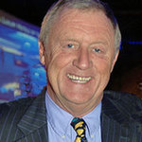

### Charities & foundations supported

* Children with AIDS
* Children With Leukaemia
* Epilepsy Action
* Killing Cancer
* Mary's Meals
* Neurofibromatosis Association
* Prince's Trust
* Sophie's Gift

### Causes supported

* AIDS & HIV,
* At-Risk/Disadvantaged Youths,
* Cancer,
* Children,
* Education,
* Family/Parent Support,
* Health,
* Hunger

# Christian Bale

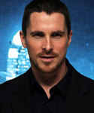

### Charities & foundations supported

### Greenpeace

* Sea Shepherd Conservation Society
* WWF

### Causes supported

* Animals,
* Conservation,
* Environment,
* Oceans

# Christian Kane



### Charities & foundations supported

### Hole in the Wall Gang

* Susan G. Komen for the Cure
* TJ Martell Foundation

### Causes supported

* AIDS & HIV,
* Cancer,
* Children,
* Healt

# Christian LeBlanc

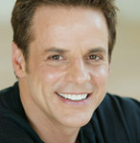

### Charities & foundations supported

* Kiva

### Causes supported

* Economic/Business Support

# Christian Slater

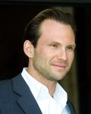

### Charities & foundations supported

* 21st Century Leaders
* Clothes Off Our Back
* Feeding America
* Get Schooled Foundation
* Global Green
* Global Green Plan
* Make-A-Wish Foundation
* Not On Our Watch
* Racing for Kids
* Whatever It Takes

### Causes supported

* At-Risk/Disadvantaged Youths,
* Cancer,
* Children,
* Disaster Relief,
* Education,
* Environment
* , Health,
* Human Rights,
* Hunger,
* Miscellaneous,
* Peace,
* Poverty,
* Refugees,
* Water

# Christie Brinkley

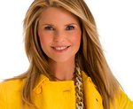

### Charities & foundations supported

* Clothes Off Our Back
* Cousteau Society
* End Hunger Network
* Global Security Institute
* Greenpeace
* March Of Dimes
* Max Cure Foundation
* New York Coalition For Healthy School Food
* Nu Skin Force For Good Foundation
* Peace Action
* Peconic Land Trust
* Red Cross
* Smile Train
* Society for Animal Protective Legislation
* Stand Up To Cancer
* Stop Global Warming
* Susan G. Komen for the Cure
* UNICEF
* United Service Organization
* Wellness In The Schools

### Causes supported

* Adoption,
* Fostering,
* Orphans,
* AIDS & HIV,
* Animals,
* Cancer,
* Children,
* Conservation,
* Disaster Relief,
* Environment,
* Health,
* Human Rights,
* Hunger,
* Miscellaneous,
* Peace,
* Poverty,
* Veteran/Service Member Support,
* Weapons Reduction

# Christina Aguilera



### Charities & foundations supported

* 1736 Family Crisis Center
* AIDS Project Los Angeles
* Amnesty International
* Artists for Peace and Justice
* Declare Yourself
* Defenders of Wildlife
* FFAWN
* GRAMMY Foundation
* Kerry Women Together
* MusiCares
* National Alliance of Breast Cancer Organisations
* National Center for Missing and Exploited Children
* National Coalition Against Domestic Violence
* Red Cross
* Refuge
* Women's Center & Shelter of Greater Pittsburgh
* World Food Programme
* World Hunger Relief

### Causes supported

* Abuse,
* AIDS & HIV,
* Animals,
* Cancer,
* Children,
* Creative Arts,
* Disaster Relief,
* Economic/Business Support,
* Education,
* Environment,
* Family/Parent Support,
* Health,
* Homelessness,
* Human Rights,
* Hunger,
* Miscellaneous,
* Missing Children,
* Poverty,
* Rape/Sexual Abuse,
* Unemployment/Career Support,
* Voter Education,
* Women

# Christina Applegate



### Charities & foundations supported

* A Day Made Better
* Adopt-A-Classroom
* Dizzy Feet Foundation
* Entertainment Industry Foundation
* Right Action for Women
* Spirit of Women Health Network
* Stand Up To Cancer
* Tug McGraw Foundation
* World Society for the Protection of Animals

### Causes supported

* AIDS & HIV,
* Animals,
* Cancer,
* Children,
* Creative Arts,
* Education,
* Family/Parent Support,
* Health,
* Hunger,
* Poverty,
* Women

# Christina DeRosa



### Charities & foundations supported

* Young Storytellers Foundation

### Causes supported

* Education,
* Literacy

# Christina Hendricks



### Charities & foundations supported

* Clothes Off Our Back
* Step Up

### Causes supported

* Children,
* Economic/Business Support
* , Health, Women

# Christina Lindley

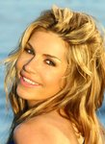

### Charities & foundations supported

### Last Chance For Africa

* Mentors For Youth

### Causes supported

* At-Risk/Disadvantaged Youths,
* Hunger,
* Poverty

# Christina Milian

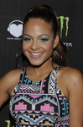

### Charities & foundations supported

* Ante Up For Africa
* Cathy's Kids Foundation
* Children Uniting Nations
* Elton John AIDS Foundation
* ENOUGH Project
* Music Saves Lives
* Not On Our Watch
* Stand Up To Cancer

### Causes supported

* AIDS & HIV,
* At-Risk/Disadvantaged Youths,
* Blood, Marrow & Organ Donation,
* Cancer,
* Children,
* Disaster Relief,
* Health,
* Human Rights,
* Peace,
* Rape/Sexual Abuse,
* Refugees

# Christina Perri

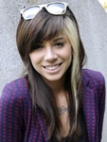

### Charities & foundations supported

### To Write Love on Her Arms

### Causes supported

* Addiction,
* Depression and Suicide,
* Substance Abuse

# Christina Ricci



### Charities & foundations supported

### Rape, Abuse & Incest National Network

* UNICEF

### Causes supported

* Children,
* Health,
* Human Rights,
* Poverty,
* Rape/Sexual Abuse

# Christine Lahti

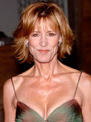

### Charities & foundations supported

* Heifer International
* Peace Over Violence
* V-Day

### Causes supported

* Abuse,
* AIDS & HIV,
* Animals,
* Children,
* Human Rights,
* Hunger,
* Poverty,
* Rape/Sexual Abuse,
* Women

# Christine Ohuruogu



### Charities & foundations supported

* London Coaching Foundation

### Causes supported

* Sports

# Christine Taylor



### Charities & foundations supported

* Elizabeth Glaser Pediatric AIDS Foundation

### Causes supported

* AIDS & HIV,
* Children,
* Family/Parent Support,
* Health

# 

# Christopher Atkins

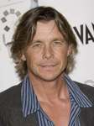

### Charities & foundations supported

* Bailey Baio Angel Foundation
* Neurofibromatosis, Inc.

### Causes supported

* Children,
* Family/Parent Support,
* Health

# Christopher Biggins



### Charities & foundations supported

* ChildLine
* Kidscape

### Causes supported

* Abuse,
* Children,
* Depression and Suicide,
* Rape/Sexual Abuse

# Christopher Eccleston



### Charities & foundations supported

* Mencap
* Red Cross

### Causes supported

* AIDS & HIV,
* Children,
* Disaster Relief,
* Human Rights,
* Literacy,
* Mental Challenges,
* Unemployment/Career Support

# Christopher Guest



### Charities & foundations supported

* Alliance For Climate Protection
* Casey Lee Ball Foundation
* Hollywood Rock Academy Foundation
* Live Earth

### Causes supported

* Cancer,
* Children,
* Creative Arts,
* Environment,
* Health

# Christopher Lee

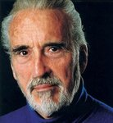

### Charities & foundations supported

:

* Cinema For Peace
* UNICEF

### Causes supported

* Children,
* Health,
* Human Rights,
* Peace,
* Poverty

# Christopher Meloni

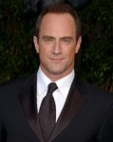

### Charities & foundations supported

* Alzheimer's Association
* Human Rights Campaign
* Smile Train

### Causes supported

* Children,
* Gay/Lesbian Support,
* Health,
* Miscellaneous

# Christopher Reeve



### Charities & foundations supported

* 21st Century Leaders
* Christopher & Dana Reeve Foundation
* Whatever It Takes

### Causes supported

* Children,
* Family/Parent Support,
* Miscellaneous,
* Physical Challenges

# Christopher Walken



### Charities & foundations supported

### WhyHunger

### Causes supported

* Economic/Business Support
* , Hunger,
* Poverty

# Chris Tucker



### Charities & foundations supported

* BrittiCares International
* Chris Tucker Foundation
* Clinton Foundation
* US Doctors for Africa

### Causes supported

* AIDS & HIV,
* Cancer,
* Children,
* Economic/Business Support,
* Education,
* Environment,
* Health,
* Peace,
* Poverty

# Christy Turlington



### Charities & foundations supported

* Action Against Hunger
* African Rainforest Conservancy
* American Cancer Society
* CARE
* Every Mother Counts
* Music Rising
* ONE Campaign
* PETA
* (RED)
* Roseann’s Gift
* Stand Up To Cancer
* Walkabout Foundation
* Worldwide Orphans Foundation

### Causes supported

* Adoption,
* Fostering,
* Orphans,
* AIDS & HIV,
* Animals,
* Cancer,
* Children,
* Conservation,
* Creative Arts,
* Disaster Relief,
* Education,
* Environment,
* Health,
* Hunger,
* Physical Challenges,
* Poverty,
* Unemployment/Career Support,
* Water,
* Women

# Chris Walla



### Charities & foundations supported

* Bridge School
* PETA
* Planned Parenthood

### Causes supported

* Animals,
* Children,
* Education,
* Environment,
* Hunger,
* Miscellaneous,
* Physical Challenges,
* Voter Education,
* Women

# Chris Webber



### Charities & foundations supported

* Chris Webber Foundation
* Make-A-Wish Foundation
* Save The Music Foundation

### Causes supported

* At-Risk/Disadvantaged Youths,
* Cancer,
* Children,
* Creative Arts,
* Education,
* Health,
* Literacy

# Chris Young

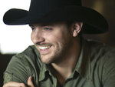

### Charities & foundations supported

* Little Kids Rock

### Causes supported

* At-Risk/Disadvantaged Youths,
* Children,
* Creative Arts

# Chuck Norris

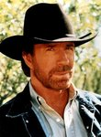

### Charities & foundations supported

* Kick Start Foundation
* Kids Wish Network
* Vijay Amritraj Foundation

### Causes supported

* Adoption,
* Fostering,
* Orphans,
* AIDS & HIV,
* Children,
* Grief Support,
* Health,
* Mental Challenges,
* Miscellaneous,
* Physical Challenges,
* Sports,
* Women

**Chuck Swift**

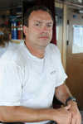

### Charities & foundations supported

* Sea Shepherd Conservation Society

### Causes supported

* Animals,
* Environment,
* Oceans

**Chuck Wicks**

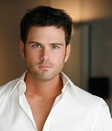

### Charities & foundations supported

### Boys & Girls Clubs of America

### Causes supported

* At-Risk/Disadvantaged Youths,
* Children

**Chuy**

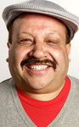

### Charities & foundations supported

* Bailey Baio Angel Foundation
* Mama na Dada
* Reality Cares

### Causes supported

* Children,
* Education,
* Family/Parent Support,
* Health,
* Miscellaneous,
* Poverty,
* Women

**Ciara**



### Charities & foundations supported

* Best Buddies International
* Candie's Foundation
* City Harvest
* DoSomething.org
* Get Schooled Foundation
* Save The Music Foundation
* Shriners Hospitals for Children
* Stand Up To Cancer
* Usher's New Look Foundation

### Causes supported

* At-Risk/Disadvantaged Youths,
* Cancer,
* Children,
* Creative Arts,
* Disaster Relief,
* Education,
* Health,
* Hunger,
* Mental Challenges,
* Miscellaneous,
* Philanthropy,
* Sports,
* Women

**Cindy Crawford**

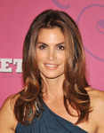

### Charities & foundations supported

* Barbara Davis Center for Childhood Diabetes
* City Hearts: Kids Say Yes to the Arts
* DKMS
* Dream Foundation
* Love Our Children USA
* Neurofibromatosis, Inc.
* New York Coalition For Healthy School Food
* Not On Our Watch
* PETA
* Ronald McDonald House Charities
* St. Jude Children's Research Hospital
* Susan G. Komen for the Cure
* Wellness In The Schools

### Causes supported

* Abuse,
* Animals,
* At-Risk/Disadvantaged Youths
* , Blood, Marrow & Organ Donation,
* Cancer,
* Children,
* Creative Arts,
* Disaster Relief,
* Education,
* Family/Parent Support,
* Health,
* Human Rights,
* Poverty,
* Refugees

**Claire Danes**



### Charities & foundations supported

* The Saban Free Clinic
* V-Day

### Causes supported

* Abuse,
* Health,
* Human Rights,
* Rape/Sexual Abuse,
* Women

**Claire King**

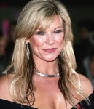

### Charities & foundations supported

* TigerTime
* World Horse Welfare

### Causes supported

* Animals,
* Conservation

**Clarence Clemons**

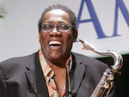

### Charities & foundations supported

* Home Safe
* Little Kids Rock

### Causes supported

* Children,
* Creative Arts,
* Miscellaneous

**Clarence Seedorf**

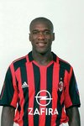

### Charities & foundations supported

* Goal4Africa

### Causes supported

* Education,
* Sports

**Claudia Schiffer**



### Charities & foundations supported

* 21st Century Leaders
* Epilepsy Action
* Make Poverty History
* National Society for the Prevention of Cruelty to Children
* Neurofibromatosis Association
* Not On Our Watch
* ONE Campaign
* UNICEF
* Whatever It Takes

### Causes supported

* Abuse,
* AIDS & HIV,
* Children,
* Disaster Relief,
* Health,
* Human Rights,
* Miscellaneous,
* Poverty,
* Refugees

**Clay Aiken**



### Charities & foundations supported

* Broadway Cares/Equity Fights AIDS
* David Foster Foundation
* Griffith Park Recovery Fund
* National Inclusion Project
* National Kidney Foundation
* Ronald McDonald House Charities
* STOMP Out Bullying
* Toys for Tots
* True Colors Fund
* UNICEF

### Causes supported

* Abuse,
* AIDS & HIV,
* At-Risk/Disadvantaged Youths,
* Blood, Marrow & Organ Donation,
* Children,
* Family/Parent Support,
* Gay/Lesbian Support,
* Health,
* Human Rights,
* Mental Challenges,
* Miscellaneous,
* Poverty

**Clay Matthews**

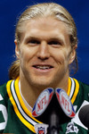

### Charities & foundations supported

* Cure Duchenne

### Causes supported

* Children,
* Health

**Clay Walker**

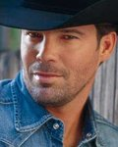

### Charities & foundations supported

* Band Against MS Foundation
* Camp Heartland
* Max Cure Foundation
* Nancy Davis Foundation for Multiple Sclerosis
* Red Cross

### Causes supported

* AIDS & HIV,
* Cancer
* , Children,
* Disaster Relief,
* Health,
* Human Rights

**Cliff Richard**

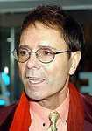

### Charities & foundations supported

* Alzheimer's Research UK
* Cliff Richard Tennis Foundation
* Kidney Research UK
* Olivia Newton-John Cancer & Wellness Centre
* Roy Castle Lung Cancer Foundation
* TEARfund
* Teenage Cancer Trust
* The Hunger Project

### Causes supported

* AIDS & HIV,
* At-Risk/Disadvantaged Youths,
* Cancer,
* Children,
* Disaster Relief,
* Environment,
* Health,
* Hunger,
* Poverty,
* Sports

**Clint Black**

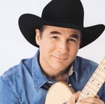

### Charities & foundations supported

* Monroe Carell Jr. Children's Hospital at Vanderbilt
* Red Cross
* St. Jude Children's Research Hospital

### Causes supported

* AIDS & HIV,
* Children,
* Disaster Relief,
* Health,
* Human Rights

**Clint Eastwood**



### Charities & foundations supported

* Artists for Peace and Justice
* Barbara Davis Center for Childhood Diabetes
* Best Buddies International
* Best Friends Animal Society
* City of Hope
* Film Foundation
* Image of Change
* Red Cross
* Unite for Japan

### Causes supported

* AIDS & HIV,
* Animals,
* Cancer,
* Children,
* Creative Arts,
* Disaster Relief,
* Health,
* Human Rights,
* Mental Challenges,
* Miscellaneous,
* Philanthropy,
* Poverty

**Clive Anderson**

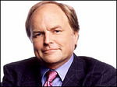

### Charities & foundations supported

* Save the Rhino

### Causes supported

* Conservation

**Clive Owen**

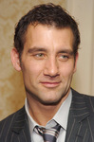

### Charities & foundations supported

* Aegis Trust

### Causes supported

* Human Rights,
* Miscellaneous

**Coco Rocha**

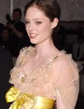

**Charities & foundations supported**

### Environmental Justice Foundation

### Causes supported

* Environment,
* Human Rights

**Cody Simpson**

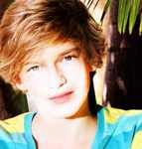

### Charities & foundations supported

* PETA

### Causes supported

* Animals

**Colbie Caillat**



### Charities & foundations supported

* City of Hope
* Farm Sanctuary
* First Tee
* Hero in Heels
* Larry King Cardiac Foundation
* Save The Music Foundation
* United Service Organization
* Wish Upon A Hero Foundation

### Causes supported

* AIDS & HIV,
* Animals,
* Cancer,
* Children,
* Creative Arts,
* Education,
* Health,
* Philanthropy,
* Sports,
* Veteran/Service Member Support,
* Women

**Coldplay**

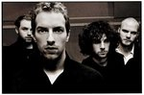

### Charities & foundations supported

* 21st Century Leaders
* Amnesty International
* Cancer Active
* Children with AIDS
* City of Hope
* GRAMMY Foundation
* Keech Hospice Care
* Keep A Child Alive
* Live 8
* Lucy Blackman Trust
* Make A Child Smile Appeal
* Make Trade Fair
* Mercy Corps
* Mines Advisory Group
* MusiCares
* Oxfam
* Red Cross
* Rush Philanthropic Arts Foundation
* St. Jude Children's Research Hospital
* The CarbonNeutral Company
* War Child
* Whatever It Takes

### Causes supported

* Adoption,
* Fostering,
* Orphans,
* AIDS & HIV
* , At-Risk/Disadvantaged Youths,
* Cancer,
* Children,
* Creative Arts,
* Disaster Relief,
* Environment,
* Fair Trade,
* Family/Parent Support,
* Health,
* Human Rights,
* Miscellaneous,
* Peace,
* Poverty,
* Unemployment/Career Support,
* Weapons Reduction

**Colin Farrell**

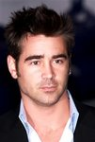

### Charities & foundations supported

* Belong To
* Children's Hospital Los Angeles
* Foundation for Angelman Syndrome Therapeutics
* It Gets Better Project
* Special Olympics
* The Trevor Project
* UNICEF
* World Food Programme

### Causes supported

* At-Risk/Disadvantaged Youths,
* Children,
* Depression and Suicide,
* Gay/Lesbian Support,
* Health,
* Homelessness,
* Human Rights,
* Hunger
* , Mental Challenges,
* Physical Challenges,
* Poverty

**Colin Firth**

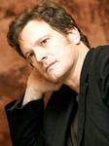

### Charities & foundations supported

* Amnesty International
* Make Poverty History
* Make Trade Fair
* Out Of The Blue
* Oxfam
* Soil Association
* Survival International

### Causes supported

* Children,
* Conservation,
* Creative Arts,
* Disaster Relief,
* Environment,
* Fair Trade,
* Human Rights,
* Mental Challenges,
* Physical Challenges,
* Poverty

**Colin Powell**

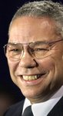

### Charities & foundations supported

* Aid for the World
* Children's Health Fund
* Hands On Nashville
* Smile Train

### Causes supported

* Children,
* Education,
* Health,
* Hunger,
* Miscellaneous,
* Philanthropy,
* Poverty

**Collin Raye**



### Charities & foundations supported

* Operation Kids

### Causes supported

* Children,
* Missing Children

**Common**

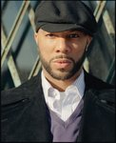

### Charities & foundations supported

* Aid Still Required
* Artists for Peace and Justice
* Believe in Dreams
* Common Ground Foundation
* Get Schooled Foundation
* Hear The World
* Keep A Child Alive
* PETA
* (RED)
* Red Cross

### Causes supported

* AIDS & HIV,
* Animals,
* At-Risk/Disadvantaged Youths,
* Children,
* Disaster Relief,
* Education,
* Family/Parent Support,
* Health,
* Human Rights,
* Literacy,
* Miscellaneous,
* Poverty,
* Women

**Conan O'Brien**

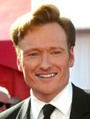

### Charities & foundations supported

* Autism Speaks
* Bob Woodruff Foundation
* Farm Sanctuary
* Fresh Air Fund
* St. Francis Food Pantries and Shelters
* STILLERSTRONG

### Causes supported

* Animals,
* At-Risk/Disadvantaged Youths,
* Children,
* Education,
* Health,
* Hunger,
* Mental Challenges,
* Poverty,
* Veteran/Service Member Support

**Connie Sellecca**



### Charities & foundations supported

* Sellecca-Tesh Foundation for the Forgotten Generation

### Causes supported

* Creative Arts,
* Senior Citizen Support

**Constance Marie**



### Charities & foundations supported

* East Los Angeles Women's Center
* Padres Contra el Cancer
* Young Storytellers Foundation

### Causes supported

* Cancer,
* Children,
* Education,
* Family/Parent Support,
* Literacy,
* Women

**Constance Zimmer**



### Charities & foundations supported

* Heifer International
* Keep America Beautiful

### Causes supported

* AIDS & HIV,
* Animals,
* Children,
* Conservation,
* Environment,
* Hunger,
* Poverty,
* Water

**Constantine Maroulis**



### Charities & foundations supported

* Broadway Cares/Equity Fights AIDS

### Causes supported

* AIDS & HIV,
* Children

**Corbin Bleu**

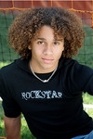

### Charities & foundations supported

* Alzheimer's Association
* Los Angeles Mission
* Make-A-Wish Foundation
* ONE Campaign
* Starlight Children's Foundation
* St. Jude Children's Research Hospital

### Causes supported

* AIDS & HIV,
* Cancer,
* Children,
* Health,
* Homelessness,
* Poverty

**Corey Feldman**

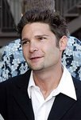

### Charities & foundations supported

* Camp Rainbow
* Farm Sanctuary
* Greenpeace
* Last Chance for Animals
* Mama na Dada
* MoveOn
* PETA
* The Humane Society

### Causes supported

* Animals,
* Children,
* Conservation,
* Education,
* Environment,
* Health,
* Poverty,
* Voter Education,
* Women

**Corinne Bailey Rae**



### Charities & foundations supported

* 46664
* Amnesty International
* Children of Peace
* CORD
* FFAWN
* Joanna
* Live Earth
* Oxfam
* Peace One Day
* Pump Aid
* Sahara
* Share Our Strength
* The Truth Isn't Sexy
* Together For Peace

### Causes supported

* Abuse,
* AIDS & HIV,
* Children,
* Disaster Relief,
* Education,
* Environment,
* Family/Parent Support,
* Human Rights,
* Hunger,
* Peace,
* Poverty,
* Rape/Sexual Abuse,
* Refugees,
* Unemployment/Career Support,
* Water,
* Women

**Cory Monteith**

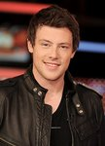

### Charities & foundations supported

* Virgin Unite
* Young Storytellers Foundation

### Causes supported

* Adoption,
* Fostering,
* Orphans,
* AIDS & HIV,
* Children,
* Disaster Relief,
* Education,
* Health,
* Homelessness,
* Literacy,
* Mental Challenges,
* Physical Challenges

**Courteney Cox**



### Charities & foundations supported

* 21st Century Leaders
* Barbara Davis Center for Childhood Diabetes
* Blue Planet Run Foundation
* Camp Laurel
* Clothes Off Our Back
* EB Medical Research Foundation
* Feeding America
* Food Bank For New York City
* Healthy Child Healthy World
* Hillsides
* Last Chance for Animals
* Libby Ross Foundation
* Lili Claire Foundation
* Los Angeles Regional Foodbank
* Millennium Promise
* National Stroke Association
* OmniPeace
* P.A.D.
* Pediatric Epilepsy Project
* Project A.L.S.
* Red Cross
* Spirit of Women Health Network
* St. Francis Food Pantries and Shelters
* Susan G. Komen for the Cure
* The Art of Elysium
* The Lunchbox Fund
* The Rescue Train
* Toys for Tots
* United Way
* Whatever It Takes

### Causes supported

* AIDS & HIV,
* Animals,
* At-Risk/Disadvantaged Youths,
* Cancer,
* Children,
* Disaster Relief,
* Education,
* Environment,
* Family/Parent Support,
* Health,
* Human Rights,
* Hunger,
* Mental Challenges,
* Miscellaneous,
* Poverty,
* Rape/Sexual Abuse,
* Water,
* Women

**Craig Biggio**

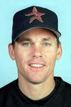

### Charities & foundations supported

* Sunshine Kids Foundation

### Causes supported

* Cancer,
* Children

**Craig David**

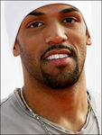

### Causes supported

* Health

**Cristiano Ronaldo**

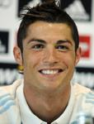

### Charities & foundations supported

* Aid Still Required
* Save the Children

### Causes supported

* Abuse,
* AIDS & HIV,
* Children,
* Disaster Relief,
* Education,
* Poverty

**Cristina Saralegui**



### Charities & foundations supported

* American Foundation for AIDS Research
* National Parks Conservation Association

### Causes supported

* AIDS & HIV,
* Conservation,
* Environment,
* Health

**Crosby, Stills and Nash**

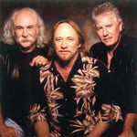

### Charities & foundations supported

* Plastic Pollution Coalition
* rock CAN roll

### Causes supported

* Environment,
* Hunger,
* Oceans

**Crowded House**



### Charities & foundations supported

* Global Angels
* Live Earth
* Nordoff Robbins
* Oxfam

### Causes supported

* Adoption,
* Fostering,
* Orphans,
* At-Risk/Disadvantaged Youths,
* Children,
* Disaster Relief,
* Environment,
* Health,
* Homelessness,
* Human Rights,
* Hunger,
* Miscellaneous,
* Poverty,
* Refugees

**Counting Crows**



### Charities & foundations supported

* Farm Aid
* GreyBird Foundation
* Kids for Tomorrow
* Nuçi's Space

### Causes supported

* Children,
* Creative Arts,
* Depression and Suicide,
* Economic/Business Support,
* Education,
* Environment,
* Hunger,
* Miscellaneous,
* Poverty,
* Voter Education

**Crystal Bowersox**

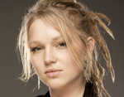

### Charities & foundations supported

* Children's Aid Society
* Children's Hospital Los Angeles
* Diabetes Hands Foundation
* Diabetes Research Institute
* K.I.D.S.
* Red Cross

### Causes supported

* Abuse,
* Adoption,
* Fostering,
* Orphans,
* AIDS & HIV,
* At-Risk/Disadvantaged Youths,
* Children,
* Disaster Relief,
* Family/Parent Support,
* Health,
* Homelessness,
* Human Rights,
* Literacy,
* Veteran/Service Member Support

**Cuba Gooding Jr.**

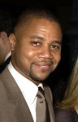

### Charities & foundations supported

* A Place Called Home
* Barbara Davis Center for Childhood Diabetes
* City of Hope
* Variety - The Children's Charity

### Causes supported

* AIDS & HIV,
* At-Risk/Disadvantaged Youths,
* Cancer,
* Children,
* Health

**Curtis Granderson**



### Charities & foundations supported

* Grand Kids Foundation

### Causes supported

* At-Risk/Disadvantaged Youths,
* Children,
* Sports

**Curtis Stone**

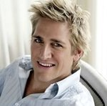

### Charities & foundations supported

* Aid For AIDS
* Dine Out Los Angeles
* Hospice of Visiting Nurses Services
* Sea Shepherd Conservation Society

### Causes supported

* AIDS & HIV,
* Animals,
* Environment,
* Health,
* Hunger,
* Oceans

**Cybill Shepherd**

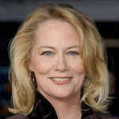

### Charities & foundations supported

* GLAAD
* Human Rights Campaign
* Nancy Davis Foundation for Multiple Sclerosis

### Causes supported

* Gay/Lesbian Support,
* Health

**Cyndi Lauper**



### Charities & foundations supported

* 46664
* Broadway Cares/Equity Fights AIDS
* Human Rights Campaign
* M·A·C AIDS Fund
* True Colors Fund
* True Colors Residence

### Causes supported

* AIDS & HIV,
* At-Risk/Disadvantaged Youths,
* Gay/Lesbian Support,
* Homelessness

**Cynthia Nixon**



### Charities & foundations supported

* Actors Fund of America
* A Day Made Better
* BID 2 BEAT AIDS
* Broadway Cares/Equity Fights AIDS
* Point Foundation
* Susan G. Komen for the Cure
* V-Day

### Causes supported

* Abuse,
* AIDS & HIV,
* Cancer,
* Creative Arts,
* Education,
* Gay/Lesbian Support,
* Human Rights,
* Miscellaneous,
* Rape/Sexual Abuse,
* Women