**Daddy Yankee**

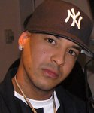

### Charities & foundations supported

* Red Cross

### Causes supported

* AIDS & HIV,
* Disaster Relief
* , Human Rights

# Dai Henwood



### Charities & foundations supported

* RNZSPCA

### Causes supported

* Animals

# Daisy Fuentes

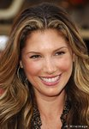

### Charities & foundations supported

* Barbara Davis Center for Childhood Diabetes
* Nancy Davis Foundation for Multiple Sclerosis
* Padres Contra el Cancer
* Smile Train
* The Heart Truth
* The HollyRod Foundation

### Causes supported

* Cancer,
* Children,
* Family/Parent Support,
* Health,
* Miscellaneous,
* Physical Challenges,
* Women

# Dakota Fanning

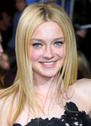v

### Charities & foundations supported

* Alzheimer's Association
* Barbara Davis Center for Childhood Diabetes
* First Star
* Parkinson Society Maritime Region
* Shane's Inspiration
* St. Jude Children's Research Hospital
* Variety Power Of Youth

### Causes supported

* Abuse,
* At-Risk/Disadvantaged Youths
* , Children,
* Health,
* Philanthropy,
* Physical Challenges,
* Voter Education

# Dalai Lama

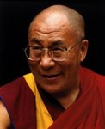

### Charities & foundations supported

* Augie's Quest
* Australia Tibet Council
* BODHI
* Cinema For Peace
* International Campaign for Tibet
* Nuclear Age Peace Foundation
* Robert F Kennedy Memorial
* Sea Shepherd Conservation Society

### Causes supported

* Animals,
* Conservation,
* Education,
* Environment,
* Health,
* Human Rights,
* Oceans,
* Peace,
* Weapons Reduction

# Dale Earnhardt, Jr.

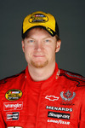

### Charities & foundations supported

* Jeff Gordon Children's Foundation
* Kids Wish Network

### Causes supported

* Cancer,
* Children,
* Grief Support,
* Health

# Damian Lewis

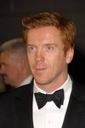

### Charities & foundations supported

* Christian Aid
* Prince's Trust
* UNICEF

### Causes supported

* At-Risk/Disadvantaged Youths,
* Children,
* Education,
* Health,
* Human Rights,
* Peace,
* Poverty,
* Women

# Damien Hirst

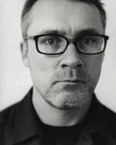

### Charities & foundations supported

* ARK
* Dorset Wildlife Trust
* Great Ormond Street Hospital
* LIVESTRONG
* (RED)
* Silverlake Conservatory of Music
* Sir Bobby Robson Foundation
* War Child

### Causes supported

* AIDS & HIV,
* Cancer,
* Children,
* Conservation,
* Creative Arts,
* Disaster Relief,
* Environment,
* Health,
* Peace,
* Poverty,
* Women

# Damien Rice

# Damien Rice

### Charities & foundations supported

# CARE

# Global Green

# International Campaign for Tibet

# Iraq Veterans Against the War

# Oxfam

# Simon Community

# United for Peace and Justice

# US Campaign for Burma

### Causes supported

* AIDS & HIV,
* Children,
* Disaster Relief,
* Education,
* Environment,
* Health,
* Homelessness,
* Human Rights,
* Peace,
* Poverty,
* Veteran/Service Member Support,
* Water,
* Women

# Damon Albarn

# Damon Albarn

### Charities & foundations supported

* UNICEF
* Youth Music

### Causes supported

* Children,
* Creative Arts,
* Health,
* Human Rights,
* Poverty

# Damon Wayans

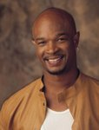

### Charities & foundations supported

* Clothes Off Our Back
* Feeding America
* Home Safe
* Hope North
* The Art of Elysium

### Causes supported

* Adoption,
* Fostering,
* Orphans,
* AIDS & HIV,
* Cancer,
* Children,
* Health,
* Hunger,
* Miscellaneous,
* Refugees

# Dana Delany

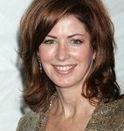

### Charities & foundations supported

* Feeding America
* Global Green
* Scleroderma Research Foundation
* SixDegrees.org
* Stand Up To Cancer

### Causes supported

* Cancer,
* Environment,
* Health,
* Hunger,
* Peace,
* Philanthropy,
* Poverty,
* Water

# Dan Brown



### Causes supported

* Education

# Dane Cook

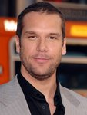

### Charities & foundations supported

* Artists for Peace and Justice
* Variety - The Children's Charity

### Causes supported

* Children,
* Disaster Relief
* , Miscellaneous,
* Poverty

# Daniela Kingsley



### Charities & foundations supported

### Prince's Trust

### Causes supported

* At-Risk/Disadvantaged Youths,
* Children,
* Education

# Daniela Nardini



### Charities & foundations supported

* Oxfam

### Causes supported

* Disaster Relief,
* Human Rights,
* Poverty

# Daniel Baldwin

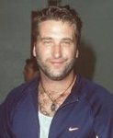

### Charities & foundations supported

* California Disabled Veteran Business Alliance
* Carol M. Baldwin Cancer Research Fund
* TLC for the Blind

### Causes supported

* Cancer,
* Physical Challenges,
* Veteran/Service Member Support

# Daniel Bedingfield

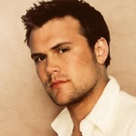

### Charities & foundations supported

* Amnesty International
* Global Angels

### Causes supported

* Adoption,
* Fostering,
* Orphans,
* At-Risk/Disadvantaged Youths,
* Children,
* Health,
* Homelessness,
* Human Rights
* , Hunger,
* Poverty,
* Refugees

# Daniel Craig

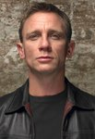

### Charities & foundations supported

* Actors Fund of America
* Afghanistan Relief Organization
* Artists for Peace and Justice
* Barnardo's
* Broadway Cares/Equity Fights AIDS
* ChildLine
* Comic Relief
* Dorset Wildlife Trust
* Epilepsy Action
* Neurofibromatosis Association
* Royal National Lifeboat Institution
* Variety Club
* Worldwide Orphans Foundation

### Causes supported

* Abuse,
* Adoption,
* Fostering,
* Orphans,
* AIDS & HIV,
* At-Risk/Disadvantaged Youths,
* Children,
* Conservation,
* Creative Arts,
* Depression and Suicide,
* Disaster Relief,
* Education,
* Emergency services,
* Environment,
* Family/Parent Support,
* Health,
* Homelessness,
* Human Rights,
* Mental Challenges,
* Miscellaneous,
* Physical Challenges,
* Poverty

**Daniel Dae Kim**

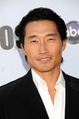

### Charities & foundations supported

* Alana Dung Research Foundation
* ARTafterDARK
* Milk+Bookies
* Red Cross

### Causes supported

* **AIDS & HIV,**
* **Cancer,**
* **Creative Arts,**
* **Disaster Relief,**
* **Human Rights,**
* **Literacy,**
* **Philanthropy**

**Daniel Goddard**

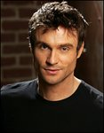

### Charities & foundations supported

* Kiva
* Racing for Kids

### Causes supported

* Children,
* Economic/Business Support

**Daniel J. Travanti**



### Charities & foundations supported

### Hey U.G.L.Y.

### Causes supported

* Children,
* Miscellaneous

**Danielle Lloyd**



### Charities & foundations supported

* Children with AIDS

### Causes supported

* Abuse,
* AIDS & HIV,
* Children,
* Family/Parent Support,
* Health,
* Veteran/Service Member Support

**Daniel Radcliffe**

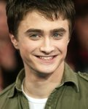

### Charities & foundations supported

* Book Aid International
* Broadway Cares/Equity Fights AIDS
* Charity Projects Entertainment Fund
* Comic Relief
* Demelza House
* Great Ormond Street Hospital
* Kids Wish Network
* Luke Neuhedel Foundation
* Lupus Foundation of America
* Northampton Welfare Rights Advice Service
* Only Make Believe
* Project Last Stand
* Rebuilding Sri Lanka
* Save the Children
* The Trevor Project
* UNICEF

### Causes supported

* Abuse,
* AIDS & HIV,
* Cancer,
* Children,
* Conservation,
* Creative Arts,
* Depression and Suicide,
* Disaster Relief,
* Education,
* Environment,
* Family/Parent Support,
* Gay/Lesbian Support,
* Grief Support,
* Health,
* Homelessness,
* Human Rights,
* Poverty,
* Refugees

**Dan Martin**

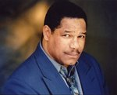

### Causes supported

* Homelessness,
* Veteran/Service Member Support

**Danny Boyle**

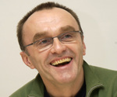

### Charities & foundations supported

* Dramatic Need
* Railway Children

### Causes supported

* At-Risk/Disadvantaged Youths,
* Children,
* Creative Arts,
* Education

**Danny DeVito**

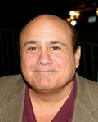

### Charities & foundations supported

* Hollywood Arts Council
* Keep Memory Alive
* Operation USA
* Seany Foundation
* Solar Neighbors Program

### Causes supported

* Cancer,
* Children,
* Creative Arts,
* Disaster Relief,
* Environment,
* Health,
* Poverty

**Danny Glover**

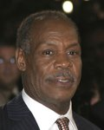

### Charities & foundations supported

* Black AIDS Institute
* HELP USA
* Jazz Foundation of America
* ONE Campaign
* Plastic Pollution Coalition
* UNICEF

### Causes supported

* AIDS & HIV,
* Children,
* Creative Arts,
* Environment,
* Health,
* Homelessness,
* Human Rights,
* Oceans,
* Poverty

**Dan Marino**

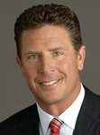

### Charities & foundations supported

* Caddy for a Cure
* Dan Marino Foundation

### Causes supported

* Children,
* Health,
* Miscellaneous,
* Physical Challenges

**Dannii Minogue**



### Charities & foundations supported

* Great Ormond Street Hospital
* Olivia Newton-John Cancer & Wellness Centre
* Terrence Higgins Trust
* World AIDS Day

### Causes supported

* AIDS & HIV,
* Cancer,
* Children,
* Health

**Dan Zanes**

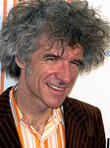

### Charities & foundations supported

* Heifer International
* Little Kids Rock

### Causes supported

* AIDS & HIV,
* Animals,
* At-Risk/Disadvantaged Youths,
* Children,
* Creative Arts,
* Hunger,
* Poverty

**Darius Rucker**

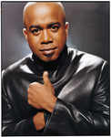

### Charities & foundations supported

* ANNIKA Foundation
* Fisher House Foundation

### Causes supported

* Children,
* Health,
* Sports,
* Veteran/Service Member Support

**Darrell Green**

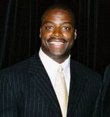

### Charities & foundations supported

* Darrell Green Youth Life Foundation
* Dr. Donda West Foundation

### Causes supported

* At-Risk/Disadvantaged Youths,
* Creative Arts,
* Education

**Darren Criss**

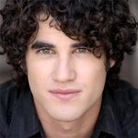

### Charities & foundations supported

* Amnesty International
* Education Through Music, New York
* The Trevor Project
* Toys for Tots

### Causes supported

* At-Risk/Disadvantaged Youths,
* Children,
* Creative Arts,
* Depression and Suicide,
* Education,
* Gay/Lesbian Support,
* Human Rights

**Darren Darnborough**

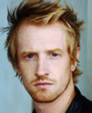

### Charities & foundations supported

* Virgin Unite

### Causes supported

* Adoption,
* Fostering,
* Orphans,
* AIDS & HIV,
* Children,
* Disaster Relief,
* Health,
* Homelessness,
* Mental Challenges,
* Physical Challenges

**Darren Hayes**



### Charities & foundations supported

* Make-A-Wish Foundation

### Causes supported

* Cancer,
* Children,
* Health

**Darryl McDaniels**

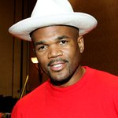

### Charities & foundations supported

* Children's Hospital Los Angeles
* DKMS
* Felix Organization
* Food Bank For New York City
* Josh Beckett Foundation
* New York Foundling
* The Lunchbox Fund
* WhyHunger

### Causes supported

* Adoption,
* Fostering,
* Orphans,
* At-Risk/Disadvantaged Youths,
* Blood, Marrow & Organ Donation,
* Cancer,
* Children,
* Economic/Business Support,
* Health,
* Hunger,
* Poverty

**Darren Sharper**

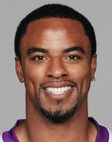

### Charities & foundations supported

### United Way

### Causes supported

* Education,
* Health,
* Miscellaneous,
* Poverty

**Darryl Pollard**

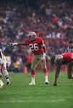

### Charities & foundations supported

* Image of Change

### Causes supported

* Philanthropy

**Daryl Hannah**

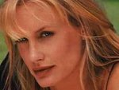

### Charities & foundations supported

* Act Green
* Amazon Watch
* Centre For Environmental Education
* Clothes Off Our Back
* ecoAmerica
* Environmental Media Association
* Green Treks
* Reality Cares
* Reef Check Foundation
* Sea Shepherd Conservation Society
* Solar Neighbors Program
* Somaly Mam Foundation
* Sustainable Biodiesel Alliance
* The Gorilla Organization

### Causes supported

* Animals,
* Children,
* Conservation,
* Education,
* Environment,
* Health,
* Human Rights
* , Miscellaneous,
* Oceans,
* Poverty,
* Rape/Sexual Abuse,
* Water,
* Women

**Dash Mihok**



### Charities & foundations supported

* Tourette Syndrome Association

### Causes supported

* Children,
* Health

**Dave Annable**



### Charities & foundations supported

* Peace Over Violence
* The Art of Elysium
* Tiger Woods Learning Center

### Causes supported

* Abuse,
* AIDS & HIV,
* Cancer,
* Children,
* Education,
* Health,
* Rape/Sexual Abuse,
* Women

# Dave Dobbyn



### Charities & foundations supported

* Hear The World
* TEARfund
* World Vision

### Causes supported

* Adoption,
* Fostering,
* Orphans,
* AIDS & HIV,
* At-Risk/Disadvantaged Youths,
* Children,
* Disaster Relief,
* Environment,
* Health,
* Poverty

**Dave Downing**

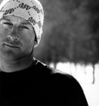

### Charities & foundations supported

* Chill Foundation

### Causes supported

* At-Risk/Disadvantaged Youths

**Dave Grohl**

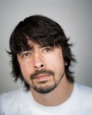

### Charities & foundations supported

* 21st Century Leaders
* HeadCount
* LIFEbeat
* Live Earth
* Milk+Bookies
* Teen Cancer America
* Whatever It Takes
* White Knot for Equality
* Worldwide Orphans Foundation

### Causes supported

* Adoption,
* Fostering,
* Orphans,
* AIDS & HIV,
* Cancer,
* Children,
* Environment,
* Gay/Lesbian Support,
* Health,
* Human Rights,
* Literacy,
* Miscellaneous,
* Philanthropy,
* Poverty,
* Voter Education

**Dave Mason**

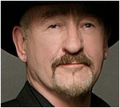

### Charities & foundations supported

* Little Kids Rock
* Michael Bolton Charities

### Causes supported

* Abuse,
* At-Risk/Disadvantaged Youths,
* Children,
* Creative Arts,
* Women

**Dave Matthews**

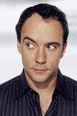

### Charities & foundations supported

* Artists for a New South Africa
* Bama Works Fund
* Farm Aid
* GRAMMY Foundation
* Green Music Group
* Habitat For Humanity
* HeadCount
* Hudson River Sloop Clearwater
* Kids Wish Network
* Kokua Hawaii Foundation
* Live Earth
* MusiCares

### Causes supported

* AIDS & HIV,
* At-Risk/Disadvantaged Youths,
* Children,
* Conservation,
* Creative Arts,
* Disaster Relief,
* Economic/Business Support,
* Environment,
* Grief Support,
* Health,
* Homelessness,
* Hunger,
* Mental Challenges,
* Miscellaneous,
* Physical Challenges,
* Unemployment/Career Support,
* Voter Education

**Dave Matthews Band**

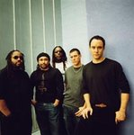

### Charities & foundations supported

* Amnesty International
* Bama Works Fund
* GRAMMY Foundation
* Green Music Group
* Habitat For Humanity
* HeadCount
* Kevin Youkilis Hits For Kids
* Kokua Hawaii Foundation
* Live Earth
* MusiCares
* Stand Up For A Cure
* World AIDS Day

### Causes supported

* AIDS & HIV,
* At-Risk/Disadvantaged Youths,
* Cancer,
* Children,
* Conservation,
* Creative Arts,
* Disaster Relief,
* Environment,
* Health,
* Homelessness,
* Human Rights,
* Mental Challenges,
* Physical Challenges,
* Unemployment/Career Support,
* Voter Education

**Dave Mustaine**



### Charities & foundations supported

* Little Kids Rock

### Causes supported

* At-Risk/Disadvantaged Youths,
* Children,
* Creative Arts

**Dave Eggers**

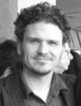

### Charities & foundations supported

* Alliance For The Lost Boys Of Sudan
* Valentino Achak Deng Foundation

### Causes supported

* Children,
* Disaster Relief,
* Education,
* Human Rights,
* Literacy,
* Peace,
* Refugees

**Dave Navarro**



### Charities & foundations supported

* ACT Today!
* Amazon Watch
* Coalition of Skin Diseases
* Los Angeles Youth Network
* MusiCares
* PETA
* The HollyRod Foundation
* Until There's a Cure

### Causes supported

* AIDS & HIV,
* Animals,
* At-Risk/Disadvantaged Youths,
* Cancer,
* Conservation,
* Creative Arts,
* Environment,
* Family/Parent Support,
* Health,
* Homelessness,
* Human Rights,
* Mental Challenges,
* Physical Challenges,
* Unemployment/Career Support,
* Water

**Dave Stewart**

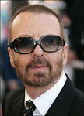

### Charities & foundations supported

* 46664
* Amnesty International
* Fulfillment Fund
* GO Campaign
* Greenpeace
* Hear The World
* Lupus LA
* Nelson Mandela Foundation
* Peace One Day
* Stand Up To Cancer
* White Knot for Equality

### Causes supported

* Adoption,
* Fostering,
* Orphans,
* AIDS & HIV,
* Animals,
* Cancer,
* Children,
* Conservation,
* Education,
* Environment,
* Gay/Lesbian Support,
* Health,
* Human Rights,
* Peace,
* Poverty

**David Archuleta**

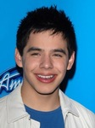

### Charities & foundations supported

* DoSomething.org
* Habitat For Humanity
* Lisa Lopes Foundation
* Muscular Dystrophy Association
* Music for Relief
* Rising Stars Outreach
* Stand Up To Cancer
* We Are The World Foundation

### Causes supported

* Adoption,
* Fostering,
* Orphans,
* Cancer,
* Disaster Relief,
* Education,
* Environment,
* Health,
* Homelessness,
* Philanthropy,
* Physical Challenges

**David Arquette**

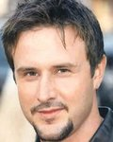

### Charities & foundations supported

* 21st Century Leaders
* Alzheimer's Association
* Cathy's Kids Foundation
* Clothes Off Our Back
* EB Medical Research Foundation
* Feeding America
* Food Bank For New York City
* Hillsides
* Millennium Promise
* Red Cross
* Susan G. Komen for the Cure
* The Art of Elysium
* The Lunchbox Fund
* The Rescue Train
* Whatever It Takes

### Causes supported

* AIDS & HIV,
* Animals,
* At-Risk/Disadvantaged Youths,
* Blood, Marrow & Organ Donation,
* Cancer,
* Children,
* Disaster Relief,
* Health,
* Human Rights,
* Hunger,
* Miscellaneous,
* Poverty,
* Rape/Sexual Abuse

**David Attenborough**



### Charities & foundations supported

* Cool Earth
* Population Matters
* World Land Trust
* WWF

### Causes supported

* Animals,
* Conservation,
* Environment

**David Banner**

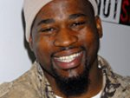

### Charities & foundations supported

* A Place Called Home
* California Disabled Veteran Business Alliance
* Heal the Hood Foundation
* Red Cross
* Stewpot Neighborhood Children's Program

### Causes supported

* AIDS & HIV,
* At-Risk/Disadvantaged Youths,
* Disaster Relief,
* Education,
* Human Rights,
* Veteran/Service Member Support

**David Beckham**

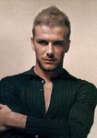

### Charities & foundations supported

* CHOC Children's
* Comic Relief
* FC Harlem
* Help for Heroes
* Malaria No More
* mothers2mothers
* National Society for the Prevention of Cruelty to Children
* Peace One Day
* Prince's Trust
* Raising Malawi
* Red Cross
* Sport Relief
* UNICEF
* Victoria and David Beckham Charitable Trust

### Causes supported

* Abuse,
* Adoption,
* Fostering,
* Orphans,
* AIDS & HIV,
* At-Risk/Disadvantaged Youths,
* Cancer,
* Children,
* Conservation,
* Disaster Relief,
* Education,
* Environment,
* Fair Trade,
* Health,
* Homelessness,
* Human Rights,
* Hunger,
* Literacy,
* Miscellaneous,
* Peace,
* Physical Challenges,
* Poverty,
* Sports,
* Veteran/Service Member Support,
* Women

**David Blaine**



### Charities & foundations supported

* charity:water
* Prince's Trust
* Red Cross
* Robert F Kennedy Memorial
* The Salvation Army

### Causes supported

* Abuse,
* AIDS & HIV,
* At-Risk/Disadvantaged Youths,
* Children,
* Disaster Relief,
* Education,
* Family/Parent Support,
* Grief Support,
* Homelessness,
* Human Rights,
* Poverty,
* Senior Citizen Support,
* Water

**David Bowie**



### Charities & foundations supported

* 21st Century Leaders
* Food Bank For New York City
* Keep A Child Alive
* Mines Advisory Group
* Save the Children
* The Lunchbox Fund
* War Child
* Whatever It Takes
* Witness

### Causes supported

* Abuse,
* AIDS & HIV,
* At-Risk/Disadvantaged Youths,
* Children,
* Disaster Relief,
* Education,
* Family/Parent Support,
* Health,
* Human Rights,
* Hunger,
* Miscellaneous,
* Peace,
* Poverty,
* Weapons Reduction

**David Bryan**



### Charities & foundations supported

* Only Make Believe

### Causes supported

* Children,
* Creative Arts

**David Cameron**

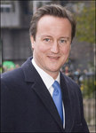

### Charities & foundations supported

* ABF The Soldiers' Charity
* Make-A-Wish Foundation

### Causes supported

* Cancer,
* Children,
* Health,
* Veteran/Service Member Support

# 

# David Carradine

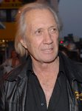

### Charities & foundations supported

* Food 4 Africa

### Causes supported

* Abuse,
* AIDS & HIV,
* Children,
* Hunger,
* Poverty

**David Cassidy**

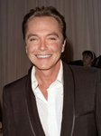

### Charities & foundations supported

* Children in Need
* Neurofibromatosis, Inc.

### Causes supported

* Abuse,
* Children,
* Health,
* Homelessness,
* Mental Challenges,
* Physical Challenges,
* Substance Abuse

**David Cook**

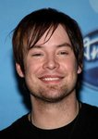

### Charities & foundations supported

* Accelerate Brain Cancer Cure
* David Wright Foundation
* Jonsson Cancer Center Foundation
* Nancy Davis Foundation for Multiple Sclerosis
* Stand Up To Cancer

### Causes supported

* Cancer,
* Children,
* Health

**David Copperfield**

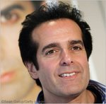

### Charities & foundations supported

* Children's Medical Research Institute
* Jeans for Genes
* Keep Memory Alive
* spcaLA

### Causes supported

* Animals,
* Children,
* Family/Parent Support,
* Health

**David Coulthard**

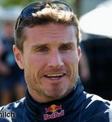

### Charities & foundations supported

* Elton John AIDS Foundation
* Keech Hospice Care
* National Literacy Trust
* National Society for the Prevention of Cruelty to Children
* Wings For Life

### Causes supported

* Abuse,
* AIDS & HIV,
* Children,
* Family/Parent Support,
* Health,
* Literacy,
* Physical Challenges

**David Duchovny**



### Charities & foundations supported

* 600million.org
* Believe in Dreams
* Clothes Off Our Back
* First Book
* Global Green
* Neurofibromatosis, Inc.

### Causes supported

* Animals,
* Children,
* Education,
* Environment,
* Family/Parent Support,
* Health,
* Peace,
* Poverty,
* Water

**David Faustino**



### Charities & foundations supported

* Nancy Davis Foundation for Multiple Sclerosis

### Causes supported

* Health

**David Foster**



### Charities & foundations supported

* Andrea Bocelli Foundation
* Andre Agassi Foundation for Education
* Barbara Davis Center for Childhood Diabetes
* Celebrity Fight Night Foundation
* Cure Duchenne
* David Foster Foundation
* Dream Foundation
* Leeza's Place
* Muhammad Ali Parkinson Center
* Project Clean Water
* Red Cross
* Robert F Kennedy Memorial
* United Service Organization

### Causes supported

* AIDS & HIV,
* At-Risk/Disadvantaged Youths,
* Blood, Marrow & Organ Donation,
* Children,
* Disaster Relief,
* Education,
* Family/Parent Support,
* Health,
* Human Rights,
* Physical Challenges,
* Poverty,
* Veteran/Service Member Support,
* Water

**David Garrett**



### Charities & foundations supported

* Save The Music Foundation

### Causes supported

* Children,
* Creative Arts,
* Education

**David Geffen**

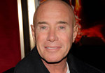

### Charities & foundations supported

* American Foundation for Equal Rights
* Barbara Davis Center for Childhood Diabetes
* David Geffen Foundation

### Causes supported

* Children,
* Creative Arts,
* Gay/Lesbian Support,
* Health

**David Gilmour**

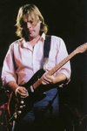

### Charities & foundations supported

* Crisis
* Save the Rhino
* Witness

### Causes supported

* Conservation,
* Homelessness,
* Human Rights

**David Good**

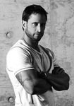

### Charities & foundations supported

* Stand Up To Cancer

### Causes supported

* Cancer

**David Gower**

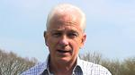

### Charities & foundations supported

* CHICKS
* Children with AIDS
* Leukaemia Busters
* World Land Trust

**Causes supported**

* AIDS & HIV,
* At-Risk/Disadvantaged Youths,
* Cancer,
* Children,
* Conservation,
* Environment,
* Family/Parent Support,
* Health

**David Hasselhoff**

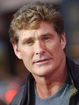

### Charities & foundations supported

* Actors and Others for Animals
* Children's Hospital Los Angeles
* Make-A-Wish Foundation
* United Cerebral Palsy
* Wheels for Humanity

### Causes supported

* Animals,
* Cancer,
* Children,
* Health,
* Physical Challenges

**David Hyde Pierce**



### Charities & foundations supported

* Broadway Cares/Equity Fights AIDS
* The Doe Fund

### Causes supported

* AIDS & HIV,
* Homelessness

**David Ian**

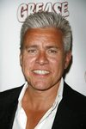

### Charities & foundations supported

* Make-A-Wish Foundation

### Causes supported

* Cancer,
* Children,
* Health

**David Jason**



### Charities & foundations supported

* Cats Protection
* National Literacy Trust

### Causes supported

* Animals,
* Literacy

**David Letterman**

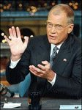

### Charities & foundations supported

* American Foundation for Courtesy and Grooming

### Causes supported

* At-Risk/Disadvantaged Youths,
* Children,
* Education

**David Lynch**

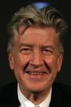

### Charities & foundations supported

* David Lynch Foundation

### Causes supported

* Education,
* Health,
* Miscellaneous

**David Ortiz**

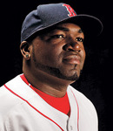

### Charities & foundations supported

* Children's Hospital Los Angeles
* David Ortiz Children's Fund
* Josh Beckett Foundation
* The Mark Wahlberg Youth Foundation

### Causes supported

* At-Risk/Disadvantaged Youths,
* Children,
* Health

**David Prowse**



### Charities & foundations supported

* Make-A-Wish Foundation

### Causes supported

* Cancer,
* Children,
* Health

**David Schwimmer**

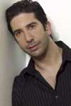

### Charities & foundations supported

* Rape Foundation
* SickKids Foundation

### Causes supported

* Abuse,
* Children,
* Health,
* Mental Challenges,
* Rape/Sexual Abuse

**David Spade**

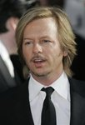

### Charities & foundations supported

* Andre Agassi Foundation for Education
* Children Affected by AIDS Foundation
* DNA Foundation
* Make-A-Wish Foundation
* Stand Up To Cancer
* Variety - The Children's Charity

### Causes supported

* AIDS & HIV,
* At-Risk/Disadvantaged Youths,
* Cancer,
* Children,
* Education,
* Health,
* Human Rights,
* Rape/Sexual Abuse

**David Suzuki**

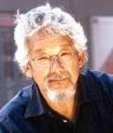

### Charities & foundations supported

* David Suzuki Foundation
* Right Livelihood Award Foundation

### Causes supported

* Conservation,
* Education,
* Environment,
* Human Rights,
* Poverty,
* Weapons Reduction

**David Tennant**



### Charities & foundations supported

* Association for International Cancer Research
* CAFOD
* Comic Relief
* Kidscape
* Willow Foundation

### Causes supported

* Abuse,
* Addiction,
* At-Risk/Disadvantaged Youths,
* Cancer,
* Children,
* Disaster Relief,
* Economic/Business Support,
* Environment,
* Health,
* Homelessness,
* Human Rights,
* Hunger,
* Miscellaneous,
* Poverty,
* Rape/Sexual Abuse

**David Walliams**



### Charities & foundations supported

* CARE
* Comic Relief
* Cystic Fibrosis Foundation
* Cystic Fibrosis Trust
* Dramatic Need
* Not On Our Watch
* Sport Relief
* Wildlife Warriors Worldwide

### Causes supported

* AIDS & HIV,
* Animals,
* At-Risk/Disadvantaged Youths,
* Cancer,
* Children,
* Conservation,
* Creative Arts,
* Disaster Relief,
* Education,
* Environment,
* Fair Trade,
* Health,
* Homelessness,
* Human Rights,
* Hunger,
* Literacy,
* Miscellaneous,
* Poverty,
* Refugees,
* Women

**David Wright**

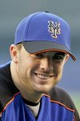

### Charities & foundations supported

* David Wright Foundation

### Causes supported

* Children

**Davina McCall**



### Charities & foundations supported

* Children with AIDS
* Comic Relief
* National Society for the Prevention of Cruelty to Children
* Sport Relief
* Wellbeing of Women

### Causes supported

* Abuse,
* AIDS & HIV,
* Cancer,
* Children,
* Conservation,
* Disaster Relief,
* Education,
* Environment,
* Fair Trade,
* Family/Parent Support,
* Health,
* Homelessness,
* Human Rights,
* Hunger,
* Literacy,
* Miscellaneous,
* Poverty,
* Women

**Dawn Olivieri**



### Charities & foundations supported

* Believe in Dreams
* Greenpeace
* United Global Shift

### Causes supported

* Animals,
* Conservation,
* Environment,
* Family/Parent Support,
* Health,
* Philanthropy

**Dayanara Torres**



### Charities & foundations supported

* Ronald McDonald House Charities

### Causes supported

* Children,
* Family/Parent Support

**D.B. Sweeney**

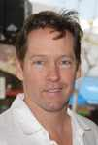

### Charities & foundations supported

* United Service Organization

### Causes supported

* Veteran/Service Member Support

**Dean Cain**

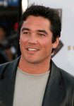

### Charities & foundations supported

* City Harvest
* Feeding America
* Food Bank For New York City
* Sheckler Foundation

### Causes supported

* Cancer,
* Children,
* Hunger

**Dean Koontz**

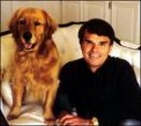

### Charities & foundations supported

* Canine Companions for Independence

### Causes supported

* Animals,
* Health

**Death Cab for Cutie**

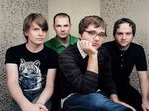

### Charities & foundations supported

* Bridge School
* HeadCount
* PETA
* Planned Parenthood

### Causes supported

* Animals,
* Children,
* Education,
* Human Rights,
* Hunger,
* Miscellaneous,
* Physical Challenges,
* Voter Education,
* Women

**Deborah Gibson**

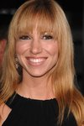

### Charities & foundations supported

* Children International
* Gibson Girl Foundation
* Girl Prep
* Nancy Davis Foundation for Multiple Sclerosis

### Causes supported

* At-Risk/Disadvantaged Youths,
* Children,
* Creative Arts,
* Health,
* Miscellaneous,
* Poverty,
* Women

**Debra Christofferson**



### Charities & foundations supported

* Make-A-Wish Foundation

### Causes supported

* Cancer,
* Children,
* Health

**Debra Messing**

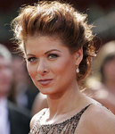

### Charities & foundations supported

* ASPCA
* Autism Speaks
* Clothes Off Our Back
* Feeding America
* The Art of Elysium
* The Trevor Project

### Causes supported

* AIDS & HIV,
* Animals,
* Cancer,
* Children,
* Depression and Suicide,
* Gay/Lesbian Support,
* Health,
* Hunger,
* Mental Challenges,
* Women

**Debra Winger**



### Charities & foundations supported

* Sightsavers International
* Tahirih Justice Center

### Causes supported

* Human Rights,
* Physical Challenges,
* Women

**Deepak Chopra**

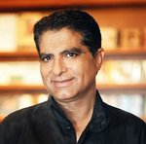

### Charities & foundations supported

* 21st Century Leaders
* American India Foundation
* Born This Way Foundation
* Cinema For Peace
* Global Fund
* Rush Philanthropic Arts Foundation
* Whatever It Takes

### Causes supported

* AIDS & HIV,
* At-Risk/Disadvantaged Youths,
* Children,
* Creative Arts,
* Economic/Business Support,
* Education,
* Gay/Lesbian Support,
* Health,
* Human Rights,
* Miscellaneous,
* Peace,
* Poverty,
* Women

**Deep Purple**

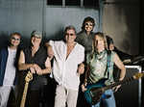

### Charities & foundations supported

* Pro Dono

### Causes supported

* Philanthropy

**Dee Snider**

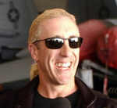

### Charities & foundations supported

* Charity Navigator
* March Of Dimes

### Causes supported

* Children,
* Health,
* Philanthropy

**Def Leppard**

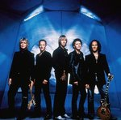

### Charities & foundations supported

* Hands On Nashville
* Precious Paws
* Raven Drum Foundation

### Causes supported

* Animals,
* Philanthropy,
* Veteran/Service Member Support

**Deidre Hall**

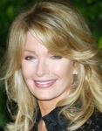

### Charities & foundations supported

* Entertainment Industry Foundation
* Operation Smile
* Revlon Run/Walk For Women

### Causes supported

* Cancer,
* Children,
* Creative Arts,
* Education,
* Health,
* Hunger,
* Poverty,
* Women

**Delia Smith**



### Charities & foundations supported

* Sir Bobby Robson Foundation

### Causes supported

* Cancer

**Delta Burke**



### Charities & foundations supported

* Sandwich Women's Club

### Causes supported

* Miscellaneous,
* Women

**Delta Goodrem**



### Charities & foundations supported

* Olivia Newton-John Cancer & Wellness Centre

### Causes supported

* Cancer

**Demi Lovato**

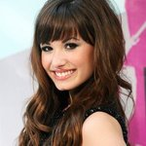

### Charities & foundations supported

* A Day Made Better
* City of Hope
* DonateMyDress.org
* Kids Wish Network
* Love Our Children USA
* Red Cross
* Shoe Revolt
* Stand Up To Cancer
* St. Jude Children's Research Hospital
* STOMP Out Bullying

### Causes supported

* Abuse,
* AIDS & HIV,
* At-Risk/Disadvantaged Youths,
* Cancer,
* Children,
* Disaster Relief,
* Education,
* Family/Parent Support,
* Grief Support,
* Health,
* Human Rights,
* Rape/Sexual Abuse,
* Women

**Denise van Outen**

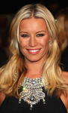

### Charities & foundations supported

* Breast Cancer Care
* Comic Relief

### Causes supported

* Cancer,
* Disaster Relief,
* Homelessness,
* Human Rights,
* Poverty,
* Women

# 

# Denise Richards



### Charities & foundations supported

* Barbara Davis Center for Childhood Diabetes
* Best Friends Animal Society
* Clothes Off Our Back
* Feeding America
* Much Love Animal Rescue
* What A Pair

### Causes supported

* Animals,
* Cancer,
* Children,
* Health,
* Hunger,
* Women

**Denis Leary**



### Charities & foundations supported

* Leary Firefighters Foundation
* LIVESTRONG
* Oxfam
* Red Cross

### Causes supported

* AIDS & HIV,
* Cancer,
* Disaster Relief,
* Emergency services,
* Human Rights,
* Poverty

**Dennis Hopper**

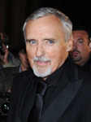

### Charities & foundations supported

* Oceana

### Causes supported

# Animals,

# Conservation,

# Environment,

# Oceans,

# Water

# Dennis Quaid

# Dennis Quaid

### Charities & foundations supported

# Boys & Girls Clubs of America

# Dennis Quaid Charity Weekend

# International Hospital for Children

# Muhammad Ali Parkinson Center

# NCCRA

# Quaid Foundation

### Causes supported

* At-Risk/Disadvantaged Youths,
* Cancer,
* Children,
* Disaster Relief,
* Family/Parent Support,
* Health,
* Miscellaneous,
* Poverty

**Dennis Rodman**

# Dennis Rodman

### Charities & foundations supported

* Boys & Girls Clubs of America
* PETA

### Causes supported

* Animals,
* At-Risk/Disadvantaged Youths,
* Children

**Denzel Washington**

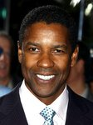

### Charities & foundations supported

* Artists for a New South Africa
* Barbara Davis Center for Childhood Diabetes
* Boys & Girls Clubs of America
* Cedars-Sinai Medical Center
* Elevate Hope Foundation
* Farm Sanctuary
* Fisher House Foundation
* Hillsides
* Keep A Child Alive
* Luke Neuhedel Foundation
* Nelson Mandela Children's Fund
* Project Angel Food
* Save Africa's Children

### Causes supported

* Abuse,
* Adoption,
* Fostering,
* Orphans,
* AIDS & HIV,
* Animals,
* At-Risk/Disadvantaged Youths,
* Cancer,
* Children,
* Creative Arts,
* Disaster Relief,
* Education,
* Family/Parent Support,
* Health,
* Human Rights,
* Physical Challenges,
* Poverty,
* Rape/Sexual Abuse,
* Veteran/Service Member Support

**Depeche Mode**



### Charities & foundations supported

* GRAMMY Foundation
* MusiCares
* Musicians on Call
* Teenage Cancer Trust

### Causes supported

* Cancer,
* Children,
* Creative Arts,
* Health,
* Unemployment/Career Support

**Derek Jacobi**



### Charities & foundations supported

* Children of Peace
* Environmental Investigation Agency
* National Literacy Trust

### Causes supported

* Animals,
* Children,
* Conservation,
* Environment,
* Literacy,
* Peace

**Derek Jeter**

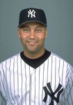

### Charities & foundations supported

* Soles4Souls
* Turn 2 Foundation

### Causes supported

* At-Risk/Disadvantaged Youths,
* Disaster Relief,
* Health,
* Miscellaneous,
* Poverty,
* Refugees,
* Substance Abuse

**Derek Strong**

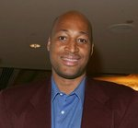

### Charities & foundations supported

* A Call To Men
* BrittiCares International
* Shane's Inspiration

### Causes supported

* Cancer,
* Children,
* Miscellaneous,
* Physical Challenges,
* Women

# 

# Dermot Mulroney

# Dermot Mulroney

### Charities & foundations supported

* Barbara Davis Center for Childhood Diabetes
* Milk+Bookies

### Causes supported

* Children,
* Health,
* Literacy,
* Philanthropy

**Dermot O'Leary**

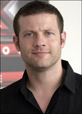

### Charities & foundations supported

* Barnardo's
* CAFOD
* Make Poverty History
* Mary's Meals

### Causes supported

* Abuse,
* Addiction,
* At-Risk/Disadvantaged Youths,
* Children,
* Disaster Relief,
* Economic/Business Support,
* Environment,
* Family/Parent Support,
* Homelessness,
* Human Rights,
* Hunger,
* Mental Challenges,
* Miscellaneous,
* Physical Challenges,
* Poverty

**Derrick Brooks**

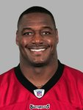

### Charities & foundations supported

* Derrick Brooks Charities

### Causes supported

* Miscellaneous

**Deryck Whibley**

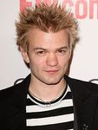

### Charities & foundations supported

* A Place Called Home

### Causes supported

* At-Risk/Disadvantaged Youths

**Desmond Tutu**

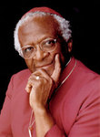

### Charities & foundations supported

* 21st Century Leaders
* Action Against Hunger
* Artists for a New South Africa
* Batonga Foundation
* CBM
* Desmond Tutu Peace Centre
* Elton John AIDS Foundation
* Free The Children
* Free The Slaves
* Girls Not Brides
* Nuclear Age Peace Foundation
* Oxfam
* Pencils of Promise
* The Elders
* Ubuntu Education Fund
* UNICEF
* Whatever It Takes

### Causes supported

* Abuse,
* AIDS & HIV,
* Children,
* Disaster Relief,
* Education,
* Environment,
* Health,
* Human Rights,
* Hunger,
* Literacy,
* Miscellaneous,
* Peace,
* Physical Challenges,
* Poverty,
* Water,
* Weapons Reduction,
* Women

**Detroit Pistons**

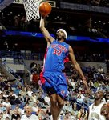

### Charities & foundations supported

* Make-A-Wish Foundation
* Red Cross

### Causes supported

* AIDS & HIV,
* Cancer,
* Children,
* Disaster Relief,
* Health,
* Human Rights

**Devo**

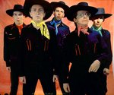

### Charities & foundations supported

* Keep-a-Breast
* Witness

### Causes supported

* Cancer,
* Creative Arts,
* Education,
* Human Rights

**Devon Allman**

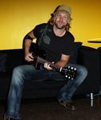

### Charities & foundations supported

* rock CAN roll

### Causes supported

* Hunger

**Dev Patel**



### Charities & foundations supported

* Greenpeace
* Railway Children

### Causes supported

* Animals,
* At-Risk/Disadvantaged Youths,
* Conservation,
* Environment

**Diana Krall**



### Charities & foundations supported

* Amnesty International

### Causes supported

* Human Rights

**Diana Rigg**

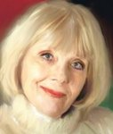

### Charities & foundations supported

* Bliss
* Build Africa
* Children with AIDS
* Variety Club
* World Society for the Protection of Animals

### Causes supported

* AIDS & HIV,
* Animals,
* At-Risk/Disadvantaged Youths
* , Children,
* Family/Parent Support,
* Health,
* Physical Challenges,
* Poverty

**Diana Ross**

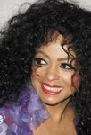

### Charities & foundations supported

* Celebrity Fight Night Foundation
* Muhammad Ali Parkinson Center
* United Service Organization

### Causes supported

* Health,
* Veteran/Service Member Support

**Diane Dimond**

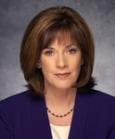

### Charities & foundations supported

* Crime Survivors, Inc.

### Causes supported

* Abuse,
* Miscellaneous,
* Missing Children,
* Rape/Sexual Abuse,
* Women

**Diane Farr**

### Diane Farr

### Charities & foundations supported

* Mineseeker Foundation

### Causes supported

* Hunger,
* Miscellaneous,
* Weapons Reduction

**Diane Keaton**



* NCCRA
* Stand Up To Cancer

### Causes supported

* Cancer,
* Health

Diane Lane



### Charities & foundations supported

* Artists for Peace and Justice
* Beautiful Lengths
* Heifer International
* Oceana
* US Doctors for Africa

### Causes supported

* AIDS & HIV,
* Animals,
* Cancer,
* Children,
* Conservation,
* Disaster Relief,
* Environment,
* Health,
* Hunger,
* Miscellaneous,
* Oceans,
* Poverty,
* Water,
* Women

**Diane Pernet**



### Charities & foundations supported

* Designers Against AIDS

### Causes supported

* AIDS & HIV

**Diane Sawyer**

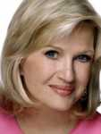

### Charities & foundations supported

* Stand Up To Cancer
* United Nations Foundation

### Causes supported

AIDS & HIV, Cancer, Children, Environment, Health, Human Rights, Peace, Women

**Diane von Furstenberg**



### Charities & foundations supported

* Friends of the High Line
* Vital Voices

### Causes supported

* Abuse,
* Conservation,
* Economic/Business Support,
* Human Rights,
* Rape/Sexual Abuse,
* Women

**Dick King-Smith**

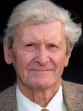

### Causes supported

* Animals,
* Children

**Dick Van Dyke**

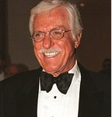

### Charities & foundations supported

* Cell Therapy Foundation
* Midnight Mission
* TJ Martell Foundation

### Causes supported

* AIDS & HIV,
* Cancer,
* Children,
* Health,
* Homelessness

# Didi Conn



### Charities & foundations supported

* Olivia Newton-John Cancer & Wellness Centre

### Causes supported

* Cancer

**Didier Drogba**

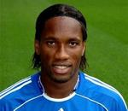

### Charities & foundations supported

* Didier Drogba Foundation
* (RED)
* United Nations Development Programme

### Causes supported

* AIDS & HIV,
* Children,
* Economic/Business Support,
* Education,
* Health,
* Poverty,
* Women

**Dido**

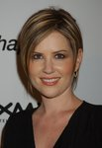

### Charities & foundations supported

* 46664
* Life College
* Live 8
* Treatment Action Campaign
* War Child
* WhyHunger

### Causes supported

* Adoption,
* Fostering,
* Orphans,
* AIDS & HIV,
* Children,
* Disaster Relief,
* Economic/Business Support,
* Education,
* Hunger,
* Peace,
* Poverty

**Diego Luna**

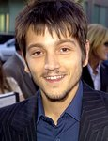

### Charities & foundations supported

* Witness

### Causes supported

* Human Rights

**Diego Maradona**

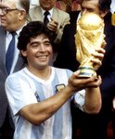

### Charities & foundations supported

* UNICEF

### Causes supported

* Children,
* Health,
* Human Rights,
* Poverty

**Dierks Bentley**

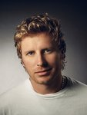

### Charities & foundations supported

* Amnesty International
* Animal Rescue Foundation
* Children's Miracle Network Hospitals
* Fisher House Foundation
* Kasey Kahne Foundation
* Monroe Carell Jr. Children's Hospital at Vanderbilt

### Causes supported

* Animals,
* At-Risk/Disadvantaged Youths,
* Children,
* Health,
* Human Rights,
* Veteran/Service Member Support

**Digit**



### Charities & foundations supported

* Campaign for the Arts
* Lisa Lopes Foundation

### Causes supported

* Adoption,
* Fostering,
* Orphans,
* Children,
* Creative Arts,
* Education

# Dikembe Mutombo

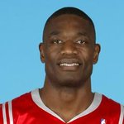

### Charities & foundations supported

* Dikembe Mutombo Foundation
* HOPE Worldwide
* ONE Campaign
* Right To Play

### Causes supported

* Adoption,
* Fostering,
* Orphans,
* AIDS & HIV,
* At-Risk/Disadvantaged Youths,
* Children,
* Disaster Relief,
* Education,
* Health,
* Poverty

**Dina Manzo**

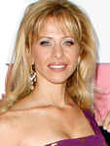

### Charities & foundations supported

* Project Ladybug
* Reality Cares

### Causes supported

* Children,
* Health,
* Miscellaneous

**Dionne Warwick**

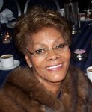

### Charities & foundations supported

* American Foundation for AIDS Research
* Celebrity Fight Night Foundation
* Hear The World
* Muhammad Ali Parkinson Center
* National Black Leadership Commission on AIDS, Inc.
* Starkey Hearing Foundation
* Starlight Children's Foundation
* The Hunger Project

### Causes supported

* AIDS & HIV,
* Cancer,
* Children,
* Health,
* Hunger

# Dita Von Teese



### Charities & foundations supported

* Keep-a-Breast
* PETA
* The Heart Truth

### Causes supported

* Animals,
* Cancer,
* Creative Arts,
* Education,
* Health,
* Women

**Dixie Chicks**



### Charities & foundations supported

* ACT Today!
* Center for Autism and Related Disorders
* Conservation International

### Causes supported

* Animals,
* Conservation,
* Environment,
* Mental Challenges,
* Physical Challenges

# Dizzee Rascal

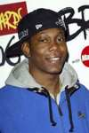

### Charities & foundations supported

* Children in Need
* Great Ormond Street Hospital
* War Child

### Causes supported

* Abuse,
* Children,
* Disaster Relief,
* Health,
* Homelessness,
* Mental Challenges,
* Peace,
* Physical Challenges,
* Substance Abuse

# Djimon Hounsou

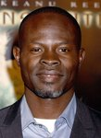

### Charities & foundations supported

* Global Fund
* Oxfam
* Racing for Kids
* Raising Malawi
* SOS Children's Villages
* UNICEF

### Causes supported

* Adoption,
* Fostering,
* Orphans,
* AIDS & HIV,
* Children,
* Disaster Relief,
* Health,
* Homelessness,
* Human Rights,
* Poverty

**Dolly Parton**



### Charities & foundations supported

* Barbara Davis Center for Childhood Diabetes
* Boot Campaign
* Cancer Research UK
* Dogs Deserve Better
* Imagination Library
* Operation Once in a Lifetime

### Causes supported

* Animals,
* Cancer,
* Children,
* Family/Parent Support,
* Health,
* Literacy,
* Veteran/Service Member Support

**Dom DeLuise**

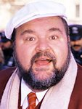

### Charities & foundations supported

* Neurofibromatosis, Inc.
* Pearl S. Buck Foundation
* Rising Stars Outreach

### Causes supported

* Adoption,
* Fostering,
* Orphans,
* AIDS & HIV,
* Children,
* Education,
* Family/Parent Support,
* Health,
* Physical Challenges,
* Poverty

**Dominic Monaghan**

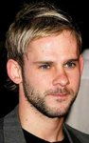

### Charities & foundations supported

* Epilepsy Action
* Neurofibromatosis Association
* Project Last Stand

### Causes supported

* Conservation,
* Environment,
* Health

**Dominic Scott Kay**



### Charities & foundations supported

* Mattel Children's Hospital
* Starlight Children's Foundation

### Causes supported

* AIDS & HIV,
* Cancer,
* Children,
* Health

# Donald Faison

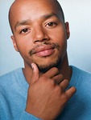

### Charities & foundations supported

* Los Angeles Mission
* MoveOn
* Soles4Souls
* Somaly Mam Foundation

### Causes supported

* Disaster Relief,
* Homelessness,
* Poverty,
* Rape/Sexual Abuse,
* Refugees,
* Voter Education,
* Women

**Donald Glover**

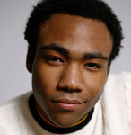

### Charities & foundations supported

* Community Connections

### Causes supported

* Adoption,
* Fostering,
* Orphans

**Donald Trump**

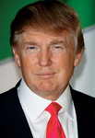

### Charities & foundations supported

* Celebrity Fight Night Foundation
* Children with AIDS
* David Foster Foundation
* DoSomething.org
* Friends of Scotland
* Jimmy Fund
* Make A Child Smile Appeal
* Make-A-Wish Foundation
* Mississippi Animal Rescue League
* Muhammad Ali Parkinson Center
* Neurofibromatosis, Inc.
* Operation Smile
* Paralyzed Veterans of America
* Pediatric Epilepsy Project
* Raising Malawi
* Reef Relief
* Smile Train
* St. Francis Food Pantries and Shelters
* The Doe Fund
* UNICEF
* Wounded Warrior Project

### Causes supported

* Adoption,
* Fostering,
* Orphans,
* AIDS & HIV,
* Animals,
* Cancer,
* Children,
* Conservation,
* Environment,
* Family/Parent Support,
* Health,
* Homelessness,
* Human Rights,
* Hunger,
* Miscellaneous,
* Oceans,
* Philanthropy,
* Physical Challenges,
* Poverty,
* Veteran/Service Member Support

**Donal Logue**



### Charities & foundations supported

* Los Angeles Mission
* Peace First

### Causes supported

* Children,
* Homelessness,
* Peace

**Donatella Versac**

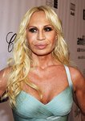

### Charities & foundations supported

* One Foundation

### Causes supported

* Disaster Relief

**Don Cheadle**

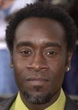

### Charities & foundations supported

* Aid Still Required
* Ante Up For Africa
* ENOUGH Project
* H.O.M.E.
* International Rescue Committee
* Jewish World Watch
* Not On Our Watch
* Satellite Sentinel Project
* Soles4Souls
* UNICEF
* United Nations Environment Programme
* US Doctors for Africa
* Vine Group
* World Food Programme

### Causes supported

* AIDS & HIV,
* Children,
* Disaster Relief,
* Education,
* Environment,
* Health,
* Human Rights,
* Hunger,
* Mental Challenges,
* Peace,
* Physical Challenges,
* Poverty,
* Rape/Sexual Abuse,
* Refugees,
* Women

**Don Felder**

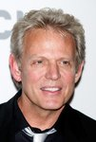

### Charities & foundations supported

* National Center for Missing and Exploited Children

### Causes supported

* Children,
* Family/Parent Support,
* Missing Children,
* Rape/Sexual Abuse

**Don Henley**



### Charities & foundations supported

* Caddo Lake Institute
* Walden Woods Project

### Causes supported

Conservation, Environment

**Don Most**

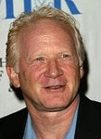

### Charities & foundations supported

* City of Hope
* The Hollywood Cookbook

### Causes supported

* AIDS & HIV,
* At-Risk/Disadvantaged Youths,
* Cancer,
* Children,
* Disaster Relief,
* Health,
* Homelessness,
* Women

**Donna Karan**

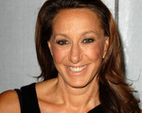

### Charities & foundations supported

* Clinton Foundation
* Robert F Kennedy Memorial
* The Heart Truth
* Urban Zen Foundation
* Walkabout Foundation

### Causes supported

* Children,
* Conservation,
* Economic/Business Support,
* Education,
* Environment,
* Health,
* Human Rights,
* Peace,
* Physical Challenges,
* Poverty, Women

**Donnie Wahlberg**

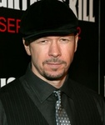

### Charities & foundations supported

* Entertainment Industry Foundation

### Causes supported

* Cancer,
* Children,
* Creative Arts,
* Education,
* Health,
* Hunger,
* Poverty

# Donny Osmond

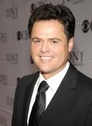

### Charities & foundations supported

* Andre Agassi Foundation for Education
* Children's Miracle Network Hospitals
* Gibson Girl Foundation
* MedicAlert Foundation
* Racing for Kids
* STOMP Out Bullying

### Causes supported

* Abuse,
* At-Risk/Disadvantaged Youths,
* Children,
* Creative Arts,
* Education,
* Family/Parent Support,
* Health

**Don Rickles**

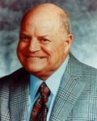

### Charities & foundations supported

* Barbara Davis Center for Childhood Diabetes
* Pediatric Epilepsy Project
* The Saban Free Clinic

### Causes supported

* Children,
* Health

**Doobie Brothers**

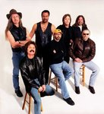

### Charities & foundations supported

* City of Hope

### Causes supported

* AIDS & HIV,
* Cancer

**Doris Day**



### Charities & foundations supported

* Hollywood Arts Council
* The Humane Society

### Causes supported

Animals, Creative Arts

**Dot Marie Jones**

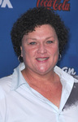

### Charities & foundations supported

* AIDS Project Los Angeles
* Young Storytellers Foundation

### Causes supported

* AIDS & HIV,
* Education,
* Health,
* Literacy

# Douglas Brinkley



### Charities & foundations supported

* Music For Tomorrow

### Causes supported

* Creative Arts

**Doug Pitt**

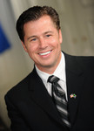

### Charities & foundations supported

* Care to Learn
* Jolie-Pitt Foundation
* WorldServe International

### Causes supported

* Adoption,
* Fostering,
* Orphans,
* AIDS & HIV,
* At-Risk/Disadvantaged Youths,
* Children,
* Education,
* Health,
* Poverty,
* Water

**Dougray Scott**

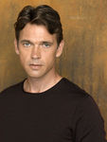

### Charities & foundations supported

* Red Cross

### Causes supported

* AIDS & HIV,
* Disaster Relief,
* Human Rights

**Doutzen Kroes**

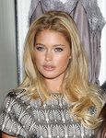

### Causes supported

* AIDS & HIV

**Drake**

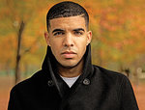

### Charities & foundations supported

* DNA Foundation

### Causes supported

* Children,
* Human Rights,
* Rape/Sexual Abuse

**Dr. Bill Dorfman**

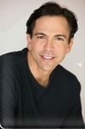

### Charities & foundations supported

* Smiles for Life

### Causes supported

* At-Risk/Disadvantaged Youths,
* Children,
* Health

**Drew Barrymore**



### Charities & foundations supported

* ASPCA
* Declare Yourself
* Much Love Animal Rescue
* Raising Malawi
* Red Cross
* Shop For Charity
* The Rescue Train
* UNICEF
* World Food Programme

### Causes supported

* Adoption,
* Fostering,
* Orphans,
* AIDS & HIV,
* Animals,
* Children,
* Disaster Relief,
* Health,
* Human Rights,
* Hunger,
* Miscellaneous,
* Poverty,
* Voter Education

**Drew Carey**

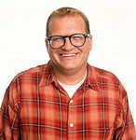

### Charities & foundations supported

* Children Affected by AIDS Foundation
* Children International
* Larry King Cardiac Foundation
* Save the Children

### Causes supported

* Abuse,
* AIDS & HIV,
* Children,
* Disaster Relief,
* Education,
* Health,
* Poverty

# Dr. Mehmet Oz

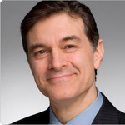

### Charities & foundations supported

* HealthCorps

### Causes supported

* Health

**Dr. Phil McGraw**

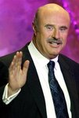

### Charities & foundations supported

* Children's Miracle Network Hospitals
* Dr. Phil Foundation
* MaleSurvior
* Nancy Davis Foundation for Multiple Sclerosis
* New York Coalition For Healthy School Food
* Red Cross
* T.Y.M.E. Ministries
* Wellness In The Schools

### Causes supported

* Adoption,
* Fostering,
* Orphans,
* AIDS & HIV,
* At-Risk/Disadvantaged Youths,
* Children,
* Disaster Relief,
* Education,
* Family/Parent Support,
* Health,
* Human Rights,
* Mental Challenges,
* Physical Challenges,
* Rape/Sexual Abuse

**Duane Martin**

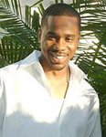

### Charities & foundations supported

* Will and Jada Smith Family Foundation

### Causes supported

* At-Risk/Disadvantaged Youths,
* Children,
* Family/Parent Support

**Duchess of Cornwall**

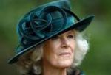

### Charities & foundations supported

* Brooke
* Dispensaire Français
* JDRF
* JDRF UK
* National Osteoporosis Society
* Prince's Trust
* ShelterBox
* Wiltshire Bobby Van

### Causes supported

* Animals,
* At-Risk/Disadvantaged Youths,
* Children,
* Disaster Relief,
* Education,
* Health,
* Miscellaneous,
* Senior Citizen Support,
* Veteran/Service Member Support,
* Women

**Duncan Bannatyne**

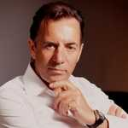

### Charities & foundations supported

* Comic Relief
* Mary's Meals

### Causes supported

* Disaster Relief,
* Homelessness,
* Human Rights,
* Hunger,
* Poverty

# Duran Duran

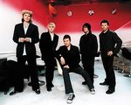

### Charities & foundations supported

* Children with AIDS
* EB Medical Research Foundation

### Causes supported

* AIDS & HIV,
* Children,
* Family/Parent Support,
* Health

# Dustin Hoffman



### Charities & foundations supported

* Achievable Foundation
* Cinema For Peace
* MusiCares

### Causes supported

* AIDS & HIV,
* Cancer,
* Children,
* Creative Arts,
* Health,
* Mental Challenges,
* Peace,
* Unemployment/Career Support

# Dustin Lance Black



### Causes supported

* Gay/Lesbian Support

**Dwain Chambers**

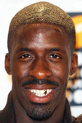

### Charities & foundations supported

* London Coaching Foundation

### Causes supported

* Sports

**Dwayne Johnson**

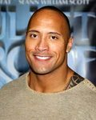

### Charities & foundations supported

* Beacon Experience
* Boot Campaign
* Dwayne Johnson Rock Foundation
* I Have a Dream Foundation
* Kids Wish Network
* Make-A-Wish Foundation
* Make The Difference Network
* Parkinson Society Maritime Region
* Red Cross
* Rush Philanthropic Arts Foundation
* Starlight Children's Foundation
* Until There's a Cure

### Causes supported

* AIDS & HIV,
* At-Risk/Disadvantaged Youths,
* Cancer,
* Children,
* Creative Arts,
* Disaster Relief,
* Education,
* Grief Support,
* Health,
* Human Rights,
* Miscellaneous,
* Veteran/Service Member Support

**Dwight Howard**

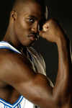

### Charities & foundations supported

* Blessings in a Backpack
* Get Schooled Foundation
* UNICEF

### Causes supported

* At-Risk/Disadvantaged Youths
* , Children,
* Education,
* Health,
* Human
* Rights,
* Hunger,
* Poverty

# Dylan Riley Snyder



### Charities & foundations supported

* A Place Called Home
* The Thirst Project

### Causes supported

* At-Risk/Disadvantaged Youths,
* Water

**Dynamo**

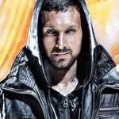

### Charities & foundations supported

* BeatBullying
* Comic Relief
* Prince's Trust
* Sport Relief
* Teenage Cancer Trust

### Causes supported

* AIDS & HIV,
* At-Risk/Disadvantaged Youths,
* Cancer,
* Children,
* Conservation,
* Disaster Relief,
* Education,
* Environment,
* Fair Trade
* , Health,
* Homelessness,
* Human Rights,
* Hunger,
* Literacy,
* Miscellaneous,
* Poverty