**LaDainian Tomlinson**



Charities & foundations supported

* AmberWatch Foundation
* Celebrity Fight Night Foundation
* LIVESTRONG
* Operation Kids
* Tomlinson’s Touching Lives Foundation

Causes supported

* At-Risk/Disadvantaged Youths
* , Cancer,
* Children,
* Education,
* Health,
* Missing Children,
* Poverty,
* Sports

# Lady Antebellum

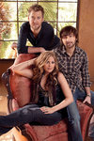

Charities & foundations supported

* Aid Still Required
* American Cancer Society
* City of Hope
* Fisher House Foundation
* Musicians on Call
* Red Cross
* Stand Up To Cancer

Causes supported

* AIDS & HIV,
* Cancer,
* Disaster Relief,
* Health,
* Human Rights,
* Veteran/Service Member Support

# Lady Gaga

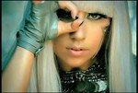

Charities & foundations supported

* Alzheimer's Association
* Artists for Peace and Justice
* Born This Way Foundation
* CLIC Sargent
* It Gets Better Project
* Lupus Foundation of America
* M·A·C AIDS Fund
* Oxfam
* Stand Up To Cancer

Causes supported

* AIDS & HIV
* Cancer,
* Children,
* Disaster Relief, Family/Parent Support,
* Gay/Lesbian Support,
* Grief Support,
* Health, Human Rights,
* Miscellaneous, Poverty

# Laila Ali



Charities & foundations supported

* American Diabetes Association
* A Place Called Home
* Diamond in the RAW Foundation
* Feeding America
* Leeza's Place
* Milagro Foundation
* National Stroke Association
* Olivia Newton-John Cancer & Wellness Centre
* ONE Campaign
* P.A.D.
* Spirit of Women Health Network
* Women's Sports Foundation

Causes supported

* AIDS & HIV,
* At-Risk/Disadvantaged Youths
* , Cancer, Children,
* Creative Arts, Health,
* Hunger, Literacy,
* Poverty, Sports,
* Women

# Laird Hamilton



### Causes supported

* Environment,
* Health

# Lamar Odom

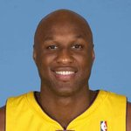’

Charities & foundations supported

* Cathy's Kids Foundation
* DKMS
* Nancy Davis Foundation for Multiple Sclerosis
* Soles4Souls

Causes supported

* At-Risk/Disadvantaged Youths
* , Blood, Marrow & Organ Donation,
* Cancer, Disaster Relief,
* Health, Poverty,
* Refugees

# Lance Armstrong

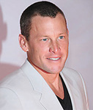

Charities & foundations supported

* Athletes For Hope
* Augie's Quest
* Jeff Gordon Children's Foundation
* Leukaemia and Lymphoma Research
* LIVESTRONG
* Pablove Foundation
* Padres Contra el Cancer
* Stand Up To Cancer
* STILLERSTRONG
* Tony Hawk Foundation
* US Doctors for Africa

Causes supported

* AIDS & HIV, At-Risk/Disadvantaged Youths,
* Cancer, Children,
* Creative Arts, Education,
* Family/Parent Support,
* Grief Support, Health,
* Miscellaneous, Poverty,
* Sports

# Lance Bass

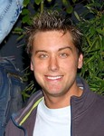

Charities & foundations supported

* Animal Avengers
* Brett Favre Fourward Foundation
* International Medical Corps
* Leeza's Place
* Love Our Children USA
* Soles4Souls
* STOMP Out Bullying
* The Thirst Project
* The Trevor Project

Causes supported

* Abuse, Animals,
* At-Risk/Disadvantaged Youths,
* Children, Depression and Suicide
* , Disaster Relief,
* Family/Parent Support,
* Gay/Lesbian Support,
* Health, Hunger, Mental Challenges
* , Miscellaneous,
* Physical Challenge
* s, Poverty, Refugees,
* Water

# Landon Donovan

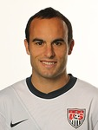

Charities & foundations supported

* Kids Wish Network
* Make-A-Wish Foundation

Causes supported

* Cancer
* , Children
* , Grief Support,
* Health

# Lang Lang

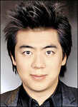

Charities & foundations supported

* UNICEF
* WildAid

Causes supported

* Animals,
* Children,
* Conservation,
* Environment
* , Health, Human Rights,
* Poverty

# Larry Davi



Charities & foundations supported

* Make-A-Wish Foundation
* Nevada Cancer Institute

Causes supported

* Cancer,
* Children,
* Health,
* Voter Education

# Larry Fitzgerald

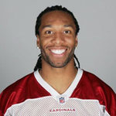

Charities & foundations supported

* Oxfam
* USAID

Causes supported

* Disaster Relief
* , Economic/Business Support,
* Education, Health,
* Human Rights, Hunger,
* Poverty, Rape/Sexual Abuse,
* Women

# Larry Hagman

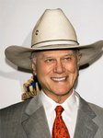

Charities & foundations supported

* American Cancer Society
* Cedars-Sinai Medical Center
* National Kidney Foundation
* Solar Electric Light Fund

Causes supported

* Blood, Marrow & Organ Donation,
* Cancer,
* Conservation, Education,
* Environment,
* Health, Hunger,
* Poverty, Water,
* Women

# Larry King



Charities & foundations supported

* Children's Miracle Network Hospitals
* HELP USA
* Hollywood Arts Council
* Larry King Cardiac Foundation
* Muhammad Ali Parkinson Center
* Pediatric Epilepsy Project
* Red Cross
* Robert F Kennedy Memorial
* Screen Actors Guild Foundation

Causes supported

* AIDS & HIV,
* Children,
* Creative Arts,
* Disaster Relief,
* Education, Health,
* Homelessness,
* Human Rights

# Larry Lamb

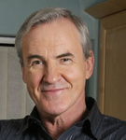

Charities & foundations supported

* YouthNet
* Causes supported
* At-Risk/Disadvantaged Youths, Children

# Lars Ulric

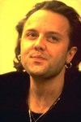

Charities & foundations supported

* Apollo Alliance
* Live Earth
* MusiCares
* Rainforest Action Network
* Sierra Club
* WWF

Causes supported

* Animals,
* Creative Arts,
* Economic/Business Support,
* Environment,
* Unemployment/Career Support

# LaTanya Richardson



Charities & foundations supported

* Artists for a New South Africa
* Champions for Children

Causes supported

* Abuse,
* AIDS & HIV,
* Children

# La Toya Jackson



Charities & foundations supported

* AIDS Project Los Angeles

Causes supported

* AIDS & HIV,
* Health

# Laura Bush

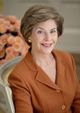

Charities & foundations supported

* Covenant House
* Jumpstart
* Susan G. Komen for the Cure
* The Heart Truth
* World Vision

Causes supported

* Adoption,
* Fostering, Orphans,
* AIDS & HIV, At-Risk/Disadvantaged Youths,
* Cancer, Children,
* Education, Health,
* Homelessness, Literacy,
* Poverty,
* Women

# Laura Hillenbrand



Charities & foundations supported

* Operation International Children

Causes supported

* Children
* , Disaster Relief
* , Education

# Laura Linney



Charities & foundations supported

* American Foundation for AIDS Research
* Clothes Off Our Back
* Dress for Success

Causes supported

* AIDS & HIV,
* Children,
* Health,
* Women

# Laura Vandervoort



Charities & foundations supported

* PETA

Causes supported

* Animals

# Lauren Bush



Charities & foundations supported

* The FEED Foundation
* World Food Programme

Causes supported

* Children,
* Hunger,
* Poverty

# Laurence Fishburne

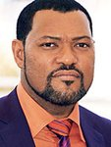

Charities & foundations supported

* 21st Century Leaders
* Artists for a New South Africa
* UNICEF
* Whatever It Takes

Causes supported

* AIDS & HIV,
* Children, Health
* , Human Rights,
* Miscellaneous,
* Poverty

# Laurence Llewelyn-Bowen



Charities & foundations supported

* Barnardo's
* CARE
* ChildLine
* CLIC Sargent
* Great Ormond Street Hospital
* Mencap
* MS Trust
* Multiple Sclerosis Society
* National Literacy Trust
* National Society for the Prevention of Cruelty to Children
* Prince's Trust
* Save the Children
* Scope
* Shooting Star Children's Hospice

Causes supported

* Abuse,
* AIDS & HIV,
* At-Risk/Disadvantaged Youths,
* Cancer, Children,
* Depression and Suicide,
* Disaster Relief, Education,
* Environment, Family/Parent Support,
* Grief Support, Health
* , Homelessness, Literacy,
* Mental Challenges,
* Physical Challenges, Poverty,
* Unemployment/Career Support,
* Women

# Lauren Conrad

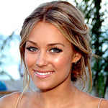

Charities & foundations supported

* Aid Still Required
* Avon Foundation
* Clothes Off Our Back
* Feeding America
* Keep America Beautiful
* Soles4Souls
* The Art of Elysium

Causes supported

* Abuse,
* AIDS & HIV,
* Cancer,
* Children,
* Conservation, Disaster Relief,
* Education,
* Environment, Health,
* Hunger, Poverty,
* Refugees, Water,
* Women

# Lauren Graham

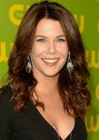

Charities & foundations supported

* Broadway Cares/Equity Fights AIDS
* Fresh Air Fund

Causes supported

* AIDS & HIV,
* At-Risk/Disadvantaged Youths,
* Children

# Lauren Laverne



Charities & foundations supported

* Mind
* Save the Children

Causes supported

* Abuse, AIDS & HIV,
* Children,
* Disaster Relief
* , Education, Mental Challenges,
* Poverty

# Lauren LoGiudice



Charities & foundations supported

* United Cerebral Palsy

Causes supported

* Health

# Lea Michele

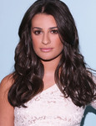

Charities & foundations supported

* PETA
* Shoe Revolt

Causes supported

* Abuse,
* Animals,
* Rape/Sexual Abuse,
* Women

# LeAnn Rimes



Charities & foundations supported

* A Star For The Night
* Children's Miracle Network Hospitals
* Leeza's Place
* Mary Kay Ash Charitable Foundation
* Monroe Carell Jr. Children's Hospital at Vanderbilt
* National Psoriasis Foundation
* Operation Once in a Lifetime
* Stand Up To Cancer

Causes supported

* Abuse, Cancer,
* Children, Family/Parent Support,
* Health, Veteran/Service Member Support,
* Women

# LeBron James

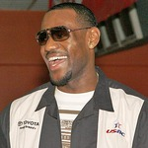

Charities & foundations supported

* Boys & Girls Clubs of America
* Children's Defense Fund
* ONEXONE

Causes supported

* At-Risk/Disadvantaged Youths, Children,
* Family/Parent Support,
* Human Rights, Hunger,
* Mental Challenges,
* Physical Challenges

# Led Zeppelin

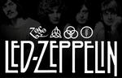

Charities & foundations supported

* City of Hope
* Mount Sinai Hospital
* Racehorse Sanctuary

Causes supported

* AIDS & HIV,
* Animals, Cancer,
* Health

# Lee Ann Womack



Charities & foundations supported

* CARE
* Kids Wish Network

Causes supported

* AIDS & HIV, Children,
* Disaster Relief,
* Education,
* Environment,
* Grief Support, Health,
* Poverty,
* Women

# Lee Evans



Charities & foundations supported

* Great Ormond Street Hospital
* Save the Children

Causes supported

* Abuse,
* AIDS & HIV,
* Children, Disaster Relief,
* Education,
* Health,
* Poverty

# Lee Loughnane

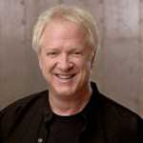

Charities & foundations supported

* American Cancer Society
* Ara Parseghian Medical Research Foundation
* Hannah and Friends
* WhyHunger

Causes supported

* Cancer,
* Children,
* Economic/Business Support,
* Health,
* Hunger, Mental Challenges,
* Physical Challenges,
* Poverty

# Lee Meriwether

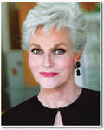

Charities & foundations supported

* AbilityFirst

Causes supported

* Mental Challenges,
* Physical Challenges

# Leeza Gibbons



Charities & foundations supported

* ACT Today!
* American Association of Retired Persons
* Center for Autism and Related Disorders
* Children's Miracle Network Hospitals
* Food 4 Africa
* Keep Memory Alive
* Larry King Cardiac Foundation
* Leeza's Place
* Los Angeles Mission
* Make The Difference Network
* Nancy Davis Foundation for Multiple Sclerosis
* Olivia Newton-John Cancer & Wellness Centre
* Red Cross

Causes supported

* Abuse,
* AIDS & HIV,
* Cancer, Children,
* Disaster Relief, Health,
* Homelessness, Human Rights
* , Hunger,
* Mental Challenges,
* Miscellaneous,
* Physical Challenges,
* Poverty

# Leighton Meester



Charities & foundations supported

* ONE Campaign

Causes supported

* AIDS & HIV,
* Poverty

# Lemar

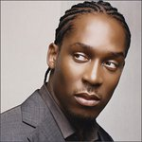

Charities & foundations supported

* Prince's Trust
* SADS UK

Causes supported

* At-Risk/Disadvantaged Youths,
* Children,
* Education,
* Health

# Lennox Lewis

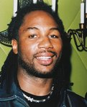

Charities & foundations supported

* DoSomething.org
* Jackson Memorial Foundation
* Muhammad Ali Center
* Muhammad Ali Parkinson Center

Causes supported

* AIDS & HIV,
* Cancer,
* Children,
* Health, Human Rights,
* Hunger,
* Philanthropy

# Lenny Henry



Charities & foundations supported

* Comic Relief

Causes supported

* Disaster Relief,
* Homelessness,
* Human Rights,
* Poverty

# Lenny Kravitz

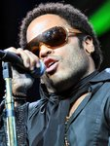

Charities & foundations supported

* Amnesty International
* Artists Against Racism
* Elevate Hope Foundation
* Live Earth
* Rock the Vote
* WhyHunger
* Zero Hunger

Causes supported

* Abuse,
* Cancer, Children,
* Creative Arts,
* Economic/Business Support,
* Environment, Human Rights,
* Hunger, Miscellaneous,
* Poverty, Voter Education,
* Women

# Leo Messi

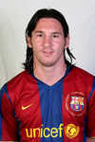

Charities & foundations supported

* UNICEF

Causes supported

* Children,
* Health,
* Human Rights,
* Poverty

# Leona Lewis



Charities & foundations supported

* Comic Relief
* Great Ormond Street Hospital
* Humane Society International
* Rays of Sunshine
* SADS UK
* Shriners Hospitals for Children
* Sport Relief
* Stand Up To Cancer
* Teenage Cancer Trust
* United Service Organization
* Wellbeing of Women
* World Society for the Protection of Animals
* WWF

Causes supported

* AIDS & HIV,
* Animals,
* Cancer, Children,
* Conservation, Disaster Relief,
* Education, Environment,
* Fair Trade, Health, Homelessness,
* Human Rights, Hunger,
* Literacy, Miscellaneous,
* Poverty,
* Veteran/Service Member Support,
* Women

# Leonard Cohen

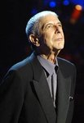

Charities & foundations supported

* Red Cross

Causes supported

* AIDS & HIV,
* Disaster Relief,
* Human Rights

# Leonard Nimoy



Charities & foundations supported

* American Cancer Society
* Nimoy Foundation

Causes supported

* Cancer,
* Health,
* Miscellaneous

# Leonardo DiCaprio

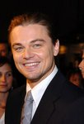

Charities & foundations supported

* Cinema For Peace
* Declare Yourself
* Feeding America
* Film Foundation
* Global Cool
* Global Green
* International Fund For Animal Welfare
* Leonardo DiCaprio Foundation
* Natural Resources Defense Council
* Pediatric Epilepsy Project
* Reef Check Foundation
* SOS Children's Villages
* Stop Global Warming
* The Gorilla Organization
* TreePeople
* Unite for Japan
* WildAid

Causes supported

* Adoption,
* Fostering, Orphans,
* AIDS & HIV,
* Animals, Children,
* Conservation,
* Creative Arts, Disaster Relief,
* Environment,
* Health, Homelessness,
* Human Rights, Hunger,
* Oceans, Peace, Poverty,
* Voter Education,
* Water

# Leo Sayer



Charities & foundations supported

* Amnesty International
* Anti-Slavery International
* UNICEF

Causes supported

* Children,
* Health,
* Human Rights,
* Poverty

# Lesley Garrett



Charities & foundations supported

* National Society for the Prevention of Cruelty to Children

Causes supported

* Abuse,
* Children

# Leslie David Baker

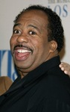

Charities & foundations supported

* Red Cross

Causes supported

* AIDS & HIV,
* Disaster Relief,
* Human Rights

# Leslie Osborne



Charities & foundations supported

* Boys & Girls Clubs of America

Causes supported

* At-Risk/Disadvantaged Youths
* , Children

# Levon Helm

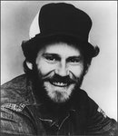

Charities & foundations supported

* Michael J. Fox Foundation

Causes supported

* Health

# Lewis Black



Charities & foundations supported

* rock CAN roll

Causes supported

* Hunger

# Lewis Hamilton

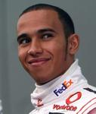

Charities & foundations supported

* Education Africa
* Great Ormond Street Hospital
* Honeypot

Causes supported

* At-Risk/Disadvantaged Youths,
* Children,
* Education,
* Health

# Liam Gallagher

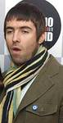

Charities & foundations supported

* Street Child Africa
* Teenage Cancer Trust

Causes supported

* Cancer,
* Children,
* Health,
* Poverty

# Liam Neeson



Charities & foundations supported

* 21st Century Leaders
* Bicycle For A Day
* Clothes Off Our Back
* Great Ormond Street Hospital
* Helen & Douglas House
* Ireland Funds
* Make Poverty History
* Medicinema
* ONE Campaign
* PeacePlayers International
* UNICEF
* Whatever It Takes

Causes supported

* AIDS & HIV, Children,
* Creative Arts,
* Education,
* Environment,
* Family/Parent Support,
* Health, Human Rights,
* Miscellaneous, Peace,
* Poverty

# Liberty DeVitto

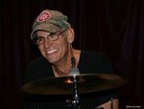

Charities & foundations supported

* Little Kids Rock

Causes supported

* At-Risk/Disadvantaged Youths,
* Children,
* Creative Arts

# Lil' Kim



Charities & foundations supported

* Lil' Kim Cares Foundation
* Lisa Lopes Foundation
* MusiCares
* Table to Table

Causes supported

* Abuse, Adoption,
* Fostering, Orphans,
* AIDS & HIV, Children,
* Creative Arts,
* Homelessness,
* Hunger,
* Unemployment/Career Support,
* Women

# Lil Wayne

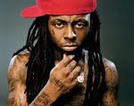

Charities & foundations supported

* Make It Right

Causes supported

* Disaster Relief,
* Homelessness

# Lily Allen



Charities & foundations supported

* Breast Cancer Campaign
* Food Bank For New York City
* Mines Advisory Group
* The Lunchbox Fund

Causes supported

* At-Risk/Disadvantaged Youths,
* Cancer, Hunger,
* Poverty,
* Weapons Reduction,
* Women

# Lily Cole



Charities & foundations supported

* American Foundation for AIDS Research
* Cancer Research UK
* Comic Relief
* Education Africa
* Environmental Investigation Agency
* Environmental Justice Foundation
* Greenpeace
* Hoping Foundation
* WaterAid
* World Land Trust

Causes supported

* AIDS & HIV,
* Animals, Cancer,
* Children, Conservation,
* Disaster Relief,
* Education, Environment,
* Health, Homelessness,
* Human Rights,
* Poverty,
* Refugees,
* Water

# Lily Tomlin



Charities & foundations supported

* PAWS/LA
* Save the Chimps
* Smile Train

Causes supported

* AIDS & HIV,
* Animals,
* Children,
* Grief Support,
* Health,
* Miscellaneous,
* Senior Citizen Support

# Linda Blair



Charities & foundations supported

* Dogs In Danger
* Linda Blair WorldHeart Foundation
* Reality Cares

Causes supported

* Animals,
* Miscellaneous

# Linda Dano



Charities & foundations supported

* Alzheimer's Association
* Rosie's Broadway Kids

Causes supported

* Children,
* Education,
* Health

# Linda Evangelist



Charities & foundations supported

* Aids Life

Causes supported

* AIDS & HIV

# Lindsay Loha



Charities & foundations supported

* Angelwear
* BID 2 BEAT AIDS
* DoSomething.org
* Hear The World
* ONE Campaign
* Red Cross
* Save the Children
* TRAID

Causes supported

* Abuse, Adoption,
* Fostering,Orphans,
* AIDS & HIV, Cancer,
* Child ,Creative Arts, Disaster Relief,
* Education,
* Environment, Health,
* Homelessness, Human Rights,
* Literacy, Mental Challenges, Philanthropy, Physical Challenges, Poverty

# Linford Christie

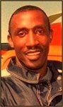

Charities & foundations supported

* Starlight Children's Foundation

Causes supported

* AIDS & HIV,
* Cancer,
* Children,
* Health

Linkin Park

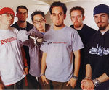

Charities & foundations supported

* ACT Today!
* American Forests
* City of Hope
* Friends and Helpers Foundation
* Green Music Group
* Habitat For Humanity
* LIFEbeat
* Live Earth
* Los Angeles Youth Network
* Make-A-Wish Foundation
* MusiCares
* Music for Relief
* Surfrider Foundation
* The HollyRod Foundation
* Unite The United

Causes supported

* Abuse,
* AIDS & HIV,
* At-Risk/Disadvantaged Youths,
* Cancer, Children, Conservation,
* Creative Arts,
* Disaster Relief, Environment,
* Family/Parent Support, Health,
* Homelessness, Mental Challenges,
* Oceans, Physical Challenges,
* Substance Abuse,
* Unemployment/Career Support, Women

Lionel Richie

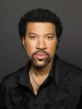

Charities & foundations supported

* Breast Cancer Research Foundation
* City of Hope

Causes supported

* AIDS & HIV,
* Cancer,
* Women

# Lisa Edelstein



Charities & foundations supported

* AmberWatch Foundation
* Best Friends Animal Society
* Farm Sanctuary
* Malaria No More
* Red Cross
* The Humane Society

Causes supported

* AIDS & HIV,
* Animals,
* Disaster Relief,
* Health,
* Human Rights,
* Missing Children

# Lisa Kudrow



Charities & foundations supported

* Clothes Off Our Back
* Dress for Success
* Feeding America
* Los Angeles Regional Foodbank
* P.S. ARTS
* Shoe Revolt
* The Art of Elysium
* Waterkeeper Alliance

Causes supported

* Abuse, AIDS & HIV,
* Cancer, Children,
* Creative Arts,
* Education, Environment,
* Health, Hunger,
* Oceans,
* Rape/Sexual Abuse, Water,
* Women

# Lisa LoCicero



Charities & foundations supported

* American Cancer Society

Causes supported

* Cancer,
* Health

# Lisa Lopes



Charities & foundations supported

* Lisa Lopes Foundation

Causes supported

* Adoption,
* Fostering,
* Orphans

# Lisa Masterson

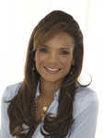

Charities & foundations supported

* United Nations Foundation

Causes supported

* AIDS & HIV,
* Children,
* Environment,
* Health,
* Human Rights,
* Peace,
* Women

# Lisa Snowdo



Charities & foundations supported

* Breast Cancer Care
* Comic Relief
* Help a London Child
* Sport Relief

Causes supported

* AIDS & HIV,
* At-Risk/Disadvantaged Youths,
* Cancer, Children, Conservation, Disaster Relief,
* Education, Environment, Fair Trade,
* Health, Homelessness,
* Human Rights, Hunger,
* Literacy, Miscellaneous,
* Poverty,
* Women

# Lisbeth Lenton



Charities & foundations supported

* Lenovo Hope Fund

# Livia Firth

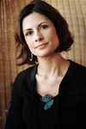

Charities & foundations supported

* Oxfam

Causes supported

* Disaster Relief,
* Human Rights,
* Poverty

# Liv Tyler



Charities & foundations supported

* Breast Cancer Research Foundation
* Food Bank For New York City
* St. Jude Children's Research Hospital
* The Lunchbox Fund
* To Write Love on Her Arms
* UNICEF

Causes supported

* Addiction,
* At-Risk/Disadvantaged Youths,
* Cancer, Children,
* Depression and Suicide,
* Health, Human Rights,
* Hunger, Poverty,
* Substance Abuse,
* Women

# Liya Kebede



Charities & foundations supported

* Liya Kebede Foundation

Causes supported

* Children,
* Family/Parent Support,
* Health,
* Women

# Liza Minnelli

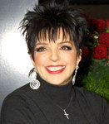

Charities & foundations supported

* American Foundation for AIDS Research

Causes supported

* AIDS & HIV, Health

# Liz Friedman



Charities & foundations supported

* The Art of Elysium

Causes supported

* AIDS & HIV
* , Cancer,
* Children,
* Health

# Liz McClarnon



Charities & foundations supported

* Breast Cancer Campaign
* Cancer Research UK

Causes supported

* Cancer,
* Health,
* Women

# LL Cool J

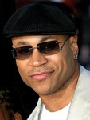

Charities & foundations supported

* Diamond Empowerment Fund
* Hip-Hop Summit Action Network
* J/P Haitian Relief Organization
* Jumpstart
* MusiCares
* Sentebale

Causes supported

* Abuse, AIDS & HIV,
* At-Risk/Disadvantaged Youths,
* Creative Arts,
* Disaster Relief
* , Education,
* Literacy, Miscellaneous,
* Physical Challenges,
* Poverty,
* Unemployment/Career Support

# Lo Bosworth



Charities & foundations supported

* Get Schooled Foundation
* Jumpstart
* Matt Leinart Foundation

Causes supported

* At-Risk/Disadvantaged Youths,
* Children,
* Education,
* Literacy,
* Mental Challenges,
* Physical Challenges

# Loretta Swit

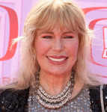

Charities & foundations supported

* Farm Sanctuary
* Romanian League in Defense of Animals

Causes supported

* Animals

# Lori McKenna



Charities & foundations supported

* Casting For Recovery
* Kevin Youkilis Hits For Kids

Causes supported

* Cancer,
* Children,
* Health,
* Women

# Lorna Scott

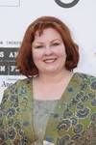

Charities & foundations supported

* Bailey Baio Angel Foundation
* Shane's Inspiration

Causes supported

* Children,
* Family/Parent Support,
* Health,
* Physical Challenges

# Lorraine Bracco



Charities & foundations supported

* Bicycle For A Day
* Felix Organization
* Keep Memory Alive
* Riverkeeper

Causes supported

* Adoption,
* Fostering,
* Orphans,
* Conservation,
* Environment, Health

# Lorraine Kelly



Charities & foundations supported

* Aberlour Child Care Trust
* Association for International Cancer Research
* Children with AIDS
* Comic Relief
* Muscle Help Foundation
* National Osteoporosis Society
* Refuge
* The Children's Trust, Tadworth

Causes supported

* Abuse, AIDS & HIV,
* At-Risk/Disadvantaged Youths,
* Cancer, Children, Disaster Relief,
* Family/Parent Support,
* Health, Homelessness,
* Human Rights, Physical Challenges,
* Poverty,
* Veteran/Service Member Support,
* Women

# Lou Diamond Phillips



Charities & foundations supported

* ACT Today!
* Cedars-Sinai Medical Center
* Center for Autism and Related Disorders
* Ragdoll Restoration Foundation
* Sharon Osbourne Colon Cancer Program
* The Rescue Train

Causes supported

* Animals,
* At-Risk/Disadvantaged Youths,
* Cancer,
* Family/Parent Support,
* Health, Mental Challenges,
* Physical Challenges

# Lou Ferrigno

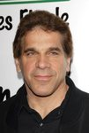

Charities & foundations supported

* Muscular Dystrophy Association
* National Center for Missing and Exploited Children
* Starkey Hearing Foundation
* St. Jude Children's Research Hospital

causes supported

* Children,
* Family/Parent Support
* , Health, Missing Children,
* Rape/Sexual Abuse

# Lou Gossett Jr

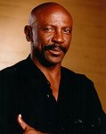

Charities & foundations supported

* Aviation Angels
* Eracism Foundation

Causes supported

* AIDS & HIV,
* At-Risk/Disadvantaged Youths,
* Education,
* Human Rights,
* Peace,
* Women

# Louie Anderson



Charities & foundations supported

* Comic Relief

Causes supported

* Disaster Relief,
* Homelessness,
* Human Rights,
* Poverty

# Louise Burfitt-Dons

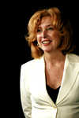

Charities & foundations supported

* Act Against Bullying
* National Society for the Prevention of Cruelty to Children
* Oxfam

Causes supported

* Abuse, Children,
* Disaster Relief,
* Human Rights,
* Miscellaneous
* , Poverty

# Louis Van Amstel



Charities & foundations supported

* GLAAD

Causes supported

* Gay/Lesbian Support

# Louis Walsh

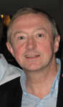

Charities & foundations supported

* Humane Society International

Causes supported

* Animals

# Lou Reed



Charities & foundations supported

* Hoping Foundation

Causes supported

* Children,
* Refugees

# Luciano Pavarotti

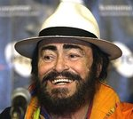

Charities & foundations supported

* MusiCares
* Red Cross
* UNHCR
* War Child

Causes supported

* AIDS & HIV,
* Children, Creative Arts,
* Disaster Relief,
* Human Rights,
* Peace, Refugees,
* Unemployment/Career Support

# Lucy Lawless



Charities & foundations supported

* Greenpeace
* Richmond/Ermet AIDS Foundation
* Starship Foundation

Causes supported

* AIDS & HIV, Animals,
* Cancer,
* Children, Conservation,
* Environment,
* Family/Parent Support,
* Grief Support,
* Health,
* Physical Challenges

# Lucy Liu



Charities & foundations supported

* 21st Century Leaders
* Bicycle For A Day
* Entertainment Industry Foundation
* Raising Malawi
* UNICEF
* USAID
* Whatever It Takes

Causes supported

* Abuse,
* Adoption, Fostering,
* Orphans,
* AIDS & HIV, Cancer,
* Children,
* Creative Arts, Disaster Relief,
* Economic/Business Support,
* Education,
* Environment,
* Health, Human Rights,
* Hunger,
* Miscellaneous,
* Poverty,
* Rape/Sexual Abuse,
* Women

**Ludacris**

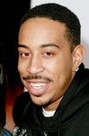

Charities & foundations supported

* 46664
* Artists for Peace and Justice
* Charity Folks
* Common Ground Foundation
* DNA Foundation
* Get Schooled Foundation
* Live Earth
* Ludacris Foundation

Causes supported

* AIDS & HIV,
* At-Risk/Disadvantaged Youths,
* Children, Disaster Relief,
* Economic/Business Support,
* Education,
* Environment, Human Rights,
* Literacy,
* Miscellaneous,
* Poverty,
* Rape/Sexual Abuse

# Luke Leighfield



Charities & foundations supported

* Christian Aid

Causes supported

* Human Rights
* , Peace,
* Poverty,
* Women

# Luke Mitchell



Causes supported

# Adoption

# Fostering,

# Orphans,

# Children

# Luke Wilson

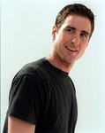

Charities & foundations supported

* Artists for Peace and Justice
* Los Angeles Police Memorial Foundation
* Project HOME

Causes supported

* Adoption,
* Fostering, Orphans,
* Disaster Relief,
* Emergency services,
* Family/Parent Support,
* Homelessness,
* Miscellaneous,
* Poverty

# Luol Deng

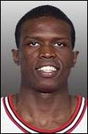

Charities & foundations supported

* Alliance For The Lost Boys Of Sudan
* Nothing But Nets

Causes supported

* Health,
* Refugees

# Lyle Lovett



Charities & foundations supported

* LIVESTRONG

Causes supported

* Cancer

# Lynn Harrell



Charities & foundations supported

* Save the Children

Causes supported

* Abuse, AIDS & HIV,
* Children,
* Disaster Relief,
* Education,
* Poverty