**Nadia Comaneci**



**Charities & foundations supported**

* Laureus Sport for Good Foundation
* Muscular Dystrophy Association
* Nadia Comaneci Children's Clinic
* Special Olympics

**Causes supported**

* At-Risk/Disadvantaged Youths,
* Children
* Health
* Mental Challenges
* Physical Challenges
* Sports

**Nadji Jeter**

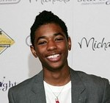

**Charities & foundations supported**

* Starlight Children's Foundation

**Causes supported**

* AIDS & HIV
* Cancer
* Children
* Health

**Nana Mouskouri**

### Nana Mouskouri Charities & foundations supported (1)

* UNICEF

**Causes supported**

* Children
* Health
* Human Rights
* Poverty

**Nancy Cartwright**

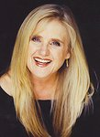

### Charities & foundations supported

* Cedars-Sinai Medical Center
* Devonshire PALS
* Happy House
* Make-A-Wish Foundation
* Sharon Osbourne Colon Cancer Program

**Causes supported**

* At-Risk/Disadvantaged Youths
* Cancer
* Children
* Family/Parent Support
* Health
* Miscellaneous

**Nancy Lee Grahn**



**Charities & foundations supported**

* American Cancer Society

**Causes supported**

* Cancer
* Health

**Nancy Lieberman**



**Charities & foundations supported**

* Racing for Kids

**Causes supported**

* Children

**Nancy O'Dell**

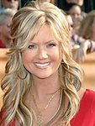

**Charities & foundations supported**

* Augie's Quest
* Barbara Davis Center for Childhood Diabetes
* Best Buddies International
* Clothes Off Our Back
* Dress for Success
* Feeding America
* Hope North
* Libby Ross Foundation
* March Of Dimes
* Muscular Dystrophy Association
* Nancy Davis Foundation for Multiple Sclerosis
* Red Cross
* The Art of Elysium
* The HollyRod Foundation

### Causes supported

* Adoption
* Fostering
* Orphans
* AIDS & HIV
* Cancer
* Children
* Disaster Relief
* Family/Parent Support
* Health
* Human Rights
* Hunger
* Mental Challenges
* Miscellaneous
* Physical Challenges
* Refugees
* Women

# Nandita Das



**Charities & foundations supported**

* United Nations Development Programme

**Causes supported**

* AIDS & HIV
* Children
* Disaster Relief
* Economic/Business Support
* Education
* Environment
* Human Rights
* Peace
* Physical Challenges
* Poverty
* Women

**Naomi Campbell**



**Charities & foundations supported**

* 21st Century Leaders
* 46664
* American Foundation for AIDS Research
* Breast Cancer Care
* Crusaid
* Diamond Empowerment Fund
* Live Earth
* Millennium Promise
* Whatever It Takes
* White Ribbon Alliance

**Causes supported**

* AIDS & HIV
* Cancer
* Education
* Environment
* Family/Parent Support
* Health
* Miscellaneous
* Poverty
* Women

**Naomi Judd**



**Charities & foundations supported**

* American Liver Foundation
* Mary Kay Ash Charitable Foundation
* Naomi Judd Education and Research Fund
* Ronald McDonald House Charities

**Causes supported**

* Abuse
* Cancer
* Children
* Family/Parent Support
* Health
* Women

**Naomi Watts**



**Charities & foundations supported**

* ALAFA
* Urban Zen Foundation
* Worldwide Orphans Foundation

**Causes supported**

* Adoption
* Fostering
* Orphans
* AIDS & HIV
* Children
* Conservation
* Health
* Poverty

**Nas**

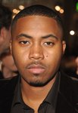

**Charities & foundations supported**

* Chris Webber Foundation
* Common Ground Foundation

**Causes supported**

* At-Risk/Disadvantaged Youths
* Children
* Education
* Literacy

**Natalie Cole**



**Charities & foundations supported**

* Nancy Davis Foundation for Multiple Sclerosis
* Save the Children
* The Hunger Project
* United Kidney Research Organization
* US Doctors for Africa

**Causes supported**

* Abuse
* AIDS & HIV
* Children
* Disaster Relief
* Education
* Health
* Hunger
* Poverty

**Natalie Imbruglia**



**Charities & foundations supported**

* 21st Century Leaders
* Breakthrough Breast Cancer
* Move For AIDS
* Oxfam
* ROTA
* UNFPA
* Virgin Unite
* Whatever It Takes

### Causes supported

* Adoption
* Fostering
* Orphans
* AIDS & HIV
* Cancer
* Children
* Disaster Relief
* Education, Health
* Homelessness
* Human Rights
* Mental Challenges
* Miscellaneous
* Physical Challenges
* Poverty

**Natalie Maines**

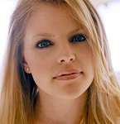

**Charities & foundations supported**

* Conservation International
* Voice For The Animals Foundation

**Causes supported**

* Animals
* Conservation
* Environment
* Voter Education

**Natalie Merchant**

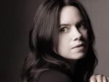

**Causes supported**

* Environment
* Health

**Natalie Morales**

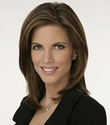

**Charities & foundations supported**

* Children's Hospital Los Angeles
* Lupus Foundation of America

### Causes supported

* Animals
* Children
* Family/Parent Support
* Health

**Natalie Portman**



**Charities & foundations supported**

* Afghanistan Relief Organization
* Artists for Peace and Justice
* FINCA
* Food Bank For New York City
* Listen Campaign
* Live 8
* Milo Gladstein Foundation
* PETA
* Shoe4Africa
* The Lunchbox Fund
* Tony Blair Faith Foundation

### Causes supported

* Adoption
* Fostering
* Orphans
* AIDS & HIV
* Animals
* At-Risk/Disadvantaged Youths
* Children
* Disaster Relief
* Economic/Business Support
* Education
* Environment
* Health
* Homelessness
* Human Rights
* Hunger
* Literacy
* Miscellaneous
* Peace
* Poverty
* Refugees
* Water

**Natasha Bedingfield**

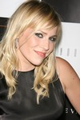

**Charities & foundations supported**

* Amnesty International
* Andre Agassi Foundation for Education
* [Global Angels](http://www.looktothestars.org/charity/global-angels)
* (RED)
* Save The Music Foundation
* Sentebale
* Stand Up To Cancer
* The Black Eyed Peas Foundation
* Virgin Unite

**Causes supported**

* Abuse
* Adoption
* Fostering
* Orphans
* AIDS & HIV
* At-Risk/Disadvantaged Youths
* Cancer
* Children
* Creative Arts
* Disaster Relief
* Education
* Family/Parent Support
* Health, Homelessness
* Human Rights
* Hunger
* Mental Challenges
* Peace
* Physical Challenges
* Poverty
* Refugees
* Women

**Natasha Hamilton**



### Charities & foundations supported

* Barnardo’s
* Mines Advisory Group

**Causes supported**

* Abuse
* At-Risk/Disadvantaged Youths
* Children
* Family/Parent Support
* Homelessness
* Mental Challenges
* Physical Challenges
* Weapons Reduction

**Natasha Henstridge**



**Charities & foundations supported**

* American Heart Association
* Elevate Hope Foundation
* See Jane

### Causes supported

* Abuse
* Children
* Creative Arts
* Health
* Women

**Natasha Kaplinsky**



**Charities & foundations supported**

* Breast Cancer Campaign
* Save the Children

**Causes supported**

* Abuse
* AIDS & HIV
* Cancer
* Children
* Disaster Relief
* Education
* Poverty
* Women

**Nate Parker**

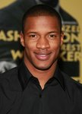

**Charities & foundations supported**

* Boys & Girls Clubs of America
* Peace4Kids

**Causes supported**

* Adoption
* Fostering
* Orphans
* At-Risk/Disadvantaged Youths
* Children
* Education

**Nate Robertson**

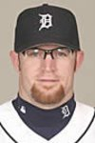

**Charities & foundations supported**

Grand Kids Foundation

**Causes supported**

* At-Risk/Disadvantaged Youths
* Children
* Sports

**Naturally 7**

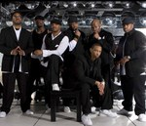

**Charities & foundations supported**

* CBM
* STOMP Out Bullying

**Causes supported**

* Abuse
* Children
* Family/Parent Support
* Health
* Physical Challenges

**Neil deGrasse Tyson**

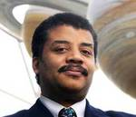

**Charities & foundations supported**

* Doctors Without Borders
* PETA

**Causes supported**

* Animals
* Disaster Relief
* Health

**Neil Diamond**



**Charities & foundations supported**

* Barbara Davis Center for Childhood Diabetes
* GRAMMY Foundation
* Habitat For Humanity
* MusiCares
* Music for Relief

**Causes supported**

* Children
* Creative Arts
* Disaster Relief
* Environment
* Health
* Homelessness
* Unemployment/Career Support

# Neil Finn

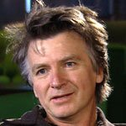

**Charities & foundations supported**

* Amnesty International
* Gracelands Trust
* Nordoff Robbins
* Raukatauri Music Therapy Trust
* Scope
* Starship Foundation
* World Vision

**Causes supported**

* Adoption
* Fostering
* Orphans
* AIDS & HIV
* Cancer
* Children
* Creative Arts
* Family/Parent Support
* Grief Support
* Health
* Human Rights
* Mental Challenges
* Miscellaneous
* Physical Challenges
* Poverty

**Neil Fox**

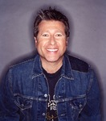

**Charities & foundations supported**

* Campaign to End Child Poverty
* Macmillan Cancer Support
* Variety Club
* Women's Aid

**Causes supported**

* Abuse
* At-Risk/Disadvantaged Youths
* Cancer
* Children
* Health
* Physical Challenges
* Poverty
* Women

**Neil Patrick Harris**

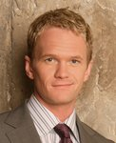

**Charities & foundations supported**

* AIDS Healthcare Foundation
* Broadway Cares/Equity Fights AIDS
* Children International
* Clothes Off Our Back
* Feeding America
* First Book
* Food on Foot
* Global Green
* Hope North
* Motion Picture and Television Fund Foundation
* Noreen Fraser Foundation
* Real Medicine Foundation
* Stand Up To Cancer
* Susan G. Komen for the Cure
* The Trevor Project

**Causes supported**

* Adoption
* Fostering
* Orphans
* AIDS & HIV
* Cancer
* Children
* Creative Arts
* Depression and Suicide
* Disaster Relief
* Education
* Environment
* Gay/Lesbian Support
* Health
* Homelessness
* Hunger
* Miscellaneous
* Peace
* Poverty
* Refugees
* Water
* Women

**Neil Young**

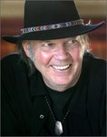

**Charities & foundations supported**

* Bridge School
* Farm Aid
* Live 8
* MusiCares
* Sarah McLachlan School of Music

**Causes supported**

* Adoption
* Fostering
* Orphans
* AIDS & HIV
* Children
* Creative Arts
* Economic/Business Support
* Environment
* Miscellaneous
* Physical Challenges
* Poverty
* Unemployment/Career Support
* Voter Education

**Neko Case**



Charities & foundations supported

* Best Friends Animal Society
* Bridge School

**Causes supported**

* Animals
* Children
* Physical Challenges

# Nelly

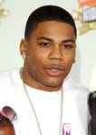

**Charities & foundations supported**

* 21st Century Leaders
* 4sho4kids
* Ante Up For Africa
* ENOUGH Project
* Not On Our Watch
* Whatever It Takes

### Causes supported

* Addiction
* Children
* Disaster Relief
* Health
* Human Rights
* Mental Challenges
* Miscellaneous
* Peace
* Rape/Sexual Abuse
* Refugees

**Nelly Furtado**



**Charities & foundations supported**

* Alzheimer's Association
* Children in Need
* Jumpstart
* MusiCan
* The Heart Truth
* The Land Conservancy
* War Child

### Causes supported

* Abuse
* Children
* Disaster Relief
* Education
* Environment
* Health
* Homelessness
* Literacy
* Mental Challenges
* Peace
* Physical Challenges
* Substance Abuse
* Women

**Nelsan Ellis**

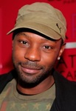

**Charities & foundations supported**

* Red Cross

**Causes supported**

* AIDS & HIV
* Disaster Relief
* Human Rights

**Nelson Mandela**

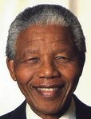

**Charities & foundations supported**

* 46664
* Action Against Hunger
* Artists for a New South Africa
* CHOC South Africa
* Chris Tucker Foundation
* Cotlands
* Diana, Princess of Wales Memorial Fund
* Girls Not Brides
* Goal4Africa
* Hear The World
* Ithemba Trust
* Make Poverty History
* Mineseeker Foundation
* Nelson Mandela Foundation
* ONE Campaign
* Reach For A Dream Foundation
* Red Cross
* SOS Children's Villages
* St. Mary's Hospital
* The Elders
* Walter SisuluPaediatric Cardiac Centre for Africa

**Causes supported**

* Abuse
* Adoption
* Fostering
* Orphans
* AIDS & HIV
* Cancer
* Children
* Disaster Relief
* Education
* Environment
* Family/Parent Support
* Health
* Homelessness
* Human Rights
* Hunger
* Literacy
* Mental Challenges
* Miscellaneous
* Peace
* Poverty
* Refugees
* Sports
* Water
* Weapons Reduction
* Women

**Neon Trees**

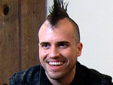

**Charities & foundations supported**

Little Kids Rock

**Causes supported**

* At-Risk/Disadvantaged Youths
* Children
* Creative Arts

**New Kids On The Block**

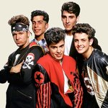

**Charities & foundations supported**

* City of Hope
* Gibson Girl Foundation
* Musicians on Call

**Causes supported**

* AIDS & HIV
* Cancer
* Creative Arts
* Health

**Ne-Yo**

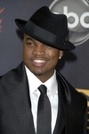

**Charities & foundations supported**

* Habitat For Humanity
* Music for Relief
* Save The Music Foundation
* Stand Up To Cancer
* UNICEF

**Causes supported**

* Cancer
* Children
* Creative Arts
* Disaster Relief
* Education
* Environment
* Health
* Homelessness
* Human Rights
* Poverty

**Nicholas Gonzalez**

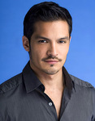

**Charities & foundations supported**

* Friends of El Faro
* NALIP
* PETA

**Causes supported**

* Adoption
* Fostering
* Orphans
* Animals
* Children
* Creative Arts
* Education

**Nicholas Hoult**

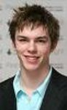

**Charities & foundations supported**

* Campaign to End Child Poverty
* Environmental Justice Foundation
* National Society for the Prevention of Cruelty to Children

**Causes supported**

* Abuse
* Children
* Environment
* Human Rights
* Poverty

**Nicholas Sparks**

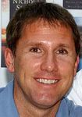

**Charities & foundations supported**

* Nicholas Sparks Foundation

**Causes supported**

* Education
* Miscellaneous

**Nick Buoniconti**



**Charities & foundations supported**

* Buoniconti Fund To Cure Paralysis
* The Miami Project

**Causes supported**

* Physical Challenges

**Nick Cannon**

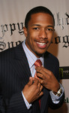

**Charities & foundations supported**

* Alzheimer's Association
* Andre Agassi Foundation for Education
* A Place Called Home
* DoSomething.org
* Get Schooled Foundation
* Reality Cares

### Causes supported

* At-Risk/Disadvantaged Youths
* Children
* Education
* Health
* Miscellaneous
* Philanthropy

# Nick Carter

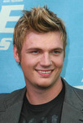

**Charities & foundations supported**

* United Nations Environment Programme

**Causes supported**

* Cancer
* Conservation
* Environment

**Nickelback**

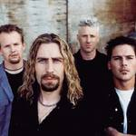

**Charities & foundations supported**

* Obakki Foundation
* STOMP Out Bullying

**Causes supported**

* Abuse
* Children
* Family/Parent Support
* Miscellaneous

**Nick Harmer**

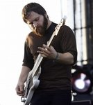

**Charities & foundations supported**

* 826 Valencia
* Bridge School
* Kiva
* Planned Parenthood

**Causes supported**

* Children
* Economic/Business Support
* Education
* Hunger
* Miscellaneous
* Physical Challenges
* Women

**Nick Jonas**

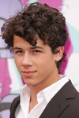

**Charities & foundations supported**

* Alzheimer's Association
* American Diabetes Association
* Andre Agassi Foundation for Education
* BID 2 BEAT AIDS
* Change for the Children Foundation
* Children's Hospital Los Angeles
* Children's Miracle Network Hospitals
* City of Hope
* DoSomething.org
* Entertainment Industry Foundation
* Family Health International
* Feeding America
* Gibson Girl Foundation
* JDRF
* LIFEbeat
* Los Angeles Regional Foodbank
* Make-A-Wish Foundation
* MusiCares
* Music for Relief
* Nothing But Nets
* Oxfam
* PROJECT ZAMBI
* Red Cross
* Revlon Run/Walk For Women
* Shriners Hospitals for Children
* St. Jude Children's Research Hospital
* The Salvation Army
* TJ Martell Foundation
* USAID
* Variety Power Of Youth

### Causes supported

* Abuse
* Adoption
* Fostering
* Orphans
* AIDS & HIV
* At-Risk/Disadvantaged Youths
* Cancer
* Children
* Creative Arts
* Disaster Relief
* Economic/Business Support
* Education
* Environment
* Family/Parent Support
* Grief Support
* Health
* Homelessness
* Human Rights
* Hunger
* Miscellaneous
* Philanthropy
* Poverty
* Rape/Sexual Abuse
* Senior Citizen Support
* Unemployment/Career Support
* Veteran/Service Member Support
* Women

**Nick Lachey**

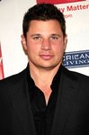

**Charities & foundations supported**

* Clothes Off Our Back
* Feeding America
* Matt Leinart Foundation
* Music Rising
* Save The Music Foundation
* Soles4Souls

**Causes supported**

* At-Risk/Disadvantaged Youths
* Children, Creative Arts
* Disaster Relief
* Education
* Hunger
* Mental Challenges
* Physical Challenges
* Poverty
* Refugees
* Unemployment/Career Support

**Nick Swisher**

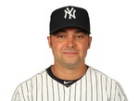

**Charities & foundations supported**

* Wounded Warrior Project

**Causes supported**

* [Veteran/Service Member Support](http://www.looktothestars.org/cause/veteran-service-member-support)

**Nicky Hilton**

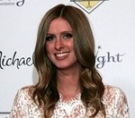

**Charities & foundations supported**

* Artists for Peace and Justice
* Barbara Davis Center for Childhood Diabetes
* Cathy's Kids Foundation
* Make-A-Wish Foundation
* Nancy Davis Foundation for Multiple Sclerosis
* Starlight Children's Foundation
* The Art of Elysium
* Union Rescue Mission
* Vine Group

**Causes supported**

* AIDS & HIV,
* At-Risk/Disadvantaged Youths,
* Blood, Marrow & Organ Donation,
* Cancer,
* Children,
* Disaster Relief,
* Education,
* Health,
* Homelessness,
* Miscellaneous,
* Poverty

**Nicola Roberts**

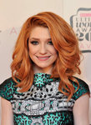

**Charities & foundations supported**

* Lowe Syndrome Trust

**Causes supported**

* Abuse,
* At-Risk/Disadvantaged Youths,
* Health

**Nicolas Cage**

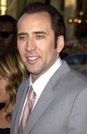

**Charities & foundations supported**

* Amnesty International
* Chrysalis
* Hillsides
* Oceana
* Screen Actors Guild Foundation
* The Art of Elysium

**Causes supported**

* AIDS & HIV
* Animals
* Cancer
* Children
* Conservation
* Creative Arts
* Environment
* Health
* Homelessness
* Human Rights
* Oceans
* Rape/Sexual Abuse
* Water

**Nicolas Kiefer**

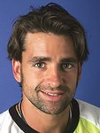

**Charities & foundations supported**

* Laureus Sport for Good Foundation

### Causes supported

* At-Risk/Disadvantaged Youths
* Sports

**Nicole Beharie**



**Charities & foundations supported**

* ASTEP

**Causes supported**

* Poverty

**Nicole Kidman**



**Charities & foundations supported**

* 21st Century Leaders
* Artists for Peace and Justice
* Breast Cancer Care
* Cinema For Peace
* FARA
* Global Green Plan
* Jeans for Genes
* Kids Wish Network
* Mayor's Fund to Advance New York City
* Musicians on Call
* Red Cross
* SixDegrees.org
* Starlight Children's Foundation
* The McGrath Foundation
* UNICEF
* UNIFEM
* Whatever It Takes

### Causes supported

* Abuse,
* Adoption,
* Fostering,
* Orphans,
* AIDS & HIV,
* At-Risk/Disadvantaged Youths,
* Cancer,
* Children,
* Disaster Relief,
* Education,
* Environment,
* Family/Parent Support,
* Grief Support,
* Health,
* Human Rights,
* Miscellaneous,
* Peace,
* Philanthropy,
* Poverty,
* Women

**Nicole Richie**

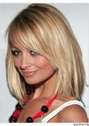

Charities & foundations supported

* March Of Dimes
* Red Cross
* Richie Madden Children's Foundation
* The Art of Elysium
* UNICEF

**Causes supported**

* AIDS & HIV
* Cancer
* Children
* Disaster Relief
* Family/Parent Support
* Health
* Human Rights
* Poverty

**Nicole Scherzinger**



### Charities & foundations supported

* Reality Cares

**Causes supported**

* Miscellaneous

**Nicollette Sheridan**



**Charities & foundations supported**

* ALS Association
* Best Friends Animal Society
* Bony Pony Ranch
* National Stroke Association
* P.A.D.
* Padres Contra el Cancer
* Spirit of Women Health Network

### Causes supported

* Animals,
* At-Risk/Disadvantaged Youths
* Cancer
* Children
* Creative Arts
* Education
* Family/Parent Support
* Health
* Physical Challenges
* Women

# Nigel Barker

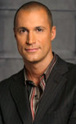

**Charities & foundations supported**

* Elizabeth Glaser Pediatric AIDS Foundation
* Make-A-Wish Foundation
* PETA
* The Humane Society
* TigerTime

Causes supported

* AIDS & HIV
* Animals
* Cancer
* Children
* Conservation
* Family/Parent Support
* Health

# Nigel Havers

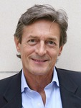

**Charities & foundations supported**

* CHICKS

**Causes supported**

* At-Risk/Disadvantaged Youths
* Children

**Nigella Lawson**

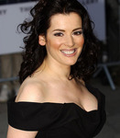

**Charities & foundations supported**

* Leukaemia and Lymphoma Research
* Mary's Meals

**Causes supported**

* Cancer,
* Hunger

**Nigel Lythgoe**



**Charities & foundations supported**

* Barbara Davis Center for Childhood Diabetes
* Dizzy Feet Foundation
* LA's BEST
* Muscular Dystrophy Association
* STOMP Out Bullying

**Causes supported**

* Abuse,
* At-Risk/Disadvantaged Youths,
* Children,
* Creative Arts,
* Family/Parent Support,
* Health

**Niki Taylor**



**Charities & foundations supported**

* Red Cross
* The HollyRod Foundation

**Causes supported**

* AIDS & HIV
* Disaster Relief
* Family/Parent Support
* Health
* Human Rights
* Physical Challenges

**Nikka Costa**



**Charities & foundations supported**

* Artists for a New South Africa

**Causes supported**

* AIDS & HIV

**Nikki Cox**



**Charities & foundations supported**

* A Star For The Night

**Causes supported**

* Children

**Nikki Sixx**

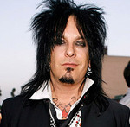

**Charities & foundations supported**

* Fisher House Foundation

**Causes supported**

* Veteran/Service Member Support

**Nina Wadia**

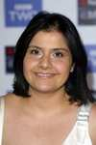

**Charities & foundations supported**

* Sightsavers International

**Causes supported**

* Physical Challenges

**Nine Inch Nails**

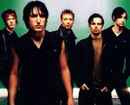

**Charities & foundations supported**

* HeadCount

**Causes supported**

* Human Rights
* Voter Education

**Noah Wyle**

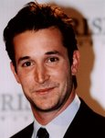

**Charities & foundations supported**

* Healthy Child Healthy World
* Human Rights Watch
* Oceana

### Causes supported

* Animals
* Children
* Conservation
* Environment
* Human Rights
* Oceans
* Water

# Noel Edmonds

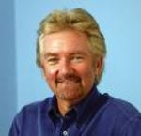

**Charities & foundations supported**

### National Society for the Prevention of Cruelty to Children

### Causes supported

* Abuse
* Children

**Noel Gallagher**

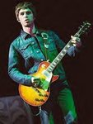

**Charities & foundations supported**

* Pablove Foundation
* Teenage Cancer Trust

**Causes supported**

* At-Risk/Disadvantaged Youths
* Cancer
* Children
* Creative Arts
* Education
* Grief Support
* Health

**Noelle Pikus-Pace**

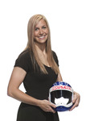

**Charities & foundations supported**

* JDRF

**Causes supported**

* Health

**Nolan Gould**

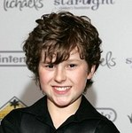

**Charities & foundations supported**

* Habitat For Humanity
* Shoe Revolt
* Starlight Children's Foundation

**Causes supported**

* Abuse,
* AIDS & HIV,
* Cancer,
* Children,
* Disaster Relief,
* Health,
* Homelessness,
* Rape/Sexual Abuse,
* Women

# NomarGarciaparra

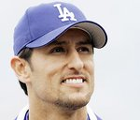

**Charities & foundations supported**

* Children's Hospital Los Angeles
* Mia Hamm Foundation

**Causes supported**

* Children
* Health
* Sports

**Norah Jones**

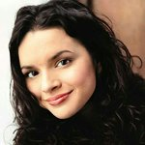

**Charities & foundations supported**

* Aid Still Required
* Gram Parsons Foundation
* Iraq Veterans Against the War
* LIVESTRONG
* Stand Up To Cancer
* United for Peace and Justice
* Yéle Haiti Foundation

**Causes supported**

* Addiction,
* Cancer,
* Creative Arts,
* Disaster Relief,
* Economic/Business Support,
* Environment,
* Hunger,
* Peace,
* Poverty,
* Substance Abuse,
* Veteran/Service Member Support

**Norman Lear**



**Charities & foundations supported**

* Adopt-A-Minefield
* Autism Speaks
* Conservation International
* Declare Yourself
* Doctors Without Borders
* Elizabeth Glaser Pediatric AIDS Foundation
* Environmental Media Association
* Global Green
* Habitat For Humanity
* [Lear Family Foundation](http://www.looktothestars.org/charity/lear-family-foundation)
* Natural Resources Defense Council
* Rape Foundation

### Causes supported

* Abuse
* AIDS & HIV
* Animals
* At-Risk/Disadvantaged Youths
* Cancer
* Children
* Conservation
* Creative Arts, [Disaster Relief](http://www.looktothestars.org/cause/disaster-relief)
* Education
* Environment
* Family/Parent Support
* Health
* Homelessness
* Human Rights
* Mental Challenges
* Oceans
* Peace
* Physical Challenges
* Poverty
* Rape/Sexual Abuse
* Voter Education
* Water
* Weapons Reduction
* Women

**Norwood Young**

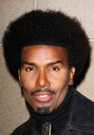

**Charities & foundations supported**

* A Place Called Home
* Feed His People

**Causes supported**

* At-Risk/Disadvantaged Youths
* Hunger

# Novak Djokovic

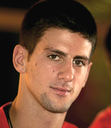

**Charities & foundations supported**

* UNICEF

**Causes supported**

* Children
* Health
* Human Rights
* Poverty