**Oak Ridge Boys**

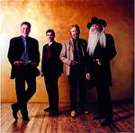

Charities & foundations supported

* Save the Children

Causes supported

* Abuse,
* AIDS & HIV,
* Children,
* Disaster Relief,
* Education,
* Poverty

# OK Go



### Causes supported

* Disaster Relief

# Oksana Grigorieva



Charities & foundations supported

* Chernobyl Children's Project International

Causes supported

* Children,
* Disaster Relief

# Ole Gunnar Solskjaer



Charities & foundations supported

* UNICEF

Causes supported

* Children,
* Health,
* Human Rights,
* Poverty

# Oliver Phelps



Charities & foundations supported

* Royal National Lifeboat Institution

Causes supported

* Emergency services

# Oliver Stone

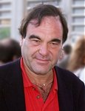

Charities & foundations supported

* Global Green
* Global Green Plan

Causes supported

* Environment,
* Health,
* Peace,
* Poverty,
* Water

# Olivia Munn

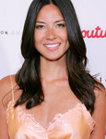

Charities & foundations supported

* Artists for Peace and Justice
* Habitat For Humanity
* PETA
* UNICEF

Causes supported

* animals,
* Children,
* Disaster Relief,
* Health, Homelessness,
* Human Rights,
* Miscellaneous,
* Poverty

# Olivia Newton-John



Charities & foundations supported

* Cedars-Sinai Medical Center
* Cure Breast Cancer
* Healthy Child Healthy World
* Leeza's Place
* Olivia Newton-John Cancer & Wellness Centre
* Red Cross

Causes supported

* AIDS & HIV,
* Cancer, Children,
* Disaster Relief, Environment,
* Health, Human Rights,
* Women

# Olivia Wilde



Charities & foundations supported

* Aid Still Required
* Artists for Peace and Justice

Causes supported

* Disaster Relief,
* Miscellaneous,
* Poverty

# Olly Murs

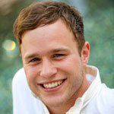

Charities & foundations supported

* Comic Relief
* Sport Relief
* UNICEF

Causes supported

* AIDS & HIV, Cancer,
* Children, Conservation, Disaster Relief,
* Education, Environment,
* Fair Trade, Health,
* Homelessness, Human Rights,
* Hunger, Literacy,
* Miscellaneous, Poverty

# Omarosa



Charities & foundations supported

* Aviation Angels
* Tomorrow's Aeronautic Museum

Causes supported

* At-Risk/Disadvantaged Youths,
* Education

# Omid Djalili



Charities & foundations supported

* Christian Aid

Causes supported

* Human Rights,
* Peace,
* Poverty,
* Women

# One Direction

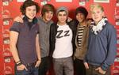

Charities & foundations supported

* Comic Relief
* Greenpeace
* Sport Relief

Causes supported

* AIDS & HIV,
* Animals, Cancer,
* Children,
* Conservation,
* Disaster Relief, Education,
* Environment, Fair Trade,
* Health, Homelessness,
* Human Rights, Hunger,
* Literacy,
* Miscellaneous,
* Poverty

# OneRepublic

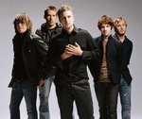

charities & foundations supported

* Feeding America
* Muscular Dystrophy Association
* Save The Music Foundation

Causes supported

* Children,
* Creative Arts,
* Education,
* Health,
* Hunger

# Oprah

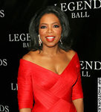

Charities & foundations supported

* 46664
* Born This Way Foundation
* Charlize Theron Africa Outreach Project
* Clinton Foundation
* Elevate Hope Foundation
* Free The Children
* Heifer International
* Lower East Side Girls Club
* Mississippi Animal Rescue League
* Mpilonhle
* Oprah's Angel Network
* Oprah Winfrey Leadership Academy for Girls in South Africa
* Peace Over Violence
* Project Cuddle
* Red Cross
* Robert F Kennedy Memorial
* Somaly Mam Foundation
* V-Day
* Women for Women International
* Worldwide Orphans Foundation

Causes supported

* Abuse, Adoption,
* Fostering,
* Orphans, AIDS & HIV, Animals, Cancer,
* Children, Creative Arts,
* Disaster Relief, Economic/Business Support,
* Education, Environment,
* Family/Parent Support,
* Gay/Lesbian Support, Health,
* Human Rights, Hunger,
* Miscellaneous, Peace, Poverty,
* Rape/Sexual Abuse, Women

# Orianthi

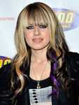

Charities & foundations supported

* Stand Up To Cancer

Causes supported

* Cancer

# Orlando Bloom



Charities & foundations supported

* EB Medical Research Foundation
* Food Bank For New York City
* Global Cool
* Global Green
* Great Ormond Street Hospital
* Luke Neuhedel Foundation
* Malaria No More
* ONE Campaign
* Peace First
* Prince's Trust
* Project HOME
* Red Cross
* The Lunchbox Fund
* UNICEF

Causes supported

* AIDS & HIV,
* At-Risk/Disadvantaged Youths,
* Cancer, Children,
* Disaster Relief, Education,
* Environment,
* Family/Parent Support,
* Health, Homelessness,
* Human Rights, Hunger,
* Peace, Poverty, Water

# Orlando Cepeda

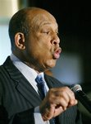

Charities & foundations supported

* Boys & Girls Clubs of America
* HOPE Worldwide

Causes supported

* Adoption,
* Fostering, Orphans,
* AIDS & HIV,
* At-Risk/Disadvantaged Youths,
* Children,
* Disaster Relief,
* Education,
* Health,
* Poverty

# Oscar Torre

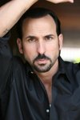

Charities & foundations supported

* Children's Hospital Los Angeles

Causes supported

* AIDS & HIV,
* Cancer,
* Children,
* Health

# Owain Yeoma

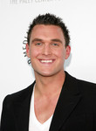

Charities & foundations supported

* PETA

Causes supported

* Animals

# Owen Wilson



Charities & foundations supported

* BID 2 BEAT AIDS
* Chandler Sky Foundation
* City Hearts: Kids Say Yes to the Arts
* Solar Neighbors Program
* STILLERSTRONG

Causes supported

* Abuse,
* Adoption,
* Fostering,
* Orphans,
* AIDS & HIV,
* At-Risk/Disadvantaged Youths,
* Children,
* Creative Arts,
* Education,
* Environment,
* Poverty

# Ozzy Osbourne

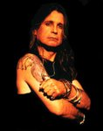

Charities & foundations supported

* 21st Century Leaders
* Children in Need
* Los Angeles Youth Network
* MusiCares
* Music for Relief
* Prince's Trust
* Save the Children
* Sharon Osbourne Colon Cancer Program
* Starkey Hearing Foundation
* Whatever It Takes

Causes supported

* Abuse,
* AIDS & HIV,
* At-Risk/Disadvantaged Youths,
* Cancer, Children,
* Creative Arts, Disaster Relief
* , Education,
* Environment,
* Health, Homelessness,
* Mental Challenges,
* Miscellaneous,
* Physical Challenges,
* Poverty,
* Substance Abuse,
* Unemployment/Career Support