**Padma Lakshmi**

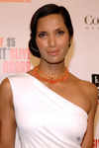

Charities & foundations supported

* Endometriosis Foundation of America
* Keep A Child Alive

Causes supported

* AIDS & HIV,
* Children,
* Family/Parent Support,
* Health,
* Women

Paige Hemmis

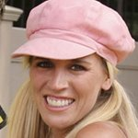

Charities & foundations supported

* Habitat For Humanity
* The Hollywood Cookbook

Causes supported

* AIDS & HIV,
* At-Risk/Disadvantaged Youths,
* Children,
* Disaster Relief,
* Health,
* Homelessness,
* Women

# Paloma Faith

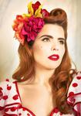

Charities & foundations supported

* Prince's Trust

Causes supported

* At-Risk/Disadvantaged Youths,
* Children,
* Education

# Pamela Anderson



Charities & foundations supported

* Aid Still Required
* Cool Earth
* Feed the Children
* Greenpeace
* Hauser Bears
* Last Chance for Animals
* PETA

Causes supported

* Abuse
* Adoption,
* Fostering,
* Orphans,
* Animals,
* Children,
* Conservation,
* Disaster Relief, Environment,
* Hunger, Poverty

# Pamela Stephenson



Charities & foundations supported

* Amnesty International
* Cancer Research UK
* Women for Women International

Causes supported

* Cancer, Economic/Business Support,
* Education, Health,
* Human Rights
* , Poverty,
* Women

Paramore

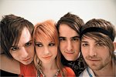

Charities & foundations supported

* Children's Hospital Los Angeles
* Invisible Children
* Make-A-Wish Foundation
* Memorial Sloan-Kettering
* Stand Up To Cancer
* TJ Martell Foundation
* United Service Organization

Causes supported

* AIDS & HIV,
* Cancer,
* Children
* , Health, Human Rights,
* Peace, Veteran/Service Member Support

# Paris Hilton



Charities & foundations supported

* ACT for MS
* Barbara Davis Center for Childhood Diabetes
* Bottletop
* Cancer Research UK
* Cathy's Kids Foundation
* Children's Hospital Los Angeles
* Clothes Off Our Back
* Education Africa
* Feeding America
* Gibson Girl Foundation
* GRAMMY Foundation
* Leeza's Place
* Life Rolls On Foundation
* Make-A-Wish Foundation
* MusiCares
* Nancy Davis Foundation for Multiple Sclerosis
* Olivia Newton-John Cancer & Wellness Centre
* Playing For Good
* Precious Paws
* Richie Madden Children's Foundation
* Soles4Souls
* Starlight Children's Foundation
* The Art of Elysium
* Union Rescue Mission

Causes supported

* AIDS & HIV, Animals,
* At-Risk/Disadvantaged Youths
* , Blood, Marrow & Organ Donation,
* Cancer, Children,
* Creative Arts, Disaster Relief,
* Education,
* Environment,
* Family/Parent Support,
* Health, Homelessness, Hunger,
* Physical Challenges, Poverty,
* Refugees, Sports,
* Unemployment/Career Support, Water
* Women

# Parker Posey



Charities & foundations supported

* Soles4Souls

Causes supported

* Disaster Relief,
* Poverty,
* Refugees

# Parminder Nagra



Charities & foundations supported

* Lupus LA
* Make-A-Wish Foundation
* Vijay Amritraj Foundation

Causes supported

* Adoption,
* Fostering, Orphans,
* AIDS & HIV, Cancer,
* Children, Health,
* Mental Challenges,
* Miscellaneous,
* Physical Challenges,
* Women

Pat Benatar



Charities & foundations supported

* Starkey Hearing Foundation

Causes supported

* Health

# Pat Boone

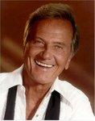

Charities & foundations supported

* Society of Singers

Causes supported

* Education,
* Unemployment/Career Support

# Pat Green

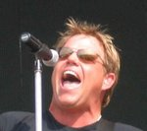

Charities & foundations supported

* Fourth and Goal
* Red Cross

Causes supported

* AIDS & HIV,
* Disaster Relief,
* Human Rights
* , Sports

# Pat LaFontaine



Charities & foundations supported

* Companions in Courage Foundation

Causes supported

* Children

# Patricia Arquette



Charities & foundations supported

* Eracism Foundation
* Libby Ross Foundation
* The Art of Elysium
* The Heart Truth

Causes supported

* AIDS & HIV,
* Cancer,
* Children,
* Education,
* Health, Human Rights,
* Peace,
* Women

# Patricia Heaton



Charities & foundations supported

* Cure Autism Now
* Fresh Air Fund
* Heifer International
* Operation Gratitude
* Red Cross
* Tuberous Sclerosis Alliance
* World Vision

Causes supported

* Adoption,
* Fostering, Orphans,
* AIDS & HIV, Animals,
* At-Risk/Disadvantaged Youths
* Children, Disaster Relief,
* Health, Human Rights,
* Hunger, Mental Challenges,
* Poverty,
* Veteran/Service Member Support

# Patrick Dempsey

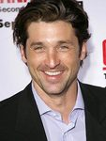

Charities & foundations supported

* Patrick Dempsey Center for Cancer Hope and Healing

Causes supported

* Cancer,
* Health

# Patrick Fabian



Charities & foundations supported

* Lili Claire Foundation

Causes supported

* Children,
* Family/Parent Support,
* Mental Challenges

# Patrick Gallagher

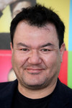

Charities & foundations supported

* Hollywood Arts
* Reality Cares
* SBC P.R.I.M.E.

Causes supported

* At-Risk/Disadvantaged Youths,
* Miscellaneous

Patrick Monahan

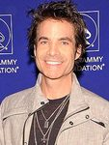

Charities & foundations supported

* GRAMMY Foundation
* Little Kids Rock

Causes supported

* At-Risk/Disadvantaged Youths,
* Children,
* Creative Arts

# Patrick Stewart

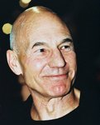

Charities & foundations supported

* 21st Century Leaders
* BeatBullying
* Children of Peace
* Dignity in Dying
* Precious Paws
* Refuge
* Variety Club
* Whatever It Takes

Causes supported

* Abuse,
* Animals,
* At-Risk/Disadvantaged Youths
* , Children,
* Education, Health,
* Human Rights,
* Miscellaneous,
* Peace,
* Physical Challenges,
* Women

# Patrick Swayze

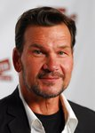

Charities & foundations supported

* Pancreatic Cancer Action Network
* Stand Up To Cancer

Causes supported

* Cancer

# Patrick Warburton

* 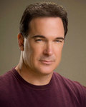

Charities & foundations supported

* A World Fit For Kids!
* Racing for Kids
* St. Jude Children's Research Hospital
* TLC for the Blind

Causes supported

* At-Risk/Disadvantaged Youths,
* Children,
* Health,
* Physical Challenges

# Patti LaBelle



Charities & foundations supported

* Bells for Peace
* Carma Foundation
* Clothes Off Our Back
* Elevate Hope Foundation
* First Book
* Lisa Lopes Foundation
* Red Cross
* The HollyRod Foundation
* Women Alive Coalition

Causes supported

* Abuse,
* Adoption, Fostering,
* Orphans,
* AIDS & HIV, Children,
* Creative Arts, Disaster Relief,
* Education,
* Family/Parent Support,
* Health, Human Rights,
* Miscellaneous,
* Physical Challenges,
* Poverty, Women

# Patti Smith

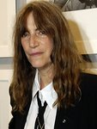

Charities & foundations supported

* Amnesty International
* Sweet Relief Musicians Fund

Causes supported

* Creative Arts,
* Economic/Business Support,
* Human Rights,
* Peace,
* Unemployment/Career Support

# Pau Gasol

* 

Charities & foundations supported

* Aid Still Required
* UNICEF
* WildAid

Causes supported

* Animals,
* Children, Conservation,
* Disaster Relief,
* Environment,
* Health,
* Human Rights,
* Poverty

# Paula Abdul



Charities& foundations supported

* American Humane Association
* Bony Pony Ranch
* Clothes Off Our Back
* Dizzy Feet Foundation
* In Defense of Animals
* Kids Wish Network
* Leeza's Place
* Much Love Animal Rescue
* Music Saves Lives
* NEDA
* Peace Alliance
* Red Cross
* Save The Music Foundation
* Shane's Inspiration
* The Rescue Train
* Unite for Japan

Causes supported

* Abuse, AIDS & HIV,
* Animals,
* At-Risk/Disadvantaged Youths,
* Blood, Marrow & Organ Donation,
* Children,
* Creative Arts,
* Disaster Relief, Education,
* Grief Support,
* Health, Human Rights,
* Miscellaneous,
* Peace,
* Physical Challenges

Paula Deen



Charities & foundations supported

* Blessings in a Backpack
* Robert F Kennedy Memorial

Causes supported

* Children,
* Human Rights,
* Hunger

# Pauley Perrette

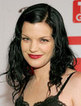

Charities & foundations supported

* The Thirst Project

Causes supported

* Water

# Paul Johansson



Charities & foundations supported

* Lili Claire Foundation

Causes supported

* Children,
* Family/Parent Support,
* Mental Challenges

# Paul McCartney

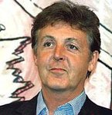

Charities & foundations supported

* 21st Century Leaders
* Adopt-A-Minefield
* Aid Still Required
* American Wild Horse Preservation Campaign
* Barbara Davis Center for Childhood Diabetes
* Children With Leukaemia
* David Lynch Foundation
* Dorset Wildlife Trust
* Great Ormond Street Hospital
* Greenpeace
* Humane Society International
* International Rescue Committee
* Keep A Child Alive
* Kids Wish Network
* Make Poverty History
* Natural Resources Defense Council
* No More Landmines
* Nordoff Robbins
* ParalympicsGB
* PETA
* Prince's Trust
* Red Cross
* Society for Animal Protective Legislation
* St. Francis Food Pantries and Shelters
* STOMP Out Bullying
* TigerTime
* War Child
* Watering Seeds Organization
* Whatever It Takes
* Worldwide Orphans Foundation

Causes supported

* Abuse,
* Adoption, Fostering,
* Orphans,
* AIDS & HIV,
* Animals, At-Risk/Disadvantaged Youths,
* Cancer, Children,
* Conservation,
* Disaster Relief,
* Education, Environment,
* Family/Parent Support, Grief Support,
* Health, Human Rights,
* Hunger,
* Miscellaneous,
* Oceans, Peace, Physical Challenges,
* Poverty,
* Refugees,
* Sports, Weapons Reduction,
* Women

Paul Newman



Charities & foundations supported

* Canary Foundation
* Children In The Wilderness
* HELP USA
* Hole in the Wall Gang
* International Rescue Committee
* NALIP
* Newman's Own Foundation
* Wilderness Safaris Wildlife Trust

Causes supported

* AIDS & HIV, Animals,
* At-Risk/Disadvantaged Youths,
* Cancer, Children,
* Conservation, Creative Arts,
* Disaster Relief,
* Education, Environment,
* Health, Homelessness,
* Human Rights, Hunger,
* Literacy, Mental Challenges,
* Physical Challenges,
* Refugees,
* Women

# Paul Rodgers

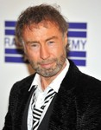

Charities & foundations supported

* Amnesty International
* Racehorse Sanctuary

Causes supported

* Animals,
* Human Rights

Paul Rudd

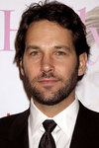

Charities & foundations supported

* American Cancer Society

Causes supported

* Cancer,
* Health

Paul Simon

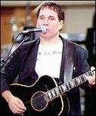

Charities & foundations supported

* Children's Health Fund
* Life College
* Little Kids Rock
* Love Hope Strength Foundation
* Project A.L.S.
* Rosie's Broadway Kids
* The Doe Fund
* Ubuntu Education Fund

Causes supported

* Cancer,
* Children,
* Creative Arts,
* Education, Health
* Homelessness, Poverty

# Paul Sorvino

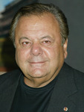

Charities & foundations supported

* Farm Sanctuary

Causes supported

* Animals

# Paul Teutul Sr.

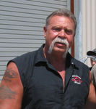

Charities & foundations supported

* Make-A-Wish Foundation

Causes supported

* Cancer,
* Children,
* Health

Paul Walker

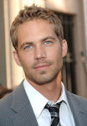

Charities & foundations supported

* REACH OUT Worldwide

Causes supported

* Disaster Relief

# Paul Wall

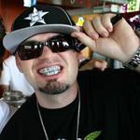

Charities & foundations supported

* A Place Called Home

Causes supported

* At-Risk/Disadvantaged Youths,
* Human Rights

# Paul Weller

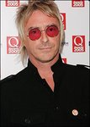

Charities & foundations supported

* Make Roads Safe
* Nordoff Robbins
* Prince's Trust
* Teenage Cancer Trust

Causes supported

* At-Risk/Disadvantaged Youths,
* Cancer, Children,
* Education,
* Health,
* Miscellaneous

# Paul Wesley

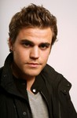

Charities & foundations supported

* The Humane Society

Causes supported

* Animals

# P. Diddy



Charities & foundations supported

* Barbara Davis Center for Childhood Diabetes
* Breast Cancer Research Foundation
* Children's Hope Foundation
* Hip-Hop Summit Action Network
* i.am scholarship Fund
* Jackie Robinson Foundation
* ONE Campaign
* Tony Hawk Foundation
* Usher's New Look Foundation

Causes supported

* AIDS & HIV,
* /Disadvantaged Youths,
* Cancer, Children,
* Disaster Relief, Education,
* Family/Parent Support,
* Health, Miscellaneous,
* Poverty, Sports,
* Women

# Peaches Geldof



Charities & foundations supported

* Bottletop
* Cancer Research UK
* Environmental Justice Foundation
* Sea Turtle Trust

Causes supported

* AIDS & HIV, Animals,
* At-Risk/Disadvantaged Youths,
* Cancer, Conservation, Education,
* Environment
* , Health,
* Human Rights,
* Oceans,
* Poverty

# Pearl Jam

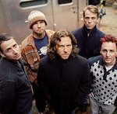

charities & foundations supported

* Bridge School
* Crohn's & Colitis Foundation of America
* FAO
* Habitat For Humanity
* HeadCount
* Jazz Foundation of America
* Red Cross
* Robin Hood
* Rock the Vote
* Sweet Relief Musicians Fund

Causes supported

* AIDS & HIV,
* Animals, Children,
* Conservation,
* Creative Arts,
* Disaster Relief, Economic/Business Support,
* Education,
* Environment,
* Health, Homelessness,
* Human Rights,
* Hunger, Physical Challenges,
* Poverty,
* Refugees,
* Unemployment/Career Support,
* Voter Education,
* Women

# Pelé

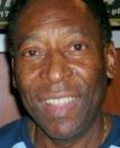

Charities & foundations supported

* 46664
* ABC Trust
* FC Harlem
* Great Ormond Street Hospital
* The Littlest Lamb

Causes supported

* AIDS & HIV,
* Children
* , Health,
* Sports

Penelope Cruz



Charities & foundations supported

* 21st Century Leaders
* Artists for Peace and Justice
* Global Green
* Greenpeace
* ONE Campaign
* Pacific Lodge Boys' Home
* (RED)
* Red Cross
* St. Jude Children's Research Hospital
* The Art of Elysium
* UNICEF
* Whatever It Takes

Causes supported

* Abuse,
* Addiction, AIDS & HIV,
* Animals,
* At-Risk/Disadvantaged Youths,
* Cancer, Children,
* Conservation,
* Disaster Relief,
* Environment,
* Health,
* Human Rights,
* Miscellaneous, Peace,
* Poverty, Substance Abuse,
* Water,
* Women

# Penn Badgley



Charities & foundations supported

* Red Cross

Causes supported

* AIDS & HIV,
* Disaster Relief,
* Human Rights

# Penny Lancaster



Charities & foundations supported

* Caudwell Children
* Kidscape
* Lowe Syndrome Trust
* PDSA

Causes supported

* Abuse,
* Animals,
* Children,
* Health,
* Rape/Sexual Abuse

# Penny Marshall



Charities & foundations supported

* A Day Made Better
* Alzheimer's Association
* A Place Called Home
* Felix Organization
* iwantpeace.com
* New York Cares

Causes supported

* Adoption,
* Fostering, Orphans,
* At-Risk/Disadvantaged Youths,
* Education,
* Health,
* Miscellaneous,
* Peace

# Penny Smith

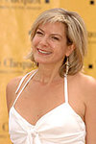

Charities & foundations supported

* Age Concern
* Age UK
* Help The Aged
* The Children's Trust, Tadworth

Causes supported

* Children,
* Health,
* Miscellaneous,

Senior Citizen Support

# Pennywise

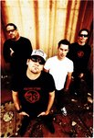

Charities & foundations supported

* Children's Hospital Los Angeles
* Memorial Sloan-Kettering
* TJ Martell Foundation

Causes supported

* AIDS & HIV,
* Cancer,
* Children,
* Health

# Perez Hilton

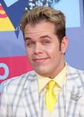

Charities & foundations supported

* PETA
* St. Francis Food Pantries and Shelters

Causes supported

* Animals,
* At-Risk/Disadvantaged Youths,
* Gay/Lesbian Support,
* Hunger

# Perry Farrell



Charities & foundations supported

* American India Foundation
* Global Fund
* Prince's Trust
* Surfrider Foundation

Causes supported

* AIDS & HIV,
* At-Risk/Disadvantaged Youths,
* Children,
* Economic/Business Support,
* Education,
* Environment,
* Health, Human Rights,
* Oceans,
* Poverty,
* Women

# Pete Doherty



Charities & foundations supported

* Love Music Hate Racism
* Samaritans
* Teenage Cancer Trust

Causes supported

* Abuse, Addiction,
* At-Risk/Disadvantaged Youths,
* Cancer, Children,
* Depression and Suicide,
* Family/Parent Support,
* Gay/Lesbian Support,
* Health,
* Human Rights

# Peter André

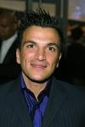

Charities & foundations supported

* Caudwell Children
* Children in Need
* National Society for the Prevention of Cruelty to Children
* Wellbeing of Women

Causes supported

* Abuse,
* Cancer,
* Children, Health,
* Homelessness,
* Mental Challenges,
* Physical Challenges,
* Substance Abuse,
* Women

# Peter Buffett



Charities & foundations supported

* Food Bank For New York City
* NoVo Foundation

Causes supported

* Human Rights,
* Hunger,
* Women

# Peter Coyote



Charities & foundations supported

* See Jane

Causes supported

* Children,
* Environment,
* Women

# Peter Crouch



Charities & foundations supported

* Comic Relief
* Cystic Fibrosis Foundation
* Cystic Fibrosis Trust

Causes supported

* Disaster Relief,
* Health
* Homelessness,
* Human Rights,
* Poverty

# Peter Dinklage



Charities & foundations supported

* Farm Sanctuary

Causes supported

* Animals

# Peter Facinelli

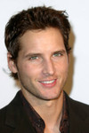

Charities & foundations supported

* Alex's Lemonade Stand Foundation
* Christopher & Dana Reeve Foundation
* FINCA
* Keep America Beautiful
* Milk+Bookies
* OmniPeace

Causes supported

* Cancer,
* Children,
* Conservation,
* Economic/Business Support,
* Education, Environment,
* Family/Parent Support,
* Human Rights,
* Literacy, Philanthropy,
* Physical Challenges,
* Poverty,
* Water,
* Women

# Peter Falk

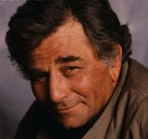

Charities & foundations supported

* PETA

Causes supported

* Animals

# Peter Fonda

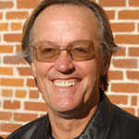

Charities & foundations supported

* AIDS Project Los Angeles
* American Humane Association
* SickKids Foundation

Causes supported

* Abuse,
* AIDS & HIV,
* Animals,
* Children, Health,
* Human Rights

# Peter Frampton

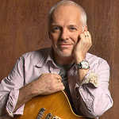

Charities & foundations supported :

* Red Cross

Causes supported

* AIDS & HIV,
* Disaster Relief,
* Human Rights

# Peter Gabriel

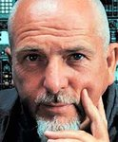

Charities & foundations supported

* 46664
* Amnesty International
* Girls Not Brides
* Global Angels
* Greenpeace
* Life College
* Nordoff Robbins
* The Elders
* Witness

Causes supported

* Abuse,
* Adoption,
* Fostering,
* Orphans, AIDS & HIV,
* Animals,
* At-Risk/Disadvantaged Youths,
* Children, Conservation,
* Education, Environment,
* Health,
* Homelessness,
* Human Rights,
* Hunger,
* Literacy, Miscellaneous,
* Poverty, Refugees,
* Women

# Peter Gallagher



Charities & foundations supported

* Actors Fund of America
* American Heart Association
* Dine Out Los Angeles

Causes supported

* AIDS & HIV,
* Creative Arts, Health,
* Miscellaneous

# Peter Kay



Charities & foundations supported

* Children in Need
* Comic Relief
* Elton John AIDS Foundation
* Willow Foundation

Causes supported

* Abuse, AIDS & HIV,
* Cancer, Children,
* Disaster Relief,
* Health, Homelessness,
* Human Rights,
* Mental Challenges,
* Physical Challenges,
* Poverty,
* Substance Abuse

# Peter Mayhew

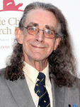

Charities & foundations supported

* Make-A-Wish Foundation
* St. Jude Children's Research Hospital
* Toteman Epilepsy Awareness Project

Causes supported

* Cancer,
* Children,
* Health

# Peter Tork



### Causes supported

* Cancer

# Peter Wentz

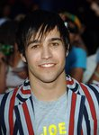

**Charities & foundations supported**

* **Invisible Children**
* **Live Earth**
* **Music Rising**
* **UNICEF**

**Causes supported**

* **Children,**
* **Creative Arts,**
* **Disaster Relief,**
* **Environment,**
* **Health, Human Rights,**
* **Peace, Poverty,**
* **Unemployment/Career Support**

# Pete Seeger

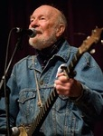

**Charities & foundations supported**

* **Amnesty International**
* **WhyHunger**

**Causes supported**

* **Economic/Business Support,**
* **Human Rights,**
* **Hunger,**
* **Poverty**

# Pete Townshend

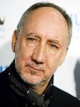

**Charities & foundations supported**

* **Amnesty International**
* **Children's Health Fund**
* **Crossroads Centre**
* **Nordoff Robbins**
* **Teenage Cancer Trust**
* **Teen Cancer America**
* **War Child**

**Causes supported**

* **Addiction,**
* **Cancer,**
* **Children,**
* **Disaster Relief,**
* **Family/Parent Support,**
* **Health, Human Rights**
* **, Miscellaneous,**
* **Peace,**
* **Substance Abuse**

# Pete Yorn



**Charities & foundations supported**

* **Food Bank For New York City**
* **Lili Claire Foundation**
* **The Lunchbox Fund**

**Causes supported**

* **At-Risk/Disadvantaged Youths,**
* **Children,**
* **Family/Parent Support,**
* **Hunger,**
* **Mental Challenges,**
* **Poverty**

# Petra Nemcova



**Charities & foundations supported**

* **Blue Planet Run Foundation**
* **Diamond Empowerment Fund**
* **Happy Hearts Fund**
* **Music Rising**
* **Redlight Children Campaign**
* **Somaly Mam Foundation**
* **Yéle Haiti Foundation**

**Causes supported**

* **Children,**
* **Creative Arts,**
* **Disaster Relief,**
* **Economic/Business Support,**
* **Education,**
* **Environment,**
* **Human Rights,**
* **Hunger,**
* **Poverty,**
* **Rape/Sexual Abuse,**
* **Unemployment/Career Support,**
* **Water,**
* **Women**

# Peyton Manning

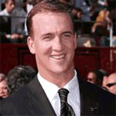

**Charities& foundations supported**

* **Red Cross**

**Causes supported**

* **AIDS & HIV,**
* **Disaster Relief,**
* **Human Rights**

# Pharrell Williams

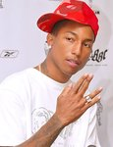

**Charities & foundations supported**

* **Get Schooled Foundation**
* **Great Ormond Street Hospital**

**Causes supported**

* **At-Risk/Disadvantaged Youths,**
* **Children,**
* **Education,**
* **Health**

# Phil Collins

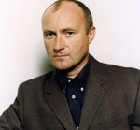

**Charities & foundations supported**

* **21st Century Leaders**
* **Andre Agassi Foundation for Education**
* **Cats Protection**
* **Children With Leukaemia**
* **Great Ormond Street Hospital**
* **Kidney Research UK**
* **Little Dreams Foundation**
* **Love Our Children USA**
* **National Literacy Trust**
* **Parkinson Society Maritime Region**
* **Prince's Trust**
* **St. Francis Food Pantries and Shelters**
* **Topsy Foundation**
* **Whatever It Takes**
* **World Smile Foundation**

**Causes supported**

* **Abuse,**
* **Adoption,**
* **Fostering, Orphans,**
* **AIDS & HIV, Animals,**
* **At-Risk/Disadvantaged Youths,**
* **Cancer, Children,**
* **Creative Arts, Education,**
* **Family/Parent Support,**
* **Health, Hunger,**
* **Literacy, Miscellaneous,**
* **Poverty, Sports**

# Philip Pullman

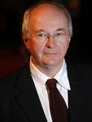

**Charities & foundations supported**

* **British Humanist Association**

**Causes supported**

* **Education,**
* **Philanthropy**

# Phil Keoghan



**Charities & foundations supported**

* **Reality Cares**
* **TeamVRC**

**Causes supported**

* **Environment,**
* **Health,**
* **Miscellaneous, Sports**

# Phil Laak

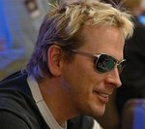

**Charities & foundations supported**

* **Dream Foundation**
* **Vine Group**

**Causes supported**

* **Children,**
* **Education,**
* **Family/Parent Support,**
* **Health**

# Phillip Schofield

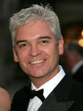

**Charities & foundations supported**

* **Kidney Research UK**
* **Prince's Trust**

**Causes supported**

* **At-Risk/Disadvantaged Youths,**
* **Children,**
* **Education,**
* **Health**

# Phish

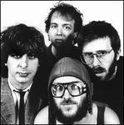

**Charities & foundations supported**

* **Kevin Youkilis Hits For Kids**
* **Reef Relief**

**Causes supported**

* **Children,**
* **Conservation,**
* **Environment,**
* **Health,**
* **Oceans**

# Phoebe Cates



**Charities & foundations supported**

* **Heifer International**

**Causes supported**

* **AIDS & HIV,**
* **Animals,**
* **Children,**
* **Hunger,**
* **Poverty**

Pierce Brosnan



**Charities & foundations supported**

* **21st Century Leaders**
* **Artists for Peace and Justice**
* **Children's Town Malambanyama**
* **Children Uniting Nations**
* **City Hearts: Kids Say Yes to the Arts**
* **Collaboration Foundation**
* **Earth Communications Office**
* **Earth Island Institute**
* **End Hunger Network**
* **Entertainment Industry Foundation**
* **Environmental Media Association**
* **First Star**
* **Gibson Girl Foundation**
* **Global Fund for Women**
* **Global Green**
* **Global Security Institute**
* **Helen & Douglas House**
* **In Defense of Animals**
* **International Fund For Animal Welfare**
* **Jane Goodall Institute**
* **Natural Resources Defense Council**
* **Oceana**
* **Ocean Futures Society**
* **Prince's Trust**
* **Red Cross**
* **Revlon Run/Walk For Women**
* **Roots & Shoots**
* **Sea Shepherd Conservation Society**
* **Starlight Children's Foundation**
* **Tapestry Institute**
* **The Humane Society**
* **The Whaleman Foundation**
* **UNICEF**
* **Variety - The Children's Charity**
* **Waterkeeper Alliance**
* **Whaleman Foundation**
* **Whatever It Takes**

**Causes supported**

* **Abuse,**
* **Adoption,**
* **Fostering,**
* **Orphans, AIDS & HIV,**
* **Animals,**
* **At-Risk/Disadvantaged Youths,**
* **Cancer, Children,**
* **Conservation,**
* **Creative Arts,**
* **Disaster Relief,**
* **Economic/Business Support,**
* **Education, Environment,**
* **Family/Parent Support,**
* **Health, Human Rights,**
* **Hunger,**
* **Miscellaneous,**
* **Oceans, Peace,**
* **Poverty, Water,**
* **Weapons Reduction,**
* **Women**

# Pierre Omidyar



**Charities & foundations supported**

* **UNHCR**

**Causes supported**

* **Human Rights,**
* **Refugees**

# Piers Morgan

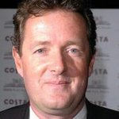

**Charities & foundations supported**

* **Children with AIDS**
* **Comic Relief**
* **Education Africa**
* **Intrepid Fallen Heroes Fund**
* **Norwood**
* **Rays of Sunshine**

**Causes supported**

* **AIDS & HIV,**
* **Children,**
* **Disaster Relief,**
* **Education, Family/Parent Support,**
* **Health,**
* **Homelessness,**
* **Human Rights,**
* **Literacy, Mental Challenges,**
* **Poverty,**
* **veteran/Service Member Support**

Pink

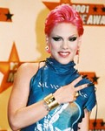

**Charities & foundations supported**

* **Artists for Peace and Justice**
* **GLAAD**
* **Greenpeace**
* **Human Rights Campaign**
* **Keep-a-Breast**
* **Make Poverty History**
* **ONE Campaign**
* **PETA**
* **Planned Parenthood**
* **Population Services International**
* **Prince's Trust**
* **Run For The Cure Foundation**
* **Save the Children**
* **See It and Stop It**
* **Sweet Relief Musicians Fund**
* **Take Back The Night**
* **Treatment Action Campaign**
* **UNESCO**
* **UNICEF**
* **World Society for the Protection of Animals**
* **YouthAIDS**

**Causes supported**

* **Abuse,**
* **AIDS & HIV,**
* **Animals,**
* **At-Risk/Disadvantaged Youths,**
* **Cancer, Children,**
* **Conservation,**
* **Creative Arts, Disaster Relief,**
* **Economic/Business Support,**
* **Education, Environment,**
* **Gay/Lesbian Support,**
* **Health, Human Rights,**
* **Miscellaneous,**
* **Poverty, Rape/Sexual Abuse,**
* **Unemployment/Career Support,**
* **Women**

# Pink Floyd

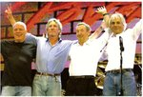

**Charities & foundations supported**

* **Live 8**
* **Nordoff Robbins**
* **Syd Barrett Trust**

**Causes supported**

* **Adoption,**
* **Fostering,**
* **Orphans, AIDS & HIV,**
* **Children,**
* **Mental Challenges,**
* **Miscellaneous,**
* **Poverty**

# Pixie Lott

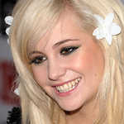

**Charities & foundations supported**

* **Help for Heroes**
* **Variety Club**

**Causes supported**

* **At-Risk/Disadvantaged Youths,**
* **Cancer,**
* **Children,**
* **Health,**
* **Physical Challenges,**
* **Veteran/Service Member Support,**
* **Women**

# Placido Domingo



**Charities & foundations supported**

* **Doctors Without Borders**
* **Hear The World**
* **Orca Network**

**Causes supported**

* **Animals,**
* **Conservation,**
* **Disaster Relief,**
* **Health**

# P.O.D.

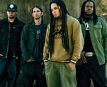

**Charities & foundations supported**

* **Musicians on Call**

**Causes supported**

* **Health**

# Portia de Rossi



**Charities & foundations supported**

* **Family Health International**
* **Farm Sanctuary**
* **Locks Of Love**
* **PROJECT ZAMBI**
* **Save The Music Foundation**
* **The Art of Elysium**
* **The Gentle Barn**
* **The Humane Society**

**Causes supported**

* **Adoption,**
* **Fostering,**
* **Orphans,**
* **AIDS & HIV,**
* **Animals,**
* **At-Risk/Disadvantaged Youths,**
* **Cancer, Children,**
* **Creative Arts,**
* **Education, Health,**
* **Poverty**

Portishead

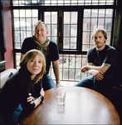

**Charities & foundations supported**

* **Amnesty International**

**Causes supported**

* **Human Rights**

# Powderfinger

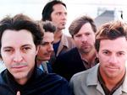

**Charities & foundations supported**

* **World Vision**

**Causes supported**

* **Adoption**
* **Fostering,**
* **Orphans,**
* **AIDS & HIV,**
* **Children,**
* **Poverty**

# Pras



**Charities & foundations supported**

* **J/P Haitian Relief Organization**

**Causes supported**

* **Disaster Relief**

# Preity Zinta



**Charities & foundations supported**

* **Red Cross**
* **The Loomba Trust**

**Causes supported**

* **Abuse,**
* **AIDS & HIV,**
* **Children, Disaster Relief,**
* **Economic/Business Support,**
* **Education, Emergency services,**
* **Family/Parent Support**
* **, Homelessness,**
* **Human Rights, Poverty,**
* **Rape/Sexual Abuse,**
* **Veteran/Service Member Support,**
* **Women**

# Prince

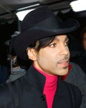

**Charities & foundations supported**

* **City of Hope**
* **Edith Couey Memorial Scholarship Trust Fund**
* **Elevate Hope Foundation**
* **Goss-Michael Foundation**
* **H.A.L.O.**
* **Jazz Foundation of America**
* **The Bridge**
* **Urban Farming**

**Causes supported**

* **Abuse,**
* **Adoption,**
* **Fostering, Orphans,**
* **AIDS & HIV,**
* **At-Risk/Disadvantaged Youths,**
* **Cancer, Children,**
* **Creative Arts,**
* **Education,**
* **Family/Parent Support,**
* **Hunger**

# Prince Albert II of Monaco

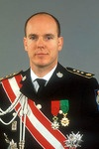

**Charities & foundations supported**

* **Born Free Foundation**
* **Prince Albert II of Monaco Foundation**
* **United Nations Development Programme**

**Causes supported**

* **Animals,**
* **Economic/Business Support,**
* **Education,**
* **Environment,**
* **Poverty**

# Prince Charles

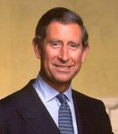

**Charities & foundations supported**

* **Avoided Deforestation Partners**
* **Breakthrough Breast Cancer**
* **Kids Company**
* **Prince's Regeneration Trust**
* **Prince's Trust**
* **Red Cross**
* **Sentebale**
* **ShelterBox**
* **Shooting Star Children's Hospice**

**Causes supported**

* **Abuse,**
* **AIDS & HIV,**
* **At-Risk/Disadvantaged Youths,**
* **Cancer, Children,**
* **Conservation,**
* **Disaster Relief, Education,**
* **Environment,**
* **Family/Parent Support,**
* **Health, Human Rights,**
* **Miscellaneous,**
* **Physical Challenges**

# Prince Harry

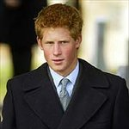

**Charities & foundations supported**

* **Canine Partners**
* **Diana Awards**
* **Diana, Princess of Wales Memorial Fund**
* **Dolen Cymru**
* **Global Angels**
* **HALO Trust**
* **Help for Heroes**
* **Henry van Straubenzee Memorial Fund**
* **MapAction**
* **National AIDS Trust**
* **Sentebale**
* **Skill Force**
* **The Countryside Foundation For Education**
* **The Foundation of Prince William and Prince Harry**
* **The Warrior Programme**
* **Tusk Trust**
* **Walking With The Wounded**
* **WellChild**

**Causes supported**

* **Abuse,**
* **Adoption,**
* **Fostering, Orphans,**
* **AIDS & HIV, Animals,**
* **At-Risk/Disadvantaged Youths,**
* **Cancer, Children, Conservation, Disaster Relief, Education, Health,**
* **Homelessness, Human Rights, Hunger**
* **, Miscellaneous, Peace,**
* **Philanthropy, Physical Challenges,**
* **Poverty, Refugees,**
* **Veteran/Service Member Support,**
* **Weapons Reduction**

# Princess Beatrice



**Charities & foundations supported**

* **Children In Crisis**
* **Elephant Family**
* **Great Ormond Street Hospital**
* **Springboard For Children**

**Causes supported**

* **Animals,**
* **Children,**
* **Education,**
* **Health,**
* **Literacy,**
* **Poverty**

# Princess Diana

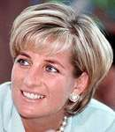

**Charities & foundations supported**

* **Centrepoint**
* **Children With Leukaemia**
* **Diana Awards**
* **Diana, Princess of Wales Memorial Fund**
* **National AIDS Trust**
* **People's Princess Charitable Foundation**

**Causes supported**

* **AIDS & HIV,**
* **At-Risk/Disadvantaged Youths,**
* **Cancer, Children,**
* **Education, Health,**
* **Homelessness,**
* **Miscellaneous,**
* **Refugees,**
* **Weapons Reduction**

# Princess Eugenie

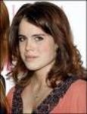

**Charities & foundations supported**

* **Elephant Family**
* **Great Ormond Street Hospital**
* **Kids Company**

**Causes supported**

* **Animals,**
* **At-Risk/Disadvantaged Youths,**
* **Children,**
* **Education,**
* **Health**

# Prince William

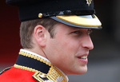

**Charities & foundations supported**

* **BeatBullying**
* **Centrepoint**
* **Child Bereavement Charity**
* **Diana Awards**
* **Diana, Princess of Wales Memorial Fund**
* **Help for Heroes**
* **Henry van Straubenzee Memorial Fund**
* **National AIDS Trust**
* **Royal Marsden Hospital NHS Foundation Trust**
* **Royal Wedding Charity Fund**
* **Sentebale**
* **Skill Force**
* **Teenage Cancer Trust**
* **The Countryside Foundation For Education**
* **The Foundation of Prince William and Prince Harry**
* **Tusk Trust**

**Causes supported**

* **Abuse,**
* **AIDS & HIV,**
* **Animals, At-Risk/Disadvantaged Youths,**
* **Cancer,**
* **Children,**
* **Conservation,**
* **Creative Arts,**
* **Education,**
* **Environment, Family/Parent Support,**
* **Grief Support,**
* **Health, Homelessness,**
* **Human Rights,**
* **Miscellaneous,**
* **Philanthropy,**
* **Physical Challenges,**
* **Poverty,**
* **Refugees, Sports,**
* **Unemployment/Career Support,**
* **Veteran/Service Member Support,**
* **Weapons Reduction**

# Priscilla Presley



**Charities & foundations supported**

* **Barbara Davis Center for Childhood Diabetes**
* **Dream Foundation**

**Causes supported**

* **Children,**
* **Family/Parent Support,**
* **Health**

# Priyanka Chopra



**Charities & foundations supported**

* **UNICEF**

**Causes supported**

* **Children,**
* **Health,**
* **Human Rights,**
* **Poverty**

# Professor Brian Cox



**Charities & foundations supported**

* **British Humanist Association**
* **Save the Rhino**

**Causes supported**

* **Conservation,**
* **Philanthropy**

# Prunella Scales



**Charities & foundations supported**

* **SOS Children's Villages**

**Causes supported**

* **Adoption,**
* **Fostering,**
* **Orphans,**
* **AIDS & HIV,**
* **Children,**
* **Disaster Relief,**
* **Homelessness,**
* **Human Rights,**
* **Poverty**

# Pussycat Dolls



**Charities & foundations supported**

* **Habitat For Humanity**
* **Honeypot**
* **i.am scholarship Fund**
* **Music for Relief**
* **National Breast Cancer Foundation**
* **Project Clean Water**
* **Stand Up To Cancer**

**Causes supported**

* **At-Risk/Disadvantaged Youths,**
* **Cancer,**
* **Children,**
* **Disaster Relief,**
* **Education,**
* **Environment,**
* **Homelessness,**
* **Water,**
* **Women**